3GPP TSG-RAN WG2 Meeting #117 Electronic R2-220xxxx
Online, 21 Feb – 03 Mar 2022

Agenda item: 8.21.2
Source: Huawei, HiSilicon
Title: Report of [AT117-e][074][TEI17] EPS Fallback (Huawei)
Document for: Discussion and Decision

1 Introduction
This document is the report of the following email discussion:
- [AT117-e][074][TEI17] EPS Fallback (Huawei)
Scope: Related to R2-2202818, R2-2202505, R2-2202791. Whether to have a EPS fallback enhancement where the UE goes directly to EUTRA for conn establishment upon paging in NR (MT), or NAS indication in the UE (MO). Determine and clarify the potential impact to other groups and security implications for MT and MO cases, aiming to understand whether the scope for this proposal can be kept limited to RAN2. If possible, determine if LS is needed to SA3.
Intended outcome: Report, agreeable LS to SA3 if applicable.
Deadline: For on-line CB W2 Thursday

2 Contact points
Company | Name | Email
Qualcomm Incorporated | Masato | mkitazoe@qti.qualcomm.com

3 Discussion
AS discussed during W2 Monday session, R2-2202818, R2-2202505, R2-2202791 propose similar solution for EPS fallback enhancement, i.e. the idle/inactive UE goes directly to E-UTRA for connection establishment upon paging (for voice) in NR (MT), or NAS indication in the UE (MO).
The motivation is to reduce EPS fallback latency for idle/inactive UE, which is long according to the existing EPS fallback procedure and has negative impact on UE experience. The performance gain on the latency reduction is clear as analysed in the contributions. There is wide support of addressing latency reduction for EPS fallback, while some companies raise the comments that whether other WGs are impacted need further discussion.
Considering the difference among the solutions in R2-2202818, R2-2202505, R2-2202791 is only on which message to indicate EPS fallback, i.e. via paging or SIB, which is in RAN scope, the potential impact to other groups (if any) should be same, and is discussed together without differentiation as follows.

3.1 Potential impact to SA2/CT1
In SA2, the stage 2 procedure of EPS fallback has been captured in TS 23.501 clause 5.16.3.10 and TS 23.502 clause 4.13.6.1, which is specific to the connected UEs via HO and redirection. In 38.300, Inter system fallback towards E-UTRAN is performed when 5GC does not support emergency services, voice services, for load balancing etc. Depending on factors such as CN interface availability, network configuration and radio conditions, the fallback procedure results in either RRC_CONNECTED state mobility (handover procedure) or RRC_IDLE state mobility (redirection), see TS 23.501 [3] and TS 38.331 [12].
Analysis:
Some companies commented online/offline whether the solutions have impact on core network. Starting with MT case, the existing procedures for VoLTE call establishment in MT side is shown in the below figure (copied from GSM Association Official Document N2020.01 - VoLTE Service Description and Implementation Guidelines), it is understood VoNR also reuse the same IMS procedures.
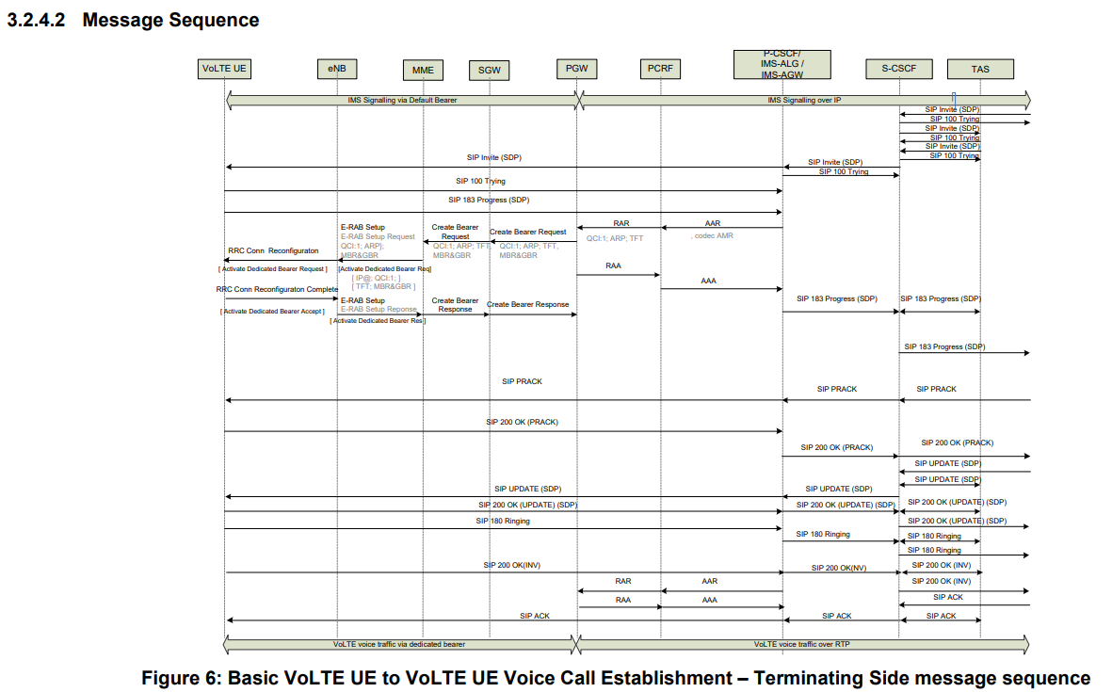
We can see:
- The IMS system is above core network and RAN. The IMS session is established between UE and IMS system, and the SIP signalling is carried via QCI5 in LTE (5QI5 in NR), while the voice traffic is via QCI1 in LTE (5QI1 in NR).
- In the existing EPS fallback procedure,
  - If the UE is in connected, the gNB will trigger EPS fallback via HO/redirection to EPS in the step of QCI1 setup request. After UE accessing E-UTRA, the IMS session and 5QI5 are resumed and 5QI1 is established for voice traffic. This is because 5GC-EPC interworking can ensure the lossless IMS session continuity for connected mobility and idle mobility as 5.17.2.2 in TS 23.501.
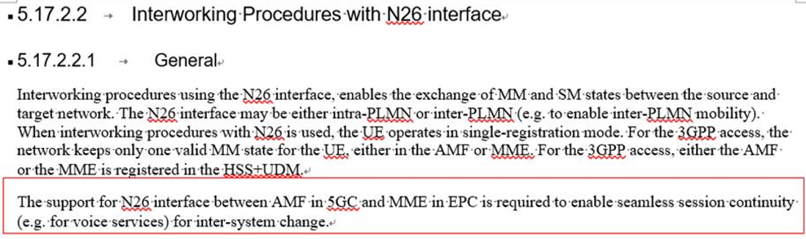
  - If the UE is in idle/inactive, the SIP Invite message (DL arrival of QCI5) will trigger paging message. Upon UE entering connected state in NR, the IMS session is resumed and the SIP Invite message can be sent to the UE, followed by same steps for connected UE.
Back to the paging/SIB triggered EPS fallback solution, after receiving the paging triggered by SIP Invite message, the UE autonomously selects E-UTRA for connection establishment instead of responding the paging message in NR. The same procedure of redirection will be performed in LTE side. For instance, by TAU, the IMS session and QCI5 will be resumed, and SIP signalling from MO side will arrive the MT UE, which triggers QCI1 setup for voice traffic.
For MO case, the UE just decides to initiate call via NR or E-UTRA based on SIB indication, nothing new compared with the existing MO call procedure. Note that even in today, the UE may do so by UE implementation.
To summarize, the above VoLTE procedure is not changed by the solution for MT case or MO case. The UE still uses the existing IMS procedures and inter-system idle mobility procedure defined in SA2/CT1. The only change is the UE is aware about this is a voice call from the paging message and then enters connected mode in E-UTRA to resume data transmission including IMS session as usual. Thus there should be no new SA2/CT1 procedure/signalling needed, and no change on the existing stage 3 SA2/CT1 procedure. (The stage 2 procedure may need update to cover the new solution for idle/inactive UE (if agreed), but should not require SA2 big effort on technical discussion. Thus the impact if any should be minimum.)

Question 1.1: Do companies agree no new SA2/CT1 procedure/signalling is required to enable the paging/SIB triggered EPS fallback solution and no stage 3 procedure for voice call setup is impacted by the new solution?
Company | Yes/No | Comments
Qualcomm Incorporated | No | MT enhancement:  - Voice indication in paging so far is only for MUSIM, and the use of it by AMF is conditioned to UE’s MUSIM capability signalled via NAS. If the feature needs to be repurposed for this MT enhancement, then new UE capability may be necessary.  - It is not always TAU that the UE initiates after reselecting to LTE. It can be Attach with PDN connectivity request, if without N26 interface. This may require some changes in TS 23.401 if it needs to be triggered by paging in NR.  - Since the UE “disappears” from NR after voice indication via paging, a new paging strategy (e.g. for re-paging) may have to be employed by 5GS. This requires knowledge at 5GC on UE capability for this MT enhancement.  - We also understand that the stage-2 procedure in TS23.502 has to be changed to cover this new procedure.  MO enhancement:  - We would like to ask the proponent to clarify:  - The state of upper layer (NAS, IMS) when the MO triggers reselection to LTE.  - Which layer (NAS or IMS?) triggers MO voice call after reselection to LTE.  - Note that similar (at least from the view point of external UE behaviour) procedure is defined in TS24.501 for emergency call fallback where NAS triggers fallback when MO emergency call is not successful due to e.g. lower layer failure. This involves not only NAS, but also IMS layer.  All in all, we do not think RAN2 alone cannot fully assess and conclude on SA2/CT1 impact.

Question 1.2: Do companies identify any other potential SA2/CT1 impact? If so please list the detailed aspects.
Company | Yes/No | Comments
Qualcomm Incorporated | Yes | Please see our input to Q1.1.

3.2 Potential impact to SA3
During online discussion, there was comment that in the EPS fallback solution, paging indicating voice is more risky than MUSIM. However, we understand the paging cause for MUSIM does impact the UE’s decision on releasing the link where receiving paging or response to the paging link, the result is just like EPS fallback. In addition, the similar solution is specified in LTE, i.e. paging indicating CS or PS domain. In case of CS domain, UE needs to initiate CSFB and let NW to move it to LTE, similar outcome of paging triggered EPS fallback.
Furthermore, we observed SA3 has discussed the security requirement specific to paging in MUSIM and there is no problem foreseen (i.e. in SA3 agreed TP S3-212687, the conclusion is no security threats of exposing 'paging cause’).

Question 2.1: Regarding SA3 impact, do companies agree there is no new issue compared with MUSIM?
Company | Yes/No | Comments

Question 2.2: If companies answer for 2.1 is no, do companies think LS to SA3 is needed? If so, what’s the content?
Company | Yes/No | Comments

4 Conclusion
TBD

