3GPP TSG-RAN WG2 Meeting #117 Electronic R2-220xxxx
Online, 21 February – 03 March 2022

Agenda item: 8.24.3
Source: Bell Mobility (Rapporteur)
Title: Report of [AT117-e][061][NR17] n77 variants (Bell Mobility)
Document for: Discussion and Decision

1 Introduction
This document is the report of the following email discussion:
- [AT117-e][061][NR17] n77 variants (Bell Mobility)
Scope: Treat R2-2202183. Collect one round of comments, based on comments determine whether any action need to be taken by RAN2 (or whether to just wait for RAN4). IF actions are to be taken, CB online W2 Monday
Intended outcome: Report
Deadline: W1 Friday

2 Contact Points
Respondents to the email discussion are kindly asked to fill in the following table.
Company | Name | Email Address
Bell Mobility | Melissa Pinheiro | melissa.pinheiro@bell.ca
Qualcomm Incorporated | Masato Kitazoe | mkitazoe@qti.qualcomm.com
Huawei, HiSilicon | Yang Zhao | zhaoyang@huawei.com
Nokia, Nokia Shanghai Bell | Tero Henttonen | tero.henttonen@nokia.com
TELUS | Navaneetha Krishna, Madan Gopal | navaneeth.madangopal@telus.com
Apple | Naveen Palle | naveen.palle@apple.com
Samsung | Jaehyuk Jang | jack.jang@samsung.com
AT&T | Joe Schumacher | jq304t@att.com
Ericsson | Håkan Palm | hakan.l.palm@ericsson.com
MediaTek | Felix Tsai | chun-fan.tsai@mediatek.com
CATT | Jie Shi | shijie@catt.cn

3 Discussion
This discussion concerns the document R2-2202183, which consider the n77 spectrum operation in Canada, where the spectrum from 3450-3650 MHz was auctioned in June 2021. The spectrum is a subset of two 3GPP defined bands: n78 and n77. In market devices are therefore only tested and certified to operate in the available range, 3450-3650 MHz. In Q1 2023, a new auction will take place for spectrum from 3650-3980 MHz which will again be another subset of n77 3GPP defined band as showed in Figure below
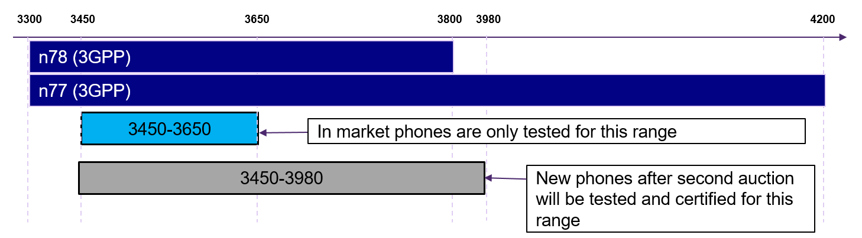
Figure 1. Spectrum allocation in Canada
The contribution raises the following issue:
- As network has no knowledge about the UE constraint of being tested and certified only for a subset of the declared supported band, radio link failures and performance degradation is expected to occur. Can RAN2 signalling differentiate between devices certified for current n77 spectrum in Canada(certified up to 3650 MHz) and future devices that will be certified for the wider range (up to 3980 MHz)?
The companies are requested to provide feedback to this issue.
Question 1: Do companies agree with the stated issue for n77 in Canada?
Answers to Question 1
Company | Yes/No | Technical Arguments
Qualcomm Incorporated | Yes | Going forward, RAN2 will have to understand the situation a bit better, for them to be able to develop a solution.  We understand that the “in market” UEs tested for 3450-3650 range is NOT implemented to access only n77 cells of 3450-3650 range in Canada. So it is simply a UE supporting n77 and NS_1 in standard compliant manner.
Huawei, HiSilicon | Unclear | It is not very clear about the situation.  Generally, if UE report the support of n77/n78, it means that the whole frequency range is supported. Based on the RAN5’s test design, the test cases can cover the whole frequency range of band n77 and n78. In addition, considering the UE roaming, the whole frequency range of band n77/n78 should be supported by UEs.  It’s better to first check with UE vendors whether there is existing UEs in the field who reported support of band n77/n78 but actually it only supports 3450~3650 in Canada strictly.
Nokia, Nokia Shanghai Bell | Yes | We have similar view as QC: The situation described means that Canadian operators can only assume UEs that support NS_1 (as per global band definition). And since the current signalling for NS_55 support is for the US frequencies (which are different from the Canadian ones), it cannot be used to distinguish "new" UEs from current UEs.
Bell Mobility | Yes | The issue is related to phased introduction of 3.5GHz spectrum in Canada and has similarities to the US band n77 that was originally introduced to cover the frequency range 3700-3980 MHz, and later extended to include 3450-3550 MHz frequency range.  Due to regulations in Canada devices cannot operate outside of 3450-3650MHz and some UE’s will limit the UE frequency range operation in a proprietary way which may lead to RLF.  Also, for devices that do not implement such mechanism, once the network is operating on the broader range both OEM and operator will share liability and regulatory bodies can question both OEM and operator. So, there is a legal issue with operation of such devices.  Canadian operators require a standard mechanism to differentiate current n77 UEs that support frequency range from 3450-3650 MHz (2022 devices) and extended n77 devices (3450-3980 MHz range, 2023+ devices) to be compliant to local regulations and to avoid performance issues.  We would like to resolve this within Rel-17
TELUS | Yes | We are aligned with Bell on this issue in Canada. Though this is a problem that could occur in other parts of the world as deployments continue, and a general solution is warranted, for the time being we feel the need for a quick resolution in Rel-17.
Apple | Yes
Qualcomm Incorporated |  | (Second comment after seeing the input from Bell Mobility).  It looks like we need to think about three types of UEs.  - Type 1 (2022 devices): UE being implemented to only camp, access and connect in 3450-3650 MHz range in Canada.  - Type 2: Normal n77 UE supporting the entire range of n77.  - Type 3 (2023+ devices): UE optimized for extended range of n77 in Canada.  Type 1 and Type 2 UEs are legacy UEs and we cannot change the behaviour of those UEs.  For Type 1 UE, the network is expected to refrain from sending the UE outside 3450-3650 MHz range.  For Type 2 UE, it is not clear what the desired behaviour is, e.g. should the UE be allowed to camp on outside 3450-3650 MHz? In connected mode, there is no way for the network to distinguish between Type 1 and Type 2 UEs. So probably the same handling is only possible.  For Type 3 UE, camping on extended range is allowed. In connected mode, the network can also send the UE outside 3450-3650 MHz range. This UE type can be distinguished by a new UE capability parameter.
Samsung | Yes | -
AT&T | Yes | We see this situation as similar to the DoD band and frequency range n77 extension in the US.  We don’t believe that existing signalling can differentiate UEs for Canada but a similar solution could be applied as done for DoD band in US.
Ericsson | Yes | Thanks for the further clarifications on the Canadian situation!
MediaTek | Unclear | Currently Canada only has 3450-3650MHz, but it was NOT specified in 3GPP spec (i.e. not the same as what we had for US). So, we understand that UE in Canada supports full n77 range if claim to support (i.e. Type 2 UE in QC’s comment). We are not sure whether there is really Type 1 UE in the market.
CATT | Unclear | We hope some company clarify the issue of whether there is really Type 1 UE in the market. If the answer is yes, we are fine to question 1.
T-Mobile USA | No | From a standards compliance perspective there’s nothing that needs to be addressed, UE’s that meet all of the n77 requirements are required and tested to ensure that they operate from 3300-4200 MHz. There’s no limitation from a standards compliance perspective.  What Bell Canada seeks to address is a UE regulatory certification/testing issue which currently outside of 3GPP’s scope. “In market phones” problem applies to any global band i.e. n41 and n77 where UE’s are subject to time varying regional regulatory body certification/testing requirements. Industry Canada only has requirements for 3450-3630 and the FCC only has requirements for 3450-3550 and 3700 – 3980 MHz. 3GPP recently addressed changes within n77 precipitated by new spectrum auctions in the US. Japan, China and Europe have different “In Market” requirements set by the local regulatory body. Which portion of a global band is available in a “market” changes over time.  This is an ongoing problem that needs a long term solution that addresses the constantly changing market availability of spectrum within a global band, where some regulators only certify devices to operate in part of the full 3GPP band. This solution needs to be flexible and easily implementable. RAN plenary needs to decide if 3GPP should expand the 3GPP scope to address UE regulatory certification, the requirements for a new feature and have the SA and RAN TSG’s develop the appropriate solution.  What we don’t want to see is repeat of the problems caused by the original version of n77 note 12 and the unforeseen problems that came about when new spectrum was authorized in the US.

Summary 1: TBD.
Proposal 1: TBD.

If companies agree to the issue, can the existing signalling help differentiate between the different UEs?
Question 2: Is there signalling mechanism that allows network to differentiate users that are only certified up to 3650 MHz in n77 from those that are certified up to 3890 MHz in n77?
Answers to Question 2
Company | Yes/No | Technical Arguments
Qualcomm Incorporated |  | Solutions explored for n77 DoD band access (e.g. introducing new band, new NS value) seem applicable in this case as well.
Huawei, HiSilicon |  | We think we’d better to first understand the issue better before going to solutions.
Nokia, Nokia Shanghai Bell |  | We would note that the current capability signalling for n77 cannot be used since it concerns different frequency portions of n77 - this is illustrated by the figure below.  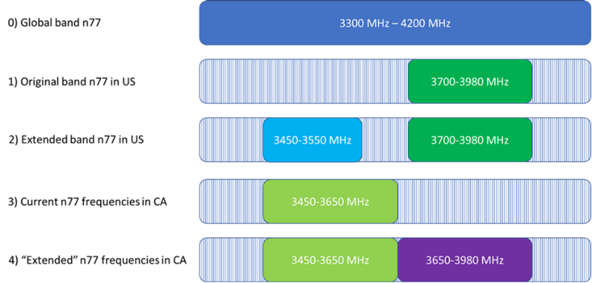  We think there can be several solutions to the stated problem (e.g. new frequency band, new NS-value, new capabilities), but as Huawei also said, before determining the solutions, we think RAN4 needs to be involved in understanding the problem boundary conditions.
Bell Mobility |  | The introduction of new frequency bands is not the desired outcome of this discussion, as this would fragment the already established ecosystem. Creating a similar signalling as was done for n77 DoD (extendedBandCA-n77-r17 IE along with a new NS_XX) seems to be a feasible approach.  Also would like to ask if re-using the existing signalling defined for US and changing the fields description can be a possible solution (see below)  extendedBand-n77-r16  This field is only applicable for UEs that indicate support for band n77.  In USA, If present, the UE supports the restriction to 3450 - 3550 MHz and 3700 - 3980 MHz ranges of band n77 in the USA as specified in Note 12 of Table 5.2-1 in TS 38.101-1 [2]. If absent, the UE supports only restriction to the 3700 - 3980 MHz range of band n77 in the USA.  In Canada, if absent the UE only supports 3450 - 3650 MHz range of band n77. If present, the UE supports the 3450-3980 MHz range of band n77.  A UE that indicates this field shall also support NS value 55 as specified in TS 38.101-1 [2].
TELUS |  | We echo Bell’s reluctance on the introduction of a new band as this would lead to further fragmentation of our device ecosystem.  Adaptation of the extendedBand-n77-r16 field would be ideal in terms of both implementation timeline and roaming compatibility when n77 bands are activated in Canada starting June 17th, 2022.
Apple |  | We see that something similar to NS_55 approach can be a way to resolve this.
Samsung |  | We can wait for RAN4 discussion, but in general, the solution discussed for USA can be reused. Note that we prefer a separate capability for Canada to avoid any misunderstanding, as Nokia pointed out.
AT&T |  | If the Canadian operators require an immediate solution, we think that introducing a new IE and new NS value using the same approach used for n77 DoD band in the US could be done. Certainly, this is not ideal and a more generic bitmap solution would be better to make it future proof but using the same approach with a different IE and different NS value would be the quickest solution.  We would have some concerns with re-using extendedBand-n77-r16 and defining it differently and having the UE provide the IE based on the UE reading MCC information. This could cause some concerns in cross-border handover situations. We also think that it would be better to use a different NS value than NS_55 for the extended frequency range for Canada for the purpose of cell barring so that the description can be clear.
Ericsson |  | We proposed to introduce a new frequency band (number) to solve the n77 extension in the US. The new band number would cover both the original and the extended sub-bands of the “global” n77, and documented properly in the RAN4 specs. This would have been a cleaner approach, both in specifications and implementations.  We do not understand how this would lead to more device fragmentation than when using specific capability bits and NS values to differentiate tested and certified UEs.in the sub-bands.  Note that we have an ongoing discussion to resolve remaining issues on NS_55 in CA configuration, see [AT117-e][032][NR1615].  Reusing same extendedBand-n77-r16 and NS_55 would not be wise, as explained by Nokia.
MediaTek |  | We suggest waiting for RAN4 conclusion to understand the issue better and see if there is any solution suggested by RAN4.  We share similar concern as Nokia and Ericsson on reusing the existing capability bit in USA for Canada. If really needed, new capability bit could be introduced.
CATT |  | We are fine to reuse the solution for n77 in USA and introduce a new capability, but we hope to wait the RAN4 progress to have more understanding to this issue before RAN2 make the decision.
T-Mobile USA |  | See our proposal for RAN plenary discussion in Question 1, if that’s not acceptable then a new band number should be used.

Summary 2: TBD.
Proposal 2: TBD.

Finally, it is also stated that this issue is being raised up in RAN4 as it's related to spectrum allocation. Is there a need for RAN2 to take some actions on this topic, e.g. liaise with RAN4 on this topic, or should RAN2 wait for the RAN4 to inform what is expected on this topic?
Question 3: Does RAN2 need to take some actions on this, e.g. send LS to RAN4 on the conclusions of this topic and/or ask for guidance on what is required from signalling in this case?
Answers to Question 3
Company | Yes/No | Technical Arguments
Huawei, HiSilicon |  | We understand same paper has been submitted to RAN4 and discussion already starts in RAN4. So seems no need to have LS to RAN4.
Nokia, Nokia Shanghai Bell |  | We understand RAN4 is discussing the issue already as indicated in the Bell Mobility contribution. So we expect RAN4 to provide guidande to RAN2, at which time RAN2 can better provide feedback. Until then, if we really want to tell RAN4 something, it would be that the existing extendedBand-n77-r16 capability signalling doesn't work in this case.
Bell Mobility | Yes | RAN2 should ask RAN4 to provide guidance on the issue if RAN2 concludes that no existing signalling can be used to solve the issue
TELUS | Yes | RAN2 would have to seek guidance from RAN4 in case current signalling is not reused to resolve the issue.
Apple |  | We think we can wait for RAN4 guidance. They also are aware and are discussing this including the option of using NS_55 type of approach.
Samsung |  | We have same understanding as Huawei.
AT&T | Yes | We also have the same understanding as Huawei and others that RAN4 is discussing this issue as well. However, we would support an LS to RAN4 to communicate the RAN2 agreements/conclusions that existing signalling does not support the differentiation of the subset of the n77 spectrum in Canada.
Ericsson |  | If RAN2 now prefers to introduce a new frequency band (that would cover both the old sub-band and new sub-band), an LS should be sent to RAN4.  If instead RAN2 prefers the same approach as we introduced for n77 in would be adopted now for Canada, but with its own capability bit and new NS-value, it could be wise to communicate this to RAN4.
MediaTek |  | We understand RAN4 already discussed this issue so it seems no LS is needed at this moment.  If RAN2 later on has some preference on the solution, we can them inform RAN4.
CATT |  | We have the same view as Huawei.
T-Mobile USA | No | This is a RAN plenary topic..

Summary 3: TBD.
Proposal 3: TBD.

3 Conclusion
TBD.

