3GPP TSG-RAN WG2 Meeting #117 Electronic R2-220xxxx
Online, 21 February – 03 March 2022

Agenda item: 8.24.3
Source: Bell Mobility (Rapporteur)
Title: Report of [AT117-e][061][NR17] n77 variants (Bell Mobility)
Document for: Discussion and Decision

1 Introduction
This document is the report of the following email discussion:
- [AT117-e][061][NR17] n77 variants (Bell Mobility)
Scope: Treat R2-2202183. Collect one round of comments, based on comments determine whether any action need to be taken by RAN2 (or whether to just wait for RAN4). IF actions are to be taken, CB online W2 Monday
Intended outcome: Report
Deadline: W1 Friday

2 Contact Points
Respondents to the email discussion are kindly asked to fill in the following table.
Company | Name | Email Address
Bell Mobility | Melissa Pinheiro | melissa.pinheiro@bell.ca
Qualcomm Incorporated | Masato Kitazoe | mkitazoe@qti.qualcomm.com
Huawei, HiSilicon | Yang Zhao | zhaoyang@huawei.com

3 Discussion
This discussion concerns the document R2-2202183, which consider the n77 spectrum operation in Canada, where the spectrum from 3450-3650 MHz was auctioned in June 2021. The spectrum is a subset of two 3GPP defined bands: n78 and n77. In market devices are therefore only tested and certified to operate in the available range, 3450-3650 MHz. In Q1 2023, a new auction will take place for spectrum from 3650-3980 MHz which will again be another subset of n77 3GPP defined band as showed in Figure below
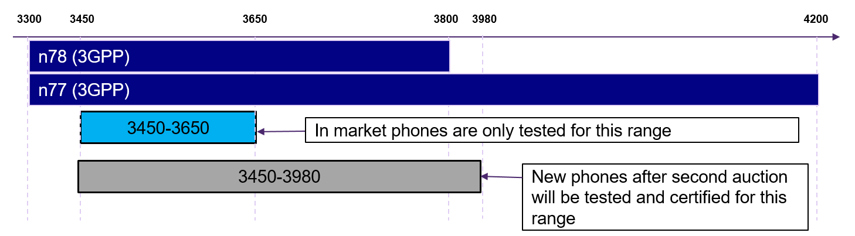
Figure 1. Spetrcum allocation in Canada
The contribution raises the following issue:
- As network has no knowledge about the UE constraint of being tested and certified only for a subset of the declared supported band, radio link failures and performance degradation is expected to occur. Can RAN2 signalling differentiate between devices certified for current n77 spectrum in Canada(certified up to 3650 MHz) and future devices that will be certified for the wider range (up to 3980 MHz)?
The companies are requested to provide feedback to this issue.
Question 1: Do companies agree with the stated issue for n77 in Canada?
Answers to Question 1
Company | Yes/No | Technical Arguments
Qualcomm Incorporated | Yes | Going forward, RAN2 will have to understand the situation a bit better, for them to be able to develop a solution.  We understand that the “in market” UEs tested for 3450-3650 range is NOT implemented to access only n77 cells of 3450-3650 range in Canada. So it is simply a UE supporting n77 and NS_1 in standard compliant manner.
Huawei, HiSilicon | Unclear | It is not very clear about the situation.  Generally, if UE report the support of n77/n78, it means that the whole frequency range is supported. Based on the RAN5’s test design, the test cases can cover the whole frequency range of band n77 and n78. In addition, considering the UE roaming, the whole frequency range of band n77/n78 should be supported by UEs.  It’s better to first check with UE vendors whether there is existing UEs in the field who reported support of band n77/n78 but actually it only supports 3450~3650 in Canada strictly.

Summary 1: TBD.
Proposal 1: TBD.

If companies agree to the issue, can the existing signalling help differentiate between the different UEs?
Question 2: Is there signalling mechanism that allows network to differentiate users that are only certified up to 3650 MHz in n77 from those that are certified up to 3890 MHz in n77?
Answers to Question 2
Company | Yes/No | Technical Arguments
Qualcomm Incorporated |  | Solutions explored for n77 DoD band access (e.g. introducing new band, new NS value) seem applicable in this case as well.
Huawei, HiSilicon |  | We think we’d better to first understand the issue better before going to solutions.

Summary 2: TBD.
Proposal 2: TBD.

Finally, it is also stated that this issue is being raised up in RAN4 as it's related to spectrum allocation. Is there a need for RAN2 to take some actions on this topic, e.g. liaise with RAN4 on this topic, or should RAN2 wait for the RAN4 to inform what is expected on this topic?
Question 3: Does RAN2 need to take some actions on this, e.g. send LS to RAN4 on the conclusions of this topic and/or ask for guidance on what is required from signalling in this case?
Answers to Question 3
Company | Yes/No | Technical Arguments
Huawei, HiSilicon |  | We understand same paper has been submitted to RAN4 and discussion already starts in RAN4. So seems no need to have LS to RAN4.

Summary 3: TBD.
Proposal 3: TBD.

3 Conclusion
TBD.

