3GPP TSG-RAN WG2 Meeting #117-e R2-22xxxxx
Online, Feb 21st – March 03rd, 2022

Agenda item: 9.2.3
Source: MediaTek Inc.
Title: [AT117-e][015][IoT-NTN] Miscellaneous Issues (MediaTek)
Document for: Discussion and Decision

1 Introduction
This document is aimed to make a report of the email discussion on IOT NTN miscellaneous issues:

- [AT117-e][015][IoT-NTN] Miscellaneous Issues (MediaTek)
Scope: Based on R2-2203721 (and related summarized input), Include OI 2.13 and OI 2.14 from AI 9.2.5, and progress the following:
- P3 on cell reselection priority
- Location Reporting in IoT-NTN, and kick this part off as soon as LS reply is received (e.g. for NB-IoT), and/or as soon as relevant progress is achieved for NR NTN (e.g. for eMTC).
- UE report of remaining GNSS validity duration (Chair comment: this is a R1 agreement and can thus be followed, however the R1 agreed range might not be sufficient for this reporting to be useful, suggest to discuss this).
- For Prediction of discontinuous coverage: Can attempt to address the earlier defined FFS: FFS whether additional assumptions (like averaging time) need to be clarified, e.g. to have predictable performance.
- For Prediction of discontinuous coverage: additional new parameters, like satellite footprint reference location on ground and coverage radius (condition that they shall be defined without RAN1 involvement).
- Determine agreeable parts, Aim to agree less controversial points offline (with no CB). Identify CB points.
Intended outcome: Report
Deadline: In time for first on-line CB W2 Tuesday, later CB TBD.

2 Contact Information
Company | Name | Email
MediaTek | Abhishek Roy | Abhishek.Roy@mediatek.com
Ericsson | Jonas Sedin | Jonas.sedin@ericsson.com
Intel | Tangxun | xun.tang@intel.com
Apple | Pavan Nuggehalli | pnuggehalli@apple.com

3 Discussion (Phase I)
3.1 Prioritize TN vs NTN Frequencies
OI 2.3 Whether existing offset are sufficient to prioritize TN vs NTN frequencies
Out of 5 contributions (R2-2202414, R2-2202729, R2-2202747, R2-2203002 and R2-2203453), 4 contributions (R2-2202414, R2-2202729, R2-2203002 and R2-2203453 suggested that the same existing offset are sufficient to prioritize TN over NTN frequencies. Only one contribution R2-2202747 suggested using new offset. Note that this is also discussed and recently agreed in NR-NTN [1] with the following agreement: “2. No further enhancement on cell reselection priority in NTN. Remove the corresponding FFS from 38.304 CR.” Hence, based on these, the rapporteur asks the following question:
Question 1: Do companies agree that IoT-NTN can use NR-NTN agreements that “No further enhancement on cell reselection priority in NTN”?

Company | Agree/Disagree | Comments
Ericsson | Agree | Yes, this is in line with NR NTN. And this would be sufficient to prioritize TN over NTN and NTN over TN (this was discussed in NR NTN, but we doubt it is needed).
Intel | Agree
Apple | Agree

2.2 Reporting GNSS Validity
The joint (co-source) contribution in R2-2203530 has mentioned concerns about RAN2 116bis-e agreements on GNSS validity. According to this contribution it would make IoT NTN challenging for network operations if the network is not aware of GNSS validity duration. According to this contribution if the GNSS validity timer is set to a low value by the UE and the UE goes to idle mode without the network being aware and the network then attempts to reach the UE there could be problem. When UE is unreachable, it is difficult for the network to know what to do with the UE resources and there is a risk that significant resources are wasted on UEs that have gone to idle mode. Hence, it is suggested that UE reports the remaining GNSS validity duration to the network, following the RAN1 agreement:
Agreement
The UE autonomously determines its GNSS validity duration X and reports information associated with this valid duration to the network via RRC signalling.
- X = {10s, 20s, 30s, 40s, 50s, 60s, 5 min, 10 min, 15 min, 20 min, 25 min, 30 min, 60 min, 90 min, 120 min, infinity}
Based on these discussions the rapporteur would like to raise the following question:
Question 2: Do companies agree that UE needs to report the remaining GNSS validity duration to the network?

Company | Agree/Disagree | Comments
Ericsson | Agree | RAN1 made the agreement to report it and they would not have introduced the GNSS validity duration without the reporting. As stated in the contribution above, using this duration, the network knows when to release the UE so that there is no state mismatch and the network can prioritize UEs with a short duration. This is needed for the network and we do not think that it is an optimization.  Regarding chair comments:  (Chair comment: this is a R1 agreement and can thus be followed, however the R1 agreed range might not be sufficient for this reporting to be useful, suggest to discuss this).  As the point of the reporting is to give the network an idea whether UE might disappear soon or not, we believe the value range reported does not need to be super precise. To keep it simple, we can use the X values in the RAN1 agreement to be reported. However, we can further discuss the values needed.
Intel | Agree | This is in line with the RAN1 agreement in LS R2-2200084.
Apple | Agree

3.3 Discontinuous Coverage
Discontinuous coverage was discussed during RAN2 117-e online session on Feb-21 and the following agreement is made:
- RAN2 assumes that for Discontinuous Coverage, network can signal mean ephemeris parameters (for neighbors and potentially serving satellite for coverage prediction purpose), using the same (already introduced) ephemeris format. UE can always assume these are mean values and It is up to the network implementation to derive this mean value (and any trade-off between instantaneous and mean values if needed). FFS whether additional assumptions (like averaging time) need to be clarified, e.g. to have predictable performance.

Hence, based on the above agreement, n order to make some progress on the FFS, the rapporteur would like to ask the following question:
Question 3: Do companies agree that the additional assumption need to be clarified for a predictably better performance? If “agree” then companies are requested to mention any such additional assumptions (like averaging time etc.).

Company | Agree/Disagree | Comments
Ericsson | - | We assume the additional information would be how long the ephemeris would be valid, similar to the validity duration, but with a much longer duration. If companies for instance want to introduce a parameter that indicates how many hours {1,2,3…, 24} that an ephemeris for discontinuous coverage would be considered valid, we are fine with this. Otherwise state the maximum time that a UE can use an ephemeris value could also be fine for us.  Satellite companies can also voice whether this would be useful.
Intel | Disagree | It’s up to NW implementation to generate this “mean” ephemeris. And this “averaging time” is similar to the validity duration, i.e. when it is longer than the averaging time the ephemeris is outdated. If this averaging time information is needed, we can reuse the validity duration in SIB for this purpose.
Apple | Agree | We would be fine to introduce a parameter as Ericsson suggests to indicates for how long the ephemeris is considered valid. We think reusing the currently defined validity duration is not practical (since it is likely tailored for the “instantaneous” ephemeris of the serving cell)

Another major open issue in Discontinuous Coverage is to decide on “whether additional new parameters like satellite footprint reference point on ground, satellite coverage radius can be used”. A set of 13 contributions (R2-2202352, R2-2202458, R2-2202559, R2-2202589, R2-2202621, R2-2202748, R2-2202931, R2-2203001, R2-2203081, R2-2203223, R2-2203258, R2-2203293 and R2-2203453) are submitted on this Discontinuous Coverage. All the contributions suggested use of additional new parameters, like cell coverage or reference point on the ground for supporting Discontinuous Coverage. The rapporteur agrees that there is a considerable support from many companies to include additional, new parameters for supporting Discontinuous Coverage. However, given the completion of IoT-NTN Work Item (WI) in RAN1, RAN2 needs to define and include any such additional new parameters without any RAN1 involvement. Hence, the rapporteur asks the following question:
Question 4a: Do companies agree that RAN2 can include some additional, simple, new parameter(s) without any RAN1 involvement.

Company | Agree/Disagree | Comments
Ericsson | Agree | We think RAN2 can introduce this without RAN1. We are not sure what RAN1 can help us with here, since the parameters suggested are anyways quite simple.
Intel | Agree | We think satellite coverage radius is a simple parameter as it is per satellite, but not per cell. And there is no RAN1 impact.
Apple | Agree | Parameters like footprint reference point and radius can be specified by RAN2 without RAN1 involvement.

Question 4b: If the answer to Question 4a is “yes” (i.e., no RAN1 involvement), then the companies are requested to mention any such simple, additional parameter(s) and explain how these parameters can be defined and included without any RAN1 involvement. (Possible additional parameters include satellite coverage radius, elevation angle, satellite footprint reference point on ground, etc.)
Company | Additional Parameters | Comments
Ericsson | 1) Coverage radius below satellite nadir for moving beams  2) Coverage radius and satellite footprint reference for earth-fixed cells | We think that the below parameters are roughly a compromise of most contributions on this issue:  1) Using a radius to characterize the coverage of a satellite is quite a typical, especially for LEO.  In the below figure the coverage of a LEO satellite at 600 km altitude can be seen and the red line would represent the coverage radius.  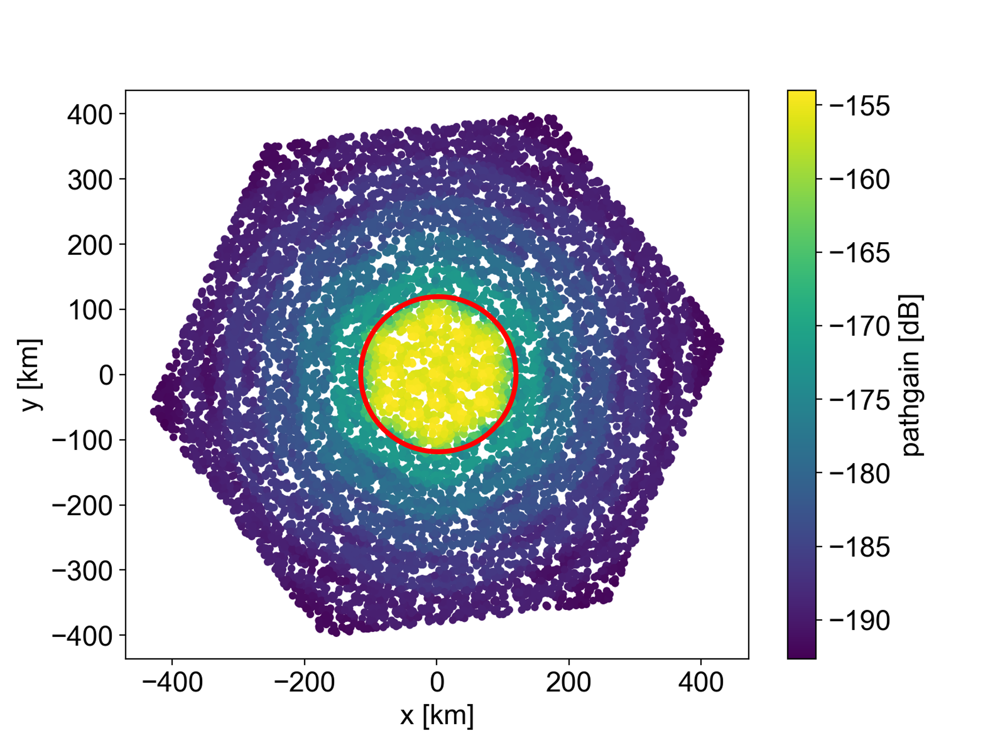  We think that this coverage could easily be characterized by a radius from the satellite nadir point as we would believe that for these satellite solutions it is most likely that the satellite would point its beams roughly directly downwards.  2) The coverage radius and satellite footprint reference locations. This can be used by the UE to estimate when a reference location will be illuminated using the ephemeris. The network would thus include one or two reference locations on what central location that upcoming satellite will point its beams towards. We can skip any type of elevation angle or time when these reference locations are illuminated and let UE estimate.
Intel | satellite coverage radius | It is a per satellite parameter, and the value range can reuse the beam footprint range in TR 38.821. As for satellite footprint reference, we think it is the sub-satellite point and the position can be calculated based on ephemeris.

3.4 UE’s Location Reporting
The major open issues in Location Reporting are the following:
OI 2.13 [Other] UE location reporting in eMTC
OI 2.14 [Other] UE location reporting in NB-IoT
A total 8 contributions (R2-2202414, R2-2202549, R2-2202729, R2-2203002, R2-2203052, R2-2203080, R2-2203193 and R2-2203453) are submitted in RAN2 117-e on this aspect. 3 contributions (R2-2202414, R2-2202729 and R2-2203453) suggested sending coarse location reporting before security establishment and location reporting by NAS. On the other hand, 2 contributions in R2-2202549 and R2-2203193, have suggested not to use location information in Rel-17 as UE reported location could be debatable and may require network verification. 3 other contributions in R2-2203002, R2-2203052 and R2-2203080 has suggested to wait for LS response from SA2/SA3 before further progress in IoT-NTN.
The rapporteur would like to note and mention that RAN2 had already spend a lot of time in discussion and making agreements on this issue in NR-NTN session. SA3 has mentioned not to use location report before security establishment. Two LSs are sent from RAN2: R2-2201881 and R2-2209158 for confirming about this location information report. Hence, the rapporteur suggests waiting for the LS response and check any progress and outcome in NR-NTN before discussing this in IoT-NTN – possibly in the Phase 2.

5 Conclusion
<To be updated later>

6 References
- R2-117-e Agenda v5.0
- R2-2202352 Discussion on the additional new parameters for supporting discontinuous coverage for IoT over NTN Transsion Holdings
- R2-2202414 Discussion on the remaining issue of IoT over NTN Spreadtrum Communications
- R2-2202458 Discussion on additional parameters for Non continuous coverage Intel Corporation
- R2-2202549 Location reporting in NAS Apple
- R2-2202550 Support of discontinuous coverage Apple
- R2-2202559 Additional issues on the support of the discontinuous coverage Qualcomm Incorporated
- R2-2202562 Signalling of multiple TACs per PLMN in eMTC and NB-IoT Qualcomm Incorporated
- R2-2202589 Satellite assistance information and exchange for discontinuity Prediction in IoT NTN Lenovo, Motorola Mobility
- R2-2202615 UP leftover issues for IoT-NTN CMCC
- R2-2202621 Discussion on open issues for support of Non continuous coverage CMCC
- R2-2202729 Remaining Issues of CP Impact of IoT over NTN CMCC
- R2-2202746 Remaining issues of user plane in IoT NTN ZTE Corporation, Sanechips
- R2-2202747 Remaining issues of control plane in IoT NTN ZTE Corporation, Sanechips
- R2-2202748 Remaining issues of discontinuous coverage in IoT NTN ZTE Corporation, Sanechips
- R2-2202749 Remaining issues of UE capabilities in IoT NTN ZTE Corporation, Sanechips
- R2-2202931 Discussion on discontinuous coverage Xiaomi
- R2-2203000 Discussion on UP open issues in IoT NTN OPPO
- R2-2203001 Discussion on the open issues of discontinuous coverage for IoT over NTN OPPO
- R2-2203002 Discussion on Control Plane open issues for IoT NTN OPPO
- R2-2203052 On remaining control plane issues for IoT-NTN Nokia Solutions & Networks (I)
- R2-2203080 Further Discussion on the Open Issues of IoT-NTN Control Plane CATT
- R2-2203081 Open Issue on UP and Discontinous Coverage CATT
- R2-2203192 Issues related to IOT NTN RRC running CR Xiaomi
- R2-2203193 Remaining issues of IOT NTN RRC Xiaomi
- R2-2203222 OI 2.9: Signalling of multiple TACs per PLMN in eMTC and NB-IoT Huawei, HiSilicon
- R2-2203223 OI 3.5: Discussion on non continuous coverage Huawei, HiSilicon
- R2-2203258 On IoT NTN open issues for Discontinuous Coverage and User plane Nokia, Nokia Shanghai Bell
- R2-2203293 (O1 3.5) Parameters for coverage gap prediction and Idle mode behaviour Interdigital, Inc.
- R2-2203453 Control plane and discontinuous coverage aspects of IoT NTN Ericsson
- R2-2203483 User plane aspects of NB-IoT and LTE-M in NTNs Ericsson
- R2-2203530 On GNSS validity duration reporting Ericsson, Nokia, Nokia Shanghai Bell, Turkcell, NEC, Qualcomm, ZTE.
- R2-2201881 LS on UE location during initial access in NTN
- R2-2203386 Pre117-e][102][NTN] Idle mode open issues (ZTE)
- R2-2203154 Pre117-e][NTN][101] RRC open issues (Ericsson)

