3GPP TSG-RAN WG2 Meeting #115-e R2-2108946
Electronic, 9th – 27th August, 2021

Agenda Item: 8.11.3
Source: Huawei, HiSilicon
Title: [AT115-e][615][POS] UL and UL DL positioning in RRC_INACTIVE (Huawei)
Document for: Discussion and Agreement

Introduction
This document is to handle the following email discussion:
- [AT115-e][615][POS] UL and UL+DL positioning in RRC_INACTIVE (Huawei)
Scope: Evaluate the proposed UL and UL+DL positioning schemes and attempt to converge on an agreeable procedure.
Intended outcome: Report in R2-2108946
Deadline: Tuesday 2021-08-24 0800 UTC

In this discussion, we will take the following contributions into the background for the discussion
R2-2108383 Summary of [Post114-e][602][POS] Stage 2 procedure for deferred MT-LR in RRC_INACTIVE Qualcomm Incorporated discussion Late
R2-2108826 Summary of AI 8.11.3 for RRC INACTIVE positioning ZTE discussion
R2-2108605 Way-forward for INACTIVE positioning Huawei, China Unicom, China Telecom, Futurewei, HiSilicon, Intel Corporation, Interdigital, Spreadtrum Communications, VIVO, Xiaomi, ZTE Corporation discussion Rel-17 NR_pos_enh-Core Late

  - Contact Information
Company | Delegate name | Delegate email
Ericsson | Ritesh Shreevastav | Ritesh.shreevastav@ericsson.com
vivo | Xiang Pan | panxiang@vivo.com
InterDigital | Jaya Rao, Fumihiro Hasegawa | jaya.rao@interdigital.com, fumihiro.hasegawa@interdigital.com
ZTE | Yu Pan | pan.yu24@zte.com.cn
OPPO | Xin You | youxin@oppo.com
Spreadtrum | Huifang Fan | Huifang.fan@unisoc.com
Nokia | Mani Thyagarajan | mani.thyagarajan@nokia.com

Background

Email disussion [Post114-e][602][POS]
After RAN2#114-e, the following email dicsussion has been performed on the stage2 description for RRC_INACTIVE positioning

- [Post114-e][602][POS] Stage 2 procedure for deferred MT-LR in RRC_INACTIVE (Qualcomm)
Scope: Develop stage 2 level descriptions of the positioning procedures in RRC_INACTIVE, using the deferred MT-LR procedure as a framework for parts where some LCS procedural context is necessary. (This does not imply that only deferred MT-LR would be supported.) The scope can include the possibility of no stage 2 impact.
Intended outcome: Report to next meeting
Deadline: Long

In the email dicsussion, the following solutions have been provided: the first solution is proposed in [Post114-e][602][POS] as in Section 4.1; while another solution has been proposed by Huawei, HiSilicon in the annex of the email discussion, as in Section 4.2.

Way-forward for stage2 in R2-2108605
In the way-forward for the stage2 description for UL/UL+DL positioning in RRC_INACTIVE, a comparison has been given for the two solutions listed in Section 4.1 and Section 4.2.
 |  | Solution in 4.1 | Solution in 4.2
Required Number of SDT procedures |  | - 2 for UL  - 2 for UL+DL | - 1 for UL  - 2 for UL+ DL
UL/UL+DL positioning request |  | At Step 16 of Clause 6.3.1 of TS 23.273 | At Step 27 of Clause 6.3.1 of TS 23.273
UE Positioning in the overall deferred MT-LR procedure |  | At Step 25/26 of Clause 6.3.1 of TS 23.273 | At Step 27 of Clause 6.3.1 of TS 23.273
Time-domain characteristics of SRS |  | - Semi-persistent SRS  - SRS configuration delivered to the UE in RRC_CONNECTED | - Periodic SRS  - SRS configuration delivered to the UE in RRC_INACTIVE
SRS deactivation mechanism |  | Deactivation MAC CE | - Expiration of TAT for UL  - RRCRelease with SRS configuration for UL+DL
When is the positioning method determined? |  | Determined at the configuration of triggered event is received when UE receives LCS Periodic-Triggered Invoke Request | Determined when the UE receives Event Report
Triggered Event and Event Report |  | Event Report sent after the UE requests to the network for SRS transmission | Event Report sent immediately after event trigger
Required Stage-3 changes | Changes needed by both Solutions | SRS in RRC_INACTIVE
 | XN-AP | - SRS configuration in the UE context transfer  - LMF routing id transferred from last serving gNB to the serving gNB | No stage-3 impacts
 | LCS Periodic-Triggered Invoke Request | Type of Positioning Method requested (UL or DL or UL+DL)
 | RRC message | The "Location Event Indication" may be a new RRC message or an extension of the RRC LocationMeasurementIndication message.
Required SA2 changes |  | - SRS transmission request from the UE to the network  - Event report is not immediately sent after event is triggered, but after SRS transmission request | No SA2 stage2 impacts

With the two solutions above, a joint contribution has been proosed for the way-forward of the stage2. A consolidated solution has been given as in Section 4.3 to allow the UE to be configured with periodic SRS when the UE is released to RRC_INACTIVE if the UE is configured with periodic event.

Discussion during RAN2#115e
During RAN2#115e, the following agreements have been achieved for the LCS/LPP message transport and the stage2 procedure baseline for DL and RAT-independent positioning:

R2-2108383 Summary of [Post114-e][602][POS] Stage 2 procedure for deferred MT-LR in RRC_INACTIVE Qualcomm Incorporated discussion Late

Agreements:
LPP PDU and LCS message transfer:
Proposal 1: The LPP PDU Transfer Procedure in Annex A is used as baseline for further work.
NOTE 1: Some details may depend on further progress of the SDT work item.
NOTE 2: Whether such a procedure needs to be captured in Stage 2 specification or not can be decided later when the procedure has been fully developed/agreed. That is, the procedure can be considered as "running baseline".

Proposal 2: The LCS Message Transfer Procedure in Annex B is used as baseline for further work.
NOTE 1: Some details may depend on further progress of the SDT work item.
NOTE 2: Whether such a procedure needs to be captured in Stage 2 specification or not can be decided later when the procedure has been fully developed/agreed. That is, the procedure can be considered as "running baseline".

Proposal 3: UL LPP message segmentation can also be used by the UE in RRC_INACTIVE state; i.e., a LPP message body can be sent in several shorter LPP messages instead of one long LPP message by using the SDT "Subsequent Data Transmission" phase. FFS spec impact.

DL and RAT-independent positioning:
Proposal 4: The Deferred 5GC-MT-LR Procedure with SDT for DL-only and RAT-independent positioning in Annex C is used as baseline for further work.
NOTE 1: Some details may depend on further progress of SDT work item.
NOTE 2: Whether such a procedure needs to be captured in Stage 2 specification or not can be decided later when the procedure has been fully developed/agreed. That is, the procedure can be considered as "running baseline".
NOTE 3: Once the procedure is stable from RAN2 perspective, send an LS to SA2 including the baseline procedure.

Agreement:
(High priority)Proposal 1: Support all the RAT independent positioning methods in RRC_INACTIVE state.

Discussion on UL/UL+DL positioning method
For the consolidated solution, the main difference with the solution in Section 4.2 is that, the consolidated solution has considered the case of periodic event, that the UE can be configured with periodic SRS, whose periodicity is aligned with the periodicity of the defined periodic event, when the UE is released to RRC_INACTIVE.
In this case, the SRS configuration does not need to be configured to the UE by the UE’s request and the network’s on-the-fly configuration. When the periodic event is triggered, the UE would send periodic SRS and the network can perform measurements on the periodic SRS.
Question1: Do companies agree that, the UE can be configured with periodic SRS when periodic event is defined for the deferred MT-LR, as in the consolidated solution?
Company | Yes/No | Comments
Ericsson |  | Before providing configuration, we need to know that UE can transmit UL SRS in inactive mode. This has to be acked by RAN1. There are still questions pending upon whether TA value similar to PUR can be used or not. What will be the transmit power and in FR2 the spatial relations in inactive mode. How to mitigate interference.  Also, as companies mentioned during Rel-16 DL-PRS exhange between gNBs for spatial relations determination that for positioning we should not rely upon Xn but NRPPa; hence this should be applicable here as well.
Qualcomm | No | This appears not feasible. It means that the UE would transmit SRS even before any TRP is configured to measure the SRS.  [Huawei, HiSilicon] We think that the periodic deferred MT-LR has to be first sent to the UE in RRC_CONNECTED, where the gNB and LMF would do the necessary signaling exchange for the SRS configuration. And, the configuration is sent to the UE. When the UE moves to RRC_INACTIVE, the gNB just carries on with the SRS configuration in CONNECTED in RRC_INACTIVE.  The note at step 2 says that steps 3-8 are not needed in this case. But this leaves only Step 1, 2, 9-12 of the procedure, which means that step 9 (TRP Measurement Request) cannot be performed since no SRS configuration is available at the LMF (without steps 6-8). Note that while the LMF might assume that UL SRS will take place (e.g. based on some initial notification from the anchor gNB) and send TRP Measurement Requests without any new notification from the anchor gNB, this breaks down if the UE has changed cell. There would be other problems when the UE changes cell as the anchor gNB would have provided UL transmission budget for UL SRS tranmission that will not now occur.  [Huawei, HiSilicon] Steps 3-8 are not needed only when SRS can be transmitted. If the SRS cannot be sent, e..g, due to cell reselection, the UE still can request SRS configuration by sending another event report to another gNB  Furthermore, we can’t see that an anchor gNB could always authorize UL SRS a long time in advance for unknown future link conditions.  [Huawei, HiSilicon] When a TAT is runnig in the UE side, there will also be a TAT running in the network side such that when the TAT expires in the UE side, the network knows the TA’s expiry in the UE side. For the TA update, some simple solution, like RACH can work to let the UE obtain the TA again, but that can be up to RAN1 to decide
vivo | Yes, but the valid duration of SRS configuraiton depends on the period of the event | The maxium period is 10240 milli-seconds for peridical SRS configuration. Therefore, for the periodic location, if the periodicity of the event is much longer than that of SRS, most SRS are send in vain and the purpose of saving energy in RRC_INACTIVE can not be achieved.  In this case, the periodicities are not aligned and the periodical SRS can be configured with a short TA timer.  >>>>PeriodicitySRS ENUMERATED (0.125, 0.25, 0.5, 0.625, 1, 1.25, 2, 2.5, 4, 5, 8, 10, 16, 20, 32, 40, 64, 80, 160, 320, 640, 1280, 2560, 5120, 10240, …) Milli-seconds  LCS-PeriodicLocationRequestArg ::= SEQUENCE {  referenceNumber [0] IMPLICIT OCTET STRING ( SIZE( 1 ) ),  periodicLDRInfo [1] IMPLICIT SEQUENCE {  reportingAmount INTEGER ( 1 .. 8639999 ),  reportingInterval INTEGER ( 1 .. 8639999 ),  ... },  Meanwhile, we agree with QC that the gNB cannot aware the SRS turns invalid due to UE mobility and the step 3-8 for the solution in 4.3 are aways essential.  [Huawei, HiSilicon] When a TAT is runnig in the UE side, there will also be a TAT running in the network side such that when the TAT expires in the UE side, the network knows the TA’s expiry in the UE side. For the TA update, some simple solution, like RACH can work to let the UE obtain the TA again, but that can be up to RAN1 to decide
InterDigital | Yes, with comments | We think configuring of UE with periodic SRS as proposed in the consolidated solution in section 4.3 can be used as a starting point. This is a comment that’s applicable to either solution but further discussion may be needed for clarifying any issues related to timing of SRS transmission in INACTIVE and validity of the periodic SRS configuration when considering different scenarios including mobility and/or cell change.
Huawei, HiSilicon | Yes | Regarding the replies from the abvoe companies, we also have some replies and please see them inlined.
Intel | Depends on | If the periodic SRS can be configured in step1, and TRP measurement request can also be configured in step 1, we do not see the problem on this.  If periodic SRS is configured in step 2, we do agree that the measurement request is needed before LMF and measured TRPs, and therefore the Note should be updated.
Xiaomi | Yes | The periodic SRS is more simple for the UL positoning in RRC inactive, we think it can be used as start point.
CATT | Yes | The gNB can be aware of the UE mobility state based on UE history info and the period for deferred MT-LR. The gNB can decide whether to configure periodic SRS to the UE for UL positioning in RRC_INACTIVE. For example, if the gNB thinks the UE is low mobility while periodic deferred MT-LR is required, it can configure periodic SRS to the UE for UL positioning in RRC_INACTIVE.
ZTE | Yes | Periodic SRS should be the first step to support positioning in RRC_INACTIVE, then is semi-persistent SRS and aperiodic SRS.
OPPO | See comments | We see no problem if the periodicity of the pre-configured period SRS aligns with the deferred event. While for the TA issue, we share similar view as QC, TA timer that introduced in SDT WID does not consider the mobility case.
Spreadtrum | Yes | Supporting of periodic SRS can be as the baseline procedure of the UL positioning in RRC inactive.
Nokia | No | It would have helped to see the new solution as part of the [Post114-e][602] email discussion to analyze the feasibility and to compare the solutions. We need more time to analyze the different solutions on the table. Continuing this discussion as a Post115-e email discussion is preferred.

We then ask the final question on whether companies think the consolidated solution in Section 4.3 can be taken as the baseline for UL/UL+DL positioning in RRC_INACTIVE. Companies are invited to analyse the solution in Section 4.3 and provide inputs below.
Question2: Do companies agree to adopt the consolidated solution in Section 4.3 as the baseline procedure for UL/UL+DL positioning in RRC_INACTIVE?
Company | Yes/No | Comments
Ericsson |  | Both Solutions are complicated. The gain Vs pain analysis would highlight that there are more pain. NB-IoT/MTC PUR feature is based upon stationary device whose TA is as such valid for long duration.  Positioning is required primarily for moving objects; in connected mode UE may perform several TA adjustments and is well sycnhronized and interference is managed. In inactive, this is not the case. The TA validity, synchronized UL SRS transmission and interfernce management are questionable.  Without ensuring how fundamentals of UL SRS in Inactive would work, we are already jumping into all the details.
Qualcomm | No | We cannot see the difference between the Solution in 4.2 and the "consolidated solution". The "consolidated solution" is the same as Solution 4.2 with the addition of the Question 1 feature, whose feasibility is highly questionable.  As commented above in section 2.2, the starting point is different for both solutions (i.e. section 6.3 vs. section 6.7 of TS 23.273). The ultimate goal of positioning in RRC_INACTIVE state should be UE power savings. Solution 4.2 is not a solution for power savings, since each time an event is triggered, a positioning procedure is executed (with a high chance of not being finished without transition to RRC_CONNECTED, e.g. if the UE or LMF sends an LPP message that is too large for SDT transfer or if the gNB is not aware of, or not able to support, all the follow on SDT transfers).  Therefore, we think the solution should be based on the "Low Power Periodic and Triggered 5GC-MT-LR Procedure" version in 6.7 of TS 23.273, which is the case with solution in 4.1.
vivo | Yes | In our view, the fundamental difference between the two solutions is whether UE can request for SRS configuration.  For solution in 4.1, the UE can request for SRS configuration via the "Location Event Indication", which may be a new RRC message or an extension of the RRC LocationMeasurementIndication message.  It is an enhancement as the UE cannot request SRS configuration now.  For solution in 4.3, the SRS configuraiton is send by the gNB and will not introduce spec impacts but the UE shall initiate the SDT first to send the event report, otherwise, the gNB cannot send the SRS configuration via SDT.  In general, we think the solution in 4.3 can be a baseline for UL positioning in RRC_INACTIVE as it introduce few spec impact. The solution in 4.1 can seen as an enhancement if time permits.
InterDigital | Yes, with comments | We support to adopt the consolidated procedure in section 4.3 as a starting point. Hovever, we think some discussions may be needed to describe whether the consolidated procedure can account for some of aspects of solution 4.1 and 4.2. In addition, it may be beneficial to discuss whether and what changes would be necessary in the consolidated procedure for possibly supporting semi-persistent SRS for positioning in INACTIVE.  While the note provided after step 10 in procedure 4.2.1 describe some details, we think it can be further discussed on how the timing of UE sending the periodic SRS can be controllled such that some alignment can be done with respect to the timing the gNBs perform measurements of SRS (i.e. between steps 8 to 10 in procedure 4.2.1). For the SRS deactivation, some details of TAT configuration can be discussed. For example, whether the serving gNB can configure the TAT such that the LMF can send the measurement request and SRS configuration to gNBs via NRPPa with the awareness that the UE releases the SRS after the TA expiry.
Huawei, HiSilicon | Yes | We can take the stage2 procedure as baseline and think about the necessary stage3 changes.
Intel | Yes with comments | We agree with vivo. The main difference between 4.1 and 4.3 is whether the SRS is requested by UE (4.1), or based on existing (4.3), i.e. configured by gNB/LMF.  However as mentioned in question 1, if periodic SRS is configured in step 2, we do agree that the measurement request is needed before LMF and measured TRPs, and therefore the Note should be updated.  Our answer “yes” is, we agree to use procedure for further discussion. But we do not see the need to capture it into stage 2.
Xiaomi | Yes with comments | If only periodic SRS is uesed for deferred UL and UL+DL positioning in RRC inactive, we think only periodic envent should be supported, thus the unnecessary SRS transmission can be avoided and UE power consumption can be reduced. Moreover, if we decide to support aperiodic SRS and semi-SRS in later, the unified procedure should be considered for all SRS tyeps.
CATT | Yes with comments | We support to use the procedure for further discussion. And we think in 4.3 event report is always triggered. So in 4.3.1, if the UE is configured with periodic SRS in step 2 and the camped cell of the UE is not changed from the cell where the UE receives RRCRelease with suspendConfig, the steps from 3-5 are always needed but the steps from 6-8 are not needed.
ZTE | Yes | Support section 4.3 as a baseline. Periodic events/SRS in RRC_INACTIVE is fundamental, we suggest to focus on this first. Also we wonder if it is necessary to trigger SDT procedure twice in section 4.1.
OPPO | Yes with comments | Currently we haven’t reached any ULpositoining-specific agreement for RRC_INACTIVE positioning, and there are still many open issues, i.e. how to configure SRS, how to guarantee TA validity, etc.  We agree to use the consolidated solution in Section 4.3 as the baseline for further discussion and it can be updated according to the future agreements.
Spreadtrum | Yes with comments | There are many issues to be discussed for UL positioning in RRC_INACTIVE , such as how to configure SRS, whether to support pre-configuration SRS, TA issues, etc. we can use the consolidated solution in Section 4.3 as the baseline for further discussion. And we can update the procedure according to the future agreements.
Nokia | No | It would have helped to see the new solution as part of the [Post114-e][602] email discussion to analyze the feasibility and to compare the solutions. We need more time to analyze the different solutions on the table. Continuing this discussion as a Post115-e email discussion is preferred.

Finally, we have the following open question:
Question3: Do companies think there are other issues might need to be discussed?
Company | Comments
vivo | As a common understanding of the two solutions, the following proposal should be agreed as a starting point:  SRS configuration for UL positioning in RRC_INACTIVE can be carried in RRCRelease message with suspendConfig.  [Huawei, HiSilicon] We agree that this can be helpful. But it is not within the scope of the email discussion.  - [AT115-e][615][POS] UL and UL+DL positioning in RRC_INACTIVE (Huawei)  Scope: Evaluate the proposed UL and UL+DL positioning schemes and attempt to converge on an agreeable procedure.  Intended outcome: Report in R2-2108946  Deadline: Tuesday 2021-08-24 0800 UTC  Besides, the baseline solution all assume this. SO, we think it should be OK

Annex

4.1 Solution in [Post114-e][602][POS]

4.1.1 UL Solution
Figure B: Low Power Periodic and Triggered 5GC-MT-LR Procedure with SDT (UL-only positioning).

1. Steps 1-21 for the deferred 5GC-MT-LR procedure for periodic or triggered location events specified in TS 23.273 [8], clause 6.3.1 are performed.
At Step 15 of this procedure described in Figure 6.3.1-1 of TS 23.273 [8], the LMF may perform one or more positioning procedures to obtain an initial UE location estimate. During this step, the LMF may request and obtain the UE positioning capabilities which may include an indication that the UE can support UL positioning in RRC_INACTIVE state.
The LMF may also provide an UL-PRS configuration, or a set of alternative UL-PRS configurations to the serving gNB via an NRPPa Positioning Information Request message. The serving gNB may then send an NRPPa Positioning Information Response message that indicates whether UL positioning can be supported for the UE in RRC_INACTIVE state. For a subsequent change of anchor gNB, the UL-PRS configuration(s) is sent to the new serving gNB as part of the transfer of a UE context to the new serving gNB.
The serving gNB then sends an RRCConnectionRelease with suspendConfig to move the UE to RRC_INACTIVE state.
2. The UE monitors for occurrence of the trigger or periodic event requested during step 1. The UE determines which positioning method(s) will be used for the detected event from the request in Step 1 (based on the position method(s) included in an LPP Request Location Information message carried in the LCS Periodic-Triggered Invoke Request during Step 1).
3. When event reporting is allowed in RRC_INACTIVE state and after (or slightly before) an event is detected and if CG-SDT resources are not configured or cannot be selected, the UE performs a 2-step or 4-step RACH procedure. In the case of a 2-step RACH, the UE includes an RRC Resume Request message in the PUSCH payload for MsgA; in the case of a 4-step RACH, the UE sends an RRC Resume Request message in msg3 to the gNB.
Otherwise, if CG-SDT resources are configured on the selected UL carrier and are valid, the UE sends an RRC Resume Request message in the CG transmission to the gNB.
The UE sends a "Location Event Indication" along with the RRC Resume Request to trigger UL positioning at the gNB.
UL-PRS is already configured in the UE and anchor gNB during Step 1.
Editor's Note: The "Location Event Indication" may be a new RRC message or an extension of the RRC LocationMeasurementIndication message.
4. The serving gNB fetches the UE context from the anchor gNB. The UE context includes the UL-PRS configuration(s) (as determined during Step 1).
5. The serving gNB determines the UL-PRS configuration based on the UE context information received at Step 4b and sends a NRPPa Positioning Information Update message to the LMF via the serving AMF (probably through the anchor gNB).
6. The LMF may send a NRPPa Positioning Activation message (possibly with a starting time) to the serving gNB to request UL-PRS activation in the UE.
7. The serving gNB provides the UL-PRS configuration to the UE along with the RRC Release message over msg4 or MsgB. The message may also include the CG Configuration and a MAC-CE SRS Activation Request (possibly with a starting time).
NOTE: The UL-PRS configuration at this step may be an index to a pre-configured UL-PRS configuration (during Step 1), or a delta-UL-PRS configuration, etc.
8. The serving gNB sends a NRPPa Positioning Activation Response message to the LMF when activation in the UE was successful.
9. The LMF sends a NRPPa Measurement Request to a group of gNBs incl. the UL-PRS measurement configuration.
10. The UE transmits UL-PRS according to the activated configuration at Step 7.
11.Each configured gNB at Step 9 measures the UL-PRS.
12. Same as Step 3, but with the RRC Resume Request message including the SS LCS Event Report indicating the type of event being reported.
13. The serving gNB sends the SS LCS Event Report to the anchor gNB, which provides the SS LCS Event Report to the LMF (via serving AMF).
14. The gNBs that performed the UL-PRS measurements provide an NRRPPa Measurement Response message to the LMF including the UL-PRS measurements performed at Step 11.
15. The LMF may send a NRPPa Positioning Deactivation Request message to the anchor gNB which forwards the message to the serving gNB. The serving gNB sends the UL-PRS Deactivation to the UE at Step 15b.
Editor's Note: This may be a downlink message in response to UL SDT.
16. The LMF sends an SS LCS Event Report Acknowledgement to the anchor gNB.
17. The serving gNB provides the SS LCS Event Report Acknowledgement to the UE along with the RRC Release message.
18. Steps 28-31 for the deferred 5GC-MT-LR procedure for periodic or triggered location events specified in TS 23.273 [8], clause 6.3.1 are performed.

4.1.2 UL+DL solution
1. Steps 1-21 for the deferred 5GC-MT-LR procedure for periodic or triggered location events specified in TS 23.273 [8], clause 6.3.1 are performed.
At Step 15 of this procedure described in Figure 6.3.1-1 of TS 23.273 [8], the LMF may perform one or more positioning procedures to obtain an initial UE location estimate. During this step, the LMF may request and obtain the UE positioning capabilities which may include an indication that the UE can support UL+DL positioning in RRC_INACTIVE state.
The LMF may also provide an UL-PRS configuration, or a set of alternative UL-PRS configurations to the serving gNB via an NRPPa Positioning Information Request message. The serving gNB may then send an NRPPa Positioning Information Response message that indicates whether UL positioning can be supported for the UE in RRC_INACTIVE state. For a subsequent change of anchor gNB, the UL-PRS configuration(s) is sent to the new serving gNB as part of the transfer of a UE context to the new serving gNB.
The serving gNB then sends an RRCConnectionRelease with suspendConfig to move the UE to RRC_INACTIVE state.
2. The UE monitors for occurrence of the trigger or periodic event requested during step 1. The UE determines which positioning method(s) will be used for the detected event from the request in Step 1 (based on the position method(s) included in an LPP Request Location Information message carried in the LCS Periodic-Triggered Invoke Request during Step 1).
3. When event reporting is allowed in RRC_INACTIVE state and after (or slightly before) an event is detected and if CG-SDT resources are not configured or cannot be selected, the UE performs a 2-step or 4-step RACH procedure. In the case of a 2-step RACH, the UE includes an RRC Resume Request message in the PUSCH payload for MsgA; in the case of a 4-step RACH, the UE sends an RRC Resume Request message in msg3 to the gNB.
Otherwise, if CG-SDT resources are configured on the selected UL carrier and are valid, the UE sends an RRC Resume Request message in the CG transmission to the gNB.
The UE sends a "Location Event Indication" along with the RRC Resume Request to trigger UL positioning at the gNB.
UL-PRS is already configured in the UE and anchor gNB during Step 1.
Editor's Note: The "Location Event Indication" may be a new RRC message or an extension of the RRC LocationMeasurementIndication message.
4. The serving gNB fetches the UE context from the anchor gNB. The UE context includes the UL-PRS configuration(s) (as determined during Step 1).
5. The serving gNB determines the UL-PRS configuration based on the UE context information received at Step 4b and sends a NRPPa Positioning Information Update message to the LMF via the serving AMF (probably through the anchor gNB).
6. The LMF may send a NRPPa Positioning Activation message (possibly with a starting time) to the serving gNB to request UL-PRS activation in the UE.
7. The serving gNB provides the UL-PRS configuration to the UE along with the RRC Release message over msg4 or MsgB. The message may also include the CG Configuration and a MAC-CE SRS Activation Request (possibly with a starting time).
NOTE: The UL-PRS configuration at this step may be an index to a pre-configured UL-PRS configuration (during Step 1), or a delta-UL-PRS configuration, etc.
8. The serving gNB sends a NRPPa Positioning Activation Response message to the LMF when activation in the UE was successful.
9. The LMF sends a NRPPa Measurement Request to a group of gNBs incl. the UL-PRS measurement configuration.
10. The UE transmits UL-PRS according to the activated configuration at Step 7.
11. The UE measures the DL-PRS, and each configured gNB at Step 9 measures the UL-PRS.
12. Same as Step 3, but with the RRC Resume Request message including the SS LCS Event Report indicating the type of event being reported. The LCS Event Report includes an LPP Provide Location Information message containing the DL-PRS measurements.
13. The serving gNB sends the SS LCS Event Report to the anchor gNB, which provides the SS LCS Event Report to the LMF (via serving AMF).
14. The gNBs that performed the UL-PRS measurements provide an NRRPPa Measurement Response message to the LMF including the UL-PRS measurements performed at Step 11b.
15. The LMF may send a NRPPa Positioning Deactivation Request message to the anchor gNB which forwards the message to the serving gNB. The serving gNB sends the UL-PRS Deactivation to the UE at Step 15b.
Editor's Note: This may be a downlink message in response to UL SDT.
16. The LMF sends a SS LCS Event Report Acknowledgement to the anchor gNB.
17. The serving gNB provides the SS LCS Event Report Acknowledgement to the UE along with the RRC Release message.
18. Steps 28-31 for the deferred 5GC-MT-LR procedure for periodic or triggered location events specified in TS 23.273 [8], clause 6.3.1 are performed.

Solution provided by Huawei, HiSilicon

UL solution
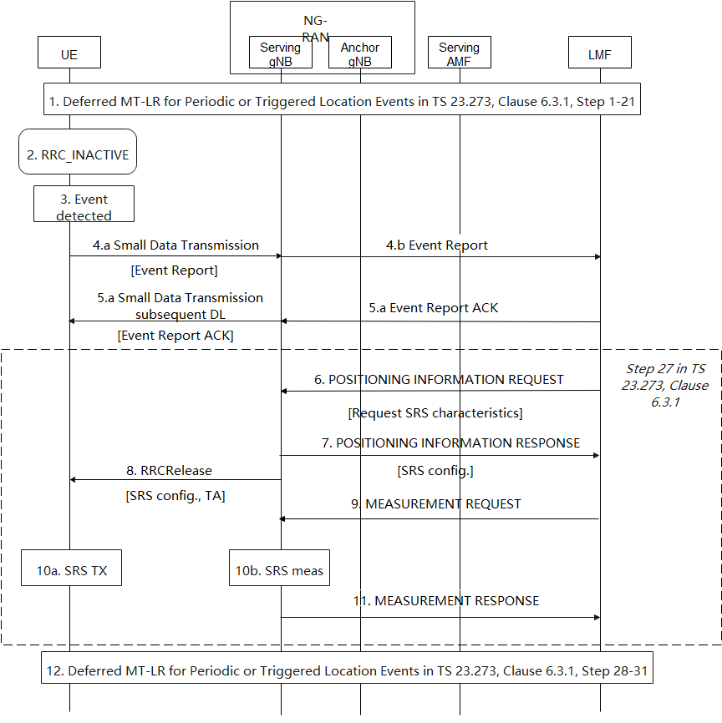
- Steps 1-21 of TS 23.273, Clause 6.3.1 for deferred MT-LR for Periodic or Triggered Location Events are performed.
- The UE is released by the anchor gNB from RRC_CONNECCTED to RRC_INACTIVE by RRCRelease with SuspendConfig. The UE may be configured with CG-SDT or RA-SDT for small data transmission.
NOTE: Before step 2, the anchor gNB should know the UE capability for UL positioning in RRC_INACTIVE and the preference information of positioning in RRC_INACTIVE, such that the gNB can make informed decision on transferring the RRC state of the UE to RRC_INACTIVE, instead of RRC_IDLE.
- The UE monitors for occurrence of the triggered or periodic event requested in step 16 of TS 23.273 Clause 6.3.1.
- If a certain event is triggered or the periodic timer of the periodic event expires, the UE sends Event Report to the network with Small Data Transmission from the UE to the gNB and then to the LMF.
NOTE: The serving gNB of the UE when UE performs step 4 might be the same or different from the anchor gNB where the UE is released to the RRC_INACTIVE state. If the serving gNB is the same as the anchor gNB, either RA-SDT or CG-SDT can be performed; if the serving gNB is different from the anchor gNB, only RA-SDT can be performed.
- When the LMF receives the event report and if it can handle this event report, the LMF returns a supplementary services acknowledgment for the event report to the UE by subsequent DL Small data Transmission from gNB to the UE.
- If location estimate is needed for the Event Report and the LMF determines to perform UL positioning for the UE based on prior knowledge of the UE capability for UL positioning, the LMF sends NRPPa message POSITIONING INFORMATION REQUEST to the serving gNB of the UE with the field Requested SRS transmission characteristics for the SRS transmission in the UL.
- After the request from the LMF, according to the Requested SRS transmission characteristics field within POSITIONING INFORMATION REQUST, the gNB configures the SRS of the UE and send the configuration to the LMF.
- The serving gNB configures the UE with RRCRelease message with SuspendConfig to keep the UE in RRC_INACTIVE state. The RRCRelease message contains the SRS configuration for UL positioning and TA configuration for uplink transmission.
- The LMF sends a NRPPa MEASUREMENT REQUEST to a group of gNBs for SRS measurement including the SRS configuration.
- The UE sends SRS after it receives the SRS configuration from the serving gNB and the gNBs that have received the NRPPa message for measurement request perform measurement of the SRSs sent by the UE.
NOTE: The UE sends SRS immediately (still up to the UE requirements) after it receives the SRS configuration means that only periodic SRS is supported for UL positioning in RRC_INACTIVE. The UE will release the SRS configuration when the TA expires. The network shall take the length of the time it takes to perform the measurement into account in the TA configuration .
- After performing the SRS measurements, the gNBs send measurement results to the LMF with NRPPa message MEASUREMENT RESPONSE.
- Steps 28-31 of TS 23.273, Clause 6.3.1 for deferred MT-LR for Periodic or Triggered Location Events are performed.

4.2.2 UL+DL solution
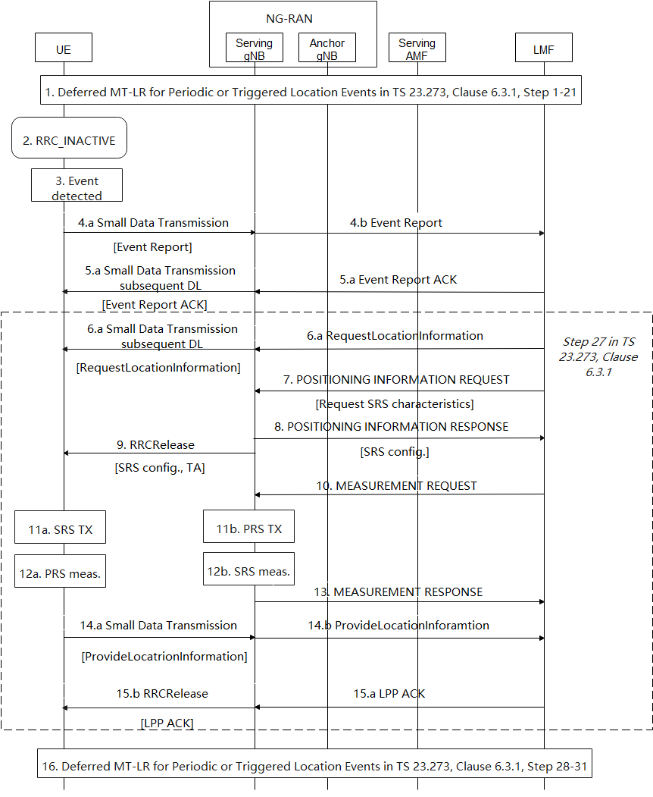

- Steps 1-21 of TS 23.273, Clause 6.3.1 for deferred MT-LR for Periodic or Triggered Location Events are performed.
- The UE is released by the anchor gNB from RRC_CONNECCTED to RRC_INACTIVE by RRCRelease with SuspendConfig. The UE may be configured with CG-SDT or RA-SDT for small data transmission.
NOTE: Before step 2, the anchor gNB should know the UE capability for UL+DL positioning in RRC_INACTIVE and the on-going deferred MT-LR session in the UE, such that the gNB can make informed decision on transferring the RRC state of the UE to RRC_INACTIVE, instead of RRC_IDLE.
- The UE monitors for occurrence of the triggered or periodic event requested in step 16 of TS 23.273 Clause 6.3.1.
- If a certain event is triggered or the periodic timer of the periodic event expires, the UE sends Event Report to the network with Small Data Transmission from the UE to the gNB and then to the LMF.
NOTE: The serving gNB of the UE when UE performs step 4 might be the same or different from the anchor gNB where the UE is released to the RRC_INACTIVE state. If the serving gNB is the same as the anchor gNB, either RA-SDT or CG-SDT can be performed; if the serving gNB is different from the anchor gNB, only RA-SDT can be performed.
- When the LMF receives the event report and if it can handle this event report, the LMF returns a supplementary services acknowledgment for the Event Report to the UE by subsequent DL Small data Transmission from gNB to the UE
- If location estimate is needed for the Event Report and the LMF determines to perform UL+DL positioning for the UE based on prior knowledge of the UE capability for UL+DL positioning, the LMF sends LPP message RequestLocationInformation to the UE via subsequent DL Small Data Transmission from the gNB to the UE.
- For the UL+DL positioning, the LMF sends NRPPa message POSITIONING INFORMATION REQUEST to the serving gNB of the UE with the field Requested SRS transmission characteristics for the SRS transmission in the UL positioning.
- After the request from the LMF, according to the Requested SRS transmission characteristics field within POSITIONING INFORMATION REQUST, the gNB configures the SRS of the UE and send the configuration to the LMF.
- The serving gNB sends to the UE the RRCRelease message with SuspendConfig to keep the UE in RRC_INACTIVE state. The RRCRelease message also contains the SRS configuration for UL positioning and TA configuration for uplink transmission.
- The LMF sends a NRPPa MEASUREMENT REQUEST to a group of gNBs for SRS measurement including the SRS configuration.
- The UE sends SRS after it receives the SRS configuration from the serving gNB and the gNBs that have received the NRPPa message for measurement request perform measurement of the SRSs sent by the UE.
NOTE: The UE sends SRS immediately (still up to the UE requirements) after it receives the SRS configuration means that only periodic SRS is supported for UL positioning in RRC_INACTIVE. The UE will release the SRS configuration when the TA expires. The network shall take the length of the time it takes to perform the measurement into account in the TA configuration.
- At the same period of time the UE performs SRS transmission, the UE also performs PRS measurement for DL positioning.
- After performing the SRS measurements, the gNBs send measurement results to the LMF with NRPPa message MEASUREMENT RESPONSE.
- With Small Data Transmission, the UE sends the LPP message ProvideLocationInformation for the sending the PRS measurement results from step 12a to the LMF.
- After successful reception of the LPP message, the LMF sends an LPP acknowledgement to the UE. The LPP ACK message is sent along with the RRCRelease message with suspendConfig such that the UE stays in RRC_INACTIVE.
- Steps 28-31 of TS 23.273, Clause 6.3.1 for deferred MT-LR for Periodic or Triggered Location Events are performed.

Consolidated solution in R2-2108605

4.3.1 UL solution

- Steps 1-21 of TS 23.273, Clause 6.3.1 for deferred MT-LR for Periodic or Triggered Location Events are performed.
- The UE is released by the anchor gNB from RRC_CONNECCTED to RRC_INACTIVE by RRCRelease with SuspendConfig. The UE may be configured with CG-SDT or RA-SDT for small data transmission. The UE may also be configured with periodic SRS if the configured type of the event is periodic-triggered event.
NOTE: Before step 2, the anchor gNB should know the UE capability for UL positioning in RRC_INACTIVE and the on-going deferred MT-LR session in the UE, such that the gNB can make informed decision on transferring the RRC state of the UE to RRC_INACTIVE, instead of RRC_IDLE.
NOTE: If the UE is configured with periodic SRS in step 2 and the camped cell of the UE is not changed from the cell where the UE receives RRCRelease with suspendConfig, the steps from 3-8 are not needed.
- The UE monitors for occurrence of the triggered or periodic event requested in step 16 of TS 23.273 Clause 6.3.1.
- If a certain event is triggered or the periodic timer of the periodic event expires, the UE sends Event Report to the network with Small Data Transmission from the UE to the gNB and then to the LMF.
NOTE: The serving gNB of the UE when UE performs step 4 might be the same or different from the anchor gNB where the UE is released to the RRC_INACTIVE state. If the serving gNB is the same as the anchor gNB, either RA-SDT or CG-SDT can be performed; if the serving gNB is different from the anchor gNB, only RA-SDT can be performed.
- When the LMF receives the event report and if it can handle this event report, the LMF returns a supplementary services acknowledgment for the event report to the UE by subsequent DL Small data Transmission from gNB to the UE.
- If location estimate is needed for the Event Report and the LMF determines to perform UL positioning for the UE based on prior knowledge of the UE capability for UL positioning, the LMF sends NRPPa message POSITIONING INFORMATION REQUEST to the serving gNB of the UE with the field Requested SRS transmission characteristics for the SRS transmission in the UL.
- After the request from the LMF, according to the Requested SRS transmission characteristics field within POSITIONING INFORMATION REQUST, the gNB configures the SRS of the UE and send the configuration to the LMF.
- The serving gNB configures the UE with RRCRelease message with SuspendConfig to keep the UE in RRC_INACTIVE state. The RRCRelease message contains the SRS configuration for UL positioning and TA configuration for uplink transmission.
- The LMF sends a NRPPa MEASUREMENT REQUEST to a group of gNBs for SRS measurement including the SRS configuration.
- The UE sends SRS after it receives the SRS configuration from the serving gNB and the gNBs that have received the NRPPa message for measurement request perform measurement of the SRSs sent by the UE.
NOTE: The UE sends SRS immediately (still up to the UE requirements) after it receives the SRS configuration means that only periodic SRS is supported for UL positioning in RRC_INACTIVE. The UE will release the SRS configuration when the TA expires. The network shall take the length of the time it takes to perform the measurement into account in the TA configuration.
- After performing the SRS measurements, the gNBs send measurement results to the LMF with NRPPa message MEASUREMENT RESPONSE.
- Steps 28-31 of TS 23.273, Clause 6.3.1 for deferred MT-LR for Periodic or Triggered Location Events are performed.

4.3.2 UL + DL solution

- Steps 1-21 of TS 23.273, Clause 6.3.1 for deferred MT-LR for Periodic or Triggered Location Events are performed.
- The UE is released by the anchor gNB from RRC_CONNECCTED to RRC_INACTIVE by RRCRelease with SuspendConfig. The UE may be configured with CG-SDT or RA-SDT for small data transmission. The UE may also be configured with periodic SRS if the configured type of the event is periodic-triggered event.
NOTE: Before step 2, the anchor gNB should know the UE capability for UL+DL positioning in RRC_INACTIVE and the on-going deferred MT-LR session in the UE, such that the gNB can make informed decision on transferring the RRC state of the UE to RRC_INACTIVE, instead of RRC_IDLE.
NOTE: If the UE is configured with periodic SRS in step 2 and the camped cell of the UE is not changed from the cell where the UE receives RRCRelease with suspendConfig, the steps 7-9 for configuration UL positioning are not needed.
- The UE monitors for occurrence of the triggered or periodic event requested in step 16 of TS 23.273 Clause 6.3.1.
- If a certain event is triggered or the periodic timer of the periodic event expires, the UE sends Event Report to the network with Small Data Transmission from the UE to the gNB and then to the LMF.
NOTE: The serving gNB of the UE when UE performs step 4 might be the same or different from the anchor gNB where the UE is released to the RRC_INACTIVE state. If the serving gNB is the same as the anchor gNB, either RA-SDT or CG-SDT can be performed; if the serving gNB is different from the anchor gNB, only RA-SDT can be performed.
- When the LMF receives the event report and if it can handle this event report, the LMF returns a supplementary services acknowledgment for the Event Report to the UE by subsequent DL Small data Transmission from gNB to the UE
- If location estimate is needed for the Event Report and the LMF determines to perform UL+DL positioning for the UE based on prior knowledge of the UE capability for UL+DL positioning, the LMF sends LPP message RequestLocationInformation to the UE via subsequent DL Small Data Transmission from the gNB to the UE.
- For the UL+DL positioning, the LMF sends NRPPa message POSITIONING INFORMATION REQUEST to the serving gNB of the UE with the field Requested SRS transmission characteristics for the SRS transmission in the UL positioning.
- After the request from the LMF, according to the Requested SRS transmission characteristics field within POSITIONING INFORMATION REQUST, the gNB configures the SRS of the UE and send the configuration to the LMF.
- The serving gNB sends to the UE the RRCRelease message with SuspendConfig to keep the UE in RRC_INACTIVE state. The RRCRelease message also contains the SRS configuration for UL positioning and TA configuration for uplink transmission.
- The LMF sends a NRPPa MEASUREMENT REQUEST to a group of gNBs for SRS measurement including the SRS configuration.
- The UE sends SRS after it receives the SRS configuration from the serving gNB and the gNBs that have received the NRPPa message for measurement request perform measurement of the SRSs sent by the UE.
NOTE: The UE sends SRS immediately (still up to the UE requirements) after it receives the SRS configuration means that only periodic SRS is supported for UL positioning in RRC_INACTIVE. The UE will release the SRS configuration when the TA expires. The network shall take the length of the time it takes to perform the measurement into account in the TA configuration.
- At the same period of time the UE performs SRS transmission, the UE also performs PRS measurement for DL positioning.
- After performing the SRS measurements, the gNBs send measurement results to the LMF with NRPPa message MEASUREMENT RESPONSE.
- With Small Data Transmission, the UE sends the LPP message ProvideLocationInformation for the sending the PRS measurement results from step 12a to the LMF.
- After successful reception of the LPP message, the LMF sends an LPP acknowledgement to the UE. The LPP ACK message is sent along with the RRCRelease message with suspendConfig such that the UE stays in RRC_INACTIVE.
- Steps 28-31 of TS 23.273, Clause 6.3.1 for deferred MT-LR for Periodic or Triggered Location Events are performed.

Conclusions
TBD

