3GPP TSG-RAN WG2 Meeting #115-e R2-2108946
Electronic, 9th – 27th August, 2021

Agenda Item: 8.11.3
Source: Huawei, HiSilicon
Title: [AT115-e][615][POS] UL and UL DL positioning in RRC_INACTIVE (Huawei)
Document for: Discussion and Agreement

Introduction
This document is to handle the following email discussion:
- [AT115-e][615][POS] UL and UL+DL positioning in RRC_INACTIVE (Huawei)
Scope: Evaluate the proposed UL and UL+DL positioning schemes and attempt to converge on an agreeable procedure.
Intended outcome: Report in R2-2108946
Deadline: Tuesday 2021-08-24 0800 UTC

In this discussion, we will take the following contributions into the background for the discussion
R2-2108383 Summary of [Post114-e][602][POS] Stage 2 procedure for deferred MT-LR in RRC_INACTIVE Qualcomm Incorporated discussion Late
R2-2108826 Summary of AI 8.11.3 for RRC INACTIVE positioning ZTE discussion
R2-2108605 Way-forward for INACTIVE positioning Huawei, China Unicom, China Telecom, Futurewei, HiSilicon, Intel Corporation, Interdigital, Spreadtrum Communications, VIVO, Xiaomi, ZTE Corporation discussion Rel-17 NR_pos_enh-Core Late

  - Contact Information
Company | Delegate name | Delegate email

Background

Email disussion [Post114-e][602][POS]
After RAN2#114-e, the following email dicsussion has been performed on the stage2 description for RRC_INACTIVE positioning

- [Post114-e][602][POS] Stage 2 procedure for deferred MT-LR in RRC_INACTIVE (Qualcomm)
Scope: Develop stage 2 level descriptions of the positioning procedures in RRC_INACTIVE, using the deferred MT-LR procedure as a framework for parts where some LCS procedural context is necessary. (This does not imply that only deferred MT-LR would be supported.) The scope can include the possibility of no stage 2 impact.
Intended outcome: Report to next meeting
Deadline: Long

In the email dicsussion, the following solutions have been provided: the first solution is proposed in [Post114-e][602][POS] as in Section 4.1; while another solution has been proposed by Huawei, HiSilicon in the annex of the email discussion, as in Section 4.2.

Way-forward for stage2 in R2-2108605
In the way-forward for the stage2 description for UL/UL+DL positioning in RRC_INACTIVE, a comparison has been given for the two solutions listed in Section 4.1 and Section 4.2.
 |  | Solution in 4.1 | Solution in 4.2
Required Number of SDT procedures |  | - 2 for UL  - 2 for UL+DL | - 1 for UL  - 2 for UL+ DL
UL/UL+DL positioning request |  | At Step 16 of Clause 6.3.1 of TS 23.273 | At Step 27 of Clause 6.3.1 of TS 23.273
UE Positioning in the overall deferred MT-LR procedure |  | At Step 25/26 of Clause 6.3.1 of TS 23.273 | At Step 27 of Clause 6.3.1 of TS 23.273
Time-domain characteristics of SRS |  | - Semi-persistent SRS  - SRS configuration delivered to the UE in RRC_CONNECTED | - Periodic SRS  - SRS configuration delivered to the UE in RRC_INACTIVE
SRS deactivation mechanism |  | Deactivation MAC CE | - Expiration of TAT for UL  - RRCRelease with SRS configuration for UL+DL
When is the positioning method determined? |  | Determined at the configuration of triggered event is received when UE receives LCS Periodic-Triggered Invoke Request | Determined when the UE receives Event Report
Triggered Event and Event Report |  | Event Report sent after the UE requests to the network for SRS transmission | Event Report sent immediately after event trigger
Required Stage-3 changes | Changes needed by both Solutions | SRS in RRC_INACTIVE
 | XN-AP | - SRS configuration in the UE context transfer  - LMF routing id transferred from last serving gNB to the serving gNB | No stage-3 impacts
 | LCS Periodic-Triggered Invoke Request | Type of Positioning Method requested (UL or DL or UL+DL)
 | RRC message | The "Location Event Indication" may be a new RRC message or an extension of the RRC LocationMeasurementIndication message.
Required SA2 changes |  | - SRS transmission request from the UE to the network  - Event report is not immediately sent after event is triggered, but after SRS transmission request | No SA2 stage2 impacts

With the two solutions above, a joint contribution has been proosed for the way-forward of the stage2. A consolidated solution has been given as in Section 4.3 to allow the UE to be configured with periodic SRS when the UE is released to RRC_INACTIVE if the UE is configured with periodic event.

Discussion during RAN2#115e
During RAN2#115e, the following agreements have been achieved for the LCS/LPP message transport and the stage2 procedure baseline for DL and RAT-independent positioning:

R2-2108383 Summary of [Post114-e][602][POS] Stage 2 procedure for deferred MT-LR in RRC_INACTIVE Qualcomm Incorporated discussion Late

Agreements:
LPP PDU and LCS message transfer:
Proposal 1: The LPP PDU Transfer Procedure in Annex A is used as baseline for further work.
NOTE 1: Some details may depend on further progress of the SDT work item.
NOTE 2: Whether such a procedure needs to be captured in Stage 2 specification or not can be decided later when the procedure has been fully developed/agreed. That is, the procedure can be considered as "running baseline".

Proposal 2: The LCS Message Transfer Procedure in Annex B is used as baseline for further work.
NOTE 1: Some details may depend on further progress of the SDT work item.
NOTE 2: Whether such a procedure needs to be captured in Stage 2 specification or not can be decided later when the procedure has been fully developed/agreed. That is, the procedure can be considered as "running baseline".

Proposal 3: UL LPP message segmentation can also be used by the UE in RRC_INACTIVE state; i.e., a LPP message body can be sent in several shorter LPP messages instead of one long LPP message by using the SDT "Subsequent Data Transmission" phase. FFS spec impact.

DL and RAT-independent positioning:
Proposal 4: The Deferred 5GC-MT-LR Procedure with SDT for DL-only and RAT-independent positioning in Annex C is used as baseline for further work.
NOTE 1: Some details may depend on further progress of SDT work item.
NOTE 2: Whether such a procedure needs to be captured in Stage 2 specification or not can be decided later when the procedure has been fully developed/agreed. That is, the procedure can be considered as "running baseline".
NOTE 3: Once the procedure is stable from RAN2 perspective, send an LS to SA2 including the baseline procedure.

Agreement:
(High priority)Proposal 1: Support all the RAT independent positioning methods in RRC_INACTIVE state.

Discussion on UL/UL+DL positioning method
For the consolidated solution, the main difference with the solution in Section 4.2 is that, the consolidated solution has considered the case of periodic event, that the UE can be configured with periodic SRS, whose periodicity is aligned with the periodicity of the defined periodic event, when the UE is released to RRC_INACTIVE.
In this case, the SRS configuration does not need to be configured to the UE by the UE’s request and the network’s on-the-fly configuration. When the periodic event is triggered, the UE would send periodic SRS and the network can perform measurements on the periodic SRS.
Question1: Do companies agree that, the UE can be configured with periodic SRS when periodic event is defined for the deferred MT-LR, as in the consolidated solution?
Company | Yes/No | Comments

We then ask the final question on whether companies think the consolidated solution in Section 4.3 can be taken as the baseline for UL/UL+DL positioning in RRC_INACTIVE. Companies are invited to analyse the solution in Section 4.3 and provide inputs below.
Question2: Do companies agree to adopt the consolidated solution in Section 4.3 as the baseline procedure for UL/UL+DL positioning in RRC_INACTIVE?
Company | Yes/No | Comments

Finally, we have the following open question:
Question3: Do companies think there are other issues might need to be discussed?
Company | Comments

Annex

4.1 Solution in [Post114-e][602][POS]

4.1.1 UL Solution
Figure B: Low Power Periodic and Triggered 5GC-MT-LR Procedure with SDT (UL-only positioning).

1. Steps 1-21 for the deferred 5GC-MT-LR procedure for periodic or triggered location events specified in TS 23.273 [8], clause 6.3.1 are performed.
At Step 15 of this procedure described in Figure 6.3.1-1 of TS 23.273 [8], the LMF may perform one or more positioning procedures to obtain an initial UE location estimate. During this step, the LMF may request and obtain the UE positioning capabilities which may include an indication that the UE can support UL positioning in RRC_INACTIVE state.
The LMF may also provide an UL-PRS configuration, or a set of alternative UL-PRS configurations to the serving gNB via an NRPPa Positioning Information Request message. The serving gNB may then send an NRPPa Positioning Information Response message that indicates whether UL positioning can be supported for the UE in RRC_INACTIVE state. For a subsequent change of anchor gNB, the UL-PRS configuration(s) is sent to the new serving gNB as part of the transfer of a UE context to the new serving gNB.
The serving gNB then sends an RRCConnectionRelease with suspendConfig to move the UE to RRC_INACTIVE state.
2. The UE monitors for occurrence of the trigger or periodic event requested during step 1. The UE determines which positioning method(s) will be used for the detected event from the request in Step 1 (based on the position method(s) included in an LPP Request Location Information message carried in the LCS Periodic-Triggered Invoke Request during Step 1).
3. When event reporting is allowed in RRC_INACTIVE state and after (or slightly before) an event is detected and if CG-SDT resources are not configured or cannot be selected, the UE performs a 2-step or 4-step RACH procedure. In the case of a 2-step RACH, the UE includes an RRC Resume Request message in the PUSCH payload for MsgA; in the case of a 4-step RACH, the UE sends an RRC Resume Request message in msg3 to the gNB.
Otherwise, if CG-SDT resources are configured on the selected UL carrier and are valid, the UE sends an RRC Resume Request message in the CG transmission to the gNB.
The UE sends a "Location Event Indication" along with the RRC Resume Request to trigger UL positioning at the gNB.
UL-PRS is already configured in the UE and anchor gNB during Step 1.
Editor's Note: The "Location Event Indication" may be a new RRC message or an extension of the RRC LocationMeasurementIndication message.
4. The serving gNB fetches the UE context from the anchor gNB. The UE context includes the UL-PRS configuration(s) (as determined during Step 1).
5. The serving gNB determines the UL-PRS configuration based on the UE context information received at Step 4b and sends a NRPPa Positioning Information Update message to the LMF via the serving AMF (probably through the anchor gNB).
6. The LMF may send a NRPPa Positioning Activation message (possibly with a starting time) to the serving gNB to request UL-PRS activation in the UE.
7. The serving gNB provides the UL-PRS configuration to the UE along with the RRC Release message over msg4 or MsgB. The message may also include the CG Configuration and a MAC-CE SRS Activation Request (possibly with a starting time).
NOTE: The UL-PRS configuration at this step may be an index to a pre-configured UL-PRS configuration (during Step 1), or a delta-UL-PRS configuration, etc.
8. The serving gNB sends a NRPPa Positioning Activation Response message to the LMF when activation in the UE was successful.
9. The LMF sends a NRPPa Measurement Request to a group of gNBs incl. the UL-PRS measurement configuration.
10. The UE transmits UL-PRS according to the activated configuration at Step 7.
11.Each configured gNB at Step 9 measures the UL-PRS.
12. Same as Step 3, but with the RRC Resume Request message including the SS LCS Event Report indicating the type of event being reported.
13. The serving gNB sends the SS LCS Event Report to the anchor gNB, which provides the SS LCS Event Report to the LMF (via serving AMF).
14. The gNBs that performed the UL-PRS measurements provide an NRRPPa Measurement Response message to the LMF including the UL-PRS measurements performed at Step 11.
15. The LMF may send a NRPPa Positioning Deactivation Request message to the anchor gNB which forwards the message to the serving gNB. The serving gNB sends the UL-PRS Deactivation to the UE at Step 15b.
Editor's Note: This may be a downlink message in response to UL SDT.
16. The LMF sends an SS LCS Event Report Acknowledgement to the anchor gNB.
17. The serving gNB provides the SS LCS Event Report Acknowledgement to the UE along with the RRC Release message.
18. Steps 28-31 for the deferred 5GC-MT-LR procedure for periodic or triggered location events specified in TS 23.273 [8], clause 6.3.1 are performed.

4.1.2 UL+DL solution
1. Steps 1-21 for the deferred 5GC-MT-LR procedure for periodic or triggered location events specified in TS 23.273 [8], clause 6.3.1 are performed.
At Step 15 of this procedure described in Figure 6.3.1-1 of TS 23.273 [8], the LMF may perform one or more positioning procedures to obtain an initial UE location estimate. During this step, the LMF may request and obtain the UE positioning capabilities which may include an indication that the UE can support UL+DL positioning in RRC_INACTIVE state.
The LMF may also provide an UL-PRS configuration, or a set of alternative UL-PRS configurations to the serving gNB via an NRPPa Positioning Information Request message. The serving gNB may then send an NRPPa Positioning Information Response message that indicates whether UL positioning can be supported for the UE in RRC_INACTIVE state. For a subsequent change of anchor gNB, the UL-PRS configuration(s) is sent to the new serving gNB as part of the transfer of a UE context to the new serving gNB.
The serving gNB then sends an RRCConnectionRelease with suspendConfig to move the UE to RRC_INACTIVE state.
2. The UE monitors for occurrence of the trigger or periodic event requested during step 1. The UE determines which positioning method(s) will be used for the detected event from the request in Step 1 (based on the position method(s) included in an LPP Request Location Information message carried in the LCS Periodic-Triggered Invoke Request during Step 1).
3. When event reporting is allowed in RRC_INACTIVE state and after (or slightly before) an event is detected and if CG-SDT resources are not configured or cannot be selected, the UE performs a 2-step or 4-step RACH procedure. In the case of a 2-step RACH, the UE includes an RRC Resume Request message in the PUSCH payload for MsgA; in the case of a 4-step RACH, the UE sends an RRC Resume Request message in msg3 to the gNB.
Otherwise, if CG-SDT resources are configured on the selected UL carrier and are valid, the UE sends an RRC Resume Request message in the CG transmission to the gNB.
The UE sends a "Location Event Indication" along with the RRC Resume Request to trigger UL positioning at the gNB.
UL-PRS is already configured in the UE and anchor gNB during Step 1.
Editor's Note: The "Location Event Indication" may be a new RRC message or an extension of the RRC LocationMeasurementIndication message.
4. The serving gNB fetches the UE context from the anchor gNB. The UE context includes the UL-PRS configuration(s) (as determined during Step 1).
5. The serving gNB determines the UL-PRS configuration based on the UE context information received at Step 4b and sends a NRPPa Positioning Information Update message to the LMF via the serving AMF (probably through the anchor gNB).
6. The LMF may send a NRPPa Positioning Activation message (possibly with a starting time) to the serving gNB to request UL-PRS activation in the UE.
7. The serving gNB provides the UL-PRS configuration to the UE along with the RRC Release message over msg4 or MsgB. The message may also include the CG Configuration and a MAC-CE SRS Activation Request (possibly with a starting time).
NOTE: The UL-PRS configuration at this step may be an index to a pre-configured UL-PRS configuration (during Step 1), or a delta-UL-PRS configuration, etc.
8. The serving gNB sends a NRPPa Positioning Activation Response message to the LMF when activation in the UE was successful.
9. The LMF sends a NRPPa Measurement Request to a group of gNBs incl. the UL-PRS measurement configuration.
10. The UE transmits UL-PRS according to the activated configuration at Step 7.
11. The UE measures the DL-PRS, and each configured gNB at Step 9 measures the UL-PRS.
12. Same as Step 3, but with the RRC Resume Request message including the SS LCS Event Report indicating the type of event being reported. The LCS Event Report includes an LPP Provide Location Information message containing the DL-PRS measurements.
13. The serving gNB sends the SS LCS Event Report to the anchor gNB, which provides the SS LCS Event Report to the LMF (via serving AMF).
14. The gNBs that performed the UL-PRS measurements provide an NRRPPa Measurement Response message to the LMF including the UL-PRS measurements performed at Step 11b.
15. The LMF may send a NRPPa Positioning Deactivation Request message to the anchor gNB which forwards the message to the serving gNB. The serving gNB sends the UL-PRS Deactivation to the UE at Step 15b.
Editor's Note: This may be a downlink message in response to UL SDT.
16. The LMF sends a SS LCS Event Report Acknowledgement to the anchor gNB.
17. The serving gNB provides the SS LCS Event Report Acknowledgement to the UE along with the RRC Release message.
18. Steps 28-31 for the deferred 5GC-MT-LR procedure for periodic or triggered location events specified in TS 23.273 [8], clause 6.3.1 are performed.

Solution provided by Huawei, HiSilicon

UL solution
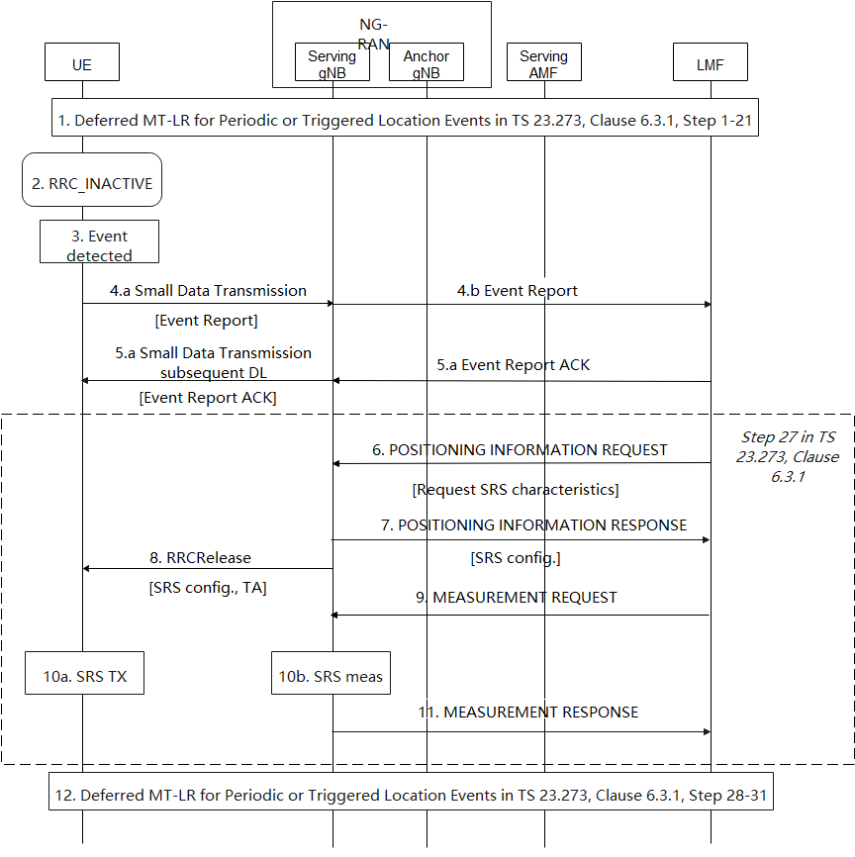
- Steps 1-21 of TS 23.273, Clause 6.3.1 for deferred MT-LR for Periodic or Triggered Location Events are performed.
- The UE is released by the anchor gNB from RRC_CONNECCTED to RRC_INACTIVE by RRCRelease with SuspendConfig. The UE may be configured with CG-SDT or RA-SDT for small data transmission.
NOTE: Before step 2, the anchor gNB should know the UE capability for UL positioning in RRC_INACTIVE and the preference information of positioning in RRC_INACTIVE, such that the gNB can make informed decision on transferring the RRC state of the UE to RRC_INACTIVE, instead of RRC_IDLE.
- The UE monitors for occurrence of the triggered or periodic event requested in step 16 of TS 23.273 Clause 6.3.1.
- If a certain event is triggered or the periodic timer of the periodic event expires, the UE sends Event Report to the network with Small Data Transmission from the UE to the gNB and then to the LMF.
NOTE: The serving gNB of the UE when UE performs step 4 might be the same or different from the anchor gNB where the UE is released to the RRC_INACTIVE state. If the serving gNB is the same as the anchor gNB, either RA-SDT or CG-SDT can be performed; if the serving gNB is different from the anchor gNB, only RA-SDT can be performed.
- When the LMF receives the event report and if it can handle this event report, the LMF returns a supplementary services acknowledgment for the event report to the UE by subsequent DL Small data Transmission from gNB to the UE.
- If location estimate is needed for the Event Report and the LMF determines to perform UL positioning for the UE based on prior knowledge of the UE capability for UL positioning, the LMF sends NRPPa message POSITIONING INFORMATION REQUEST to the serving gNB of the UE with the field Requested SRS transmission characteristics for the SRS transmission in the UL.
- After the request from the LMF, according to the Requested SRS transmission characteristics field within POSITIONING INFORMATION REQUST, the gNB configures the SRS of the UE and send the configuration to the LMF.
- The serving gNB configures the UE with RRCRelease message with SuspendConfig to keep the UE in RRC_INACTIVE state. The RRCRelease message contains the SRS configuration for UL positioning and TA configuration for uplink transmission.
- The LMF sends a NRPPa MEASUREMENT REQUEST to a group of gNBs for SRS measurement including the SRS configuration.
- The UE sends SRS after it receives the SRS configuration from the serving gNB and the gNBs that have received the NRPPa message for measurement request perform measurement of the SRSs sent by the UE.
NOTE: The UE sends SRS immediately (still up to the UE requirements) after it receives the SRS configuration means that only periodic SRS is supported for UL positioning in RRC_INACTIVE. The UE will release the SRS configuration when the TA expires. The network shall take the length of the time it takes to perform the measurement into account in the TA configuration .
- After performing the SRS measurements, the gNBs send measurement results to the LMF with NRPPa message MEASUREMENT RESPONSE.
- Steps 28-31 of TS 23.273, Clause 6.3.1 for deferred MT-LR for Periodic or Triggered Location Events are performed.

4.2.2 UL+DL solution
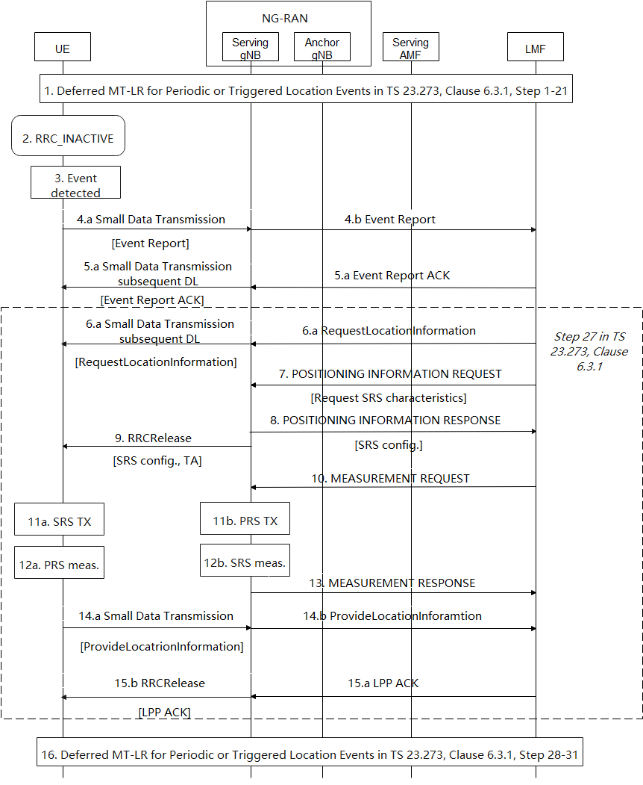

- Steps 1-21 of TS 23.273, Clause 6.3.1 for deferred MT-LR for Periodic or Triggered Location Events are performed.
- The UE is released by the anchor gNB from RRC_CONNECCTED to RRC_INACTIVE by RRCRelease with SuspendConfig. The UE may be configured with CG-SDT or RA-SDT for small data transmission.
NOTE: Before step 2, the anchor gNB should know the UE capability for UL+DL positioning in RRC_INACTIVE and the on-going deferred MT-LR session in the UE, such that the gNB can make informed decision on transferring the RRC state of the UE to RRC_INACTIVE, instead of RRC_IDLE.
- The UE monitors for occurrence of the triggered or periodic event requested in step 16 of TS 23.273 Clause 6.3.1.
- If a certain event is triggered or the periodic timer of the periodic event expires, the UE sends Event Report to the network with Small Data Transmission from the UE to the gNB and then to the LMF.
NOTE: The serving gNB of the UE when UE performs step 4 might be the same or different from the anchor gNB where the UE is released to the RRC_INACTIVE state. If the serving gNB is the same as the anchor gNB, either RA-SDT or CG-SDT can be performed; if the serving gNB is different from the anchor gNB, only RA-SDT can be performed.
- When the LMF receives the event report and if it can handle this event report, the LMF returns a supplementary services acknowledgment for the Event Report to the UE by subsequent DL Small data Transmission from gNB to the UE
- If location estimate is needed for the Event Report and the LMF determines to perform UL+DL positioning for the UE based on prior knowledge of the UE capability for UL+DL positioning, the LMF sends LPP message RequestLocationInformation to the UE via subsequent DL Small Data Transmission from the gNB to the UE.
- For the UL+DL positioning, the LMF sends NRPPa message POSITIONING INFORMATION REQUEST to the serving gNB of the UE with the field Requested SRS transmission characteristics for the SRS transmission in the UL positioning.
- After the request from the LMF, according to the Requested SRS transmission characteristics field within POSITIONING INFORMATION REQUST, the gNB configures the SRS of the UE and send the configuration to the LMF.
- The serving gNB sends to the UE the RRCRelease message with SuspendConfig to keep the UE in RRC_INACTIVE state. The RRCRelease message also contains the SRS configuration for UL positioning and TA configuration for uplink transmission.
- The LMF sends a NRPPa MEASUREMENT REQUEST to a group of gNBs for SRS measurement including the SRS configuration.
- The UE sends SRS after it receives the SRS configuration from the serving gNB and the gNBs that have received the NRPPa message for measurement request perform measurement of the SRSs sent by the UE.
NOTE: The UE sends SRS immediately (still up to the UE requirements) after it receives the SRS configuration means that only periodic SRS is supported for UL positioning in RRC_INACTIVE. The UE will release the SRS configuration when the TA expires. The network shall take the length of the time it takes to perform the measurement into account in the TA configuration.
- At the same period of time the UE performs SRS transmission, the UE also performs PRS measurement for DL positioning.
- After performing the SRS measurements, the gNBs send measurement results to the LMF with NRPPa message MEASUREMENT RESPONSE.
- With Small Data Transmission, the UE sends the LPP message ProvideLocationInformation for the sending the PRS measurement results from step 12a to the LMF.
- After successful reception of the LPP message, the LMF sends an LPP acknowledgement to the UE. The LPP ACK message is sent along with the RRCRelease message with suspendConfig such that the UE stays in RRC_INACTIVE.
- Steps 28-31 of TS 23.273, Clause 6.3.1 for deferred MT-LR for Periodic or Triggered Location Events are performed.

Consolidated solution in R2-2108605

4.3.1 UL solution

- Steps 1-21 of TS 23.273, Clause 6.3.1 for deferred MT-LR for Periodic or Triggered Location Events are performed.
- The UE is released by the anchor gNB from RRC_CONNECCTED to RRC_INACTIVE by RRCRelease with SuspendConfig. The UE may be configured with CG-SDT or RA-SDT for small data transmission. The UE may also be configured with periodic SRS if the configured type of the event is periodic-triggered event.
NOTE: Before step 2, the anchor gNB should know the UE capability for UL positioning in RRC_INACTIVE and the on-going deferred MT-LR session in the UE, such that the gNB can make informed decision on transferring the RRC state of the UE to RRC_INACTIVE, instead of RRC_IDLE.
NOTE: If the UE is configured with periodic SRS in step 2 and the camped cell of the UE is not changed from the cell where the UE receives RRCRelease with suspendConfig, the steps from 3-8 are not needed.
- The UE monitors for occurrence of the triggered or periodic event requested in step 16 of TS 23.273 Clause 6.3.1.
- If a certain event is triggered or the periodic timer of the periodic event expires, the UE sends Event Report to the network with Small Data Transmission from the UE to the gNB and then to the LMF.
NOTE: The serving gNB of the UE when UE performs step 4 might be the same or different from the anchor gNB where the UE is released to the RRC_INACTIVE state. If the serving gNB is the same as the anchor gNB, either RA-SDT or CG-SDT can be performed; if the serving gNB is different from the anchor gNB, only RA-SDT can be performed.
- When the LMF receives the event report and if it can handle this event report, the LMF returns a supplementary services acknowledgment for the event report to the UE by subsequent DL Small data Transmission from gNB to the UE.
- If location estimate is needed for the Event Report and the LMF determines to perform UL positioning for the UE based on prior knowledge of the UE capability for UL positioning, the LMF sends NRPPa message POSITIONING INFORMATION REQUEST to the serving gNB of the UE with the field Requested SRS transmission characteristics for the SRS transmission in the UL.
- After the request from the LMF, according to the Requested SRS transmission characteristics field within POSITIONING INFORMATION REQUST, the gNB configures the SRS of the UE and send the configuration to the LMF.
- The serving gNB configures the UE with RRCRelease message with SuspendConfig to keep the UE in RRC_INACTIVE state. The RRCRelease message contains the SRS configuration for UL positioning and TA configuration for uplink transmission.
- The LMF sends a NRPPa MEASUREMENT REQUEST to a group of gNBs for SRS measurement including the SRS configuration.
- The UE sends SRS after it receives the SRS configuration from the serving gNB and the gNBs that have received the NRPPa message for measurement request perform measurement of the SRSs sent by the UE.
NOTE: The UE sends SRS immediately (still up to the UE requirements) after it receives the SRS configuration means that only periodic SRS is supported for UL positioning in RRC_INACTIVE. The UE will release the SRS configuration when the TA expires. The network shall take the length of the time it takes to perform the measurement into account in the TA configuration.
- After performing the SRS measurements, the gNBs send measurement results to the LMF with NRPPa message MEASUREMENT RESPONSE.
- Steps 28-31 of TS 23.273, Clause 6.3.1 for deferred MT-LR for Periodic or Triggered Location Events are performed.

4.3.2 UL + DL solution

- Steps 1-21 of TS 23.273, Clause 6.3.1 for deferred MT-LR for Periodic or Triggered Location Events are performed.
- The UE is released by the anchor gNB from RRC_CONNECCTED to RRC_INACTIVE by RRCRelease with SuspendConfig. The UE may be configured with CG-SDT or RA-SDT for small data transmission. The UE may also be configured with periodic SRS if the configured type of the event is periodic-triggered event.
NOTE: Before step 2, the anchor gNB should know the UE capability for UL+DL positioning in RRC_INACTIVE and the on-going deferred MT-LR session in the UE, such that the gNB can make informed decision on transferring the RRC state of the UE to RRC_INACTIVE, instead of RRC_IDLE.
NOTE: If the UE is configured with periodic SRS in step 2 and the camped cell of the UE is not changed from the cell where the UE receives RRCRelease with suspendConfig, the steps 7-9 for configuration UL positioning are not needed.
- The UE monitors for occurrence of the triggered or periodic event requested in step 16 of TS 23.273 Clause 6.3.1.
- If a certain event is triggered or the periodic timer of the periodic event expires, the UE sends Event Report to the network with Small Data Transmission from the UE to the gNB and then to the LMF.
NOTE: The serving gNB of the UE when UE performs step 4 might be the same or different from the anchor gNB where the UE is released to the RRC_INACTIVE state. If the serving gNB is the same as the anchor gNB, either RA-SDT or CG-SDT can be performed; if the serving gNB is different from the anchor gNB, only RA-SDT can be performed.
- When the LMF receives the event report and if it can handle this event report, the LMF returns a supplementary services acknowledgment for the Event Report to the UE by subsequent DL Small data Transmission from gNB to the UE
- If location estimate is needed for the Event Report and the LMF determines to perform UL+DL positioning for the UE based on prior knowledge of the UE capability for UL+DL positioning, the LMF sends LPP message RequestLocationInformation to the UE via subsequent DL Small Data Transmission from the gNB to the UE.
- For the UL+DL positioning, the LMF sends NRPPa message POSITIONING INFORMATION REQUEST to the serving gNB of the UE with the field Requested SRS transmission characteristics for the SRS transmission in the UL positioning.
- After the request from the LMF, according to the Requested SRS transmission characteristics field within POSITIONING INFORMATION REQUST, the gNB configures the SRS of the UE and send the configuration to the LMF.
- The serving gNB sends to the UE the RRCRelease message with SuspendConfig to keep the UE in RRC_INACTIVE state. The RRCRelease message also contains the SRS configuration for UL positioning and TA configuration for uplink transmission.
- The LMF sends a NRPPa MEASUREMENT REQUEST to a group of gNBs for SRS measurement including the SRS configuration.
- The UE sends SRS after it receives the SRS configuration from the serving gNB and the gNBs that have received the NRPPa message for measurement request perform measurement of the SRSs sent by the UE.
NOTE: The UE sends SRS immediately (still up to the UE requirements) after it receives the SRS configuration means that only periodic SRS is supported for UL positioning in RRC_INACTIVE. The UE will release the SRS configuration when the TA expires. The network shall take the length of the time it takes to perform the measurement into account in the TA configuration.
- At the same period of time the UE performs SRS transmission, the UE also performs PRS measurement for DL positioning.
- After performing the SRS measurements, the gNBs send measurement results to the LMF with NRPPa message MEASUREMENT RESPONSE.
- With Small Data Transmission, the UE sends the LPP message ProvideLocationInformation for the sending the PRS measurement results from step 12a to the LMF.
- After successful reception of the LPP message, the LMF sends an LPP acknowledgement to the UE. The LPP ACK message is sent along with the RRCRelease message with suspendConfig such that the UE stays in RRC_INACTIVE.
- Steps 28-31 of TS 23.273, Clause 6.3.1 for deferred MT-LR for Periodic or Triggered Location Events are performed.

Conclusions
TBD

