3GPP TSG-RAN WG2 Meeting #115-e R2-2108933
Electronic Meeting, August 16 – 27, 2021
Agenda item: 6.3.1
Source: Qualcomm Incorporated
Title: Summary of [AT115-e][603][POS] AI 7.5 LTE Positioning and Rel-16 stage 2 CRs
Document for: Discussion

1. Introduction
This document summarizes the following email discussion:
- [AT115-e][603][POS] AI 7.5 LTE Positioning and Rel-16 stage 2 CRs (Qualcomm)
Scope:
- Handle the CR in R2-2107959 and determine conclusion.
- Handle the CR in R2-2107333 and determine conclusion
- Handle the CR in R2-2107958 and determine conclusion
Intended outcome: Agreed CRs (without comebacks), report in R2-2108933
Deadline: Tuesday 2021-08-24 0800 UTC

1.1 References
[1] R2-2107959, "Correction on user-plane positioning support by SUPL", Samsung, Qualcomm Incorporated,
CR Rel-16 36.305 16.3.0 0105 - F LCS_LTE
[2] R2-2107958, "Correction on user-plane positioning support by SUPL", Samsung, Qualcomm Incorporated,
CR Rel-16 38.305 16.5.0 0078 - F NR_pos-Core
[3] R2-2107333, "Correction to NB-IoT positioning", Huawei, HiSilicon,
CR Rel-16 38.305 16.5.0 0076 - F NR_pos-Core

2. Correction on user-plane positioning support by SUPL [1],[2]

2.1 Background
Both CRs [1][2] clarify the "SUPL column" in Table 4.3.1-1 "Supported versions of UE positioning methods".
A new NOTE is proposed as follows (the equivalent NOTE is proposed for 36.305 [1]):
Table 4.3.1-1: Supported versions of UE positioning methods
Method | UE-based | UE-assisted, LMF-based | NG-RAN node assisted | SUPL ^{Note 8}
A-GNSS | Yes | Yes | No | Yes
OTDOA ^{Note1, Note 2} | No | Yes | No | Yes
E-CID ^{Note 4, Note 7} | No | Yes | Yes | Yes for E-UTRA
Sensor | Yes | Yes | No | No
WLAN | Yes | Yes | No | Yes
Bluetooth | No | Yes | No | No
TBS ^{Note 5} | Yes | Yes | No | Yes (MBS)
DL-TDOA | Yes | Yes | No | Yes
DL-AoD | Yes | Yes | No | Yes
Multi-RTT | No | Yes | Yes | Yes
NR E-CID | No | Yes | Yes | Yes (DL NR E-CID)
UL-TDOA | No | No | Yes | Yes
UL-AoA | No | No | Yes | Yes
NOTE 1: This includes TBS positioning based on PRS signals.
NOTE 2: In this version of the specification only OTDOA based on LTE signals is supported.
NOTE 3: Void
NOTE 4: This includes Cell-ID for NR method when UE is served by gNB.
NOTE 5: In this version of the specification only for TBS positioning based on MBS signals.
NOTE 6: Void
NOTE 7: Enhanced Cell ID based on LTE signals.
NOTE 8: This shows whether the positioning method is supported by SUPL ULP [16].

This is to avoid confusion with Annex B (36.305) or Annex A (38.305), as also discussed in R2-2104512 from RAN2#113bis ("Report of [AT113b-e][602][POS] Positioning corrections for NR Rel-15 (Samsung)").
Additional changes are proposed to the informative Annex A (38.305) and Annex B (36.305):
38.305 [2]:
- NRCellInformation as defined in SUPL ULP is added.
- Comments on "NR signals are not supported" are deleted.
- Not needed copy of RRC MeasResultListEUTRA is deleted.
- SUPL ULP reference is updated to the latest version 2.0.6 (which includes the NR positioning support).
36.305 [1]:
- LteCellInformation is corrected (as defined in SUPL ULP).
- Not needed copy of RRC MeasResultListEUTRA is deleted.
- SUPL ULP reference is updated to the latest version 2.0.6.

2.2 Discussion

Question 1: Do you agree with the CR to TS 38.305 in R2-2107958, "Correction on user-plane positioning support by SUPL"?
Company | Yes/No | Comments
ZTE | Yes | It is reasonable to modify restrictions of NR signals in 38.305
Huawei, HiSilicon | Yes | The description for SUPL should be updated based on the latest SUPL spec.
Ericsson | yes
Apple | yes
CATT | General Yes | We are ok with most of the modifications. Only one place should be pointed that in the ASN.1 part in A.1, the “…” in first modified line seems not correct. Please double check if it should be removed.
Qualcomm |  | To CATT: Thanks for checking. I assume this is not supposed to be an ASN.1 ellipsis, but an indication that some parts are omitted.  Agree, this "…" should be deleted.

Question 2: Do you agree with the CR to TS 36.305 in R2-2107959, "Correction on user-plane positioning support by SUPL"?
Company | Yes/No | Comments
ZTE | Yes
Huawei, HiSilicon | Yes | The description for SUPL should be updated based on the latest SUPL spec.
Ericsson | yes
Apple | yes
CATT | Yes

3. Correction to NB-IoT positioning [3]

3.1 Background
TS 23.273 Rel-16 specifies "Low Power Periodic and Triggered 5GC-MT-LR Procedures" in clause 6.7 which allows a UE to provide LCS Event Reports in idle state using EDT for Control Plane with CIoT 5GS Optimization.
If the UE and NG-RAN node both support EDT, the UE sends an RRCEarlyDataRequest message to the NG-RAN node and includes a NAS control plane service request. Otherwise, the UE established an RRC connection with the NG-RAN node and sends the NAS control plane service request.
However, in the current Stage 2 TS 38.305 for the NB-IoT positioning procedures, there is no description that a UE can send an LCS Event Report to the network in CM_IDLE without transition to RRC_CONNECTED.
Therefore, the following changes are proposed in [3]:
1. Add a new clause for the previous description of NB-IOT positioning measurement in RRC_IDLE state and measurement report in RRC_CONNECTED, in Clause 7.1.3
2. Add a new clause for NB-IOT positioning measurement and event report in RRC_IDLE with CP CIoT 5GC Optimization.
3. Reference to TS 36.300 is added.
For reference, the proposed procedure in [3] is repeated below (item #2 above).

--------------------------------------------------- Begin excerpt from [3] ------------------------------------------------------------

7.1.3.y NB-IoT positioning measurement report in RRC_IDLE state with Control Plane CIoT 5GC Optimization

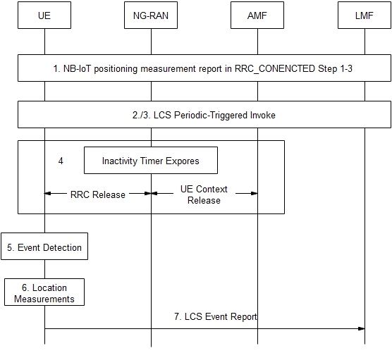
Figure 7.1.3.2-1: UE positioning measurements and measurement report in RRC_IDLE state with Control Plane CIoT 5GC Optimization.
- Step 1-3 for NB-IOT positioning with measurement report in RRC_CONENCTED are performed.
- The LMF sends LCS Periodic-Triggered Invoke Request to the UE as in TS 23.273 [35] carrying location reqeust information received from the AMF. It may also include an LPP message to request the type of location measurement or location estimate in step 6. For E-CID positioning method, when NRSRP/NRSRQ measurements are requested the UE is requested to provide NRSRP/NRSRQ measurements for intra-frequency neighbour cells and for inter-frequency neighbour cells. The UE may use inter-frequency information in system information of the serving cell specified in TS 36.331 [13] to decide on which inter-frequency cells to measure.
- If the request can be supported, the UE returns a LCS Periodic-Trigger Invoke Accept message to the LMF.
- The UE may finish any other activities in progress (e.g., SMS or data transfer), and waits until the network releases or suspends the connection (after a certain period of inactivity). The UE will then receive an RRC connection release or suspend from the ng-eNB due to the expiration of the inactivity timer.
- For a periodic or triggered location request in step 2 and 3 were successfully performed, the UE monitors for occurrence of the trigger or periodic event requested in step 2.
- If the configured event is detected in step 5, the UE performs measurements according to the request in step 2.
- If the UE and ng-eNB node both support Control Plane CIoT 5GC Optimization, the UE sends an RRCEarlyDataRequest message as in TS 36.300 [xx] to the ng-eNB and includes a NAS control plane service request as in TS 24.501 [29]. The NAS control plane service request includes an Event Report message as in Clause 7.3.4, including the measurement report or location estimate with the measurement performed in step 5.
--------------------------------------------------- End excerpt from [3] ------------------------------------------------------------

Rapporteur's comments:
- It is not clear why the CR is specific to NB-IoT. As part of negotiating 5G network behaviour during registration, a UE indicates in a Registration Request whether Control Plane CIoT 5GS Optimisation is supported for location event reporting. This indication may be passed to the LMF by the AMF at step 14 in clause 6.3.1 of TS 23.273 as specified in TS 29.572 (UeLcsCapability). Therefore, all UEs supporting Control Plane CIoT 5GS Optimisation and LCS Event Reporting can make use of the procedure.
- Steps 1-4 are confusing in this context, since the procedures before Step 5 comprise all the deferred MT-LR Initiation Procedures. A suggestion would be to collapse steps 1-4 into a single box with "Deferred 5GC-MT-LR Procedure for Periodic or Triggered Location Events in TS 23.273 Clause 6.3.1 Steps 1-23".
- It may make sense to add this procedure after clause 7.3.4 (Deferred MT-LR Event Reporting Support) in TS 38.305.

Question 3: Do you agree with the CR to TS 38.305 in R2-2107333, "Correction to NB-IoT positioning"?
Company | Yes/No | Comments
ZTE |  | We understand the intention of the CR, however there are 2 questions:  - The provided new skeleton is deferred MT-LR procedure, the existing 305 procedure is not. So does the new skeleton provided as the exact update of the original skeleton?  - If we want to support reporting measurement report in RRC_IDLE, why don’t we just modify step 9 in the existing 305 procedure, since step 8 in the existing 305 procedure already has a description of supporting Control Plane CIoT 5GC Optimization. A change can be made in step 9 based on the description of step 8 for simplicity.
Huawei, HiSilicon | Yes | Some responses to the rapporteur’s comments:  1/ Currently, only eMTC UE and NB-IOT UE supports control plane CIoT 5GS Optimization. Note that R17 SDT UEs do not support Control Plane solution. While for eMTC UE, we are not sure if they can support the positioning measurements in RRC_IDLE. In terms of positioning, eMTC UEs are just like other LTE UEs except for NB-IOT positioning. Hence, the above paragraph may only be applicable for NB-IOT positioning.  2/ Thanks for the comments.  One thing I would like to point out is that, from my thinking, the description should include both deferred MT-LR and immediate MT-LR, because for NB-IOT UE, even for immediate MT-LR, the measurement still needs to be performed in RRC_IDLE, just like the existing paragraph 7.1.3. However, for the current stage2 description in SA2 spec 23.273, only deferred MT-LR is mentioned, so the current CR only include deferred MT-LR. I would be happy to also add the decription for deferred MT-LR if companies also think this should be added  Another thing is the data inactivity timer. The difference between the ng-eNB with and without the support of 5GC optimization is that, it is possible that the UE context is still kept in the NG interface. So I have put the “UE context release” to dashed lines. On whether step2 should also be under the box within 1, I think step1-23 may not really include the RRC state transition descrption that is applicable for our case. Hence, I think it would be more suitable to still keep it in the description.  Finally, the CP CIOT 5GC optimization should only include the MO-EDT and PUR solution, as in 7.3a and 7.3d in TS 36.300. it should not include the CP solution in 7.3a  Please see if the revised description below is OK  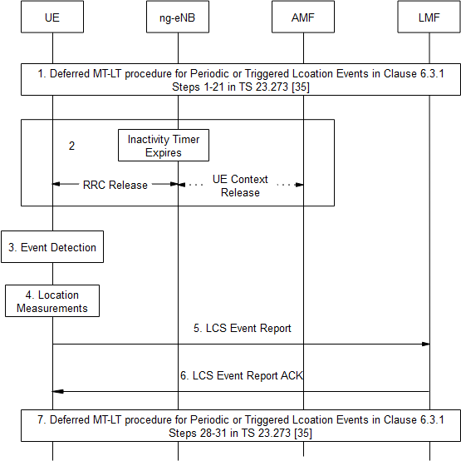  Figure 7.1.3.2-1: UE positioning measurements and measurement report in RRC_IDLE state with Control Plane CIoT 5GC Optimization with MO-EDT or PUR.  - Step 1-23 for deferred MT-LR periodic or Triggered Location Event in Clause 6.3.1 in TS 23.273 [35] are performed.  - The UE may finish any other activities in progress (e.g., SMS or data transfer), and waits until the network releases or suspends the connection (after a certain period of inactivity). The UE will then receive an RRC connection release or suspend from the ng-eNB due to the expiration of the inactivity timer.  - For a periodic or triggered location request in step 2 and 3 were successfully performed, the UE monitors for occurrence of the trigger or periodic event requested in step 2.  - If the configured event is detected in step 3, the UE performs measurements according to the request in step 1. For E-CID positioning method, when NRSRP/NRSRQ measurements are requested the UE is requested to provide NRSRP/NRSRQ measurements for intra-frequency neighbour cells and for inter-frequency neighbour cells. The UE may use inter-frequency information in system information of the serving cell specified in TS 36.331 [13] to decide on which inter-frequency cells to measure.  - If the UE and ng-eNB node both support Control Plane CIoT 5GC Optimization with MO-EDT or PUR, the UE sends an RRCEarlyDataRequest message as in TS 36.300 [xx] to the ng-eNB and includes a NAS control plane service request as in TS 24.501 [29]. The NAS control plane service request includes an Event Report message as in Clause 7.3.4, including the measurement report or location estimate with the measurement performed in step 5.  - The LMF sends an Event Report Acknowledgement to the UE by subsequent DL transmission from the ng-eNB to the UE.  - Step 28-31 for deferred MT-LR periodic or Triggered Location Event in Clause 6.3.1 in TS 23.273 [35] are performed
Ericsson | No, | The reason for not agreeing to the CR is that LCS event reporting in Inactive mode for low power UE is already captured in SA2 specification.  - At step 16, if the AMF indicates the UE supports and is allowed to use Control Plane CIoT 5GS Optimisation at step 14 and if the LMF decides to allow Control Plane CIoT 5GS Optimisation, the LMF includes an indication in the LCS Periodic-Triggered Invoke Request that the UE is allowed to use Control Plane CIoT 5GS Optimisation to send Event Reports. The LMF may also include criteria indicating when Control Plane CIoT 5GS Optimisation may be used to send Event Reports. The criteria may include a maximum duration for sending Event Reports using Control Plane CIoT 5GS Optimisation, a maximum number of consecutive Event Reports to be sent using Control Plane CIoT 5GS Optimisation or both.  but if the CR is pursued:  The WI code of the CR should be changed to TEI16. The CR in diagram should say ng-eNB. We do not think a specific feature PUR, MO-EDT needs to be explicitly mentioned here. Besides, ECID is based upon RRM measurements which is already clear and hence no such special mentioning is needed.
Apple | No | Agree with E///
CATT | No | Share the same view with Ericsson. We don’t need to specify how to transfer LCS event report in 38.305.
Qualcomm |  | We consider this is being an alignment between 23.273, section 6.7 and 38.305, which we would support in principle. Otherwise, it should not be a Cat F CR.  However, the "Low Power Periodic and Triggered 5GC-MT-LR Procedures" (as any LCS procedure) does not depend on a particular positioning method. The procedure is applicable, if the UE and network support/allow "Control Plane CIoT 5GS Optimisation and LCS Event Reporting", as specified in 23.273. This can also apply to a e.g., MTC UE supporting A-GNSS etc., and is not a "Correction to NB-IoT positioning". There is currently no immediate MT-LR defined supporting EDT/CP CIoT Optimization.  Before Step 3, the UE does not wait until the network releases or suspends the connection. Step 3 is performed once the configured event at step 1 occurs, regardless of the RRC state of the UE. Therefore, Step 2 should be deleted and replaced by the "Determine Reporting Mode" step in section 6.7. of 23.273: "The UE determines whether to report the event detected at step 22 in clause 6.3.1 using Control Plane CIoT 5GS Optimisation or using a NAS signalling connection. If the UE is currently in CM CONNECTED state, the UE shall use a NAS signalling connection. Otherwise, the determination shall be based on criteria received from the LMF at step 14 in clause 6.3.1 when criteria are received."  Step 5 should show "RRCEarlyDataRequest + Event Report".

4. Summary

