3GPP TSG RAN WG2 Meeting #115-e R2-21XXXXX
e-Meeting, 9th – 27th August, 2021
Agenda item: 6.1.3.1
Source: Samsung
Title: Report of Offline 020: MAC II
Document for: Discussion and Decision

1 Introduction
This document is a discussion report of the following offline discussion:
- [AT115-e][020][NR16] MAC II (Samsung)
Scope: Take on-line outcome into account, Treat remaining aspects, determine agreeable parts and agree CRs Treat R2-2108257, R2-2107197, R2-2107610, R2-2108094, R2-2108095, R2-2108787, R2-2107735, R2-2107200, R2-2108283, R2-2108284, R2-2108285,
Intended outcome: Report, Agreed CRs.
Deadline: On-line first, Schedule 1
R2-2108257 Clarification of PUCCH resource in LCH-based Prioritization Samsung CR Rel-16 38.321 16.5.0 1141 - F NR_IIOT-Core
R2-2107197 Overlapping UCI and PUSCH CATT discussion NR_IIOT-Core
R2-2107610 UCI multiplexing and overlapped SR/PUSCH Apple CR Rel-16 38.321 16.5.0 1132 - F NR_newRAT-Core
R2-2108094 Corrections to retransmission of configured grant with empty buffer Ericsson, MediaTek Inc. discussion
R2-2108095 Corrections to retransmission of configured grant with empty buffer Ericsson, MediaTek Inc. CR Rel-16 38.321 16.5.0 1136 - F NR_IIOT-Core
R2-2108787 UCI on retransmission uplink grant LG Electronics UK discussion TEI16
R2-2107735 Ignoring the retransmission grant overlapped with UCI OPPO discussion Rel-16 TEI16
R2-2107200 Handling of pending empty PDUs after UCI multiplexing CATT discussion NR_IIOT-Core
R2-2108283 Autonomous Transmission of MAC PDU with only Padding or Periodic BSR Nokia, Nokia Shanghai Bell discussion Rel-16 NR_IIOT-Core
R2-2108284 Avoiding autonomous transmission of MAC PDU with only Padding BSR or unuseful Periodic BSR – Option 1 Nokia, Nokia Shanghai Bell CR Rel-16 38.321 16.5.0 1146 - F NR_IIOT-Core
R2-2108285 Avoiding autonomous transmission of MAC PDU with only Padding BSR or unuseful Periodic BSR – Option 2 Nokia, Nokia Shanghai Bell CR Rel-16 38.321 16.5.0 1147 - F NR_IIOT-Core

2 Contact Information
Company | Name | Email
Samsung | Sangkyu Baek | sangkyu.baek@samsung.com

3 Phase 1 Discussion

3.1 Issue #1: NOTE for the final PUCCH resource
R2-2108257 Clarification of PUCCH resource in LCH-based Prioritization Samsung CR Rel-16 38.321 16.5.0 1141 - F NR_IIOT-Core
R2-2107197 Overlapping UCI and PUSCH CATT discussion NR_IIOT-Core
R2-2107610 UCI multiplexing and overlapped SR/PUSCH Apple CR Rel-16 38.321 16.5.0 1132 - F NR_newRAT-Core
The contributions above propose to capture the last meeting’s RAN2 agreement as follows:
- We go with Understanding 1: MAC does not use knowledge of UCI multiplexing when MAC executes LCH based prioritization and deciding when to transmit SR (i.e. in the context of the cases listed in R2-2105781)
- [016] MAC CR is postponed (until R1 has made more progress).
For careful checking for better TP, MAC CR has been postponed in the last meeting. In this meeting, three companies provided CRs, which all propose to have a NOTE in MAC specification.
R2-2108257 (Samsung)
5.4.1 and 5.4.4 (Same NOTE)
NOTE Y: If the MAC entity is configured with lch-basedPrioritization, the MAC entity does not consider UCI multiplexing in the physical layer when determining whether the PUSCH duration of an uplink grant overlaps with the PUCCH resource for the SR transmission.
R2-2107197 (CATT)
5.4.1
NOTE X: If the MAC entity is configured with lch-basedPrioritization, the MAC entity does not take the UCI multiplexing in the physical layer into account when determining whether the PUSCH duration of an uplink grant overlaps with the PUCCH resource for an SR transmission.
5.4.4
NOTE Y: If the MAC entity is configured with lch-basedPrioritization, the MAC entity does not take the UCI multiplexing in the physical layer into account when determining whether the PUCCH resource for the SR transmission occasion overlaps with the PUSCH duration of an uplink grant and whether the physical layer can signal the SR on one valid PUCCH resource for SR.
R2-2107610 (Apple)
5.4.1
NOTE 8: If the MAC entity is configured with lch-basedPrioritization and the PUCCH resource with an SR transmission overlaps with other UCI(s) according to the procedure specified in TS 38.213 [6] clause 9.2.5, the MAC entity determines a prioritized SR transmission for the PUCCH resource with an SR transmission that is configured by RRC.
5.4.4
NOTE 5: If the MAC entity is configured with lch-basedPrioritization and the PUCCH resource for the SR transmission occasion for the pending SR overlaps with other UCI(s) according to the procedure specified in TS 38.213 [6] clause 9.2.5, the MAC entity determines a prioritized SR transmission for the valid PUCCH resource for SR that is configured by RRC.
Since only detail of TP is different and there was no objection to have a NOTE during the RAN#114-e offline discussion, the rapporteur would suggest to agree to have NOTEs for 5.4.1 and 5.4.4, as proposed by those CRs. The rapporteur would start the discussion with compromise TP considering all three CRs.
Q1) Do companies agree to have the following NOTE for subclause 5.4.1 UL Grand Reception?
NOTE X: If the MAC entity is configured with lch-basedPrioritization, the MAC entity does not take the UCI multiplexing according to the procedure specified in TS 38.213 [6] into account when determining whether the PUSCH duration of an uplink grant overlaps with the PUCCH resource for an SR transmission.
Company | Yes/No | Comment (or any suggestion)
Q2) Do companies agree to have the following NOTE for subclause 5.4.4 Scheduling Request?
NOTE Y: If the MAC entity is configured with lch-basedPrioritization, the MAC entity does not take the UCI multiplexing according to the procedure specified in TS 38.213 [6] into account when determining whether the PUCCH resource for the valid SR transmission occasion overlaps with the PUSCH duration of an uplink grant.
Company | Yes/No | Comment (or any suggestion)
< Summary >

3.2 Issue #2: Retransmission resource for a skipped CG
R2-2108094 Corrections to retransmission of configured grant with empty buffer Ericsson, MediaTek Inc. discussion
R2-2108095 Corrections to retransmission of configured grant with empty buffer Ericsson, MediaTek Inc. CR Rel-16 38.321 16.5.0 1136 - F NR_IIOT-Core
R2-2108787 UCI on retransmission uplink grant LG Electronics UK discussion TEI16
R2-2107735 Ignoring the retransmission grant overlapped with UCI OPPO discussion Rel-16 TEI16
[R2-2108094, R2-2108095] points out that MAC specification does not follow a RAN1 agreement on UL skipping. As shown in the figure below, a problematic scenario is
- CG is skipped due to the absence of pending data and UCI. HARQ buffer is flushed.
- gNB mis-detects the skipped CG. (i.e. false alarm/false positive)
- gNB allocates a retransmission grant by CS-RNTI for the skipped CG. The PUSCH duration of the retransmission grant overlaps with UCI. This UCI should be multiplexed in the PUSCH. However, the current MAC specification ignores the retransmission grant.
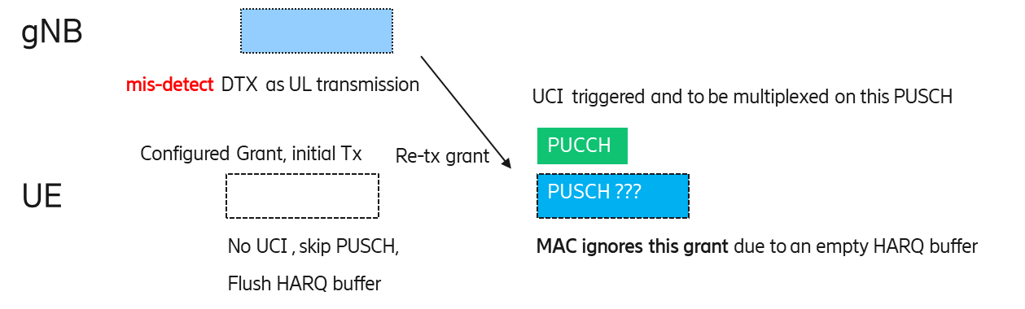
[R2-2108094, R2-2108095 (Ericsson, MediaTek)] propose to allow the initial transmission for UL grant addressed to CS-RNTI, if the HARQ buffer is empty, as follows:
For each uplink grant, the HARQ entity shall:
1> identify the HARQ process associated with this grant, and for each identified HARQ process:
2> if the received grant was not addressed to a Temporary C-RNTI on PDCCH, and the NDI provided in the associated HARQ information has been toggled compared to the value in the previous transmission of this TB of this HARQ process; or
2> if the uplink grant was received on PDCCH for the C-RNTI and the HARQ buffer of the identified process is empty; or
2> if the uplink grant received on PDCCH was addressed to CS-RNTI and if the HARQ buffer of the identified process is empty; or
… (omitted)
2> if the uplink grant is part of a bundle of the configured uplink grant, and may be used for initial transmission according to clause 6.1.2.3 of TS 38.214 [7], and if no MAC PDU has been obtained for this bundle:
… (omitted)
3> else if the MAC entity is not configured with lch-basedPrioritization; or
3> if this uplink grant is a prioritized uplink grant:
4> obtain the MAC PDU to transmit from the Multiplexing and assembly entity, if any;
3> if a MAC PDU to transmit has been obtained:
4> if the uplink grant is not a configured grant configured with autonomousTx; or
4> if the uplink grant is a prioritized uplink grant:
5> deliver the MAC PDU and the uplink grant and the HARQ information of the TB to the identified HARQ process;
5> instruct the identified HARQ process to trigger a new transmission;
…
2> else (i.e. retransmission):
3> if the uplink grant received on PDCCH was addressed to CS-RNTI and if the HARQ buffer of the identified process is empty; or
3> if the uplink grant is part of a bundle and if no MAC PDU has been obtained for this bundle; or
3> if the uplink grant is part of a bundle of the configured uplink grant, and the PUSCH duration of the uplink grant overlaps with an uplink grant received in a Random Access Response (i.e. MAC RAR or fallbackRAR) or an uplink grant determined as specified in clause 5.1.2a for MSGA payload for this Serving Cell; or:
3> if the MAC entity is not configured with lch-basedPrioritization and this uplink grant is part of a bundle of the configured uplink grant, and the PUSCH duration of the uplink grant overlaps with a PUSCH duration of another uplink grant received on the PDCCH; or:
3> if the MAC entity is configured with lch-basedPrioritization and this uplink grant is not a prioritized uplink grant:
4> ignore the uplink grant.
3> else:
4> deliver the uplink grant and the HARQ information (redundancy version) of the TB to the identified HARQ process;
4> instruct the identified HARQ process to trigger a retransmission;
…
On the other hand, [R2-2108787] and [R2-2107735] propose to keep the current text.
R2-2108787 (LG Electronics)
Proposal 1. The dynamic uplink grant received for retransmission of skipped initial transmission shall be ignored as today, i.e., it is not to be used for UCI transmission even though UCI is overlapped with this invalid retransmission uplink grant.
R2-2107735 (OPPO)
Proposal 2 RAN2 agrees to keep the current spec, i.e. ignore the retransmission grant whose PUSCH is overlapped with UCI if no MAC PDU has already been obtained for the corresponding HARQ process when Rel-16 LCH based prioritization is not configured and Rel-16 PUSCH skipping is enabled.
Q3) Do companies agree to allow the initial transmission for UL grant addressed to CS-RNTI, if the HARQ buffer is empty?
- Yes, the MAC entity shall treat the retransmission grant as the initial transmission.
- No, the MAC entity shall ignore the retransmission grant as today.
Company | Yes/No | Comments (optional)
< Summary >

3.3 Issue #3: Retransmission of Padding BSR-only MAC PDU
R2-2107200 Handling of pending empty PDUs after UCI multiplexing CATT discussion NR_IIOT-Core
R2-2108283 Autonomous Transmission of MAC PDU with only Padding or Periodic BSR Nokia, Nokia Shanghai Bell discussion Rel-16 NR_IIOT-Core
R2-2108284 Avoiding autonomous transmission of MAC PDU with only Padding BSR or unuseful Periodic BSR – Option 1 Nokia, Nokia Shanghai Bell CR Rel-16 38.321 16.5.0 1146 - F NR_IIOT-Core
R2-2108285 Avoiding autonomous transmission of MAC PDU with only Padding BSR or unuseful Periodic BSR – Option 2 Nokia, Nokia Shanghai Bell CR Rel-16 38.321 16.5.0 1147 - F NR_IIOT-Core
[R2-2107200] and [R2-2108283] point out that MAC may generate a MAC PDU carrying UCI-only TB (or with BSR) for a configured grant, if there is no UL transmission for the CG and CG overlaps with one PUCCH carrying UCI. In case that AutonomousTx is configured (potentially CGRT is configured and potentially LBT failure occurs), padding-only MAC PDU (or BSR-only MAC PDU) may be retransmitted in the next CG occasion. It would negatively impact the latency performance. Moreover, the delayed BSR may be outdated.
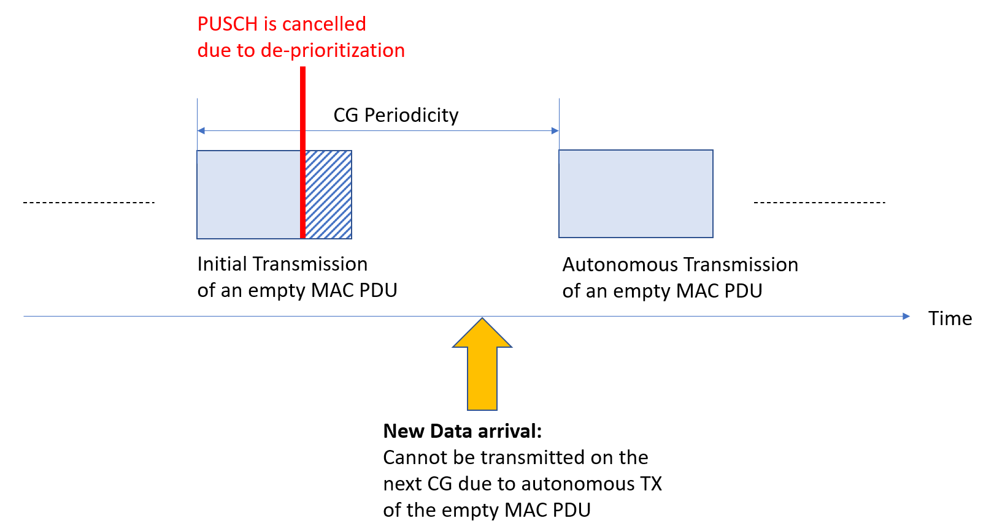
[R2-2107200] and [R2-2108283] propose to have a mechanism to avoid autonomous transmission of padding-only MAC PDU. The rapporteur would like to ask if companies would agree to resolve the issue.
Q4) Do companies agree to have a mechanism to avoid autonomous transmission of a MAC PDU that includes only padding BSR or periodic BSR indicating no data?
Company | Yes/No | Comments (optional)
< Summary >

Assuming that companies agree to resolve the issue, RAN2 needs to decide the option. (Note that if companies disagree, then none of the solutions is needed.) Anyway, the following solutions were proposed:
R2-2108283, R2-2108284, R2-2108285 (Nokia)
Proposal: RAN2 should discuss how to avoid autonomous transmission of a MAC PDU that includes only padding BSR or periodic BSR indicating no data, based on the following options:
- Flush this MAC PDU when it is deprioritized, so it will not be fetched for autonomous TX in the subsequent CG, if it only has padding or periodic BSR indicating no data (CR: R2-2108284)
- Do not consider this MAC PDU as obtained for autonomous transmission in HARQ entity procedure, if it only has padding or periodic BSR indicating no data (CR: R2-2108285)
R2-2107200 (CATT)
Proposal 1: MAC flushes the corresponding HARQ process after an empty MAC PDU aimed for an UCI-only TB has been delivered to PHY.
Q5) Assuming that RAN2 introduce a mechanism to avoid autonomous transmission of a MAC PDU that includes only padding BSR or periodic BSR indicating no data, which option is preferred?
- Option 1. Flush this MAC PDU when it is deprioritized, so it will not be fetched for autonomous TX in the subsequent CG, if it only has padding or periodic BSR indicating no data [R2-2108284].
- Option 2. Do not consider this MAC PDU as obtained for autonomous transmission in HARQ entity procedure, if it only has padding or periodic BSR indicating no data [R2-2108285].
- Option 3. MAC flushes the corresponding HARQ process after an empty MAC PDU aimed for an UCI-only TB has been delivered to PHY [R2-2107200]
Company | Option | Comments (optional)
< Summary >

4 Phase-1 Conclusion

