3GPP TSG RAN WG2 Meeting #111-e R2-200xxxx
Electronic meeting, August 17th - 28th, 2020

Source: Huawei, HiSilicon
Title: [AT111-e][613][POS] Integrity Error Sources (Huawei)
Agenda item: 8.11.3.2
Document for: Discussion and Decision

Introduction
This document provides the summary of the following email discussion and its outcome.
- [AT111-e][613][POS] Integrity error sources (Huawei)
Scope: Categorise the identified error sources and develop a way forward, considering RAT-dependent and RAT-independent methods, with the understanding that the use of specific positioning methods may be use-case-dependent.
Intended outcome: Summary in R2-2008263
Deadline: Thursday 2020-08-27 1200 UTC
The intention of this offline discussion is to reach a common understanding on the error sources for positioning integrity. The tdocs under the scope of this discussion are:
[1] R2-2006580 Discussion on positioning integrity validation and reporting Huawei, HiSilicon discussion Rel-17 FS_NR_pos_enh
[2] R2-2006674 Discussion on error sources, threat models, occurrence rates and failure modes CATT discussion Rel-17 FS_NR_pos_enh
[3] R2-2006565 Identify Error sources for positioning integrity vivo discussion FS_NR_pos_enh
[4] R2-2006955 Factors impacting positioning integrity Ericsson discussion Rel-17
[5] R2-2007647 Discussion on GNSS position integrity error sources ESA discussion Rel-17 FS_NR_pos_enh
[6] R2-2007938 Discussion of the positioning error sources, threat models and failure modes ZTE Corporation, Sanechips discussion Rel-17 FS_NR_pos_enh
[7] R2-2006541 TP for Study on Positioning Integrity and Reliability, Swift Navigation, Deutsche Telekom, u-blox, Ericsson, Mitsubishi Electric, Intel Corporation, CATT, UIC.

Discussion

General view
According to the online discussion, the identification of error sources can be considered as a starting point of integrity validation and reporting. Regarding the methodology to study the integrity error sources, relevant proposals have been excerpted from [1], [2] and [4] as follows:
Tdoc | Source | Relevant proposals
[1] R2-2006580 | Huawei, HiSilicon | Proposal 1 Study the potential error sources for each positioning method of RAT-dependent and RAT-independent positioning separately.
[2] R2-2006674 | CATT | Proposal 1 RAN2 should discuss what kind of integrity monitors are required in RAT-Independent system and in RAT-Dependent separately.
[4] R2-2006955 | Ericsson | Proposal 1 The attributes impacting integrity are classified as static, semi-static and dynamic factors and shall be captured in the TR.

- Q1: Please kindly provide your views on the following options:
    - If you prefer option 1, please provide your further comments on Q3 and Q4；
    - If you prefer option 2, comments are also welcome for Q3 and Q4.
- Option 1: Study the potential error sources for each positioning methods for RAT-dependent and RAT-independent positioning separately.
- Option 2: Study the potential error sources by categorizing the attributes into static, semi-static and dynamic factors.

Company | Comments
Huawei, HiSilicon | Go for Option 1.  Considering different positioning methods and scenarios, the error sources may be different. As a starting point, the analysis of error sources should be conducted separately for each positioning methods of RAT-dependent and RAT-independent positioning systems considering the huge difference between cellular networks and satellite networks.
Swift Navigation | Option 1.  Agree with Huawei and others that RAT-Dependent and RAT-Independent sources of error need to be addressed separately.  Swift Navigation, Deutsche Telekom, u-blox, Ericsson, Mitsubishi Electric, Intel Corporation, CATT, UIC also note the following in [7] (Section 9.6.5):  ‘Integrity validation is a multifaceted process which varies according to industry-specific compliance regimes. A full Integrity Qualification Strategy (IQS) requires a complete dossier of documentation, justification, methodology, tests and traceability through the entire qualification process. This observation is a crucial point which highlights that specifying integrity as part of the 3GPP standards alone does not constitute proof of integrity, i.e. integrity validation is beyond the scope of this study.’  With respect to the Study objectives, this statement reinforces that 3GPP can define general categories of errors for both RAT-Dependent and RAT-Independent methods, but it is impossible to enumerate every possible error source in general without reference to a specific implementation. Integrity can only be validated end-to-end for a specific implementation by performing comprehensive fault-tree analysis and validating the complete qualification dossier. Hence, we further support Huawei’s comments in Question 3 for reaching consensus on a taxonomy of potential error sources to be considered as an input to integrity validation within a positioning system.
Intel | Agree with Option 1.  RAT-dependent and RAT-independent positioning methods share different positioning assistance data and measurement methodologies. Error sources identified from these two positioning methods are independent from each other due to different environment and report mechanism.  Moreover, under RAT-dependent positioning, we suggest to further classify RAT-dependent error sources into location server error cause and target device error cause. Then further divide the error causes into following categories:  Assistance data integrity/time synchronization/channel propagation and interference/location accuracy
InterDigital | Both Option1 and Option 2.  Option 1 and Option 2 look at different perspectives of the study. While Option 1 divides RAT dependent/independent work, Option 2 describes dynamics in error sources. Our proposal is to conduct both. Option 2 may identify upper-level error sources, which lead to our response for Q2; identification of upper/semi-static configuration level error sources and physical layer error sources.  We agree with Huawei that error sources can be different between RAT dependent and independent positioning. Our view is that both option 1 and option 2 should be done simultaneously to increase efficiency of the work.
CATT | Go for Option1.  There are several ways to support integrity monitors in GNSS Navigation system. But there is no integrity monitor in RAT-Independent system so far. The errors affecting the measurement in a GNSS receiver are different from RAT-Dependent positioning methods.  RTCM (Radio Technical Commission for Maritime Services) SC-134 is working on the integrity message definition now. The latest integrity message groups are updated in May 2020 by RTCM and are planned to be finalized in Q4 2020. 3GPP can learn from the message groups by RTCM and make a decision what kind of message can be used for RAT-Independent positioning methods.
ESA | Option 1 and Option 2 do not seem mutually exclusive. We think is best to start with Option 1 and have a first categorisation of error sources: RAT-dependent, and RAT-independent. Option 2 can be addressed in parallel. It deals with an attribute of individual error sources and therefore can be used to enhance the analysis proposed in Option 1. For us, option 2 would translate to simply tagging identified and selected error sources as one of the following three categories: static, semi-static, dynamic. From Ericsson´s contribution it seems that Option 2 is applicable to RAT-dependent only?! We don´t see Option 2 applicable to RAT-independent/GNSS.
Nokia | We do not see the point of this dichotomy at this stage of the study. We should try to identify risks applicable to all RAT-I methods and RAT-D methods, rather than investigate each single method individually.  Neither Option 1 nor Option 2 seems to be an appropriate way forward from our perspective.
OPPO | Option 1 and Option 2 can be studied together.  Based on option 1, the positioning method specific error sources can be conducted respectively. And option 2 is applicable to category the error sources for both RAT-dependent and RAT-independent positioning method based on its characteristic, i.e. static, semi-static and dynamic. There is no conflict between the two options.

Additionally, as mentioned by CATT in [2], RAN2 doesn’t know the priorities of these errors and hard to make decision which error should be reported and which should not without RAN1 suggestions. Same concerns have been raised in [1].
- Q2: Please kindly provide your views on the following proposal if we can propose an LS to RAN1
- Proposal #1: LS to RAN1 to study the error sources that influence the positioning accuracy for RAT-dependent and RAT-independent positioning methods for the study of integrity.

Company | Y/N | Comments
Huawei, HiSilicon | Y | We agree that the error sources and the corresponding impacts on the positioning integrity should be studied with the inputs from RAN1.
Swift Navigation | N | R2-2006541 [7] provides an extensive background on the RAT-Independent GNSS error sources and integrity methods which have been developed over several decades. GNSS experts are well represented in RAN2, for example through the RAN2-led work to standardize PPP-RTK (SSR) in Release 16. Both [5] and [7] have provided an introduction to common GNSS error sources for consideration within this study.  Considering the above, it is recommended that the RAN2-led work for categorizing the RAT-Independent GNSS error sources can proceed without requiring an LS to RAN1.  We defer to other 3GPP experts on whether further guidance from RAN1 is required for non-GNSS RAT-Independent positioning errors (e.g. WiFi, Bluetooth) and RAT-Dependent methods.
Intel | Partially Yes | Agree Swift, for RAT independent positioning method, we do not need the inputs from RAN1.  Regarding RAT dependent positioning method, we agree that joint study between RAN1 and RAN2 is needed as need RAN1 input to evaluate each error source impact and corresponding error source value range
InterDigital | N | There could be errors sources at network-level or related to semi-static configuration. RAN2 should identify error sources related at network level. Even recognizing existence of physical layer error sources will be helpful for RAN1. Once we have higher-layer perspective, we can allow RAN1 to identify physical layer level error sources.  Study of error sources may depend on KPI discussion as well. Perhaps, we should solidity KPI discussion and then focus on error sources. At this point, RAN1 may be confused without specifying how “error sources” can affect the system performance.
CATT | N | Integrity is not in the scope of RAN1 based on SID, and the SI is scheduled to the complete in the next meeting. We don’t think RAN1 has the time-budget to do the study either.  So We suggest focusing on the RAT-Dependent UE-Based method in SI only by RAN2.
ESA | Y(RAT-D)  N (RAT-I) | Agree with Intel
Nokia | No | Considering that integrity may be derived from the combination of different positioning methods (RAT-D and RAT-I), and be based on proprietary algorithms, the inputs from RAN1 performed on specific methods may not help much. Besides, RAT-independent aspects are for RAN2 to study and RAN1 cannot help with that.
OPPO | Y, but | We are OK to send the LS to RAN1 for the RAT-dependent positioning error sources evaluation. While for RAT-independent positioning, we prefer to identify the error sources in RAN2.

Error Sources for RAT-dependent Positioning
Concerning the error sources for RAT-dependent positioning, only two companies provide their views, which is summarized as follows:
Tdoc | Source | Relevant proposals
[3] R2-2006565 | vivo | Proposal 2: Source of error include below factors at least  - The DOP of TRPs  - The SNR and RSRP of receiving PRS  - Synchro error of TRPs  - Multi-path and NLOS of receiving PRS.
[1] R2-2006580 | Huawei, HiSilicon | Proposal 2 The error sources for RAT-dependent positioning can be studied separately for timing-based positioning methods (e.g. DL-TDOA, UL-TDOA, Multi-RTT), and angle-based positioning methods (e.g. DL-AoD, UL-AoA).

- Q3: Please kindly provide your views on the following proposal:
- Proposal #2: Study the potential error sources for timing-based positioning methods and angle-based positioning methods separately. For instance,
  - For timing based positioning, the error sources may include time measurement error, UE clock drifting within and across PRS occasions, reference station/TRP synchronization, radio environment, measurement geometry, cell data base accuracy, etc.
  - For angle measurements based positioning, the error sources may include angle measurement error, gNB antenna calibration, radio environment, measurement geometry, cell data base accuracy, etc.

Company | Comments
Huawei, HiSilicon | Due to different positioning mechanisms, the error sources may vary for different RAT-dependent positioning methods. AS of now, for RAT-dependent positioning, there are two types of measurements, namely, timing-based measurement and angle-based measurement. At least for timing-based positioning methods (e.g. DL-TDOA, UL-TDOA, Multi-RTT) and angle-based positioning methods (e.g. DL-AoD, UL-AoA), the error sources should be identified and analyzed separately in terms of types of measurements.
Swift Navigation | We defer to RAT-Dependent experts for the identification of RAT-Dependent error sources.  Further to [7] and our comments provided for Questions 1 and 2, it is important to understand that to develop an integrity concept for a new positioning method, a methodical approach must be taken to ensure that all feared events (e.g. potential error sources) are identified and enumerated. To complete the IQS dossier it is necessary to prove that all eventualities have been taken into account. Therefore, we believe it is necessary to begin with a clear Concept of Operations (CONOPS) from which a high-level fault tree analysis (FTA) can be performed. A final detailed FTA can only be performed for a specific implementation which is why we suggest that the aim should be to use the CONOPS as a guideline to determine the set of error categories, e.g. [5], [7]. Listing various errors without a methodical integrity framework will not be sufficient to support an integrity case.
Intel | Agree error sources should be identified per positioning method. However, it is not appropriate to only separate into timing based and angle based positioning, as some assistance data and relative parameters are shared between both positioning methods, such as accuracy of geographical coordinates of the TRPs, time stamp, etc  It is suggested to classified error sources based on reference signal and data source, such as: assistance data integrity/time synchronization/channel propagation and interference/location accuracy, detail error sources for different factors are FFS
InterDigital | The potential error sources can be initially identified and categorized based on the impacting areas that fall within the scope of RAN1, RAN2 and RAN3/SA. RAN2 can then study the error sources for different RAT-dependent positioning methods that are within the scope of RAN2.
CATT | The errors affecting the measurement depend on the following factors:  - Reference signals;  - network timing synchronization  - Propagation channel;  - Location calculation.  Prefer to study the RAT-Dependent positioning methods separately.
Nokia | Angle and timing measurements benefit to be combined to provide higher accuracy and integrity, in consequence there is no interest to study them separately. We should try to identify more important risks that are commonly applicable to different positioning methods. From our point of view, the risks associated to both timing-based and angle measurement-based methods mentioned above are all unintentional (natural) causes.  We may also need to consider intentional man-made attacks to create DoS, tamper location or impersonate other UEs positions
OPPO | As a starting point, the error sources for RAT-dependent positioning methods can be identified with two categories, i.e. timing-based positioning methods and angle-based positioning methods.

Error Sources for RAT-independent Positioning
Concerning the error sources for RAT-independent positioning, a comprehensive analysis has been provide in [5] provided by ESA, which also indicates the following observation:
Observation 2: For an assisted positioning with GNSS there are three major factors in determining overall position accuracy: the quality of the range measurements, the quality of the satellite geometry, and the quality of the GNSS assistance data.

- Q4: Please kindly provide your views on the following proposal:
- Proposal #3: Categorize the error sources for RAT-independent positioning into different factors: Range measurements, Satellite geometry, GNSS assistance data, etc. The error sources for different factors are FFS.

Company | Comments
Huawei, HiSilicon | As a starting point for the error sources identification for RAT-independent positioning, we may first reach a consensus on the taxonomy for all the potential error resources, and then discuss the specific ones for each category.
Swift Navigation | This diagram shows a simplified high-level CONOPS for the UE-based GNSS case. It is a simplified version of the architecture presented in [5].  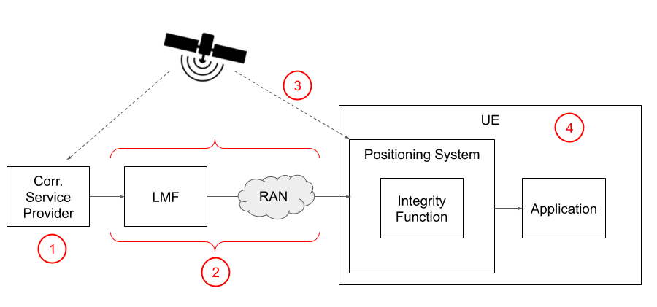  From this diagram we can identify 4 possible sources of feared events:  - Faults in the correction data e.g.  - Incorrect computation by the provider  - External feared event impacting the provider  - Faults in transmitting the data to the UE, e.g.  - Data integrity faults  - External feared events, e.g.  - Satellite feared events  - Atmospheric feared events  - Multipath  - UE faults  We propose to adopt these 4 high-level categories for the UE-based GNSS case. We suggest that for other methods a corresponding high-level architecture is proposed in order to consider the error categories.
Intel | RAT-independent positioning should follow satellite network factors to category error sources. The error sources described in R2-2008256 can be the start point, i.e. to consider following error sources: fault probability assumptions, network-detected integrity faults, correction data faults, UE-detected event, positioning integrity validation, data integrity, redundancy. IEs are FFS.
CATT | The errors affecting the measurement in a GNSS receiver depend on the following factors:  - Space segment;  - Propagation in atmosphere;  - Local propagation effects near the receiver antenna;  - User segment (i.e., received signal processing, thermal noise, interference)  Below please find the assistance data and measurement between network and UE according to the study results from RTCM.  RTCM (Radio Technical Commission for Maritime Services) SC-134 is working on the integrity message definition now.  The latest integrity message groups are updated in May 2020 in RTCM and are planned to be finalized in Q4 2020. 3GPP can learn from the message groups by RTCM and make a decision what kind of message can be used in 3GPP.  Table 2-1 Integrity message groups defined by RTCM  Group Name Sub-Group Name  Signal In Space Integrity Constellations and Satellites Integrity data  Fast Constellation and Satellites Health Status  Global Integrity Precise Orbit and Clock Integrity Parameters  Displacements error Integrity Parameters  Satellite bias Integrity Parameters  Network Integrity Reference Station Specific Integrity Monitoring parameters data and measurements variances  Local Integrity Pseudorange corrections Integrity Parameters  Carrier Phase Integrity Parameters Corrections  More detail info please refer to our proposal:  https://www.3gpp.org/ftp/tsg_ran/WG2_RL2/TSGR2_111-e/Docs/R2-2006674.zip
ESA | We are ok with Swift´s structure, it can be used to structure the analysis of various GNSS error sources presented in R2-2007647.  To improve the baseline, we would suggest few modifications:  -Amend point number 3 and 4 as follows:  - External feared events, e.g.  - Satellite feared events  - Atmospheric feared events  - Multipath  - Jamming  - Spoofing  - UE faults  - GNSS Rx design faults  - GNSS Rx measurement noise  - Incorrect reception and decoding of corrections  -picture should be better aligned to NG-RAN UE positioning architecture (see TS 38.305) – maybe something more like the figure from below:  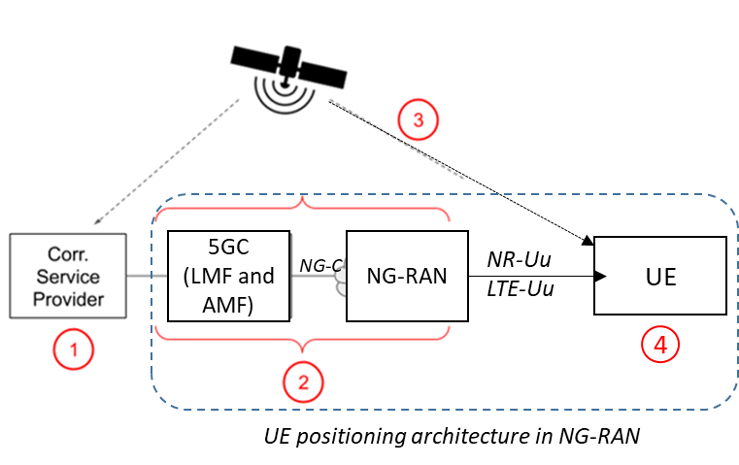  -on UE side, we think is best for now not to mention “Integrity function”. According to 38.305, section 5.4.1, UE can perform measurements, compute position (with or without AD), and include an LCS application. There is no consensus yet on the “Integrity function” capability nor did we discuss where this will be computed (although the final outcome can be something as Swift proposal).  - an Observation for Conclusions section – looking at taxonomy proposed by Swift and supported by ESA – category 1 errors seems to be outside of 3GPP scope and therefore we should agree whether we address it or not.
Nokia | The error sources affecting the integrity for GNSS has been analysed extensively for many years. We believe this is not necessary to conduct the study in 3GPP separately, as mostly likely we can reuse what are already available in the existing standards/literature.  On the other hand, we would like to point out that RAT-independent based methods are not limited to satellites. We may also consider:  - non 3GPP RAT based, like WiFI and BT  - Sensor, or environment verification based

Conclusions
To be seen.

