3GPP TSG RAN WG1 #121 R1-250xxxx
St Julian’s, Malta, May 19th – 23rd, 2025
Agenda Item: 7
Source: Moderator (MediaTek)
Title: Summary #1 on collision handling between SSB and RA occasion
Document for: Discussion

1 Introduction
This is the moderator summary for discussions on corrections to collision handling between SSB and RA occasion based on the contributions listed in section 1.1 and with regards to the RAN4 LS in R1-2501697 [1].

1.1 List of Contributions
R1-2503423 | Discussion on Reply LS on collision between SSB and RA occasion for LTM | Nokia
R1-2503546 | Discussions on collision handling between SSB and RA occasion for LTM | Samsung
R1-2503679 | Discussion on collision handling of SSB and RA occasion for LTM | ZTE Corporation, Sanechips
R1-2503680 | Draft CR on collision handling of SSB and RA occasion for LTM | ZTE Corporation, Sanechips
R1-2504296 | Discussion on collision between SSB and RA occasion for LTM | Google
R1-2504301 | Correction on handling collision of SSB and RA occasion for LTM | Google
R1-2504636 | Correction on handling collision of SSB and RA occasion for LTM in 38.213 | Huawei, HiSilicon

2 Discussion

2.1 Background
In RAN4 LS [1], RAN1 was informed about the following RAN4 consensus:
- RACH shall be prioritized over SSB, if the collision is outside MG.
- If collision happens within MG, it is up to UE implementation, i.e., UE may transmit or drop RACH when the RACH occasion colliding with the MG occasion.

2.2 Summary of contributions
Nokia | Proposal 1: For RAN1, it should be sufficient to specify that RACH shall be prioritized over SSB if the collision occurs outside of the MG in TS 38.213.  Proposal 2: RAN1 should inform RAN2 about this reply from RAN4 for any potential RAN2 specification impact.
Samsung | Proposal: adopt the following TP to clarify corresponding UE’s behaviour when a collision between SSB and a RACH occasion associated with different cells occur outside a MG.  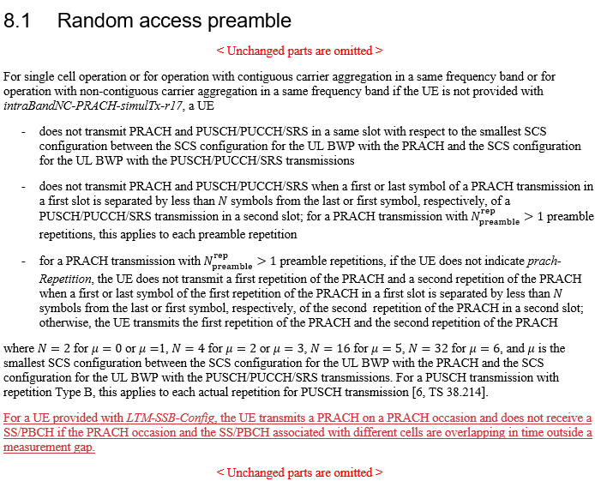
ZTE | Proposal 1: RAN1 should capture the following method recommended by RAN4 into Clause 8.1 of TS 38.213-i60 to clarify UE behavior when the collision between a SSB and a valid RACH occasion associated with different cells happens:  - If the collision is outside MG, RACH shalle be prioritized over SSB  - The corresponding draft CR can be found in [2]  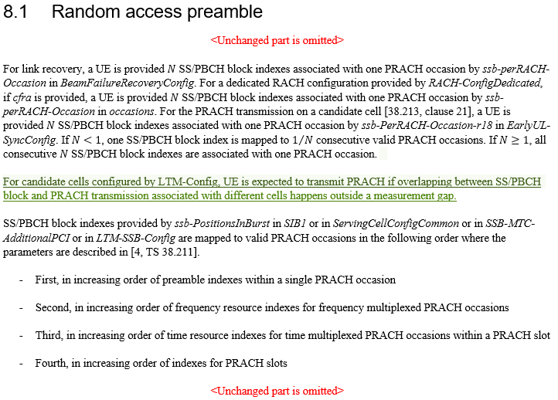
Google | Observation 1: Collision handling of SSB and RA occasion associated with different cells should only consider whether the collision is inside the measurement gap or outside measurement gap.  Observation 2: Collision handling of SSB and RA occasion associated with different cells can apply for both intra-band and inter-band cases.  Observation 3: Collision handling of SSB and RA occasion associated with different cells can be performed upon a SSB and a RO is overlapped in time domain.  Proposal 1: Endorse the Text Proposal 1 in TS 38.213, according to the reply LS from RAN4 (R1-2501697).  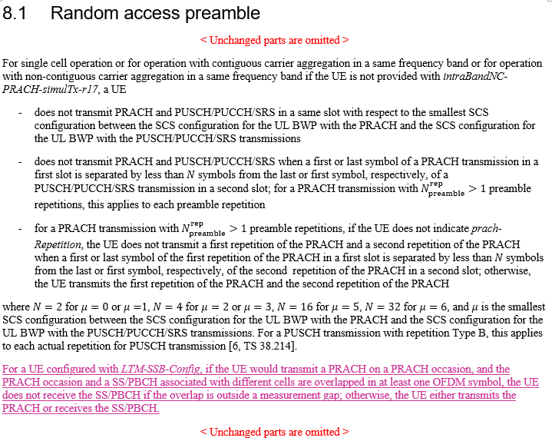
Huawei | 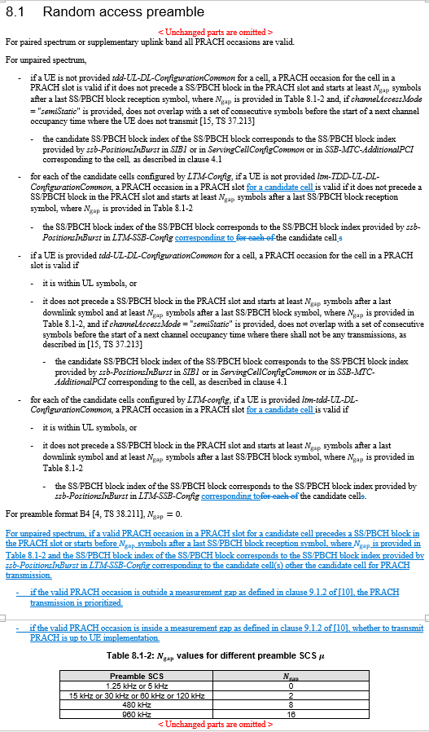

Moderator’s summary: Based on company contributions, all companies think that a CR is needed for TS38.213, clause 8.1 to capture the RAN4 consensus. The TPs proposed by companies are similarly addressing the case where RACH is prioritized over SS/PBCH when the collision associated with different cells occurs outside of a MG. In addition, one company (Nokia) is proposing to inform RAN2 for potential RAN2 specification impact.
Based on this, please find a proposed TP in section 2.2 and a question on possible LS to RAN2 in section 2.3.
Please insert your comments and answers into the tables in section 2.2 and section 2.3.

2.2 Proposed TP
The following proposal is made based on the summary of contributions.

Proposal 1: Adopt the following TP to Section 8.1, TS38.213.

8.1 Random access preamble
< Unchanged parts are omitted >
For single cell operation or for operation with contiguous carrier aggregation in a same frequency band or for operation with non-contiguous carrier aggregation in a same frequency band if the UE is not provided with intraBandNC-PRACH-simulTx-r17, a UE
- does not transmit PRACH and PUSCH/PUCCH/SRS in a same slot with respect to the smallest SCS configuration between the SCS configuration for the UL BWP with the PRACH and the SCS configuration for the UL BWP with the PUSCH/PUCCH/SRS transmissions
- does not transmit PRACH and PUSCH/PUCCH/SRS when a first or last symbol of a PRACH transmission in a first slot is separated by less than $N$ symbols from the last or first symbol, respectively, of a PUSCH/PUCCH/SRS transmission in a second slot; for a PRACH transmission with $N_{preamble}^{rep}>1$ preamble repetitions, this applies to each preamble repetition
- for a PRACH transmission with $N_{preamble}^{rep}>1$ preamble repetitions, if the UE does not indicate prach-Repetition, the UE does not transmit a first repetition of the PRACH and a second repetition of the PRACH when a first or last symbol of the first repetition of the PRACH in a first slot is separated by less than $N$ symbols from the last or first symbol, respectively, of the second repetition of the PRACH in a second slot; otherwise, the UE transmits the first repetition of the PRACH and the second repetition of the PRACH
where $N=2$ for $μ=0$ or $μ=1$, $N=4$ for $μ=2$ or $μ=3$, $N=16$ for $μ=5$ , $N=32$ for $μ=6$ , and $μ$ is the smallest SCS configuration between the SCS configuration for the UL BWP with the PRACH and the SCS configuration for the UL BWP with the PUSCH/PUCCH/SRS transmissions. For a PUSCH transmission with repetition Type B, this applies to each actual repetition for PUSCH transmission [6, TS 38.214].
For a UE provided with LTM-SSB-Config, the UE transmits a PRACH on a PRACH occasion and does not receive a SS/PBCH if the PRACH occasion and the SS/PBCH associated with different cells are overlapping in time outside a measurement gap.
< Unchanged parts are omitted >

Please insert your comments on Proposal 1 in the table below.
Company | Comment

2.3 Questions
Please insert your answer to Question #1 in the table below.
Question #1: Do you think that an LS needs to be sent to RAN2 to inform them about the RAN4 LS?
Company | Comment

Conclusion
TBD

References
- R1-2501697, Reply LS to RAN1 on collision between SSB and RA occasion for LTM, Source: RAN4, RAN1#120-bis, Wuhan, China, April 2025.

