**RAN1#115 Online Schedule**

**RAN1 Breakout1  
(Salon A1)**

**RAN1 Main**

**(International Ballroom N)**

**RAN1 Breakout2**

**(Salon A2)**

|  |  |  |  |  |  |  |  |  |  |  |  |  |  |  |  |
| --- | --- | --- | --- | --- | --- | --- | --- | --- | --- | --- | --- | --- | --- | --- | --- |
|  | **Monday** | | | **Tuesday** | | | **Wednesday** | | | **Thursday** | | | **Friday** | | |
| **08:15**  **~**  **10:30**  **(135 min)** | **RAN1#115 commences at 09:00 (local time) on Monday**  Agenda items 1, 2, 3, 4, 5  Agenda items 6, 7.1 | | | AI/ML (135) | CovEnh (45)  Mobility (60)  Pos (30) | UE features (135) | AI/ML (135) | Sidelink (135) | UE features (135) | AI/ML (135) | Sidelink (75)  <5MHz, DSS, RedCap (60) | UE features (135) | AI 7.1 (15)  AI/ML (120) | CovEnh (45)  Sat Eval (45)  TBD (45) | UE features (135)  MIMO (90)  Mobility (25) NES (20) |
| **Morning coffee break: 10:30 ~ 11:00** | | | | | | | | | | | | | | | |
| **11:00**  **~**  **12:45**  **(105 min)** | Agenda item 7.1, 7.2 (105) | | | NCR, XR, MC-Enh (105) | Pos (105) | UE features (105) | MC-Enh (45)  MIMO (60) | Pos (105) | UE features (105) | NCR, MC-Enh (75)  AI 7.2 (30) | Pos (105) | UE features (105) | NES (60)  MC-Enh (45) | Sidelink (60)  Mobility (45) | UE features (TBD) |
| **Lunch break: 12:45 ~ 14:00** | | | | | | | | | | | | | **Break for 15 min (12:45 ~ 13:00)**  **Reconvene joint session at 13:00** . Any open issues . Session reports (start with 8.16)  **RAN1#115 is expected to close at 14:30 (local time) on Friday** | | |
| **14:00**  **~**  **15:30**  **(90 min)** | MIMO (90) | Pos (90) | UE features (90) | AI 8.17 Others (20)  AI 7.1/7.2 (70) | <5MHz, DSS, RedCap, (70)  Sat Eval (20) | UE features (90) | MIMO (90) | NTN (90) | UE features (90) | AI 7.1 (70)  AI 8.17,  AI 5 LSs (20) | AI 7.2 (90) | UE features (90) |
| **Afternoon coffee break: 15:30 ~ 16:00** | | | | | | | | | | | | |
| **16:00**  **~**  **18:30**  **(150 min)** | MIMO (60)  NES (90) | NTN (60)  SL (90) | UE features (150) | AI 7.1/7.2 (60)  NES (90) | NTN (60)  7.2 (90) | UE features (150) | AI 7.2 (20)  AI 5 LSs (30)  NES (100) | 7.2 (50)  CovEnh (40)  Mobility (60) | UE features (150) | NES (150) | NTN (90)  Mobility (60) | UE features (150) |
| **All sessions end at 18:45 (at the latest) – no exceptions** | | | | | | | | | | | | | | | |

**RAN1#115 Offline Session Schedule**

**Buckinghams (42)**

**Salon C 1-2 (108)**

|  |  |  |  |  |  |  |  |  |  |  |
| --- | --- | --- | --- | --- | --- | --- | --- | --- | --- | --- |
|  | **Monday** | | **Tuesday** | | **Wednesday** | | **Thursday** | | **Friday** | |
| **08:15**  **~**  **10:30**  **(135 min)** |  | | Positioning (100)  <5MHz (35) | XR (30)  NES (105) | Positioning (135) | MC-Enh (45)  NES (90) | David (135) | NES (90)  MC-Enh (45) | Mobility (45)  Sidelink (90) | NES (90)  MC-Enh (45) |
| **Morning coffee break: 10:30 ~ 11:00** | | | | | | | | | | |
| **11:00**  **~**  **12:45**  **(105 min)** | AI/ML (105) | Positioning (105) | AI/ML (105) | eRedCap (50)  DSS (20)  Sat Eval (35) | AI/ML (105) | NTN (60)  Mobility (45) | AI/ML (105) | David (105) |  |  |
| **Lunch break: 12:45 ~ 14:00** | | | | | | | | | To be assigned by David | |
| **14:00**  **~**  **15:30**  **(90 min)** | NTN (90) | NES (90) | MIMO (90) | NTN (90) | CovEnh (60)  Positioning (30) | NCR (30)  XR (30)  MC-Enh (30) | David (90) | David (90) |
| **Afternoon coffee break: 15:30 ~ 16:00** | | | | | | | | |
| **16:00**  **~**  **18:30**  **(150 min)** | Sidelink (50)  Mobility (50)  CovEnh (50) | NCR (40)  NES (20)  MC-Enh (90) | MIMO (150) | Sidelink (150) | AI/ML (150) | Sidelink (90)  eRedCap (40)  <5MHz (20) | AI/ML (150) | David (150) |
| **All sessions end at 18:45 – no exceptions** | | | | | | | | | | |

**RAN1#115 Detailed Schedule for RAN1 Main Session**

|  |  |  |  |  |  |
| --- | --- | --- | --- | --- | --- |
|  | **Monday** | **Tuesday** | **Wednesday** | **Thursday** | **Friday** |
| **08:15**  **~**  **10:30**  **(135 min)** |  | Rel-18 AI/ML . 8.14.1 . 8.14.2 | Rel-18 AI/ML . 8.14.3 . 8.14.1 . 8.14.2 | Rel-18 AI/ML . 8.14.1 . 8.14.2 . 8.14.3 (if there is time) |  |
| **Morning coffee break: 10:30 ~ 11:00** | | | | | |
| **11:00**  **~**  **12:45**  **(105 min)** | Agenda item 7.1  Agenda item 7.2 . MIMO . IIoT & URLLC . Coverage Enh . UE power saving | Rel-18 NCR, XR, MC-Enh . NCR 🡪 XR 🡪 MC-Enh | Rel-18 MC-Enh . Both agenda items  Rel-18 MIMO . DMRS, SRS, unified TCI | NCR, MC-Enh (75) . Any open issues  AI 7.2 (30) . Any open issues |  |
| **Lunch break: 12:45 ~ 14:00** | | | | |  |
| **14:00**  **~**  **15:30**  **(90 min)** | Rel-18 MIMO . Unified TCI . Two TA . CSI . DMRS . SRS (if there is time) | Agenda item 8.17  Comebacks for AI 7.1 | Rel-18 MIMO . Two TA, CSI, STxMP, 8TX | AI 7.1 (70) . Any open issues  AI 8.17, AI 5 LSs (20) . Any open issues |
| **Afternoon coffee break: 15:30 ~ 16:00** | | | | |
| **16:00**  **~**  **18:30**  **(150 min)** | Rel-18 MIMO . SRS . STxMP . 8TX  Rel-18 NES . Both agenda items | Comebacks for AI 7.1  Comebacks for AI 7.2 . TR38.901, MIMO, IIoT & URLLC  Rel-18 NES . Both agenda items | Comebacks for AI 7.2 . CovEnh, UE power saving  Comebacks for AI 5  Rel-18 NES . Both agenda items | TBD (30)  NES (120) . Any open issues |
| **All sessions end at 18:45 – no exceptions** | | | | | |

**Meeting Room Locations**

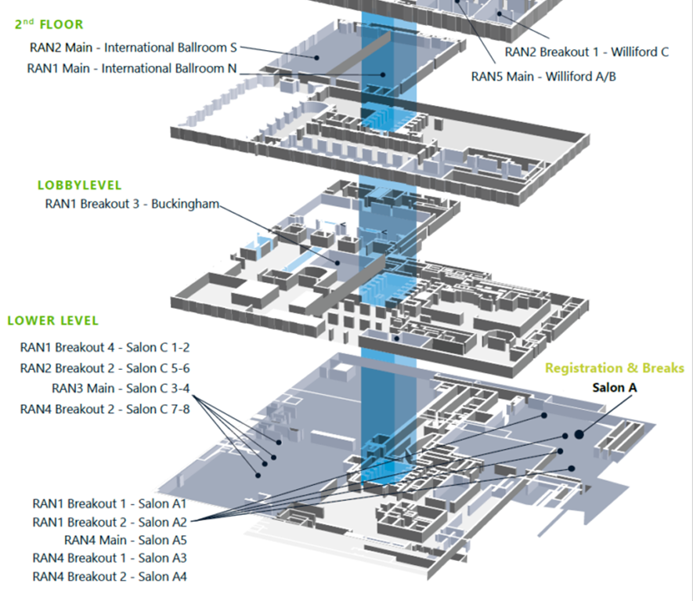

**Online session rooms:**

**International Ballroom N (2nd floor)**

**Salon A1 (lower level)**

**Salon A2 (lower level)**

**Offline session rooms:**

**Buckingham (lobby level)**

**Salon C 1-2 (lower level)**