3GPP TSG RAN WG1 #114bis R1-230XXXX
Xiamen, China, October 9th – October 13th, 2023
Agenda item: 8.17
Source: Moderator (Samsung)
Title: Summary of discussion on multiplexing HARQ-ACK in a PUSCH
Document for: Discussion and Decision

Introduction
This contribution aims to collect and summarize company views on the issue of multiplexing HARQ-ACK in a PUSCH as raised in [1].
Please consider entering the contact information below for better coordination for this discussion.
Company | Contact(s) | Email address(es)
Samsung (Moderator) | Sa Zhang | sa.zhang@samsung.com

Background
In RAN1#113 meeting, the following agreement was made.
Agreement
If UCI multiplexing of different priorities is not enabled, the restriction on scheduling PDSCH after UL grant is removed for the case of PUSCH with repetitions except the first repetition
- UE generates Type-1 HARQ-ACK codebook according to the existing specification with the modification of setting the actual ‘ACK/NACK’ value corresponding to PDSCH(s) scheduled after the UL grant.
- UE generates Type-2/3 HARQ-ACK codebook according to the existing specification.
  - For Type-2 CB, UL DAI is used for generating HARQ CB.
- This feature is subject to separate UE capabilities for type-1, type-2, and type-3 codebooks.
- RRC parameter(s) to configure the function of scheduling PDSCH after a UL DCI format and multiplexing associated HARQ on a PUSCH repetition except the first repetition are introduced in Rel-18.
- Note: the number of PUSCH repetitions can be scheduled/configured by gNB.
- Note: same principle of current specification which UL DAI in UL grant is applied to each PUSCH repetition is reused.
- The timeline specified in TS 38.213 Clause 9.2.5 are satisfied, i.e. $T_{proc,1}^{mux}$between the last PDSCH and PUCCH, $T_{proc,2}^{mux}$ between the last PDCCH among UL grant /DL grant(s) and the earliest PUCCH or PUSCH
- Additional UE capabilities are introduced to support the following functions (UE will be configured by gNB to use the following features via RRC)
  - HARQ-ACK codebook size change on a PUCCH slot
  - PUCCH resource change on a PUCCH slot

It was pointed out in [1] that if the time domain of the PUCCH resource does not change before and after the UL grant, a UE does not need additional timeline to determine the PUSCH for HARQ-ACK multiplexing. It is proposed that the restriction on PUCCH resource change only impact time domain.

Discussion
It was pointed out in [1] that when a DL assignment comes after an UL grant for a UE, the UE determines the HARQ-ACK codebook and a PUCCH resource based on the HARQ-ACK codebook size and the PRI indication in the last DCI format for DL assignment before the UL grant. After that, the UE multiplexes the HARQ-ACK in a PUSCH overlapping with the PUCCH, if any. If PUCCH time domain resource is different from the PUCCH that UE determines before the UL grant, UE may multiplex the HARQ-ACK in another PUSCH. As a result, it would take additional time for the UE to re-determine the PUSCH and the REs for both the HARQ-ACK and the data in the PUSCH.
An example is given in [1] to illustrate the issue as show in Figure 1. UE first determines to multiplex HARQ-ACK in PUCCH#1 before receiving the UL DCI#1 and UL DCI#2, and then UE determines to multiplex HARQ-ACK in PUSCH#1 after receiving the UL DCI#1 and UL DCI#2. If the UE receives DL DCI 2a, UE needs to re-determine the PUSCH for multiplexing based on the PUCCH resource indicated by DL DCI 2a. On the other hand, if UE receives DL DCI 2b indicating the same PUCCH time domain resource as PUCCH#1, the UE does not need to re-determine the PUSCH for HARQ-ACK multiplexing. The additional timeline is not required for this case. Therefore, the additional UE capability is not needed either.

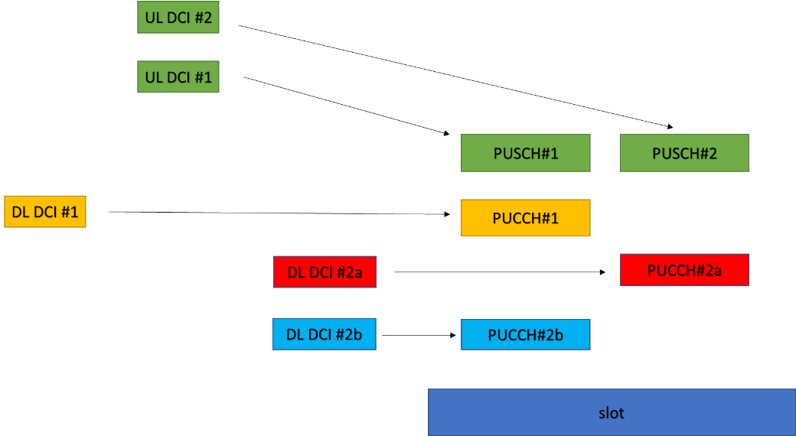
Figure 1
Q1: Do you agree that the PUCCH resource change in frequency domain does not impact the PUSCH determination for HARQ-ACK multiplexing, i.e., the UE determines the same PUSCH for HARQ-ACK multiplexing if the time domain resource of PUCCH does not change? If not, please clarify the reason.
Company | View

If a UE is capable of supporting the PUCCH resource change in the frequency but does not support PUCCH resource change in the time domain, the UE cannot report the capability of supporting PUCCH resource change based on the current agreement. In this case, gNB cannot indicate a different PUCCH resource after UL grant. This is very restrictive for the gNB scheduling. For example, if the size of HARQ-ACK codebook is no larger than 2 before the UL grant, gNB cannot schedule a DL grant resulting in the size of HARQ-ACK codebook larger than 2 because the PUCCH resource has to be changed for this case.
Q2: Do you agree that the restriction on the PUCCH resource change in the frequency domain would put unnecessary restriction on gNB if UE is capable of supporting the PUCCH resource change in the frequency domain and does not support PUCCH resource change in the time domain? If not, please clarify the reason.
Company | View

To reduce the restriction on gNB scheduling, it is proposed in [1] that the previous agreement should only limit to PUCCH resource change in time domain.
Q3: Do you agree with the following proposal? If not, please clarify the reason.
Proposal: Update the previous agreement made RAN1#113 as following,
Agreement
If UCI multiplexing of different priorities is not enabled, the restriction on scheduling PDSCH after UL grant is removed for the case of PUSCH with repetitions except the first repetition
- UE generates Type-1 HARQ-ACK codebook according to the existing specification with the modification of setting the actual ‘ACK/NACK’ value corresponding to PDSCH(s) scheduled after the UL grant.
- UE generates Type-2/3 HARQ-ACK codebook according to the existing specification.
  - For Type-2 CB, UL DAI is used for generating HARQ CB.
- This feature is subject to separate UE capabilities for type-1, type-2, and type-3 codebooks.
- RRC parameter(s) to configure the function of scheduling PDSCH after a UL DCI format and multiplexing associated HARQ on a PUSCH repetition except the first repetition are introduced in Rel-18.
- Note: the number of PUSCH repetitions can be scheduled/configured by gNB.
- Note: same principle of current specification which UL DAI in UL grant is applied to each PUSCH repetition is reused.
- The timeline specified in TS 38.213 Clause 9.2.5 are satisfied, i.e. $T_{proc,1}^{mux}$between the last PDSCH and PUCCH, $T_{proc,2}^{mux}$ between the last PDCCH among UL grant /DL grant(s) and the earliest PUCCH or PUSCH
- Additional UE capabilities are introduced to support the following functions (UE will be configured by gNB to use the following features via RRC)
  - HARQ-ACK codebook size change on a PUCCH slot
  - PUCCH time domain resource change on a PUCCH slot

Company | View

Conclusion
To be updated.

Reference
[1] R1-2309416 Remaining issue for HARQ-ACK multiplexing on PUSCH Samsung

