Maintenance of Multi-RAT Dual-Connectivity and Carrier Aggregation enhancements (LTE, NR)
R1-2105864 Moderator summary of MR DC-CA pre-meeting preparation phase Moderator (Nokia)

R1-2104324 Remaing issues for Rel-16 single uplink Tx ZTE
R1-2104475 Correction for power control of NR-DC CATT
R1-2105375 Remaining issues on Rel-16 carrier aggregation MediaTek Inc.
R1-2105524 Discussion on half duplex operation for TDD CA Huawei, HiSilicon
R1-2105789 Maintenance for Rel-16 MR-DCCA Ericsson
R1-2105863 Removal of FR2-FR2 dual connectivity from Rel-16 Nokia, Nokia Shanghai Bell
R1-2105918 Corrections on CCS with different subcarrier spacings for PDCCH and PDSCH in TS 38.214 Huawei, HiSilicon
R1-2105926 Correction on the MR-DC Uplink Power Control in 38.213 Huawei, HiSilicon

[105-e-NR-MRDC-CA-01] Email discussion/approval on the following until May-25 – Karri (Nokia)
- 1Tx: Discuss the changes proposed in R1-2104324 to LTE 36.212/213
- PC1: Discuss the proposed changes in R1-2104475 and if agreed, introduce them together with another change to 38.213, or include in the editor’s alignment CR
- UA: Discuss the proposed changes in R1-2105375 to TS38.214
- XCC: Discuss the proposed change in R1-2105918 and if agreed, could also be taken together with another change to 38.214 or include in the editor’s alignment CR

R1-2106308 [105-e-NR-MRDC-CA-01] Moderator summary Moderator (Nokia)

Agreement:
TP-1 and TP-2 in R1-2104324 for TS36.212 and TS36.213 respectively are endorsed. The changes are to be incorporated by the specification editors of the respective specifications and request the 36.212 and 36.213 spec editors to take the subframeAssignment-r15 to tdm-PatternConfig/tdm-PatternConfigNE-DC change to Rel-15.

Agreement:
Alignment of the order of SCG and MCG in the section 7.6.2 of TS38.213 as below is endorsed to be included in the 38.213 editor’s alignment CR in thread [105-e-NR-AlignmentCRs-38213]
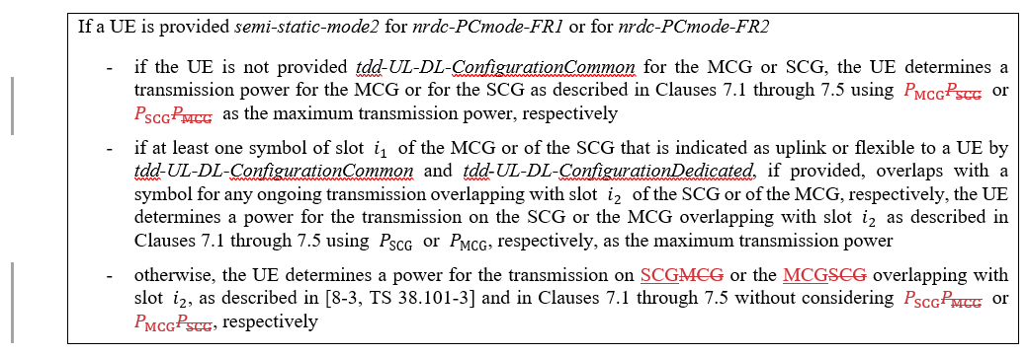

Agreement:
Adopt the following text in 38.214 5.2.1.5.1 “Aperiodic CSI Reporting/Aperiodic CSI-RS when the triggering PDCCH and the CSI-RS have the same numerology”:
The aperiodic CSI-RS is transmitted in a slot , , if UE is configured with ca-SlotOffset for at least one of the triggered and triggering cell, and in slot , otherwise, and where
- n is the slot containing the triggering DCI, X is the CSI-RS triggering offset according to the higher layer parameter aperiodicTriggeringOffset or aperiodicTriggeringOffset-r16,
- 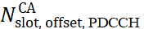and 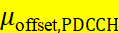 are the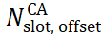 and the which are determined by higher-layer configured ca-SlotOffset for the cell receiving the PDCCH, 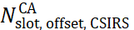and 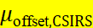 are the and the which are determined by higher-layer configured ca-SlotOffset for the cell transmitting the CSI-RS respectively, as defined in [4, TS 38.211] clause 4.5.

Agreement:
Adopt the following text in 38.214 5.2.2.5 “CSI reference resource definition”:
- In the time domain, the CSI reference resource for a CSI reporting in uplink slot n’ is defined by a single downlink slot n-n_{CSI_ref},
- where 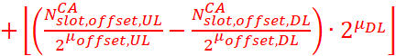 and and are the subcarrier spacing configurations for DL and UL, respectively, and the 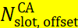 and the are determined by higher-layer configured ca-SlotOffset for the cells transmitting the uplink and downlink, as defined in clause 4.5 of [4, TS 38.211]

R1-2106343 (TS36.212, Rel-15, CR0367) Alignment of EN-DC/NE-DC parameter names Futurewei
R1-2106344 (TS36.212, Rel-16, CR0368) Alignment of EN-DC/NE-DC parameter names Futurewei

R1-2106376 (TS36.213, Rel-5, CR1398) Editorial corrections on RRC parameter names alignment for EN-DC/NE-DC Coexistence Lenovo, Motorola Mobility
R1-2106377 (TS36.213, Rel-16, CR1399) Editorial corrections on RRC parameter names alignment for EN-DC/NE-DC Coexistence (mirrored to Rel-16) Lenovo, Motorola Mobility
R1-2106378 (TS36.213, Rel-16, CR1400) Editorial Corrections on RRC parameter name alignment for single Tx switched uplink solution for EN-DC feature of Rel-16 MR DC/CA Lenovo, Motorola Mobility

R1-2106307 (TS38.214, CR0200, Rel-16, F) 38.214 CR on unaligned frame boundary CA with A-CSI-RS transmission and CSI reference resource definition Moderator (Nokia), MediaTek

Agreement:
Correction of the subscript when referencing the SCS of a PDSCH in the section 5.5 of TS38.214 as below is endorsed to be included in the 38.214 editor’s alignment CR in thread [105-e-NR-AlignmentCRs-38214].
This clause applies only if the PDCCH carrying the scheduling DCI is received on one carrier with one OFDM subcarrier spacing (µ_{PDCCH}), and the PDSCH scheduled to be received by the DCI is on another carrier with another OFDM subcarrier spacing (µ_{PDSCH}).

