3GPP TSG RAN WG1 #104b-e R1-210xxxx
e-Meeting, April 12th – April 20th, 2021

Source: Moderator (OPPO)
Title: Summary#1 of email thread [104b-e-NR-R17-IIoT_URLLC-04]
Agenda Item: 8.3.3
Document for: Discussion and Decision

Introduction
In this paper, discussions under the following email thread in RAN1#104b-e are summarized.
[104b-e-NR-R17-IIoT_URLLC-04] Email discussion on intra-UE multiplexing/prioritization– Jia (OPPO)
- 1st check point: 4/15
- 2nd check point: 4/19
- 3rd check point: 4/20

Multiplexing UCIs of different priorities in a PUCCH

Agreements in previous meetings
Agreements:
Support multiplexing for following scenarios in R17:
- Multiplexing a high-priority HARQ-ACK and a low-priority HARQ-ACK into a PUCCH in R17.
- Multiplexing a low-priority HARQ-ACK and a high-priority SR into a PUCCH for some HARQ-ACK/SR PF combinations (FFS applicable combinations).
- Multiplexing a low-priority HARQ-ACK, a high-priority HARQ-ACK and a high-priority SR into a PUCCH.
For the above multiplexing scenarios,
- FFS conditions, if needed, for the multiplexing, e.g
  - Whether to support multiplexing between different resources not confined within a sub-slot.
  - Whether to support multiplexing in case a PUCCH overlaps with more than one PUCCH.
  - Timeline requirements.
- FFS: details, if needed, of the multiplexing scheme, e.g.
  - How to minimize impact on the latency for high-priority HARQ-ACK.
  - How to determine the PUCCH resource used for multiplexing (e.g. HP or LP PUCCH resource, or a dedicated PUCCH resource for the multiplexing).
  - How to multiplex the HARQ-ACK bits (e.g. multiplexing, bundling).
  - How to encode the UCIs with different priorities (e.g. separate coding vs. joint coding)
  - How to guarantee the target code rate (e.g. payload control, multiplexing priority, LP HARQ-ACK compression/compaction).
  - Explicit indication for enabling multiplexing.
Multiplexing rule and order (e.g. HP/LP multiplexing is after resolving collision within the same priority).
Agreements:
For multiplexing UCIs of different priorities in a PUCCH in R17,
- Support of multiplexing between different resources not confined within a sub-slot if conditions are met
  - FFS: Details
- Support multiplexing in case a PUCCH overlaps with more than one PUCCH if conditions are met
  - FFS details
Agreements:
For multiplexing a high-priority (HP) HARQ-ACK and a low-priority (LP) HARQ-ACK into a PUCCH in R17, when the total number of LP and HP HARQ-ACK bits are more than 2 bits, down-select from the following options in RAN1#104-e:
- Option 1: Support joint coding.
- Option 2: Support separate coding.
- Option 3: Combination of Option1 and 2.
- FFS the details
For multiplexing a high-priority (HP) HARQ-ACK and a low-priority (LP) HARQ-ACK into a PUCCH in R17, when the total number of LP and HP HARQ-ACK bits is 2 bits, provide design details for decision for the following cases in RAN1#104-e:
- Multiplexing on a PUCCH format 0
- Multiplexing on a PUCCH format 1
Agreements:
For multiplexing a high-priority (HP) HARQ-ACK and a low-priority (LP) HARQ-ACK into a PUCCH in R17, support a mechanism for gNB to enable/disable the multiplexing.
- FFS the type of the mechanism, e.g. DCI indication and/or RRC configuration
- FFS: Interaction between the enable/disable mechanism and other multiplexing conditions
- FFS for other types of UCI.
Agreements:
For multiplexing a high-priority (HP) HARQ-ACK and a low-priority (LP) HARQ-ACK into a PUCCH in R17,
- Use a PUCCH resource in the second PUCCH-Config (the PUCCH-config containing the PUCCH resource of the HP HARQ-ACK) at least in case the total number of LP and HP HARQ-ACK bits is more than 2.
- FFS: The PUCCH resource is configured dedicated for multiplexing of HP HARQ-ACK and LP HARQ-ACK.
- FFS in case the total number of LP and HP HARQ-ACK bits is 2.
- FFS details
Working assumption:
Reuse Rel-15 intra-UE PUCCH/PUSCH multiplexing timeline requirements for Rel-17 intra-UE PUCCH/PUSCH multiplexing with different priorities
- FFS whether or not to specify a different behavior than Rel-15 when the timeline requirements are not met
Agreements:
When a PUCCH carrying HP SR with PF0 overlaps with a PUCCH carrying LP HARQ-ACK with PF0, further study the following options (proponents are encouraged to provide more details and analysis):
- Opt.1: The positive SR and HARQ-ACK are multiplexed and transmitted on the SR resource.
  - Opt.1a: The UE does not transmit negative SR.
  - Opt.1b: For negative SR, the UE transmit only HARQ-ACK on the HARQ-ACK resource.
  - Opt.1c: For negative SR, the UE transmits SR and HARQ-ACK on the SR resource
  - FFS: whether with power boost to transmit multiplexed payload or not.
- Opt.2: The SR and HARQ-ACK are multiplexed and transmitted on the HARQ-ACK resource.
  - Opt.2a: If SR is positive, an offset (e.g. 1 PRB) is added to the starting PRB of the HARQ-ACK PUCCH resource.
  - Opt.2b: Using 4 CS values as for SR+1-bit HARQ-ACK in Rel-15/16. For the case of 2-bit HARQ-ACK, the HARQ-ACK is reduced/compressed to 1-bit.
  - Opt.2c: If SR is positive, SR is multiplexed on HARQ-ACK resource in the same way as Rel-15. If SR is negative, transmit only HARQ-ACK on HARQ-ACK resource.
- Opt.3: No enhancement over Rel-16.
- Other options not excluded.
- FFS: Whether/How to differentiate HP SR and LP SR when multiplexed with LP HARQ-ACK?
Agreements:
When a PUCCH carrying HP SR with PF0 overlaps with a PUCCH carrying LP HARQ-ACK with PF1, further study the following options (proponents are encouraged to provide more details and analysis):
- Opt.1: The positive SR and HARQ-ACK are multiplexed and transmitted on the SR resource.
  - Opt.1a: The UE does not transmit negative SR.
  - Opt.1b: For negative SR, the UE transmit only HARQ-ACK on the HARQ-ACK resource.
  - Opt.1c: For negative SR, the UE transmits SR and HARQ-ACK on the SR resource
  - FFS: whether with power boost to transmit multiplexed payload or not.
- Opt.2: The SR and HARQ-ACK are multiplexed and transmitted on the HARQ-ACK resource.
  - Opt.2a: If SR is positive, an offset (e.g. 1 PRB) is added to the starting PRB of the HARQ-ACK PUCCH resource.
  - Opt.2b: Applying QPSK for SR+1-bit HARQ-ACK. For the case of 2-bit HARQ-ACK, the HARQ-ACK is reduced/compressed to 1-bit.
  - FFS on conditions of multiplexing.
- Opt.3: For positive SR, transmit HARQ-ACK on the SR resource. For negative SR, transmit HARQ-ACK on the HARQ-ACK resource.
- Opt.4: For positive SR, transmit SR on the SR resource and drop HARQ-ACK. For negative SR, transmit HARQ-ACK on the HARQ-ACK resource.
- Opt.5: No enhancement over Rel-16.
- Other options not excluded.
- FFS: Whether/How to differentiate HP SR and LP SR when multiplexed with LP HARQ-ACK?
Agreements:
When a PUCCH carrying HP SR with PF1 overlaps with a PUCCH carrying LP HARQ-ACK with PF0, further study the following options (proponents are encouraged to provide more details and analysis):
- Opt.1: The SR and HARQ-ACK are multiplexed and transmitted on the SR resource.
  - Opt.1a: For positive SR, the UE transmits the PUCCH in the resource using PUCCH format 1 for SR. The value of cyclic shift of sequence, i.e., , of this PUCCH format 1 is determined by HARQ-ACK, and the bit, i.e., b(0), of this PUCCH format 1 is determined by SR. For negative SR, the UE transmits only a PUCCH with HARQ-ACK information and drops the PUCCH with negative SR.
  - Opt.1b: SR and HARQ-ACK are multiplexed and modulated to be transmitted on the SR resource
- Opt.2: The SR and HARQ-ACK are multiplexed and transmitted on the HARQ-ACK resource.
  - Opt.2a: If SR is positive, an offset (e.g. 1 PRB) is added to the starting PRB of the HARQ-ACK PUCCH resource.
  - Opt.2b: Using 4 CS values as for SR+1-bit HARQ-ACK in Rel-15/16. For the case of 2-bit HARQ-ACK, the HARQ-ACK is reduced/compressed to 1-bit.
  - Opt.2c: If SR is positive, SR is multiplexed on HARQ-ACK resource in the same way as Rel-15. If SR is negative, transmit only HARQ-ACK on HARQ-ACK resource.
  - Opt.2d: HP SR and LP HARQ-ACK are multiplexed by the Rel-15 cyclic shift only if latency requirement for HP SR is met. Otherwise, drop the LP HARQ-ACK and only transmit the HP SR on its resource.
- Opt.3: For positive SR, transmit HARQ-ACK on the SR resource. For negative SR, transmit HARQ-ACK on the HARQ-ACK resource.
- Opt.4: No enhancement over Rel-16.
- Other options not excluded.
- FFS: Whether/How to differentiate HP SR and LP SR when multiplexed with LP HARQ-ACK?

Coding for UCIs with different priorities (e.g. separate coding vs. joint coding)

Inputs from Tdocs
When the total number of LP and HP HARQ-ACK bits is more than 2,
- Option 1: Joint coding (incl. with compression for the LP HARQ-ACK).
  - (2 simulations) OPPO, MTK, Xiaomi, Intel, QC, Leno/Moto
- Option 2: Separate coding.
  - (5 simulations) HW, Spreadtrum, ZTE, vivo, APT, E///, Nokia, CMCC, Samsung, Sony, ETRI, WILUS
- Option 3: Separate coding and joint coding are both supported under some condition.
  - (3 simulations) CATT, IDC, Quectel, Apple (reuse Rel-15/16 encoding chain), Pana, LGE, Sharp, DCM, QC
- Option 3a: HP and LP HARQ-ACKs are multiplexed as in Fig 10 of [21], and HP HARQ-ACK is embedded in the LP HARQ-ACK codeword through spreading and OCC.
  - QC
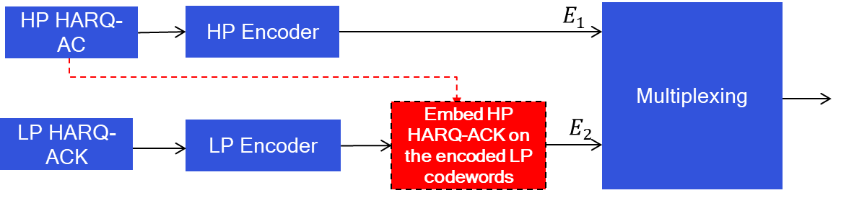
Fig 10: A framework to multiplex the HP and LP HARQ-ACK on a same PUCCH/PUSCH.

When the total number of LP and HP HARQ-ACK bits is 2,
For multiplexing on a PUCCH format 0,
- Option 1: Treat the two bits as HARQ-ACK bits with HP priority and using R15 mapping rules.
  - HW, OPPO, ZTE, Intel, Pana, Samsung, Sharp, CATT
- Option 2: Support HARQ-ACK values to CS indices mapping with unequal distance between mapped CS indices.
  - (1 simulation) APT, QC, Pana
For multiplexing on a PUCCH format 1,
- Option 1: Treat the two bits as HARQ-ACK bits with HP priority and using R15 mapping rules.
  - HW, OPPO, ZTE, Intel, Pana, Samsung, CATT
- Option 2: Support transmit the 2-bits HARQ-ACK values via two orthogonal sequences S1 and S2.
  - S1 and S2 are generated based on the same base sequence S with different CS indices CS1 and CS2.
  - 1-bit is transmitted via sequence selection between S1 and S2, while the other bit is transmitted using the selected sequence following legacy Rel-15 PF1 with 1-bit payload.
  - gNB can signal either HP 1-bit or LP 1-bit is transmitted via sequence selection.
  - (1 simulation) QC, Pana

Simulations provided by Tdocs
Huawei results:
Observation 1: For multiplexing HP HARQ-ACK and LP HARQ-ACK on PUCCH in case that the total number of bits is more than 2, separate coding can provide better reliability for HP HARQ-ACK with the SNR gain of about 2.5~6 dB.
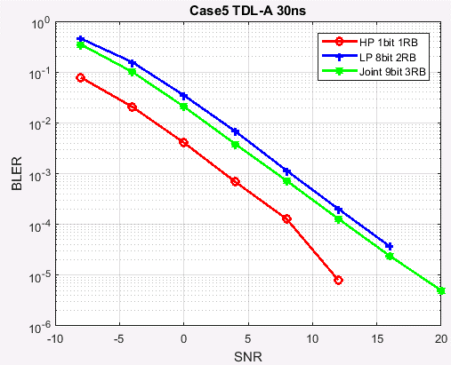
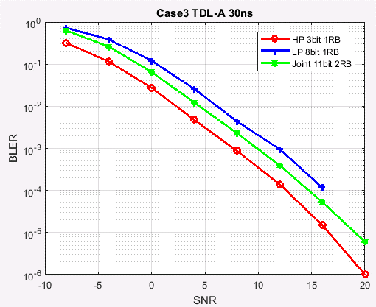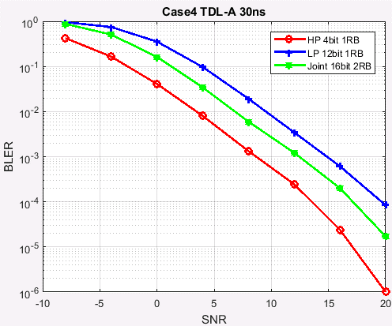
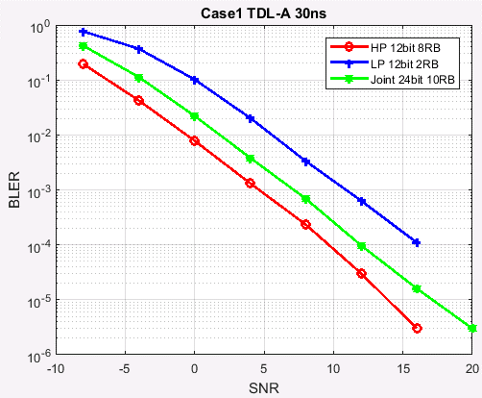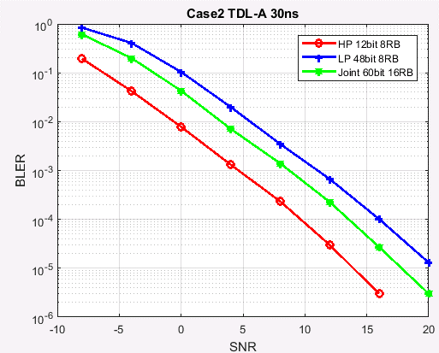

ZTE results:
For 1bit HP UCI and 8bits LP UCI, the performance of separate coding with 5RBs is better than that of joint coding with 8RBs.
- For separate coding with 5RBs: the required SNR to satisfy BER@10^-4 for HP UCI is about -5.92dB, while the required SNR to satisfy BER@10^-2 for LP UCI is about -6.2dB.
- For joint coding with 5RBs: the required SNR to satisfy BER@10^-4 for HP UCI and BER@10^-2 for LP UCI is about -5.67dB.
- For joint coding with 5RBs: the required SNR to satisfy BER@10^-4 for HP UCI and BER@10^-2 for LP UCI is about -2.96dB.
For 4bits HP UCI and 6bits LP UCI, the performance of separate coding with 6RBs is still better than that of joint coding with 8RBs.
- For separate coding with 7RBs: the required SNR to satisfy BER@10^-4 for HP UCI is about -5.9dB while the required SNR to satisfy BER@10^-2 for LP UCI is about -6.83dB.
- For joint coding with 8RBs: the required SNR to satisfy BER@10^-4 for HP UCI and BER@10^-2 for LP UCI is about -5.43dB.
- For joint coding with 7RBs: the required SNR to satisfy BER@10^-4 for HP UCI and BER@10^-2 for LP UCI is about -4.80dB.
For 4bits HP UCI and 16bits LP UCI, the performance of separate coding with 6RBs is still better than that of joint coding with 8RBs.
- For separate coding with 6RBs: the required SNR to satisfy BER@10^-4 for HP UCI is about -4.0dB while the required SNR to satisfy BER@10^-2 for LP UCI is about -4.43dB.
- For joint coding with 8RBs: the required SNR to satisfy BER@10^-4 for HP UCI and BER@10^-2 for LP UCI is about -2.76dB.
- For joint coding with 6RBs: the required SNR to satisfy BER@10^-4 for HP UCI and BER@10^-2 for LP UCI is about -1.5dB.
For 10bits HP UCI and 10bits LP UCI, the performance of separate coding with 7RBs is still better than that of joint coding with 8RBs.
- For separate coding with 7RBs: the required SNR to satisfy BER@10^-4 for HP UCI is about -3.57dB while the required SNR to satisfy BER@10^-2 for LP UCI is about -4.84dB.
- For joint coding with 8RBs: the required SNR to satisfy BER@10^-4 for HP UCI and BER@10^-2 for LP UCI is about -2.81dB.
- For joint coding with 7RBs: the required SNR to satisfy BER@10^-4 for HP UCI and BER@10^-2 for LP UCI is about -2.05dB.
For 12bits HP UCI and 12bits LP UCI, the performance of separate coding with 7RBs is still better than that of joint coding with 8RBs.
- For separate coding with 6RBs: the required SNR to satisfy BER@10^-4 for HP UCI is about -2.95dB while the required SNR to satisfy BER@10^-2 for LP UCI is about -3.69dB.
- For joint coding with 8RBs: the required SNR to satisfy BER@10^-4 for HP UCI and BER@10^-2 for LP UCI is about -2.60dB.
- For joint coding with 7RBs: the required SNR to satisfy BER@10^-4 for HP UCI and BER@10^-2 for LP UCI is about -1.64dB.
For 8bits HP UCI and 48bits LP UCI, the performance of separate coding with 6RBs is still better than that of joint coding with 8RBs.
- For separate coding with 6RBs: the required SNR to satisfy BER@10^-4 for HP UCI is about -0.89dB while the required SNR to satisfy BER@10^-2 for LP UCI is about -0.38dB.
- For joint coding with 8RBs: the required SNR to satisfy BER@10^-4 for HP UCI and BER@10^-2 for LP UCI is about 0.23dB.
- For joint coding with 6RBs: the required SNR to satisfy BER@10^-4 for HP UCI and BER@10^-2 for LP UCI is about 2dB.

vivo results:

CATT results:
We propose that separate coding is supported. Besides, joint coding can also be supported at least for the case when HP HARQ-ACK or LP HARQ-ACK includes only 1 or 2 bits.
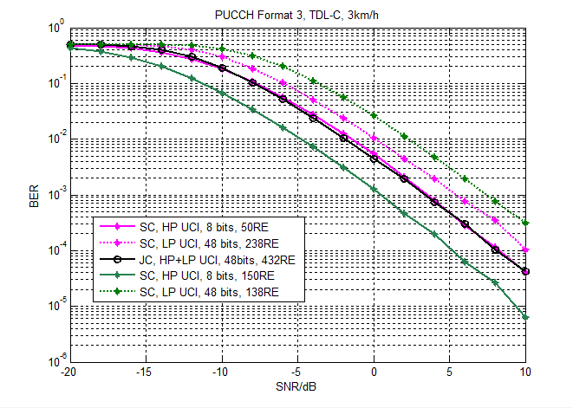
IDC results:
Table 1. Required SNR for separate vs joint coding.
4HP/16LP | % HP RE | BLER: LP 10⁻², HP 10⁻⁴ |  |  |  | BLER: LP 10⁻³, HP 10⁻⁵
4HP/16LP | % HP RE | HP | LP | Joint | Gain | HP | LP | Joint | Gain
TDL30-A3 | 90.1 | -4.8 | 2.8 | 0.9 | -1.9 | -2.6 | 6.3 | 3 | -3.3
TDL30-A3 | 70.0 | -4.1 | -1.8 | 0.9 | 2.7 | -1.8 | 1.5 | 3 | 1.5
TDL30-A3 | 50.0 | -3.3 | -3.8 | 0.9 | 4.2 | -0.6 | -0.5 | 3 | 3.5
TDL300-C3 | 90.1 | -8.8 | 0.9 | -3.9 | -4.8 | -7 | 3.5 | -2.5 | -6
TDL300-C3 | 70.0 | -8.2 | -4.2 | -3.9 | 0.3 | -6.4 | -1.9 | -2.5 | -0.6
TDL300-C3 | 50.0 | -7.2 | -6.2 | -3.9 | 2.3 | -5.7 | -3.9 | -2.5 | 1.4

10HP/10LP | % HP RE | BLER: LP 10⁻², HP 10⁻⁴ |  |  |  | BLER: LP 10⁻³, HP 10⁻⁵
10HP/10LP | % HP RE | HP | LP | Joint | Gain | HP | LP | Joint | Gain
TDL30-A3 | 90.1 | -2.3 | -0.5 | 0.9 | 1.4 | -0.2 | 3 | 3 | 0
TDL30-A3 | 70.0 | -1.7 | -5 | 0.9 | 2.6 | 0.5 | -1.7 | 3 | 2.5
TDL30-A3 | 50.0 | -0.7 | -6.9 | 0.9 | 1.6 | 1.9 | -3.6 | 3 | 1.1
TDL300-C3 | 90.1 | -6.7 | -2.6 | -3.9 | -1.3 | -5.3 | 0 | -2.5 | -2.5
TDL300-C3 | 70.0 | -5.9 | -7.3 | -3.9 | 2 | -4.6 | -4.9 | -2.5 | 2.1
TDL300-C3 | 50.0 | -4.9 | -9.2 | -3.9 | 1 | -3.5 | -6.8 | -2.5 | 1

12HP/8LP | % HP RE | BLER: LP 10⁻², HP 10⁻⁴ |  |  |  | BLER: LP 10⁻³, HP 10⁻⁵
12HP/8LP | % HP RE | HP | LP | Joint | Gain | HP | LP | Joint | Gain
TDL30-A3 | 90.1 | -0.3 | -1.5 | 0.9 | 1.2 | 2.1 | 2 | 3 | 0.9
TDL30-A3 | 70.0 | 0.4 | -5.8 | 0.9 | 0.5 | 2.3 | -2.4 | 3 | 0.7
TDL30-A3 | 50.0 | 1.5 | -7.7 | 0.9 | -0.6 | 4 | -4.3 | 3 | -1
TDL300-C3 | 90.1 | -4.7 | -3.6 | -3.9 | -0.3 | -3 | -0.9 | -2.5 | -1.6
TDL300-C3 | 70.0 | -3.9 | -8 | -3.9 | 0 | -2.6 | -5.6 | -2.5 | 0.1
TDL300-C3 | 50.0 | -2.8 | -9.9 | -3.9 | -1.1 | -1.2 | -7.5 | -2.5 | -1.3

12HP/12LP | % HP RE | BLER: LP 10⁻², HP 10⁻⁴ |  |  |  | BLER: LP 10⁻³, HP 10⁻⁵
12HP/12LP | % HP RE | HP | LP | Joint | Gain | HP | LP | Joint | Gain
TDL30-A3 | 90.1 | -0.3 | 2 | 1.1 | -0.9 | 2 | 5.4 | 3.4 | -2
TDL30-A3 | 70.0 | 0.5 | -2.7 | 1.1 | 0.6 | 3.1 | 0.6 | 3.4 | 0.3
TDL30-A3 | 50.0 | 1.7 | -4.5 | 1.1 | -0.6 | 3.8 | -1.2 | 3.4 | -0.4
TDL300-C3 | 90.1 | -4.9 | 0 | -3.5 | -3.5 | -3.3 | 2.5 | -1.7 | -4.2
TDL300-C3 | 70.0 | -4 | -5 | -3.5 | 0.5 | -2.2 | -2.8 | -1.7 | 0.5
TDL300-C3 | 50.0 | -2.8 | -6.9 | -3.5 | -0.7 | -0.9 | -4.7 | -1.7 | -0.8

8HP/48LP | % HP RE | BLER: LP 10⁻², HP 10⁻⁴ |  |  |  | BLER: LP 10⁻³, HP 10⁻⁵
8HP/48LP | % HP RE | HP | LP | Joint | Gain | HP | LP | Joint | Gain
TDL30-A3 | 90.1 | -2.6 | 8.1 | 4.3 | -3.8 | 1.2 | 11.7 | 8 | -3.7
TDL30-A3 | 70.0 | -1.8 | 2.2 | 4.3 | 2.1 | 2.2 | 5.6 | 8 | 2.4
TDL30-A3 | 50.0 | -1 | -0.1 | 4.3 | 4.4 | 2.9 | 3.2 | 8 | 4.8
TDL300-C3 | 90.1 | -7 | 6.6 | -0.8 | -7.4 | -5.5 | 9.4 | 1.1 | -8.3
TDL300-C3 | 70.0 | -6.4 | 0 | -0.8 | -0.8 | -4.7 | 2.5 | 1.1 | -1.4
TDL300-C3 | 50.0 | -5.4 | -2.5 | -0.8 | 1.7 | -3.7 | -0.2 | 1.1 | 1.3

12HP/44LP | % HP RE | BLER: LP 10⁻², HP 10⁻⁴ |  |  |  | BLER: LP 10⁻³, HP 10⁻⁵
12HP/44LP | % HP RE | HP | LP | Joint | Gain | HP | LP | Joint | Gain
TDL30-A3 | 90.1 | 0.4 | 7.6 | 4.3 | -3.3 | 3.9 | 11.2 | 8 | -3.2
TDL30-A3 | 70.0 | 1.1 | 1.9 | 4.3 | 2.4 | 5.2 | 5.2 | 8 | 2.8
TDL30-A3 | 50.0 | 2.2 | -0.4 | 4.3 | 2.1 | 5.8 | 2.9 | 8 | 2.2
TDL300-C3 | 90.1 | -4.5 | 6.1 | -0.8 | -6.9 | -2.8 | 9 | 1.1 | -7.9
TDL300-C3 | 70.0 | -3.8 | -0.4 | -0.8 | -0.4 | -1.7 | 2.1 | 1.1 | -1
TDL300-C3 | 50.0 | -2.6 | -2.9 | -0.8 | 1.8 | -1.1 | -0.5 | 1.1 | 1.6

Nokia results:
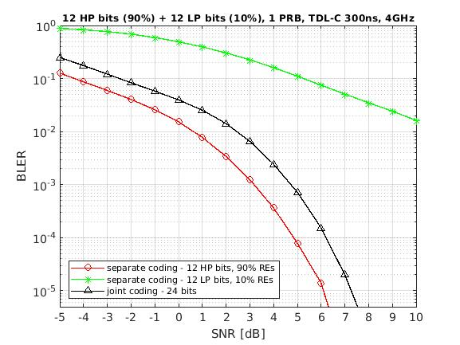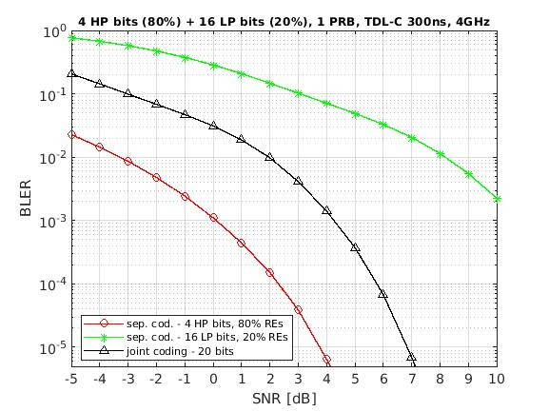
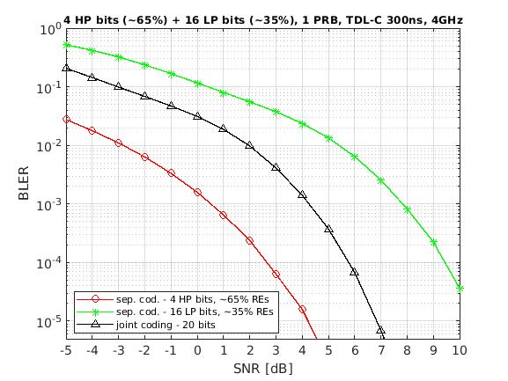
Intel results:
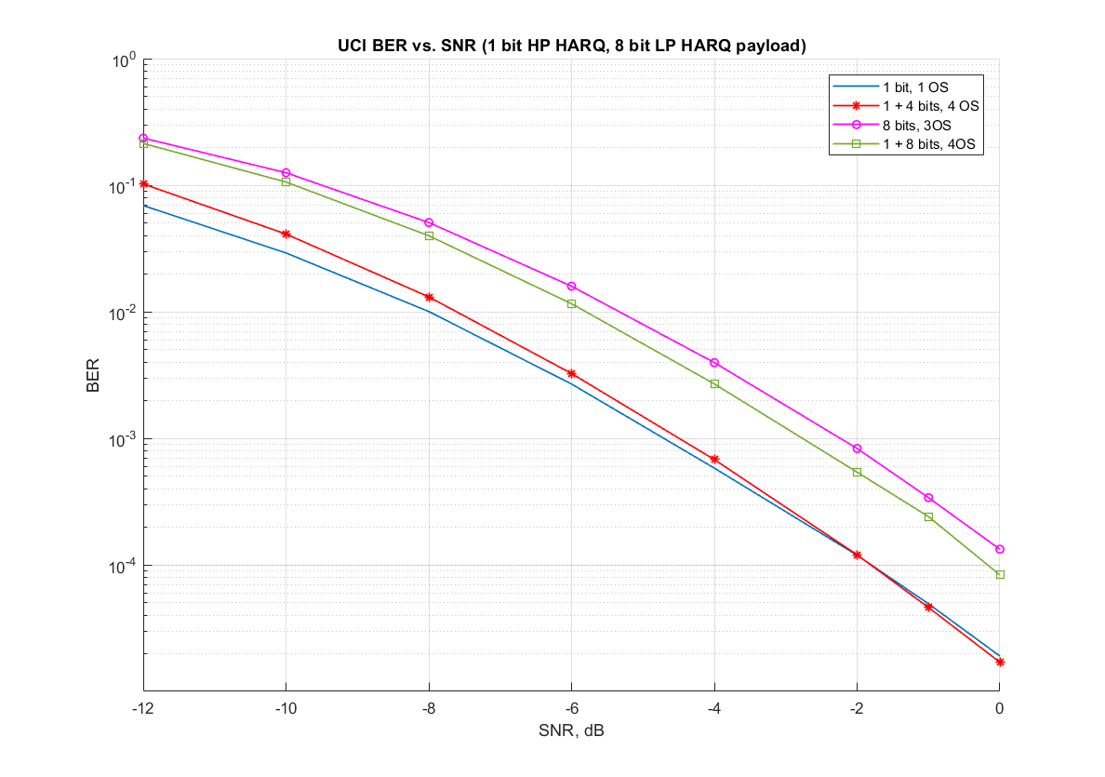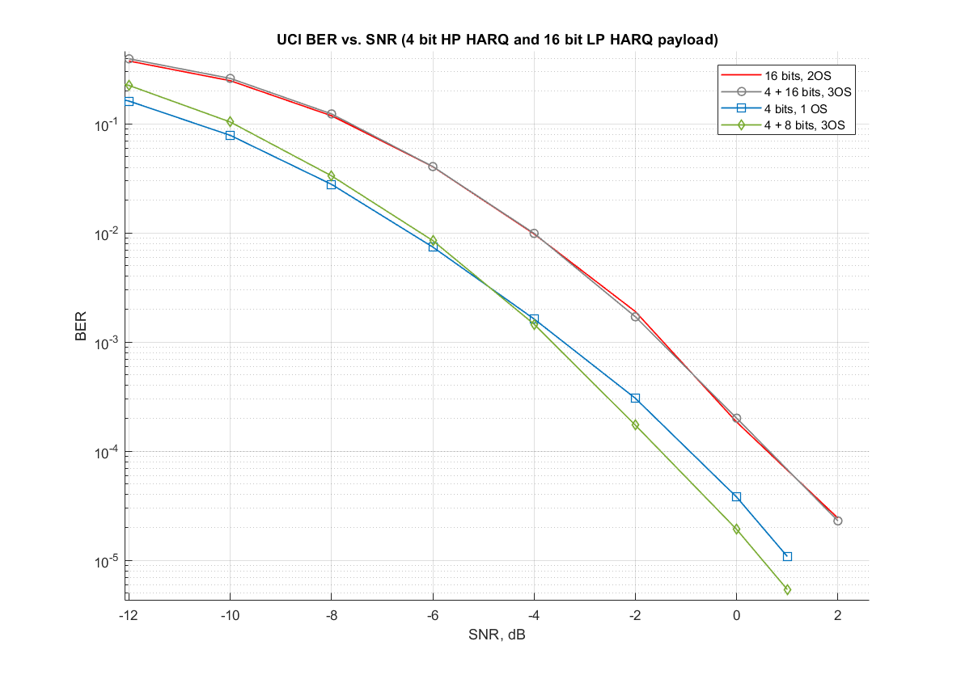
Qualcomm results:
For HP+LP HARQ-ACK bits =2:
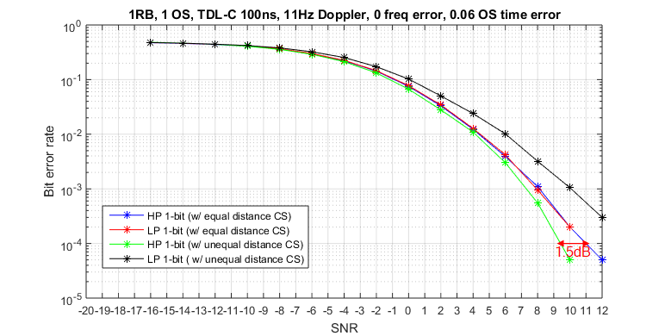
Fig 3: Performance comparison between equal and unequal CS with PF 0
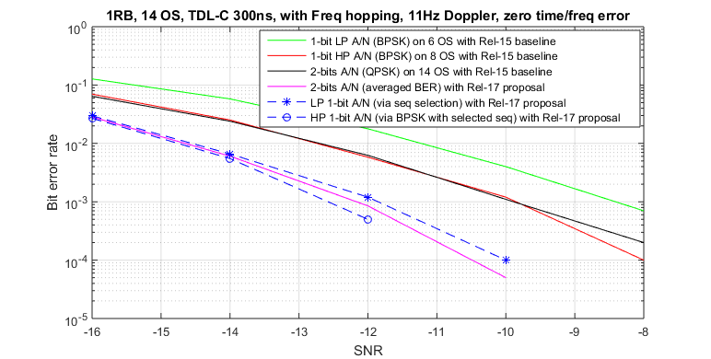
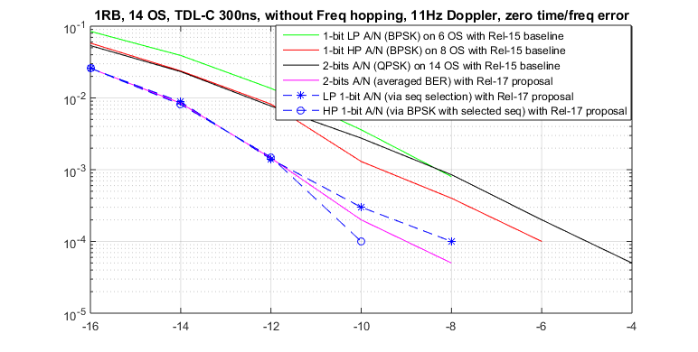
Fig 7: Performance comparison between Rel-17 proposal and Rel-15 PF1 baseline (w/ TDM or w/o TDM)
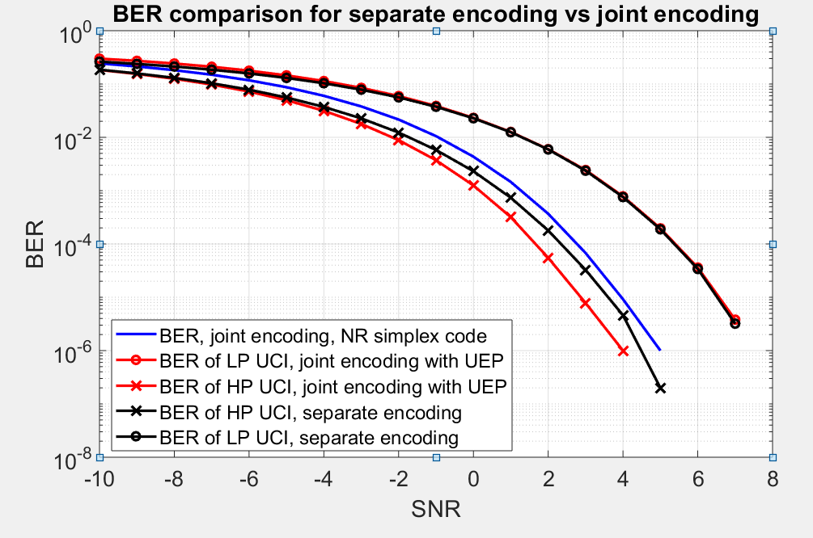
Fig 9: Performance comparison between separate encoding and joint encoding for 1 bit HP HARQ-ACK multiplexing with 1 bit LP HARQ-ACK

For HP+LP HARQ-ACK bits >2 (Separate coding vs. scheme in Figure 10 of [21]):
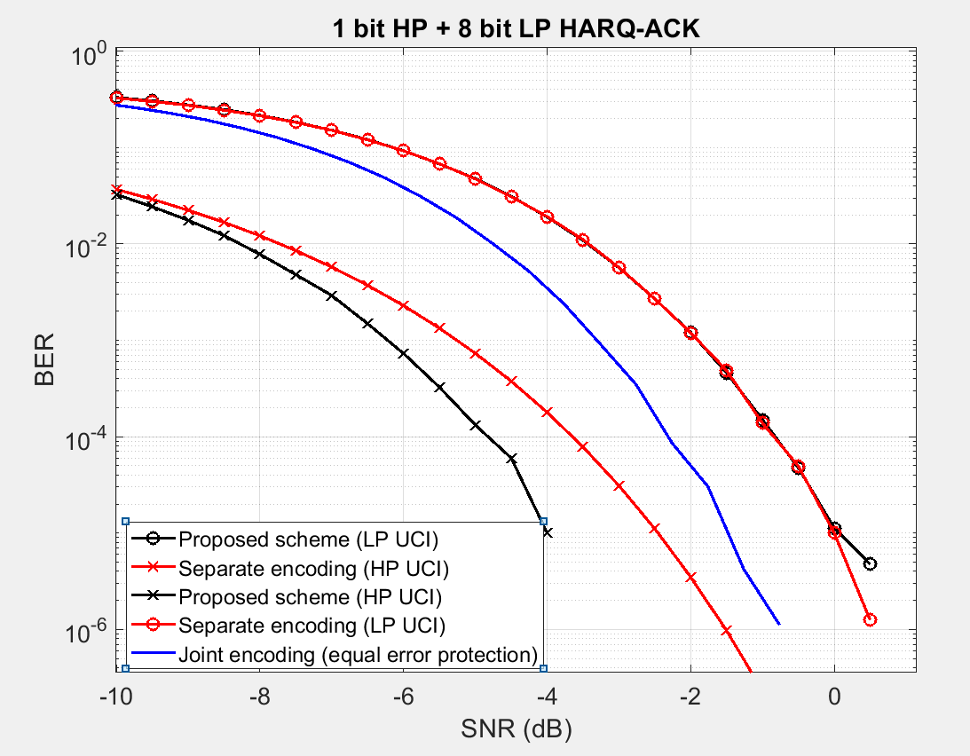
Fig 12: Performance comparison between separate encoding and proposed scheme for 1 bit HP HARQ-ACK multiplexing with 8 bits LP HARQ-ACK.
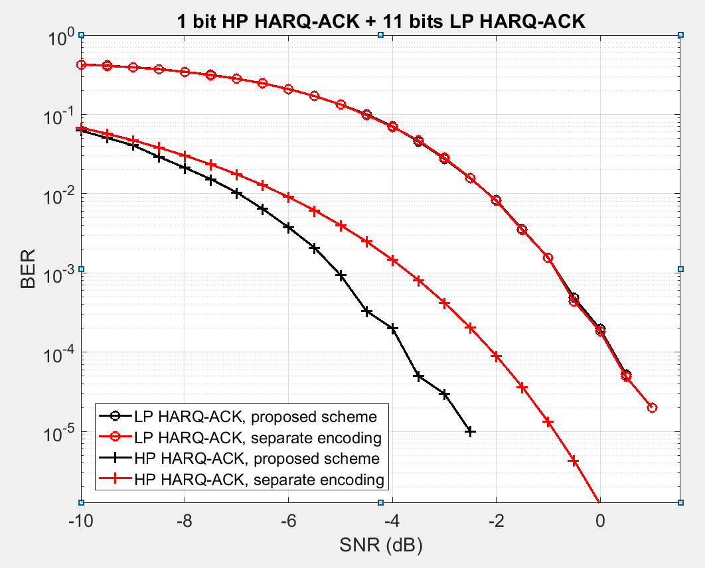
Fig 13: Performance comparison between separate encoding and proposed scheme for 1 bit HP HARQ-ACK multiplexing with 11 bits LP HARQ-ACK.

For HP+LP HARQ-ACK bits >2 (Separate coding vs. joint coding with HARQ-ACK compression):
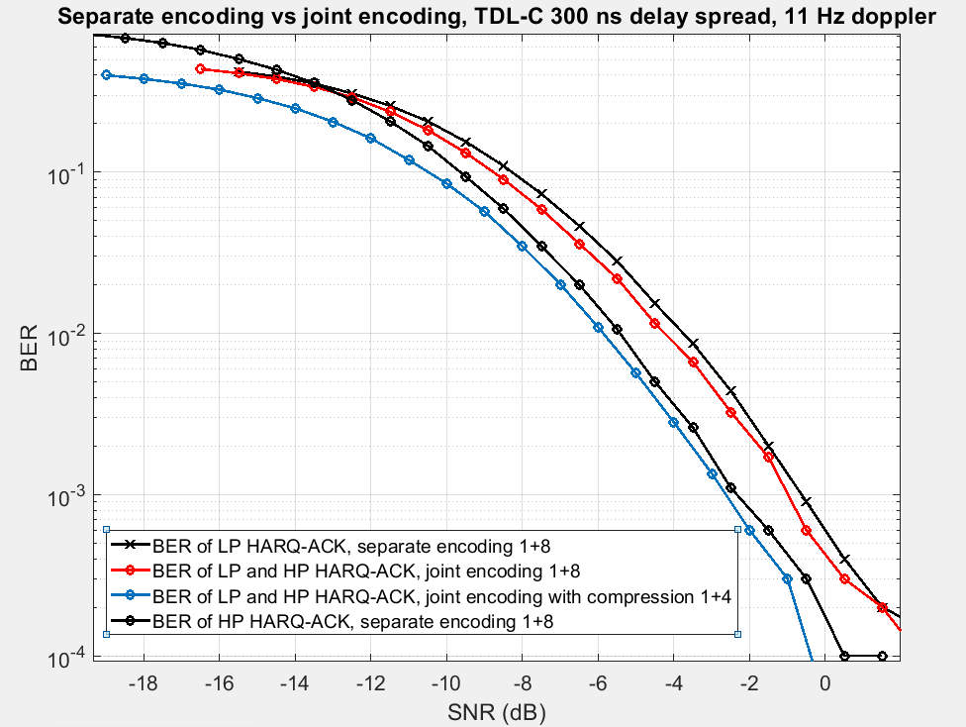
Fig 14: Performance comparison between separate encoding and joint encoding for 1 bit HP HARQ-ACK multiplexing with 8 bits LP HARQ-ACK on a PUCCH
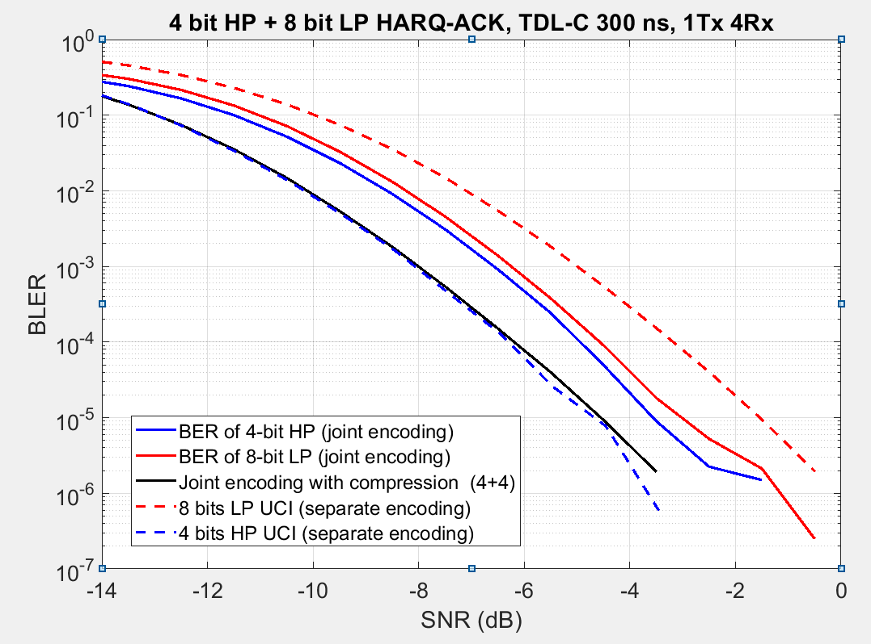
Fig 15: Performance comparison between separate encoding and joint encoding for 4 bit HP HARQ-ACK multiplexing with 8 bits LP HARQ-ACK on a PUCCH

Samsung results:

Analysis on options
Table: Analysis recorded in the meetings
Analysis on Separate coding for HP HARQ-ACK > 2bits
 |  | Arguments | Counter arguments
Advantages | Resource efficiency | Provide more optimized resource usage for HARQ-ACK. Avoid unnecessary dropping/compression of LP HARQ-ACK.  Joint coding cannot provide distinguished latency/reliability protections for UCIs of different priorities, thus use more resources to transmit LP HARQ-ACK with high reliability. Or, UE must either sacrifice the reliability of the HP HARQ-ACK if a high coding rate is selected.  In case the number of high-priority HARQ-ACK/UCI bits is low and the number of low-priority HARQ-ACK/UCI bits is high, which would typically be the case, joint coding may not be preferable from coding gain perspective as, in this case, the effective coding rate for high-priority HARQ-ACK/UCI would be higher compared to separate coding. | The gain is uncertain because it is related to the payload size and the maximum coding rate of HP and LP HARQ-ACK.  If the payload size of LP HARQ-ACK is less than HP HARQ-ACK, separate coding may not bring too much benefit since LP HARQ-ACK may not occupy too many resources.  There are much simpler ways to enhance the reliability when multiplexing, such as bundling, threshold on LP UCI payload, and payload compressing.  For a same effective coding rate, separate encoding has smaller coding gain than joint encoding
Advantages | Latency | For PUCCH format 3/4, HP HARQ-ACK can be mapped on the earlier symbols with separate coding.  For joint coding, the gNB can only start the decoding procedure after it has received all symbols of the jointly coded UCI, the processing of the HP HARQ-ACK is delayed.
Advantages | Robustness against DCI mis-detection | For Type-2 HARQ-ACK codebook, the size is determined by the DAI values and a miss detection of a ‘last’ DCI format can lead to UE and gNB have different understanding of the size of HARQ-ACK codebook (e.g. in case of single-cell operation). In such case, separate coding can also help HP UCI detection to not be affected by an incorrect assumption for the size of the LP HARQ-ACK codebook.  In theory, the mis-detection of low priority DCI would be more often than high priority DCI. | This is very limited corner case, and it doesn’t justify complicating the specifications and the UE implementation. The probability of missed the DCI is very low even for LP traffic (~1%). In addition, the chance of having a missed LP “last” DCI and the corresponding LP HARQ-ACK get multiplexed with HP UCI is even lower because it is expected that multiplexing between LP and HP UCIs doesn’t occur often. For example, if multiplexing between LP and HP UCIs has probability of 1%, the probability of missing LP “last” DCI and the corresponding LP HARQ-ACK get multiplexed with HP UCI will be 0.01%.  Having separate coding doesn’t resolve the issue of codebook-size ambiguity between the UE and the gNB. The LP and HP UCIs will be added together in a PUCCH resource, and that resource set is determined based on the total UCI size. Missing last DCI (LP or HP) can change the resource set and separate encoding doesn’t resolve the issue.
Problems | Coverage gain
Problems | Standardization efforts | - Signal multiple coding rates for HP and LP HARQ-ACK on PUCCH (also need to signal multiple code rates for HP/LP UCI with different payload size).  - New procedures need to be defined to perform separate coding and modulation  - PUCCH resource (i.e., #RBs for PUCCH format 2 and 3) determination  - RE mapping  - Power control | RM and Polar coding defined in TS 38.212 section 6.3.1 can be reused.  Already used in Rel-15 for CSI part-1 (with/without HARQ-ACK) and CSI part-2.
Problems | UE complexity | - Multiple channel encoders are required to prepare one PUCCH at the UE, which increases the implementation complexity and impacts the UE processing timeline.  - Separate CRC bits are used for LP and HP HARQ-ACK, which increases the effective coding rate for a fixed # resources (compared to joint encoding).
Analysis on Joint coding for HP HARQ-ACK > 2bits
Advantages | Less UE complexity & standardization efforts | No need for an additional polar encoder  Rel-15 rate matching equations could be essentially re-used  More resource efficient in some cases, depending on the amount of resource and the size of each of high-priority and low-priority HARQ-ACKs.  If bundling is agreed, joint coding could provide good performance at least in most of the cases when bundling is used.
Problems | Priority protection | Joint coding cannot provide distinguished latency/reliability protections for UCIs of different priorities, thus results in either low spectrum utilization or degraded performance.  Always relying on bundling so that joint coding could be used without impacting the high-priority HARQ-ACK defies the main Rel-17 intra-UE topic objective of trying to avoid losing/dropping low-priority HARQ-ACK information whenever possible
Analysis on unequal-distance CS allocation for HP HARQ-ACK > 2bits
Problems | Over-optimization | The current PUCCH format 0 can provide reliable transmission for 2-bit HP HARQ-ACK. No clear motivation to further enhance the reliability of HP HARQ-ACK through an unequal-distance CS allocation for HP HARQ-ACK bit state and LP HARQ-ACK bit state with respect to its implementation complexity.

Proposals from Tdocs
Company | Proposals/observations from Tdocs
Huawei | Observation 1: For multiplexing HP HARQ-ACK and LP HARQ-ACK on PUCCH in case that the total number of bits is more than 2, separate coding can provide better reliability for HP HARQ-ACK with the SNR gain of about 2.5~6 dB.  Proposal 1: For multiplexing HP HARQ-ACK and LP HARQ-ACK on PUCCH in case that the total number of bits is 2 bits, the 1-bit HP HARQ-ACK and the 1-bit LP HARQ-ACK are concatenated and transmitted on PUCCH format 0 or PUCCH format 1 following the existing mechanism.  Proposal 2: For multiplexing HP HARQ-ACK and LP HARQ-ACK on PUCCH in case that the total number of bits is more than 2, separate coding is adopted.
OPPO | Proposal 6: Joint coding is used to support the multiplexing of HP HARQ-ACK and LP HARQ-ACK in one PUCCH with more than 2 HARQ-ACK bits.  Proposal 7: No enhancement is supported for multiplexing of 1-bit HP HARQ-ACK and 1-bit LP HARQ-ACK on a PUCCH format 0/1.
Spreadtrum | - Support separate coding for multiplexing of HP HARQ-ACK and LP HARQ-ACK for total bit number being larger than 2.
ZTE | Observation 1: The separate coding is beneficial in terms of resource efficiency when the two UCIs with different priorities will be transmitted in a same PUCCH.  Proposal 1: Adopt separate coding for the multiplexing of high priority UCI and low priority UCI on a PUCCH format 2/3/4 when the total payload of the UCIs is more than 2 bits.  Proposal 2: When the two UCIs with different priorities will be multiplexed on a PUCCH format 2/3/4 by separate coding, for a certain priority UCI,  - If its number of bits is more than 2 bits but no more than 11 bit, RM coding is performed for this UCI.  - If its number of bits is more than 11 bits, Polar coding is performed for this UCI.  Proposal 3: More things should be further studied, for example, the RE mapping scheme of HP and LP UCI coded bit, the compression/bundling/Partial dropping for LP UCI, after the separate coding scheme is determined.
vivo | Observation 1: The BER performance of separate encoding is better than joint encoding.  Proposal 3: Separate encoding is preferred for LP UCI and HP UCI multiplexing on PUCCH.  Proposal 4: For encoding the UCIs with different priorities, it should be clarified firstly whether the number of separately encoded UCIs need be extended for both PUCCH.
CATT | Proposal 8: For multiplexing of HP HARQ-ACK and LP HARQ-ACK when total number of bits is more than 2, combination of joint coding and separate can be supported.  Proposal 9: The following two options can be considered to avoid the impact on HP HARQ-ACK(s) due to missing DCIs corresponding to LP HARQ-ACK codebook.  - Option 1: Define a reference number of bits for LP HARQ-ACK codebook  - Option 2: Indicate information for determine the number of LP HARQ-ACK bits by DCI corresponding to HP HARQ-ACK
MTK | - Joint coding is used for multiplexing a HP HARQ-ACK and a LP HARQ-ACK into a PUCCH, when the total number of LP and HP HARQ-ACK bits are more than 2 bits.
APT | Proposal 1 Separate coding of high priority UCI and low priority UCI when multiplexed in a PUCCH is supported as a baseline.  Proposal 4 For multiplexing LP HARQ-ACK and HP HARQ-ACK on a PUCCH format 0, HARQ-ACK values to CS indices mapping with unequal distance between mapped CS indices should be supported.
IDC | Observation 1: Separate coding provides significant gain over joint coding in typical scenarios when the number of LP bits is larger than the number of HP bits (e.g. 4.8 dB for 8 HP/48 LP).  Proposal 7: At least separate coding is supported when multiplexing LP and HP bits in PUCCH.  Proposal 8: Support joint encoding of HP bits with a subset of LP bits when the number of HP bits is 1 or 2. FFS additional conditions.  Proposal 9: Support joint encoding of LP bits with HP bits when the number of LP bits is 1 or 2.
E/// | Proposal 9 Support separate encoding of high and low priority HARQ feedback in a PUCCH resource.  Proposal 10 Study joint vs separate coding further for very small payloads.
Nokia | - Observation 3.2: In principle, multiplexing could be supported for all four possible combinations of high-priority HARQ-ACK overlapping with low-priority HARQ-ACK considering Type-1 and Type-2 codebooks. If there would be a need to prioritize some cases for the discussions, the cases involving same HARQ-ACK codebook type (Type-1/Type-2) could be discussed first. The case corresponding to multiplexing high-priority Type-1 HARQ-ACK and low-priority Type-2 HARQ-ACK could also be of interest.  - Proposal 3.7: For the scenario where a PUCCH carrying high-priority HARQ-ACK overlaps with another PUCCH carrying low-priority HARQ-ACK, RAN1 to adopt separate encoding for the multiplexing of high-priority HARQ-ACK and low-priority HARQ-ACK.
Quectel | Proposal 1: Both separate coding and joint coding are supported when the total number of LP and HP HARQ-ACK bits is larger than 2.
CMCC | Proposal 5: For multiplexing a high-priority (HP) HARQ-ACK and a low-priority (LP) HARQ-ACK into a PUCCH in R17, when the total number of LP and HP HARQ-ACK bits are more than 2 bits, separate coding and mapping with different coding rates is supported.  Proposal 6: For determining the code rates for HP UCI and LP UCI when multiplexing, two maxCodeRates can be configured for PUCCH resource used for multiplexing, one is used for LP UCI and the other is used for HP UCI.
Xiaomi | Proposal 4: Support joint decoding for multiplexing a high-priority (HP) HARQ-ACK and a low-priority (LP) HARQ-ACK into a PUCCH.
Intel | Observation 3:  - Separate coding requires significantly more standardization efforts compared to joint coding  - Multiple channel encodings are performed for preparing one PUCCH for separate coding, causing increased UE complexity  - The latency benefit for separate coding is questionable since receiver would have to wait until the DMRS symbols anyways before decoding  - Joint coding can be built upon the legacy UCI multiplexing approach, which requires significantly less standardization efforts, is less complex and able to provide protection for HP HARQ-ACK, e.g., by LP HARQ-ACK payload reduction when needed.  Observation 4: Joint coding with LP HARQ-ACK payload reduction can match or outperform separate coding with reasonable resource split.  Proposal 3: When combined payload is 2 bits, multiplexing LP and HP HARQ-ACK bits follow Rel-15 approach assuming both bits are HP.  Proposal 4: Support joint coding of LP and HP HARQ-ACK payload bits when combined payload is more than 2 bits.  - LP HARQ-ACK payload bits can be partially dropped if needed
Apple | Observation 5-1: both joint encoding and separate encoding of UCIs are used in Rel-15 UCI multiplexing.
Qualcomm | Proposal 2: For 1-bit high priority HARQ-ACK and 1-bit low priority HARQ-ACK transmitted in a PUCCH format 0 resource, support HARQ-ACK values to CS indices mapping with unequal distance between mapped CS indices.  - FFS: Solution for 1-bit HP HARQ-ACK and 1-bit LP HARQ-ACK multiplexing with 1-bit HP or LP SR on PUCCH format 0  Proposal 3: For 1-bit high priority HARQ-ACK and 1-bit low priority HARQ-ACK transmitted in a PUCCH format 1 resource, support transmit the 2-bits HARQ-ACK values via two orthogonal sequences S1 and S2.  - S1 and S2 are generated based on the same base sequence S with different CS indices CS1 and CS2.  - 1-bit is transmitted via sequence selection between S1 and S2, while the other bit is transmitted using the selected sequence following legacy Rel-15 PF1 with 1-bit payload.  - gNB can signal either HP 1-bit or LP 1-bit is transmitted via sequence selection.  FFS: Solution for 1-bit HP HARQ-ACK and 1-bit LP HARQ-ACK multiplexing with 1-bit HP or LP SR on PUCCH format 1  Proposal 5: In NR Rel-17, for multiplexing a high-priority (HP) HARQ-ACK and a low-priority (LP) HARQ-ACK into a PUCCH/PUSCH, when the total number of LP and HP HARQ-ACK bits are more than 2 bits, the HP and LP HARQ-ACKs are multiplexed according to the procedure in Fig 10.  - The high priority HARQ-ACK is embedded in the LP HARQ-ACK codeword through spreading and OCC.  Proposal 6: For multiplexing a high-priority (HP) HARQ-ACK and a low-priority (LP) HARQ-ACK in R17, when the total number of LP and HP HARQ-ACK bits are more than 2 bits,  - Support compressing the LP HARQ-ACK payload prior to joint encoding of the HP and LP HARQ-ACK.
Panasonic | Proposal 2: For multiplexing a HP HARQ-ACK and a LP HARQ-ACK into a PUCCH, when the total number of LP and HP HARQ-ACK bits are more than 2 bits, the combination of joint coding and separate coding is supported.  Proposal 3: For the determination of coding scheme, at least the number of HP HARQ-ACK bits and/or the number of LP HARQ-ACK bits should be considered.  Proposal 4:  - For multiplexing a HP HARQ-ACK and a LP HARQ-ACK into a PUCCH format 0, when the total number of LP and HP HARQ-ACK bits is 2 bits, either of the following options is supported.  - Option 1: Treat the two bits as HARQ-ACK bits with HP and using Rel.15 mapping rules.  - Option 2: Support HARQ-ACK values to cyclic shift indices mapping with unequal distance between mapped cyclic shift indices.  - At least following factors should be considered for the decision of multiplexing scheme.  - The link performance in multi-user scenario  - Specification impacts  Proposal 5:  - For multiplexing a HP HARQ-ACK and a LP HARQ-ACK into a PUCCH format 1, when the total number of LP and HP HARQ-ACK bits is 2 bits, either of the following options is supported.  - Option 1: Treat the two bits as HARQ-ACK bits with HP and using Rel.15 mapping rules.  - Option 2: Support transmitting the 2-bit HARQ-ACK values via two orthogonal sequences S1 and S2.  - S1 and S2 are generated based on the same base sequences S with different cyclic shift indices CS1 and CS2.  - 1-bit is transmitted via sequence selection between S1 and S2, while other bit is transmitted using the selected sequence following legacy Rel.15 PUCCH format 1 with 1-bit payload.  Proposal 8: For multiplexing a high-priority HARQ-ACK and a low-priority HARQ-ACK into a PUCCH, after resolving the overlapping for PUCCH transmissions of same priority index, UE procedure for multiplexing HARQ-ACK codebooks with different priority indexes should be performed.
Samsung | Observation 1: Separate coding shows a gain over joint coding in case of RM coding.  Proposal 3: Support separate coding for UCIs with different priorities multiplexed on a PUCCH format 2/3/4 or a PUSCH.  Proposal 4: Support multiplexing 1 bit HP HARQ-ACK and 1 bit LP HARQ-ACK into a HP PUCCH resource, HP HARQ-ACK is placed before LP HARQ-ACK.  - For both PUCCH format 0 and 1, modulation of 2 bits HARQ-ACK of a same priority can be reused.  Observation 2: Multiplexing of LP HARQ-ACK codebook and HP HARQ-ACK codebook with same and/or different HARQ-ACK codebook types can be enabled via the configuration for HP/LP multiplexing.  Proposal 5: Consider solutions to ensure the reliability of multiplexing of LP Type-2 HARQ-ACK codebook and HP HARQ-ACK codebook and/or HP data.
Sony | Proposal 1: The UCI bits of different L1 priorities are separately coded when multiplexing into a PUCCH.  Proposal 2: Allow encoded UCI bits of different L1 priorities to be mapped to different symbols in the PUCCH.
ETRI | Proposal 7: Separate coding in one PUCCH is supported.
LGE | Proposal #1: Support Option 3 (i.e., combination of joint coding and separate coding) for multiplexing of LP UCI and HP UCI on PUCCH with the total UCI payload size of more than 2 bits.  - Whether to apply joint coding or separate coding is determined according to UCI payload size of a priority or total UCI payload size of LP and HP.  Proposal #2: Decide UCI bit mapping used for cyclic shift or QPSK modulation for multiplexing of LP UCI and HP UCI on PUCCH format 0/1 with the total UCI payload size of 2 bits.  - HP UCI bit and LP UCI bit are mapped to MSB and LSB, respectively.  Proposal #9: Consider how to generate the HARQ-ACK payload per each of LP and HP for the multiplexing of LP/HP HARQ-ACK on PUCCH (or PUSCH), according to HARQ-ACK codebook type (e.g. Type-1/2/3 codebook).
Sharp | Proposal 9: For multiplexing a HP HARQ-ACK and a LP HARQ-ACK into a PUCCH,  - When the total number of LP and HP HARQ-ACK bits is 2 bits, the LP-HARQ-ACK is appended to HP HARQ-ACK, and the concatenated HARQ-ACK bits are reported on the original PUCCH resource for the HP HARQ-ACK with PF 0 or 1.  - When the total number of LP and HP HARQ-ACK bits is 2 bits, a HP HARQ-ACK PUCCH resource with PF 2/3/4  - Joint coding or separate is determined based on a payload threshold  - In case of separate coding. code rate for HARQ-ACK with different priorities are determined based on existing or additional configured maxCoderate parameters.
DCM | Proposal 1:  - Support Option 3 (i.e. combination of separate coding and joint coding) for encoding scheme for combined UCI bits in case the total number of LP and HP HARQ-ACK bits are more than 2 bits.  - The condition to determine coding scheme can be LP UCI payload size.  Proposal 2:  - For separate coding, a scaling factor can be introduced for HP and LP UCI coding rate determination.  Proposal 3:  - For separate coding, an effective UCI payload size $O_{eff_UCI}$ is introduced for PUCCH resource selection and PRB determination procedure, where $O_{eff_UCI}$ is determined by HP UCI payload size, LP UCI payload size, HP UCI coding rate for multiplexing, LP UCI coding rate for multiplexing, and also additional CRC bits introduced by separate coding.
Leno/Moto | - Proposal 3: Support joint encoding of HP UCI with LP HARQ-ACK, if multiplexed in PUCCH of PUCCH formats 2, 3, and 4.
WILUS | - Proposal 1: We prefer to support the separate encoding for multiplexing UCIs of different priorities in a PUCCH.  - Proposal 2: For multiplexing HARQ-ACK information with different priorities, TDM-ed mapping can be used to map UCIs with two priorities in a PUCCH.  - The HARQ-ACK information with higher priority is mapped to the symbols preceding symbols for the HARQ-ACK information with lower priority.  - Proposal 3: We propose to configure two maximum code rates per PUCCH format in the second PUCCH-Config, one for LP-UCI and the other for HP-UCI.  - Proposal 6:  - To multiplex with 1-bit LP-HARQ and 1-bit HP-HARQ in PF0, use the new CS mapping.  - CS=0, 3, 6, 9 for (HP-HARQ, LP-HARQ)=(NACK, NACK), (NACK, ACK), (ACK, NACK), (ACK,ACK) respectively  - To multiplex with 1-bit LP-HARQ in PF1 and 1-bit HP-HARQ in PF1, reuse Rel-15 multiplexing rules without modification.  - Proposal 7: To multiplex with HP-SR with PF0 and LP-HARQ with PF0, we propose,  - If HP-SR is negative, then transmit LP-HARQ on HARQ-ACK resource.  - In case of 1-bit LP-HARQ, use 2 CSs, i.e., {0, 6} CS index  - In case of 2-bit LP-HARQ, use 4 CSs, i.e., {0, 3, 6, 9} CS index  - If HP-SR is positive, then transmit LP-HARQ and HP-SR on HARQ-ACK resource  - In case of 1-bit LP-HARQ, use 2 CSs, i.e., {3, 9} CS index  - In case of 2-bit LP-HARQ, use 4 CSs, i.e., {1, 4, 7, 11} CS index  - To enhance HP-SR reliability, 2-bit LP-HARQ can be bundled to 1-bit and then the 1-bit bundled LP-HARQ is treated as 1-bit LP-HARQ, i.e., use 2 CSs, {3, 9} CS index .

1st round proposals and discussions

Proposal for 1st round discussion:
For multiplexing a high-priority (HP) HARQ-ACK and a low-priority (LP) HARQ-ACK into a PUCCH in R17, when the total number of LP and HP HARQ-ACK bits is more than 2, support combination of separate coding and joint coding for the two HARQ-ACKs.
  - FFS the condition for applying separate coding and joint coding.
  - FFS how to multiplex the LP and HP HARQ-ACK after separate coding.
  - FFS HARQ-ACK compression/bundling for joint coding.
Proposal for 1st round discussion:
For multiplexing a high-priority (HP) HARQ-ACK and a low-priority (LP) HARQ-ACK into a PUCCH in R17, when the total number of LP and HP HARQ-ACK bits is 2, treat the two bits as HARQ-ACK bits with HP priority and using R15 mapping rules.

Company | Comments
Sony | We agree with the proposal for UCI = 2 bits, i.e. treat the 2 bits as HP UCI and reuse Rel-15 mapping rules.  We cannot agree with the proposal for UCI > 2 bits as it isn’t clear how this combining of joint & separate coding is done.
QC | For the first proposal, although our preference is supporting joint encoding only, because of its simplicity and acceptable performance. But in principle, we are fine with this compromised proposal, because of its best performance among all the three options (See section 3.2.1 in R1-2103166). We suggest to add one more FFS on UE capability and RRC signaling in the proposal.  Proposal 1: For multiplexing a high-priority (HP) HARQ-ACK and a low-priority (LP) HARQ-ACK into a PUCCH in R17, when the total number of LP and HP HARQ-ACK bits is more than 2, support combination of separate coding and joint coding for the two HARQ-ACKs.  - FFS the condition for applying separate coding and joint coding.  - FFS how to multiplex the LP and HP HARQ-ACK after separate coding.  - FFS HARQ-ACK compression/bundling for joint coding.  - FFS signaling mechanism to enable UE to perform separate coding only, joint coding only, or both for LP and HP HARQ-ACK multiplexing.  The 2nd proposal, unfortunately, is not acceptable to us, due to the following concerns.  Firstly, we think 1+1 bits UCIs with different priorities are the baseline for Rel-17 UCI mux. We don’t see the point to not enhance the baseline scenario but enhance the 1+X bits scenario. Also, according to Rel-17 URLLC WID “Specify multiplexing behavior among HARQ-ACK/SR/CSI and PUSCH for traffic with different priorities, including the cases with UCI on PUCCH and UCI on PUSCH”, both scenarios “1+1 bits” and “1 + >1” bits should be supported and specified, because the WID does not say only specify multiplexing behavior … for 1+ >1 UCIs with different priorities. The 2nd proposal contradicts with Rel-17 URLLC WID.  Secondly, we think a common design principle should be applied to multiplexing 1-bit HP A/N + 1-bit LP A/N, and multiplexing 1 bit SR + 1 or 2 bit A/N with different priorities, i.e., proposals in section 2.6. What is the different between 1-bit HP A/N + 1 bit LP A/N and 1-bit HP SR + 1 bit LP A/N? Again, based on the WID, we support enhancement both cases and we propose RAN1 should strive for a common design between these two cases.  Proposal 2: strive for a common design between multiplexing 1-bit HP A/N with 1-bit LP A/N and multiplexing 1-bit SR with 1 (or 2) bit(s) A/N with different priorities.
CATT | We agree with both of the proposals.
Quectel | For Proposal 1:  We are in principle fine with the proposal. However, we think it is ambiguous for “combination of separate coding and joint coding ”. It seems to us that separate coding and joint coding are always combined used. We could simply say “both separate coding and joint coding are supported”. Furthermore, we share similar view as QC that the selection of coding scheme could be configured by gNB (UE capability could be also used if deemed necessary) . The configuration signaling could be explicit or implicit (e.g., by configuring a parameter for the selection condition). The exact signaling design could be left open at this meeting. We prefer to use a more generic description for the signaling design. For joint coding, partial dropping (or shortening) could be another alternative to limit the number of LP HARQ-ACK bits. We suggest the following modifications.  Proposal 1: For multiplexing a high-priority (HP) HARQ-ACK and a low-priority (LP) HARQ-ACK into a PUCCH in R17, when the total number of LP and HP HARQ-ACK bits is more than 2, both separate coding and joint coding are supported for the two HARQ-ACKs.  - FFS whether and/or how a condition for applying separate coding and joint coding is defined.  - FFS how to multiplex the LP and HP HARQ-ACK after separate coding.  - FFS HARQ-ACK compression/bundling/partial dropping for joint coding.  - FFS signaling mechanism for configuration of separate coding and/or joint coding.  For Proposal 2:  We agree this proposal. In our view, gNB can simply disable the multiplexing if the performance of HP HARQ-ACK would be degraded to an unacceptable level due to multiplexing.
DOCOMO | We agree with the both proposals for total UCI =2 bits and more than 2 bits.
NEC | We are fine with proposal 1 in principle. However, we agree with Quectel that it seems separate and joint coding are always combined. Therefore, it needs to be clarified in the revised proposal. We agree with QC that gNB can configure the coding scheme and the signaling design for this can be FFS.  We are fine with proposal 2.

Multiplexing enable/disable mechanism

Inputs from Tdocs
- Option 1: DCI indication
  - ZTE (in HP DCI or RRC), vivo, APT, IDC, NEC, Nokia, E///, Quectel, Intel, Pana, Samsung, Sony, ETRI
  - Not support: MTK
- Option 2: RRC configuration
  - HW, Spreadtrum, ZTE (in HP DCI or RRC), vivo, CATT, MTK, IDC (for SPS), China Telecom, CMCC, TCL, Xiaomi, QC, Pana, Samsung, ETRI (if no indication in DCI), LGE, Sharp, DCM

 |  | Arguments | Counter arguments
Advantages | Flexibility | Even if the multiplexing timelines are met, the latency and reliability of high priority transmission should not be affected.  Straightforward method to select from Rel-16 and Rel-17 behaviors  URLLC traffic usually has a sporadic or periodic pattern, overlapping cases occur either occasionally or predictably.  Semi-static indication for periodic or predictable URLLC transmissions. Dynamic indication based on multiplexing conditions, e.g. latency requirement, channel condition, number of UCI bits.
Problems of DCI-based indication | Not a unified solution | Not applicable in some cases, e.g. the case of HARQ-ACK for PDSCH(s) scheduling by fallback DCI or SPS HARQ-ACKs.  HW[4]: Not applicable for the case of multiplexing LP HARQ-ACK and HP SR also, since it is impossible for gNB to predict the state of SR.
Problems of DCI-based indication | extra DCI overhead
Problems of DCI-based indication | UE complexity | [MTK] Very complex to handle at the UE side and requires a lot of implementation effort as the UE needs to accommodate two scenarios for each case which will complicate the implementation.

Company | Proposals/observations from Tdocs
Huawei | Proposal 3: Adopt RRC configuration to enable/disable the multiplexing of HP HARQ-ACK and a LP HARQ-ACK on PUCCH, and the multiplexing of HARQ-ACK on PUSCH with different priorities.  - If the RRC parameter indicates ‘Enable’, extra conditions should be specified to check whether the latency/reliability of HP HARQ-ACK can be guaranteed for a certain overlapping case.
Spreadtrum | - For multiplexing a high-priority (HP) HARQ-ACK and a low-priority (LP) HARQ-ACK into a PUCCH, support RRC configuration to enable/disable the multiplexing as a baseline.
ZTE | Proposal 4: The indicator of intra-UE multiplexing UCI with different priorities should be in the scheduling DCI or RRC parameter for the high priority transmission.
vivo | Proposal 13: Semi-static indication and dynamic indication of intra-UE multiplexing and prioritization manner can be supported in Rel-17.  Proposal 14: For dynamic indication, multiplexing or prioritization indicator field can be included in DCI with HP or LP or both HP and LP.
CATT | Proposal 10: Semi-static RRC configuration to enable/disable the multiplexing between channels with different priorities is supported.
MTK | Dynamic indication of the multiplexing activation/de-activation is not supported.
APT | Proposal 3 Dynamic indication is supported for indicating whether to multiplex overlapping high priority PUCCH and low priority PUCCH.
IDC | Proposal 2: DCI indicating HP HARQ-ACK also indicates if UE multiplexes HP HARQ-ACK with LP HARQ-ACK.  Proposal 3: RRC configuration of SPS with HP HARQ-ACK includes an indication of whether the UE can multiplex HP HARQ-ACK with LP HARQ-ACK.  Proposal 4: RRC configuration of a HP SR resource includes an indication of whether the UE can multiplex HP SR with LP HARQ-ACK.
NEC | Proposal 4: Support dynamic enabling/disabling of intra-UE HARQ-ACK multiplexing to ensure URLCC performance requirements.
Nokia | - Proposal 3.1: The gNB dynamically indicates, via an explicit field in the DCI scheduling high-priority HARQ-ACK, whether multiplexing of high-priority HARQ-ACK and low-priority HARQ-ACK (or more generally low-priority multiplexed UCIs) is enabled or disabled.  - Proposal 3.4: For the scenario where a PUCCH carrying high-priority HARQ-ACK overlaps with another PUCCH carrying low-priority HARQ-ACK: If the high-priority HARQ-ACK does not have a corresponding PDCCH, the multiplexing is not supported.
E/// | Proposal 6 In case of overlapping between PUCCH and/or PUSCH resources in a slot with different priorities, dynamically enabling or disabling UCI multiplexing on PUCCH or PUSCH is supported.
China Telecom | Proposal 1: For multiplexing UCI/PUSCH with different priorities on PUCCH or PUSCH in R17, support RRC configuration to enable/disable the multiplexing as a base line.
Quectel | Proposal 7: Dynamic enabling/disabling by DCI for UCI-UCI multiplexing and UCI-PUSCH multiplexing with different priorities is supported on top of RRC configuration.
CMCC | Proposal 7: For multiplexing HP HARQ-ACK and LP HARQ-ACK into one PUCCH in R17, RRC signaling is used for gNB to enable/disable the multiplexing.
TCL | Proposal 2: Support explicit indication to enable multiplexing procedure between HP UCI and LP UCI via RRC configuration.
Xiaomi | Proposal 10: For enabling/disabling multiplexing of channels of different priorities, semi-static configuration is preferred.
Intel | Proposal 5: DCI triggering HARQ-ACK may include an indication for enabling or disabling multiplexing.  - The indication may be applicable to both HARQ-ACK/HARQ-ACK and HARQ-ACK/SR multiplexing.
Qualcomm | Proposal 17: The Rel-17 intra-UE multiplexing feature is enabled/disabled via RRC configuration on per UE basis.  Proposal 18: If the Rel-17 intra-UE multiplexing feature is enabled via RRC configuration, UCI multiplexing is performed conditioning on the delay of starting time and/or ending time of high priority UL transmissions due to multiplexing is less than a preconfigured delay threshold.
Panasonic | Proposal 6:  - For multiplexing a HP HARQ-ACK and a LP HARQ-ACK into a PUCCH in Rel.17, the multiplexing is RRC configured.  - Dynamic indication for enabling should also be supported.
Samsung | Proposal 1: Support multiplexing UCI of different priorities subject to timeline conditions and RRC configuration and/or dynamic indication from gNB.  Proposal 2: The UCI types with first priority that can be multiplexed on a PUCCH/PUSCH of a second priority are configurable by the network.
Sony | Proposal 3: The gNB dynamically enables/disable multiplexing in a HP PUCCH by an indication in the DL Grant scheduling the HP PUCCH.
ETRI | Proposal 1: The scheduling DL-DCI has an additional field whether or not to allow multiplex HP UCI and LP UCI, or otherwise by the RRC signalling.
LGE | Proposal #5: Prefer RRC configuration for the mechanism to enable/disable the multiplexing of HP HARQ-ACK and LP HARQ-ACK on PUCCH or the multiplexing of HARQ-ACK on PUSCH with different priority, with consideration of potential UE complexity and UCI/PUSCH reliability.
Sharp | Proposal 2: RRC configuration is used as the mechanism to enable/disable the multiplexing of HP HARQ-ACK and a LP HARQ-ACK on PUCCH.
DOCOMO | Proposal 5:  - RRC configuration should be baseline for enabling/disabling multiplexing of LP and HP PUCCH

1st round proposals and discussions
Proposal for 1st round discussion:
For multiplexing a high-priority (HP) HARQ-ACK and a low-priority (LP) HARQ-ACK into a PUCCH in R17, support RRC configuration as a baseline for gNB to enable/disable the multiplexing.
- FFS DCI indication
- FFS: Interaction between the enable/disable mechanism and other multiplexing conditions
- FFS for other types of UCI.
Company | Comments
Sony | We still support using DCI indication to enable/disable multiplexing as it offers the most flexibility.  It would be good to clarify what it means by “baseline” here under the context of RRC configuration. RRC configuration would anyhow be required even for DCI indication since the gNB would need to configure the UE with the new DCI indicator.
QC | Support FL proposal.  RRC based signaling has to be the baseline because this Rel-17 enhancement has to work for UCI and PUSCH without dynamic DCI, such as A/N for SPS, CG-PUSCH, etc.  Whether DCI based indication is needed can be FFS. Besides the UE complexity and DCI overhead issues, another issue with DCI based indication is how to solve the missing DCI issue? If gNB issue two DCIs, first one indicates multiplexing, second one indicates not multiplexing, if UE missed the second one, mis-alignment is caused between UE and gNB.
CATT | We are fine with proposal in general and maybe “as a baseline” can be removed.
Quectel | We still prefer to agree DCI indication together with RRC signaling. RRC signaling would be always required. DCI can be used on top of RRC signaling. For no DCI cases (e.g., SPS PDSCH), only RRC signaling is used. By the support of DCI indication, gNB can enable/disable the multiplexing considering different situations with different latency and/or reliability. Otherwise, we may have to specify different conditions (criterion) for multiplexing enabling/disabling considering different situations, which would require huge standardization efforts.
DOCOMO | We support the FL proposal in general. In response to Sony’s comment, our understanding on “baseline” is that at least the RRC configuration based semi-statically enabling/disabling will be supported. On top of RRC configuration, we can further discuss whether or not to introduce dynamic enabling/disabling mechanism by DCI. In order to avoid any misunderstanding, we propose the following changes:  Proposal for 1st round discussion:  For multiplexing a high-priority (HP) HARQ-ACK and a low-priority (LP) HARQ-ACK into a PUCCH in R17, support RRC configuration as a baseline for gNB to enable/disable the multiplexing.  - FFS whether or not to additionally introduce DCI indication to enable/disable the multiplexing  - FFS: Interaction between the enable/disable mechanism and other multiplexing conditions  - FFS for other types of UCI.
NEC | Support the FL proposal in general. We also think that the relation between RRC configuration and DCI indication to enable/disable the multiplexing should be clarified, i.e., RRC+DCI, RRC or DCI, DCI indication can override the RRC configuration.

PUCCH resource determination and mapping for multiplexing between HARQ-ACKs with different priorities

Inputs from Tdocs
In case the total number of LP and HP HARQ-ACK bits is 2:
- Option 1: Select the PUCCH resource from the second PUCCH-Config.
  - HW, Spreadtrum, ZTE, CATT, Nokia, China Telecom, Xiaomi, Sharp, DCM

 |  | Arguments | Counter arguments
Option 1 | Advantages | It can be guaranteed that the selected PUCCH resource uses the same power control as well as spatial processing as the PUCCH resource carrying the HP HARQ-ACK, and hence ensures the reliability of the HP transmission.  Unified solution with HARQ-ACK bits >2.

Reuse PUCCH resource in the second PUCCH-Config configured for HP HARQ-ACK vs. Configure a dedicated PUCCH resource for HP+LP

- Option 1: Reuse PUCCH resource in the second PUCCH-Config configured for HP HARQ-ACK
  - Spreadtrum, ZTE, IDC, Xiaomi, Sharp, DCM
- Option 2: Configure a dedicated PUCCH resource for HP+LP
  - HW, Quectel, Pana, ETRI

Resource determination for multiplexing between HARQ-ACKs with different priorities
 |  | Arguments | Counter arguments
Option 1a | Advantages
Option 2 | Advantages | Avoid the decoding error of HP HARQ-ACK due to the ambiguity of the LP HARQ-ACK number. The gNB can configure different PUCCH resources (RB/CS/OCC) for HP only and hybrid HP+LP, respectively, and simply perform the blind detection of PUCCH DMRS on the two hypotheses for easy verification of the LP DCI missing. | The ambiguity due to the uncertainty of LP HARQ-ACK multiplexing with HP HARQ-ACK can be solved by gNB implementation, i.e. blind decoding the PUCCH based on the hypothesis of different payload size under the condition that whether the LP HARQ-ACK is multiplexed with HP HARQ-ACK or not.
Option 2 | Problems | Considering that maximum 16 resources can be configured in each PUCCH-resource-set, and the reliability of scheduling DCI for HP HARQ-ACK is generally high enough to avoid miss detection, we do not see much necessity to configure dedicated PUCCH resources for multiplexing.

Resource mapping rules:
  - If no enough resource for both HP and LP HARQ-ACK.
    - Option 1: LP HARQ-ACK is compressed/bundled/Compaction.
      - OPPO, ZTE, MTK, TCL, LGE (bundling for LP HARQ-ACK in spatial domain and/or CBG domain), WILUS
    - Option 2: LP HARQ-ACK is dropped.
      - LGE,
    - Option 3: LP HARQ-ACK is partially dropped.
      - TCL, Intel

Company | Proposals/observations from Tdocs
Huawei | Proposal 4: Support a group of dedicated PUCCH sets in the second PUCCH-Configuration to carry the multiplexed HP HARQ-ACK and LP HARQ-ACK.
OPPO | Proposal 3: A PUCCH resource in the PUCCH resource set configured for HP HARQ-ACK is used to transmit HP HARQ-ACK and LP HARQ-ACK.  Proposal 4: The PUCCH resource for multiplexing HP HARQ-ACK and LP HARQ-ACK is determined based on the PRI indicated in the last HP DCI and an offset.  - If the value of C-DAI in the last LP DCI is even or no LP DCI is received, $∆_{offset}=0$;  - Otherwise, $∆_{offset}=1$.
Spreadtrum | - Not support to configure dedicate PUCCH resources for multiplexing of HP HARQ-ACK and LP HARQ-ACK.  - Support to multiplex on the HP PUCCH resources if a 1 bit LP HARQ-ACK overlaps with a 1 bit HP HARQ-ACK
ZTE | Proposal 5: For the case that the total number of bits is no more than 2 bits, the PRI+x in the HP DCI is used to implicitly determine an extended PUCCH resource from the PUCCH set in the PUCCH-config with high priority for the multiplexed UCI,, x is predefined, e.g., x=1.  Proposal 11: LP UCI compression is slightly preferred in case there is no enough resource left for LP UCI.
CATT | Proposal 4: For multiplexing of HP HARQ-ACK and LP HARQ-ACK when total number of bits is 2, 1 bit HP HARQ-ACK and 1 bit LP HARQ-ACK are treated as two HP HARQ-ACK bits and transmitted on the time-frequency resource for the HP HARQ-ACK transmission.
MTK | Group-bundling is supported when multiplexing and when the resulted UCI payload is large.
APT | Proposal 2 Consider the following alternatives for PUCCH resource set determination when multiplexing high priority PUCCH and low priority PUCCH.  - Alt. 1: Use payload size of high priority UCI to determine PUCCH resource set.  - Alt. 2: An indication of which PUCCH resource set is selected is included in scheduling DCI.  - Alt. 3: Use payload size of high priority UCI and a configured payload size to determine PUCCH resource set.
IDC | Proposal 5: DCI indicating HP HARQ-ACK also indicates the PUCCH resource for multiplexing HP HARQ-ACK and LP HARQ-ACK.  Proposal 6: The PUCCH resource for multiplexing HP HARQ-ACK and LP HARQ-ACK is from the PUCCH configuration for HP HARQ-ACK (for any total number of LP and HP bits).  Proposal 10: DCI indicating HP HARQ-ACK includes an indication of the DAI of LP HARQ-ACK.
Nokia | - Proposal 3.3: For the scenario where a PUCCH carrying 1-bit high-priority HARQ-ACK overlaps with another PUCCH carrying 1-bit low-priority HARQ-ACK, the multiplexing of high-priority HARQ-ACK and low-priority HARQ-ACK is done on the high-priority PUCCH resource.  - Observation 3.1: Errors in low-priority HARQ-ACK codebook size determination may cause selection of different PUCCH resource set or use of smaller number of RBs for the multiplexed high-priority and low-priority HARQ-ACKs feedback than what gNB would expect. This problem of discrepancy on the determination of PUCCH resource and number of RBs is present regardless of whether joint or separate coding is used for the multiplexing of high-priority and low-priority HARQ-ACKs.  - Proposal 3.5: RAN1 to define how to avoid discrepancy between the UE and the gNB on the determination of PUCCH resource set and number of RBs for UCI containing multiplexed high-priority and low-priority HARQ-ACKs.  - Proposal 3.6: For the scenario where a PUCCH carrying high-priority HARQ-ACK overlaps with another PUCCH carrying low-priority HARQ-ACK and the total payload size is two bits, multiplexing can be done on the high-priority PUCCH resource by treating the two bits as high-priority HARQ-ACK bits and using existing rules of mapping two HARQ-ACK bits of the same priority. The order of the two bits could be [high-priority HARQ-ACK bit, low-priority HARQ-ACK bit].
China Telecom | Proposal 3: For multiplexing a high-priority (HP) HARQ-ACK and a low-priority (LP) HARQ-ACK into a PUCCH when the total number of bits is 2,  - Treat the two bits as HARQ-ACK bits with HP and using R15 mapping rules.  - Use a PUCCH resource in the second PUCCH-Config (the PUCCH-config containing the PUCCH resource of the HP HARQ-ACK).
Quectel | Proposal 2: Optional configuration of a set or subset of PUCCH resources dedicated for multiplexing of UCIs with different priorities is supported.  Proposal 3: For separate coding, the sum number of HP HARQ-ACK bits and LP HARQ-ACK bits is used to determine the HP PUCCH resource set for HP HARQ-ACK and LP HARQ-ACK multiplexing; for joint coding, the sum number of HP HARQ-ACK bits and LP information bits derived by bundling or compressing (if adopted) is used to determine the HP PUCCH resource set for HP HARQ-ACK and LP HARQ-ACK multiplexing .  Proposal 4: When HP DCI corresponding to the HP HARQ-ACK is available, the PRI contained in HP DCI is used to determine the target HP PUCCH resource from the HP PUCCH resource set; when HP DCI corresponding to the HP HARQ-ACK is unavailable (i.e., SPS PDSCH), the number of information bits is used to determine the HP PUCCH resource based on existing rules for SPS PDSCH.
TCL | Proposal 1: If the total UCI bits exceed the payload of the multiplexed PUCCH resource, partially dropped low priority UCI and/or compressed/bundled low-priority HARQ-ACK should be supported.
Xiaomi | Proposal 5: Configuring dedicated resources for multiplexing of HP HARQ-ACK and LP HARQ-ACK is not necessary.  Proposal 6: When the total number of LP and HP HARQ-ACK bits is 2, PUCCH resource of the HP HARQ-ACK should be adopted as the resource for multiplexing.
Apple | Proposal 3-1: For {HP HARQ-ACK at PUCCH Format 0, LP HARQ at PUCCH Format 0}, or {HP HARQ-ACK at PUCCH Format 1, LP HARQ at PUCCH Format 1}, or {HP HARQ at PUCCH Format 1, LP HARQ at PUCCH Format 0},  - If there are $O_{1}$ HP HARQ-ACK bit(s), $O_{2}$LP HARQ-ACK bit(s), $O_{UCI}=O_{1}+O_{2}≥ 3,$ then $O_{UCI}$ is used to look up a HP PUCCH resource set/HP PUCCH resource.  - If such a HP PUCCH resource is not available, then the LP UCI is discarded; and the HP UCI is carried over its configured PUCCH resource.  - If such a HP PUCCH resource is available, 3 bits are counted in the payload.  - If there are 1 HP HARQ-ACK bit, 1 LP HARQ bit (i.e. $O_{1}+O_{2}=2)$, then 1 padding bit included with them, $O_{UCI}=3$ bits is used to look up a HP PUCCH resource set/HP PUCCH resource.  - If such a HP PUCCH resource is not available, then the LP UCI is discarded; and the HP UCI is carried over its configured PUCCH resource.  - If such a HP PUCCH resource is available, then 3 bits are counted in the payload (1 HP HARQ-ACK bit + 1 LP HARQ bit + 1 padding bit).  Proposal 4-1: For {HP SR at PUCCH Format 0, LP HARQ-ACK at PUCCH Format 0}, or {HP SR at PUCCH Format 1, LP HARQ-ACK at PUCCH Format 1}, or {HP SR at PUCCH Format 1, LP HARQ-ACK at PUCCH Format 0}, {HP SR at PUCCH Format 1, LP HARQ-ACK at PUCCH Format 0},  - If there are 2 HARQ-ACK bits, then the 1 SR bit is included in the payload, $O_{UCI}=3$ bits is used to look up a HP PUCCH resource.  - If such a HP PUCCH resource is not available, then the LP UCI is discarded; and the HP UCI is carried over its configured PUCCH resource.  - If such a HP PUCCH resource is available, 3 bits are counted in the payload.  - If there are 1 HARQ-ACK bit, 1 SR bit, then 1 padding bit included with them, $O_{UCI}=3$ bits is used to look up a HP PUCCH resource.  - If such a HP PUCCH resource is not available, then the LP UCI is discarded; and the HP UCI is carried over its configured PUCCH resource.  - If such a HP PUCCH resource is available, then 3 bits are counted in the payload (1 HARQ-ACK bit + 1 SR bit + 1 padding bit).  Proposal 5-1: leverage the Rel-15 design, LP HARQ-ACK can be mapped to UCI Part II in separate encoding.  Proposal 5-2: leverage the Rel-15 design, LP HARQ-ACK can be mapped to UCI Part I in joint encoding.  Proposal 5-3: HP and LP CSI is jointly treated for CSI omission, introduce physical layer priority in the CSI priority rule.  Proposal 6-1: leverage the Rel-15/16 design, LP HARQ-ACK can be mapped to UCI Part I or UCI part II in separate encoding.  Proposal 6-2: leverage the Rel-15/16 design, LP HARQ-ACK can be mapped to UCI Part 0 in joint encoding.  Proposal 8-1: consider PRB # adjustment and CSI omission/HARQ compaction for the PUCCH resource under multi-CSI-PUCCH-ResourceList and pucch-CSI-ResourceList.
Panasonic | Proposal 7: In case the total number of LP and HP HARQ-ACK bits is more than 2, PUCCH resource is configured dedicated for multiplexing of HP HARQ-ACK and LP HARQ-ACK.
ETRI | Proposal 4: Whenever being transmitted, all the LP HARQ-ACK bits are multiplexed.  Proposal 5: Introduce additional PUCCH resource set for multiplexing HP UCI and LP UCI when more than two bits in total are involved.  Proposal 6: The LP DCI determines the final PUCCH resource in at least for the HP SPS case.  Observation 1: The proposed options may reduce the multiplexing capability in the PUCCH resource set from the second PUCCH config.  Proposal 8: Introduce additional PUCCH resource set for multiplexing HP UCI and LP UCI when two bits in total are involved.
LGE | Proposal #6: Consider the bundling for LP HARQ-ACK in spatial domain and/or CBG domain for the case of exceeding the maximum UCI coding rate on PUCCH.  Proposal #7: Consider the partial dropping for LP HARQ-ACK according to HARQ-ACK codebook type for the case of exceeding the maximum UCI coding rate on PUCCH.  Proposal #8: Discuss and decide at least the following details for PUCCH resource determination based on the agreed HP PUCCH configuration.  - How to select one of multiple HP PUCCH resource sets  - How to determine a PUCCH resource in the selected HP PUCCH resource set
Sharp | Proposal 4: A HP PUCCH resource configured for HP HARQ-ACK should be used for HP HARQ-ACK and LP HARQ-ACK multiplexing on PUCCH for all case.
DOCOMO | Proposal 4:  - PUCCH resource for HP HARQ-ACK is used for multiplexing LP HARQ-ACK and HP HARQ-ACK.
Leno/Moto | - Proposal 1: A PUCCH resource configured by the second PUCCH-Config for multiplexing UCI of mixed priorities including up to 2bit HARQ-ACK information with/without a positive HP SR is determined based on:  - a last DCI format indicating a higher priority index, or  - a last DCI format if no DCI format indicating a higher priority index is detected, or  - a PUCCH resource configured for UCI of mixed priorities for up to 2 HARQ-ACK bits with a positive SR, when there is no corresponding DCI format.  - Proposal 2: UE determines whether to multiplex LP HARQ-ACK with HP UCI in a PUCCH resource of PUCCH format 2, 3, or 4 of higher priority index, based on the total UCI payload size and configured max. code rate/max PRB parameters.
WILUS | - Proposal 4: Further discuss whether/how to multiplex HP HARQ-ACK and LP HARQ-ACK in a PUCCH resource if the second PUCCH-Config contains only the first PUCCH resource (for 1- or 2-bit HARQ-ACK information).  - Proposal 5: If the required # of RBs for low-priority HARQ-ACK information exceed the limit of PUCCH formats, then bundle the low-priority HARQ-ACK information. Detail bundling rules should be further discussed in Rel-17 URLLC/IIoT WI.

1st round proposals and discussions
Proposal for 1st round discussion:
For multiplexing a high-priority (HP) HARQ-ACK and a low-priority (LP) HARQ-ACK into a PUCCH in R17,
- Use a PUCCH resource in the second PUCCH-Config (the PUCCH-config containing the PUCCH resource of the HP HARQ-ACK) in case the total number of LP and HP HARQ-ACK bits is 2.
Company | Comments
Sony | Agree
QC | In Section 2.6, there are many companies propose to do resource selection, for example, when the overlapping HP SR and LP HARQ-ACK are both in PF1, this FL proposal conflicting with those resource selection proposals. We suggest to settle down proposals in Section 2.6 first, before discussion this proposal. Our view is that, after the issues in section 2.6 are settled, the resource selection for total bits =2 will be automatically resolved. At this point, we cannot accept this proposal.
CATT | Agree
Quectel | Support
DOCOMO | Support
NEC | Agree

Timeline and latency requirements

Inputs from Tdocs
Latency requirements:
- Option 1: The latency requirement can be defined as the ending symbol of PUCCH resource for multiplexed UCI transmission is not later than X symbols after the ending symbol of PUCCH for the higher priority UCI.
  - Option 1a: X=0.
    - HW, China Telecom, TCL
  - Option 1b: X>0.
    - CMCC

Company | Proposals/observations from Tdocs
Huawei | Proposal 5: For HP HARQ-ACK overlapping with LP HARQ-ACK, the multiplexing is allowed only when the PUCCH carrying the multiplexed UCI ends no later than the PUCCH carrying HP HARQ-ACK.  Proposal 6: For Rel-17 intra-UE PUCCH/PUSCH multiplexing, confirm the working assumption to reuse intra-UE PUCCH/PUSCH multiplexing timeline requirements and if the timeline requirements are not satisfied, return back to Rel-16 prioritization rule.
CATT | Observation 1: Reuse Rel-15 intra-UE PUCCH/PUSCH multiplexing timeline requirements for Rel-17 intra-UE PUCCH/PUSCH multiplexing with different priorities will introduce more limitation on scheduling for high priority channels in Rel-17.  Observation 2: If the timeline requirement is allowed to be not met, gNB and UE may have different understandings on whether the multiplexing timeline is satisfied and whether the multiplexing should be performed.  Proposal 2: The time unit of high priority PUCCH is used as the time unit for multiplexing.  Proposal 3: For a low priority PUCCH which goes across multiple time units for multiplexing, the low priority PUCCH joins the multiplexing procedure in each of the overlapping time units for multiplexing from the first overlapping slot, unless the low priority PUCCH was determined to be dropped or multiplexed with other channels.
MTK | - Guard gap timeline of the new multiplexed PUCCH is of the earliest PUCCH.  - Multiplexing allowed only if the resulted PUCCH is confined within the sub-slot of the HP-PUCCH sub-slot.
Nokia | - Proposal 3.14: For the scenario of the multiplexing between HARQ-ACK and PUSCH with different priorities,  - RAN1 should confirm the working assumption of reusing Rel-15 timeline conditions for multiplexing HARQ-ACK and PUSCH can be reused.  - If multiplexing timeline conditions are not met or no multiplexing is indicated from gNB, Rel-16 prioritization rule should be applied (i.e. the transmission of the low-priority channel(s) is cancelled).
China Telecom | Proposal 2: Multiplexing for channels with different priorities is allowed only when the ending symbol of PUCCH or PUSCH resource carrying the multiplexed UCI is no later than the ending symbol of channel carrying HP traffic.
CMCC | Proposal 8: The following conditions need to be considered for multiplexing of HARQ-ACK into PUSCH with different priorities on top of reusing Rel-15 intra-UE PUCCH/PUSCH multiplexing timeline requirements:  - Latency check, i.e. for multiplexing of HP HARQ-ACK into LP PUSCH, multiplexing is performed only if the last symbol of PUSCH resource carrying multiplexed UCI and UL-SCH is not X symbol(s) later than the original PUCCH resource for HP HARQ-ACK
TCL | Proposal 3: Multiplexing for UCIs with different priorities should only be allowed when the PUCCH carrying the multiplexed UCI ends no later than the PUCCH carrying high-priority UCI.
Xiaomi | Proposal 1: Confirm the working assumption to reuse Rel-15 intra-UE PUCCH/PUSCH multiplexing timeline requirements for Rel-17 intra-UE PUCCH/PUSCH multiplexing with different priorities.  Proposal 2: When the multiplexing timeline is not met, HP channels can be transmitted and LP channels is dropped.
Qualcomm | Proposal 14: On top of Rel-16 cancellation time (N2+d1) for PUCCH/PUCCH or PUCCH/PUSCH collision, additional time d2 is needed (which results N2+d1+d2 in total cancellation time) for LP CG-PUSCH and HP DG-PUSCH collision resolution. The additional number of OFDM symbols (d2) needed is listed in following table  Table 7. d2 for LP CG-PUSCH and HP DG-PUSCH collision resolution  Proposal 15: For d1 defined for PUCCH vs PUCCH or PUCCH vs PUSCH cancellation with different priorities, support subcarrier spacing dependent d1 values. FFS exact d1 values for each subcarrier spacing.  Proposal 16: Confirm the working assumption made in #104-e to reuse Rel-15 intra-UE PUCCH/PUSCH multiplexing timeline requirements for Rel-17 intra-UE PUCCH/PUSCH multiplexing with different priorities.
   | d2 [symbols]
  0 | 1
  1 | 2
  2 | 4
  3 | 8
LGE | Proposal #3: Consider additional condition for the processing of inter-priority multiplexing and the latency requirement for HP UCI.  Proposal #4: Discuss and decide the overall multiplexing procedures/steps for the inter-priority multiplexing of UCIs on PUCCH/PUSCH.  - It is desirable to proceed the multiplexing and transmission at least for HP PUCCH/PUSCH (if the timeline requirements among the HP PUCCH/PUSCH are met) even in case when the timeline requirements with LP are not met.
Sharp | Proposal 1: Confirm the working assumption of reusing Rel-15 intra-UE PUCCH/PUSCH multiplexing timeline requirements for Rel-17 intra-UE PUCCH/PUSCH multiplexing with different priorities.  - The Rel-16 dropping rule is reused if the multiplexing timeline requirements are not met.

Multiplexing HARQ-ACK and SR with different priorities

Inputs from Tdocs
When a PUCCH carrying HP SR with PF0 overlaps with a PUCCH carrying LP HARQ-ACK with PF0
- Opt.1: The positive SR and HARQ-ACK are multiplexed and transmitted on the SR resource.
  - Opt.1a: The UE does not transmit negative SR.
    - DCM
  - Opt.1b: For negative SR, the UE transmit only HARQ-ACK on the HARQ-ACK resource.
    - ZTE, CATT, Quectel, DCM
  - Opt.1c: For negative SR, the UE transmits SR and HARQ-ACK on the SR resource
    - Nokia, Xiaomi
  - Opt.1d: with a power boost
    - QC
- Opt.2: The SR and HARQ-ACK are multiplexed and transmitted on the HARQ-ACK resource.
  - Opt.2a: If SR is positive, an offset (e.g. 1 PRB) is added to the starting PRB of the HARQ-ACK PUCCH resource.
    - E///, LGE
  - Opt.2b: Using 4 CS values as for SR+1-bit HARQ-ACK in Rel-15/16. For the case of 2-bit HARQ-ACK, the HARQ-ACK is reduced/compressed to 1-bit.
    - Spreadtrum, LGE
  - Opt.2c: If SR is positive, SR is multiplexed on HARQ-ACK resource in the same way as Rel-15. If SR is negative, transmit only HARQ-ACK on HARQ-ACK resource.
    - HW, Spreadtrum, vivo, China Telecom, Intel, Pana, Sony
- Opt.3: No enhancement over Rel-16.
  - OPPO (R15 or R16 according to the number of PUCCH symbols.), Samsung
- Opt.4: using a padding bit to bring the final UCI payload to 3 bits if there are 2 UCI bits for HARQ/SR.
  - Apple

When a PUCCH carrying HP SR with PF0 overlaps with a PUCCH carrying LP HARQ-ACK with PF1
- Opt.1: The positive SR and HARQ-ACK are multiplexed and transmitted on the SR resource.
  - Opt.1a: The UE does not transmit negative SR.
    - DCM
  - Opt.1b: For negative SR, the UE transmit only HARQ-ACK on the HARQ-ACK resource.
    - ZTE, CATT, China Telecom, Sony, DCM
  - Opt.1c: For negative SR, the UE transmits SR and HARQ-ACK on the SR resource
    - Nokia, Xiaomi
- Opt.2: The SR and HARQ-ACK are multiplexed and transmitted on the HARQ-ACK resource.
  - Opt.2a: If SR is positive, an offset (e.g. 1 PRB) is added to the starting PRB of the HARQ-ACK PUCCH resource.
    - E///
  - Opt.2b: Applying QPSK for SR+1-bit HARQ-ACK. For the case of 2-bit HARQ-ACK, the HARQ-ACK is reduced/compressed to 1-bit.
    - LGE, WILUS
- Opt.3: For positive SR, transmit HARQ-ACK on the SR resource. For negative SR, transmit HARQ-ACK on the HARQ-ACK resource.
  - Intel, QC, DCM
- Opt.4: For positive SR, transmit SR on the SR resource and drop HARQ-ACK. For negative SR, transmit HARQ-ACK on the HARQ-ACK resource.
  - HW, Spreadtrum, vivo, Quectel, Pana
- Opt.5: No enhancement over Rel-16.
  - OPPO, Samsung
- Opt.6: using a padding bit to bring the final UCI payload to 3 bits if there are 2 UCI bits for HARQ/SR.
  - Apple

When a PUCCH carrying HP SR with PF1 overlaps with a PUCCH carrying LP HARQ-ACK with PF0
- Opt.1: The SR and HARQ-ACK are multiplexed and transmitted on the SR resource.
  - Opt.1a: For positive SR, the UE transmits the PUCCH in the resource using PUCCH format 1 for SR. The value of cyclic shift of sequence, i.e., , of this PUCCH format 1 is determined by HARQ-ACK, and the bit, i.e., b(0), of this PUCCH format 1 is determined by SR. For negative SR, the UE transmits only a PUCCH with HARQ-ACK information and drops the PUCCH with negative SR.
    - ZTE, CATT
  - Opt.1b: SR and HARQ-ACK are multiplexed and modulated to be transmitted on the SR resource
- Opt.2: The SR and HARQ-ACK are multiplexed and transmitted on the HARQ-ACK resource.
  - Opt.2a: If SR is positive, an offset (e.g. 1 PRB) is added to the starting PRB of the HARQ-ACK PUCCH resource.
    - E///, LGE
  - Opt.2b: Using 4 CS values as for SR+1-bit HARQ-ACK in Rel-15/16. For the case of 2-bit HARQ-ACK, the HARQ-ACK is reduced/compressed to 1-bit.
    - Spreadtrum
  - Opt.2c: If SR is positive, SR is multiplexed on HARQ-ACK resource in the same way as Rel-15. If SR is negative, transmit only HARQ-ACK on HARQ-ACK resource.
    - HW, Spreadtrum, vivo, Intel, Sony
  - Opt.2d: HP SR and LP HARQ-ACK are multiplexed by the Rel-15 cyclic shift only if latency requirement for HP SR is met. Otherwise, drop the LP HARQ-ACK and only transmit the HP SR on its resource.
- Opt.3: For positive SR, transmit HARQ-ACK on the SR resource. For negative SR, transmit HARQ-ACK on the HARQ-ACK resource.
  - Nokia, China Telecom, Quectel, Xiaomi, QC, Sharp, DCM
- Opt.4: No enhancement over Rel-16.
  - OPPO, Pana, Samsung
- Opt.5: using a padding bit to bring the final UCI payload to 3 bits if there are 2 UCI bits for HARQ/SR.
  - Apple

Company | Proposals/observations from Tdocs
Huawei | Proposal 7: For multiplexing HP SR and LP HARQ-ACK with PF0/PF1,  - For the case of HP SR with PF0 vs LP HARQ-ACK with PF0, SR is multiplexed on HARQ-ACK resource in the same way as Rel-15 if SR is positive and transmit only HARQ-ACK on HARQ-ACK resource if SR is negative (i.e. option 2c);  - For the case of HP SR with PF0 vs LP HARQ-ACK with PF1, drop LP HARQ-ACK if HP SR is positive (i.e. option 4);  - For the case of HP SR with PF1 vs LP HARQ-ACK with PF0, SR is multiplexed on HARQ-ACK resource in the same way as Rel-15 if SR is positive and transmit only HARQ-ACK on HARQ-ACK resource if SR is negative (i.e. option 2c);  - For the case of HP SR with PF1 vs LP HARQ-ACK with PF1, reuse the resource selection method in Rel-15.  Proposal 8: For multiplexing HP SR and LP HARQ-ACK with PF2/PF3/PF4,  - Adopt separate coding to HP SR and LP HARQ-ACK on one PUCCH resource  - The PUCCH resource is selected from the dedicated PUCCH resource sets in the second PUCCH-Config for multiplexing HP HARQ-ACK and LP HARQ-ACK  - The multiplexing is only allowed if the ending symbol of the PUCCH resource carrying multiplexed SR and HARQ-ACK is no later than the ending symbol of the PUCCH resource carrying SR.
OPPO | Proposal 1: Rel-15 or Rel-16 mechanism should be reused to support multiplexing of HARQ-ACK and SR with different priorities.  Proposal 2: When PF0 is used by both HP SR and LP HARQ-ACK, whether to use Rel-15 mechanism or Rel-16 mechanism can be determined according to the number of PUCCH symbols. The details are summarized in the table 1.  Table 1: Multiplexing of LP HARQ-ACK and HP SR
   |  | LP HARQ-ACK
   |  | PF 0 | PF 1
  HP SR  (positive) | PF 0 | If $N_{symb}^{ACK}≥N_{symb}^{SR}$, Rel-15 mechanism;  Otherwise, Rel-16 mechanism. | Rel-16 mechanism
  HP SR  (positive) | PF 1 | Rel-16 mechanism | Rel-15 mechanism
Spreadtrum | - If a PUCCH carrying HP SR with PF0 overlaps with a PUCCH carrying LP HARQ-ACK with PF0, if SR is positive, SR is multiplexed on HARQ-ACK resource in the same way as Rel-15. If SR is negative, transmit only HARQ-ACK on HARQ-ACK resource.  - To distinguish between HP SR and LP SR on HARQ-ACK with PF0, Opt. 2b can also be considered.  - If a PUCCH carrying HP SR with PF0 overlaps with a PUCCH carrying LP HARQ-ACK with PF1, for positive SR, transmit SR on the SR resource and drop HARQ-ACK. For negative SR, transmit HARQ-ACK on the HARQ-ACK resource.  - If a PUCCH carrying HP SR with PF1 overlaps with a PUCCH carrying LP HARQ-ACK with PF0, if SR is positive, SR is multiplexed on HARQ-ACK resource in the same way as Rel-15. If SR is negative, transmit only HARQ-ACK on HARQ-ACK resource.
ZTE | Proposal 6: Adopt the following rules to multiplex high priority SR and low priority HARQ-ACK.
  HARQ-ACK  SR | PUCCH format 0 | PUCCH format 1 | PUCCH format 2/3/4
  PUCCH format 0 | For positive SR, the UE transmits the PUCCH in the resource using PUCCH format 0 in PRB(s) for SR. The same way in Rel-15 can be reused for the UE to determine the value of and for computing the value of cyclic shift .  For negative SR, the UE transmits only a PUCCH with HARQ-ACK information. |  | For positive SR, the UE Reuse Rel-15 rules.  For negative SR, the UE transmits only a PUCCH with HARQ-ACK information and drops the PUCCH with negative SR.
  PUCCH format 1 | For positive SR, the UE transmits the PUCCH in the resource using PUCCH format 1 in PRB(s) for SR. The value of cyclic shift of sequence, i.e., , of this PUCCH format 1 is determined by HARQ-ACK, and the bit, i.e., b(0), of this PUCCH format 1 is determined by SR  For negative SR, the UE transmits only a PUCCH with HARQ-ACK information and drops the PUCCH with negative SR. | Reuse Rel-15 rules.
vivo | Proposal 1: Support multiplexing a high-priority HARQ-ACK and a low-priority SR into a PUCCH in Rel-17.  Proposal 2: The priorities of investigation scenarios bases on Table 1.  Proposal 5: When a PUCCH carrying HP SR with PF0 overlaps with a PUCCH carrying LP HARQ-ACK with PF0, option 2c is adapted.  - If SR is positive, SR is multiplexed on HARQ-ACK resource in the same way as Rel-15. If SR is negative, transmit only HARQ-ACK on HARQ-ACK resource.  Proposal 6: When a PUCCH carrying HP SR with PF0 overlaps with a PUCCH carrying LP HARQ-ACK with PF1, option 4 is adapted.  - For positive SR, transmit SR on the SR resource and drop HARQ-ACK. For negative SR, transmit HARQ-ACK on the HARQ-ACK resource.  Proposal 7: When a PUCCH carrying HP SR with PF1 overlaps with a PUCCH carrying LP HARQ-ACK with PF0, option 2c is adapted.  - If SR is positive, SR is multiplexed on HARQ-ACK resource in the same way as Rel-15. If SR is negative, transmit only HARQ-ACK on HARQ-ACK resource.  Proposal 8: For multiplexing a HP HARQ-ACK and a LP HARQ-ACK, when the total number of LP and HP HARQ-ACK bits is 2 bits,  - On PUCCH format 0: HP HARQ-ACK bit and LP HARQ-ACK bit are mapped into a cyclic shift as in R15/R16.  - On PUCCH format 1: HP HARQ-ACK bit and LP HARQ-ACK bit are modulated into a QPSK symbol as in R15/R16.  Proposal 9: Define UCIs of different priorities multiplexing rule at least for the following cases  - LP HARQ-ACK using PF 1 and HP HARQ-ACK and LP SR using PF 0.  - HP HARQ-ACK using PF 1 and LP HARQ-ACK and HP SR using PF 0.
CATT | Proposal 5: For multiplexing of HP SR and LP HARQ-ACK with PF0/1,  - positive SR and HARQ-ACK are multiplexed on the SR resource;  - for negative SR, the UE transmits only HARQ-ACK on the HARQ-ACK resource.  Proposal 6: For multiplexing of HP SR and LP HARQ-ACK with PF2/3/4,  - for positive SR, drop LP HARQ-ACK;  - for negative SR, transmit only HARQ-ACK on the HARQ-ACK resource.  Proposal 7: For multiplexing of 1 bit HP HARQ-ACK, 1 bit LP HARQ-ACK and 1 bits HP SR, the following two options can be further considered:  - Option 1: Multiplexing of 1 bit HP HARQ-ACK, 1 bit LP HARQ-ACK and 1 bit HP SR to a PUCCH resource with PF 2/3/4 for HP HARQ-ACK  - Option 2: Multiplexing of 1 bit HP HARQ-ACK, 1 bit LP HARQ-ACK and 1 bit HP SR to a PUCCH resource with PF 0/1 for HP HARQ-ACK
IDC | Proposal 1: Support multiplexing for following additional scenarios:  - High-priority SR in a low-priority PUSCH (UL-SCH only)  - High-priority SR and HARQ-ACK in a low-priority PUSCH (UL-SCH only)  - High-priority SR in a low-priority PUSCH (UL-SCH + low-priority HARQ-ACK and/or CSI)  - High-priority SR and HARQ-ACK in a low-priority PUSCH (UL-SCH + low-priority HARQ-ACK/CSI)
E/// | Proposal 7 When PUCCH with HP SR overlaps with PUCCH with LP HARQ-ACK:  • For 1-2 LP HARQ-ACK bits: The PUCCH resource for HARQ-ACK is used for multiplexing of the HP SR and LP HARQ-ACK. If SR is positive, an offset (e.g. 1 PRB) is added to the starting PRB of the HARQ-ACK PUCCH resource (i.e. Opt. 2a).  • For more than 2 LP HARQ-ACK bits: Rel-15 rules are used for multiplexing HARQ-ACK and SR in a PUCCH resource. If SR is positive, an offset (e.g. 1 PRB) is added to the starting PRB of the PUCCH resource (i.e. Opt. 2a).  Proposal 8 When PUCCH with HP HARQ-ACK/SR overlaps with PUCCH with LP HARQ-ACK:  • First, a PUCCH resource set associated to HP HARQ-ACK based on the total number of HP HARQ-ACK/SR and LP HARQ-ACK is determined. Then, a PUCCH resource in the PUCCH resource set to carry both HP and LP HARQ-ACK based on the last DCI corresponding to the HP HARQ-ACK is determined.
Nokia | - Proposal 3.8: For the scenario where a PUCCH carrying high-priority SR overlaps with a PUCCH carrying low-priority HARQ-ACK:  - If SR is with F0 and HARQ-ACK is with F0/F1: the SR and HARQ-ACK are multiplexed and transmitted on the SR resource.  - If SR is with F1 and HARQ-ACK is with F0/F1: Transmit HARQ-ACK on the SR resource if SR is positive; and transmit HARQ-ACK on the HARQ-ACK resource when SR is negative.  - If SR is with F0/F1 and HARQ-ACK is with F2/F3/F4: If SR is positive, transmit SR on the SR resource and drop HARQ-ACK; if SR is negative, transmit HARQ-ACK-only on the HARQ-ACK resource.
China Telecom | Proposal 4: Resource selection is adopted in Rel-17 when a PUCCH carrying HP SR overlaps with a PUCCH carrying LP HARQ-ACK:  - When HP SR is positive, SR resource is used for the transmission.  - If SR resource corresponds to PF0, positive HP SR and LP HARQ-ACK are multiplexed using the cyclic shift values the same as in Rel-15.  - If SR resource corresponds to PF1, HARQ-ACK is transmitted on the SR resource to indicate the positive SR.  - When HP SR is negative, the UE transmits only LP HARQ-ACK on the HARQ-ACK resource.
Quectel | Proposal 8: When a PUCCH carrying HP SR with PF0 overlaps with a PUCCH carrying LP HARQ-ACK with PF0, Opt.1b (i.e., The positive SR and HARQ-ACK are multiplexed and transmitted on the SR resource, and the UE transmits only HARQ-ACK on the HARQ-ACK resource for negative SR) is supported.  Proposal 9: When a PUCCH carrying HP SR with PF0 overlaps with a PUCCH carrying LP HARQ-ACK with PF1, Opt.4 (i.e., for positive SR, transmit SR on the SR resource and drop HARQ-ACK. For negative SR, transmit HARQ-ACK on the HARQ-ACK resource) is supported.  Proposal 10: When a PUCCH carrying HP SR with PF1 overlaps with a PUCCH carrying LP HARQ-ACK with PF0, Opt 3 (i.e., for positive SR, transmit HARQ-ACK on the SR resource. For negative SR, transmit HARQ-ACK on the HARQ-ACK resource) is supported.
Xiaomi | Proposal 7: When a PUCCH carrying HP SR with PF0 overlaps with a PUCCH carrying LP HARQ-ACK with PF0/PF1, support Opt1 and Opt 1c.  Proposal 8: Power boosting is not needed to transmit multiplexed payload for HP SR and LP HARQ-ACK.  Proposal 9: when a PUCCH carrying HP SR with PF1 overlaps with a PUCCH carrying LP HARQ-ACK with PF0, support Opt 3, that is, for positive SR, transmit HARQ-ACK on the SR resource. For negative SR, transmit HARQ-ACK on the HARQ-ACK resource.
Intel | Proposal 10:  HP SR PF0, LP HARQ PF0:  - If SR is positive, SR is multiplexed on HARQ-ACK resource in the same way as Rel-15. If SR is negative, transmit only HARQ-ACK on HARQ-ACK resource.  HP SR PF0, LP HARQ PF1:  - For positive SR, transmit SR on the SR resource and drop HARQ-ACK. For negative SR, transmit HARQ-ACK on the HARQ-ACK resource  HP SR PF1, LP HARQ PF0:  - If SR is positive, SR is multiplexed on HARQ-ACK resource in the same way as Rel-15. If SR is negative, transmit only HARQ-ACK on HARQ-ACK resource.  Collision handling LP SR and HP HARQ-ACKs
   | HARQ-ACK with PF0 | HARQ-ACK with  PF1 | HARQ-ACK with PF2 | HARQ-ACK with  PF3 or PF4
  SR with PF0 | Multiplexed UCI is transmitted using PF0 on HARQ-ACK resource | Drop SR and transmit HARQ-ACK on HARQ-ACK resource | Multiplexed UCI is transmitted using PF 2 on HARQ-ACK resource if SR is with PF 0. SR is dropped if it is PF 1 | Multiplex HARQ-ACK and SR according to Rel-15 procedure.
Qualcomm | Proposal 7: In NR Rel-17, if a HARQ-ACK (with single priority) transmission on PUCCH format 0 or PUCCH format 1 collide with one SR, the UE performs the actions in Table 4 to resolve the collision.  - FFS: collision resolution for 1-bit HP HARQ-ACK and 1-bit LP HARQ-ACK overlapping with 1-bit HP or LP SR  Table 4. Collision resolution for overlapping HARQ-ACK and SR in NR Rel-17  Proposal 8: In NR Rel-17, for the case of multiplexing 1 bit SR and up to 2 bits HARQ-ACK with different priorities in a PUCCH format 0, adopt the multiplexed payload to CS indices mapping as shown in Fig 17 and Fig 18.  Proposal 9: In NR Rel-17, if a HARQ-ACK transmission on PUCCH format 2/3/4 collide with K SR transmissions including $K_{1}$ HP SRs and $K_{2}$ LP SRs, the UE append $log_{2}(1+K)$bits to the HARQ-ACK payload. Furthermore, if any of the $K_{1}$ HP SR is positive, the$log_{2}(1+K)$bits shall indicate a positive HP SR.
   | Ack: PF0, LP | Ack: PF1, LP | Ack: PF0, HP | Ack: PF1, HP
  SR: PF 0, LP | Same as Rel-15 (i.e., multiplex on HARQ-ACK resource). | Same as Rel-15 (i.e., drop SR) | Multiplex the HARQ-ACK and SR on the HARQ-ACK resource (as in Rel-15), with a power boost to the multiplexed transmission. | Same as Rel-15 (drop SR).
  SR: PF1, LP | Same as rel-15 (i.e., multiplex on HARQ-ACK resource) | Same as Rel-15 (RB selection) | Multiplex the HARQ-ACK and SR on the HARQ-ACK resource (as in Rel-15), with a power boost to the multiplexed transmission. | RB selection (as in Rel-15) but with the enhancement that, if SR is positive, the power of the PUCCH transmission follows the power of the HARQ-ACK resource.
  SR: PF0, HP | Use the SR resource to transmit multiplexed SR and HARQ-ACK, with a power boost to the multiplexed transmission. | Perform RB selection (i.e., if SR is negative, then transmit HARQ-ACK on the HARQ-ACK resource. Otherwise, transmit HARQ-ACK on the SR resource.) | Same as Rel-15 | Same as Rel-15
  SR: PF1, HP | Perform RB selection (i.e., if SR is negative, then transmit HARQ-ACK on the HARQ-ACK resource. If SR is positive, transmit HARQ-ACK on the SR resource.) | Same as Rel-15 (i.e., RB selection). | Same as Rel-15 | Same as Rel-15
Panasonic | Proposal 9: When a PUCCH carrying HP SR with PF0 overlaps with a PUCCH carrying LP HARQ-ACK with PF0, the SR and HARQ-ACK are multiplexed and transmitted on the HARQ-ACK resource.  Proposal 10:  - When a PUCCH carrying HP SR with PF0 overlaps with a PUCCH carrying LP HARQ-ACK with PF1, either of following options is supported.  - Option 4: For positive SR, transmit SR on the SR resource and drop HARQ-ACK. For negative SR, transmit HARQ-ACK on the HARQ-ACK resource.  - Option 5: No enhancement over Rel.16  Proposal 11: When a PUCCH carrying HP SR with PF1 overlaps with a PUCCH carrying LP HARQ-ACK with PF0, no enhancement is necessary over Rel.16.  Proposal 12:  - When a PUCCH carrying HP SR with PF1 overlaps with a PUCCH carrying LP HARQ-ACK with PF1, either of following options is supported.  - Option 1: Same multiplexing mechanism as in Rel.15/16.  - Option 2: The SR and HARQ-ACK are multiplexed and transmitted on the SR resource.  - 1-bit for LP HARQ-ACK information bits are appended to SR information bits. For 2-bits HARQ-ACK information, bundling is used.  Proposal 13:  - When a PUCCH carrying HP SR with PF0 or PF1 overlaps with a PUCCH carrying LP HARQ-ACK with PF2, 3, or 4, following options is supported.  - The SR and HARQ-ACK are multiplexed and transmitted on the HARQ-ACK resource if the latency condition is satisfied; otherwise, LP HARQ-ACK is dropped and HP SR is transmitted.  Proposal 14:  - For multiplexing a LP HARQ-ACK, a HP HARQ-ACK and HP SR into a PUCCH, following two procedures are studied.  - Option 1: UE first resolve the overlapping for PUCCH transmission of HP HARQ-ACK and HP SR. After resolving the overlapping, multiplexing of LP HARQ-ACK is handled.  - Option 2: How UCIs are concatenated up to certain size is handled as one step procedure, e.g., with the priority of HP HARQ-ACK > HP SR > LP HARQ-ACK.
Samsung | Proposal 6: Drop LP HARQ-ACK PUCCH when a LP HARQ-ACK PF0/1 overlaps with a HP SR PUCCH.  Proposal 7: Support multiplexing of LP HARQ-ACK and HP SR when HARQ-ACK is transmitted on PUCCH format 2/3/4  - Use Rel-15 mechanism as a baseline assuming HARQ-ACK and SR have the same priority.  - FFS: how to ensure the latency and reliability of HP SR.
Sony | Proposal 4: When HP SR using PF0 multiplexes with LP HARQ-ACK using PF0:  - If SR is positive, SR is multiplexed on HARQ-ACK resource in the same way as Rel-15.  - If SR is negative, transmit only HARQ-ACK on HARQ-ACK resource.  Proposal 5: When HP SR using PF0 multiplexes with LP HARQ-ACK using PF1:  - The positive SR and HARQ-ACK are multiplexed and transmitted on the SR resource  - For negative SR, the UE transmit only HARQ-ACK on the HARQ-ACK resource.  Proposal 6: When HP SR using PF1 multiplexes with LP HARQ-ACK using PF0:  - If SR is positive, SR is multiplexed on HARQ-ACK resource in the same way as Rel-15.  - If SR is negative, transmit only HARQ-ACK on HARQ-ACK resource.
LGE | Proposal #10: Consider to support Opt 2b for the combinations of {SR PF0 + HARQ-ACK PF0} and {SR PF0 + HARQ-ACK PF1} and {SR PF1 + HARQ-ACK PF0}, to ensure HP SR reliability as well as to keep PUCCH resource overhead.  Proposal #11: Consider to support Opt 2a for the combinations of {SR PF0 + HARQ-ACK PF0} and {SR PF0 + HARQ-ACK PF1} and {SR PF1 + HARQ-ACK PF0}, to guarantee LP HARQ-ACK performance on top of HP SR reliability.
Sharp | Proposal 5: When a PUCCH carrying HP SR with PF1 overlaps with a PUCCH carrying LP HARQ-ACK with PF0,  - Transmit LP HARQ-ACK on the HP SR resource for positive HP SR, and  - Transmit LP HARQ-ACK on the LP HARQ-ACK resource for negative HP SR.  Proposal 6: When a PUCCH carrying HP SR with PF0 overlaps with a PUCCH carrying LP HARQ-ACK with PF0,  - Multiplex positive HP SR on LP HARQ-ACK PUCCH by a CS is preferred, esp. if different CS or transmit power is applied to differentiate a HP positive SR from a LP positive SR.  - Alternatively, multiplex positive HP SR and LP HARQ-ACK on a HP SR PUCCH can be considered only if a HP SR PUCCH PF0 resource is configured with multiple reserved CS values.  Proposal 7: When a PUCCH carrying HP SR with PF0 overlaps with a PUCCH carrying LP HARQ-ACK with PF1, the Rel-16 dropping behaviour may be applied.  - If multiplexing timeline is satisfied, positive HP SR and LP HARQ-ACK multiplexing on the HP SR PUCCH with PF0 can be considered only if the HP SR PUCCH PF0 resource is configured with multiple reserved CS values.  Proposal 6: For multiplexing of HP HARQ-ACK, LP HARQ-ACK and SR, the multiplexing order and SR bit generation methods should be further clarified.  Proposal 8: For multiplexing of HP HARQ-ACK, LP HARQ-ACK and SR, the multiplexing order and SR bit generation methods should be further clarified.
DOCOMO | Proposal 6:  - Agree the table for UE behavior on multiplexing eMBB HARQ-ACK and URLLC SR as a baseline. Further considerations are needed for down-selection.
   | URLLC SR PF0 | URLLC SR PF1
  eMBB HARQ-ACK PF0 | - Opt.1a (2nd preference): For positive SR, same as Rel-15/16 multiplexing for same priority to multiplex eMBB HARQ-ACK bit(s) and URLLC SR bit, but transmitted on URLLC SR PF0 resource. For negative SR, the UE does not transmit negative SR but transmits HARQ-ACK bit(s) on URLLC SR PF0 resource..  - Opt.1b (1st preference): For positive SR, same as Rel-15/16 multiplexing for same priority to multiplex eMBB HARQ-ACK bit(s) and URLLC SR bit, but transmitted on URLLC SR PF0 resource. For negative SR, the UE transmits only HARQ-ACK on the HARQ-ACK resource. | - Opt 3: eMBB HARQ-ACK transmitted on URLLC PF1 resource if URLLC SR positive, while eMBB HARQ-ACK transmitted on eMBB PF0 resource if URLLC SR negative.
  eMBB HARQ-ACK PF1 | - Opt 1a (2nd preference):  - If latency requirement can be fulfilled for eMBB PF1 resource, URLLC SR and eMBB HARQ-ACK multiplexed by cyclic shift method on URLLC PF0 resource.  - Otherwise, eMBB HARQ-ACK is dropped.  - Opt.1c/Opt.3 (1st preference): eMBB HARQ-ACK transmitted on URLLC PF0 resource if URLLC SR positive, while eMBB HARQ-ACK transmitted on eMBB PF1 resource if URLLC SR negative. | - Same as Rel-15/16 multiplexing for same priority
  eMBB HARQ-ACK PF2/3/4 | - Opt 1: If latency and reliability condition satisfied for eMBB HARQ-ACK resource, URLLC SR is appended after eMBB HARQ-ACK and transmitted on eMBB HARQ-ACK resource. Otherwise, eMBB HARQ-ACK is dropped and URLLC SR is transmitted.  - Opt 2: eMBB HARQ-ACK is dropped and URLLC SR is transmitted.
WILUS | - Proposal 8: We propose to support Option 2b for multiplexing with HP-SR with PF0 and LP-HARQ with PF1.  - To multiplex with HP-SR with PF0 and LP-HARQ with PF1, use the HARQ-ACK resource.  - Applying QPSK for SR+1-bit HARQ-ACK. For the case of 2-bit HARQ-ACK, the HARQ-ACK is reduced/compressed to 1-bit.  - Proposal 9: To multiplex with HP-SR with PF1 and LP-HARQ with PF0, reuse multiplexing rule for HP-SR with PF0 and LP-HARQ with PF0.
Apple | Proposal 4-1: For {HP SR at PUCCH Format 0, LP HARQ-ACK at PUCCH Format 0}, or {HP SR at PUCCH Format 1, LP HARQ-ACK at PUCCH Format 1}, or {HP SR at PUCCH Format 1, LP HARQ-ACK at PUCCH Format 0}, {HP SR at PUCCH Format 1, LP HARQ-ACK at PUCCH Format 0},  - If there are 2 HARQ-ACK bits, then the 1 SR bit is included in the payload, $O_{UCI}=3$ bits is used to look up a HP PUCCH resource.  - If such a HP PUCCH resource is not available, then the LP UCI is discarded; and the HP UCI is carried over its configured PUCCH resource.  - If such a HP PUCCH resource is available, 3 bits are counted in the payload.  - If there are 1 HARQ-ACK bit, 1 SR bit, then 1 padding bit included with them, $O_{UCI}=3$ bits is used to look up a HP PUCCH resource.  - If such a HP PUCCH resource is not available, then the LP UCI is discarded; and the HP UCI is carried over its configured PUCCH resource.  - If such a HP PUCCH resource is available, then 3 bits are counted in the payload (1 HARQ-ACK bit + 1 SR bit + 1 padding bit).

1st round proposals and discussions
Proposal for 1st round discussion:
When a PUCCH carrying HP SR with PF0 overlaps with a PUCCH carrying LP HARQ-ACK with PF0, down-select the following options:
- Opt.1b: The positive SR and HARQ-ACK are multiplexed and transmitted on the SR resource. For negative SR, the UE transmit only HARQ-ACK on the HARQ-ACK resource.
- Opt.2c: If SR is positive, SR is multiplexed on HARQ-ACK resource in the same way as Rel-15. If SR is negative, transmit only HARQ-ACK on HARQ-ACK resource.
- Opt.3: No enhancement over Rel-16.
- FFS: Whether/How to differentiate HP SR and LP SR when multiplexed with LP HARQ-ACK?
Proposal for 1st round discussion:
When a PUCCH carrying HP SR with PF0 overlaps with a PUCCH carrying LP HARQ-ACK with PF1, down-select the following options:
- Opt.1b: The positive SR and HARQ-ACK are multiplexed and transmitted on the SR resource. For negative SR, the UE transmit only HARQ-ACK on the HARQ-ACK resource.
- Opt.4: For positive SR, transmit SR on the SR resource and drop HARQ-ACK. For negative SR, transmit HARQ-ACK on the HARQ-ACK resource.
- Opt.5: No enhancement over Rel-16.
- FFS: Whether/How to differentiate HP SR and LP SR when multiplexed with LP HARQ-ACK?
Proposal for 1st round discussion:
When a PUCCH carrying HP SR with PF1 overlaps with a PUCCH carrying LP HARQ-ACK with PF0, down-select the following options:
- Opt.2c: If SR is positive, SR is multiplexed on HARQ-ACK resource in the same way as Rel-15. If SR is negative, transmit only HARQ-ACK on HARQ-ACK resource.
- Opt.3: For positive SR, transmit HARQ-ACK on the SR resource. For negative SR, transmit HARQ-ACK on the HARQ-ACK resource.
- Opt.4: No enhancement over Rel-16.
- FFS: Whether/How to differentiate HP SR and LP SR when multiplexed with LP HARQ-ACK?
Company | Comments
Sony | Agree to all 3 proposals
QC | For proposal 1, we cannot accept this proposal. It seems the down selection is purely based on # supporting companies, without much technical discussion. We have following questions for proposal 1.  Opt.1b: The positive SR and HARQ-ACK are multiplexed and transmitted on the SR resource – Question: SR resource is only 1 single CS in one RB, how to use 1 CS to transmit positive SR + up to 2 bits HARQ-ACK? What is the motivation to apply RB selection between positive and negative SR. why not just transmit the up to 3 bits SR + HARQ-ACK in one RB?  Option 2c: What is the difference between this option and Rel-15 baseline? To me, “If SR is negative, transmit only HARQ-ACK on HARQ-ACK resource” this is exactly Rel-15 behavior.  No matter which option we take, without power boost, how to guarantee the HP SR performance?  For proposal 2, again, we cannot accept the proposal in current form. We have a few questions as below.  Opt.1b: The positive SR and HARQ-ACK are multiplexed and transmitted on the SR resource – Question: Again, SR resource in PF0 is only 1 CS within 1 RB, how to transmit positive SR + up to 2 bits HARQ-ACK with 1 CS? Does it mean transmit positive SR and HARQ-ACK in the RB of SR. If yes, option 1b is performing RB selection to transmit positive or negative SR, in the RB of SR, transmit HARQ-ACK is enough, what does it mean by “transmit positive SR and HARQ-ACK on SR resource”?  Option 4: if UE still have power headroom, why drop LP HARQ-ACK? Why not transmit them both with a power boost?  For proposal 3, is there a typo in the proposal? This should be HP SR with PF1 overlap with LP HARQ-ACK in PF1?
CATT | Fine with the proposals.
Quectel | We are generally fine with the proposals. Only a clarification question: is the down selection to be performed at this meeting or next meeting?
DOCOMO | Support the three proposals

Multiplexing scenarios, rules and order (incl. more than two overlapping channels)
Company | Proposals/observations from Tdocs
Huawei | Proposal 9: The discussion about multiplexing more than 2 PUCCHs should be postponed until the multiplexing rules for two colliding PUCCHs are agreed.
OPPO | Proposal 9: For more than two overlapping channels, timeline and procedure for multiplexing and prioritization specified in 38.213 can be reused.
Spreadtrum | - In case a PUCCH overlaps with more than one PUCCH with different priorities, perform multiplexing/dropping of overlapping PUCCHs with the same priority first, and then deal with multiplexing/dropping of resulted PUCCHs with different priorities in general.
ZTE | Proposal 7: Determine the multiplexing rules for the UCI multiplexing rules of more than two overlapping PUCCHs with different priorities after the UCI multiplexing rules for two overlapping PUCCHs is clear.
vivo | Proposal 17: To avoid the dropping of LP UCI, the overlapping handling order may need be reconsidered.
ATP | Proposal 9 A first UCI multiplexing procedure for low priority PUCCHs is performed as specified in Clause 9.2.5 in TS 38.213 first, and a second UCI multiplexing procedure for multiplexing high priority PUCCHs and the resulting low priority PUCCH is performed once a high priotiy PUCCH is scheduled, with the resulting low priority PUCCH from the first UCI multiplexing procedure included in the set of PUCCH resources over which the second UCI multiplexing procedure is performed.
E/// | Proposal 1 Prioritize work to stablish early on a common understanding on the overall framework of the expected procedures than detailed solutions.  Proposal 2 Investigate the candidate frameworks A1, A2, B1, B2 and their combinations for gain and complexity analysis, starting with B2 and A2-B2.  Proposal 3 Consider investigating the complexity of potential features for multiplexing UCI with different priority in PUCCH/PUSCH.  Proposal 11 Resolve overlapping between PUCCH resources based on Rel-15 procedures where the overlapping is resolved starting from the first set of mutually overlapping PUCCH resources in a slot (a.k.a. set Q) until there are no overlapping PUCCH resources in the slot.  Proposal 12 To determine a single PUCCH resource for a set of mutually overlapping PUCCH resources with different priority, drop SR and CSI of low priority, if any. Then, use sub-slot PUCCH resources if there is a sub-slot HARQ-ACK PUCCH in the set, starting from the earlier and smaller sub-slot.  Proposal 13 For UCI multiplexing on PUSCH, one or more PUCCH can overlap with PUSCH where the corresponding UCI can be multiplexed in the PUSCH.
NEC | Observation 1: If the resource used for transmitting multiplexed HARQ-ACK feedback spans multiple sub-slots, there is a risk of losing a high priority HARQ-ACK due to collision of multiplexed transmission with another high priority PUCCH transmission in a later sub-slot.  Observation 2: The straightforward method for multiplexing two Type-1 HARQ-ACK codebooks on a PUCCH by constructing two Type-1 HARQ-ACK codebooks separately as Rel-16 and pasting them together as a multiplexed HARQ-ACK codebook may lead to unnecessary redundancy.  Proposal 1: HARQ-ACK feedback multiplexing between different PUCCH resources not confined within a sub-slot is supported only if the latency requirements and timeline conditions are satisfied and the resulted PUCCH resource does not collide with a URLLC PUCCH resource in the second sub-slot.  Proposal 2: Multiplexed feedback consists of original codebook for one service followed by one bit representing the result of bundling the other codebook’s bits. Content of the two codebooks determine which codebook’s bits are bundled.  Proposal 3: Support transmitting 1-bit indicator with multiplexed HARQ-ACK feedback as proposed in proposal 1 to explicitly indicate which codebook is bundled.  Proposal 5: Support multiplexing of two Type-1 HARQ-ACK codebooks of different priorities on a PUCCH in Rel-17 as follows:  - Firstly, UE constructs the high-priority Type-1 HARQ-ACK codebook based on K1 set of high-priority HARQ-ACK as Rel-16, and constructs low-priority Type-1 HARQ-ACK codebook based on K1’ set obtained by removing values in the intersection of the two separate HARQ-ACK timing K1 sets of two Type-1 CBs from the K1 set of low-priority HARQ-ACK.  - Then, UE pastes the two HARQ-ACK codebooks together as a multiplexed HARQ-ACK codebook.
Nokia | - Proposal 3.9: For handling the scenarios where a PUCCH of a given priority crosses the sub-slot boundary of the PUCCH config of another priority and overlaps with a PUCCH of another priority, adopt the following procedure:  - Multiplexing of low-priority PUCCH and high-priority PUCCH, is allowed only if this multiplexing is done on a high-priority PUCCH resource. In addition:  - UE does not expect an overlap between the resulting PUCCH resource to be used for multiplexing and another high-priority PUCCH;  - and if the resulting PUCCH resource overlaps with a low-priority PUCCH, the low-priority PUCCH is then dropped.  - Additional conditions are FFS.  - Proposal 3.10: For handling the scenarios with more than two overlapping PUCCHs of different priorities, adopt the following procedure:  - Allow a single checking/multiplexing step between channels of different priorities, where in case multiplexing is feasible:  - UE does not expect an overlap between the resulting resource to be used for multiplexing and a high-priority PUCCH;  - and if the resulting PUCCH resource overlaps with a low-priority PUCCH, the low-priority PUCCH is then dropped.
CMCC | Proposal 2: The following conditions need to be considered for multiplexing of LP HARQ-ACK and HP HARQ-ACK/HP SR on top of reusing Rel-15 intra-UE PUCCH multiplexing timeline requirements:  - Latency check, i.e. the last symbol of PUCCH resource carrying multiplexed LP UCI and HP UCI is not X symbol(s) later than the original PUCCH resource for HP UCI;  - Reliability check, i.e. the code rate or the total REs of the HP UCI after multiplexing is not larger than the code rate or less than the total REs before multiplexing  Proposal 3: Support multiplexing in case a PUCCH overlaps with more than one PUCCH with principle of ensuring the performance of each HP PUCCH.  Proposal 4: The low priority PUCCH and the first high priority PUCCH satisfying the multiplexing conditions are multiplexed only if the PUCCH carrying multiplexed UCI(s) do not overlap with any other high priority PUCCH.
TCL | Proposal 7: The scenario of multiplexing more than two overlapping channels should be further studied.
Xiaomi | Proposal 3: When a LP PUCCH overlaps with multiple HP PUCCHs contained in multiple subslots, whether multiplexing timeline is met is only determined by the LP PUCCH and HP PUCCH(s) contained in one subslot, rather than by the LP PUCCH and HP PUCCH(s) in all the subslots.  Proposal 12: The R16 agreement about multiplexing/cancelling order is not applicable in some cases and needs to be reconsidered. It is more nature for UE to operate in a“first come first process” manner.
Intel | Proposal 11: P/SP CSI is dropped if its resource overlaps with HP SR or HP HARQ-ACK.  Proposal 12: Instead of two-step approach, consider joint multiplexing of UCIs of different priorities into a PUCCH resource if UE supports intra-UE multiplexing across different priorities.  Proposal 13: When UCIs of different priorities overlap and if at least one is based on a DCI, UE may drop the low priority UCI and transmit the high priority UCI, when timeline conditions are not satisfied.
Samsung | Observation 3: For determination of the PUCCH time unit for handling PUCCH collisions with different PUCCH time units (i.e. slot and sub-slot PUCCH configuration) of different priorities, when A LP HARQ-ACK PUCCH overlaps with more than one HP sub-slot, at least following cases should be considered.  - Case 1) Each HP sub-slot contains zero or more HP SR PUCCH resource.  - Case 2) Each HP sub-slot contains zero or one HP HARQ-ACK PUCCH resource.  - Case 3) Each HP sub-slot contains zero or more HP SR PUCCH resource and zero or one HP HARQ-ACK PUCCH resource.  - Note: Multiplexing of PUCCH with different priorities is performed within a PUCCH time unit (i.e. either within a slot or a sub-slot). E.g. for each PUCCH time unit, put all the associated PUCCHs (e.g. for a same priority, associated PUCCHs are the PUCCHs within the PUCCH time unit) in the corresponding set Q and then reuse Rel-15/Rel-16 rules.  - Aiming to reuse Rel-15/16 pseudo code for PUCCH multiplexing with limited optimization.  Proposal 8: The time unit for solving the collision of PUCCHs with different L1 priority indexes should be the HP PUCCH time unit.  - If a LP HARQ-ACK PUCCH overlaps with multiple HP PUCCH time units, determine an associated HP PUCCH time unit for the LP HARQ-ACK PUCCH.  - FFS details.  Proposal 9: Down select from the following options for multiplexing/prioritizing LP HARQ-ACK PUCCH, HP HARQ-ACK PUCCH and HP SR PUCCH on a same PUCCH. FFS potential enhancements.  - Option 1) All PUCCHs are viewed with same priority – Rel-15 multiplexing applies.  - Option 2) First, multiplex overlapping HP HARQ-ACK PUCCH and LP HARQ-ACK, then multiplex resulting PUCCH and SR PUCCH (if there is overlapping)  Proposal 10: Determine order for resolving overlapping among HP/LP PUCCHs and HP/LP PUSCHs.
ETRI | Proposal 2: Multiplex HP UCI, and check to multiplex each LP UCI at earliest order.  Proposal 3: Further study how to adjust the power of PUCCH for payload from the other priority.
DOCOMO | Proposal 7:  - For collision handling among LP HARQ-ACK, HP HARQ-ACK, and HP SR, following UE behaviour is proposed:  - Step 1: multiplexing of HP HARQ-ACK and HP SR by following Rel-16 procedure.  - Step 2: multiplexing of the outcome of step 1 and LP HARQ-ACK by following Case 1.
Leno/Moto | - Proposal 4: If LP HARQ-ACK not multiplexed due to payload size limitation, UE can further check possible multiplexing in the next sub-slot, unless a PUCCH of low priority index for LP HARQ-ACK is limited up to a current sub-slot.

Multiplexing UCIs of different priorities in a PUSCH

Agreements in previous meetings
Agreements:
Support multiplexing for following scenarios in R17:
- Multiplexing a low-priority HARQ-ACK in a high-priority PUSCH (conveying UL-SCH only).
- Multiplexing a high-priority HARQ-ACK in a low-priority PUSCH (conveying UL-SCH only)
- Multiplexing a low-priority HARQ-ACK, a high-priority PUSCH conveying UL-SCH, a high-priority HARQ-ACK and/or CSI.
- Multiplexing a high-priority HARQ-ACK, a low-priority PUSCH conveying UL-SCH, a low-priority HARQ-ACK and/or CSI.
For the above multiplexing scenarios,
- Support separate configurations of at least beta-offset values (FFS for alpha) for multiplexing with different priority combinations.
  - FFS for other separate configurations.
  - FFS: value range of beta-offset (e.g. <1).
- FFS the conditions, if needed, for multiplexing, e.g.
  - FFS: Whether to support multiplexing in case a PUCCH/PUSCH overlaps with more than one PUCCH/PUSCH.
  - Timeline requirements.
- FFS: details, if needed, of the multiplexing scheme, e.g.
  - How to minimize impact on the latency for high-priority HARQ-ACK.
  - How to multiplex the HARQ-ACK bits (e.g. multiplexing, bundling)?
  - How to encode the UCIs with different priorities (e.g. separate coding vs. joint coding).
  - How to guarantee the target code rate (e.g. payload control, multiplexing priority, LP HARQ-ACK compression/compaction).
  - Explicit indication for multiplexing.
  - Multiplexing rule and order (e.g. HP/LP multiplexing is after resolving collision within the same priority).
  - How to handle multiplexing of UCI of different priorities and CG-UCI in a CG-PUSCH
Agreements:
For HARQ-ACK multiplexing on PUSCH of different priority in R17, support a mechanism for gNB to enable/disable the multiplexing.
- FFS the type of the mechanism, e.g. DCI indication and/or RRC configuration, beta_offset=0
- FFS: Interaction between the enable/disable mechanism and other multiplexing conditions
- FFS for other types of UCI.
Working assumption:
Reuse Rel-15 intra-UE PUCCH/PUSCH multiplexing timeline requirements for Rel-17 intra-UE PUCCH/PUSCH multiplexing with different priorities
- FFS whether or not to specify a different behavior than Rel-15 when the timeline requirements are not met
Agreements:
For multiplexing LP HARQ-ACK in a HP PUSCH, support 0< beta-offset <1.
- FFS value(s)
- FFS to additionally support beta-offset =0 or a value disabling the multiplexing
- Aim to NOT increase the corresponding bitwidth in the DCI (compared to Rel-16)

Coding for UCIs with different priorities (e.g. separate coding vs. joint coding)

Inputs from Tdocs
- Option 1: Separate coding
  - HW, vivo, APT, Nokia, Intel, Samsung, Lenovo/Moto, ITRI
  - Arguments:
    - Match different reliability requirements to different maximal coding rate.
    - Separate beta-offsets are supported for different priority combinations.
- Option 2: Joint coding with unequal error protection
  - QC
Company | Proposals/observations from Tdocs
Huawei | Proposal 12: For multiplexing HP HARQ-ACK/CSI and LP HARQ-ACK/CSI on one PUSCH, support separate coding with different beta-offsets for these two UCIs.
vivo | Proposal 10: For separate encoding the UCIs with different priorities on PUSCH, it should be discussed whether and how to increase the number of separately encoded UCIs for PUSCH.  Proposal 11: Separate encoding is preferred for LP UCI and HP UCI multiplexing on PUSCH.  Proposal 12: For separate encoding the UCI with different priorities on PUSCH, a beta-offset set to provide beta-offsets for LP UCI and HP UCI multiplexing on PUSCH should be indicated/configured by network.
APT | Proposal 5 Separate coding of high priority UCI and low priority UCI when multiplexed in a PUSCH is supported.
Nokia | - Proposal 3.15: For the scenario where multiplexing HARQ-ACK bits of different priorities in a PUSCH, RAN1 to adopt separate encoding for the HARQ-ACK bits of different priorities.
Intel | Proposal 6: Separate encoding and beta-offset values are used for multiplexing LP and HP HARQ-ACK bits onto the PUSCH.  - LP HARQ-ACK payload bits can be partially dropped if needed.
Qualcomm | Proposal 4: For multiplexing 1 bit high-priority (HP) HARQ-ACK and 1 bit low-priority (LP) HARQ-ACK into a PUSCH in R17, support joint coding of the HP and LP HARQ-ACK with unequal error protection.
Samsung | Observation 1: Separate coding shows a gain over joint coding in case of RM coding.  Proposal 3: Support separate coding for UCIs with different priorities multiplexed on a PUCCH format 2/3/4 or a PUSCH.  Proposal 4: Support multiplexing 1 bit HP HARQ-ACK and 1 bit LP HARQ-ACK into a HP PUCCH resource, HP HARQ-ACK is placed before LP HARQ-ACK.  - For both PUCCH format 0 and 1, modulation of 2 bits HARQ-ACK of a same priority can be reused.  Observation 2: Multiplexing of LP HARQ-ACK codebook and HP HARQ-ACK codebook with same and/or different HARQ-ACK codebook types can be enabled via the configuration for HP/LP multiplexing.  Proposal 5: Consider solutions to ensure the reliability of multiplexing of LP Type-2 HARQ-ACK codebook and HP HARQ-ACK codebook and/or HP data.
Leno/Moto | - Proposal 10: UCI with different priorities that is multiplexed in PUSCH are separately encoded and rate-matched.
ITRI | Proposal 5:  Support separate coding for UCI with different priority indexes when they are multiplexed on a PUSCH.

1st round proposals and discussions
Proposal for 1st round discussion:
For multiplexing a high-priority (HP) HARQ-ACK and a low-priority (LP) HARQ-ACK into a PUSCH in R17, support separate coding for the two HARQ-ACKs.

Company | Comments
Sony | Agree
QC | Unfortunately, this proposal is not acceptable to us, due to the following concerns.  First, what is the technical benefit to adopt the separate encoding? From performance point of view, separate encoding is worse then combination of joint+separate encoding, see simulation results in Section 3.2.1 in R1-2103166. From spec impact point of view, separate encoding has much larger spec impact than joint encoding. We don’t see any benefit to adopt separate encoding for this UCI mux on PUSCH use case.  PS: this is the list of spec impact we can think of for separate encoding. We’d like to see answers to following questions, before we can accept this proposal to adopt separate coding.  - How to signal multiple code rates for HP+LP UCI on PUSCH with UL-SCH? How to signal multiple code rates for HP+LP UCI on PUSCH without UL-SCH? Need double both RRC and DCI signalling overhead?  - How to concatenate encoded HP and LP UCI bits? Any interleaving across HP and LP encoded bits to improve robustness to busty error/interference?  - How to split/concatenate the HP+LP UCI between the two frequency hops (split between two hops first then concatenate or the other way), when hopping is enabled for HP+LP UCI PUSCH with UL-SCH, PUSCH without UL-SCH.  - How to handle the following 4 combinations (puncture + rate match) cases for HP/LP on PUSCH  - <=2 bits HP A/N puncture CSI-2 or PUSCH, <=2 bits LP A/N puncture CSI-2 or PUSCH  - <=2 bits HP A/N puncture CSI-2 or PUSCH, >2 bits LP A/N rate match CSI-2 or PUSCH  - >2 bits HP A/N rate match CSI-2 or PUSCH, <=2 bits LP A/N puncture CSI-2 or PUSCH  - >2 bits HP A/N rate match CSI-2 or PUSCH, >2 bits LP A/N rate match CSI-2 or PUSCH  - What is the additional/new rate matching equations for HP+LP UCI on PUSCH with UL-SCH, on PUSCH without UL-SCH  - What are the new RE mapping rules to map HP+LP UCI on PUSCH with UL-SCH, or on PUSCH without-UL_SCH? The new rules start to map HP A/N to which REs, followed by mapping LP A/N to which REs? What are the exact changes needed in the Pseudo codes in Section 6.2.7?  - How to decide reference BPRE in power control with separate encoding, when HP+LP UCI transmitted on PUSCH with UL-SCH, or on PUSCH without UL-SCH?  Second, what is the motivation to adopt different design for UCI multiplexing on PUCCH and UCI multiplexing on PUSCH? For HP + LP A/N on PUCCH, combination of joint and separate coding is proposed. For HP + LP A/N on PUSCH, why adopt a different design? We think RAN1 should strive for a common design for these two cases. Like we commented for UCI mux on PUCCH, we can accept the combination of joint+separate encoding as a compromised solution, because it can offer the best performance. Based on the motivation to have a unified design for UCI on PUCCH/PUSCH, we propose the following:  Proposal 1: For multiplexing a high-priority (HP) HARQ-ACK and a low-priority (LP) HARQ-ACK into a PUSCH in R17, support combination of separate coding and joint coding for the two HARQ-ACKs.  - FFS the condition for applying separate coding and joint coding.  - FFS how to multiplex the LP and HP HARQ-ACK after separate coding.  - FFS HARQ-ACK compression/bundling for joint coding.  FFS signaling mechanism to enable UE to perform separate coding only, joint coding only, or both for LP and HP HARQ-ACK multiplexing.
CATT | Agree
Quectel | We do not have strong view for this proposal. As different coding schemes are supported by UCI on PUCCH and UCI on PUSCH in Rel-15, we can accept this proposal.
DOCOMO | Support
NEC | Agree with the proposal.

Enhancements for multiplexing parameters

Beta-offset value and configuration

Inputs from Tdocs
Support Beta-offset =0?
- Yes
  - HW, Spreadtrum, CATT, IDC, E///, Nokia, China Telecom, Pana, DCM, ITRI
- No
  - ZTE, Sharp
Other Beta-offset values
- 0.5
  - Spreadtrum
- 0.8
  - Spreadtrum
- Non-numerical
  - Sony
Separate configurations of Beta-offset values for different priorities.
  - OPPO, CATT, MTK, ATP, IDC, E///, Nokia, China Telecom, Intel, QC, Sony, LGE, DCM, ITRI

Company | Proposals/observations from Tdocs
Huawei | Proposal 10: For multiplexing LP HARQ-ACK on HP PUSCH, support beta-offset = 0.
OPPO | Proposal 2: Rel-17 multiplexing of UCIs with different priority is configured by RRC. And Only high priority UCI transmission is allowed even if Rel-17 multiplexing of UCIs with different priority is configured, when  - Low-priority UCI is compressed to 0 bit;  - Beta-offset in UL grant is set to 0.  Proposal 7: To support multiplexing UCI in one PUSCH when the UE would transmit multiple overlapping PUCCH and PUSCH with different priority, the following mechanisms should be supported to ensure the latency and reliability of high-priority information:  - The timeline of ending symbols used for UCI transmission should be considered.  - Beta-offset values and scaling factors should be separately configured for different priorities.  - Low-priority HARQ-ACK should be compressed when the actual coding rate is higher than a threshold.
Spreadtrum | - gNB can set the smaller beta_offset values for multiplexing LP HARQ-ACK in a HP PUSCH, such as 0.8, 0.5 and 0.
ZTE | Proposal 9: The beta-offset should not be used to disable the intra-UE multiplexing UCI with data.
CATT | Proposal 12: For a UE supporting multiplexing between different priorities, consider enhancements to UCI multiplexed on PUSCH based on independent beta offsets for different priority combination of UCI and PUSCH.  Proposal 13: An additional UL DAI bit field can be considered to be added in the UL DCI for multiplexing PUCCH and PUSCH with different priority.
MTK | - Two sets of beta-offset could be defined one for high priority UCI and one for low priority UCI multiplexing.
APT | Proposal 7 Separate beta offsets and scalings can be configured for low priority UCI multiplexed in low priority PUSCH, for low priority UCI multiplexed in high priority PUSCH, for high priority UCI multiplexed in low priority PUSCH and for high priority UCI multiplexed in high priority PUSCH.
IDC | Proposal 15: A beta_offset indicator field set to 0 indicates that UE disables multiplexing of LP HARQ-ACK in HP PUSCH.  Proposal 11: Support separate configuration of beta_offset parameters for the following cases:  - LP HARQ-ACK multiplexed in LP PUSCH  - LP HARQ-ACK multiplexed in HP PUSCH  - HP HARQ-ACK multiplexed in LP PUSCH  - HP HARQ-ACK multiplexed in HP PUSCH  Proposal 12: DCI format 0_1 and 0_2 can be configured with two beta_offset indicator fields, where one is applicable to LP HARQ-ACK and the other to HP HARQ-ACK.
E/// | Proposal 14 For UCI multiplexing on PUSCH, a different target code rate and beta factor is considered for high priority HARQ-ACK.  Proposal 15 Support dynamically enable/disable multiplexing by beta factor (e.g. beta=0 to disable mux)
Nokia | - Proposal 3.11: For the scenarios of multiplexing HARQ-ACK bits in DG PUSCH of different priorities, gNB dynamically indicates via beta_offset (e.g. beta_offset = 0) in the corresponding scheduling DCI whether to multiplex HARQ-ACK in PUSCH of different PHY priority or not. FFS whether to support multiplexing of HARQ-ACK bits on CG PUSCH of a different PHY priority.  - Proposal 3.12: For the scenarios of multiplexing HARQ-ACK bits in PUSCH of different priorities, RAN1 should specify:  - two additional sets of beta_offset values for:  - multiplexing low-priority HARQ-ACK in high-priority PUSCH;  - multiplexing high-priority HARQ-ACK in low-priority PUSCH;  - for multiplexing of low-priority and high-priority HARQ-ACK, the beta_offset indicator field in the DCI points to the respective two sets of beta_offset values to be applied independently for low- and high-priority HARQ-ACK;
China Telecom | Proposal 5: Up to four sets of beta-offset values can be configured by RRC signalling corresponding to the four cases for multiplexing a LP HARQ-ACK in a HP PUSCH, a HP HARQ-ACK in a LP PUSCH, a HP HARQ-ACK in a HP PUSCH, a LP HARQ-ACK in a LP PUSCH.  - Beta-offset =0 can be configured in the value set for multiplexing a LP HARQ-ACK in a HP PUSCH.
Intel | Proposal 6: Separate encoding and beta-offset values are used for multiplexing LP and HP HARQ-ACK bits onto the PUSCH.  - LP HARQ-ACK payload bits can be partially dropped if needed.
Qualcomm | Proposal 10: In NR Rel-17, up to four sets of beta offset values can be configured to the UE to indicate separate beta offset values for the following cases:  - Multiplexing LP HARQ-ACK/UCI on LP PUSCH  - Multiplexing LP HARQ-ACK/UCI on HP PUSCH  - Multiplexing HP HARQ-ACK/UCI on LP PUSCH  - Multiplexing HP HARQ-ACK/UCI on HP PUSCH
Panasonic | Proposal 15:  - For multiplexing a LP HARQ-ACK in a HP PUSCH (conveying UL-SCH only), enhancement of beta-offset values including $β=0$, which allows for dropping LP HARQ-ACK should be supported.  - For multiplexing a HP HARQ-ACK in a LP PUSCH (conveying UL-SCH only), enhancement of beta-offset values including specific or non-numerical value, which allows for dropping LP PUSCH should be supported.
Sony | Proposal 7: For multiplexing of UCI into PUSCH of different L1 priorities, the gNB is able to configure four different sets of β offsets.  Proposal 8: For multiplexing of UCI into PUSCH of different L1 priorities, the gNB is able to configure separate α offsets for different PUSCH L1 priorities.  Proposal 10: The gNB dynamically indicates whether to enable/disable multiplexing of UCI bits into PUSCH of different L1 priorities.  Proposal 11: The “beta_offset indicator” DCI field in the UL Grant scheduling the PUSCH is used to enable/disable multiplexing of UCI bits into PUSCH, where some of the indices are used to disable multiplexing and instead use prioritisation. That is:  - If beta_offset indicator is numerical then:  - LP UCI is multiplexed into HP PUSCH using the indicated β offset value  - HP UCI is multiplexed into LP PUSCH using the indicated β offset value  - If beta_offset indicator = “NOT MULTIPLEX” then:  - For the case of LP UCI & HP PUSCH, the LP UCI is dropped and HP PUSCH is transmitted  - For HP UCI & LP PUSCH, the LP PUSCH is dropped and HP UCI is transmitted on PUCCH
LGE | Proposal #12: Support separate configuration of beta offset as well as alpha factor per each of UCI priority or per UCI priority combination (e.g. for LP and HP, or for LP only case and other cases) for each priority (e.g. LP, HP) of PUSCH, to ensure reliability/protection of HP PUSCH.
Sharp | Proposal 10: Do not support beta offset = 0 for UCI disabling signalling.
DOCOMO | Proposal 8:  - Support beta-offset =0 or a value disabling the UCI multiplexing on PUSCH of different priorities  Proposal 9:  - Introduce new RRC parameter for the new beta-offset range (i.e. 0 < beta-offset < 1) in order to let UE to use different beta-offset values for different multiplexing scenario.
ITRI | Proposal 6:  When UCIs corresponding to different priorities are decided to multiplex in a PUSCH:  - The beta-offset of UCI with the same priority as PUSCH is determined by RRC; while the beta-offset of UCI with different priority from the PUSCH is determined by the UL grant DCI.  Proposal 7:  For PUCCH multiplexed in PUSCH, beta-offset configuration can be used to enable or disable the multiplexing. The multiplexing disabled if beta-offset=0; otherwise the UE should perform the multiplexing.

1st round proposals and discussions
Proposal for 1st round discussion:
In NR Rel-17, up to four sets of beta offset values can be configured to the UE to indicate separate beta_offset values for the following cases:
- Multiplexing LP HARQ-ACK/UCI on LP PUSCH
- Multiplexing LP HARQ-ACK/UCI on HP PUSCH
- Multiplexing HP HARQ-ACK/UCI on LP PUSCH
- Multiplexing HP HARQ-ACK/UCI on HP PUSCH

Company | Comments
Sony | Agree
QC | We support this FL proposal
CATT | Agree with the proposal in principle and “/UCI” can be removed.
Quectel | Support
DOCOMO | Support the proposal in general, while single configuration may be enough for LP UCI on LP PUSCH case and HP UCI on HP PUSCH case as in Rel-16. However, we are fine with the current proposal description since it is “up to four sets.”
NEC | Agree with the proposal.

Separate configurations of alpha values?

Inputs from Tdocs
- Yes
  - Quectel, CMCC, LGE, Lenovo/Moto, ITRI
  - Arguments:
    - To guarantee HP PUSCH reliability (with LP UCI piggybacking), similar to the reason for beta offset.
    - R16 has supported separate alpha values for HP PUSCH and LP PUSCH.
- No
  - Nokia, China Telecom
  - Arguments:
    - The same goal on controlling number of REs can be achieved with combination of alpha and different beta values

Company | Proposals/observations from Tdocs
Nokia | - Proposal 3.13: For the scenarios of multiplexing HARQ-ACK bits in a PUSCH of different priorities, do not support separate configurations of the scaling factor “alpha”.
China Telecom | Proposal 5: Up to four sets of beta-offset values can be configured by RRC signalling corresponding to the four cases for multiplexing a LP HARQ-ACK in a HP PUSCH, a HP HARQ-ACK in a LP PUSCH, a HP HARQ-ACK in a HP PUSCH, a LP HARQ-ACK in a LP PUSCH.  - Beta-offset =0 can be configured in the value set for multiplexing a LP HARQ-ACK in a HP PUSCH.
Quectel | Proposal 6: Separate configuration of scaling factors (“alpha”) is supported for UCI-PUSCH multiplexing with different priority combinations.
CMCC | Proposal 10: Support separate configuration of alpha for multiplexing with different priority combinations of HARQ-ACK and PUSCH.
LGE | Proposal #12: Support separate configuration of beta offset as well as alpha factor per each of UCI priority or per UCI priority combination (e.g. for LP and HP, or for LP only case and other cases) for each priority (e.g. LP, HP) of PUSCH, to ensure reliability/protection of HP PUSCH.
Leno/Moto | - Proposal 9: Support configuring more than one scaling value for the variable , to allocate different maximum numbers of resource elements to UCI with different priorities.
ITRI | Proposal 4:  Support separate configuration of alpha for multiplexing with different priority combinations of HARQ-ACK and PUSCH.

Multiplexing enable/disable mechanism

Inputs from Tdocs
Multiplexing enable/disable mechanism
- Option 1: By beta_offset (e.g. beta=0 to disable mux)
  - CATT, IDC, E///, CMCC, Sony, DCM, ITRI
- Option 2: By new DCI field
  - ZTE (in HP DCI or RRC), APT, IDC, Quectel, Intel, Samsung, ETRI
- Option 3: By RRC configuration
  - ZTE (in HP DCI or RRC), CATT, MTK, IDC (for CG PUSCH and SPS), CMCC, TCL, Xiaomi, Intel, QC, ETRI (when no DCI indication), Sharp

The arguments are similar to that for Section 2.3.

Company | Proposals/observations from Tdocs
ZTE | Proposal 10: The indicator of intra-UE multiplexing UCI with data exists in the scheduling DCI or RRC parameter for the high priority transmission.
CATT | Proposal 10: Semi-static RRC configuration to enable/disable the multiplexing between channels with different priorities is supported.  Proposal 11: A value of zero for beta-offset in a DCI can be used to dynamically indicate that LP UCI is not multiplexed on the HP PUSCH scheduled by the DCI.
MTK | Dynamic indication of the multiplexing activation/de-activation is not supported.
APT | Proposal 8 Dynamic indication is supported for indicating whether to multiplex overlapping high priority PUSCH and low priority PUCCH. FFS the indication method when semi-static beta offsets are configured.
IDC | Proposal 13: DCI scheduling HP PUSCH indicates if UE multiplexes LP HARQ-ACK in HP PUSCH.  Proposal 14: DCI indicating HP HARQ-ACK also indicates if UE multiplexes HP HARQ-ACK in LP PUSCH.  Proposal 15: A beta_offset indicator field set to 0 indicates that UE disables multiplexing of LP HARQ-ACK in HP PUSCH.  Proposal 16: RRC configuration for each HP CG configuration includes an indication of whether the UE can multiplex LP HARQ-ACK in corresponding HP PUSCH.  Proposal 17: RRC configuration of SPS with HP HARQ-ACK includes an indication of whether the UE can multiplex HP HARQ-ACK in LP PUSCH.  Proposal 18: DCI scheduling PUSCH includes a single DAI value. In case both LP and HP HARQ-ACK are multiplexed in PUSCH, the DAI corresponds to HP HARQ-ACK only.  Proposal 19: Support multiplexing of high-priority SR in PUSCH by selection of DMRS sequence in PUSCH.
E/// | Proposal 15 Support dynamically enable/disable multiplexing by beta factor (e.g. beta=0 to disable mux)
Quectel | Proposal 7: Dynamic enabling/disabling by DCI for UCI-UCI multiplexing and UCI-PUSCH multiplexing with different priorities is supported on top of RRC configuration.
CMCC | Proposal 11: For multiplexing HARQ-ACK on PUSCH of different priorities, RRC signaling and/or beta-offset=0 can be used for gNB enable/disable the multiplexing.
TCL | Proposal 5: RRC configuration for enabling UCI multiplexing on PUSCH with different priorities should be supported.
Xiaomi | Proposal 11: Solutions such as direct puncture or treating HP SR as HARQ-ACK/CSI bit in multiplexing can be considered for HP SR on LP PUSCH.
Intel | Proposal 9: DCI and higher layer indication can be provided to enable multiplexing of UCI onto DG PUSCH and CG PUSCH, respectively.
Qualcomm | Proposal 17: The Rel-17 intra-UE multiplexing feature is enabled/disabled via RRC configuration on per UE basis.  Proposal 18: If the Rel-17 intra-UE multiplexing feature is enabled via RRC configuration, UCI multiplexing is performed conditioning on the delay of starting time and/or ending time of high priority UL transmissions due to multiplexing is less than a preconfigured delay threshold.
Samsung | Proposal 1: Support multiplexing UCI of different priorities subject to timeline conditions and RRC configuration and/or dynamic indication from gNB.  Proposal 2: The UCI types with first priority that can be multiplexed on a PUCCH/PUSCH of a second priority are configurable by the network.
Sony | Observation 1: Disabling UCI multiplexing by indication β =0 does not work when the UCI has High L1 Priority.  Proposal 10: The gNB dynamically indicates whether to enable/disable multiplexing of UCI bits into PUSCH of different L1 priorities.  Proposal 11: The “beta_offset indicator” DCI field in the UL Grant scheduling the PUSCH is used to enable/disable multiplexing of UCI bits into PUSCH, where some of the indices are used to disable multiplexing and instead use prioritisation. That is:  - If beta_offset indicator is numerical then:  - LP UCI is multiplexed into HP PUSCH using the indicated β offset value  - HP UCI is multiplexed into LP PUSCH using the indicated β offset value  - If beta_offset indicator = “NOT MULTIPLEX” then:  - For the case of LP UCI & HP PUSCH, the LP UCI is dropped and HP PUSCH is transmitted  - For HP UCI & LP PUSCH, the LP PUSCH is dropped and HP UCI is transmitted on PUCCH
ETRI | Proposal 9: The scheduling UL-DCI has an additional field whether or not to allow multiplex HP UCI and LP UCI, or otherwise by the RRC signalling.
Sharp | Proposal 3: RRC configuration is used to separately enable/disable of UCI multiplexing on PUSCH for each scenario.
DOCOMO | Proposal 8:  - Support beta-offset =0 or a value disabling the UCI multiplexing on PUSCH of different priorities
ITRI | Proposal 7:  For PUCCH multiplexed in PUSCH, beta-offset configuration can be used to enable or disable the multiplexing. The multiplexing disabled if beta-offset=0; otherwise the UE should perform the multiplexing.

1st round proposals and discussions
Proposal for 1st round discussion:
For multiplexing a high-priority (HP) HARQ-ACK and a low-priority (LP) HARQ-ACK into a PUSCH in R17, support RRC configuration as a baseline for gNB to enable/disable the multiplexing.
- FFS the type of the mechanism, e.g. DCI indication, beta_offset=0
- FFS: Interaction between the enable/disable mechanism and other multiplexing conditions
- FFS for other types of UCI.
Company | Comments
Sony | We still prefer a dynamic indicator using an index in the beta_offset table where one of the index points to NO MULTIPLEXING. NOTE: beta_offset = 0 does not work for the case for HP HARQ-ACK multiplexing into LP PUSCH as this would lead to the HP HARQ-ACK being dropped.  It would also be good to clarify what it meant by “baseline” in this agreement. RRC configuration is anyhow needed even for dynamic indicator since gNB needs to configure the dynamic indicator for the UE.
QC | We support this FL proposal. RRC signaling has to be the baseline because this feature has to work with CG-PUSCH, SPS A/N, etc.  Whether DCI indication is needed can be FFS. In our view, we don’t see strong motivation to introduce DCI indication. Because UL grant has to arrive later than DL grants, when gNB schedule the UL grant, it already knows all the HP and LP A/N payload size, gNB can always schedule more RBs in PUSCH to accommodate UCI multiplexing. Our second concern on dynamic indication is that it increase UE implementation complexity, without strong necessity/motivation to do so.
CATT | Similar as the proposal in 2.3.2, “as a baseline” can be removed. In addition, “type of the mechanism” in the first sub-bullet is not clear.
Quectel | Similar comments to the proposal in 2.3.2 for multiplexing enabling/disabling on PUCCH.
DOCOMO | Fine with the proposal. Similar to 2.3.2, “as a baseline” can be removed to avoid any misunderstanding.
NEC | Agree with the proposal in general. Similar comments to the proposal in 2.3.2.

Resource mapping

Inputs from Tdocs
When no enough resource is left for LP HARQ-ACK.
- Option 1: The LP UCI is (partly or fully) dropped
  - TCL, Intel, Sony, LGE
- Option 2: The LP UCI is compressed/bundled.
  - OPPO, ZTE, MTK, TCL, QC, LGE, Apple

Company | Proposals/observations from Tdocs
OPPO | Proposal 8: To support multiplexing UCI in one PUSCH when the UE would transmit multiple overlapping PUCCH and PUSCH with different priority, the following mechanisms should be supported to ensure the latency and reliability of high-priority information:  - The timeline of ending symbols used for UCI transmission should be considered.  - Beta-offset values and scaling factors should be separately configured for different priorities.  - Low-priority HARQ-ACK should be compressed when the actual coding rate is higher than a threshold.
ZTE | Proposal 11: LP UCI compression is slightly preferred in case there is no enough resource left for LP UCI.
MTK | Group-bundling is supported when multiplexing and when the resulted UCI payload is large.
TCL | Proposal 4: For the multiplexing between low priority UCI and high priority PUSCH, if the resource is not sufficient for the multiplexing, considering bundling or partially drop the low priority UCI.
Intel | Proposal 6: Separate encoding and beta-offset values are used for multiplexing LP and HP HARQ-ACK bits onto the PUSCH.  - LP HARQ-ACK payload bits can be partially dropped if needed.
Qualcomm | Proposal 11: When high priority HARQ-ACK overlap with low priority PUSCH, high priority HARQ-ACK is multiplexed on low priority PUSCH by puncturing the low priority PUSCH.  Proposal 12: When low priority HARQ-ACK overlap with high priority PUSCH, compress the low priority HARQ-ACK codebook into X bits before multiplexing on the high priority PUSCH.  - FFS details of compression scheme.
Sony | Proposal 9: When multiplexing UCI bits into PUSCH of different L1 priorities, if there are insufficient REs in a PUSCH to carry the UCI bits, the LP UCI bits are dropped.
LGE | Proposal #13: Consider the bundling/dropping of LP UCI on PUSCH based on the maximum UCI coding rate as for the case of LP UCI on PUCCH.  Proposal #14: Consider how to determine the priority of CG-UCI and how to encode the CG-UCI payload in case of UCI multiplexing on NR-U CG PUSCH with different priority.  Proposal #15: Consider to keep the reserved HARQ-ACK REs for same priority with PUSCH in case of piggybacking HARQ-ACK on PUSCH for different priority.

Timeline and latency requirements

Inputs from Tdocs
Latency requirement:
- Option 1: Multiplexing is only allowed when the ending symbol of the LP PUSCH is no later than the ending symbols of PUCCHs carrying HP HARQ-ACK
  - HW, ZTE, China Telecom, TCL, LGE, ITRI
- Option 2: Multiplexing is only allowed when the ending symbol used for UCI transmission in a LP PUSCH is not later than the ending of HP PUCCH.
  - OPPO
- Option 3: On top of Rel-16 cancellation time (N2+d1) for PUCCH/PUCCH or PUCCH/PUSCH collision, additional time d2 is needed (which results N2+d1+d2 in total cancellation time) for LP CG-PUSCH and HP DG-PUSCH collision resolution.
  - QC

Company | Proposals/observations from Tdocs
Huawei | Proposal 11: For HP HARQ-ACK overlapping with LP PUSCH, the multiplexing is only allowed when the ending symbol of the LP PUSCH is no later than the ending symbol of the PUCCH carrying HP HARQ-ACK.
OPPO | Proposal 8: To support multiplexing UCI in one PUSCH when the UE would transmit multiple overlapping PUCCH and PUSCH with different priority, the following mechanisms should be supported to ensure the latency and reliability of high-priority information:  - The timeline of ending symbols used for UCI transmission should be considered.  - Beta-offset values and scaling factors should be separately configured for different priorities.  - Low-priority HARQ-ACK should be compressed when the actual coding rate is higher than a threshold.
ZTE | Proposal 12: For the overlapping between high priority HARQ-ACK and low priority PUSCH, if the gNB allows a UE to multiplex the HARQ-ACK on PUSCH, the UE maps this HARQ-ACK to PUSCH resource elements no later than the last symbol of PUCCH resource for HARQ-ACK.
CATT | Observation 1: Reuse Rel-15 intra-UE PUCCH/PUSCH multiplexing timeline requirements for Rel-17 intra-UE PUCCH/PUSCH multiplexing with different priorities will introduce more limitation on scheduling for high priority channels in Rel-17.  Observation 2: If the timeline requirement is allowed to be not met, gNB and UE may have different understandings on whether the multiplexing timeline is satisfied and whether the multiplexing should be performed.  Proposal 2: The time unit of high priority PUCCH is used as the time unit for multiplexing.  Proposal 3: For a low priority PUCCH which goes across multiple time units for multiplexing, the low priority PUCCH joins the multiplexing procedure in each of the overlapping time units for multiplexing from the first overlapping slot, unless the low priority PUCCH was determined to be dropped or multiplexed with other channels.
MTK | - Guard gap timeline of the new multiplexed PUCCH is of the earliest PUCCH.  - Multiplexing allowed only if the resulted PUCCH is confined within the sub-slot of the HP-PUCCH sub-slot.
China Telecom | Proposal 2: Multiplexing for channels with different priorities is allowed only when the ending symbol of PUCCH or PUSCH resource carrying the multiplexed UCI is no later than the ending symbol of channel carrying HP traffic.
TCL | Proposal 6: Multiplexing for UCI and PUSCH with different priorities should only be allowed when the ending symbol of multiplexed PUSCH is no later than the ending symbol of high-priority UCI.
Qualcomm | Proposal 14: On top of Rel-16 cancellation time (N2+d1) for PUCCH/PUCCH or PUCCH/PUSCH collision, additional time d2 is needed (which results N2+d1+d2 in total cancellation time) for LP CG-PUSCH and HP DG-PUSCH collision resolution. The additional number of OFDM symbols (d2) needed is listed in following table  Table 7. d2 for LP CG-PUSCH and HP DG-PUSCH collision resolution  Proposal 15: For d1 defined for PUCCH vs PUCCH or PUCCH vs PUSCH cancellation with different priorities, support subcarrier spacing dependent d1 values. FFS exact d1 values for each subcarrier spacing.  Proposal 16: Confirm the working assumption made in #104-e to reuse Rel-15 intra-UE PUCCH/PUSCH multiplexing timeline requirements for Rel-17 intra-UE PUCCH/PUSCH multiplexing with different priorities.
   | d2 [symbols]
  0 | 1
  1 | 2
  2 | 4
  3 | 8
LGE | Proposal #16: Consider the mapping of HP HARQ-ACK starting from the first symbol in LP PUSCH with consideration of latency requirement for HP UCI.  Proposal #18: For PHY prioritization for the case where low-priority CG-PUSCH collides with high-priority DG-PUSCH, Rel-15 timeline requirements between dynamic grant and configured grant is applied.  Proposal #19: Consider to introduce new timeline or offset in case of PUSCH collision handling with different priority.
ITRI | Proposal 1:  The UE can multiplex HP UCI in a LP PUSCH only if the processing time of HP UCI is sufficient. Otherwise, the UE should not perform the multiplexing and the LP PUSCH should be dropped.  Proposal 3:  To ensure the acknowledgement response validity, a UE should perform the multiplexing procedure only if the latest symbol for multiplexing the HP UCI is not later than the latest symbol of the PUCCH. Otherwise, the UE should not perform the multiplexing.

Multiplexing scenarios, rules and order (incl. more than two overlapping channels)

Company | Proposals/observations from Tdocs
OPPO | Proposal 9: For more than two overlapping channels, timeline and procedure for multiplexing and prioritization specified in 38.213 can be reused.
vivo | Proposal 17: To avoid the dropping of LP UCI, the overlapping handling order may need be reconsidered.
CATT | Proposal 14: For overlapping between PUCCH and multiple PUSCHs with different priorities, it is proposed that UCI of PUCCH is multiplexed on a PUSCH with different priority only when there is no PUSCH with same priority overlaps with the PUCCH.
ATP | Proposal 6 CG-UCI multiplexed in a high priority CG PUSCH is treated as high priority HARQ-ACK and jointly encoded with high priority HARQ-ACK, if there is high priority HARQ-ACK to be multiplexed in the CG PUSCH.
E/// | Proposal 1 Prioritize work to stablish early on a common understanding on the overall framework of the expected procedures than detailed solutions.  Proposal 2 Investigate the candidate frameworks A1, A2, B1, B2 and their combinations for gain and complexity analysis, starting with B2 and A2-B2.  Proposal 3 Consider investigating the complexity of potential features for multiplexing UCI with different priority in PUCCH/PUSCH.  Proposal 16 In case of overlapping between PUCCH and/or PUSCH resources in a slot with different priorities, methods based on partial puncturing with or without resuming and HARQ-ACK bundling as part of overlapping resolution procedures are not supported.  Proposal 17 In case of overlapping between PUCCH and/or PUSCH resources in a slot with different priorities, only UCI multiplexing methods on PUCCH or PUSCH resources that are extension of already existing UCI multiplexing methods are supported.
NEC | Proposal 6: When multiplexing both low-priority HARQ-ACK and high-priority HARQ-ACK on a PUSCH scheduled by an UL non-fallback DCI with a DAI field, which HARQ-ACK codebook the DAI field is applied to should be configured by gNB.  Proposal 7: Further study the order of prioritization or multiplexing for collision cases involving PUSCH and PUCCH with different priorities when simultaneous PUCCH/PUSCH transmission of different priorities over different cells is configured.
Nokia | - Proposal 3.16: For the scenario where multiplexing high-priority HARQ-ACK bits on a low-priority PUSCH, RAN1 to investigate UL power control aspects to guarantee the required reliability of high-priority HARQ-ACK bits.  - Proposal 3.17: Multiplexing high-priority SR in low-priority PUSCH is supported. FFS detailed ways of carrying high-priority SR information.  - Observation 3.3: Multiplexing of more than one PUCCH carrying HARQ-ACK on a PUSCH of different priority should not be supported, as the multiplexing is also not supported for the same priority.  - Observation 3.4: Multiplexing of more than one high-priority PUCCH, where one of them is carrying HARQ-ACK and the other one carrying SR, on a low-priority PUSCH could be supported.  - Observation 3.5: Potential multiplexing restrictions or partial UCI dropping for low-priority UCI of more than one overlapping PUCCH multiplexed on an overlapping high-priority PUSCH may be acceptable, whereas partial dropping or multiplexing restrictions of high-priority UCI is not acceptable.  - Proposal 3.18: RAN1 needs to take the cases of more than two overlapping channels (involving at least one PUSCH) of different priorities into account when deciding whether to support certain multiplexing enhancements in first place. This is specifically important when considering the support of multiplexing of high-priority UCI on low-priority PUSCH.
Quectel | Proposal 5: When multiplexing of a HP HARQ-ACK associated to a later DCI and a LP PUSCH scheduled by an earlier DCI is enabled, two possible solutions could be considered:  - The HP HARQ-ACK is punctured on the LP PUSCH;  - The multiplexing is expected to be applied only when certain timeline criterion are met.
CMCC | Proposal 1: Support multiplexing a high priority SR in a low priority PUSCH conveying UL-SCH and/or low priority HARQ-ACK/CSI in R17.  Proposal 9: Multiplexing in case a PUSCH/PUCCH overlaps with more than one PUCCH/PUSCH is supported with principle of ensuing the performance of each HP PUCCH/PUSCH.
TCL | Proposal 7: The scenario of multiplexing more than two overlapping channels should be further studied.
Intel | Proposal 7: CG-UCI is regarded as high priority and can be multiplexed in a similar manner as HP HARQ-ACK onto PUSCH.  Proposal 8: If both HP and LP HARQ-ACK are to be multiplexed onto CG-PUSCH that includes CG-UCI, CG-UCI is jointly encoded with HP HARQ-ACK with same beta offset.  Proposal 14: If a PUSCH overlaps with two sub-slot based PUCCHs, multiplex the UCIs from the PUCCHs onto the PUSCH if timeline conditions are met. If timeline conditions are not met, drop the low priority channel and transmit the high priority channel.  - FFS: whether to apply Rel16 intra-UE prioritization in this case.  Proposal 15: If a PUCCH overlaps with two PUSCHs, following behaviors can be considered, assuming timeline conditions are met:  - If PUCCH is of high priority, PUCCH is multiplexed onto first PUSCH.  - If first (second) PUSCH is of high (low) priority, UCI from PUCCH is multiplexed onto second PUSCH if the PUCCH is of low priority.  Proposal 16: If a PUSCH overlaps with a PUCCH repetition in a slot, multiplex the UCI onto the PUSCH and drop the PUCCH repetition.  - FFS whether this is only applicable if PUSCH is of high priority and/or PUCCH is of low priority.
Qualcomm | Proposal 1: Study modulation order and code rate selection for UCI multiplexed on PUSCH based on beta scaled spectrum efficiency of UCI.
Panasonic | Proposal 1: The collision handling between high-priority SR and low-priority PUSCH should also be supported in Rel.17.
ETRI | Proposal 10: For HARQ-ACK codebook construction, sub-slot based HARQ-ACK codebooks are concatenated, and can be transmitted for either PUSCH or PUCCH.  Proposal 11: DL-DCI for HP UCI which is received after UL-DCI for LP TB may affect the PUSCH mapping.  Proposal 12: HP UCI may not be mapped at the second hop of the PUSCH.  Proposal 13: Further study how to adjust the power of PUSCH for payload from the other priority.
LGE | Proposal #20: Consider enhanced collision handling between HP PUSCH and LP PUSCH with UCI piggybacking.
Sharp | Proposal 11: For HP HARQ-ACK with or without LP HARQ-ACK on LP PUSCH, details should be further studied on  - The timeline restrictions  - Multiplexing location, e.g. starting/ending symbol  - Detailed multiplexing methods, etc.
DOCOMO | Proposal 10:  - Discuss PUSCH selection to multiplex PUCCH if the PUCCH overlaps multiple PUSCHs with different priorities.  Proposal 11:  - Discuss processing order of intra-UE multiplexing with different priorities and cancellation due to dynamic SFI/UL CI/semi-static TDD and SSB.
Leno/Moto | - Observation 1: Rel-16 NR allow UE to perform multiplexing of UCI including HARQ-ACK into a PUSCH based on a slot-based multiplexing framework. Thus, low-latency HARQ-ACK feedback may not be fully realized.  - Proposal 5: Support multiplexing of multiple sub-slot based HARQ-ACK transmissions in a PUSCH spanning more than one sub-slot.  - Proposal 6: Specify modified timeline requirements to enable sub-slot based HARQ-ACK multiplexing in PUSCH.  - Proposal 7: In Rel-17 NR, support multiplexing of low priority SR, SR/HARQ-ACK, or HARQ-ACK without SR into a high priority PUSCH without UL-SCH.  - Observation 2: For multiplexing high priority HARQ-ACK in low priority PUSCH, applying different beta offset values depending upon priority level might not be enough to satisfy low-latency requirement.  - Proposal 8: Consider supporting repetitions of high priority UCI such as HARQ-ACK in low priority PUSCH to ensure both the low-latency and high reliability requirements.
ITRI | Proposal 2:  The HP UCI should only multiplexed on a set of LP PUSCH resource even if the LP PUSCH is configured with frequency hoping, and the set of PUSCH resource is selected from the first DMRS symbol of the LP PUSCH that can satisfy the timeline requirement.
WILUS | Proposal 10: In case of HP-PUSCH or LP-PUSCH contains LP-HARQ and HP-HARQ, it should be discussed how to indicate the presence of LP-HARQ and/or HP-HARQ to be multiplexed and “beta offset” for LP-HARQ and/or HP-HARQ.

PHY prioritization between DG and CG PUSCHs with different priorities

Agreements and discussion status in previous meetings
In Rel-16, it was agreed in the RAN1 #98b meeting that the HP PUSCH can puncture the LP PUSCH. However, this agreement was re-discussed in the RAN1 101-e meeting, and only the prioritization of two CG PUSCHs with different priorities was agreed while there was no consensus on the prioritization of DG PUSCH and CG PUSCH with different priorities. In the RAN1 #101-e meeting, the following proposals are provided.
Proposal from Feature Lead
- For collision handling between high priority CG and low priority DG, down-select following options.
  - Option 1: define a UE capability for collision handling between the CG and DG with different priorities in PHY layer.
    - If UE supports the capability, PHY layer can make the prioritization so that the UE is expected to transmit the PUSCH corresponding to the configured grant, and cancel the PUSCH transmission scheduled by the PDCCH at latest starting at the first symbol of the PUSCH corresponding to the configured grant.
    - Otherwise, MAC layer should make the prioritization so that only one MAC PDU is delivered to PHY layer.
  - Option 2: re-use Rel.15 timeline, MAC layer should make the prioritization so that only one MAC PDU (e.g. the one with higher priority) is delivered to PHY layer.
    - Supported by QC, Intel, LG, Apple
  - Option 3: PHY layer can make the prioritization so that the UE is expected to transmit the PUSCH corresponding to the configured grant, and cancel the overlapping low priority PUSCH scheduled by the PDCCH at latest starting at the first symbol of the PUSCH corresponding to the configured grant.
    - Supported by Nokia, NSB, Huawei/HiSilicon, CATT, NEC, MTK, ZTE
- No PHY collision handling necessary if MAC does not generate a PDU for the CG.
- PHY does not expect MAC to generate a PDU for a later, lower-priority, CG PUSCH, which overlaps with an earlier, higher-priority, DG PUSCH.

Proposal from Feature Lead
- For collision handling between high priority DG and low priority CG, down-select following options:
  - Option 1: Define a UE capability for collision handling between the CG and DG with different priorities in PHY layer.
    - If a UE supports the capability, the UE is expected to cancel the overlapping low priority CG by the first overlapping symbol at the latest. Further, a UE expects that the first [overlapping] symbol of the high priority DG is not earlier than Tproc,2+d1 after the last symbol of the PDCCH with the DCI format scheduling the high priority DG.
    - Otherwise, the UE can only cancel the entire PUSCH transmission corresponding to the configured grant starting in a symbol 𝑗, if the end of symbol 𝑖 for PDCCH scheduling the PUSCH is at least 𝑁₂ symbols before the beginning of symbol 𝑗.
  - Option 2: Rel.15 timeline is reused to support cancellation of the low priority CG PUSCH.
    - A UE is not expected to be scheduled by a PDCCH ending in symbol i to transmit a high priority DG PUSCH on a given serving cell overlapping in time with a transmission occasion, where the UE is allowed to transmit a CG PUSCH with low priority, starting in a symbol j on the same serving cell if the end of symbol i is not at least N2 symbols before the beginning of symbol j.
  - Option 3: PHY layer can make the prioritization so that the UE is expected to cancel the overlapping low priority CG PUSCH by the first overlapping symbol at the latest. Further, a UE expects that the first [overlapping] symbol of the high priority DG PUSCH is not earlier than Tproc,2+d1 after the last symbol of the PDCCH with the DCI format scheduling the high priority channel.
- No PHY collision handling necessary if MAC does not generate a PDU for the CG.

In the RAN1 #102-e and #103-e meetings, the following agreement was achieved.
Agreements:
Support PHY prioritization for the case where low-priority DG-PUSCH collides with high-priority CG-PUSCH in R17.
- FFS details
- Clarify R16 baseline if needed.
Agreements:
Support PHY prioritization of overlapping high-priority dynamic grant PUSCH and low-priority configured grant PUSCH on a BWP of a serving cell in R17.
- FFS the related cancelation behavior for the PUSCH of lower PHY priority and other details.
  - First clarify what is the scope of this feature, e.g. if overlapping between more than 2 channels is considered.
- FFS the timeline requirements.
  - First clarify what is the behavior of Rel-16 UE in case of DG/CG/UCI overlapping, with and without uplink skipping enabled.
- FFS UE capability for this feature.
- Note: The main bullet has been agreed in the WID by RAN Plenary.
- FFS details
- Clarify R16 baseline if needed.

Collision handling between LP DG-PUSCH and HP CG-PUSCH

Inputs from Tdocs
- Option 1: For collision between HP CG PUSCH and LP DG PUSCH, PHY layer can make the prioritization so that the UE is expected to transmit the CG PUSCH and cancel the overlapping DG PUSCH at latest from the first symbol that is overlapping with the CG PUSCH.
  - HW, ZTE, vivo, MTK, Nokia, CMCC, Intel, Samsung, Sharp
- Option 2: PHY collision handling of low priority DG PUSCH and high priority CG PUSCH is left up to UE implementation and no RAN1 specification change is necessary.
  - Xiaomi

Company | Proposals/observations from Tdocs
Huawei | Proposal 13: For collision between HP CG PUSCH and LP DG PUSCH, PHY layer can make the prioritization so that the UE is expected to transmit the CG PUSCH and cancel the overlapping DG PUSCH at latest from the first symbol that is overlapping with the CG PUSCH.
ZTE | Proposal 13: For the overlapping between HP CG and LP DG, PHY layer can make the prioritization so that the UE is expected to transmit the PUSCH corresponding to the configured grant, and cancel the overlapping low priority PUSCH scheduled by the PDCCH at latest starting at the first symbol of the PUSCH corresponding to the configured grant.
vivo | Proposal 15: For collision handling between high priority CG and low priority DG, the UE is expected to transmit the PUSCH corresponding to the configured grant, and cancel the overlapping low priority PUSCH scheduled by the PDCCH at the first overlapping symbol of the PUSCH corresponding to the configured grant at the latest.
MTK | - Support PHY prioritization for the case where high-priority DG-PUSCH collides with low-priority CG-PUSCH.  - The UE is expected to transmit the HP-CG PUSCH and cancel the overlapping LP-DG PUSCH scheduled by the PDCCH starting at latest at the first symbol of the CG PUSCH.
E/// | Proposal 18 For CA case, support PHY prioritization of overlapping high-priority dynamic grant PUSCH and low-priority configured grant PUSCH on different serving cells in R17.  Proposal 19 For cases where a UCI overlaps with multiple PUSCHs, the PUSCH to be multiplexed with the UCI is determined based on signaling known to both gNB and UE.  Proposal 20 For cases where a UCI overlaps with multiple PUSCHs, RAN1 discuss the procedure for determining the PUSCH to be multiplexed with the UCI, taking into account the Rel-17 support of multiplexing UCI and PUSCH of different priorities.  Proposal 21 Maintain the same understanding as in Rel-16, i.e., in the collision scenario between CG and DG with same/different PHY-priority index, and only one transport block is delivered to PHY, PHY transmit on the grant for which a transport block is delivered and skip the transmission on the other grant.
Nokia | - Observation 2.1: For the scenarios CG PUSCH vs. DG PUSCH of different PHY priorities, the aspects related to handling the cases where a PUCCH overlaps with at least one of the overlapping PUSCHs and the impact of uplink skipping can be discussed after reaching a conclusion on the related Rel-16 discussions.  - Proposal 2.1: For the scenario high-priority CG PUSCH vs. low-priority DG PUSCH, it is up to UE implementation to ensure that the low-priority DG PUSCH is cancelled, at the latest, from the first symbol that is overlapping with the high-priority CG PUSCH.
CMCC | Proposal 12: For collision handling between high priority CG and low priority DG, UE is expected to transmit the PUSCH corresponding to the configured grant, and cancel the low priority DG-PUSCH at the latest, from the first symbol that is overlapping with the high priority CG-PUSCH.
Xiaomi | Proposal 13: The case of HP CG-PUSCH overlapping with LP DG-PUSCH should be handled by UE implementation.
Intel | Observation 1: It may not be feasible to define a proper cancellation timeline that is testable since it may not be feasible to externally determine the exact timing when the MAC layer delivers the corresponding MAC PDU to PHY for the HP CG PUSCH.  Observation 2: Since cancelation/prioritization is taking place at PHY, UL skipping related considerations from Rel-16 may not apply to Rel-17 PHY prioritization between HP DG PUSCH and LP CG PUSCH.
Intel | Proposal 1: UE is expected to transmit the CG PUSCH and cancel the overlapping DG PUSCH at the latest from the first symbol that is overlapping with the CG PUSCH when collision between HP CG PUSCH and LP DG PUSCH occurs.  - Sufficient to capture the above in RAN1 specification.
Samsung | Proposal 13: If transmission of a CG-PUSCH with priority 1 starts after a transmission of a DG-PUSCH with priority 0 from a UE on a same serving cell and the two PUSCHs overlap, the UE is expected to cancel the DG-PUSCH before the first overlapping symbol.
Sharp | Proposal 12: PHY layer can make the prioritization so that  - For collision between HP CG-PUSCH and LP DG PUSCH, the UE is expected to transmit the HP CG-PUSCH and cancel the LP DG-PUSCH at least from the first overlapping symbol.  - For collision between LP CG-PUSCH and HP DG PUSCH, the UE is expected to transmit the HP DG-PUSCH and cancel the LP CG-PUSCH at least from the first overlapping symbol, but not before Tproc,2+d1 after the scheduling DCI of the HP DG-PUSCH.
DOCOMO | Proposal 12:  - Wait for Rel-16 discussion outcome on DG PUSCH/CG PUSCH/UCI collision handling  - If only one MAC PDU is delivered to PHY for all the collision cases, no need to further discuss PHY prioritization between DG PUSCH and CG PUSCH with different priorities.

Collision handling between HP DG-PUSCH and LP CG-PUSCH

Inputs from Tdocs
- Option 1: For the overlapping between LP CG and HP DG, PHY layer can make the prioritization so that the UE is expected to cancel the overlapping low priority CG PUSCH by the first overlapping symbol at the latest.
  - Option 1a: The UE expects that the first [overlapping] symbol of the high priority DG PUSCH is not earlier than Tproc,2+d1 after the last symbol of the PDCCH scheduling the DG PUSCH.
    - ZTE, vivo, MTK, CMCC, Samsung, Sharp
  - Option 1b: The UE expects to transmit the DG PUSCH no earlier than Tproc,2+d2 after the last symbol of the PDCCH scheduling the DG PUSCH.
    - HW,
- Option 2: The Rel-16 handling of the scenarios where a dynamically scheduled high-priority channel overlaps with a low-priority channel is adopted.
  - Nokia, Xiaomi
- Option 3: On top of Rel-16 cancellation time (N2+d1) for PUCCH/PUCCH or PUCCH/PUSCH collision, additional time d2 is needed (which results N2+d1+d2 in total cancellation time) for LP CG-PUSCH and HP DG-PUSCH collision resolution.
  - QC
- Option 4: Per UE capability.
  - Intel

Company | Proposals/observations from Tdocs
Huawei | Proposal 14: For collision between HP DG PUSCH and LP CG PUSCH, PHY layer can make the prioritization so that the UE is expected to transmit the DG PUSCH and cancel the CG PUSCH by the first overlapping symbol at the latest.  - The UE expects to transmit the DG PUSCH no earlier than T_{proc,2}+d₂ after the last symbol of the PDCCH scheduling the DG PUSCH.
ZTE | Proposal 14: For the overlapping between LP CG and HP DG, PHY layer can make the prioritization so that the UE is expected to cancel the overlapping low priority CG PUSCH by the first overlapping symbol at the latest. Further, a UE expects that the first [overlapping] symbol of the high priority DG PUSCH is not earlier than Tproc,2+d1 after the last symbol of the PDCCH with the DCI format scheduling the high priority channel.
vivo | Proposal 16: For collision handling between high priority DG and low priority CG, the UE is expected to cancel the overlapping low priority CG PUSCH by the first overlapping symbol at the latest. Further, a UE expects that the first overlapping symbol of the high priority DG PUSCH is not earlier than Tproc,2+d1 after the last symbol of the PDCCH with the DCI format scheduling the high priority channel, where d1 is determined by a reported UE capability.
MTK | - The UE is expected to transmit the HP-DG PUSCH and cancel the overlapping LP-CG PUSCH. Further, the UE expects that the first overlapping symbol of the high priority DG is not earlier than Tproc,2+d1 after the last symbol of the PDCCH scheduling the HP-DG PUSCH.
Nokia | - Proposal 2.2: The Rel-16 handling of the scenarios where a dynamically scheduled high-priority channel overlaps with a low-priority channel is adopted for the scenario of overlapping between high-priority DG PUSCH and low-priority CG PUSCH.
CMCC | Proposal 13: For collision handling between high priority DG-PUSCH and low priority CG-PUSCH, UE is expected to cancel the overlapping low priority CG PUSCH by the first overlapping symbol at the latest. Further, a UE expects that the first symbol of the high priority DG PUSCH is not earlier than Tproc,2+d1 after the last symbol of the PDCCH with the DCI format scheduling the high priority channel.
Xiaomi | Proposal 14: For LP CG-PUSCH overlaps with HP DG-PUSCH, related cancelation behaviour for LP CG-PUSCH defined in R16 can be reused.
Intel | Proposal 2. Define a new UE capability for collision handling between the LP CG and HP DG PUSCH in PHY layer.  - If UE supports the capability, the UE is expected to cancel the overlapping low priority CG PUSCH by the first overlapping symbol at the latest. Further, the UE expects that the first symbol of the high priority DG PUSCH is not earlier than Tproc,2+min(d1,d2) after the last symbol of the PDCCH with the DCI format scheduling the high priority DG PUSCH, where d1 and d2 can be from {0, 1, 2} symbols, and correspond to the additional margins for cancelation and preparation times respectively in case of intra-UE prioritization and reported as UE capability.  - Otherwise, the UE can only cancel the entire PUSCH transmission corresponding to the configured grant starting in a symbol 𝑗, if the end of symbol 𝑖 for PDCCH scheduling the PUSCH is at least Tproc,2 before the beginning of symbol 𝑗.
Samsung | Proposal 14: If transmission of a DG-PUSCH with priority 1 starts after a transmission of a CG-PUSCH with priority 0 from a UE on a same serving cell and the two PUSCHs overlap, a UE is expected to cancel the CG-PUSCH before the first overlapping symbol.
Sharp | Proposal 12: PHY layer can make the prioritization so that  - For collision between HP CG-PUSCH and LP DG PUSCH, the UE is expected to transmit the HP CG-PUSCH and cancel the LP DG-PUSCH at least from the first overlapping symbol.  - For collision between LP CG-PUSCH and HP DG PUSCH, the UE is expected to transmit the HP DG-PUSCH and cancel the LP CG-PUSCH at least from the first overlapping symbol, but not before Tproc,2+d1 after the scheduling DCI of the HP DG-PUSCH.
DOCOMO | Proposal 12:  - Wait for Rel-16 discussion outcome on DG PUSCH/CG PUSCH/UCI collision handling  - If only one MAC PDU is delivered to PHY for all the collision cases, no need to further discuss PHY prioritization between DG PUSCH and CG PUSCH with different priorities.

Simultaneous x-CC PUCCH/PUSCH transmissions for inter-band CA

Agreements in previous meetings
Agreements:
Support simultaneous PUCCH/PUSCH transmissions on different cells at least for inter-band CA.
- FFS how to trigger this function.
- FFS for intra-band CA.
Agreements:
Per UE with the capability of inter-band CA, simultaneous PUCCH/PUSCH transmission of different PHY priorities over different cells can be RRC configured within the same PUCCH group
- FFS: dynamic indication

How to trigger this function?

Inputs from Tdocs
Support dynamic indication?
- No
  - CATT, Nokia, QC
- Yes:
  - E///

Separate configurations
- MTK:
  - separately configured for inter-band and intra-band
  - separately configured for different priorities
  - enabled based on specific conditions. E.g. LP-PUCCH carrying HARQ feedback

Company | Proposals/observations from Tdocs
CATT | Proposal 15: Dynamic indication of simultaneous PUCCH/PUSCH transmission is not supported.
MTK | - The UE is to be configured separately for inter-band and intra-band simultaneous PUCCH/PUSCH transmissions.  - Per UE with the capability of inter-band CA, simultaneous PUCCH/PUSCH transmission of the same PHY priority over different cells can be RRC configured within the same PUCCH group.  - Simultaneous PUCCH/PUSCH transmissions is enabled based on specific conditions. E.g. LP-PUCCH carrying HARQ feedback.
E/// | Proposal 5 When simultaneous PUCCH/PUSCH transmissions is enabled by RRC configuration, simultaneous PUCCH/PUSCH transmissions can be dynamically disabled.  Proposal 6 In case of overlapping between PUCCH and/or PUSCH resources in a slot with different priorities, dynamically enabling or disabling UCI multiplexing on PUCCH or PUSCH is supported.
Nokia | - Proposal 4.5: For UE with the capability of inter-band CA, simultaneous PUCCH/PUSCH transmission over different cells can be triggered via higher layer signalling (e.g. RRC signalling).
Qualcomm | Proposal 19: The enabling/disabling of the feature of simultaneous PUCCH/PUSCH transmission for inter-band CA is via RRC configuration on per CC basis. For a CC where RRC enables simultaneous PUCCH/PUSCH transmission, this CC is dedicated to PUSCH transmission and UCI is not multiplexed on this CC.

Use cases for simultaneous PUCCH/PUSCH transmission
Company | Proposals/observations from Tdocs
Nokia | - Proposal 4.1: RAN1 to clarify the intention of the support of simultaneous PUCCH / PUSCH, namely what to improve in terms of e.g. LP channel or information dropping, latency, reliability, efficiency or the like.  - Observation 4.1: For the scenario of only having PUCCH for a certain priority, the support of simultaneous PUCCH/PUSCH transmission of different PHY priorities on different serving cells at least for inter-band CA requires changes to the overlapping determination and related cancelation behaviour of Rel-16 PHY prioritization operation.  - Observation 4.2: When considering more than two overlapping channels, the support of simultaneous PUCCH/PUSCH transmissions of different PHY priorities on different serving cells at least for inter-band CA to reduce the LP channel dropping in Rel-17 requires changes to all logical steps of the Rel-16 PHY prioritization operation, namely (i) the order of LP multiplexing and PHY prioritization, (ii) the order of PHY prioritization and HP UL multiplexing, (ii) the overlapping determination and (iv) the related cancelation behaviour of Rel-16 PHY prioritization operation.  - Observation 4.3: The support of simultaneous PUSCH/PUCCH of the same PHY priority will increase low-priority information and channel dropping when taking the PHY prioritization into account.  - Proposal 4.2: RAN1 to discuss and clarify, for which cases simultaneous PUCCH / PUSCH operation of different priorities should be supported with respect to the required changes to the PHY prioritization operation / behavior, including at least:  - Are changes to the processing order of LP multiplexing and PHY prioritization in scope?  - Are changes to the processing order of PHY prioritization and HP UL channel multiplexing in scope?  - Is the intention to support case-specific optimized solutions to enable simultaneous PUSCH/PUCCH of different PHY priorities for all possible overlapping cases or instead a generic enhancement of the PHY prioritization framework / procedure (with limitations for some cases)?

Support simultaneous PUCCH/PUSCH transmission of same PHY priority?

Inputs from Tdocs
- Yes:
  - CATT, E///
- No:
- Nokia
Company | Proposals/observations from Tdocs
CATT | Proposal 16: Simultaneous PUCCH/PUSCH transmission of same PHY priority over different cells for inter-band CA can be supported.
E/// | Proposal 4 Support simultaneous PUCCH/PUSCH transmission of same PHY priorities over different cells can be RRC configured within the same PUCCH group
Nokia | - Proposal 4.3: The simultaneous transmission of PUCCH and PUSCH on different serving cells is applicable only for the case when PUCCH and PUSCH are of different PHY priority.

Support simultaneous PUSCH/PUCCH transmission for intra-band CA or not?

Inputs from Tdocs
- Support with conditions
  - CATT, MTK (for some cases), Intel (when their durations are aligned), Apple (introducing PTRS for PUCCH to handle phase discontinuity problem), Samsung (no need to differentiate between intra-band CA and inter-band CA)
  - Arguments:
    - In NR Rel-15, multiple PUSCHs transmission on different carries and one among them with the piggy-backed UCI has been already supported for both inter band CA and intra band CA.
- Not support.
  - Nokia
  - Arguments:
    - Considering the most efficient implementation with a single PA (most likely case of intra-band CA), e.g. Tx discontinuity, Large Tx power back-off.

Company | Proposals/observations from Tdocs
CATT | Proposal 17: Simultaneous PUCCH/PUSCH transmission for intra-band CA can be supported.
MTK | - Support simultaneous PUCCH/PUSCH transmissions on different cells for intra-band CA for the same numerology both with aligned and non-aligned channel case.  - Support simultaneous PUCCH/PUSCH transmissions on different cells for intra-band CA for different numerology if the transmissions are aligned on symbol-level (with the symbol of the lowest SCS as a reference).  - i.e. Allocation on the carrier with higher numerology doesn’t start during an ongoing symbol on the other carrier with the smaller numerology.  - The UE is to be configured separately for inter-band and intra-band simultaneous PUCCH/PUSCH transmissions.
Nokia | - Proposal 4.4: For intra-band CA, simultaneous transmission of PUCCH and PUSCH on different cells is not supported.
Intel | Observation 5: Although UE may support simultaneous transmission over different carriers for intra-band CA based on capability signaling, the scope may be limited such as simultaneous transmissions may only be possible when their durations are aligned.
Apple | Proposal 10-1: Simultaneous PUCCH/PUSCH transmission for intra-band CA is not supported if phase discontinuity problem cannot be addressed.  Proposal 10-2: consider the feasibility of introducing PTRS for PUCCH to handle phase discontinuity problem in simultaneous PUCCH/PUSCH transmissions for intra-band CA.
Samsung | Observation 4: In RAN1 specifications, there needs to be no differentiation between intra-band CA and inter-band CA for simultaneous PUSCH and PUCCH transmissions from a UE.  Proposal 11: Send an LS to RAN4 to inquire about the feasibility/MPR for simultaneous PUCCH and PUSCH transmissions on a same cell.  Proposal 12: For UCI to be multiplexed on a PUSCH, the following conditions should be satisfied.  - Simultaneous PUSCH and PUCCH transmission does not apply.  - The PUSCH satisfies the reliability requirements of the UCI.  - FFS potential solutions to ensure the reliability of UCI on a LP PUSCH.

Support simultaneous PUSCH/PUCCH transmission on a same cell?

Inputs from Tdocs
- No:
  - Apple, DCM
Company | Proposals/observations from Tdocs
Apple | Proposal 10-3: Simultaneous PUCCH/PUSCH transmission on the same CC is not supported.
DOCOMO | Proposal 13:  - Not to introduce the simultaneous PUCCH and PUSCH transmission for same priority case.

Prioritization rules

Inputs from Tdocs
Company | Proposals/observations from Tdocs
Huawei | Observation 2: If simultaneous PUCCH/PUSCH transmission of different PHY priorities over different cells is configured, the prioritization of LP PUCCH/PUSCH can be performed as follows.  - Step 1: perform the multiplexing of LP PUCCH(s)/PUSCH assuming no overlapping HP UL channels and determine the final LP PUCCH/PUSCH;  - Step 2: judge whether the final LP PUCCH/PUSCH is overlapping with any HP UL channels before and/or after multiplexing of HP UL channels, and if an overlapping happens on the same serving cell or cells within the same band, the LP PUCCH/PUSCH is dropped.
vivo | Proposal 18: It should be clarified whether and how the two mechanisms i.e., simultaneous PUCCH/PUSCH of different priorities and multiplexing of different priorities can be configured to work together.
Intel | Proposal 17: If UE is configured with both simultaneous PUSCH and PUCCH transmissions over different carriers and Rel16 or Rel17 intra-UE prioritization, option of simultaneous transmissions should take precedence over the intra-UE prioritization.
Apple | Proposal 9-1: Clarify the Rel-16 UE behavior concerning DG/CG transmission.
Qualcomm | Proposal 20: Support the PHR for simultaneous PUCCH/PUSCH for inter-band CA with either of the following two options.  - Option 1: reuse LTE type 2 PHR for PUCCH transmission on PCC with a virtual/reference PUSCH  - Option 2: define a type 4 PHR for PUCCH transmission on a component carrier.
LGE | Proposal #17: Consider the framework designed in Rel-10 LTE-A as the baseline for supporting simultaneous transmission of PUCCH and PUSCH in Rel-17 NR.
DOCOMO | Proposal 14:  - Support PHR for simultaneous PUCCH and PUSCH transmission on different carriers.  Proposal 15:  - Discuss the interaction between capabilities for two PUCCH groups and the new capability for simultaneous PUCCH/PUSCH transmission on different carriers.

References
- R1-2101842 Summary#1 of email thread [104-e-NR-IIOT_URLLC_enh-04] OPPO
- R1-2102353 Intra-UE multiplexing enhancements Huawei, China Southern Power Grid, BUPT, HiSilicon
- R1-2102395 Enhancements on intra-UE multiplexing/prioritization OPPO
- R1-2102457 Discussion on intra-UE multiplexing/prioritization Spreadtrum Communications
- R1-2102496 Discussion on enhanced intra-UE multiplexing ZTE
- R1-2102524 Intra-UE Multiplexing/Prioritization for Rel-17 URLLC vivo
- R1-2102631 Intra-UE multiplexing and prioritization CATT
- R1-2102697 Methods for intra-UE multiplexing and prioritization MediaTek Inc.
- R1-2102731 Discussion on Intra-UE multiplexing/prioritization Asia Pacific Telecom, FGI
- R1-2102740 Intra-UE multiplexing and prioritization InterDigital, Inc.
- R1-2102747 Intra-UE Multiplexing/Prioritization Enhancements for IIoT/URLLC Ericsson
- R1-2102814 Discussion on Intra-UE prioritization and multiplexing NEC
- R1-2102820 On UL intra-UE prioritization and multiplexing enhancements Nokia, Nokia Shanghai Bell
- R1-2102868 Discussion on intra-UE multiplexing and prioritization China Telecom
- R1-2102871 Discussion on Intra-UE Multiplexing/Prioritization Quectel, Langbo
- R1-2102912 Discussion on intra-UE multiplexing or prioritization CMCC
- R1-2102952 Intra-UE Multiplexing and Prioritization TCL Communication Ltd.
- R1-2102984 Intra-UE multiplexing prioritization for URLLC/IIoT Xiaomi
- R1-2103030 Further analysis and details of intra-UE multiplexing and prioritization Intel Corporation
- R1-2103106 Views on intra-UE multiplexing/prioritization Apple
- R1-2103166 Intra-UE multiplexing and prioritization for IOT and URLLC Qualcomm Incorporated
- R1-2103207 Discussion on Intra-UE multiplexing and prioritization of different priority Panasonic Corporation
- R1-2103239 Uplink intra-UE multiplexing and prioritization Samsung
- R1-2103303 Considerations on intra-UE UL multiplexing Sony
- R1-2103327 Intra-UE Multiplexing/Prioritization ETRI
- R1-2103350 Discussion on Intra-UE multiplexing/prioritization LG Electronics
- R1-2103475 Enhancements on intra-UE UCI multiplexing with different priorities and channel prioritization Sharp
- R1-2103577 Discussion on intra-UE multiplexing/prioritization for Rel.17 URLLC NTT DOCOMO, INC.
- R1-2103613 Intra-UE multiplexing enhancement for IIoT/URLLC Lenovo, Motorola Mobility
- R1-2103632 Discussion on intra-UE multiplexing ITRI
- R1-2103697 Discussion on intra-UE multiplexing/prioritization for URLLC/IIoT WILUS Inc.

