**3GPP TSG RAN WG1 Meeting #103-E R1-** **200xxxx**

**e-Meeting, October 26th – November 13th, 2020**

**Source: Moderator (Intel Corporation)**

**Title: Discussion on [103-e-NR-Rel-16-V2X-13]**

**Agenda item: 7.2.4**

**Document for:** **Discussion and Decision**

Introduction

This contribution provides discussion on critical issues for the thread [103-e-NR-Rel-16-V2X-13].

[103-e-NR-Rel-16-V2X-13]: For LS in R1-2007521, a reply LS is necessary – target 11/2 for email approval. To be handled under 7.2.4 – Sergey (Intel)

Discussion

## Reply to Q1

The first question in the LS is related to prior RAN1 agreement, and is asked in the following form:

|  |
| --- |
| **Q1: RAN2 would like to ask RAN1 whether resource reselection is needed for dropped retransmission caused by prioritization, pre-emption and congestion control.** |

According to review of contributions [1]-[11], there are more views that further action is not required:

* Pre-emption-triggered resource re-selection is already agreed and being handled by specification
* Re-selection due to congestion control was not discussed and can be left open / undiscussed
* Re-selection due to prioritization was not discussed and can be left open / undiscussed

**Internal question 1: Please share your views on the above bullets as a brief summary related to RAN2 Q1.**

|  |  |
| --- | --- |
| **Source** | **Comments** |
| LG Electronics | We agree with 1st bullet, but for 2nd and 3rd bullets, our comments are as below:   * For 2nd and 3rd bullets, since RAN1 already discussed the re-selection triggering for the resource(s) in which the transmission is dropped due to congestion control and UL/SL prioritization, we disagree that the relevant discussions were not conducted in RAN1. Also for 3rd bullet, we don’t see any critical issues that should be resolved further. For 2nd bullet, from our perspective, the minor clarification is needed, e.g., the re-selection for the resource(s) in which the transmission is dropped due to congestion control is allowed only when the CR value doesn’t exceed CRlimit. |
| Samsung | We agree on above 3 bullets summarized by FL but we think that reply LS is necessary.  According to 5.22.1.2 of 38.321 (V16.2.1), TX resource (re-)selection conditions are defend and one of conditions below is by 1st bullet above as:  1> if a resource(s) of the selected sidelink grant is indicated for re-evaluation or pre-emption by the physical layer as specified in clause 8.1.4 of TS 38.214 [7]; or  In addition, another condition is related to 2nd and 3rd bullet above and captured as:  1> if retransmission of a MAC PDU on the selected sidelink grant has been dropped by either sidelink congestion control as specified in clause 8.1.6 of TS 38.214 or de-prioritization as specified in clause 16.2.4 of TS 38.213 [6], clause 5.4.2.2 of TS 36.321 [22] and clause 5.4.2.2:  RAN1 have agreed on above green marked condition. On the other hand, the above yellow marked condition was not defined in LTE sidelink and RAN1 did not have a discussion about this in Rel-16 NR sidelink. Therefore, reply LS is necessary. |
| CATT | We agree the 1st bullet and 3rd bullet for current RAN1 status..  Regardign the 2nd bullet, RAN1 has agreed that it is up to UE implementation how to meet the CR limits, including dropping the transmissions. Therefore, we think explicit reselection trigger is not needed.  Regarding to the 3rd bullet, we think it is necessary to have a conclusion from RAN1 perspective. If the deprioritized transmission doesn’t trigger resource reselection, it will impact the reliability of the SL transmission. Therefore, we think it would be better to introduce an reselection trigger. |
| Qualcomm | We agree with the first bullet on pre-emption, but think that it would be good to explicitly state that pre-emption is a resource selection trigger in a reply.  We share CATT’s view on the last two points that reselection trigger isn’t needed for congestion control, where the goal is to reduce the number of transmissions in the system, but is needed for UL prioritization, especially because the gNB might not know at all about Mode 2 transmissions and cannot avoid them by scheduling. |

## Reply to Q2

There is a second question:

|  |
| --- |
| **Q2: RAN2 would like to ask RAN1 to align, in the impacted RAN1 specification(s), ‘SL-L-CS-RNTI’ with ‘SL Semi-Persistent Scheduling V-RNTI’.** |

In [5], the potential RAN1 spec impact was analysed and the following TPs are proposed:

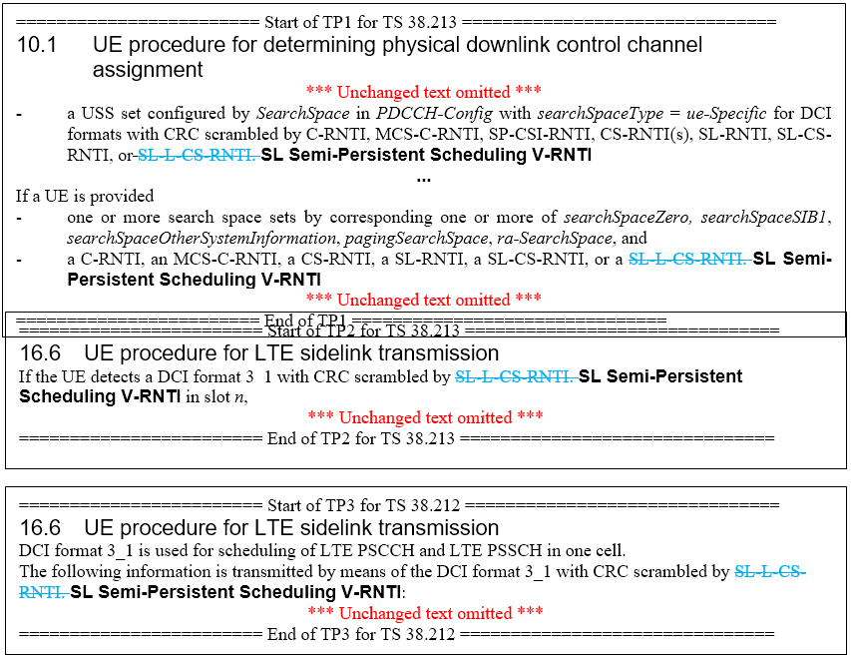

**Internal question 2: Please provide your comments to RAN Q2 and to the proposed above TP to resolve the alignment.**

|  |  |
| --- | --- |
| **Source** | **Comments** |
| LG Electronics | We are generally fine with the TP shared by FL. |
| Samsung | We are generally fine with the TP shared by FL. |
| CATT | **agree** |
| Qualcomm | We’re ok with the changes |

## Comments on the other parts of the LS

For the other contents of the LS, there is no explicit question from RAN2. However, there are section related to “Maximum value (“8” or “9”) of SL priority threshold”, “Sidelink synchronization ID”, and “Other RAN2 agreements”.

**Internal question 3: Please provide any comments on the other parts of the LS.**

|  |  |
| --- | --- |
| **Source** | **Comments** |
| Qualcomm | In our view, a reply for “Maximum value (“8” or “9”) of SL priority threshold” is needed because there is a contradiction between RAN1 and RAN2 agreements.  RAN1 agreed to use 9 for L1 SL signal prioritization. If 8 is the maximum used for sl-PrioritizationThres-r16 prioritization comparison:   * The value 9 cannot be configured for L1 prioritization because there is no counterpart in SL-SCH comparisons and there should not be a case where L1 sidelink signals are prioritized, but SL-SCH is deprioritized. * Loss of flexibility where SL-SCH cannot always be prioritized over uplink. The inconsistency issue in the first bullet would extend this bullet to all SL signals as well.   Therefore, we propose the following:  RAN1 respectfully asks RAN2 to update the range of sl-PrioritizationThres-r16 to match that of sl-PriorityThreshold-r16 and sl-PriorityThreshold-UL-URLLC-r16. |
|  |  |
|  |  |

References

1. R1-2007774 Discussion on essential corrections in resource allocation for Mode 2 LG Electronics

Proposal 1: Confirm RAN1’s understanding is that the resource reselection is triggered to re-perform the dropped retransmission caused by prioritization, pre-emption and congestion control.

Proposal 2: When CR value already exceeds CRlimit, the resource reselection triggered by the retransmission dropping due to prioritization, pre-emption and congestion control is not performed.

Proposal 3: For the case of periodic resource reservation, when the transmission on the reserved resources other than 1st resource of 1st reservation period is dropped due to the pre-emption, the resource reselection should be triggered.

1. R1-2007811 Remaining issues on Mode 2 resource allocation in NR V2X CATT

Proposal 8: In order to protect reliability of NR sidelink transmissions, resource reselection for dropped transmissions due to prioritization should be supported.

Proposal 9: The reporting operations for dropped transmissions caused by prioritization should be captured in RAN1 specification.

1. R1-2008531 Maintenance for resource allocation mechanism mode 2 NTT DOCOMO, INC.

**Proposal 1:**

* *On whether resource reselection is needed for dropped retransmission caused by prioritization, pre-emption and congestion control,* 
  + *If there is another resource available for HARQ retransmission selected in MAC, resource reselection is not mandated.*
* *Send an LS reply to RAN2 to inform of the above agreement.*

1. R1-2007799 Discussion on LS from RAN2 on RAN2 agreements and RAN1 related issue CATT

Proposal 1: An explicit reselection trigger can be introduced for the dropped retransmission caused by prioritization.

Proposal 2: RAN1 has clear agreements on resource reselection trigger caused by pre-emption.

Proposal 3: No need to introduce an explicit reselection trigger for the dropped retransmission caused by congestion control.

1. R1-2007919 [DRAFT] Reply LS on RAN2 agreements and RAN1 related issues ZTE, Sanechips

[RAN1] According to the RAN1 agreement below, resource re-selection is needed for dropped retransmission caused by pre-emption. In case of dropped retransmission caused by prioritization or congestion control, no additional behaviour needs to be defined in physical layer. LTE mechanism can be reused, e.g. incrementing by 1 the number of consecutive unused transmission opportunities on resources indicated in the selected grant.



1. R1-2008119 Draft reply LS on RAN2 agreements and RAN1 related issues Samsung

**Reply to Q1**: The resource reselection is need for dropped retransmission caused by pre-emption according to Section 8.1.4 of TS 38.214. The UE shall report pre-empted resource(s) and a subset of candidate resources to higher layer for which the higher layer reselects resource(s). On the other hand, a UE behaviour is not defined for dropped retransmission caused by congestion control according to Section 8.1.6 of TS 38.214.

**Reply to Q2**: RAN1 needs to align the higher layer parameter of ‘SL Semi-Persistent Scheduling V-RNTI’. In Section 7.3.1.4.2 of TS 38.212, ‘SL-L-CS-RNTI’ should be replaced into ‘SL Semi-Persistent Scheduling V-RNTI’.

1. R1-2008590 Draft reply LS on RAN2 agreements and RAN1 related issues Qualcomm Incorporated

Intra-UE prioritization is performed when an uplink grant overlaps in time with a sidelink transmission or reception. In Mode 2 resource allocation, the gNB is unaware of communications on sidelink an cannot avoid scheduling such conflicts. Therefore, resource selection is needed for dropped retransmissions caused by prioritization with Uu transmissions.

Congestion control directs a UE to drop transmissions to alleviate system congestion. Triggering resource selection for those dropped resources runs counter to that goal. Therefore, resource selection is not needed for dropped retransmissions caused by congestion control.

RAN1 introduced a threshold value of 9 for comparison with sidelink physical layer signals to enable cases where sidelink is always prioritized over uplink transmissions. Not using the same range in the MAC layer prioritization parameter could lead to cases where:

* SL-SCH cannot be always prioritized over uplink.
* SL-SCH is not prioritized over uplink, but physical layer signals are. This leads to inconsistency and a scenario that cannot currently be supported by NR sidelink design.

RAN1 respectfully asks RAN2 to update the range of sl-PrioritizationThres-r16 to match that of sl-PriorityThreshold-r16 and sl-PriorityThreshold-UL-URLLC-r16

1. R1-2008647 Draft Reply LS on RAN2 agreements for V2X vivo
   * **Question 1**: *RAN2 would like to ask RAN1 whether resource reselection is needed for dropped retransmission caused by prioritization, pre-emption and congestion control.*
     + **Answer:** In the case that retransmission is dropped due to pre-emption, RAN1 has agreed that resource reselection should be performed. In the other cases when retransmission is dropped due to prioritization or congestion control, RAN1 has not agreed to perform resource reselection.
   * **Question 2**: *RAN2 would like to ask RAN1 to align, in the impacted RAN1 specification(s), ‘SL-L-CS-RNTI’ with ‘SL Semi-Persistent Scheduling V-RNTI’.*
     + **Answer:** RAN1 agrees to align with RAN2 on the RNTI name and will update the related RAN1 specifications.
2. R1-2008748 Discussion on RAN2 LS on RAN2 agreements and RAN1 related issues Ericsson
3. R1-2008749 [Draft] LS reply on RAN2 agreements and RAN1 related issues Ericsson

The RAN1 agreement explicitly mentions that pre-emption triggers resource reselection. On the other hand, RAN1 has made no agreements for the cases. Our view is that they can be left up to UE implementation. That is, the specification should support the possibility of reselecting resources but not necessarily mandate it. For example:

* The UE may have exhausted the PDB, meaning that reselection is not possible.
* The UE may have additional retransmission opportunities that may eventually suffice to deliver the packet.

The RAN1 agreements require that reselection is triggered after pre-emption. For the remaining cases, the decision can be left up to UE implementation.

1. R1-2008783 On resource reselection due to dropped retransmissions Huawei, HiSilicon

*Proposal 1: Reply to RAN2 as follows:*

* *The cited RAN1 agreement does not call for any additional resource reselection procedures beyond what are already specified in TS 38.321.*