**3GPP TSG RAN WG1 #120 R1-25xxxxx**

**Athens, Greece, February 17th – 21st, 2025**

Agenda Item: 8.1

Source: Moderator (Google)

Title: Summary on PMI prediction during cell DTX

Document for: Discussion/Decision

# Introduction

In this contribution, we provide a summary about the discussion on PMI prediction during cell DTX.

# Background

## Current spec related to CSI dropping during cell DTX

Currently it is defined that UE receives the CSI-RS for CSI acquisition during cell DTX active period(s), and UE does not receive the CSI-RS for CSI acquisition during cell DTX inactive period(s). For a CSI report, it is defined that UE transmits the CSI report after receiving at least one transmission occasion of each CSI-RS resource as follows:

|  |
| --- |
| For the CSI report configuration in CSI-*ReportConfig* associated with the higher layer parameter *reportQuantity* comprising at least 'RI', the UE reports a CSI report only if receiving at least one CSI-RS transmission occasion of each periodic CSI-RS resource or semi-persistent CSI-RS resource on a serving cell with cell DTX activated [10, TS 38.321] for channel measurement and/or interference measurement in active periods of cell DTX of the serving cell no later than CSI reference resource, and the UE drops the CSI report otherwise. |

## Current spec related to CSI dropping during for PMI prediction

For PMI prediction, UE needs to measure Kp transmission occasions for periodic/semi-persistent CSI-RS resources to predict a CSI, which is defined as follows:

|  |
| --- |
| For a *CSI-ReportConfig* configured with *codebookType* set to 'typeII-Doppler-r18' or 'typeII-Doppler-PortSelection-r18', after the CSI report (re)configuration, serving cell activation, BWP change, or activation of SP-CSI, the UE reports a CSI report only if receiving at least one aperiodic or $K_{p}$ periodic or semipersistent consecutive CSI-RS transmission occasions for each CSI-RS resource in the corresponding CSI-RS Resource Set for channel measurement and one CSI-RS and/or CSI-IM resource transmission occasion for the CSI-RS and/or CSI-IM resource in the corresponding Resource Set for interference measurement no later than the CSI reference resource and within the same DRX Active Time, when DRX is configured, and drops the report otherwise. The value of $K_{p}∈\{1,2,4\}$ is indicated by UE capability, as defined in clause 5.2.1.6. |

## Current spec related to connection between cell DTX and C-DRX

The following is defined for the connection between cell DTX and UE DRX in 38.331.

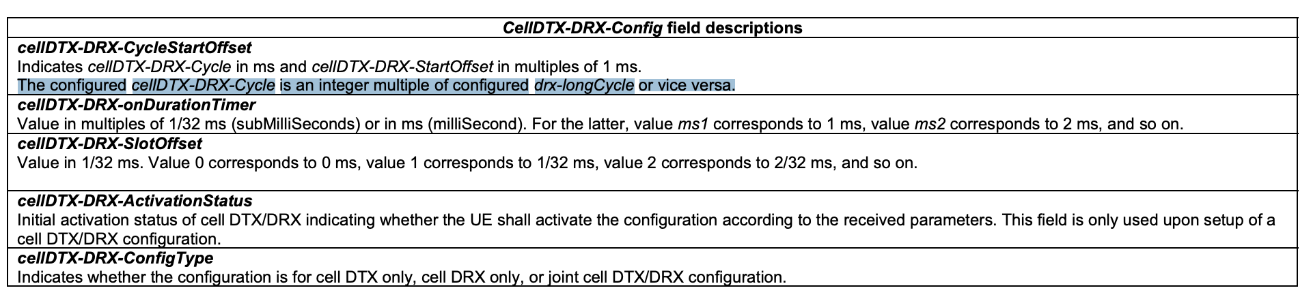

# Discussion

## Understanding about the connection between cell DTX and C-DRX in current spec

According to the spec text mentioned in 2.3, the connection between cell DTX and C-DRX is about the cycle. The active period for cell DTX and active time for C-DRX does not have to be fully overlapped.

**Discussion point #1 (for discussion only): In current spec, the active period for cell DTX and active time for C-DRX does not have to be fully overlapped.**

Company’s view

|  |  |  |
| --- | --- | --- |
| Company | Agree or not | Comment |
|  |  |  |
|  |  |  |
|  |  |  |
|  |  |  |
|  |  |  |
|  |  |  |

## One active period vs. multiple active periods

In current spec introduced in NES (section 2.1), if UE receives at least one transmission occasion of each CMR in one or multiple active periods of cell DTX, UE reports the CSI; otherwise, UE drops the CSI report.

In current spec introduced in MIMO (section 2.2), if UE receives Kp consecutive transmission occasion of each CMR in the same active time of C-DRX, UE reports the CSI; otherwise, UE drops the CSI report.

Then a discussion point is whether the dropping of CSI should be based on the Kp consecutive transmission occasions of each CMR in one or multiple active periods.

**Discussion point #2 (for potential agreement):**

**Down-select one of the following options:**

* **Option 1 (one or multiple active periods): adopt the following TP for 38.214**

|  |
| --- |
| 5.2.2.5 CSI reference resource definition <unrelated text omitted>  For the CSI report configuration in CSI-*ReportConfig* associated with the higher layer parameter *reportQuantity* comprising at least 'RI', the UE reports a CSI report only if receiving at least one CSI-RS transmission occasion of each periodic CSI-RS resource or semi-persistent CSI-RS resource on a serving cell with cell DTX activated [10, TS 38.321] for channel measurement and/or interference measurement in active periods of cell DTX of the serving cell no later than CSI reference resource, and the UE drops the CSI report otherwise.  For the CSI report configuration in CSI-*ReportConfig* configured with *codebookType* set to ‘typeII-Doppler-r18’ or ‘typeII-Doppler-PortSelection-r18’, the UE reports a CSI report only if receiving at least consecutive CSI-RS transmission occasions of each periodic CSI-RS resource or semi-persistent CSI-RS resource on a serving cell with cell DTX activated [10, TS 38.321] for channel measurement and/or interference measurement in active periods of cell DTX of the serving cell no later than CSI reference resource, and the UE drops the CSI report otherwise. |

* **Option 2 (single active periods): adopt the following TP for 38.214**

|  |
| --- |
| 5.2.2.5 CSI reference resource definition <unrelated text omitted>  For the CSI report configuration in CSI-*ReportConfig* associated with the higher layer parameter *reportQuantity* comprising at least 'RI', the UE reports a CSI report only if receiving at least one CSI-RS transmission occasion of each periodic CSI-RS resource or semi-persistent CSI-RS resource on a serving cell with cell DTX activated [10, TS 38.321] for channel measurement and/or interference measurement in active periods of cell DTX of the serving cell no later than CSI reference resource, and the UE drops the CSI report otherwise.  For the CSI report configuration in CSI-*ReportConfig* configured with *codebookType* set to 'typeII-Doppler-r18' or 'typeII-Doppler-PortSelection-r18', the UE reports a CSI report only if receiving at least consecutive CSI-RS transmission occasions of each periodic CSI-RS resource or semi-persistent CSI-RS resource on a serving cell with cell DTX activated [10, TS 38.321] for channel measurement and/or interference measurement in the same active period of cell DTX of the serving cell no later than CSI reference resource, and the UE drops the CSI report otherwise. |

* **Option 3: Do not support any TPs above**
  + **UE expects the active period of cell DTX and active time of C-DRX should be fully overlapped**

Company’s view

|  |  |
| --- | --- |
| Company | Comment |
|  |  |
|  |  |
|  |  |
|  |  |
|  |  |
|  |  |

# Conclusion

TBA