RAN1#114b Online Session Schedule
RAN1 Breakout1
RAN1 Main
RAN1 Breakout2

 | Monday |  |  | Tuesday |  |  |  | Wednesday |  |  | Thursday |  |  | Friday
08:30  ~  10:30  (120 min) | RAN1#114b commences at 09:00 (local time)  Agenda items 1, 2, 3, 4, 5  Agenda item 9 (election)  Agenda items 6, 7.1 |  |  | NCR (60)  MC_Enh (60) | UE features (120)  TEI(30)  XR(30)  CovEnh(30)  5MHz(30) |  | NTN (120) | UE features (120)  MIMO(60)  NES(40)  NCR(20) | eRedCap (45)  <5MHz (30)  DSS (45) | Pos (120)
Morning coffee break: 10:30 ~ 11:00
11:00  ~  13:00  (120 min) | Agenda item 7.1 (60)  MIMO (60) |  |  | XR (45)  7.2 (75)  SL,  RedCap, SDT, UE Power, Pos, TR38.901 | UE features (60)  MIMO(60Mobility (60) |  | 7.2 (60)  UE features (60)  SL(60) | MIMO (120) | UE features (60, 60)  POS(45)  BWP(15)  RedCap(30)  DSS(30) | 7.2 (60)  NTN (60)
Lunch break: 13:00 ~ 14:30
14:30  ~  16:30  (120 min) | MIMO (120) | Cov (60)  <5MHz (30)  DSS (30) | SL (120) | MIMO (120) | Cov (80)  AI/ML (40) |  | UE features (120)  NR-NTN(40)  Mobility(40)  POS(40) | MC_Enh (60)  7.2 (60) | Mobility (90)  AI/ML (30) | UE features (120)  SL(70)  MCE(50) |  |  |  | Any open issues (150)  . Session reports  . etc  RAN1#114b closes at 17:00 (local time)
Afternoon coffee break: 16:30 ~ 17:00
17:00  ~  19:00  (120 min) | 7.2 (60)  NTN, MIMO, URLLC  NES (60) | eRedCap (45)  AI/ML (75) | Pos (120) | NES (100)  Close at 6:40pm |  | AI/ML (100)  Close at 6:40pm | Pos (100)  Close at 6:40pm | XR (30)  NES (90) | AI/ML (120) | Sat Eval (20)  SL (100)
All sessions end at 19:15 – no exceptions
RAN1#114b Offline Session Schedule
Function Room B (50)

Function Room A (50)

 | Monday |  | Tuesday |  | Wednesday |  | Thursday |  | Friday
08:30  ~  10:30  (120 min) |  |  | 8.1 MIMO (120) | 8.3 Pos (120) | 8.13 NTN (120) | 8.7 Mobility  8.7.1 (60)  8.7.2 (60)
Morning coffee break: 10:30 ~ 11:00
11:00  ~  13:00  (120 min) | 8.5 NES (90)  8.12 MC-Enh (30) | 8.14 AI/ML  (120)  8.14.1  8.14.2 | 8.5 NES (60)  8.1 MIMO (60) | 8.14.3 AI.ML  (60)  8.4 RedCap  (30)  8.10 DSS (30) | 8.5 NES (75)  8.6 XR (45) | 8.14 AI/ML  8.14.1 (60)  8.14.2 (60)
Lunch break: 13:00 ~ 14:30
14:30  ~  16:30  (120 min) | 8.12 MC-Enh (60)  8.11 NCR (60) | 8.3 Pos (120) | 8.4 RedCap  (40)  8.9 <5MHz  (40)  8.10 DSS (40) | 8.3 Pos (60)  8.15 Sat Eval (60) | 8.1 MIMO (120) | 8.3 Pos (120) |  |  | To be assigned by Xiaodong  To be assigned by David
Afternoon coffee break: 16:30 ~ 17:00
17:00  ~  19:00  (120 min) | 8.6 XR (45)  8.13 NTN (75) | 8.8 CovEnh  8.8.1 (45)  8.8.3 (45)  8.8.2 (30) | 8.12 MC-Enh (60)  8.11 NCR (40)  Close at 6:40pm | 8.2 SL (100)  Close at 6:40pm | 8.1 MIMO (120) | 8.4 RedCap  (40)  8.9 <5MHz  (40)  8.10 DSS (40)
All sessions end at 19:15 – no exceptions

RAN1#114b Detailed Schedule for RAN1 Main Session

 | Monday | Tuesday | Wednesday | Thursday | Friday
08:30  ~  10:30  (120 min) |  | NCR (60)  . Both agenda items  MC_Enh (60)  . Both agenda items
Morning coffee break: 10:30 ~ 11:00
11:00  ~  13:00  (120 min) | MIMO (60)  . DMRS  . SRS  . Two TA | XR (45)  7.2 (75)  SL RedCap SDT  UE Power Saving  Positioning TR38.901
Lunch break: 13:00 ~ 14:30
14:30  ~  16:30  (120 min) | MIMO (120)  . CSI  . Unified TCI  . UL precoding indication  . 8 TX UL SRI/TPMI enhancement | MIMO (120)  . TBD
Afternoon coffee break: 16:30 ~ 17:00
17:00  ~  19:00  (120 min) | 7.2 (60)  . NTN MIMO URLLC  NES (60)  . Both agenda items | NES (100)  . Both agenda items
All sessions end at 19:00 – no exceptions
Meeting Room Locations (RAN1 meetings have blue borders)

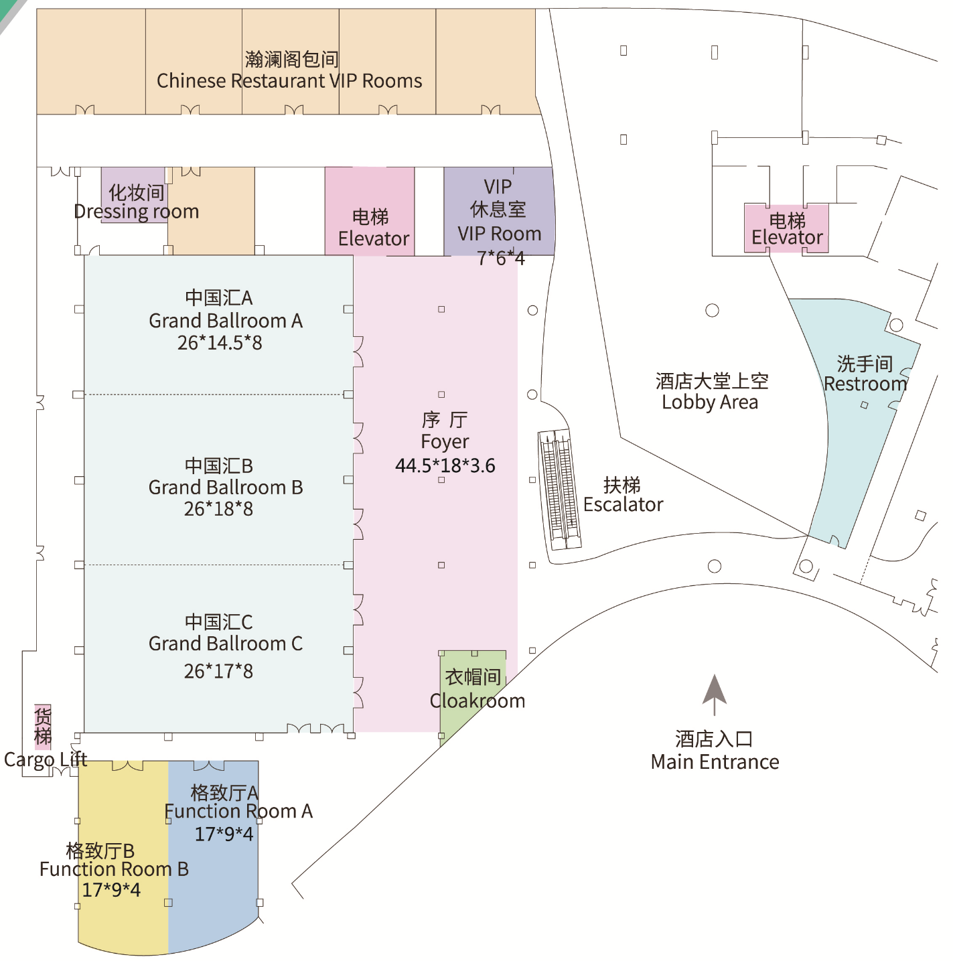

Monday morning, Friday afternoon:
Grand Ballroom A, B, C will be used for main session

Monday afternoon ~ Friday morning:
Grand Ballroom C: Main Session
Grand Ballroom B: Breakout Session 1 (Xiaodong)
Grand Ballroom A: Breakout Session 2 (David)

Offline sessions
Function Room A
Function Room B

