3GPP TSG RAN WG1 #110bis-e R1-220xxxx
e-Meeting, October 10th – 19th, 2022
Source: Apple Inc.
Title: FL summary #1 on TCI assumption for RSSI measurement for FR2-2
Agenda item: 8.2
Document for: Discussion and Decision

1 Introduction
RAN1 has received a LS from RAN4 [1] regarding TCI assumption for RSSI measurement for FR2-2 when a UE has no serving cell in FR2-2:
RAN4 would like to thank RAN1 on the LS. Meanwhile, further clarification is needed for the following case.
When a UE has no serving cell in FR2-2, it is not clear if the explicit TCI state should be configured to the UE for FR2-2 RSSI measurement. If explicit TCI state should be configured, how does the UE use such explicit TCI?
This contribution summarizes the discussions and outcome for LS reply.

2. Companies’ Views
Based on contribution [2~8], Table 1 summarizes companies’ views and proposals on this issue:
Company | Views
Vivo [2] | - When a UE has no serving cell in FR2-2, the explicit TCI state should not be configured to the UE for FR2-2 RSSI measurement since TCI state in FR1 or FR2-1 can’t be used for FR2-2. In this case, UE will perform beam sweeping for FR2-2 RSSI measurement.
ZTE[3] | - RAN1 has no see a strong need to configure an explicit TCI state to UE, especially for the case that UE has no serving cell in FR2-2.
Ericsson [4][5] | - A UE can estimate L3-RSSI based on implementation when it has no serving cell in FR2-2, regardless of whether explicit TCI state is configured or not.
LGE [6] | - When a UE has no serving cell in FR2-2, the UE does not expect to be configured with explicit TCI state index associated with a reference serving cell index.  - Send an LS to RAN2 with the following TP for TS 38.331 specification as a recommendation, to disallow a UE to be configured with explicit TCI state with a reference serving cell in FR1 or FR2-1.  ref-ServCellId  Indicates the reference FR2-2 serving cell index for the TCI state. Network includes this field if tci-StateInfo is present.
Huawei [7] | - Proposal 1: For L3-RSSI measurement, UE is not expected to be provided TCI state in RMTC if there is no serving cell in FR2-2 configured for the UE.  - Proposal 2: The spatial domain filter used to perform RSSI measurement is up to UE implementation if UE is not provided with TCI state in RMTC and there is no serving cell in FR2-2.  - Proposal 3: E-UTRA UE is not expected to be provided inter-RAT TCI state in RMTC for FR2-2.
NTT DOCOMO [8] | RAN1 to discuss whether inter-frequency L3-RSSI measurement is supported or not in FR2-2 at first  - If it is not supported, the issue identified by RAN4 (i.e., how to obtain TCI state for L3-RSSI measurement when the UE has no serving cell configuration in FR2-2) doesn’t need to be considered  - If it is supported, RAN1 needs to consider the issue identified by RAN4

3. Discussions

3.1 Round #1

#Issue 1: Whether use case in LS is valid or NOT?
As pointed out in [6][8], the first discussing point is whether to support the use case mentioned in [1], i.e., UE is configured to perform inter-frequency RSSI measurement ‘when a UE has no serving cell in FR2-2’. Contribution [8] proposed to have a wider discussion on the support of inter-frequency RSSI measurement in general. As mentioned in [5][6][7], support of inter-cell RSSI measurement was extensively discussed during RAN1 109 e-meeting. Especially, a draft TR to support inter-cell RSSI measurement was included in LS [9] to RAN4. In RAN4, a modified TP was agreed already for inter-frequency RSSI measurement based on RAN1 LS. In brief, the inter-frequency RSSI measurement feature was generally supported in. RAN1/RAN4. Therefore, FL intends to focus on the use case mentioned in LS only.
Based on the proposals summarized in Table 1, it seems that almost all companies think the use case in LS needs to be supported and therefore the following was proposed to conclude first:
[FL1 Proposal 1-1]: Inter-frequency RSSI measurement for FR2-2 can be configured for a UE when the UE has no serving cell in FR 2-2
Company | Y/N | Comments or suggested revisions

#Issue 2: Inter-frequency RSSI Measurement Configuration
Another discussing point is whether TCI-State would be explicitly configured in the RMTC configuration for this case and what is the associated UE behaviours. The RMTI configuration details are quoted below to facilitate the discussion:
TCI-State presence in RMTC-Config-r16
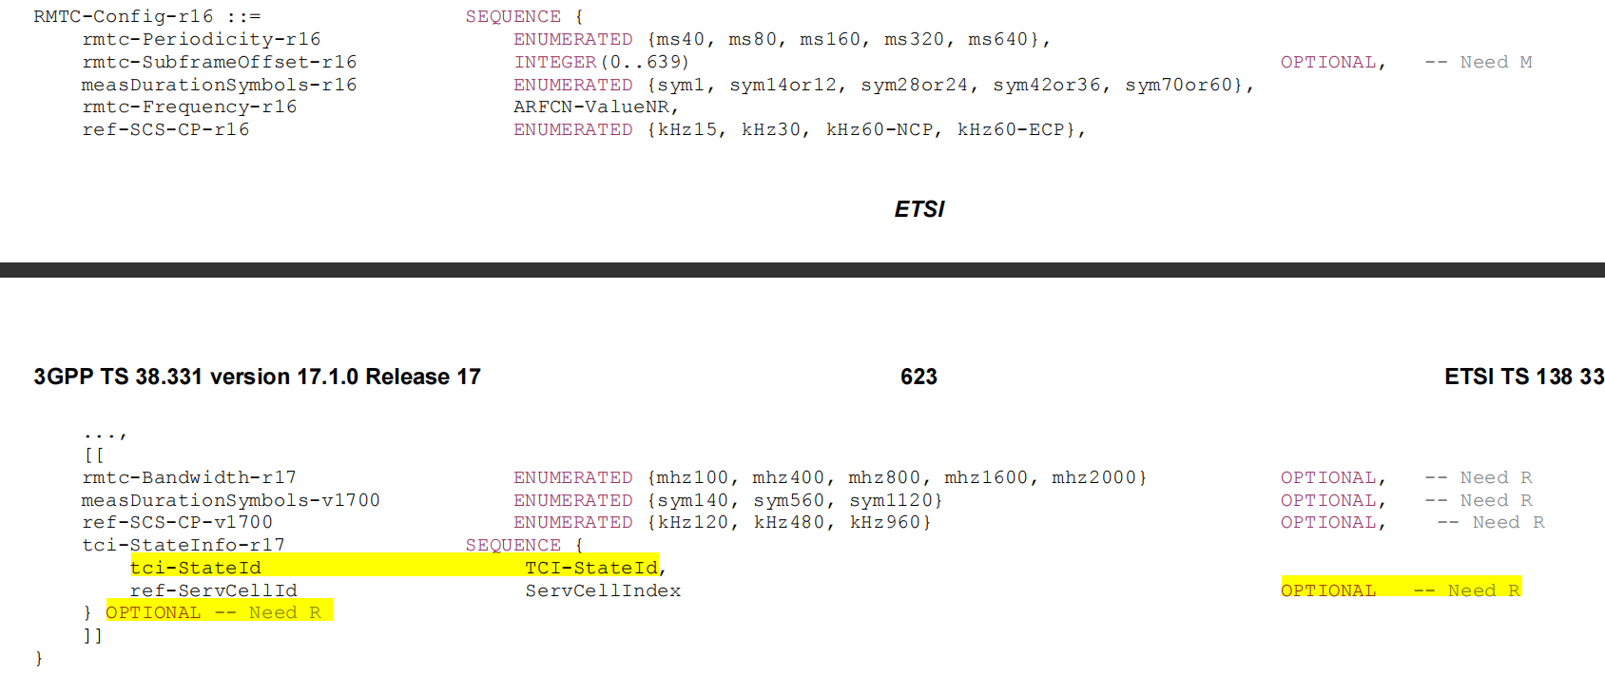

Referring to Table 1 above, companies’ views on the TCI-state configuration for this use case are already quite aligned as summarized in Table 2:
Table 2: Companies’ views on presence of TCI-State for the case in [1]
Whether allows to configure TCI-state in RMTC-Config for inter-frequency RSSI measurement on FR2-2 When a UE has no serving cell in FR2-2? | Companies
Opt.1: No. | - Vivo [2], ZTE[3], LGE [6], Huawei [7]
Opt.2: Can be configured and up to gNB. | - Ericsson [4,5]?

Although contribution [Ericsson, 4] implies that TCI-state can be configured in this case, it also proposed that ‘the UE can ignore the TCI state’. Therefore, it seems there is a common understanding in RAN1 that the TCI-state is not useful in this case and hence Opt.1 seems the right way to go.
One more discussion point for Opt.1 is that contribution [6] observed that it has RAN2 impact i.e., changing the ASN.1 field description. Depending on discussion here, if no consensus can be reached, we can leave it to RAN2 as long as RAN2 is informed with RAN1 new decision (e.g., adding ‘RAN2’ in the ‘cc’ list of LS reply).
In addition, contribution [Huawei, 7] proposed that the TCI-state discussion should also cover the inter-RAT case for E-UTRA UE (see Proposal 3 [7]).

[FL1 Question 2-1]: Which one between Opt.1 and Opt.2 is acceptable for TCI state configuration when a UE has no serving cell in FR2-2?
- When indicate your preference, please also indicate whether the other option is acceptable to move forward.
- If Opt.1 is preferred, please indicate the following in comment column of Tabel below:
  - Whether RAN2 spec change is needed/discussed in RAN1 or leave it to RAN2.
  - Whether needs to explicitly cover E-UTRA UE as proposed in [7]. If the answer is ‘no’, please briefly explain why.
- If none of them, please provide a modified version with reasoning.
Company | Preference | Comments or suggested revisions

UE behaviour for FR2_2 inter-frequency RSSI measurement
Regarding the UE behaviour for FR2_2 inter-frequency RSSI measurement, two contributions [Ericssion,4] [Huawei,7] proposed to leave for UE implementation. One contribution [vivo, 2] proposed to perform beam sweeping for RSSI measurement. Based on analysis in the submitted papers, leaving for UE implementation is a nature and good choice, especially considering the maintenance phase. Beam sweeping proposed in [2] is likely a nature choice in implementation for this case, but it can be left to vendor-choice.
Therefore, FL made the following proposal for UE behaviour :
[FL1 Proposal 2-2]: For a UE has no serving cell in FR2-2 and configured with inter-frequency RSSI measurement in FR2-2, it is up to UE implementation for inter-frequency RSSI measurement in FR2-2.
Company | Y/N | Comments or suggested revisions

Others
Please indicate anything related to LS reply is missed in the FL summary and should be included in the next round discussion in your opinion.
Company | Comments

4. Conclusion

References
- R1-2208349 LS reply on TCI assumption for RSSI measurement for FR2-2on … RAN4, Apple
- R1-2208582 Draft Reply LS on TCI assumption for RSSI measurement for FR2-2 vivo
- R1-2208703 Draft reply LS on TCI assumption for RSSI measurement for FR2-2 ZTE, Sanechips
- R1-2209182 Draft LS response on TCI assumption for RSSI measurement for FR2-2 Ericsson
- R1-2209183 Discussion on LS response on TCI assumption for RSSI measurement for FR2-2 Ericsson
- R1-2209435 Discussion on RAN4 LS on TCI assumption for RSSI measurement for FR2-2 LG Electronics
- R1-2209820 Discussion on the RAN4 LS on L3-RSSI measurement Huawei, HiSilicon
- R1-2209867 Discussion on LS reply on TCI assumption for RSSI measurement for FR2-2 NTT DOCOMO, INC.
- R1-2205582, LS on TCI assumption for RSSI measurement in FR2-2, RAN1, Qualcomm

