3GPP TSG-RAN WG1 Meeting #110bis-e R1-22xxxxx

e-Meeting, October 10 – 19, 2022
CR-Form-v12.2
[Draft] CHANGE REQUEST
 | 38.213 | CR | xxxx | rev | - | Current version: | 17.3.0
For HELP on using this form: comprehensive instructions can be found at
http://www.3gpp.org/Change-Requests.

Proposed change affects: | UICC apps |  | ME | X | Radio Access Network | X | Core Network

Title: | Correction on SCS configuration for parallel transmission of PRACH and SRS/PUCCH/PUSCH
Source to WG: | Moderator (Huawei), Samsung
Source to TSG: | RAN1
Work item code: | Tel17, NR_newRAT-Core |  |  |  |  |  | Date: |  |  | 2022-09-30
Category: | F |  |  |  |  |  | Release: |  |  | Rel-17
 | Use one of the following categories:  F (correction)  A (mirror corresponding to a change in an earlier release)  B (addition of feature),  C (functional modification of feature)  D (editorial modification)  Detailed explanations of the above categories can  be found in 3GPP TR 21.900. |  |  |  |  |  |  |  | Use one of the following releases:  Rel-8 (Release 8)  Rel-9 (Release 9)  Rel-10 (Release 10)  Rel-11 (Release 11)  …  Rel-15 (Release 15)  Rel-16 (Release 16)  Rel-17 (Release 17)  Rel-18 (Release 18)  Rel-19 (Release 19)
Reason for change: |  | According to current specification, for intra-band CA, a UE does not transmit PRACH and PUSCH/PUCCH/SRS in a same slot or when the gap between PRACH and PUSCH/PUCCH/SRS is less than N symbols.  For intra-band CA with different SCS, it is not clear which SCS should be used to determine the duration of the slot. For example, for CC1 with 15kHz SCS and CC2 with 30kHz SCS as shown in Figure 1, if 15kHz is used, the UE would not transmit the PRACH and PUCCH/PUSCH/SRS as they are in the same 15kHz slot. But if 30kHz SCS is used, the UE would transmit the PRACH and PUCCH/PUSCH/SRS as they are in the different 30kHz slot.  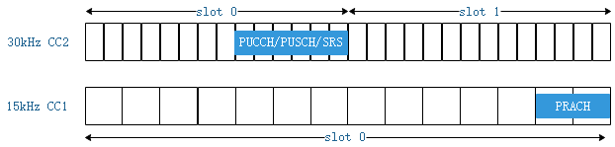  Figure 1: It is not clear whether the PRACH in CC1 and PUCCH/PUSCH/SRS in CC2 are in the same slot or not. The UE would not transmit both if they are in the same slot. Otherwise, the UE would transmit both.  Besides, it is also not clear whether the N (N=2 in the above example) symbols are based on 15kHz SCS or 30kHz SCS as shown in Figure 2. If the N symbols are N 15kHz symbols, then PUSCH/PUCCH/SRS in CC2 should be later than 4th symbol of slot 2 in CC2. If the N symbols are N 30kHz symbols, then PUSCH/PUCCH/SRS in CC2 should be later than 2nd symbol of slot 2 in CC2.  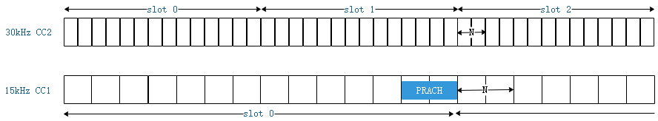  Figure 2: It is not clear whether N (e.g. N=2) symbols gap between PRACH and PUCCH/PUSCH/SRS in the spec is N 15kHz symbols or N 30kHz symbols.  Therefore, there is a need to resolve the above ambiguity.
Summary of change: |  | Clarified the slot duration and N are based on the smallest SCS configuration between SCS configuration of the UL BWP with PRACH transmission and the SCS configuration of UL BWP with PUSCH/PUCCH/SRS transmission.
Consequences if not approved: |  | Ambiguous specification
Clauses affected: |  | 8.1
 |  | Y | N
Other specs |  |  | X | Other core specifications |  |  |  | TS/TR ... CR ...
affected: |  |  | X | Test specifications |  |  |  | TS/TR ... CR ...
(show related CRs) |  |  | X | O&M Specifications |  |  |  | TS/TR ... CR ...
Other comments: |  | Impacted functionality: Simultaneous transmission of PRACH on one uplink carrier and PUSCH/PUCCH/SRS on another uplink carrier in intra-band CA.  If the UE is implemented according to the CR and the gNB is not or if the gNB is implemented according to the CR and the UE is not, the gNB and the UE may have different understanding on whether simultaneous transmission of PRACH on one uplink carrier and PUSCH/PUCCH/SRS on another uplink carrier in intra-band CA is allowed or not under certain conditions.
This CR's revision history:

8.1 Random access preamble
========================= Unchanged parts =========================
For single cell operation or for operation with carrier aggregation in a same frequency band, a UE does not transmit PRACH and PUSCH/PUCCH/SRS in a same slot with respect to the smallest SCS configuration between the SCS configuration for the UL BWP with the PRACH and the SCS configuration for the UL BWP with the PUSCH/PUCCH/SRS transmissions or when a gap between the first or last symbol of a PRACH transmission in a first slot is separated by less than $N$ symbols from the last or first symbol, respectively, of a PUSCH/PUCCH/SRS transmission in a second slot where $N=2$ for $μ=0$ or $μ=$1, $N=4$ for $μ=2$ or $μ=3$, $N=16$ for $μ=5$, $N=32$ for $μ=6$, and $μ$ is the smallest SCS configuration between the SCS configuration for the UL BWP with the PRACH and the SCS configuration for the UL BWP with the PUSCH/PUCCH/SRS transmissions.

