3GPP TSG RAN WG1 Meeting #106bis-e R1-xxxxxxx
e-Meeting, October 11th-19th, 2021

Agenda Item: 8.4.4
Source: Moderator (OPPO)
Title: Summary of 8.4.4 Other Aspects of NR-NTN
Document for: Discussion and Decision

Introduction
This document contains a summary of the contributions under AI 8.4.4 at RAN1#106e. This include the topics for RAN1 that should be specified if beneficial and needed as listed in Release-17 NR NTN WID:
- Enhancement on the PRACH sequence and/or format and extension of the ra-ResponseWindow duration (in the case of UE with GNSS capability but without pre-compensation of timing and frequency offset capabilities) [RAN1/2].
- Feeder link switch [RAN2,RAN1]
- Beam management and Bandwidth Parts (BWP) operation for NTN with frequency reuse [RAN1/2]
  - Including signalling of polarization mode

NR-NTN beam management issues
In this section, we discuss beam management related issues and potential enhancements.
In RAN1#105-e meeting, we have collected the views on the following issues and the moreover extensive discussions were conducted in the last meeting on issue #1, 5 and 7.
- Issue 1: NR BWP is not directly associated with a beam. Thus, when using TCI to change beam from beam 1 to beam 2, it does not trigger NR BWP switching. However, in NTN FRF>1 case, beam switching may result in a BWP switching.
- Issue 2: NR BWP switching in UL and DL are not jointly triggered for FDD. However, in NTN FRF>1 FDD scenario, beam switching may result in a BWP switching in both DL and UL.
- Issue 3: NR dynamic BWP switching requires data scheduling. While in NTN FRF>1 scenario, we may need a fast BWP switching triggering without data scheduling.
- Issue 4: NR BWP switching does not require re-synchronization. However, in NTN FRF>1 scenario, when a satellite beam switching is triggered, UE may need to perform re-synchronization in the switched BWP.
- Issue 5: Since satellite beam switching can be frequent and often highly predictable, mechanisms of configured BWP switching (can be a sequence of BWPs) may be preferred but current NR does not allow it.
- Issue 6: How to deal with BWP switching triggered by bwpInactivityTimer, RA procedure, or simply a need to increase throughput instead of for beam-level mobility.
- Issue 7: NR BWP switching/beam switching is done with UE specific signalling due to UE movement’s. However, in NTN scenario, a satellite BWP/beam switching is common for set of UEs, we may need to a common BWP/beam switching mechanism to save the signalling overhead.
- Issue 8: BWP configuration enhancement
- extending the number of supported BWPs per cell
- cell-specific BWP common configuration
- Issue 9: NR BM framework (TCI state and spatial relations) should be restricted within the same satellite or support the switching of the service links associated with different satellites.
- Issue 10: For NTN, current NR based measurement-based beam management will result in large signaling overhead and long latency for periodic exchange of CSI-RS transmissions and corresponding reporting.

In the 106-e meeting, we have reached some conclusions after technical discussions. In this meeting, several contributions have been submitted to continue pointing out the remaining issues.
 | Status from RAN1#106-e meeting | Contribution in RAN1#106b-e meeting
Issue 1 | No concensus on the issue | QC:  Proposal 1: Support satellite beam specific initial BWPs.  Proposal 2: Support the following SSB arrangements  - Alt 1: SSBs of all satellite beams in a same cell are transmitted within a same frequency interval and do not overlap in time  - Alt 2: SSBs of a cell are transmitted in different frequency interval, i.e., within their respective BWPs.  Proposal 3: Support signalling of the following configurations in SIB1  - initial BWPs of other satellite beams,  CORSET#0 of other satellite beams if different from that of the serving beam.  Baicells  Observation 1: In NTN FRF>1 case, especially if the satellite utilize analog or mixed beamforming, beams are associated with multiple BWPs, and therefore beam switching may trigger BWP switching.  Proposal 1: Support the association between beam switching and BWP switching.
Issue 2 | No concensus on the issue | Spreadtrum  Proposal 1: BWP switching of UL and DL simultaneously in NTN FRF>1 FDD scenario should be supported.  Baicells  Observation 2: Joint BWP switching in UL/DL is beneficial for efficiency. But it loses flexibility to independently assign UL/DL BWPs..  Proposal 2: Joint trigger of NR BWP switching in UL and DL for FDD should not be mandatory.
Issue 3 | No consensus on the issue | Spreadtrum  Proposal 2: BWP switching without data scheduling should be supported in NTN FRF>1 FDD scenario.  Baicells  Observation 3: BWP switching without data scheduling can be done only if the resources occupied by the UE in the original BWP are not occupied in the target BWP.
Issue 4 | No consensus on the issue | No new contributions
Issue 5 and Issue 7 | Majority view to deprioritize UE-dominant BWP switching based on prediction.  Continue discussion on gNB-dominant BWP switching in RAN1#106b-e meeting | Vivo  Proposal 1: Support gNB dominates beam switching mechanism in NTN based on ephemeris information of satellites, UE positions and other assistant information.  Spreadtrum  Proposal 3: RRC-configured beam sequence for gNB dominated beam switching should be deprioritized in R17.  Sony  Observation 1: Location-based beam switching can achieve the same results as measurement based at 90⁰ elevation angle.  Observation 2: RSRP-based beam switching is better than location based at 70 – 80 degree elevation angles.  Proposal 2: Support preconfigured location-based beam switching in NTN.  CMCC  Proposal 1: If gNB dominant Beam switching relying on prediction on gNB side is supported, at least UE location report is needed.  Proposal 2: If gNB dominant Beam switching relying on prediction on gNB side is supported, in addition to UE location report, more network indications can be considered, such as,  - A sequence of beam configuration  - Switching time for the sequence of beams  Huawei  Proposal 1: The gNB configures a list of TCI-states based on a sequence of predicted serving beams and beam switch can be triggered by MAC CE/DCI or upon expiration of corresponding timers.  Proposal 2: Consider the possibility of broadcasting satellite beam information in system information for UE dominant beam/BWP switching to reduce beam measurement.  Apple  Proposal 2: Support a common BWP/beam switching mechanism for a group of UEs to save signaling overhead.  ZTE  Proposal 3: Common DCI based beam management enhancement can reuse the current BWP switching or TCI indication to save both signaling cost and standardization effect.  Xiaomi  Proposal 3: Common DCI based beam management enhancement can reuse the current BWP switching or TCI indication to save both signaling cost and standardization effect.
Issue 6 | Majority view: no enhancement is needed.  Reason: gNB can simply disable this function by either providing a large value of timer duration or not providing the timer. | Huawei  Proposal 3: The function of bwp_InactivityTimer should be reconsidered in NR NTN.  NEC  Proposal 2: Support the UE initiated timer-based BWP switching to a new default BWP out of a sequence of BWPs. UE may be configured with a set of default BWPs and autonomously switch to the next BWP in the set of BWP#0 or next default BWP Id in defaultDLBWPIdSet for fallback.  Baicells  Observation 6: In NTN, there might be problems with the legacy bwp_InactivityTimer functionalilty. When UE falls back to default BWP( BWP#0 by default), it may increase burden on BWP#0.  Proposal 6: Support to configure an infinite value for bwp_InactivityTimer to ensures UE does not autonomously switch to default BWP.
Issue 8 | For BWP number extension: majority view is not to support. Reason: this would be an optional feature for a UE, thus, the network cannot benefit from this feature for the network deployment.  For common BWP configuration: majority view is not to support. Reason:  - it requires large spec effort  the RRC signalling overhead is not important. | Baicells  Observation 8: Extending the number of supported BWPs per cell and cell-specific BWP common configuration can bring more flexibility to BWP assignment.  Proposal 8: Support extending the number of supported BWPs per cell and cell-specific BWP common configuration.  QC  Proposal 4: Consider increasing the number of bits for the BWP ID (bwp-Id)  - The network can signal the difference between a BWP and a reference BWP to reduce the signalling overhead of BWP configuration.  Proposal 5: Support BWP frequency shift through DCI and/or configuration.
Issue 9 | Majority view: deprioritize  Reason: gNB can make it transparent to UE, where a switching between inter-satellite can be a beam switching or handover. | Baicells  Proposal 9: Discuss how to extend beam management framework for inter-satellite case.
Issue 10 | Majority view: current spec can support L1-RSRP beam measurement inside and outside an active BWP.  Reason: the gNB can control a UE to perform L1-RSRP beam measurement in active BWP or outside BWP (by triggering a BWP switching) | Vivo  Proposal 2: Support to enhance beam measurement and reporting mechanism for NTN.  Spreadtrum  Proposal 6: Beam measurement on multiple RS associated with different beams within a same active BWP and within across BWPs should be supported.  Baicells  Observation 10: Current spec can support L1-RSRP beam measurement inside and outside an active BWP. But the issue of large signaling overhead and long latency for CSI reporting still exists.  QC  Proposal 7: Consider enhancements on radio link monitoring to support efficient reference resource configuration and measurement outside the active BWP.  Apple  Proposal 1: Consider performing beam measurement either in initial BWP or in different BWPs with BWP switching.  Lenovo  Proposal 1: Support both Alt 1 and Alt2. I.e., Multiple RS associated with different beam can be in a same active BWP or across BWPs.  Proposal 2: Support beam measurement outside the active BWP.  InterDigital  Proposal 3: support beam measurements in inactive BWPs in the case of FRF>1 for seamless beam transition.  Proposal 4: a measurement gap can be used for a UE to measure beam quality in inactive BWPs.  Proposal 5: an event-driven beam measurement outside active BWP can be considered to minimize the performance impact from frequent beam measurement outside active BWP.

For issue 1-3, there is no clear concensus on the issue. Although a few companies still think the issues 1-3 need to be addressed in R17, Feature lead does not see the possibility to change majority views. Thus, these issues are not further discussed in this meeting.
Issue 5 and 7: gNB dominant BWP switching based on prediction
In the last meeting, we had equal number of supporting and opposing companies. Thus, we plan to continue discussion in this meeting.
Issue 6: BWP inactivity timer.
In last meeting, the majority view think that the pointed issue can be resolved by disabling the function. But, in this meeting, some companies suggest to further discuss if this function should be reconsidered in R17.
Issue 8: Common BWP configuration and BWP ID extension.
In last meeting, the majority view think there are too much spec effort and further enhancement should not be supported. In this meeting, there are a few contributions still suggesting enhancement towards this direction. However, Feature lead does not think further discussion will change the majority views. Thus, this issue is not further planed to be discussed in this meeting.
Issue 9: majority view think it should be deprioritized. In this meeting, there is one company still suggests to study the potential enhancement. However, Feature lead does not think further discussion will change the majority views. Thus, this issue is not further planed to be discussed in this meeting.
Issue 10: beam measurement and reporting enhancement to support beam measurement across different BWP.
In last meeting majority view think current spec can support L1-RSRP beam measurement inside and outside an active BWP with the reason: the gNB can control a UE to perform L1-RSRP beam measurement in active BWP or outside BWP (by triggering a BWP switching). In this meeting, there are still a number of contributions question the efficiency of the beam measurement operation based on current specification. In this case, we plan to discuss this issue to see if we can reach some new agreements.

gNB dominant BWP switching based on prediction.
Examples of procedure:
Ex-1
- UE provides location information to gNB.
- gNB configures a sequence of TCI states to UE.
- gNB configures a sequence of time instance (e.g. timer), which corresponds to TCI state change
- UE switches TCI state based on the sequence of time instance.

Ex-2
- UE provides location information to gNB.
- gNB configures a sequence of TCI states to UE.
- gNB configures a sequence of time instance (e.g. timer), which corresponds to TCI state change
- gNB configures a sequence of frequency intervals to UE
- UE switches TCI state based on the sequence of time instance and changes the active BWP frequency intervals based on the sequence of frequency intervals.

Beneficial use case: multiple satellite beams per cell with FRF>1, when UE performs L1-RSRP measurement on a set RS, and the RS are not all within a same active BWP. The UE may be triggered by gNB to switch BWP for L1-RSRP measurement.
- Reduction of UE measurement effort, e.g. with the new procedure, L1-RSRP measurement and BWP switching may be avoided.
- Signalling overhead and spectrum efficiency reduction, e.g. with the new procedure, gNB may avoid triggering BWP switching and L1-RSRP measurement and reporting.

Bwp_InactivityTimer functionality
Although the issue of switching back to which default BWP can be avoided by disabling completely the function, there are companies suggest to discuss whether this function should still be considered in NTN-NR. Given that it is a R15 function, it is worthy discussing if this function should be supported for NTN-NR.

Beam measurement and reporting
In the last meeting, we have reached a majority view that no enhancement is needed for beam measurement and reporting. But in this meeting we still have a number of companies suggesting potential enhancement. In this meeting, we will analyse the drawbacks with current specification and the benefits from the suggested enhancement.
Based on the latest discussion, for the case of measurement of multiple neighbour beams outside UE active BWP. The current specification supports to trigger the UE to switch from the active BWP to an inactive BWP in which a target RS corresponding to a target neighbour beam in transmitted and then UE performs the beam measurement and report the measurement result in the new BWP. Then the gNB may trigger the UE to switch back to the previous active BWP.
Latency: the required latency should cover
- UE BWP switching delay from active BWP to new BWP
- UE measurement and reporting processing delay
Signalling overhead:
- gNB triggers UE to switch active BWP, e.g. via DCI
- gNB triggers UE to perform L1-RSRP measurement and reporting, e.g. AP-CSI reporting via DCI
- gNB triggers UE to switch back to previous active BWP, e.g. via DCI.

Beam failure recovery
InterDigital pointed out an issue for the beam failure recovery as follows:
In order to support the beam failure procedure in NTN especially when FRF>1, following issues need to be addressed:
- New candidate beam RS (q1) configuration with multiple BWPs.
  - Assuming that a beam is associated with a BWP, the reference signals for new candidate beams will be located in other BWPs (e.g., neighboring beams). However, current specification only supports the case where all measurement RS in q1 is located in the same active BWP.
- PRACH transmission associated with the new beam (i.e., qnew)
  - The PRACH resource associated with beams in q1 is located in the active BWP. For FRF>1 case, a UE may need to switch to a BWP associated with qnew beam for the PRACH transmission which is not supported in current specification.
- BFR search space (recoverySearchSpace) monitoring.
  - The BFR search space is monitored by the UE with the new beam (qnew) requested to gNB. Therefore, when a UE monitors BFR search space, the UE has to switch to the BWP associated with the new beam requested, which is not supported in the current specification.
  - The BFR search space is monitored starting from n+4 slots later when beam failure recovery request is sent in slot n. It can be optimized further by adding additional delay (Kmac)
- PUCCH transmission with qnew
  - A UE has to transmit PUCCH with qnew beam starting from 28 symbols later the UE received a first PDCCH in the BFR search space. As similar to the other channel, Koffset has to be added for the timing relationship to address the large TA value. Therefore, the beam application time for PUCCH transmission with qnew beam has to be 28symbols + Koffset.
Proposal 6: RAN1 discuss on the necessity of BFR for NTN and required specification impacts to support BFR for NTN.

Signalling of Polarization
The following agreements were made in RAN1#102e and RAN1#103e, respectively:
Agreement:
Potential enhancements for support of polarisation signalling in NR NTN can consider at least the following:
- Configuration of DL and UL transmit polarization including Right hand and Left hand circular polarizations (RHCP, LHCP)
- Network broadcast DL and UL transmit polarization configuration
- UE polarization capability (RHCP, LHCP, Linear)
- Dependence of polarisation ignalling on deployment scenarios. For example,
  - Resource reuse mode with/without polarization for the beam management enhancement
  - Fixed polarization per cell/beam for polarization reuse and circular polarisation with intra-UE and inter-UE multiplexing (intra-UE and inter-UE) signalling

Agreement:
Indication of polarization information for DL and UL by the network is supported.
- FFS: Signalling details

In RAN1#104-e meeting, we have further achieved the following agreement that at least explicit indication for DL by the network is supported. Moreover, the details of the signalling is to be discussed in this meeting.
Agreement:
Support at least explicit indication of polarization information for DL by the network
- FFS: whether the indication is done by SIB, other RRC ignalling, DCI.
- FFS: Whether separate ignalling is needed for the UL and if so, whether or not a same polarization is indicated for DL and UL

Conclusion:
Discuss the necessity of reporting UE polarization capability considering at least following aspects,
- Deployment scenarios.
- UE implementation aspects with respect to polarization.
- Satellite implementation aspects for switching between polarization states.
Satellite implementation aspects for realizing multiplexing of Ues having different polarization capabilities.

In RAN1#105e meeting, the following agreement was reached.
Agreement:
For explicit indication of polarization information for DL by the network, support indication in SIB
- FFS: Signaling details for indication in SIB

Agreement:
- Polarization information for UL may be indicated in SIB by the network
- UE assumes a same polarization for UL and DL, when the UL polarization information is absent.
- FFS: Signaling details for indication in SIB

In RAN1#106-e meeting, the following agreements were reached.
Agreement:
When polarization signalling is present in SIB
- SIB indicates DL and/or UL polarization information using respective polarization type parameters to indicate: RHCP or LHCP or linear
- FFS: whether polarization signalling is per SSB

Polarization signalling per SSB/beam
In last meeting, we have reached agreement on the polarization signalling in SIB and there is an FFS point to further discuss whether the polarization signalling is per SSB. In this meeting, there are 15 contributions discussing this FFS issue.
vivo | Proposal 5: For beam layout Option 1, support per beam polarization signalling in SIB; for beam layout Option 2, support per SSB index polarization signalling in SIB.
Spreadtrum | Proposal 8: Beam specific indication of polarization information for DL by the network should be supported.
Baicells | Observation II-1: If all SSBs use the same polarization mode, cell-level polarization signalling is OK. Otherwise, beam-level polarization signalling is needed.
Sony | Proposal 8: Support polarization indication per SSB in SIB.
NEC | Proposal 4: Support polarization signaling per beam.
OPPO | Proposal 2: support polarization indication per SSB index, UE determines the polarization for transmission and reception via TCI framework.
CATT | Proposal 6: Per SSB polarization indication is not needed.
QC | Proposal 10: Consider at least signalling of polarization per BWP.
CMCC | Proposal 7: If polarization re-use is supported (e.g., to support FRF = 4), at least SSB-specific polarization signalling indication is needed.  Proposal 9: If SSB-specific polarization signalling indication is supported, at least one of the following options is considered.  - Option 1: implicit indication.  - Option 2: explicit indication with cell specific system information, i.e., repeating a list of polarization indications across beams.  - Option 3: explicit indication with beam specific system information, i.e., different beam specific SIB may carry different beam specific polarization indication.
Panasonic | Proposal 3: Support indication of polarization information per SSB in SIB.
LG | Proposal 1. The explicit indication of polarization is per SSB(s) in SIB.
Apple | Proposal 3: The downlink polarization signaling in SIB is per SSB.
ZTE | Proposal 1: The polarization information should be indicated via a cell-specific SIB with following options on signalling design:  - Option-1: The polarization information (e.g., RHCP or LHCP or linear) is indicated per SSB  - Option-2: The polarization information per SSB is derived by the SSB index and number of supported polarization (indicated in the cell-specific SIB) per cell.
Xiaomi | Proposal 2: The polarization signalling is cell-specific, while the polarization is associated with per SSB.
Lenovo | Proposal 5: Polarization signalling may be associated with SSB to avoid degradation of initial cell search.
FGI, Asia Pacific Telecom, III, ITRI | Proposal 1 Deprioritize whether polarization signaling is per SSB in Rel-17 NTN.

Support: vivo, Spreadtrum, Baicells, Sony, NEC, OPPO, CMCC, Panasonic, LG, Apple, Xiaomi, Lenovo
Aginst: CATT, FGI, Asia Pacific Telecom, III, ITRI

Polarization signalling via UE-dedicated RRC
In last meeting, we have extensive discussions on the UE-dedicated RRC signalling for polarization information. The discussed used cases are 1) for RRM measurement, the UE-dedicated RRC signals the polarization information of the non-serving cell. 2) for handover, the handover message includes the polarization information of the target cell.
In this meeting, companies are submitting contribtuions to further clarify their views on this topic.
vivo | Proposal 8: Not support polarization signaling in UE-specific RRC for non-serving cell.
Sony | Proposal 7: Support polarization information indication for both serving and non-serving cells in UE-specific RRC.
FGI, Asia Pacific Telecom, III, ITRI | Observation 2 Support of polarization information indication for non-serving cell via UE-specific RRC has no enhancement on the legacy and has nothing related to UE-specific polarization update.  Proposal 2 For UE to read polarization information in non-serving cells, a new UE-specific RRC configuration is not needed (besides the system information carried in the HO command on polarization in the target cell).
CMCC | Proposal 10: Support polarization information indication for non-serving cell in UE-specific RRC.
Huawei | Proposal 7: Polarization of adjacent non-serving cells is indicated to UE to reduce the measurement complexity at the UE side during handover.  Proposal 8: Polarization signalling in UE-specific RRC per BWP or per channel/RS should be supported for both serving cells and non-serving cells.
ZTE | Proposal 2: The polarization indication of non-serving cell should be provided in measurement configuration and handover command.
Xiaomi | Proposal 3: Support explicit and implicit polarization information indication for non-serving cell.

Polarization multiplexing
Last meeting there was a proposal on the polarization multiplexing. In this meeting, there are several contributions suggesting the polarization multiplexing scenario should be supported.
Proposal 3
Support polarization multiplexing scenario
Note: polarization multiplexing means that a network may transmit/receive multiple streams in a time-frequency resource with different polarization types, where the multiple streams may target/from a same UE (intra-UE polarization multiplexing) or different UEs (inter-UE polarization multiplexing).

vivo | Proposal 9: Support polarization multiplexing transmission for NR-NTN in future release, not in Rel-17.
Sony | Proposal 6: Inter-user multiplexing on the polarization domain based on UE capability is supported.
CATT | Proposal 7: In view that the application mode of polarization multiplexing and the benefit are unclear in current NTN scenario, the polarization multiplexing should be discussed in future.
CMCC | Observation 2: If there is only one polarization per SSB, and if SSB-specific polarization signalling indication is supported, polarization multiplexing can be naturally realized.
Panasonic | Proposal 2: Signaling for the following two usages of circular polarization should be supported.  - Polarization reuse for inter-cell/beam interference mitigation  - Polarization multiplexing for throughput improvement
Huawei | Observation 2: Polarization multiplexing can enhance the RRM flexibility, and enhance the link robustness/improve the coverage, or boost the throughput.  Proposal 5: Polarization multiplexing is supported to increase enhance the link robustness, improve the coverage, or boost the throughput.  Proposal 6: UE reports its polarization capability to the gNB to enable polarization domain multiplexing.
Lenovo | Proposal 7: Indication of polarization multiplexing is supported where DCI or TCI state signalling may be used for polarization-based multi-user multiplexing and single-user higher rank transmission.

UE Polarization capability reporting
In addition to polarization multiplexing scenario, the following contributions have been submitted to further discuss the support of UE polarization capability reporting.

Spreadtrum | Proposal 7: UE reporting polarization capability is not needed.
Baicells | Proposal II-2: Support the both explicit and implicit signalling for polarization capability report.
Sony | Proposal 6: Inter-user multiplexing on the polarization domain based on UE capability is supported.
CATT | Proposal 5: Reporting UE polarization capability is not necessary.
NEC | Proposal 6: Support UE polarization capability indication to gNB.
Panasonic | Proposal 6: Support the following UE polarization capability report  - Transmission capability of circular polarization (explicitly or implicitly by UE type)  - Reception capability of dual polarization signals as separate streams
LG | Observation 1. Before agree on the UE polarization capability reporting, clear benefit should be firstly shown.
Ericsson | Proposal 6 NTN UE should report its polarization capability (RHCP, LHCP, Linear) to the network.
Huawei | Proposal 6: UE reports its polarization capability to the gNB to enable polarization domain multiplexing.
Apple | Proposal 4: UE polarization capability reporting is not supported.
Xiaomi | Proposal 4: UE polarization capability reporting is supported.
Lenovo | Proposal 6: UE polarization capabilities can be indicated explicitly or implicitly during initial access.

Support: Baicells, Sony, NEC, Panasonic, Ericsson, Huawei, Xiaomi, Lenovo
Against: Spreadtrum, CATT, LG, Apple

RACH Enhancements
Samsung observed that a GNSS-aware UE can determine the time and frequency pre-compensation that it should apply when transmitting a PRACH preamble, which improves preamble detection performance for all GNSS-aware UEs. The PRACH guard time for GNSS-aware UEs can be smaller than the PRACH guard time for GNSS-challenged UEs. If PRACH preamble transmissions from GNSS-aware UEs do not interfere with PRACH preamble transmissions from GNSS-challenged UEs, preamble detection performance for all GNSS-challenged UEs improves. Samsung propose that gNB can assign separate PRACH resources to GNSS-aware UEs and GNSS-challenged UEs.
Baicells proposes to increase the SCS of the preamble to resolve the issue of residual frequency offset. Moreover, extended CP is proposed to absorb the timing error.
Qualcomm proposes transmit diversity for PRACH transmission with format 2, where the antenna switching is applied for the first half and the second half of the PRACH. The simulation shows about 2 dB gain at 1% miss detection rate.
Switching Point
CP/2

FL suggestions:
There has not been clear concensus on the need of the PRACH enhancement, although the proposals have been submitted since many meetings. It is quite clear that the concensus may not likely to happen given that we have little time left for this release. Thus, FL suggests to drop the discussion on this topic.

DL Synchronisation, System Information Acquisition
Qualcomm proposes different SIBs design based on the system information updating rate.
Samsung observed that for a spot beam size that exceeds 250 km, a BS may need to perform a multi-valued Doppler pre-compensation; e.g. it may need to group distinct sets of SSBs using distinct Doppler values for pre-compensation. Indication for multi-Doppler pre-compensation pattern on DL benefits idle UE cell reselection, connected UE handover and connected UE data channel reception. The gNB/satellite can apply different values of Doppler pre-compensation to different SSBs. Samsung proposes that the BWP configuration is extended to indicate the amount of frequency offset to adjust the PRB grid with respect to the default BWP, as the experienced Doppler shifts at different spot beams are different.

fc (GHz) | spot beam size (km) | maximum Doppler difference between UEs (kHz)
2 | 50 | 4.185
2 | 200 | 15.87
2 | 250 | 19.25
2 | 300 | 22.33
2 | ~ 600 | ~ 45

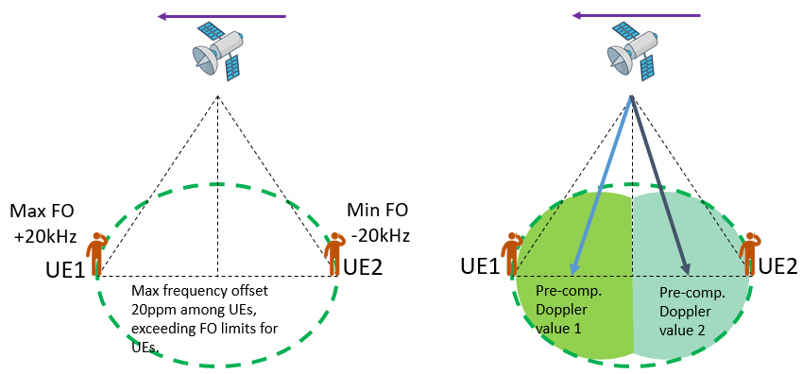
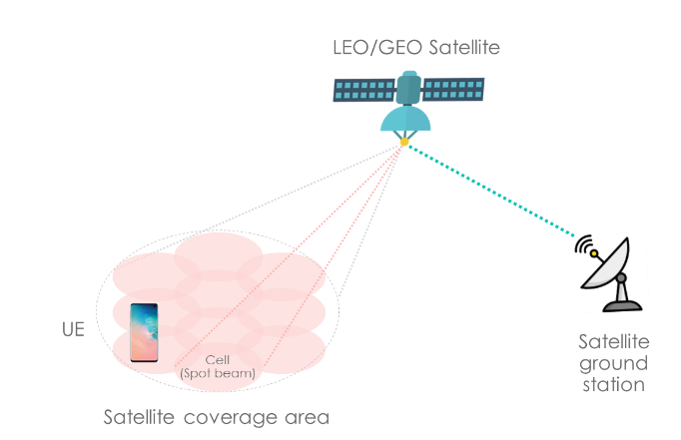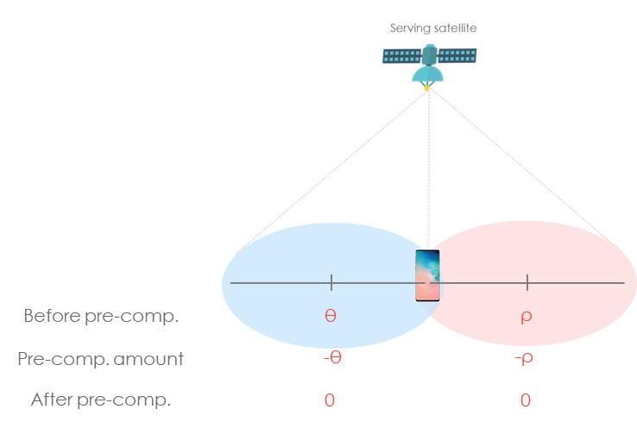

As suggested in RAN1#104-e and RAN1#105-e and RAN1#106-e meeting, DL synchronization issues should be discussed in AI 8.4.2 to check if it is in the WID scope. Thus this topic is not further discussed in this agenda item.

Power Control and PUSCH coverage
Samsung proposed that open loop power control, UE should be allowed to predict its own transmission power not only based on DL measurement, e.g., pathloss measurement but also other available information, such as gNB ephemeris and UE trajectory. Samsung proposed closed loop power control should be supported in NTN and a mechanism to disable closed loop power control should be considered.
Qualcomm proposed to support autonomous reduction of MCS for PUSCH at least for cases when UE is power limited and to study the exact triggering condition and indication of the reduced MCS
FL suggestion: this topic seems out of the WID scope. FL suggests to check with AI 8.4.3 FL to confirm if the relevant work should be discussed there.

References
R1-2108912 Discussion on beam management and other aspects for NTN Spreadtrum Communications
R1-2108974 Discussion on other aspects for NR-NTN vivo
R1-2109079 Discussion on beam management OPPO
R1-2109167 Further discussion on remaining aspects for NR over NTN Nokia, Nokia Shanghai Bell
R1-2109223 Beam management and other aspects for NTN CATT
R1-2109282 Other Aspects for NTN CMCC
R1-2109325 Discussion on other aspects for NTN Lenovo, Motorola Mobility
R1-2109360 Remaining issues for NR NTN NEC
R1-2109412 Discussion on other design aspects for NTN Xiaomi
R1-2109489 Remaining issues for NTN Samsung
R1-2109678 Discussion on other aspects for NR NTN NTT DOCOMO, INC.
R1-2109749 Discussion on other design aspects for NTN Huawei, HiSilicon
R1-2109766 Discussion on beam management and other consideration for NTN Baicells
R1-2109789 Discussion on beam management and polarization for NTN Sony
R1-2109828 Other aspects of NR-NTN FGI, Asia Pacific Telecom, III, ITRI
R1-2109846 Discussion on additional enhancement for NR-NTN ZTE
R1-2109877 Network Verified UE Location in Non-Terrestrial Networks Fraunhofer IIS, Fraunhofer HHI, Thales
R1-2109881 On beam management for NTN InterDigital, Inc.
R1-2109892 Considerations on NTN with Transparent Payload III
R1-2109930 On other enhancements for NTN Ericsson
R1-2110034 Discussion on Other Aspects of NR NTN Apple
R1-2110087 Discussions on other aspects of NTN LG Electronics
R1-2110186 BWP operation and other issues for NTN Qualcomm Incorporated
R1-2110259 Beam management and polarization signaling for NTN Panasonic

