3GPP TSG RAN WG1 Meeting #104bis-e R1-210xxxx
e-Meeting, April 12th – April 20th, 2021

Title: Session notes for 7.2.3
(Maintenance of Integrated Access and Backhaul for NR)
Source: Ad-hoc chair (Samsung)

Maintenance of Integrated Access and Backhaul for NR (1)
R1-2102588 Correction on search space definition for Type-3 CSS and USS CATT
R1-2103498 Clarification on availability indication for IAB-DU cell ZTE, Sanechips
R1-2103713 H/S/NA configuration per pair of IAB-DU cell and IAB-MT’s serving cell Ericsson, AT&T

[104b-e-NR-IAB-01] Handle R1-2102294 and the related discussion including the draft reply tdocs in AI 5: Granularity of the H/S/NA Slot Configurations for the IAB-DU (including RAN3 LS response) – Thomas (AT&T)
- Discussion and decision by April 15

Conclusion
RAN1 observations on Rel-16 IAB:
- The RAN1#98: “The H/S/NA attributes for the per-cell DU resource configuration should take into account the associated MT carrier frequency(ies)” is not explicitly captured in either RAN1 or RAN3 specifications.
- It is RAN1’s common understanding that the following interpretation of 38.213 captures the intended behavior in the usage of soft resources configured for a given IAB-DU cell in case the IAB-DU cell and IAB-MT CC are not on the same carrier frequency:
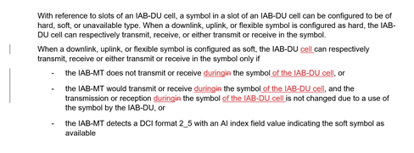

Agreement
Inform RAN3 that based on the above observations, providing H/S/NA slot configurations per (IAB-DU cell, collocated IAB-MT’s serving cell) pair is not necessary in Rel-16 and the existing per IAB-DU cell granularity is sufficient. LS is endorsed in R1-2104058.

Agreement
Text proposal for TS38.213 is endorsed in R1-2104059 (TS38.213, Rel-16, CR#0219, Cat. F).

