3GPP TSG RAN WG1 #104-e R1- 2101813
e-Meeting, January 25th – February 5th, 2021

Agenda item: 8.8.2
Source: Moderator (Qualcomm)
Title: FL summary of PUCCH coverage enhancement
Document for: Discussion/Decision

Introduction
In this document, a summary of companies’ proposals for PUCCH coverage enhancement is provided.

Dynamic PUCCH repetition factor indication

Scope of dynamic PUCCH repetition factor indication
Based on the WID, one of the objectives of this agenda item 8.8.2 is to “specify signaling mechanism to support dynamic PUCCH repetition factor indication”. One question was raised in [R1-2101523][ R1-2100400][R1-2101480] regarding the scope of dynamic PUCCH repetition factor indication. Specifically, the question is that whether dynamic PUCCH repetition factor indication should be applied to PUCCH does not have corresponding DCI, such as P-CSI, SP-CSI, SR, HARQ-ACK for SPS PDSCH. Companies are welcome to add your answer to this question in the following table.

Question: Whether dynamic PUCCH repetition factor indication can be applied to a PUCCH does not have corresponding DCI, such as P-CSI, SP-CSI, SR, HARQ-ACK for SPS PDSCH?
Company name | Answer
Samsung | No. The reasons for dynamic repetitions is to adjust to payload variations and to variations in number of symbols of the PUCCH resource. Those reasons do not exist for the listed cases.
CATT | For HARQ-ACK for SPS PDSCH, our feeling is that it is similar to the dynamically indicated HARQ-ACK for normal PDSCH, at least from the signaling perspective, i.e. it can be indicated by the activated/release DCI. It may be natural to apply the dynamic PUCCH repetition factor indication to HARQ-ACK for SPS PDSCH.  For the semi-static UCI, i.e. P-CSI, SP-CSI and SR, it may be not necessarily to have the dynamic PUCCH repetition factor indication. For SR, only one RB is needed in frequency domain and the resource consumption is not an issue even with large repetition number. gNB can configure the repetition number with a conservative manner in order to guarantee the coverage. For P-CSI and SP-CSI, if the coverage becomes a problem in certain case, gNB can trigger an A-CSI reporting.  Although we slightly prefer only apply to a PUCCH carrying HARQ-ACK for SPS PDSCH, we are open to discuss the other UCI type.
China Telecom | We think it may be pretty hard to perform dynamic PUCCH repetition for a PUCCH does not have corresponding DCI. But we are open to discuss it.

Options for dynamic PUCCH repetition factor indication
Based on the input from all companies, there are three options to support the signaling of dynamic PUCCH repetition factor.

Option 1 (without DCI enhancement): Enhance RRC signaling to allow configuration of PUCCH repetition factor per PUCCH resource. Dynamic PUCCH repetition factor indication is effectively achieved by reusing the “PUCCH resource indicator” field (without increase # bits of it) in DCI.
Supporting companies: Huawei/HiSi, ZTE, VIVO, IDC, Intel, Ericsson, Docomo, Sharp, ETRI, Wilus, CATT, CT, LG, CMCC, Xiaomi, [Panasonic?], [Apple?]

Option 2 (with DCI enhancement): Introduce a new field or increase the number of bits of existing field (e.g., PRI) in DCI for PUCCH repetition factor indication.
Supporting companies: Nokia, QC, Oppo, Samsung (with different configurations), CATT, CT, Apple, LG, CMCC, Xiaomi, ETRI, [Spreadtrum?]

Option 3: Without increasing the number of bits of “PUCCH resource indicator”, re-interpret this field such that a value of this field is mapped to a combination of PUCCH resource index and repetition factor.
Supporting companies: Lenovo, Motorola Mobility

Based on FL initial assessment, the pros and cons of the three options can be summarized in the below table.

 | Pros | Cons
Option 1 | No DCI size increment  Applicable to fallback DCI | Does not apply to P/SP-CSI or HARQ-ACK for SPS PDSCH  Medium flexibility
Option 2 | Maximal flexibility  With DCI enhancement, it (potentially) can be applied to P/SP-CSI or HARQ-ACK for SPS PDSCH | Increased DCI size/new DCI field  Not applicable to fallback DCI
Option 3 | FFS | Least flexibility because the number of repetitions for each resource index is hardcoded in spec

Based on the pros and cons of the above options, also considering the number of supporting companies, the following is proposed.

Proposal 1: Down select from the following two options to support dynamic PUCCH repetition factor indication.
- Option 1 (without DCI enhancement): Enhance RRC signaling to allow configuration of PUCCH repetition factor per PUCCH resource. PUCCH repetition factor is implicitly indicated by DCI via reusing the “PUCCH resource indicator” field (without increase # bits of it) in DCI.
- Option 2 (with DCI enhancement): PUCCH repetition factor is explicitly indicated by DCI, e.g., introduce a new field or increase the number of bits of an existing field (e.g., PRI) in DCI for PUCCH repetition factor indication.

Companies are welcome to provide comments to the above proposal in the following table.
Company name | Comments
Samsung | Option 2 is a straightforward way to account for the variable number of symbols and UCI payloads in the number of repetitions.  It is not correct that Option 1 does not require DCI size increase – it is not for free. For example, if the number of repetitions is not included in the PUCCH resource, the PRI can have fewer bits (and the additional bits can be used to indicate the repetitions).  In addition to not mixing functionalities, another important advantage of Option 2 vs. Option 1 is that an adjustment of the number of repetitions to the UCI payload is fully flexible – not so if the repetitions are part of the PUCCH resources where many-to-one mapping exists between UCI payloads and PUCCH resource.
CATT | We are fine with the proposal.
China Telecom | Support this proposal. Both option 1 and option 2 are acceptable for us.

DMRS bundling across PUCCH repetitions
The second objective of this agenda item is to “specify mechanism to support DMRS bundling across PUCCH repetitions.” Under this objective, a few topics are addressed in companies’ contributions. The topics are summarized as below.

Prerequisite for DMRS bundling across PUCCH repetitions
Several prerequisites are proposed by different companies. The prerequisites include at least the following
- Same transmission power across PUCCH repetitions
- Same frequency resource allocation across PUCCH repetitions
- No TA adjustment across PUCCH repetitions
- No Tx spatial filter change across PUCCH repetitions
- No time gap across PUCCH repetitions

Many companies expressed that RAN1 should aim to harmonize the Prerequisite of DMRS bundling for PUCCH and PUSCH.

FL’s initial assessment is that RAN1 could wait for RAN4 reply LS to decide what RAN1 need to do with those prerequisites.

[R1-2101523] proposed to study gNB assisted wideband phase compensation (single scalar estimation) to enable bundling across noncontiguous slots. Companies are encouraged to provide feedback regarding this proposal in the following table.
Company name | Comments on the proposal “to study gNB assisted wideband phase compensation (single scalar estimation) to enable bundling across noncontiguous slots”
Samsung | We don’t think this needs to be studied because of the additional UE complexity, DL overhead, and likelihood of no gains given that the size of the DMRS bundling window will be anyway limited by the gNB frequency clock error.
CATT | It seems the gNB assisted wideband phase compensation is a kind of gNB implementation. Could Ericsson elaborate a little bit for better understanding? For example, what is the specification impact?

[R1-2100460] proposed that a UE can signal to NW when the UE can ensure phase continuity for UL transmission across multiple occasions, and how long UE can maintain the phase continuity. Companies are encouraged to provide feedback regarding this proposal in the following table.
Company name | Comments on the proposal of “a UE can signal to NW when the UE can ensure phase continuity for UL transmission across multiple occasions, and how long UE can maintain the phase continuity”
Samsung | We don’t think such a detailed UE capability report is needed. The proposal is also unnecessary at the moment. It can be revisited once the design for DMRS bundling has progressed.
CATT | Open to discuss.

Interaction between DMRS bundling and intra/inter slot freq hopping
For the interaction between DMRS bundling with inter-slot and intra-slot frequency hopping, 9 companies (Vivo, ZTE, OPPO, Xiaomi, Intel, CMCC, Apple, Panasonic, CATT) propose to study or support inter-slot frequency hopping pattern enhancement with DMRS bundling across PUCCH repetitions.

For intra-slot frequency hopping enhancement with DMRS bundling across PUCCH repetitions, [R1-2100747] proposes to support it, while [R1-2101129] is against to support it.

Based on the input from companies on this topic, the following FL proposal is made

Proposal 2: Subject to the prerequisite of DMRS bundling for PUCCH repetitions, support inter-slot frequency hopping pattern enhancement for PUCCH repetitions with DMRS bundling.
- FFS: details in inter-slot frequency hopping pattern enhancement.
- FFS: intra-slot frequency hopping enhancement for PUCCH repetitions with DMRS bundling.

Companies are welcome to provide comments to the above proposal in the following table.
Company name | Comments
Samsung | OK in general. The wording can be improved (e.g. there is no “enhancement”, only additional FH pattern(s) than in Rel-16) but that can be discussed later.
CATT | Support.
China Telecom | Support this proposal.

Signalling mechanism to enable DMRS bundling across PUCCH repetitions
Two open issues are identified in the area of signaling mechanism to enable DMRS bundling across PUCCH repetitions.

This first issue is how to enable DMRS bundling across PUCCH repetitions. Several companies address this issue in their contributions and their view are summarized as below.
- Xiaomi: via dynamic signaling
- Interdigital: via semi-static configuration
- Panasonic: via UE specific configuration
- QC: via RRC configuration on per PUCCH resource basis

So far, the views are quite diverged. Companies are welcome to provide comments and solution to this open issue.
Company name | Comments
Samsung | UE specific configuration seems sufficient but OK to discuss further whether or not there is any need for DCI-based indication.
CATT | This issue is related to the second issue. Considering we are discussing how to single/configure DMRS bundling duration/size, do we really need a separate indication to enable DMRS bundling across PUCCH repetitions？  If gNB signal/configure a DMRS bundling duration/size, the DMRS bundling across PUCCH repetitions is automatically enabled.
China Telecom | Similar mechanism of PUSCH can be considered.

The second issue is how to signal/configure DMRS bundling duration/size. Several companies address this issue in their contributions and their view are summarized as below.
- VIVO: implicitly derived based on TDD configuration
- Xiaomi: via configure on per PUCCH format basis
- Interdigital: via an indication of bundling group index
- Panasonic: via UE specific configuration
- LG: whether allow multiple bundling size for an aggregated PUCCH repetitions
- QC: via signaling of a bundling window

So far, the views are quite diverged. Companies are welcome to provide comments and solution to this open issue.
Company name | Comments
Samsung | FFS.  Need for configuration of a bundling window should be further discussed.
CATT | Open to discuss.
China Telecom | Similar mechanism of PUSCH can be considered.

Interruption/prioritization between DMRS bundled PUCCH repetitions and other DL/UL channels
[R1-2100460] mentioned PUCCH repetitions with DMRS bundling may be interrupted by other transmissions/procedures, and whether and how to ensure phase continuity in these cases should be further studied. The interruptions could occurs when an PUCCH transmissions is cancelled by SFI, CI or higher priority transmissions. A PUCCH transmission can also be impacted by UL transmission in another serving cell, when intra band CA is configured.

[R1-2101398] identified that following the current specification, a PUCCH repetition occasion within a bundle of repetitions with DMRS bundling may be dropped, e.g. if another overlapping PUCCH has a UCI type with a higher priority, as mentioned above. Subsequently, the phase continuity will be lost for the first PUCCH with DMRS bundling. It is proposed in [R1-2101398] If DMRS bundling is supported, specify conditions under which a PUCCH with DMRS bundling overlapping in one (or more) occasions with a second PUCCH and yet UE is able to perform joint channel estimation across all repetitions.

So far, only two companies provided views on this issue. FL would like to collect more input on this issue before moving forward. In the table below, companies are encouraged to provide feedback on UE procedures to handle interruption/prioritization between DMRS bundled PUCCH repetitions and other DL/UL channels.
Company name | Comments on UE procedures to handle interruption/prioritization between DMRS bundled PUCCH repetitions and other DL/UL channels
Samsung | RAN4 input may be required about whether or not the UE can maintain phase continuity if the UE only suspends an ongoing transmission. Further, it is not clear whether any specification support is required for such cases. The issue can be deprioritized for now and be discussed further next time.
CATT | For UL CI, there should be no issue as UL CI cannot cancel a PUCCH transmission.  For the other two cases mentioned above, a general comment is that what is the difference from the non-continuous PUCCH transmission? If the RAN4 requirement and all the aforementioned factors are satisfied, the cancellation case seems same as the other general cases.

DMRS optimization with bundling across PUCCH repetitions
DMRS location and granularity optimization is mentioned in a few companies’ contributions [R1-2100098, R1-2100400, R1-2101021]. Furthermore, [R1-2101713] has a proposal to clarify what is the scope of “DMRS bundling”, which is related to this topic. More specifically, [R1-2101713] want to clarify whether b) in following figure is allowed by “DMRS bundling” for PUCCH repetitions?
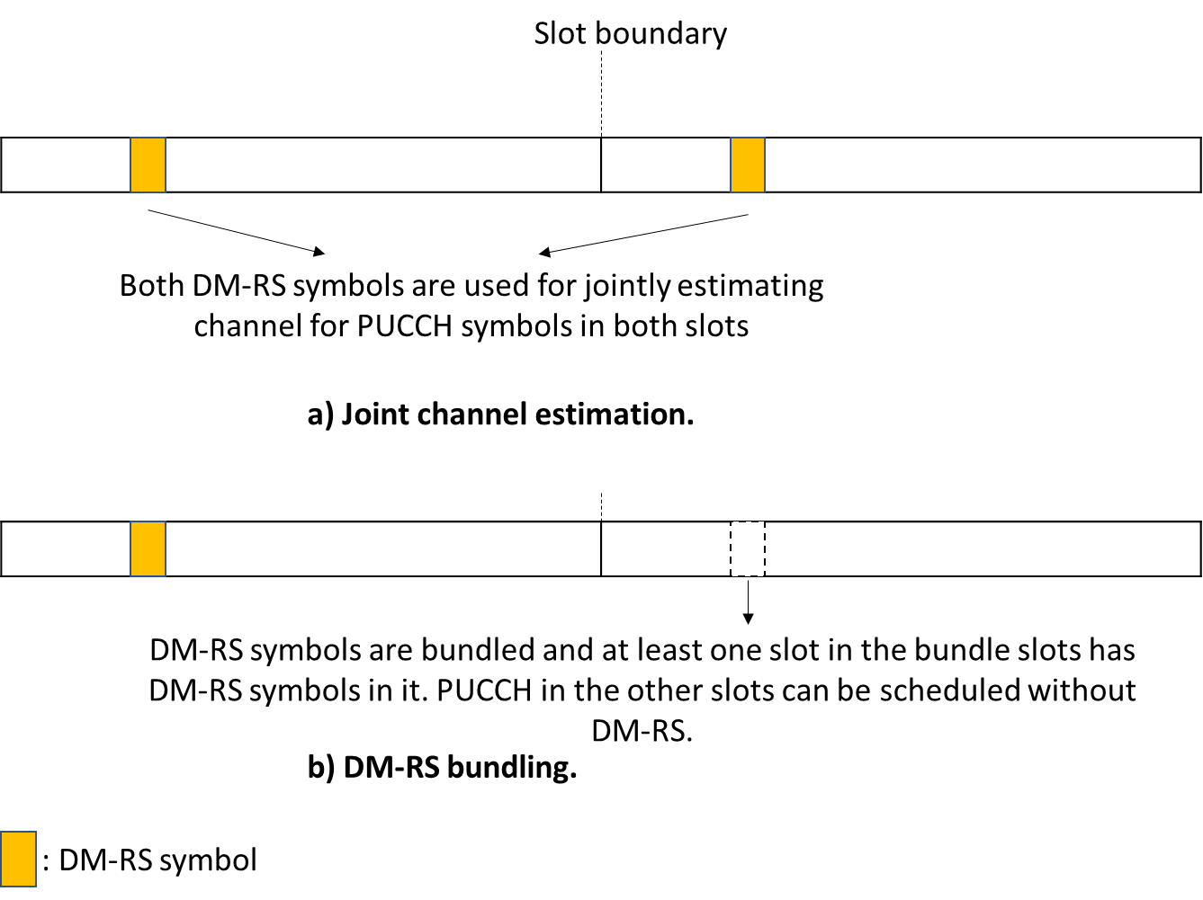

Based on the input from these contributions, there are two types of DMRS location/granularity optimization.
- Type 1: on top of Rel-15/16 DMRS patten/location/granularity defined for PUCCH transmit in a slot, introduce new DMRS pattern/location/granularity for PUCCH transmit in a slot.
- Type 2: no change of Rel-15/16 DMRS patten/location/granularity defined for PUCCH transmit in a slot. Allow a PUCCH to be transmitted without DMRS in one or more slot(s) within a set of bundled slots.

To address this open issue on DMRS optimization, there are four alternatives:
- Alt 1: Neither type 1 nor type 2 DMRS optimization is supported.
- Alt 2: Only type 1 DMRS optimization is supported, type 2 DMRS optimization is not supported.
- Alt 3: Only type 2 DMRS optimization is supported, type 1 DMRS optimization is not supported.
- Alt 4: Both type 1 and level 2 DMRS optimization are supported.

Companies are encouraged to provide feedback on this open issue in the following table.
Company name | Comments on which alternative should be adopted
Samsung | Alt 1: No need to design additional DMRS patterns.  Can be revisited/reevaluated after progress on DMRS bundling.
CATT | From our point of view, DMRS optimization is valuable to PUCCH as well. Type 1 has more flexibility and possibility to achieve a high-end optimization. We slightly support type 1. This issue is related to the definition of DMRS bundling duration. If DMRS bundling duration is signaled, the new DMRS pattern/location/granularity for PUCCH should be defined in the DMRS bundling duration, instead of in a slot.  In short, our first preference is Alt2 and second is Alt.4.

Others
There are a few other proposals mentioned in submitted contributions to this agenda. FL’s initial assessment is that they are out of the scope of this agenda. They are listed below for now just for information purpose.
[R1-2101129]: Before RRC connection is established, dynamic repetition factor for PUCCH can be indicated in SIB1.
[R1-2101224]: The maximum number of repetitions for transmission of PUCCH repetition is 32.

[R1-2101523]: The dynamic PUCCH repetition mechanism should be applied to all PUCCH formats and all UCI types including A-CSI.

References
Tdoc # | Title | Source
R1-2100098 | Discussion on coverage enhancements for PUCCH | ZTE
R1-2100175 | PUCCH enhancements for coverage | OPPO
R1-2100198 | PUCCH coverage enhancement | Huawei, HiSilicon
R1-2100400 | Discussion on PUCCH enhancements | CATT
R1-2100460 | Discussion on PUCCH enhancements | vivo
R1-2100668 | Discussion on PUCCH enhancements | Intel Corporation
R1-2100715 | Discussions on coverage enhancement for PUCCH | LG Electronics
R1-2100747 | Discussions on PUCCH enhancements | InterDigital, Inc.
R1-2100798 | Considerations on PUCCH coverage enhancement | Spreadtrum Communications
R1-2100918 | Discussion on PUCCH enhancements | China Telecom
R1-2101021 | Discussion on PUCCH enhancement for NR coverage enhancement | Panasonic Corporation
R1-2101058 | Discussion on PUCCH enhancements | CMCC
R1-2101081 | PUCCH enhancements | ETRI
R1-2101129 | PUCCH enhancement | Xiaomi
R1-2101224 | PUCCH enhancements | Samsung
R1-2101398 | PUCCH coverage enhancement | Apple
R1-2101480 | PUCCH coverage enhancements | Qualcomm Incorporated
R1-2101523 | PUCCH Dynamic Repetition and DMRS Bundling | Ericsson
R1-2101548 | Dynamic PUCCH repetition factor indication | Sharp
R1-2101576 | Enhancements for PUCCH repetition | Lenovo, Motorola Mobility
R1-2101626 | PUCCH enhancements for coverage enhancements | NTT DOCOMO, INC.
R1-2101682 | Discussion on PUCCH enhancements for coverage enhancement | WILUS Inc.
R1-2101713 | PUCCH coverage enhancements | Nokia, Nokia Shanghai Bell

