3GPP TSG RAN WG1 Meeting #104-e R1-2102079
e-Meeting, Jan. 25th – Feb. 5th, 2021
Source: Moderator (ZTE)
Title: FL summary #4 on SRS enhancements
Agenda Item: 8.1.3
Document for: Discussion and Decision

Introduction
In RAN#86, the Rel-17 WID of further enhancements on MIMO for NR is approved [1]. In the approved WID, a particular point is about SRS enhancements in terms of flexibility, coverage and capacity, targeting both FR1 and FR2. The detailed scope of the SRS enhancement is given as follows.
3. Enhancement on SRS, targeting both FR1 and FR2:
  - Identify and specify enhancements on aperiodic SRS triggering to facilitate more flexible triggering and/or DCI overhead/usage reduction
  - Specify SRS switching for up to 8 antennas (e.g., xTyR, x = {1, 2, 4} and y = {6, 8})
  - Evaluate and, if needed, specify the following mechanism(s) to enhance SRS capacity and/or coverage: SRS time bundling, increased SRS repetition, partial sounding across frequency
Previous RAN1 agreements on these SRS enhancements are given in Section 6.1.
In this contribution, we summarize companies’ views on the above SRS enhancements submitted to RAN1#103e [2]-[25].

Flexibility enhancements

SRS triggering offset

2.1.1. Reference slot definition
Table 2-1
Opt. 1 | Reference slot is the slot with the triggering DCI
Opt. 2 | Reference slot is the slot indicated by the legacy triggering offset

FL Proposal 2-1: For reference slot definition, support Opt 2 (Reference slot is the slot indicated by the legacy triggering offset).

Supported by NEC, CMCC, Xiaomi, Qualcomm, Ericsson, Sharp, InterDigital, CATT, vivo, MediaTek, Intel, Lenovo, MotM, Samsung, Apple
Concern: LG, OPPO, Huawei, HiSilicon, Spreadtrum. (Support Opt. 1 instead)

Companies’ further views are collected as follows.
Companies | Views
OPPO | Not support.  During the previous discussion, some companies think Option 2 offers more flexibility than Option 1.  According the agreement of GTW session, a list of t values is configured in RRC for each SRS resource set. Let assume that for option 2, Rel-15 RRC configured offset set is T0, and the a list of t values is {t0, t1, .. }. If a list of t values { N0+t0, N0+t1, …} is configured for option 1, then option 1 will achieve the same purpose of option 2. In summary, we don’t see any additional flexibility of option 2 compared to option 1.  In contrast, Option 2 will lead to more UE complexity since option 2 requires more procedures to achieve the same purpose.  Option 2 needs four steps:  - a. determine the RRC-configured offset,  - b. determine the additional offset indicated by DCI,  - c. calculate the total offset (RRC-configured offset + additional offset),  - d. determine the occasion for real transmission.  Option 1 needs only two steps:  - a’. determine the offset indicated by DCI,  - b’. determine the occasion for real transmission.
Huawei, HiSilicon | Support Option-1.  We share the similar view as OPPO, and do have concerns on Option-2 on flexibility for Aperiodic SRS triggering, where flexibility of SRS triggering is the goal for the enhancement.  For single SRS set case: If the slotoffset in Option-2 is not 0, then the available slot for SRS transmission before reference slot cannot be used for SRS transmission.  Example-1:  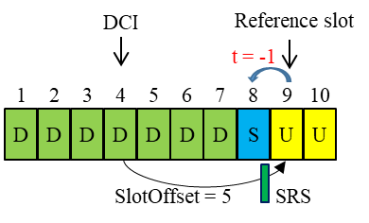  For Multi SRS sets case: With candidates list ‘t’ configured per set, the SRS transmission can be allocated in different slot easily in Option-1. However, there is some problems on flexibility for Option-2. Following are examples:  Example-2:  - SRS set-1 with slotoffset=0 and candidate list ‘t’= {0, 1}  - SRS set-2 with slotoffset=1 and candidate list ‘t’ ={0, 1}  Then, there is SRS transmission collision between set-1 and set-2 when the triggering DCI is in the slot before reference slot, due to ‘t’ is the same list.  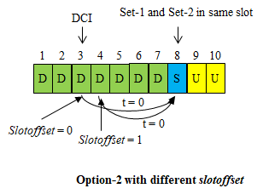  Example-3:  - SRS set-1 with slotoffset=0 and candidate list ‘t’= {0, 1}  - SRS set-2 with slotoffset=1 and candidate list ‘t’ ={1, 2}  If the triggering DCI in the following S slot, then the SRS set-1 can only be transmitted in {S, or U1}, but SRS set-2 can only be transmitted in {U2, or U3}, while U3 is out of the frame.  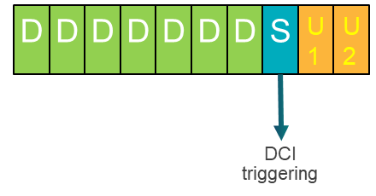  Obviously, Option-1 is no above issue. So, Option-1 should be supported.
Lenovo, MotM | Support FL proposal since it can also support the legacy UE behavior in R15/16.
InterDigital | Support FL proposal. We believe that Option2 is a better solution.  - If ever needed, by employing Option 2, the NW can still operate as Option 1 if the slotoffset in configured to 0.  - Also, switching to a different definition of slot reference for an enhancement is counter-intuitive and not helpful, as it adds unnecessary complications to specifications and implementation.  - Unlike what presented by some of our colleagues, there is no meaningful difference in UE complexity between the two options. In both cases, the slotoffset is always configured and known to the UE; thus no determination step is required.  - Another drawback of Option 1 is its limitation for AP SRS triggering for MU-MIMO. With Option 1, to be able to trigger AP SRS for multiple UEs using a single DCI, we need to have a similar set of t values configured for all involved UEs which it obviously involves RRC (re)configuration of multiple t values. However, in Option2, a same set of configured t can be used for all UEs, and only (re)configuration of a single slotoffset parameter may be needed which requires much less overhead for RRC signaling.
Intel | Support FL proposal
Apple | We are fine with FL proposal.
QC | Support FL proposal.  Reply to OPPO on UE complexity.  - Rel-17 UE must support legacy SRS triggering based on slot offset and is currently supported by UE implementation. What we are discussing in Rel-17 is additional/optional feature for enhancement of SRS triggering. So, for fair comparison, your analysis should consider the complexity for supporting legacy triggering scheme for both options. Option 1 and legacy are two different mechanics and don’t have much in common. While option 2 is an extension of legacy triggering. In other words, Legacy triggering and option 2 share common processing.  - Having this in mind, let’s discuss what is the extra complexity based on current implementation (legacy) for both options. Decoding the DCI and determining the value of ‘t’ is common for both options and is trivial operation. The most complex part from UE side is the timeline and bookkeeping/counting. Option 2 is natural and incremental extension for current implementation and doesn’t affect UE Timelines. The UE will either send SRS at the SlotOffset (legacy mechanism) or at a later slot based on reference SlotOffset (enhanced mechanics). However, to support option 1, the UE should have two timelines and two bookkeeping and counting mechanism; one is based on legacy and the other one is based counting towards available slot.  - So, as a UE vendor, we prefer option 2 from implementation point of view.
Futurewei | Regarding the comment on MU MIMO support, we think Option 1 is more suitable than Option 2. When DL MU MIMO CSI acquisition is done via SRS, the SRSs may resemble the DL DMRSs and be multiplexed in the same way as DL DMRSs. In this case, transmitting SRSs on the same slot or even on the same symbol may not be an issue but could be an advantage from SRS capacity perspective. Note that even if more than one SRS set (for the same UE or different UEs) are indicated on the same slot, it does not mean that it will cause a collision, as the SRS may be multiplexed.  To further compare the options, let’s fix a given configuration of SRS resource set with a given slotoffset and a given DCI field bitwidth. We can check which slots are within reach and which are not for different options. Option 1 can indicate x near-future slots but not far-future slots, and Option 2 can indicate x far-future slots but not near-future slots except for the no slotoffset case. It is questionable why far-future slots indication is useful. If we were to overcome the issue of Option 2 with 0 slotoffset all the time, it just reduces to Option 1. So our analysis still shows Option 1 is a better solution.
Samsung | As InterDigital mentioned, we also think option 2 can handle option 1 by setting slotoffset to zero. And using option 2, concern for supporting legacy operation used in Rel-16 mentioned by QC, Lenovo, MotM, and others can be solved as well. Also, in the current RRC spec, “slotOffset” can be absent and the UE applies no offset (value 0). Given the agreement for supporting the configuration of a list of t values in RRC for each SRS resource set, we carefully suggestion to go with e.g.,  When ‘slotoffset’ and a list of ‘t’ are configured, the reference slot is followed by option 2 and when ‘slotoffset’ is not configured (is absent) but a list of ‘t’ is configured, the reference slot is the slot with the triggering DCI (option 1).
Huawei, HiSilicon2 | Still support Option-1.  The enhancement work for A-SRS triggering is due to the limitation of A-SRS triggering with the legacy slotoffset configuration.  It is very interesting that companies argued that: on one hand “the complexity of Option-1 is more than Option-2”, but on the other hand, “Option-1 is a special case for Option-1”. If Option-1 is included in Option-2 already, how the complexity of Option-1 is more than Option-2?  To reply InterDigital/Lenovo/QC: Rel-17 UE is with the capability to use flexible triggering with available sot “t”, the slotoffset is also will be there for Rel-15/16, there is no collision. But, in Option-2, Rel-17 always need to count the SRS transmission slot with considering both slotoffset and ‘t’. On the contrary, in Option-1, only ‘t’ need to be considered in slot counting. We are also as a UE vendor, do not think the complexity of Option-1 is more than Option-2. But we think Option-2 is with more complicated slot counting than Option-1, while the two different timelines need to be considered simultaneously for Rel-17 UE.  To reply InterDigital: For MU measurement, we agree with Futurewei’s reply that the SRS resources should be measurement at the near/close/same time as much as possible, but not with introduce slotoffset to long distance slot. We have clarified in the last reply, Example-3, that if with slotoffset configuration, we can see that the second SRS sets (can be another MU-UE), the U3 slot have to be more than 8 slots delay. So, the same view with Futurewei, for the MU case, Option-1 is much more proper.  By the way, after rounds discussion, it is clear that if slotoffset is not equal to 0, the flexibility of A-SRS triggering will be restricted (please see the Example-1/2/3 in our first reply). So, in Option-2, slotoffset is need to always 0. If slotoffset is equal to 0 always, we do not need to RRC configure slotoffset anymore, which exactly is the Option-1.
CATT | Support FL proposal since Option 2 is more flexible. It is benefit to allow gNB to be able to configure reference slot in some scenarios. For example, when a TDD UL/DL pattern with more UL slots than DL slots is configured, determining reference slot according to slotOffset is helpful on avoiding collision of SRS resource sets. E.g., assuming that DDDUUUUUUU is configured, and the slotOffset of SRS resource set 1 is set to 2 and the slotOffset of SRS resource set 2 is set to 3, then even if same t is indicated for the 2 SRS sets, the 2 SRS sets wouldn’t be collided since they have different reference slots.
Ericsson | Support FL proposal. The use of non-zero slot offset allowed by Option 2 is gNB implementation, it gives more flexibility and is future proof to currently unknown problems in operators networks.
Huawei, HiSilicon3 | For the comment from CATT:  In my previous examples are based on the general configurations for slot in current deployment. For your mentioned case with more UL slots than DL, since the candidates available slots are configured per set (already agreed), so the two different slotoffset configuration in Option-2 is equivalent to two candidates available slots list configuration with a shift in Option-1. However, due to the slotoffset counting is not based on available slot for Option-2, there are similar issues shown in Example-2 and 3 in my first reply also will be happen for Option-2. For simple example shown as follows,  - SRS set-1 with slotoffset=0 and candidate list ‘t’= {0, 1}  - SRS set-2 with slotoffset=1 and candidate list ‘t’ ={0, 1}  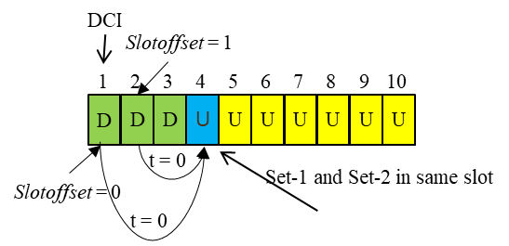  We can see SRS set1 and 2 will be collided. So, we only see the triggering flexibility in Option-2 will be restricted, but Option-1 will be not.  For the comment from Ericsson:  I think we are not convinced by “future proof to currently unknown problems”, since we have clarified there are issues for SRS collision and non-flexible SRS triggering, and also some problem on UE complexity issues for Option-2 in my previous two replies. So, we still think Option-1 should be supported, but not Option-2.

Flexible antenna switching
FL Proposal 2-9: Study the use cases, benefit and if needed, mechanism for L1 or L2 based adaptation on the number of Tx and/or Rx antennas for SRS antenna switching based on the indicated UE capability of supported SRS-TxPortSwitch
- Consider this adaption is applicable to which type(s) of SRS ( aperiodic SRS, periodic SRS, or semi-persistent SRS)
- Potential use cases to be considered: UE power saving, NW overhead saving, multi-panel UEs, etc.
  - Motivations/target use cases should be clarified before moving forward to detailed designs
- FFS via MAC CE or DCI
- FFS whether to consider dynamic DL MIMO layer adaptation together
- FFS UE reporting of the preferred Tx/Rx antenna number
- FFS potential enhancements on CSI measurement to solve issues (if any) caused by this dynamic adaption

Supported by Spreadtrum, Lenovo, MotM, Nokia, NSB, Intel, Ericsson, Xiaomi, InterDigital, Qualcomm, ZTE, Apple, Qualcomm, CATT, Samsung, CMCC
Concern: vivo, OPPO

Companies’ further views are collected as follows.
Companies | Views
OPPO | We still failed to see the use cases and benefits. Could the proponents elaborate a bit on the use cases and benefits? Moreover, we have a couple of questions for clarification  - The 2nd bullet: If power saving is the design target, we prefer to discus it in power saving session where companies can have a whole picture which mechanism(s) are most useful for power saving  - The 2nd bullet: what’s the relationship between antenna switching and multiple panels? Why do we need some specific antenna switching design for multi-panel Ues?  - The 4th bullet: DL MIMO layer is indicated by NW. In Rel-15, NW has the flexibility to dynamically change the DL MIMO layers for transmission. Moreover, NR supports UE assistance information where UE can report the preferred DL/UL MIMO layers. What’s the spec impact of this bullet?  - The 5th bullet: What is “UE reporting” referring to here? UE capability or something else? The Rx/Tx antenna number seems related to the MIMO layers that can be recommend via UE assistance information.
Huawei, HiSilicon | Not positive on this issue, but fine for study.
Lenovo, MotM | Support this proposal with MAC CE based approach.  One of applicable scenario is for multi-panel UE, where the UE RX panel(s) may be activated semi-statically and the SRS resources corresponding to the deactivated panel(s) can also be deactivated. Another purpose is for power saving, especially for UE with 1T6R and 1T8R UE in poor channel conditional, where high rank transmission is almost impossible.
InterDigital | Support FL’s proposal for study.
Intel | Generally fine with FL proposal.  Just one thing to clarify, what does the following bullet exactly mean?  - FFS potential enhancements on CSI measurement to solve issues (if any) caused by this dynamic adaption
Apple | We are fine with DL proposal
QC | Support FL proposal for the study.
Futurewei | We see some companies suggesting power saving as a motivation, but some other companies disagree. Could the proponents for this feature clarify?  @Intel: We described a CSI issue for antenna switching. That is, when the UE antenna configuration changes, the wireless channels and hence CSI change abruptly. For example, with 2 Rx antenna ports or with 8 Rx antenna ports, the channel H, PMI, RI, CQI, etc., can be all different. How to resolve this CSI issue depends on various factors, such as how often the switching occurs, but unfortunately, this is not clear yet as the motivation/target use cases have not been clarified. This issue has to be addressed, otherwise this feature may not work.
Samsung | We are ok with FL’s proposal
CATT | We are ok with the proposal for study.
Ericsson | Support the FL proposal.
CMCC | Fine with current proposal. Support the further study on the use cases to provide more clarity for motivation and benefits.  As we commented in the last round, the benefit for dynamic change between two modes ( e.g. 2T4R->1T2R->2T4R) do not bring benefits from the perspective of power saving and overhead reduction. We should be more careful with dynamic indication design.

Antenna switching up to 8Rx

Whether 4T6R is supported
FL Proposal 3-2: Support antenna switching SRS with 4T6R in NR Rel-17

Supported by OPPO, Spreadtrum, Lenovo, MotM, Nokia, NSB, NEC, Intel, Xiaomi, InterDigital, Qualcomm, NTT DOCOMO, CMCC
Concern: Futurewei, vivo, Huawei, HiSilicon, Ericsson. (Deprioritized or not support)

Companies’ further views are collected as follows.
Companies | Views
OPPO | Ok with the proposal
Huawei, HiSilicon2 | Not support.  We do have concerns on the antenna switching for 4T6R. For QC’s Tdoc and results, we have the following comments:  1. Please clarify the exact mapping between antennas and Tx chain with switches, since in the Tdoc, the mapping part is a black box. What’s the switches look like, especially for the best performance case: 4+4+4?  2. Please clarify the insertion loss modeling in the evaluation. In our understanding, with special antenna switches mapping may be with different insertion loss/modeling, which need to study.  3. It seems in the evaluation 4+4+4 for 4T6R is with best performance, but we already have the antenna switching solution for 2T6R, what’s the benefits compared to 2T6R? Actually, the same periodicity, but 2T6R may beneficial on less overhead and also each port is with much more transmit power (beneficial for channel estimation).  4. In the simulation provided by QC, although we do not know the exact antenna mapping and not sure the insertion loss modeling for the special cases, but some results show the gain of 1T6R and 2T6R are already better performance than 4T6R, e.g., Figure 3-7.
Lenovo, MotM | Support.
InterDigital | Support FL’s proposal.  In our contribution, we have shown that it is possible to support 4T6R without incurring any additional insertion loss or requiring an unconventional RF switching network.
Intel | Ok with FL proposal.
QC | Support FL proposal.  Thanks to Huawei for the questions and constructive discussion!  - There could different implementation for such RF switching network. One implementation could be based on 3x3 RF switch with one of the inputs is terminated. Such RF switch is commonly used by UE vendors for SRS switching and is supplied by several RF-FE vendors (e.g., Skyworks, Qorvo, etc.,).  - Based on this RF part, the insertion loss has a typical value of 1.18 and maximum of 1.44 dB for n78 band (3.3 to 3.8 GHz). In our analysis, we considered a 1.44 dB insertion loss (worst case) for all antenna ports.  - We are open consider (4+4) or (4+2) configuration which save on SRS resource overhead compared to 4+4+4.  - In general, there is tradeoff between 1TyR/2TyR and 4TyR depending on SRS periodicity and mobility. It is not only for 4T6R. In the appendix in our tdco, we showed results show that 4T8R is inferior to 1T8R and 2T8R at low mobility. This is due to power gain for 1T8R (6dB) compared to 4T8R. The situation is totally different for high mobility where 4T8R/4T6R outperform due to channel again and decorrelation for 1T8R/1T6R.  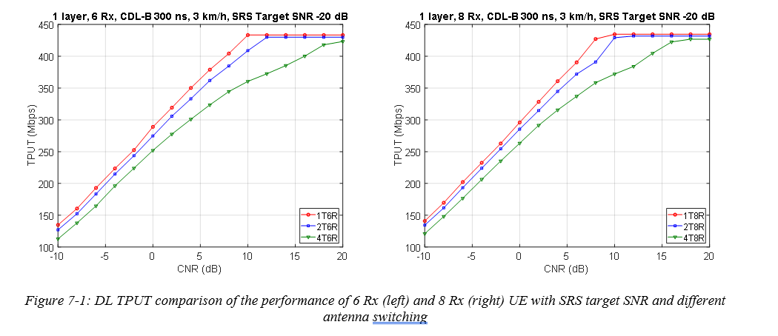  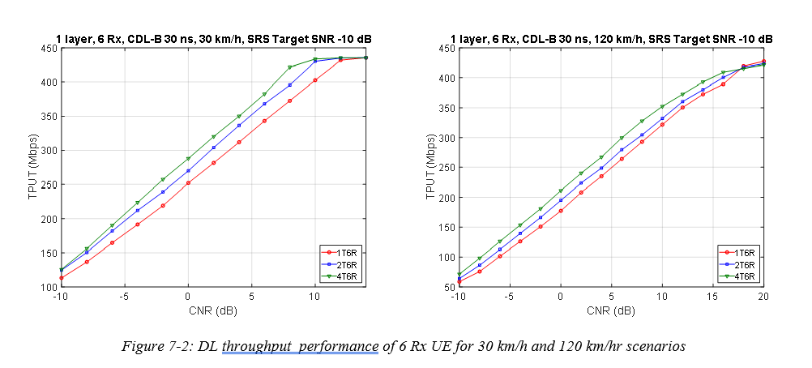
Futurewei | We had a comment on (4+2) in our contribution. The per-port Tx power seems different for 4 and 2, with 3 dB difference. As far as we understand, the power change could lead to problems.
Samsung | We are ok with FL’s proposal
Huawei, HiSilicon2 | Thanks for QC’s partial reply, please see the further comments:  - We understand the line connections as shown in your figure, but in a practical scenarios, each RF is now with 3 connectors for each switch, and each physic antenna is with 3 connectors as well, they are flexible to mapping between RF chain and physic antennas, then how to modeling the insertion loss for the special cases? And how to guarantee each line between RF and physical antenna will be the same?  - We understanding for 4T6R, there is different switching methods: 4+2, 4+4, 2+2+2 and 4+4+4, different solution may have different issues (such as different power and different insertion loss), we may not discuss one by one here. We also do not need to discuss the already agreed antenna cases again.  But, my previous question is for your exampled solution with 4+4+4 (best performance in QC’s simulation) for 4T6R, if compared to 2T6R we already supported, which is clear benefit we can obtain? In our understanding, the two antenna switching can be with same periodicity, but 2T6R may be beneficial on less overhead (2 ports per resource) and also each port is with doubled transmit power (beneficial for channel estimation).  Even the antenna configuration of 4T6R, the antenna switching solution is also possible with 2T6R. But, we do not see there is benefit on 4T6R with 4+4+4 compared to 2T6R with 2+2+2.  - By the way, as pointed in comment-2, we think 2T6R will be more beneficial than 4T6R the best case of 4+4+4. In the QC’s Tdoc, we see Figure-3-7/Figure 3-8 shown there is no clear benefit for 4T6R compared to 2T6R, copied as follows:  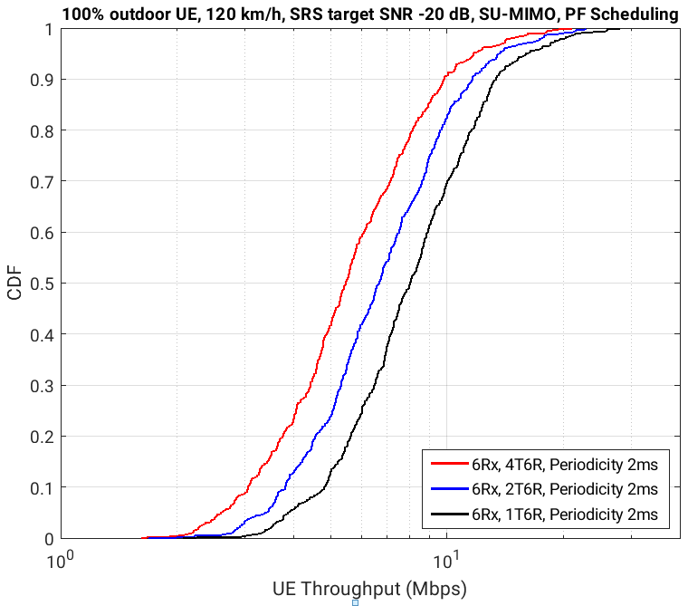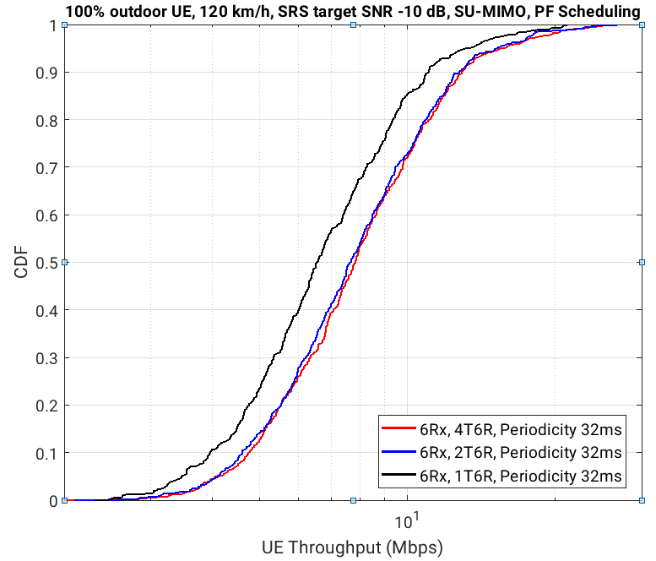
InterDigital | Support FL’s proposal.  In our contribution, we have shown that it is possible to support 4T6R without incurring any additional insertion loss or requiring an unconventional RF switching network.  Please see below more details for the antenna switching and mapping of resources for the 2T6R.  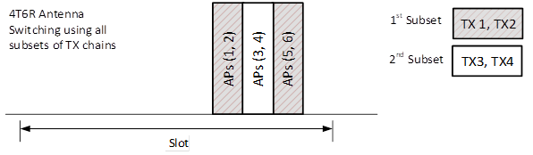
QC2 | Thanks, Huawei, for the reply! I’m not sure which part you still have concerns about.  - That is not correct understanding. It seems that my previous reply wasn’t clear and made some confusion on your side. Let me try to one more time how this works.  You can think of this 3x3 SW is a black box with three inputs and three output. Whatever inside that switch in terms of connections is unknow to us and is proprietary implementation by the vendors. We only care about the RF connections between the Tx chains of the wireless transceiver to that switch, and then from that switch to the antennas. There is only SINGLE RF connection between the Tx chain to the switch and also SINGLE RC connection between the output of the switch to the antenna port. Taking SKYWORKS RF part SKY5®-9600-11 (3P3T) for example (here is the link of the data sheet for your information). There is only one-to-one connection between antenna connector/Tx chains to the port of the switch.  This switch is programmable can connect any Tx port to any antenna port. Here is the description for Skywrods datasheet: “Any TRX port can be connected to any ANT port through a low insertion loss path, while maintaining high isolation to any of the other RF paths.”. It is not RAN1 work or concern how this switch is implemented, right? We care about how physical connection are made between Tx chains to antenna ports. And we care about the IL is the same (and also low) across all Tx/Ant mapping.  - It is good to have different solutions. It is RAN1 work to decide which solution is the best. If you have concerns on 4+4+4, as I said, there are different solutions! In your reply you mentioned different power and different insertion loss.  - We already clarified that there is no issue with the insertion loss.  - There are no issues with different power for 4+4, 2+2+2 or 4+4+4. For 4+2, the other SRS resource with two ports can either provide 3dB higher power or can provide the same power as the SRS resource with 4 ports. This can be done by using two SRS resource sets and have different PC parameters or can be done by explicit RAN1 spec that UE should keep same per-port Tx power across all SRS resources. The later solution is better as it save UE power.  - On the need of 4T6R, in our tdoc we showed by simulations both LLS/SLS that 4T6R outperforms 2T6T at high mobility or when SRS periodicity is large. We were fair in our analysis and showed both scenarios when one of the configurations (1T/2T vs 4T) is more favorable than the other. You are just looking at one of these scenarios for SU 😊. If you look at same scenario with MU (which is the most common use cases), you will see that 4T6R outperforms 2T6R.  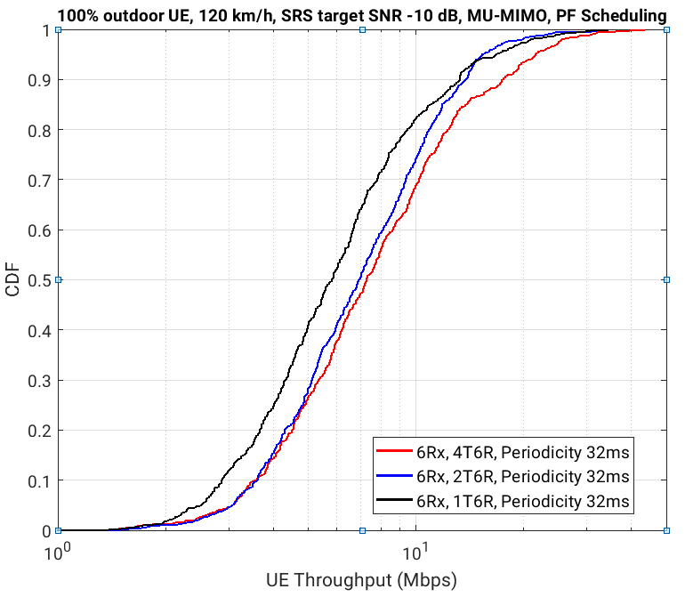  Figure 3-8: DL throughput performance of 6 Rx UE with speed 120km/h, 32ms sounding periodicity scenarios: SU and MU MIMO system performance.  Agains, some other results from SLS and LLS are below:  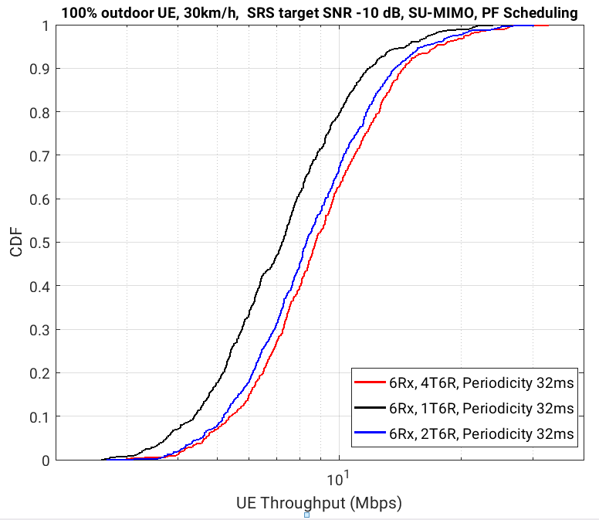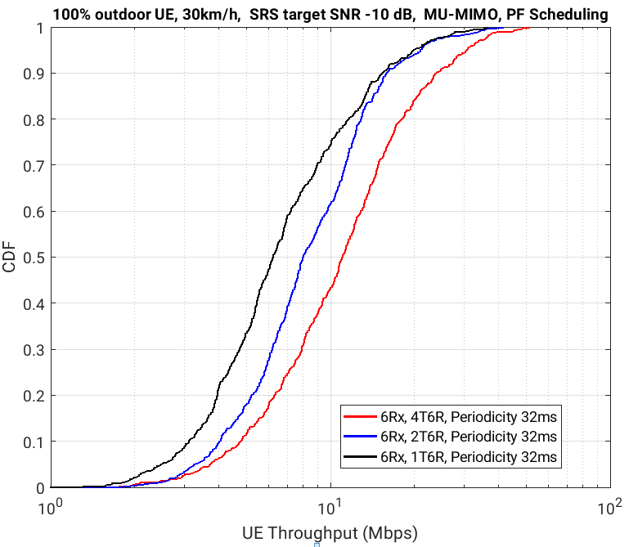  Figure 3-6: DL throughput performance of 6 Rx UE with speed 30km/h, 32ms sounding periodicity scenarios: SU and MU MIMO system performance.  Figure 7-2: DL throughput performance of 6 Rx UE for 30 km/h and 120 km/hr scenarios  Again 3GPP spec should be flexible to support future mobile devices and not to preclude any possible implementation. We shouldn’t look under our feet and try to find some corner cases just to push back. Also, if we follow your logic, then we don’t need to support 4T8R as 2T8R is good enough!!

Conclusion
FL Proposal 2-9: Study the use cases, benefit and if needed, mechanism for L1 or L2 based adaptation on the number of Tx and/or Rx antennas for SRS antenna switching based on the indicated UE capability of supported SRS-TxPortSwitch
- Consider this adaption is applicable to which type(s) of SRS ( aperiodic SRS, periodic SRS, or semi-persistent SRS)
- Potential use cases to be considered: UE power saving, NW overhead saving, multi-panel UEs, etc.
  - Motivations/target use cases should be clarified before moving forward to detailed designs
- FFS via MAC CE or DCI
- FFS whether to consider dynamic DL MIMO layer adaptation together
- FFS UE reporting of the preferred Tx/Rx antenna number
- FFS potential enhancements on CSI measurement to solve issues (if any) caused by this dynamic adaption
Supported by Spreadtrum, Lenovo, MotM, Nokia, NSB, Intel, Ericsson, Xiaomi, InterDigital, Qualcomm, ZTE, Apple, Qualcomm, CATT, Samsung, CMCC
Concern: vivo, OPPO

FL Proposal 2-1: For reference slot definition, support Opt 2 (Reference slot is the slot indicated by the legacy triggering offset).
Supported by NEC, CMCC, Xiaomi, Qualcomm, Ericsson, Sharp, InterDigital, CATT, vivo, MediaTek, Intel, Lenovo, MotM, Samsung, Apple
Concern: LG, OPPO, Huawei, HiSilicon, Spreadtrum. (Support Opt. 1 instead)

Appendix

Previous agreements
Table 6-1
RAN1#102e
Agreement
Enhance the determination of aperiodic SRS triggering offset, with at least one of the following alternatives
  - Alt 1: Delay the SRS transmission to an available slot later than the triggering offset defined in current specification, including possible re-definition of the triggering offset
  - Alt 2: Indicate triggering offset in DCI explicitly or implicitly
  - Alt 3: Update triggering offset in MAC CE
  - Further consideration aspects may include the cost v.s. the total combinations PDCCH and SRS locations for gNB to choose, DCI overhead, multi-UE SRS multiplexing, CA aspect, whether to have multiple opportunities to transmit SRS, etc.
Agreement
Study the following two alternatives in the scope to enhance at least one DCI format for aperiodic SRS triggering
  - Alt 1: Use UE-specific DCI, e.g., extending DCI 0_1 without uplink data and without CSI
  - Alt 2: Use group-common DCI, e.g., extending DCI 2_3 for cases other than carrier switching
  - Further consideration aspects may include simultaneous or CC-specific SRS triggering for multiple CCs, dynamic indication of SRS frequency resources, etc..
Agreement
For SRS overhead reduction, study reusing same resources among multiple usages, at least for “codebook” and “antenna switching”. Study aspects include
  - Whether implementation approach based on legacy SRS configuration is sufficient
    - If not, and if there are benefits other than RRC overhead reduction, study further on the case that antenna switching and PUSCH have different number of Tx antennas, whether UL BWP for different SRS usages is the same or different, whether and how to ensure UE to use same virtualization, the set of applicable usages, UE implementation complexity and overhead, etc..
Agreement
For SRS antenna switching up to 8Rx, study the configuration of {1T6R, 1T8R, 2T6R, 2T8R, 4T6R, 4T8R}.
  - Study points may include CSI latency, performance considering aspects like insertion loss, use cases, antenna structure, UE power saving, SRS resource configuration, etc..
Agreement
For SRS coverage/capacity enhancements, evaluate and, if needed, specify one or more from three categories based on the following definition.
  - Class 1 (Time bundling): Utilize relationship among two or more occasions of one or more SRS resources in one or more slots to enable joint processing within time domain.
    - Study aspects include the issue of phase discontinuity, interruption of SRS transmission by other UL signals, etc..
  - Class 2 (Increase repetition): Change the legacy SRS pattern in one resource and one occasion from time domain by increasing SRS symbols for repetition.
    - Study aspects include to use TD-OCC to compensate the negative impact on SRS capacity, inter-cell interference randomization, whether these SRS symbols are in one slot or consecutive slots, etc..
  - Class 3 (Partial frequency sounding): Support more flexibility on SRS frequency resources to allow SRS transmission on partial frequency resources within the legacy SRS frequency resources.
    - Study aspects include the partial frequency resources are with RB level or subcarrier level (e.g., larger comb, partial bandwidth), PAPR issue, etc..

RAN1#103e
Agreement
A given aperiodic SRS resource set is transmitted in the (t+1)-th available slot counting from a reference slot, where t is indicated from DCI, or RRC (if only one value of t is configured in RRC), and the candidate values of t at least include 0. Adopt at least one of the following options for the reference slot.
- Opt. 1: Reference slot is the slot with the triggering DCI.
- Opt. 2: Reference slot is the slot indicated by the legacy triggering offset.
- FFS the detailed definition of “available slot” considering UE processing complexity and timeline to determine available slot, potential co-existence with collision handling, etc., e.g.,
  - Based on only RRC configuration, “available slot” is the slot satisfying: there are UL or flexible symbol(s) for the time-domain location(s) for all the SRS resources in the resource set and it satisfies the minimum timing requirement between triggering PDCCH and all the SRS resources in the resource set
- FFS explicit or implicit indication of t
- FFS whether updating candidate triggering offsets in MAC CE may be beneficial
Agreement
Support at least DCI 0_1 and 0_2 to trigger aperiodic SRS without data and without CSI.
- FFS whether/how to re-purpose the unused fields, e.g., the triggering offset(s) and the frequency resources for triggering A-SRS on one or more component carriers, SFI-index, etc.
- FFS UL/DL DCI with data for aperiodic SRS
- FFS group common DCI
Agreement
In Rel-17 SRS coverage and capacity enhancement, support at least one scheme from Class 2 and Class 3, and deprioritize Class 1.
- Note: Extensions of Rel-15/16 frequency hopping are included in Classes 2 and 3, e.g. where UE hops once per symbol within a Rel-17 SRS resource.
Agreement
Candidate schemes for Class 2:
- Scheme 2-0: Increase the number of repetition symbols in one slot
- Scheme 2-1: Inter-slot repetition on consecutive symbols or non-consecutive symbols across slots
- Scheme 2-2: Repetition with TD-OCC
- Scheme 2-3: Repetition with CS hopping
Candidate schemes for Class 3:
- Scheme 3-1: RB-level partial frequency sounding
- Scheme 3-2: Subcarrier-level partial frequency sounding
- Scheme 3-3: Subband-level partial frequency sounding
- Scheme 3-4: Partial-frequency sounding schemes assisted with CSI-RS, where SRS is transmitted in a subset of RBs of the original SRS frequency resource
- Scheme 3-5: Dynamic change of SRS bandwidth with RB-level subband size scaling
- Note: Consider issues like gNB receiver complexity, PAPR, etc., with above schemes
- Note: Joint operation between Class 2 and Class 3 schemes can be considered
Agreement
For antenna switching up to 8Rx, support SRS resource configurations for {1T6R, 1T8R, 2T6R, 2T8R, [4T6R], 4T8R}.

References
- RP-193133, New WID: Further enhancements on MIMO for NR, Samsung
- R1-2100042, Enhancements on SRS flexibility, coverage and capacity, FUTUREWEI
- R1-2100068 , Flexible SRS Transmission and Antenna Switching, InterDigital, Inc.
- R1-2100123, Enhancements on SRS flexibility, coverage and capacity, OPPO
- R1-2100213 , Enhancements on SRS for Rel-17, Huawei, HiSilicon
- R1-2100277, Enhancements on SRS, Lenovo, Motorola Mobility
- R1-2100290, Enhancements on SRS flexibility, coverage and capacity, ZTE
- R1-2100348, Discussion on SRS enhancement for Rel-17 , CATT
- R1-2100426, Further discussion on SRS enhancement, vivo
- R1-2100590 , Enhancements on SRS flexibility, coverage and capacity, MediaTek Inc.
- R1-2100623 , Enhancements on SRS flexibility, coverage and capacity, LG Electronics
- R1-2100641 , Discussion on SRS enhancements, Intel Corporation
- R1-2100788, Considerations on SRS enhancement, Spreadtrum Communications
- R1-2100849 , Considerations on SRS flexibility, coverage and capacity, Sony
- R1-2100953, Discussion on SRS enhancement, NEC
- R1-2101010, Enhancements on SRS flexibility, coverage and capacity, Nokia, Nokia Shanghai Bell
- R1-2101037, Enhancements on SRS flexibility, coverage and capacity, CMCC
- R1-2101096 , Discussion on SRS enhancements, Xiaomi
- R1-2101191, Enhancements on SRS, Samsung
- R1-2101355 , Views on Rel-17 SRS enhancement, Apple
- R1-2101451 , Enhancements on SRS flexibility, coverage and capacity, Qualcomm Incorporated
- R1-2101519 , SRS Performance and Potential Enhancements, Ericsson
- R1-2101538, Enhancements on SRS flexibility, coverage and capacity, Sharp
- R1-2101602, Discussion on SRS enhancement, NTT DOCOMO, INC.
- R1-2101684 , Enhancements on SRS for coverage and capacity, Fraunhofer IIS, Fraunhofer HHI

