**3GPP TSG RAN WG1 #104-e R1-210xxxx**

**e-Meeting, Jan. 25th – Feb. 5th, 2021**

**Agenda Item:** 7.2.5

**Source:** Moderator (LG Electronics)

**Title:** Summary of [104-e-NR-L1enh-URLLC-05]

**Document for:** Discussion and decision

# Introduction

According to discussion at the preparation phase, the following email thread is allocated by Chairman for further discussion:

[104-e-NR-L1enh-URLLC-05] Email discussion/approval on remaining issues on SPS enhancements – Duckhyun (LG) by Feb 3

* Issue 3: SPS PDSCH release and SPS receptions with slot aggregation
* Issue 4: PUCCH resource for SPS PDSCH HARQ-ACK and SR

To address the identified issues of the above email thread, suggestions and questions for the issues are provided in Section 2. In section 3-4, the outcome from [104-e-NR-L1enh-URLLC-05] are provided including all the agreements and all the endorsed TPs.

Other submitted issues are listed up in the summary in preparation phase [4]. It would be appreciated that companies can provide input/feedback in the next meeting in order to facilitate the discussion.

# Issues in RAN1#104-e

* 1. Issue #3 SPS PDSCH release and SPS receptions with slot aggregation

In [1][3], TP and CR is provided for the case of SPS PDSCH release and SPS repetitions. According to [3], When a SPS PDSCH is configured with aggregation factor, some of the SPS PDSCH occasions within the repetition may end before the end of the release PDCCH while some others may end after the end of the release PDCCH, as shown below. In this regard, the figure may be effectively considered as a SPS PDSCH which ends in slot nD=3 and should be supported.



**1st TP from [3]:**

|  |
| --- |
| 9.1 HARQ-ACK codebook determination *** Unchanged text is omitted ***  If a UE is configured to receive SPS PDSCHs in a slot for SPS configurations that are indicated to be released by a DCI format, and if the UE receives the PDCCH providing the DCI format in the slot where the end of a last symbol of the PDCCH reception is not after the end of a last symbol of any of the last occasions of SPS PDSCH receptions, if the last occasion is in the slot, and if HARQ-ACK information for the SPS PDSCH release and the SPS PDSCH receptions would be multiplexed in a same PUCCH, the UE does not expect to receive the SPS PDSCHs, does not generate HARQ-ACK information for the SPS PDSCH receptions, and generates a HARQ-ACK information bit for the SPS PDSCH release.  *** Unchanged text is omitted *** |

According to [1], current specification doesn’t care about slot aggregation so that restrict SPS PDSCH reception even when there is no HARQ-ACK bit collision in the type-1 HARQ-ACK codebook. To solve this problem, [1] propose following TP:

**2nd TP from [1]:**

|  |
| --- |
| 9.1 HARQ-ACK codebook determination *** Unchanged text is omitted ***  If a UE is configured to receive SPS PDSCHs in a slot for SPS configurations that are indicated to be released by a DCI format, and if the UE receives the PDCCH providing the DCI format in the slot where the end of a last symbol of the PDCCH reception is not after the end of a last symbol of any of the SPS PDSCH receptions, and if HARQ-ACK information for the SPS PDSCH release and the SPS PDSCH receptions would be multiplexed with same value of $b_{r,k,n_{D}}$ in a same PUCCH, the UE does not expect to receive the SPS PDSCHs, does not generate HARQ-ACK information for the SPS PDSCH receptions, and generates a HARQ-ACK information bit for the SPS PDSCH release.  *** Unchanged text is omitted *** |

**From FL:**

As mention in the previous meeting, what makes problem is that the SPS PDSCH and SPS release are mapped to same UCI bit in the same PUCCH. In the figure brought by [3], if they are mapped to same PUCCH, those HARQ-ACK are mapped to different UCI bits due to different K1 value. Though the specification changes may be necessary to clarify previous agreement, but it is not clear whether to consider the last occasion of SPS PDSCH.

This issue is related to previous CR. We defined the problem “HARQ-ACK bit overlapping between SPS PDSCH and SPS release” and dropped SPS PDSCH HARQ-ACK to solve the problem. Though current text had make a problem with slot aggregation, however, the principle still valid with slot aggregation. Thus, I would recommend to clarify and reflect our principle into specification text.

Meanwhile, since current text already four if statement, I wouldn’t like to recommend to add more conditioning text. If both text proposal are in the light of our previous principle and work, I suggest to adopt second text proposal.

**FL recommendation: Adopt following TP for TS 38.214 Clause 9.1**

**Proposed text proposal:**

|  |
| --- |
| 9.1 HARQ-ACK codebook determination *** Unchanged text is omitted ***  If a UE is configured to receive SPS PDSCHs in a slot for SPS configurations that are indicated to be released by a DCI format, and if the UE receives the PDCCH providing the DCI format in the slot where the end of a last symbol of the PDCCH reception is not after the end of a last symbol of any of the SPS PDSCH receptions, and if HARQ-ACK information for the SPS PDSCH release and the SPS PDSCH receptions would be multiplexed into same value of $b_{r,k,n_{D}}$ in a same PUCCH, the UE does not expect to receive the SPS PDSCHs, does not generate HARQ-ACK information for the SPS PDSCH receptions, and generates a HARQ-ACK information bit for the SPS PDSCH release.  *** Unchanged text is omitted *** |

**Comment:**

|  |  |
| --- | --- |
| Company | Comment |
| Samsung | Not support. $b_{r,k,n_{D}}$ is only for Type-1 HARQ-ACK codebook. The timeline restriction applies to both Type-1 and Type-2 HARQ-ACK codebooks.  Further, even for Type-1 HARQ-ACK codebook, the proposed TP may not work for joint release as the SPS PDSCHs could map to different $b_{r,k,n_{D}}$. Take the following case as an example,  The SPS PDSCHs #0 and #1 would be multiplexed with $b_{r,k,n_{D}}=0$, SPS PDSCHs #2 and #3 would be multiplexed with $b_{r,k,n_{D}}=1$. The release PDCCH would be multiplexed at the location of SPS config#0, i.e. $b_{r,k,n_{D}}=0.$ Then the condition in the proposed TP by LG does not hold. Therefore, the intended behavior that UE should only generate one A/N for the release PDCCH and not receive the SPS PDSCHs is not specified.    1st TP from [3] should be adopted. BTW, there is a typo for the reference [2] which should be [3] instead. |
| CATT | Basically we do not see the motivation to send a release DCI in the subsequent slot(s) when slot aggregation is configured for SPS.  If it is allowed, then if the release DCI is sent in the last slot of SPS repetition, both HARQ-ACK for SPS release and SPS PDSCH would occupy the same HARQ-ACK bit if the HARQ-ACKs are multiplexed in a same HARQ-ACK codebook. In this case, if UE missed the release DCI but correctly decoded the SPS PDSCH, UE would send ACK to the gNB and gNB may think that release DCI is correctly received by the UE. Although both HARQ-ACK for release DCI in other slots except the last slot of SPS repetition and HARQ-ACK for SPS PDSCH can be transmitted in a same HARQ-ACK codebook, in order to have a unified solution and considering that the use case is unclear, we propose to not support that as well.  In summary, for SPS PDSCH repetition, it is proposed that the release DCI can only be transmitted in the first slot of SPS PDSCH repetitions and the timeline requirement in the slot applies. |
| Nokia, NSB | Do not support the current proposed TP – agree with the comments by Samsung, namely:   1. The timeline applies to both Type 1 & Type 2 CB 2. The issue of the bit mapping only applies to Type 1 CB 3. Multiplexing in the same $b_{r,k,n_{D}}$ only solves the problem for single SPS release (but not joint SPS release) |
| OPPO | We share view with CATT |
| HW/HiSi | Do not support the TP.  The UE should stop all the remaining PDSCH receptions after it has received the release DCI, including the repetition in the same slot with the release DCI. We don’t think it is reasonable for the UE to decode the SPS PDSCH after it detects the release DCI. According to our understanding the current TP seems to enforce this? Or do we miss anything here? |
| ZTE | Samsung’s proposal is preferable. |
| Qualcomm | Do not support the TP.  Neither first TP from [3] and second TP from [1] are needed. For [1], we don’t see a use case for the network to send the release DCI at the last slot of the repetition (since UE still needs to decode the previous SPS PDSCH repetitions, but does not send any HARQ-ACK feedback...). |
| Apple | It seems further discussion is needed. One question on the text from Samsung (copied below):  Does the text marked in yellow refer to SPS receptions for different SPS configurations?  Not sure what the text marked in cyan (“the last occasion is in the slot”) establishes.  If a UE is configured to receive SPS PDSCHs in a slot for SPS configurations that are indicated to be released by a DCI format, and if the UE receives the PDCCH providing the DCI format in the slot where the end of a last symbol of the PDCCH reception is not after the end of a last symbol of any of the last occasions of SPS PDSCH receptions, if the last occasion is in the slot, and if HARQ-ACK information for the SPS PDSCH release and the SPS PDSCH receptions would be multiplexed in a same PUCCH, the UE does not expect to receive the SPS PDSCHs, does not generate HARQ-ACK information for the SPS PDSCH receptions, and generates a HARQ-ACK information bit for the SPS PDSCH release. |
| Ericsson | Do not support the TPs.  We have similar view as CATT that the scenario shown (at the start of section 2.1) is not useful to support. If the scheduler decides to release the SPS (green box), then this SPS PDSCH transmission including all repetitions (all blue boxes) would contain no data. It does not make sense that the UE is required to decode and HARQ-ACK this SPS PDSCH.  On the other hand, we have concern about CATT suggestion: “the release DCI can only be transmitted in the first slot of SPS PDSCH repetitions”. This does not work for group release DCI, if the SPS configurations in the group do not start their repetitions in the same slot.  Overall, we don’t see either TP is needed. |
| vivo | Do not support the TP.  Agree with CATT and QC, we don’t think it makes sense that gNB send the release DCI in a slot other than the first slot of SPS PDSCH repetitions. |

* + 1. Update #1 on issue #3

Based on companies’ input, we may need further discussion on this issue.

If we recall the discussion on SPS PDSCH and SPS PDSCH release. Based on the comment, I think we have two option based on samsung’s proposal and CATT’s comment. To make it easier and discuss UE behavior rather than wording, I bring few figures based on my understanding. Please inform if there is any misunderstanding.

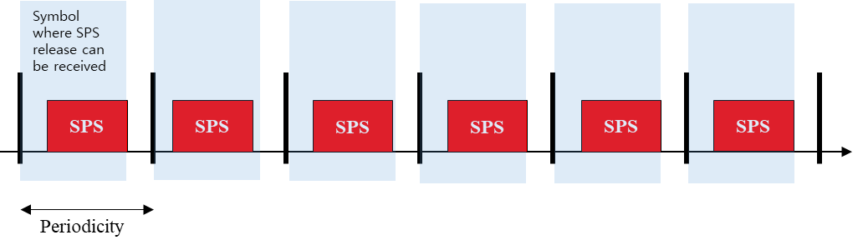

**Figure 1. Current UE behavior with 1 slot periodicity**

Current spec allow for UE to receive SPS release only in blue box, and UE drop SPS PDSCH HARQ-ACK if SPS release is indicated.

**UE behavior 1:**

Based on Samsung’s proposal, UE can receive SPS received freely in the slot where doesn’t include last occasion of SPS PDSCH. However, if UE receives SPS release in a slot other than first slot, UE drop previous receptions and clean HARQ process which is not desirable.

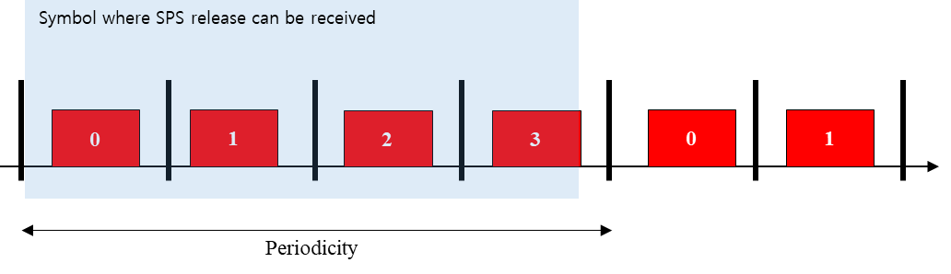

**Figure 2. UE behavior 1 based on [2] with 1 slot periodicity and 4 slot aggregation.**

**UE behavior 2:**

Based on CATT comment, propose UE behavior is in the light of the current UE behavior without slot-aggregation. UE can receive SPS release only before end of the reception of any of corresponding SPS occasion. But it has limited opportunity for SPS release comparing to above.

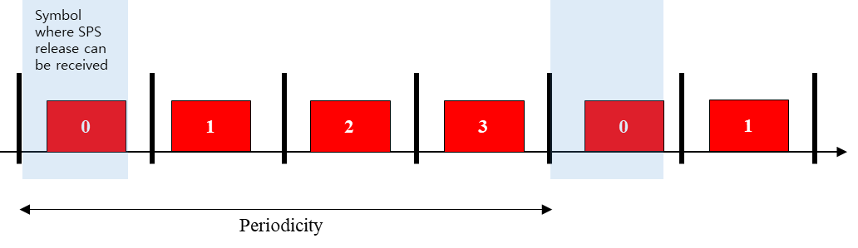

**Figure 2. UE behavior 2 based on CATT’s comment with 1 slot periodicity and 4 slot aggregation.**

Given situation, I would like to suggest to discuss and down-select on between two UE behaviors before drafting TP.

Q1: between UE behavior 1 and 2, Which is preferred?

**Comment:**

|  |  |
| --- | --- |
| Company | Comment |
| Samsung | We prefer behavior 1 for the following reasons.   1. With no aggregation factor, we had agreed that PDCCH can be received in the same slot as PDSCH subject to the timeline condition, Figure 1. To provide the same gNB flexibility, it should be supported to receive the PDCCH in any slots among the repetition, i.e. slot-level granularity. 2. One import scenario is when the numerology of the PDSCH is larger than the PDCCH, in which case, the restriction on gNB flexibility would be unnecessarily large if PDCCH is required to be only received before the end of the first PDSCH repetition. 3. The PDSCH processing time is from the last repetition, so in case of receiving the PDCCH in a slot other than the last one, there is no need to apply the timeline restriction between the PDCCH and the PDSCH in the slot. |
| HW/HiSi | We prefer behavior 2  We agree with QC from the first round comments, that there is no use case to send the release DCI later than the first repetition.  Regarding the concern that was raised for joint release, we think the system is not broken, since separate releases can be used instead. |
| CATT | We prefer behavior 2.  As commented in the 1st round discussion, we do not see the motivation to send a release DCI in the subsequent slot(s) when slot aggregation is configured for SPS.  For joint release, we share the same view with Huawei that separate release can be used if gNB wants. |
| Ericsson | In our understanding, UE behavior 1 is supported by current specification. For the SPS PDSCH with repetition, the goal is that the UE can receive the release PDCCH and HARQ-ACK is sent for the release. We expect the SPS PDSCH is empty.  Current specification satisfies this need in our understanding. For the PDCCH in Behavior 1 figure, if release PDCCH is in the same slot as repetition #0/1/2 (**even if the PDCCH ends after the SPS PDSCH repetition of the same slot**), the HARQ-ACK for release and SPS PDSCH reception do not map to the same PUCCH, hence no problem.  ***Agreement (RAN1#101)***  *It is not supported that a SPS release PDCCH in a slot is received after the end of the SPS PDSCH reception in the slot for the same SPS configuration corresponding to the SPS release PDCCH if HARQ-ACKs for the SPS release and the SPS reception would map to the same PUCCH.*  In summary, our view is still that the Behavior 1 (or, figure in [3]) is already supported, and no spec change is needed. |
| ZTE | Share the similar view with Ericsson. Neither TP is needed.  gNB could avoid the unnecessary SPS PDSCH occasions if gNB wants to release the corresponding SPS PDSCH. |

In addition to above, depending on K1 set and a slot where SPS release is received, it is difficult to use same PUCCH for both SPS PDSCH and SPS release. Though the different PUCCH case is not supported according to RAN1#103 deceision, however, current specification doesn’t prohibit the case using different PUCCH case. Thus,

Q2: Current specification is prohibiting “using different PUCCH case for SPS PDSCH and its release in the same slot”? if not, are specification changes needed?

**Comment:**

|  |  |
| --- | --- |
| Company | Comment |
| Samsung | We don’t have the understanding that current Spec. prohibits the case of different PUCCHs when the PDCCH and PDSCH are in the same slot. Specification change seems unnecessary. |
| CATT | We do not think it is precluded. We are open to discuss whether specification change is needed or not. |
| Ericsson | Current spec does not preclude the case of HARQ-ACK on different PUCCH. Thus it is allowed by current spec. This is fine in our view, and no spec change is needed. |
| ZTE | Maybe “in the same slot” should be clarified first, the same slot is for DL transmission or of PUCCHs? If it means the DL transmission such as SPS PDSCH or its release, spec doesn’t exclude the different PUCCH for SPS PDSCH and its release. If the same slot is for PUCCHs, from our understanding, I share the same feeling of FL that spec doesn’t allow the behavior “using different PUCCH case for SPS PDSCH and its release in the same slot”, if the HARQ-ACKs for SPS PDSCH and its release have the same priority. And there is no strong motivation to set the different priorities to HARQ-ACKs for SPS PDSCH and its release. |

* 1. Issue #4 PUCCH resource for SPS PDSCH HARQ-ACK and SR

According [2], when a SPS PDSCH HARQ-ACK PUCCH overlaps with a SR PUCCH, the SPS PDSCH HARQ-ACK PUCCH is used as the result PUCCH in general. However, in the current spec, PUCCH resource determination of *SPS-PUCCH-AN-List* only includes case of SPS PDSCH HARQ-ACK, the case of SPS PDSCH HARQ-ACK and SR is not included.

**Proposed changes from [2]:**

***Proposal 1: The UCI should include SPS PDSCH HARQ-ACK and SR, if any, when determining a PUCCH resource in SPS-PUCCH-AN-List. The following TP should be adopted.***

|  |
| --- |
| If the UE is provided *SPS-PUCCH-AN-List* and transmits $O_{\text{UCI}}$ UCI information bits that include only HARQ-ACK information bits in response to one or more SPS PDSCH receptions and SR, if any, the UE determines a PUCCH resource to be  - a PUCCH resource provided by *sps-PUCCH-AN-ResourceID* obtained from the first entry in *sps-PUCCH-AN-List* if $O_{\text{UCI}}≤2$, or  - a PUCCH resource provided by *sps-PUCCH-AN-ResourceID* obtained from the second entry in *sps-PUCCH-AN-List*, if provided, if where is either provided by *maxPayloadSize* obtained from the second entry in *sps-PUCCH-AN-List* or is otherwise equal to 1706, or  - a PUCCH resource provided by *sps-PUCCH-AN-ResourceID* obtained from the third entry in *sps-PUCCH-AN-List*, if provided, if where is either provided by *maxPayloadSize* obtained from the third entry in *sps-PUCCH-AN-List* or is otherwise equal to 1706, or  - a PUCCH resource provided by *sps-PUCCH-AN-ResourceID* obtained from the fourth entry in *sps-PUCCH-AN-List*, if provided, if $N_{2,SPS}<O_{\text{UCI}}≤N_{3,SPS}$ where $N_{3,SPS}$ is equal to 1706. |

**From FL:**

For my understanding, it is true that PUCCH for SPS can carry S R if they overlap in time. Adding “and SR, if any” would be simple solution for this problem.

**FL recommendation: Adopt above TP for TS 38.213 Clause 9.2.1**

**Comment:**

|  |  |
| --- | --- |
| Company | Comment |
| Samsung | Support the proposal. |
| CATT | Fine with the TP. |
| Nokia, NSB | Support the TP / proposal |
| OPPO | Support the proposal. |
| HW/HiSi | Support the TP |
| ZTE | Already covered by specification, no need to change.  See 38.213 g40 section 9.2.5.1:  If a UE would transmit a PUCCH with  HARQ-ACK information bits in a resource using PUCCH format 2 or PUCCH format 3 or PUCCH format 4 in a slot, as described in Clauses 9.2.1 and 9.2.3,  bits representing a negative or positive SR, in ascending order of the values of *schedulingRequestResourceId* anda *schedulingRequestResourceId* associated with *schedulingRequestID-BFR-SCell*, are appended to the HARQ-ACK information bits and the UE transmits the combined  UCI bits in a PUCCH using a resource with PUCCH format 2 or PUCCH format 3 or PUCCH format 4 that the UE determines as described in Clauses 9.2.1 and 9.2.3. If one of the SRs is a positive LRR, the value of the  bits indicates the positive LRR. An all-zero value for the  bits represents a negative SR value across all $K$ SRs. |
| Qualcomm | Fine with the TP.  To ZTE: The spec cited above does explain that UE picks up a PUCCH resource as described in 9.2.1. However, the TP is still needed for the UE to select a PUCCH resource based on the **total payload** of HARQ-ACK +SR, which is the same principle as the procedure in 9.2.3. Without the TP, the current spec implies that, the UE determines the PUCCH resource only based on the SPS HARQ-ACK payload, which is not correct. |
| Apple | The TP is okay. |
| Ericsson | Support the TP. |
| Sharp | Agree with the TP. And propose adding one following change with red to describe that a PUCCH resource is provided based on HARQ-ACK information bits if $O_{\text{UCI}}≤2$, as what described for PUCCH resource sets in Rel-15.  ----------  If the UE is provided *SPS-PUCCH-AN-List* and transmits $O_{\text{UCI}}$ UCI information bits that include only HARQ-ACK information bits in response to one or more SPS PDSCH receptions and SR, if any, the UE determines a PUCCH resource to be  - a PUCCH resource provided by *sps-PUCCH-AN-ResourceID* obtained from the first entry in *sps-PUCCH-AN-List* if including 1 or 2 HARQ-ACK information bits and a positive or negative SR on one SR transmission occasion if transmission of HARQ-ACK information and SR occurs simultaneously, or |
| vivo | Support the change from Sharp  In the section of 9.2, it is captured that “UCI bits include HARQ-ACK information bits, if any, SR information bits, if any, LRR information bit, if any, and CSI bits, if any.” So,  OUCI includes HARQ-ACK and SR. When SR is considered, for the first sub-bullet, it is not correct that $O_{\text{UCI}}≤2$. We can refer to the description in 9.2.1 and update the TP. |

* + 1. Update #1 on issue #4

Based on companies’ input, proposed TP with modification by sharp could be agreeable. (Hope ZTE’s concern has been resolved thanks to Qualcomm’s comment.) Please check modified TP as commented by sharp.

**Modified TP by sharp:**

**Proposed changes from [2]:**

**FL Proposal 1:Adopt above TP for TS 38.213 Clause 9.2.1**

|  |
| --- |
| If the UE is provided *SPS-PUCCH-AN-List* and transmits $O_{\text{UCI}}$ UCI information bits that include only HARQ-ACK information bits in response to one or more SPS PDSCH receptions and SR, if any, the UE determines a PUCCH resource to be  - a PUCCH resource provided by *sps-PUCCH-AN-ResourceID* obtained from the first entry in *sps-PUCCH-AN-List* if including 1 or 2 HARQ-ACK information bits and a positive or negative SR on one SR transmission occasion if transmission of HARQ-ACK information and SR occurs simultaneously, or  - a PUCCH resource provided by *sps-PUCCH-AN-ResourceID* obtained from the second entry in *sps-PUCCH-AN-List*, if provided, if where is either provided by *maxPayloadSize* obtained from the second entry in *sps-PUCCH-AN-List* or is otherwise equal to 1706, or  - a PUCCH resource provided by *sps-PUCCH-AN-ResourceID* obtained from the third entry in *sps-PUCCH-AN-List*, if provided, if where is either provided by *maxPayloadSize* obtained from the third entry in *sps-PUCCH-AN-List* or is otherwise equal to 1706, or  - a PUCCH resource provided by *sps-PUCCH-AN-ResourceID* obtained from the fourth entry in *sps-PUCCH-AN-List*, if provided, if $N_{2,SPS}<O_{\text{UCI}}≤N_{3,SPS}$ where $N_{3,SPS}$ is equal to 1706. |

Please share your view orsuggestion if you have a concern on TP and its wording.

**Comment:**

|  |  |
| --- | --- |
| Company | Comment |
| Samsung | Our initial intention is to keep the spec simple, but we can live with the updated TP. |
| HW/HiSi | We are ok with the updated TP, even though the original one was simpler. |
| CATT | Fine with the updated TP. |
| Ericsson | After comparing the updated TP and corresponding spec text for dynamic PDSCH, we suggest remove “and SR, if any”. There is no mentioning of SR in spec text for dynamic PDSCH (see blow). This then allows multiplexing of HARQ-ACK/SR/SI in a PUCCH (existing spec), not just multiplexing of HARQ-ACK/SR.  “ 38.213 V16.4.0, section 9.2.1:  If the UE transmits $O_{\text{UCI}}$ UCI information bits, that include HARQ-ACK information bits, the UE determines a PUCCH resource set to be  - a first set of PUCCH resources with *pucch-ResourceSetId* = 0 if $O_{\text{UCI}}≤2$ including 1 or 2 HARQ-ACK information bits and a positive or negative SR on one SR transmission occasion if transmission of HARQ-ACK information and SR occurs simultaneously, or  …  If the UE is provided *SPS-PUCCH-AN-List* and transmits $O_{\text{UCI}}$ UCI information bits that include only HARQ-ACK information bits in response to one or more SPS PDSCH receptions, the UE determines a PUCCH resource to be  …  ”  We are fine with adding “including 1 or 2 HARQ-ACK …” in the updated TP. |
| ZTE | If most companies think this should be fixed, we can accept majority view. |

# Final outcome from [102-e-NR-L1enh-URLLC-IIoTenh-01]

# Text proposals

From the discussion in the email thread, following has been agreed:

# References

1. R1-2100899 Remaining issues of other aspects for URLLC/IIOT LG Electronics
2. R1-2101178 Maintanence on SPS PDSCH Samsung
3. R1-2101179 Draft CR on SPS release for PDSCH with aggregation Samsung
4. R1-210xxxx, Summary on Others for URLLC and IIOT, Moderator (LG Electronics)