3GPP TSG RAN WG1#104e R1-2nnnnnn
e-Meeting, January 25th – February 5th, 2021

Agenda Item: 7.2.2
Source: Moderator (Lenovo)
Title: Feature lead summary for NR-U DL Signals and Channels
Document for: Discussion, Decision

Topic DL-A: PDCCH Monitoring

Issue DL-A1 (R1-2100890): PDCCH monitoring for grouped search space sets
Background:
It should be discussed how a UE performs PDCCH monitoring skipping procedure if the UE is configured with number of monitored PDCCH candidates or non-overlapped CCEs more than its blind decoding capability. One way is to just follow Rel-15 rule (which implies to apply search space set dropping rule for all of configured UE-specific search space sets) and drop search space sets associated to group 0 if switch to group 1 is indicated, and vice versa. However, this may result in excessive dropping of PDCCH monitoring occasions since only one of two groups will be allowed to be monitored. The other way is to apply search space set dropping rule per search space set group. For instance, if UE-specific search space sets #1/3/4 are configured as group 0 and UE-specific search space sets #2/4 are configured as group 1 for a slot, UE applies search space set dropping rule twice, one for search space sets #1/3/4 and the other for search space sets #2/4. Additional point to be considered is that search space set dropping rule per group should be also applied to type3-PDCCH CSS since it was agreed that type3-PDCCH CSS and USS can be configured with searchSpaceGroupIdList-r16. Therefore, the following proposal and text proposal for TS 38.213 section 10.1 can be made.
Proposal:
If a UE is provided with two groups of search space sets and configured with the number of monitored PDCCH candidates (or non-overlapped CCEs) for a slot more than blind decoding capability for the UE, the UE applies search space set dropping rule per search space set group for type3-PDCCH CSS and USS sets.

Company | Comments

Topic DL-B: CSI Measurement, Report

Issue DL-B1 (R1-2100240): Action time when UE receive MAC CE for (de)activation of Scell/CSI-RS/TCI state/SRS
Background:
In RAN1#103e, RAN1 concluded on the LS reply [1] on UE behavior after receiving the MAC CE deactivation command for semi-persistent CSI reporting as follows:
RAN WG1 has discussed the issue during RAN1#102-e and RAN1#103-e, and has reached the following conclusion:
For semi-persistent CSI reporting with PUCCH, if UE cannot transmit HARQ-ACK on the MAC CE deactivation due to the UL LBT failure, the UE performs deactivation at the MAC action time based on the original scheduled HARQ-ACK transmission (the original scheduled HARQ-ACK transmission time corresponds to slot n in TS 38.214 clause 5.2.1.5.

From RAN1’s perspective, UE shall apply the deactivation command based on the original scheduled HARQ-ACK time indicated by K1 in the DCI. However, another general issue is identified about the application timing for the MAC CE when an inapplicable value for HARQ-ACK feedback timing is provided in the DCI scheduling the PDSCH (K1=-1). It could be observed from current spec of TS 38.213 and TS 38.214 that the application time for MAC CE command is bundled by the HARQ-ACK transmission time for the corresponding PDSCH carrying the MAC CE. For instance, when UE receives in a PDSCH a SCell activation command in slot n, the corresponding actions shall be applied in slot n+k, where k is and K1 is the number of slots for a PUCCH transmission with HARQ-ACK indicated by PDSCH-to-HARQ_feedback timing indicator field in the DCI format scheduling the PDSCH.
The inapplicable value (k1=-1) for HARQ-ACK feedback is introduced in NR-U, which indicate UE the PUCCH resource for HARQ feedback is not allocated and will be provided in the following DCI. The action time when an inapplicable value is provided in the DCI scheduling the PDSCH carrying the MAC CE is not clear now.
Based on the current spec, the exact action time when an inapplicable K1 is provided is not clear. It does not make sense by using k1=-1 when calculating the action time because it will reduce the processing time shorter than UE capability. Deferring UE’s action time until the HARQ-ACK is actually transmitted is also not preferred because of unnecessary long latency of activation behavior. Same principle as the approved LS reply could be applied that the action time shall base on the original scheduled HARQ-ACK transmission time instead of the actual transmission time which will introduce unnecessary delay. Considering there is no applicable K1 provided in DCI, it is reasonable for UE to determine the action time based on the earliest slot that UE is able to provide the valid HARQ-ACK, i.e. N1as defined in clause 5.3 of TS 38.214.
Proposal:
When an inapplicable value for K1 is provided in the DCI format scheduling the PDSCH carrying the MAC CE, the application time for the corresponding actions for the MAC CE shall be determined by the first slot that UE is able to provide the valid HARQ-ACK as defined in clause 5.3 in TS 38.214 according to the PDSCH processing time.

Company | Comments

Issue DL-B2 (R1-2101305): Discussion on LS from RAN4 in R1-2100008
Background:
RAN4 is working on SCell activation delay requirements and has asked RAN1 a number of questions in a new LS [1] about the UE behaviour with respect to CSI reports during the SCell activation procedure in case none or some of the following three RRC parameters are configured for the SCell being activated:
- CO-DurationPerCell-r16
- SlotFormatIndicator
- CSI-RS-ValidationWith-DCI-r16
So far, RAN4 is working under the following assumption:
- When P/SP-CSI-RS is configured for CSI reporting during the SCell activation, it is assumed that at least one of the RRC parameters CO-DurationPerCell-r16, SlotFormatIndicator, and CSI-RS-ValidationWith-DCI-r16 is configured for a UE and the UE supports the corresponding capability, so that the UE measures the configured P/SP-CSI-RS and transmits CSI reports during the SCell activation period, except for the cases when the UE cancels the reception of CSI-RS according to TS 38.213.
The UE behavior for which RAN4 requests clarification is based on the following pair of agreements from Agreements from RAN1#101-e
Agreement:
- A new RRC parameter can be used to determine reception/cancellation behaviour for CSI-RS configured by higher layers at least for the following cases:
  - Reception of DCI 2_0 is not configured to the UE
  - Reception of DCI 2_0 is configured to the UE, but both SFI and CO-duration are not configured
Agreement:
- For operation with shared spectrum channel access, the new RRC parameter (as in previous agreement) is used to determine the UE behavior at least when UE is not configured with CO-duration and not configured with SFI as follows:
  - If the RRC parameter is configured, when the UE is configured by higher layers to receive periodic and semi-persistent CSI-RS in a set of symbols in a slot, the UE cancels the higher-layer configured periodic and semi-persistent CSI-RS reception in the set of symbols in the slot if:
    - The UE does not detect a DCI format indicating to the UE to receive aperiodic CSI-RS or PDSCH in the set of symbols
  - If the parameter is not configured, the UE cancels/receives the higher-layer configured periodic and semi-persistent CSI-RS reception according to current Clause 11.1 of TS38.213 and agreements we reached so far
- Note: Other rules in the specification apply for cancellation/reception in addition to the what is described in this agreement

Proposal 1:
In the LS Reply to RAN4, include the following statement regarding the assumption stated in the RAN4 LS. "It cannot be assumed that at least one of the 3 parameters is configured. RAN1 assumes that this is why RAN4 has asked questions on other scenarios regarding combinations of the the parameters configured/not configured (including none of them configured)."
Proposal 2:
Provide answers to the questions raised in the RAN4 LS for each of the example scenarios making reference to appropriate paragraphs of 38.213 Section 11.1 and 11.1.1.

Example 1
Scenario: None of the 3 parameters are configured.
Question from RAN4 LS: What is the expected UE behavior for this P/SP CSI-RS measurement and report on the being-activated SCell?
Answer:
As in Rel-15, the UE is expected to receive the p/sp-CSI-RS, except if the UE receives a DCI that schedules/triggers an UL signal/channel in one or more of the symbols occupied by p/sp-CSI-RS. The applicable rule in 38.213 Section 11.1 is as follows:
For operation on a single carrier in unpaired spectrum, if a UE is configured by higher layers to receive a PDCCH, or a PDSCH, or a CSI-RS, or a DL PRS in a set of symbols of a slot, the UE receives the PDCCH, the PDSCH, the CSI-RS, or the DL PRS if the UE does not detect a DCI format that indicates to the UE to transmit a PUSCH, a PUCCH, a PRACH, or a SRS in at least one symbol of the set of symbols of the slot; otherwise, the UE does not receive the PDCCH, or the PDSCH, or the CSI-RS, or the DL PRS in the set of symbols of the slot.

Example 2
Scenario: Only CSI-RS-ValidationWith-DCI-r16 is configured.
Question from RAN4 LS: What is the expected UE behavior for this P/SP CSI-RS measurement and report on the being-activated SCell? Does UE need to decode a DCI format from other active serving cell (indicating an aperiodic CSI-RS reception or scheduling a PDSCH reception in the set of symbols of the slot) for this being-activated SCell to validate this P/SP CSI-RS?
Answer:
The UE is expected to receive the p/sp-CSI-RS in a slot only if it decodes a DCI format indicating ap-CSI-RS or scheduling a PDSCH reception in the set of symbols in the slot occupied by the p/sp-CSI-RS. The applicable rule in 38.213 Section 11.1 is as follows:
For operation with shared spectrum channel access, if a UE is provided csi-RS-ValidationWith-DCI, is not provided CO-DurationsPerCell, and is not provided SlotFormatCombinationsPerCell, and if the UE is configured by higher layers to receive a CSI-RS in a set of symbols of a slot, the UE cancels the CSI-RS reception in the set of symbols of the slot if the UE does not detect a DCI format indicating an aperiodic CSI-RS reception or scheduling a PDSCH reception in the set of symbols of the slot.

Example 3
Scenario: CO-DurationPerCell-r16 is configured but SlotFormatIndicator is NOT configured.
Question from RAN4 LS: What is the expected UE behavior for this P/SP CSI-RS measurement and report on the being-activated SCell? Does UE need to decode a DCI format 2_0 (indicating remaining channel occupancy duration) from other active serving cell for this being-activated SCell to validate the CSI-RS?
Answer:
The UE behaviour is slightly different depending on whether or not the DCI 2_0 indicating the remaing CO duration is detected
Case 1: (DCI 2_0 detected)
The UE is expected to receive the p/sp-CSI-RS as long as the set of symbols occupied by the CSI-RS are within remaining channel occupancy duration indicated by the CO duration field the detected DCI 2_0. Ottherwise the CSI-RS reception is cancelled. The applicable rule in 38.213 Section 11.1.1 is as follows:
For operation with shared spectrum channel access, if a UE is configured by higher layers to receive a CSI-RS and the UE is provided CO-DurationsPerCell, for a set of symbols of a slot that are indicated as downlink or flexible by tdd-UL-DL-ConfigurationCommon or tdd-UL-DL-ConfigurationDedicated, or when tdd-UL-DL-ConfigurationCommon and tdd-UL-DL-ConfigurationDedicated are not provided, the UE cancels the CSI-RS reception in the set of symbols of the slot that are not within the remaining channel occupancy duration.
Case 2: (DCI 2_0 not detected):
The UE is expected to receive the the p/sp-CSI-RS as long as the set of symbols occupied by the CSI-RS are within remaining channel occupancy duration indicated by the CO duration field of a previously detected DCI 2_0. Otherwise the CSI-RS reception is cancelled. The applicable rule in 38.213 Section 11.1.1 is as follows:
- if the UE is configured by higher layers to receive CSI-RS in the set of symbols of the slot, the UE does not receive the CSI-RS in the set of symbols of the slot, except when UE is provided CO-DurationsPerCell and the set of symbols of the slot are within the remaining channel occupancy duration.

Example 4
Scenario: SlotFormatIndicator is configured, but CO-DurationPerCell-r16 is NOT configured
Question from RAN4 LS: What is the expected UE behavior for this P/SP CSI-RS measurement and report on the being-activated SCell? Does UE need to detect a DCI format 2_0 (indicating the starting point of CO duration and the slot format) from other active serving cell for this being-activated SCell to validate the CSI-RS?

Answer:

According to the following clause in 38.213 Section 11.1.1, remaining channel occupancy is defined as follows when CO-DurationPerCell-r16 is NOT configured:
The UE behaviour depends on whether or not the DCI 2_0 containing the SFI is detected.
If CO-DurationsPerCell is not provided, the remaining channel occupancy duration for the serving cell is a number of slots, starting from the slot where the UE detects the DCI format 2_0, that the SFI-index field value provides corresponding slot formats
Case 1: (DCI 2_0 detected):
The UE is expected to receive the p/sp-CSI-RS only if the set of symbols in the slot occupied by the p/sp-CSI-RS are indicated as 'D' by the SFI field in the detected DCI 2_0. Since CO-DurationPerCell-r16 is not provided, the UE assumes that the symbols indicated by SFI are within the remaining channel occupancy
- if the UE is configured by higher layers to receive PDSCH or CSI-RS in the set of symbols of the slot, the UE receives the PDSCH or the CSI-RS in the set of symbols of the slot only if an SFI-index field value in DCI format 2_0 indicates the set of symbols of the slot as downlink and, if applicable, the set of symbols is within remaining channel occupancy duration
Case 2: (DCI 2_0 not detected):
The UE cancels reception of the the p/sp-CSI-RS since CO-DurationPerCell-r16 is not provided. The applicable rule in 38.213 Section 11.1.1 is as follows:
- if the UE is configured by higher layers to receive CSI-RS in the set of symbols of the slot, the UE does not receive the CSI-RS in the set of symbols of the slot, except when UE is provided CO-DurationsPerCell and the set of symbols of the slot are within the remaining channel occupancy duration.

Company | Comments

Topic DL-C: DMRS for PDSCH mapping type B

Issue DL-C1 (R1-2100240): Front-loaded DMRS collision with CORESET
Background:
When front-loaded DMRS collides with a CORESET, it is shifted onto the first available symbol after the CORESET. For this case, the current specification prescribes different handlings of additionally configured DMRS depending on if the PDSCH duration is $l_{d}=5$ or if it is${ l}_{d}=7$:
- For $l_{d}=5$, the UE will always receive the additional DMRS on the 5th symbol, no matter if the front-loaded DMRS is shifted or not. Thus, the gap between the two configured DMRS is varying.
- For $l_{d}=7$, if the front-loaded DMRS is shifted with a certain number of symbols, then the additional DMRS is also shifted with the same number of symbols. In case the additional DMRS would appear on the last PDSCH position or even outside the PDSCH, the additional DMRS is dropped.
This different DMRS handling is illustrated in Figure 1 below:
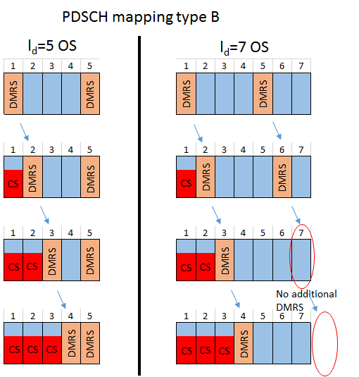
Figure 1 – Additional DMRS handling in case of shifted front-loaded DMRS
In our view there are multiple important reasons to harmonize the DMRS handling for different PDSCH durations:
From the implementation perspective:
- The UE implementation for $l_{d}=5$ is complex. The gap between the two DMRS is varying which impacts the processing pipeline in the UE and the UE needs to prepare at most 4 interpolation filters depending on how many symbols the front-loaded DMRS is shifted.
From the performance perspective:
- The purpose of the additional DMRS is to obtain better channel estimation in the presence of Doppler shifts, i.e. to estimate the channel rotation through interpolation. To make this operation meaningful, a certain minimum distance between the two DMRS should be preserved. Otherwise, there is no benefit coming from an interpolation and it would make more sense to drop the additional DMRS in order to send data instead.
From the specification:
The specification can be simplified if the DMRS handling is made consistent.
Proposal:
For PDSCH mapping type B with duration of 5 symbols, additional DMRS symbol is not transmitted if front loaded DMRS is shifted more than X symbols due to collision with CORESET. X can be FFS. Corresponding text proposal are provide in TP#3 in the appendix [R1-2100240].

Company | Comments

Issue DL-C2 (R1-2100240, R1-2100818): PDSCH mapping type B with durations larger than 7 symbols
Background [R1-2100240]:
According to Table 7.4.1.1.2-4 in TS38.211, for PDSCH mapping type B with durations larger than 7 symbols, the UE may be configured with double-symbol additional DMRS. When the front-loaded DMRS collides with a CORESET, then the additional DMRS symbols will be shifted together with the front-loaded DMRS. According to the current specification text in TS 38.211 as copied below,
It is possible that a part of the double-symbol additional DMRS symbols are shifted outside of valid range and cannot be transmitted. An example is plotted for the case of $l_{\text{d}}=8$ in Figure 2 below. In order to perform channel estimation on DMRS ports differentiated by OCC in the time domain, both of the double-symbol DMRS are required in their entirety. Thus, if only a part of the additional DMRS is transmitted, there is no benefit. A simple solution with minimum standard impact would be to drop the whole double-symbol additional DMRS symbols in this case.
- for all values of the PDSCH duration $l_{\text{d}}$ other than 2, 5, and 7 symbols, the UE is not expected to receive a DM-RS symbol beyond the $(l_{\text{d}}-1)$:th symbol;
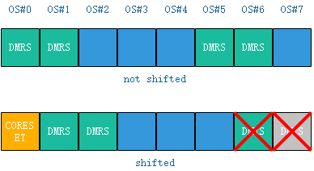
Figure 2 DMRS shifting due to collision with CORESET ($l_{\text{d}}=8$)

Proposal [R1-2100240]:
For PDSCH mapping type B with duration larger than 7 symbols, double-symbol additional DMRS symbols will be dropped if any of the symbols is located beyond the $(l_{\text{d}}-1)$:th symbol. The corresponding text proposal is in TP#3 in the appendix [R1-2100240].

Background [R1-2100818]:
The DMRS position for PDCSH mapping Type B durations {3,5,6,8,9,10,11,12,13} have been captured in 38.211 v16.4.0 section 7.4.1.1.2 [2] according to the agreements. For all values of the PDSCH duration $l_{d}$ other than 2, 5, and 7 symbols, it is specified that UE is not expect to receive a DM-RS symbol beyond the $\left(l_{d}-1\right):$th symbol. Here for double-symbol DMRS, if the front-loaded DMRS of PDSCH allocation collides with resources reserved for a CORESET, the additional DMRS may shift to the last two symbols of the PDSCH allocation. According to the current specification, the last DMRS symbol will be dropped. However, in case of double-symbol DMRS, only one DMRS symbol cannot be used for channel estimation. Since the remaining DMRS symbol of the additional DMRS is useless, it can be discarded and the occupied REs can be used for PDSCH transmission to improve PDSCH performance. Figure 1 shows an example of double-symbol DMRS drop issue.
Figure 1
If the PDSCH duration $l_{\text{d}}$ is 12 or 13 symbols, it is also specified that the UE is not expected to receive a DM-RS symbol mapped to symbol 12 or later in the slot. Here for double-symbol DMRS, if the front-loaded DMRS of PDSCH allocation collides with resources reserved for a CORESET, the later DMRS symbol of the additional DMRS may shift to symbol 12 of the PDSCH. According to the current specification, this DMRS symbol will be dropped. Then the same issue for channel estimation occurs. Figure 2 shows another example of double-symbol DMRS drop issue.
Figure 2
Proposal [R1-2100818]:
- if the PDSCH duration $l_{\text{d}}$ is 12 or 13 symbols, the UE is not expected to receive additional DM-RS mapped to symbol 12 or later in the slot;
- for all values of the PDSCH duration $l_{\text{d}}$ other than 2, 5, and 7 symbols, the UE is not expected to receive a DM-RS symbol beyond the $(l_{\text{d}}-1)$:th symbol if single-symbol DMRS is used;
- for all values of the PDSCH duration $l_{\text{d}}$ larger than 7 symbols, the UE is not expected to receive additional DM-RS beyond the $(l_{\text{d}}-1)$:th symbol if double-symbol DMRS is used;

Company | Comments

Issue DL-C3 (R1-2100240): Processing time
Background:
According to table 5.3-1 in TS 38.214, when additional DMRS is configured, the maximum allowed PDSCH decoding time N1 is relaxed by 3 symbols. The reason is that in this situation, DMRS will appear late in the PDSCH and the UE will start later with channel estimation and sub-sequent operations as shown in the upper part of figure 3.
However, when only front-loaded DMRS is configured, no relaxation of the PDSCH decoding time N1 is allowed according to the specification as illustrated in the lower part of figure 3. This poses a problem for the UE implementation in case the DMRS collides with a CORESET. Then, the DMRS can be shifted and it will appear late in the PDSCH. Similar to the situation described above, also here the channel estimation operation and the subsequent demodulation/decoding will be delayed. The UE may not be able to finish the PDSCH decoding and HARQ-ACK preparation. A detailed description and analysis of this issue can be found in section 2.3 of [2].
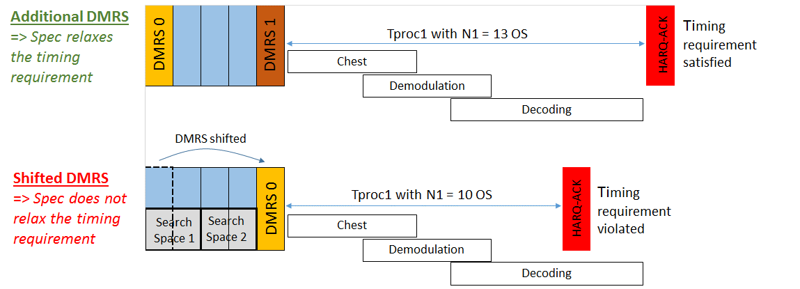
Figure 3– Timing requirements on N1 for additional DMRS being configured vs shifted DMRS
In order to overcome the above mentioned problems, which will be especially severe for processing time capability #2, the timing requirement should also be relaxed when PDSCH DMRS overlaps with a search space set that is associated with a CORESET. One possibility could be to extend T_{proc,1} with an additional “delta”-value. However, this option needs modifications of the current specification, which may not be the preferred approach at this current late stage. If RAN1 could not agree to relax the UE processing time requirements, another possibility is to introduce a new UE capability for handling the DMRS shift due to a collision with search space sets.
Proposal:
In order to address the issue of a reduced UE processing time budget in case of DMRS shift, RAN1 should consider one of the following options:
- Option 1: Relaxation of the UE processing time requirement in case of DMRS shift.
- Option 2: Introduce a Rel-16 UE capability for UEs not supporting DMRS shift due to collisions with search space sets that are associated with a CORESET.

Company | Comments

