3GPP TSG RAN WG1 Meeting #104-e R1-21xxxxx
e-Meeting, January 25th – February 5th, 2021
Agenda Item: 7.1
Source: Moderator (MediaTek)
Title: Summary for [104-e-NR-7.1CRs-11] Clarification on CSI request constraint per slot
Document for: Discussion and decision

Introduction
In RAN1 #103-e meeting, the following email discussion is assigned by Chairman to discuss “[104-e-NR-7.1CRs-11] Clarification on CSI request constraint per slot”. The email thread is triggered by Issue #17 of [1] and originates from the draft CR in [2].
R1-2101136 Draft 38.214 CR on CSI request constraint per slot MediaTek Inc.
[104-e-NR-7.1CRs-11] Draft 38.214 CR on CSI request constraint per slot – Yi-Ju (MediaTek) by Jan 29

Discussion

Background
In TS 38.214, the following constraints on receiving multiple A-CSI requests within a slot are provided:
- A UE is not expected to receive more than one DCI with non-zero CSI request per slot.
- A UE is not expected to receive more than one aperiodic CSI report request for transmission in a given slot.
However, the definition of a ‘slot’ is not clear especially when different numerologies are involved in CA/DC cases. For example, there are two cells configured in CA case as shown in Figure 1 and 2. One has SCS 15 kHz, and the other has SCS 30 kHz. The following lists some examples for determining the slot constraint:
Case 1: the slot is defined based on the smallest SCS of two cells. As shown in Figure 1, if UE receives one DCI with non-zero CSI request in Slot #0 of Cell #1, then UE does not expect to receive DCI with non-zero CSI request in red region.
Case 2: the slot is defined according to the largest SCS of two cells. As shown in Figure 2, if UE receives on DCI with non-zero CSI request in Slot #0 of Cell #1, the UE is possible to receive another DCI with non-zero CSI request in Slot #1 of Cell #1. But it needs to clarify whether UE can receive DCI with non-zero CSI request in red region of Cell #0.
Case 3: the slot is defined according to the PDCCH numerology for triggering the A-CSI report. In this example, the behaviour is the same as in Case 2.
The draft TP in R1-2101136 is provided in Appendix for reference.
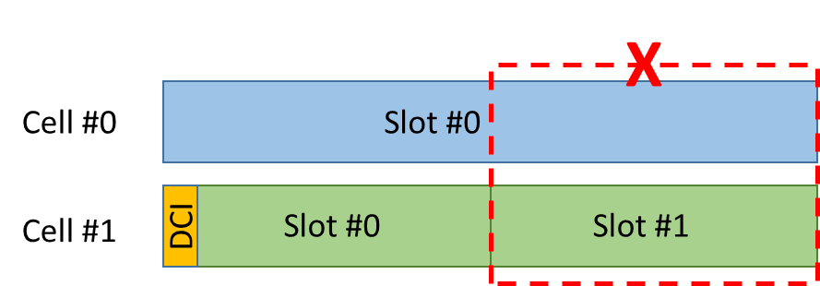
Figure 1. Case 1 – slot constraint is defined based on the smallest SCS
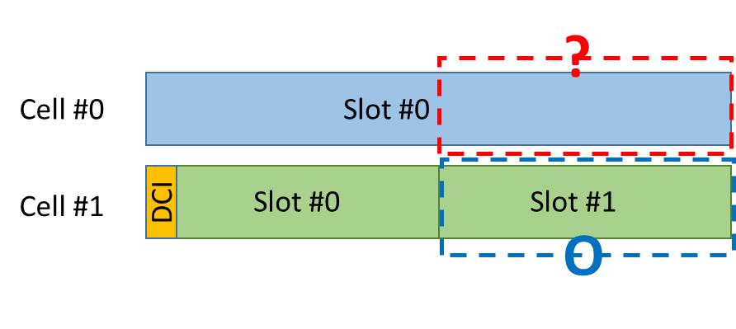
Figure 2. Case 2/3 – slot constraint is defined based on the largest SCS/PDCCH numerology

Company views
The draft CR in [2] addresses two issues as follows. Please provide company’s view in the table below.
Issue #1: for a UE not expected to receive more than one DCI with non-zero CSI request per slot, the proposed change in [2] is provided as follows. Note that ‘in a cell group’ means in MCG or SCG.
A UE is not expected to receive more than one DCI with non-zero CSI request per slot within a cell group; the slot is defined according to the smallest SCS of all configured DL BWPs in a cell group.
Q1: Do you agree with the proposed changes above?
Company | Agree or not | Comments
ZTE | No | We think the restriction is about UE processing capability of processing PDCCH. Hence it should make more sense to interpret the slot based on PDCCH numerology.
Intel | Agree
Ericsson | No | The restriction would make it impossible to trigger aperiodic CSI-RS in two consecutive 0.125ms slots in an FR1-FR2 CA scenario, whereas such triggering is possible without CA.  Using consecutive slots for ap-CSI-RS is necessary due to restrictions in how many CSI-RS resources that can be triggered in one slot.
Apple | Agree
CATT | No | The change is not needed in our view. The slot refers to a slot within a cell. For any cell, UE is not expected to receive more than one DCI with non-zero CSI request in a slot. That is, it has nothing to do with whether there is already a DCI with non-zero CSI request in another cell. In the examples given in Figure 1/2, gNB could trigger aperiodic CSI in slot#0 of cell#0.

Q2: Which option do you support if you don’t agree with the proposed change?
- Option 1: the smallest SCS of all active DL BWPs in a cell group
- Option 2: the largest SCS of all configured DL BWPs in a cell group
- Option 3: the largest SCS of all active DL BWPs in a cell group
- Option 4: The SCS of received PDCCH with non-zero CSI request in a cell group
- Note: ‘in a cell group’ means in MCG or SCG
Company | Supporting option | Comments
ZTE | Option 4
Intel | Option 2 | Back to back triggering should be allowed
Ericsson | Option 4
CATT |  | One question regarding Option 4: What if there is PDCCH with non-zero CSI request in both of the cells? Which SCS shall be used to determine whether it is a valid case?

Issue #2: for a UE not expected to receive more than one aperiodic CSI report request for transmission in a given slot, the proposed change in [2] is provided below. Note that ‘in a cell group’ means in MCG or SCG.
A UE is not expected to receive more than one aperiodic CSI report request for transmission in each reference slot, which is defined according to the smallest SCS of all configured UL BWPs in a cell group.

Q3: Do you agree with the proposed changes above?
Company | Agree or not | Comments
ZTE | No | If a BWP is not active, UE will not report or process the aperiodic CSI in this BWP. Hence UE does not need to reserve the capability for non-active BWPs. Hence we think to the interpretation based on smallest SCS of all active BWPs is sufficient.
Intel | Agree
Ericsson | No | Same reason as for Q1
Apple | Agree
CATT | No | The CR is not needed. The original text is clear that UE will not transmit CSI for more than one aperiodic CSI report request in one slot. It has nothing to do with the numerologies of another cell. That is, UE may be triggered to transmit aperiodic CSI at the same time in another CC.

Q4: Which option do you support if you don’t agree with the proposed change?
- Option 1: the smallest SCS of all active UL BWPs in a cell group
- Option 2: the largest SCS of all configured UL BWPs in a cell group
- Option 3: the largest SCS of all active UL BWPs in a cell group
- Option 4: the SCS of the UL BWP where the UCI is transmitted
- Note: ‘in a cell group’ means in MCG or SCG
Company | Supporting option | Comments
ZTE | Option 1
Intel | Option 2
Ericsson | Option 4

Q5: Any other issue? Please provide your comments if any in the following table.
Company | Comments

Conclusion
To be added after discussion.

Reference
- R1-2101768, “RAN1#104-e preparation phase initial summary on NR Rel-15 CRs”, Ad-hoc Chair (Samsung)
- R1-2101136, “Draft 38.214 CR on CSI request constraint per slot”, MediaTek Inc.

Appendix
------------------------------------------------------------- Start of the TP ----------------------------------------------------------------

5.2.1.5 Triggering/activation of CSI Reports and CSI-RS

5.2.1.5.1 Aperiodic CSI Reporting/Aperiodic CSI-RS
For CSI-RS resource sets associated with Resource Settings configured with the higher layer parameter resourceType set to 'aperiodic', 'periodic', or 'semi-persistent', trigger states for Reporting Setting(s) (configured with the higher layer parameter reportConfigType set to 'aperiodic') and/or Resource Setting for channel and/or interference measurement on one or more component carriers are configured using the higher layer parameter CSI-AperiodicTriggerStateList. For aperiodic CSI report triggering, a single set of CSI triggering states are higher layer configured, wherein the CSI triggering states can be associated with any candidate DL BWP. A UE is not expected to receive more than one DCI with non-zero CSI request per slot within a cell group; the slot is defined according to the smallest SCS of all configured DL BWPs in a cell group. A UE is not expected to be configured with different TCI-StateId's for the same aperiodic CSI-RS resource ID configured in multiple aperiodic CSI-RS resource sets with the same triggering offset in the same aperiodic trigger state. A UE is not expected to receive more than one aperiodic CSI report request for transmission in each reference slot, which is defined according to the smallest SCS of all configured UL BWPs in a cell group. A UE is not expected to be triggered with a CSI report for a non-active DL BWP. A trigger state is initiated using the CSI request field in DCI.
< Unchanged parts are omitted >
-------------------------------------------------------------- End of the TP ----------------------------------------------------------------

