3GPP TSG RAN WG1 Meeting #104-e R1-21xxxxx

e-Meeting, January 25th – February 5th, 2021

Agenda Item: 7.1

Source: Moderator (MediaTek)

Title: Summary for [104-e-NR-7.1CRs-11] Clarification on CSI request constraint per slot

**Document for: Discussion and decision**

# Introduction

In RAN1 #103-e meeting, the following email discussion is assigned by Chairman to discuss “[104-e-NR-7.1CRs-11] Clarification on CSI request constraint per slot”. The email thread is triggered by Issue #17 of [1] and originates from the draft CR in [2].

R1-2101136 Draft 38.214 CR on CSI request constraint per slot MediaTek Inc.

[104-e-NR-7.1CRs-11] Draft 38.214 CR on CSI request constraint per slot – Yi-Ju (MediaTek) by Jan 29

# Discussion

## Background

In TS 38.214, the following constraints on receiving multiple A-CSI requests within a slot are provided:

* A UE is not expected to receive more than one DCI with non-zero CSI request per slot.
* A UE is not expected to receive more than one aperiodic CSI report request for transmission in a given slot.

However, the definition of a ‘slot’ is not clear especially when different numerologies are involved in CA/DC cases. For example, there are two cells configured in CA case as shown in Figure 1 and 2. One has SCS 15 kHz, and the other has SCS 30 kHz. The following lists some examples for determining the slot constraint:

**Case 1:** the slot is defined based on the smallest SCS of two cells. As shown in Figure 1, if UE receives one DCI with non-zero CSI request in Slot #0 of Cell #1, then UE does not expect to receive DCI with non-zero CSI request in red region.

**Case 2:** the slot is defined according to the largest SCS of two cells. As shown in Figure 2, if UE receives on DCI with non-zero CSI request in Slot #0 of Cell #1, the UE is possible to receive another DCI with non-zero CSI request in Slot #1 of Cell #1. **But it needs to clarify whether UE can receive DCI with non-zero CSI request in red region of Cell #0.**

**Case 3:** the slot is defined according to the PDCCH numerology for triggering the A-CSI report. In this example, the behaviour is the same as in Case 2.

The draft TP in R1-2101136 is provided in Appendix for reference.

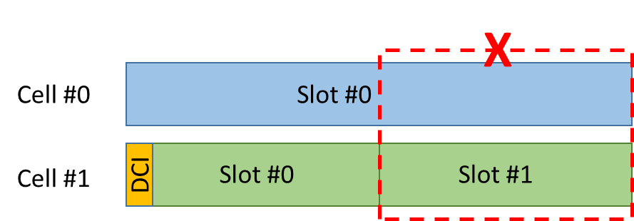

**Figure 1. Case 1 – slot constraint is defined based on the smallest SCS**

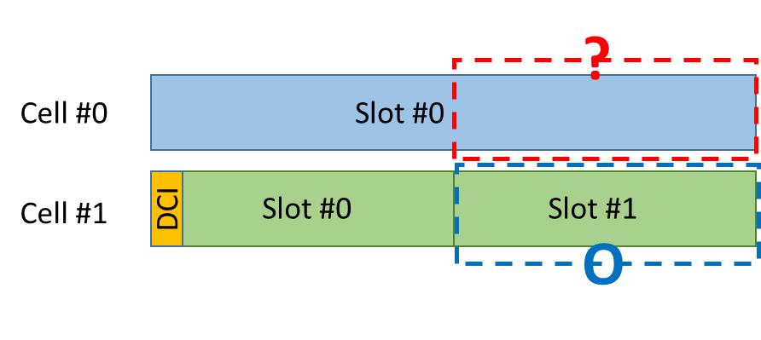

**Figure 2. Case 2/3 – slot constraint is defined based on the largest SCS/PDCCH numerology**

## Company views

### First round discussion

The draft CR in [2] addresses two issues as follows. Please provide company’s view in the table below.

**Issue #1:** for a UE not expected to receive more than one DCI with non-zero CSI request per slot, the proposed change in [2] is provided as follows. Note that ‘in a cell group’ means in MCG or SCG.

A UE is not expected to receive more than one DCI with non-zero CSI request per slot within a cell group; the slot is defined according to the smallest SCS of all configured DL BWPs in a cell group*.*

**Q1: Do you agree with the proposed changes above?**

|  |  |  |
| --- | --- | --- |
| Company | Agree or not | Comments |
| ZTE | No | We think the restriction is about UE processing capability of processing PDCCH. Hence it should make more sense to interpret the slot based on PDCCH numerology. |
| Intel | Agree |  |
| Ericsson | No | The restriction would make it impossible to trigger aperiodic CSI-RS in two consecutive 0.125ms slots in an FR1-FR2 CA scenario, whereas such triggering is possible without CA.  Using consecutive slots for ap-CSI-RS is necessary due to restrictions in how many CSI-RS resources that can be triggered in one slot. |
| Apple | Agree |  |
| CATT | No | The change is not needed in our view. The slot refers to a slot within a cell. For any cell, UE is not expected to receive more than one DCI with non-zero CSI request in a slot. That is, it has nothing to do with whether there is already a DCI with non-zero CSI request in another cell. In the examples given in Figure 1/2, gNB could trigger aperiodic CSI in slot#0 of cell#0. |
| OPPO | No | We share similar view as CATT. The principle of CR is more suitable for the UE capability restriction among multiple carriers/bands. However, the current spec is to make restriction for each carrier, which does not affect the other carriers. |
| vivo | Agree | The original intention from Rel-15 limitation is for single cell case. For UE simultaneously receiving PDCCH from multiple cells, there are no corresponding limitation. We are supportive of the most conservative limitation.  To open the discussion, we would be fine to add a Rel-16 UE capability for more aggressive counting of numerology. |
| Qualcomm | Ok, but prefer a better solution | Regarding CATT’s comment, we have different understanding. The constraints, as they stand, should apply to multiple CCs. If same numerology, no matter two CSI requests are transmitted on same or different CCs, they can not lie in same slot. The ambiguity is the numerology if two CCs have different numerologies.  We think the issue needs to be discussed, and we should strive to reach a consensus otherwise it is unclear how cross-numerology CSI request can work. |
| Samsung | No | We think that only active BWPs should be considered for CSI. Additionally, we should consider this issue conservatively because it is related to Rel-15. In this manner, we suggest to make the conclusion instead of changing the current specification:  Conclusion  For the restriction on a DCI reception with non-zero CSI request per slot, the slot is defined according to the smallest SCS of all active DL BWPs in a cell group. |
| Huawei | Yes | We are open to discuss however it may be more efficient to list a number of Alts for further decision. Given comments so far, the views and preference are very diverse. |
| CATT2 |  | Based on comments above, we may need first to discuss whether a UE can receive multiple DCIs with non-zero CSI request per slot from differetent CCs when same SCS are configured for those CCs.  If UE is capable of processing UL grant transmitted on a CC, UE would be able to process the DCI with non-zero CSI request in a slot on that CC. Is there anything preventing UE from processing another DCI with non-zero CSI request transmitted on another CC? The CSI processing capability is contolled by mechansim of CPU, and the number of CSI-RS is controlled by #of supported active CSI-RS resources. |

**Q2: Which option do you support if you don’t agree with the proposed change?**

* Option 1: the smallest SCS of all active DL BWPs in a cell group
* Option 2: the largest SCS of all configured DL BWPs in a cell group
* Option 3: the largest SCS of all active DL BWPs in a cell group
* Option 4: The SCS of received PDCCH with non-zero CSI request in a cell group
* Note: ‘in a cell group’ means in MCG or SCG

|  |  |  |
| --- | --- | --- |
| Company | Supporting option | Comments |
| ZTE | Option 4 |  |
| Intel | Option 2 | Back to back triggering should be allowed |
| Ericsson | Option 4 |  |
| CATT |  | One question regarding Option 4: What if there is PDCCH with non-zero CSI request in both of the cells? Which SCS shall be used to determine whether it is a valid case? |
| Vivo | Option | Option5. |
| Qualcomm | Option 6 | Option 1 (either of configured BWP or active BWP) is implementation-friendly, but we also understand network concern that back-to-back trigger becomes impossible. As illustrated in the figure below, even self-triggering on CC1 is avoided. In our view, it is ok to allow self-triggering because it is allowable in single CC case.    Option 4 allows back-to-back trigger, but also allows following case which seems challenging in implementation due to cross-numerology triggering. So, it is preferred to be avoided. If network want to trigger CSI of CC1 and CC2, network could put the two CSI reports into same trigger state.    Considering scheduling flexibility and reasonable UE complexity, we think it is suitable to use the minimum SCS of PDCCH and the triggered CSIRS and PUSCH (similar to the SCS of CSI timeline) to determine the SCS of “the slot”.  Option 6: lowest SCS of PDCCH carrying the CSI request, CSI-RS associated to the triggered CSI reports, and the PUSCH that carries the CSI reports.  @vivo, we are not sure what option 5 is. |
| Samsung | Option 1 but conclusion | We don’t need to change the current specification. We can make the conclusion for this CR. |
|  |  |  |

**Issue #2:** for a UE not expected to receive more than one aperiodic CSI report request for transmission in a given slot, the proposed change in [2] is provided below. Note that ‘in a cell group’ means in MCG or SCG.

A UE is not expected to receive more than one aperiodic CSI report request for transmission in each reference slot, which is defined according to the smallest SCS of all configured UL BWPs in a cell group.

**Q3: Do you agree with the proposed changes above?**

|  |  |  |
| --- | --- | --- |
| Company | Agree or not | Comments |
| ZTE | No | If a BWP is not active, UE will not report or process the aperiodic CSI in this BWP. Hence UE does not need to reserve the capability for non-active BWPs. Hence we think to the interpretation based on smallest SCS of all active BWPs is sufficient. |
| Intel | Agree |  |
| Ericsson | No | Same reason as for Q1 |
| Apple | Agree |  |
| CATT | No | The CR is not needed. The original text is clear that UE will not transmit CSI for more than one aperiodic CSI report request in one slot. It has nothing to do with the numerologies of another cell. That is, UE may be triggered to transmit aperiodic CSI at the same time in another CC. |
| OPPO | No | Same comment as for Q1 |
| vivo | Agree | Same comment as for Q1. |
| Samsung | No | Same comment as for Q1 |
| Qualcomm | Ok, but prefer better solution | Same comment as for Q1. |

**Q4: Which option do you support if you don’t agree with the proposed change?**

* Option 1: the smallest SCS of all active UL BWPs in a cell group
* Option 2: the largest SCS of all configured UL BWPs in a cell group
* Option 3: the largest SCS of all active UL BWPs in a cell group
* Option 4: the SCS of the UL BWP where the UCI is transmitted
* Note: ‘in a cell group’ means in MCG or SCG

|  |  |  |
| --- | --- | --- |
| Company | Supporting option | Comments |
| ZTE | Option 1 |  |
| Intel | Option 2 |  |
| Ericsson | Option 4 |  |
| Samsung | Option 1 but conclusion |  |
| Qualcomm | Option 6 in Q2, also fine with option 4. | Similarly to Q2, option 1 is restrictive in back-to-back trigger, the proposed option 6 can achieve the balance in back-to-back trigger and UE complexity. Option 4 is ok if it is the UL BWP where PUSCH carrying CSI is transmitted. |

**Q5: Any other issue? Please provide your comments if any in the following table.**

|  |  |
| --- | --- |
| Company | Comments |
|  |  |
|  |  |

First round discussion summary

Issue #1:  (Note: the option orders are reorganized)

* Option 1: the smallest SCS of all configured DL BWPs in a cell group: MTK, Apple(?), vivo, OPPO,
  + Observation #1: UE implementation-friendly. Figure 1a, 1b and 2 can be avoided
  + Observation #2: cannot support back-to-back CSI-RS triggering. Figure 3 is prohibited
* Option 2: the smallest SCS of all active DL BWPs in a cell group: Samsung, MTK (2nd) , OPPO,
  + Observation: same as in Option 1
* Option 3: the largest SCS of all configured DL BWPs in a cell group: Intel
  + Observation #1: can support back-to-back triggering. Figure 1a and 1b can be avoided. And it supports Figure 3
  + Observation #2: not UE implementation-friendly because Figure 2 can happen
* Option 4: the largest SCS of all active DL BWPs in a cell group:
  + Observation: same as in Option 3
* Option 5: the SCS of received PDCCH with non-zero CSI request in a cell group: ZTE, Ericsson
  + Observation #1: Figure 1a, 1b and 2 can be avoided. And Figure 3 can be supported
* Option 6: introduce Rel-16 UE capability? Vivo
* Option 7: lowest SCS of PDCCH carrying the CSI request, CSI-RS associated to the triggered CSI reports, and the PUSCH that carries the CSI reports : QC
  + Observation #1: figure 1a, 1b and 2 avoided, figure 3 w/ self-scheduling is supported
  + Observation #2: figure 3 w/ cross carrier scheduling is not supported

Issue #2: (Note: the option orders are reorganized)

* Option 1: the smallest SCS of all configured UL BWP in a cell group: MTK, Apple(?), vivo, OPPO,
* Option 2: the smallest SCS of all active UL BWP in a cell group: ZTE, Samsung, MTK (2nd) , OPPO,
* Option 3: the largest SCS of all configured UL BWP in a cell group: Intel
* Option 4: the largest SCS of all active UL BWP in a cell group:
* Option 5: the SCS of the UL BWP where the UCI is transmitted: Ericsson, QC (2nd)
* Option 6: introduce Rel-16 UE capability? vivo
* Option 7: lowest SCS of PDCCH carrying the CSI request, CSI-RS associated to the triggered CSI reports, and the PUSCH that carries the CSI reports : QC (1st)

### Second round discussion

According to the comments from CATT, OPPO, vivo and QC in the first round discussion, there are different understanding on whether the A-CSI triggering slot constraint is applied to single CC or multiple CC. If the slot constraint is counted per CC, then there may be no issue for current spec.

**Q1: Do you think the slot constraint for the following spec is counted for single CC only or across multiple CC? Please provide your inputs in the following table.**

* A UE is not expected to receive more than one DCI with non-zero CSI request per slot.
* A UE is not expected to receive more than one aperiodic CSI report request for transmission in a given slot.

|  |  |  |
| --- | --- | --- |
| Company | Single CC or multiple CC? | Other comments |
| MediaTek | Multiple CC | In our understanding, the intention for the slot constraint is that the A-CSI can be triggered across CC, i.e., DCI with non-zero CSI request in Cell #1 can trigger CSI measurement in Cell #2. So, there is no need for UE to receive multiple DCI for triggering A-CSI measurement & report in multiple CC simultaneously. |
| Qualcomm | Multiple CC | The spec is clear, otherwise it is NBC. |
| vivo | Original discussion focused on single CC case without specification for the restriction on CA case. | But this does not necessarily mean for CA case, the restriction is applied directly per CC. The restriction for CA case is unspecified.  Thus for CA case, our preference is to limit them in the most conservative way, e.g. as proposed in the original proposal. |
| Ericsson | Multiple CCs |  |
| Samsung | Multiple CCs | We have same understanding for the slot constraint. One DCI can trigger A-CSI-RS across one or more CC(s). |
| OPPO | Multiple CC | Our original understanding is that the slot constraint for single CC. As for the case of multiple C, the constraint will reduce the requirement for UE capability. Thus, we tends to clarify/specify clear rules. |
| Apple | All CCs in the same CG | This restriction is introduced because one AP CSI trigger state can contain up to 16 CSI reports and each CSI report can be measured on independent CC. We had a CR in the past related to this and at that time, the CR was not even discussed since every company said there is no ambiguity. |
| ZTE | Multiple CCs |  |

As commented by QC, the solution may be different if we also take the Rel-16 cross-carrier CSI-RS triggering with different numerology into account. In addition, if we further consider the asynchronous CA, the situation will become very complicated. Because the intention of the CR is to fix the ambiguity in Rel-15, we suggest that companies can focus on Rel-15 only during this meeting, and the issues related to Rel-16 can be further discussed in Rel-16 MR DC-CA maintenance or Rel-16 TEI.

**Q2: Do you agree that RAN1 focus on resolving the ambiguity of CSI-RS triggering constraint for Rel-15 only in this email thread?**

* Note: it means that we don’t consider cross-carrier CSI-RS triggering with different numerology and cross-carrier PUSCH scheduling with different numerology in this email thread

|  |  |  |
| --- | --- | --- |
| Company | Agree or not? | Other comments |
| MediaTek | Yes |  |
| Qualcomm | Should consider cross CC scheduling w/ different numerology | Consider cross CC scheduling w/ different numerology does not cause NBC issue, but cause forward compatibility issue. CSI timeline already considers is since Rel-15, should be natural to apply it to CSI constraints. |
| vivo | We are fine to focus on same numerology case first. |  |
| Ericsson | Yes? | In our understanding, there are more than one numerology involved in either case. A solution relevant for R15 should be relevant also for R16 – the restriction is across PDCCHs and across PUSCHs – it does not matter if we employ cross-carrier scheduling or not. |
| Samsung | Yes. | For this e-mail thread, same numerology case can be discussed (Rel-15). |
| OPPO |  | It would be better to resolving all the cases including the cross-carrier  scheduling w/wo different numerologies. Otherwise, we need to restart similar discussion in other agenda item.  On the other hand, there is limited time to address the issue which is more complicated than we expected before. We are also fine to focusing on Rel-15 case.  I also added our preferences for the various options |
| Apple | If we allow CCS with different SCS, we need to discuss it at some point |  |
| ZTE | Yes | This discussion should be limited to Rel-15. So cross-CC with different numerology should not be considered. If companies want to optimize cross-CC with different numerology, it should be discussed in Rel-16 MR-DC WI. |

Second round discussion summary

1. Most companies agree that the ‘slot constraint’ in current spec is across multiple CC. And in my understanding, although vivo think it is per CC slot constrain, they also think UE behavior is not specified in CA case.
2. Regarding whether to consider x-carrier CSI-RS triggering numerology & x-carrier PUSCH scheduling with different numerology in this email thread, below please find companies’ view.

* R15 only, i.e., same numerology for PDCCH for CSI-RS triggering, CSI-RS reception and PUSCH: MTK, vivo, Ericsson(?), Samsung, OPPO(2nd), ZTE
* R15 + R16: QC, Apple, OPPO(1st)

During the discussion, the unwanted scenarios, i.e., denoted as ‘Not OK’ in Figure 3, are identified. It is expected that the text proposal can avoid these undesired scenarios.

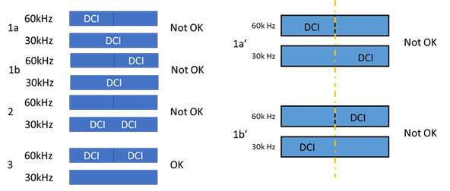

**Figure 3: undesired scenarios for CSI request constraint**

# Conclusion

**Agreement**

The following text proposal is endorsed for TS38.214 (Rel-15 only) in R1-210XXXX (TS38.214, Rel-15, CR#YYY, Cat. F)

* A UE is not expected to receive more than one DCI with non-zero ~~CSI request~~ *CSI request* field per slot per cell. A UE is not expected to receive DCI with non-zero *CSI request* field within a cell group in a slot overlapping with any slot receiving DCI with non-zero *CSI request* field in the same cell group.
* A UE is not expected to receive more than one aperiodic CSI report request for transmission in a given slot per cell. A UE is not expected to receive an aperiodic CSI report request for transmission in a slot overlapping with any slot having an aperiodic CSI report transmission in the same cell group.

**Conclusion**

The text proposal on CSI request constraint per slot and CSI reporting constraint only consider~~s~~ Rel-15 where PDCCH with which the CSI request is transmitted, the PUSCH on which the reports are to be transmitted, and the CSI-RS associated in the CSI reports triggered by the DCI have same numerology. The scenario where at least two of them have different numerology should be further discussed in Rel-16.

# Reference

1. R1-2101768, “RAN1#104-e preparation phase initial summary on NR Rel-15 CRs”, Ad-hoc Chair (Samsung)
2. R1-2101136, “Draft 38.214 CR on CSI request constraint per slot”, MediaTek Inc.

# Appendix A

------------------------------------------------------------- Start of the TP ----------------------------------------------------------------

#### 5.2.1.5 Triggering/activation of CSI Reports and CSI-RS

##### 5.2.1.5.1 Aperiodic CSI Reporting/Aperiodic CSI-RS

For CSI-RS resource sets associated with Resource Settings configured with the higher layer parameter *resourceType* set to 'aperiodic', 'periodic', or 'semi-persistent', trigger states for Reporting Setting(s) (configured with the higher layer parameter *reportConfigType* set to 'aperiodic') and/or Resource Setting for channel and/or interference measurement on one or more component carriers are configured using the higher layer parameter *CSI-AperiodicTriggerStateList*. For aperiodic CSI report triggering, a single set of CSI triggering states are higher layer configured, wherein the CSI triggering states can be associated with any candidate DL BWP. A UE is not expected to receive more than one DCI with non-zero CSI request per slot within a cell group; the slot is defined according to the smallest SCS of all configured DL BWPs in a cell group*.* A UE is not expected to be configured with different *TCI-StateId*'s for the same aperiodic CSI-RS resource ID configured in multiple aperiodic CSI-RS resource sets with the same triggering offset in the same aperiodic trigger state. A UE is not expected to receive more than one aperiodic CSI report request for transmission in each reference slot, which is defined according to the smallest SCS of all configured UL BWPs in a cell group. A UE is not expected to be triggered with a CSI report for a non-active DL BWP. A trigger state is initiated using the *CSI request* field in DCI.

< Unchanged parts are omitted >

-------------------------------------------------------------- End of the TP ----------------------------------------------------------------