**3GPP TSG RAN WG1 Meeting #103-e R1-2009342**

**e-Meeting, October 26th – November 13th, 2020**

**Source: Moderator (Nokia/NSB)**

**Title: Summary on A.I. 8.8.1.2 baseline coverage performance using LLS for FR2**

**Agenda Item: 8.8.1.2**

**Document for: Discussion and Decision**

# Introduction

This document summarizes the content of contributions submitted to 8.8.1.2 and 8.8.3 (related to FR2).

## Guidance for 3rd week discussion

Companies are encouraged to review the updated FL proposal in the sections:

**High priority (early decision expected)**

* 2.2 [H] Target metrics and values for bottleneck identification
  + Decisions for AI 8.8.1.1 and AI 8.8.1.2 may differ hence new discussion is started for this topic. An important proposal has been made Please check.

**Medium priority**

* 2.3.2 [M] Urban 28 GHz O2I
  + Here results are commented and used to formulate Fl’s proposal in 2.2 and 2.5.2
* 2.3.3 [M] Urban 28 GHz O2O
  + Here results are commented and used to formulate Fl’s proposal in 2.2 and 2.5.2
* 2.3.4 [M] Indoor 28 GHz
  + Here results are commented and used to formulate Fl’s proposal in 2.2 and 2.5.2
* 2.5.2 [M] Coverage bottleneck identification using representative values
  + Here a tentative proposal is given for coverage bottleneck identification covering at least 1st priority channels

**Low priority**

The discussion in these sections has less or no impact to others. Companies can already input their views.

* 2.6 [L] Observations from SLS evaluations
* 2.7 [L] Others

Companies are encouraged to review the sections and add view, whenever applicable.

## Guidance after the GTW session on 26th October

For the 1st checkpoint, FL plans to progress the following high priority topics:

* Section 2.2 [H] Target metrics and values for bottleneck identification
  + **FL’s recommendation 1**: This discussion will be carried out in conjunction with AI 8.8.1.1 for the target metrics. No FR2-specific discussion will take place about this.
  + **FL’s recommendation 2**: FR2-specific discussion will take place about the values for bottleneck identification if the use of absolute targets is agreed upon.
* Section 2.3.1 [H] How to aggregate evaluation results from different companies and limit number of scenarios of interest for bottleneck identification
  + **FL’s recommendation 3**: This discussion will be carried out in conjunction with AI 8.8.1.1 for the approach to follow to aggregate evaluation results No FR2-specific discussion will take place about this.
  + **FL’s recommendation 4**: FR2-specific discussion will take place about the scenarios/frame structures/channels of interest for bottleneck identification.

## [CLOSED] Common understanding for common issues between FR1 and FR2

After discussion with FL of AI 8.8.1.1, an overlap between several open issues for FR1 and FR2 has been observed. For the sake of efficiency of the discussion RAN1 will have during #103-e, this document has been organized in order to minimize such overlap when possible. All common items between FR1 and FR2 will be just mentioned herein, when applicable, given that a complete discussion on these will be carried out in AI 8.8.1.1.

FL’s view is that conclusions/agreements made in AI 8.8.1.1 for common items between FR1 and FR2 can be extended to AI 8.8.1.2, without specific discussion taking place in AI 8.8.1.2. All FR2-only issues are, on the other hand, detailed and discussed in this document and AI.

Companies are invited to express views on the FL suggestion above.

|  |  |
| --- | --- |
| **Company** | **Comments** |
| CATT | We agree with FL proposal. |
| Vivo | Support FL suggestion. |
| Nokia/NSB | Support. |
| Intel | Support FL suggestion. |
| Ericsson | Agree |
| OPPO | Support FL’s suggestion. |

The detailed plan/deadline for each topic/issue will be provided later.

**FL’s recommendation 5**

As also discussed online during last GTW, confirmed by Mr. Chairman, and confirmed by companies who expressed their views, the above FL’s view is considered as supported.

# Issues for discussion

## [CLOSED] Finalization of parameters and values

The following issues were identified by the companies’ contributions (same numbering used in the [FL summary of AI 8.8.1.1](https://www.3gpp.org/ftp/TSG_RAN/WG1_RL1/TSGR1_103-e/Inbox/drafts/8.8.1.1/2nd_round/3rd_Summary_8.8.1.1_v002_FL_FL.docx) has been used for consistency).

Table 2.1-1. FR2-only Companies’ proposals on the parameters

|  |  |  |
| --- | --- | --- |
| **Topic** | **Company Tdoc No** | **Proposal** |
| (2) Antenna gain correction factor | Vivo R1-2007683 | The correction factor for gNB Rx BF gain should be considered for FR2 for PRACH and MSG3, the same values can be assumed as that for Tx beamforming. |
| vivo R1-2007683 | The correction factor for gNB BF gain for broadcast channel should be considered in link budget template. - In FR2, the correction factor is about 8dB and 5dB in urban and indoor scenarios, respectively. |
| ZTE R1-2007742 | Consider the antenna gain correction factors in Table 1 for link budget calculation in FR2. |
| (6) Penetration margin | ZTE R1-2007742 | Consider the penetration margin with 34.14 dB for urban O2I, 9 dB for urban O2O, 0 dB for indoor scenario in FR2. |
| Intel R1-2007953 | 9 dB for Urban O2O, NLOS, 0 dB for Indoor |
| (11) PUCCH F1 for HARQ-ACK for Msg.4 | ZTE R1-2007742 | For link level simulation of PUCCH format 1 with 1-bit HARQ-ACK for Msg4 in FR2, reuse the simulation assumptions of normal PUCCH with assuming no PUCCH repetition. |
| (12) Interference density | ZTE R1-2007742 | Consider the receiver interference density values in Table 2 for link budget calculation in FR2. |
| (13) Pathloss formula | OPPO  R1-2008270 | If scenario dependent targets were identified, e.g., ISD/MPL, we can reuse the path loss formulas for channel model A in ITU-M.2412. |
| (14) PUCCH baseline configuration | NTT Docomo R1-2008558 | PUCCH short format should be considered for baseline coverage performance for FR2 with considering practical NW operation of using large number of BS antenna beams. |
| (15) Shadow fading margin | Intel R1-2007953 | 4.85 dB for Urban O2O, NLOS, 5.2 dB for Indoor |
| (16) Others | OPPO  R1-2008270 | Reuse IMT-2020 values, including for row (8)/(12) of the LB template. |

This is the last meeting prior to study item conclusion. From FL’s perspective, and like what has been said for the [AI 8.8.1.1](https://www.3gpp.org/ftp/tsg_ran/WG1_RL1/TSGR1_103-e/Inbox/R1-2009341.zip), priorities in this context seem to be the identification of consolidated performance targets/gaps, representative performance values/scenarios/frame structures, bottleneck identification. It does not seem reasonable to re-open the discussion on evaluation assumption and values, because it requires performing additional link level simulations and reassess the situation once again to obtain. This would have an impact on LB template which, as we saw for recent discussions, requires huge efforts from the companies with limited convergence for most aspects in any case.

Given these reasons, FL strongly recommends that the parameters/values/configurations suggested in Table 2.1-1 should be treated according to the “reported by companies” principle, which means RAN1 will not spend time at this meeting on the resolution of these issues.

Companies are invited to provide views on the FL suggestion above.

|  |  |
| --- | --- |
| **Company** | **Comments** |
| CATT | We agree with FL proposal. |
| Vivo | Support FL suggestion. |
| Nokia/NSB | Support |
| Intel | Support FL’s suggestion. |
| Ericsson | Agree |
| OPPO | Support FL’s suggestion. |

**FL’s recommendation 6**

Given the views expressed by companies, the above FL’s view is considered as stable and a corresponding proposal (i.e., Proposal 1) is formulated in Section 3.

## [CLOSED] Target metrics and values for bottleneck identification

At RAN1#102e meeting, the following conclusion was made for the target metrics and values:

Agreements:

* RAN1 strives for satisfying appropriate targets identified by companies particularly operators
  + The targets may be in the form of one or more of the following:
    - 1. Scenario dependent targets, e.g., ISD/MPL
    - 2. Service dependent targets, e.g., [MCL=147] dB for VoIP;
    - 3. Relative difference between channels, e.g, MIL(/[MCL])
  + Further values and details of such targets will be clarified at RAN1#103-e
  + Note: there is no intention in RAN1 to update the study item objectives due to the identified targets.

Proposals by companies concerning these aspects are summarized as follows:

**1. Scenario dependent targets, e.g., ISD/MPL**

Table 2.2-1. Proposals on target ISD/MIL/MPL values

|  |  |  |  |
| --- | --- | --- | --- |
|  | **Dense Urban FR2** | **Suburban FR2** | **Indoor FR2** |
| ZTE  R1-2007746 | 200m [MPL 123.1] |  | 20m [MPL 91.82]  12BSs per 120m x 50m |
| vivo  R1-2007679 | 200m |  | 20m as per TS 38.913 |
| CATT  R1-2007877 | 200m | 200m | 20m |
| Intel  R1-2007952 | 300m [MIL 143.8] |  | 40m [MIL 110] |
| Huawei/HiSi  R1-2007582 | 400m O2I  500m O2O |  | 70m |
| Ericsson  R1-2008344 | 200m | 500m | 20m |
| OPPO  R1-2008270 | 400m/500m | 400m/500m | 20m/40m |

**2. Relative difference between channels, e.g, MIL(/[MCL])**

Table 2.2-1. Proposals on target relative values

|  |  |  |
| --- | --- | --- |
| **Company** | **Preferred metric** | **Criteria to identify bottlenecks** |
| CATT  R1-2007877 | MIL or MCL | Worst, 2nd worst, 3rd worst |
| Qualcomm  R1-2008625 | MCL | Worse than PDCCH unicast |
| NTT DOCOMO R1-2008558 | MIL | Worse than 2nd best channel |
| InterDigital  R1-2008482 | MIL/MCL | Relative comparison between channels |
| Samsung  R1-2008180 | MIL/MCL[/MPL] | Relative difference between channels |
| Vivo  R1-2007679 | MIL/MCL | Based on relative comparison between MCL and MIL |
| ZTE  R1-2007746 | MIL | Using a margin over worst MIL or alternatively using MIL of PBCH |
| OPPO | MIL | -Step1: Obtain the final baseline performance for each scenario after aggregating evaluation results from different companies;  -Step2: Regarding the MIL of x-th worst channel as the target value;  -Step3: Determine the bottleneck channels and gaps by the MIL and the target value obtained in step2. |

The input from companies is not enough to decide due to the following reasons.

* For scenario-dependent targets, e.g., ISD/MPL
  + Proposals by companies are not aligned yet: different values are proposed. Multiple options exist for the same scenario.
  + Pathloss equation used to convert ISD target to MPL has not been agreed.
* For Relative difference between channels, e.g, MIL(/[MCL])
  + MIL seems to be preferred by majority, but situation is not clear.
  + It is not easy to decide the criteria to identify bottlenecks without seeing the final form of link budget. The level of enhancement should be realistic, but it is not clear at this moment.

It is worth observing that aside from service-dependent targets, which are peculiar to AI 8.8.1.1, the same observations made for FR2 can be found for FR1 in the [FL summary of AI 8.8.1.1](https://www.3gpp.org/ftp/TSG_RAN/WG1_RL1/TSGR1_103-e/Inbox/drafts/8.8.1.1/2nd_round/3rd_Summary_8.8.1.1_v002_FL_FL.docx).

Therefore, FL would like to propose the following guidance for the next step of the discussion:

* The proponents of scenario-dependent targets are invited to discuss and propose a single target value for each scenario
  + MIL or MPL value corresponding to the target ISD value should also be proposed, given a common path-loss equation.
* For Relative difference between channels, the same agreement made for FR1 will be extended to FR2
* Next step of the discussion will take place after an agreement on issue 2.3.1 is made.

Companies are invited to input views on the FL guidance in the table below.

|  |  |
| --- | --- |
| **Company** | **Comments** |
| CATT | First of all, we want to clarify whether both of 2 target metrics including  scenario-dependent target and Relative difference between channels need be used for  bottleneck identification or we need only down-select 1 targets metric for bottleneck  identification. |
| NTT DOCOMO | We are fine with the FL proposal. A single target ISD value should be decided so that we could see the same channels as bottlenecks. Also, it is reasonable to follow the same procedure as FR1. |
| ZTE | We are fine with FL guidance. |
| Vivo | Scenario dependent target is preferred. And the values provided in TR 38.913, if available, can be considered as starting point.   |  |  |  | | --- | --- | --- | |  | **Dense Urban FR2** | **Indoor FR2** | | Target ISD | 200m for O2O | 20m as per TS 38.913 | | MPL | 123.08dB | 94.03dB | | MIL | 140.15dB(O2O) for control channels  136.93dB(O2O) for data channels | 102.53dB for control channels  99.23dB for data channels |   Besides, the gap between coverage of FR2 urban O2I and target MPL corresponding to 200m ISD is too large to be compensated. Hence, we also suggest to down prioritize the Urban FR2 O2I. |
| Nokia/NSB | We are fine with FL’s guidance. Our preference is for reusing the same framework agreed for FR1 (when this agreement is found). If absolute targets are chosen as the single target, or one of the targets, then we are fine with vivo’s suggestion of setting ISD targets according to TS 38.913. |
| CMCC | From our observations (detail information could be found in Annex 2 of the R1-2008025), the coverage of FR2 Urban O2I is too limited compare to the 200m ISD requirement. In the contrast, the coverage for FR2 in the indoor scenario seems good enough from the perspective of maximum range (30). Also we do not have enough information or experience to decide a practical ISD for FR2. Then the relative difference or comparison is preferred. |
| Intel | We are fine with the FL’s proposal. We prefer same approach in both FR1 and FR2. |
| Ericsson | We are fine with the FL’s proposal, with the exception that MIL or MPL value from system level simulations should be able to be reported according to the setups used by companies in their simulations. System level simulations have to be rerun with parameters like ISD. |
| OPPO | We prefer to use the relative value for the target metric. Please add the description into Table 2.2-1.  Companies have different parameters/values/configurations. When a single value is used for evaluation, the values of gap obtained according to the baseline performance provided by companies are different. We need to determine how to deal with these gaps to obtain the final result. Maybe we can deal with it in the following way (like Option 1-2 and Option2-2 in FR1):  -Step1: Obtain the final baseline performance for each scenario after aggregating evaluation results from different companies;  -Step2: Regarding the MIL of x-th worst channel as the target value;  -Step3: Determine the bottleneck channels and gaps by the MIL and the target value obtained in step2. |

**FL’s update on 10/29**

FL’s comments:

* The majority of companies seem to agree with FL’s guidance.
* OPPO’s view has been updated, as requested.
* Ericsson’s comments about SLS are received. FL assumes they also apply to FR1. It may be worth observing that companies are not asked to present SLS-based results in this SI/WI, but rather LLS. If an eventual agreement during the early stage of RAN1 #103-e is such that results obtained through previous SLS simulations need to be updated, then companies will be allowed to update them until November, 6th. On the other hand, according to FL’s understanding, no restriction exists for the identification of channel bottlenecks prior to that date, if companies can agree on the existence of such bottlenecks.

**FL’s recommendation 6**

From FL’s perspective the discussion on which target metric to consider should be carried out only once, i.e., for FR1. RAN1 is already doing this. Any decision taken therein can be extended to FR2. In this context, if relative metrics are chosen, it is expected that the same logic to calculate them will be extended to FR2. Conversely, if absolute metrics are chosen, then FR2-specific scenario-dependent ISD/MPL/MIL values will be discussed. For the sake of completeness, what could look like an FR2-equivalent for the current proposal for FR1 is provided below.

**Updated FL proposal:**

* + For, Scenario dependent targets, e.g., ISD/MPL
    - * MPL is used to compute the ISD values
      * Further discussion is necessary how to capture the evaluation results with SLS in the TR
  + For Relative difference between channels
    - MIL is used to derive relative differential values
    - Relative differential value is applicable to all scenarios
    - For each channel, differential value is defined by the following formula, and used to draw observations
      * Option A-1: (MIL of the channel) – (MIL of the worst channel + X dB)
        + X is chosen considering the realistic value achieved by potential enhancement(s).
      * Option A-2: apply the following 3-step approach [FL note: companies’ views on this option have not been collected yet.]
        + Identify bottleneck channels in RACH procedure, i.e., compare coverage of msg1(PRACH), msg2 (~~PDCCH~~/PDSCH), msg3(PUSCH), and msg4(PDCCH/PDSCH) [FL note for FR2: PDCCH for msg2 does not have enough results for now].
        + Identify bottlenecks in control channel coverage, i.e., compare coverage of broadcast PDCCH vs PUCCH. This gives us an idea of control coverage that is independent of service rate requirements.
        + Identify bottlenecks in data channel coverage. Compare control channel coverage with data channel coverage.
  + FFS: interaction among Scenario dependent targets and Relative difference for bottleneck identification
    - Option B-1: use scenario dependent targets only
    - Option B-2: use relative difference between channels only
    - Option B-3: use all the 2 targets, e.g.
      * Absolute targets (i.e., scenario dependent targets) are used to filter the channels/signals, i.e., the channel can be a bottleneck or not.
      * Apply relative difference to the filtered channels/signals, which do not meet the absolute targets, to estimate the necessary amount of enhancements (in dB)
    - Other options are not precluded
    - FL note: the selection of the option will be performed in the next round of email discussion.

**FL’s update on 11/03**

After observing development of the discussion for FR1, FL would like to propose to take an additional step for FR2 as well, at least for what concerns the down-selection of absolute ISD targets, given companies proposals.

**Absolute ISD targets, given companies proposals**

This discussion is to anticipate a potential agreement on absolute targets used to identify coverage bottlenecks. The idea is to be ready to have a quick agreement on the subsequent step if necessary. Preferences expressed by companies so far are summarized in the Table below

|  |  |  |
| --- | --- | --- |
|  | **Dense Urban FR2** | **Indoor FR2** |
| 20m | X | **5** |
| 40m | X | 2 |
| 70m | X | 1 |
| 200m | **3** | X |
| 300m | 1 | X |
| 400m | 1 | X |
| 500m | 2 | X |

Largest support is for

* **Dense Urban**: ISD=200m. Corresponding MPL value has been provided in this case, i.e., 123.1 dB;
* **Indoor**: ISD=20m. Corresponding MPL value has been provided in this case, i.e., 94.03 dB.

It is also worth observing that, as pointed out by several companies, these two values correspond to the ISD values recommended for FR2 Dense Urban and Indoor scenarios in TS 38.213. For the sake of completeness, FL would also like to report an additional suggestion made by one company (vivo) on absolute MIL values, that is

|  |  |  |
| --- | --- | --- |
|  | **Dense Urban FR2** | **Indoor FR2** |
| MIL | 140.15dB(O2O) for control channels  136.93dB(O2O) for data channels | 102.53dB for control channels  99.23dB for data channels |

The following FL’s recommendation and proposal in Section 3 (Proposal 4) are then formulated.

**FL’s recommendation 7**

If absolute ISD/MPL targets are agreed to be used to coverage bottleneck identification then the following targets are considered for FR2:

* + **Dense Urban**: ISD = 200m; MPL = 123.1 dB;
  + **Indoor**: ISD = 20m; MPL = 94.03 dB;

Where MPL values are calculated from ISD targets using the following equations (taken from the document “Report ITU-R M.2412-0 - Guidelines for evaluation of radio interface technologies for IMT-2020”, which has the same models as in TR 38.901).

|  |  |
| --- | --- |
| **URBAN** | **INDOOR** |
| TABLE A1-3 Path loss and shadow fading for Uma_x | TABLE A1-2 Path loss and shadow fading for InH_x |

With values of $f_{c}$, $h_{BS}$, $h_{UT}$ are set using the values in the following table

|  |  |  |
| --- | --- | --- |
|  | **Urban** | **Indoor** |
| $$f_{c}$$ | 28 | 28 |
| $h_{BS}$ | 25.00 | 3 |
| $h_{UT}$ | 1.5 | 1.5 |

and $d_{3D}$ equal to the target range calculated by ISD/ $\sqrt{3}$.

FFS: If absolute MIL targets are also considered for coverage bottleneck identification including possible different targets for data and control channels.

Companies are invited to input views in the table below.

|  |  |
| --- | --- |
| **Company** | **Comments** |
|  |  |
| Ericsson | Support the FL proposal (also confirm the pathloss calculation). |
| ZTE | Similar to FR1, it should be ‘d3D equal to the target range calculated by ISD/ $\sqrt{3}$.’  In addition, one minor editorial suggestion for the FFS part. It seems sufficient to say ‘If MIL targets are also considered for coverage bottleneck identification’. Using ‘control and data channels’ are kind of vague, e.g. not sure whether it includes the channels in RACH procedure. |
| Nokia/NSB | Concerning ZTE’s comment on $d_{2D}$, from our understanding, it would be more technically correct if $d_{2D}$ is used to characterize the range, which can be calculated by target ISD/ $\sqrt{3}.$ $d_{3D}$ can then be derived from $d_{2D}$ for the calculation of the corresponding target pathloss. The relationship between $d_{2D}$ and $d_{3D}$ can be illustrated as follows [TR 38.901] [M.2412-0].  Concerning ZTE’s comment on the FFS, our understanding is that MIL targets in the FFS refer to vivo’s proposal to consider different targets for data and control channels. We therefore propose the following wording (in blue) on top of ZTE’s proposed text (in red) to capture both views.  “FFS: If MIL targets are also considered for coverage bottleneck identification including possible different targets for data and control channels.” |

**FL’s update on 11/09**

After the GTW on Thursday 11/05, one companies expressed concerns about how $d_{3D}$ should be calculated. It was communicated to FL offline, by the same company, that said concerns can be considered as addressed and the initial definition of $d_{3D}$ can be supported. A corresponding proposal has been added to Section 3.

**FL’s update on 11/10**

From FL’s perspective, current situation is as follows:

* Aggregated metrics for FR2 provide very clear picture of the coverage of all channels, across all considered 1st priority scenarios. It appears that intuitive understanding related to TX power difference between UE and gNB in FR2, i.e., UL coverage can be very problematic in general, is fully visible from the aggregated evaluation results with (almost) no exception. In other words, (almost) all UL channels suffer non-negligible coverage shortage as compared to DL counterparts.
* The “almost” in the previous sentence is related to PUCCH F1, for which companies’ opinions may differ. However, given the very limited number of potentially controversial issues, if doubts and concern exist in this regard, it may be wiser (and faster) to deal with them on a case by case basis with no specific agreed approach.
* FR2 deployments are characterized by big challenges associated to propagation conditions in FR2 (especially for O2I scenarios). Additionally, it should be noted that the impact of antenna array gain at the UE is non-negligible in the case, and a lot of time has been dedicated to its modelling by RAN1 in this SI. Therefore, it seems reasonable to express link budget gain which should stem from enhancements of coverage bottleneck channels in the form of MPL increase (in dB), regardless of the adopted approach to identify coverage bottlenecks. Two additional observations can be made:
  + This approach allows to map any additional dB coming from enhancements to actual range extension for the considered channel, given the already agreed equations.
  + Any MIL increase, regardless of how it is achieved, corresponds to an equivalent MPL increase, whereas the converse is not necessarily true.

Given the above, it is becoming rather evident that agreements related to FR1 may be not be adapted to situation in FR2 and, FR2-specific agreements on how target metrics are used to identity coverage bottlenecks may be necessary.

Now, if we consider the current status of the discussion in FR1, the peculiarities of FR2, and the results presented in the document in **Sections 2.3.2**, **2.3.3** and **2.3.4** (companies are strongly encouraged to check these sections very carefully), the following FL’s proposal is formulated. Companies should note that priority has been given to clarity, to formulate a concise and streamlined proposal which could capture all the essential elements stemming from the analysis of the results and the charts in Section 2.3:

**FL proposal:**

Performance targets for FR2 are calculated, for all scenarios, as follows:

* [Absolute] ISD targets are used to find corresponding absolute target MPL values;
* [Relative] Relative differential MIL value of a target channel is calculated considering PUCCH F1 as reference channel, as follows:
  + (MIL of the target channel) – (MIL of PUCCH F1)

Coverage bottleneck identification for FR2 is performed using at least absolute MPL and relative differential MIL targets, as follows:

1. Absolute MPL targets are used to filter the channels/signals, i.e., the candidate bottleneck channels.
2. Filtered channels/signals whose relative differential MIL value is negative are considered coverage bottleneck.

The necessary link budget increase for each bottleneck channel/signal, expressed in the form of MPL increase (in dB), that enhancements for that channel/signal should deliver, are obtained by changing the sign of the relative differential MIL value of the channel/signal.

Other options to draw additional observations from collected results are not precluded.

Companies are invited to add views about this FL’s proposal in the table below. FL would also like to remind everyone that

* Sections 2.3.2, 2.3.3 and 2.3.4 should be carefully checked before commenting.
* Available time is scarce and constructive attitude is highly appreciated. Please also remember that the sooner we complete analysis of 1st priority scenarios/channels/frame structures the better for the analysis of 2nd priority ones (which will start afterwards, if time allows it).

|  |  |
| --- | --- |
| **Company** | **Comments** |
| CATT | In general, we are fine with FL proposal and we think MIL of the worst channel among the channels that have more than 3 samples can be made as reference channel which aligns with FR1. |
| Samsung | We are generally fine with FL proposal. On the other hand, we would like to point out that the necessary link budget increase would be challenging (19.20dB for PUSCH eMBB) if we take PUCCH F1 as reference channel (from sections 2.3.2/2.3.3/2.3.4). |
| Ericsson | The FL proposal looks good overall, but we are not sure that PF1 is the best reference. Selecting PF1 as the reference has the merit that since it has the best coverage, if all other channels can match it, then no control channel will limit coverage. On the other hand, all channels except PF1 are by definition bottlenecks, which does not help limit the effort in a potential work item.  Using the Nth worst channel would be more focussed, and so we somewhat prefer that. **So our proposal would be to report (MIL of the target channel) – (MIL of worst channel) for the N worst channels.**  Identifying the exact order of the bottlenecks may be challenging given the variation we have in results. Please find below a chart comparing the MIL channels in all scenarios for FR1. The red error bars are +/- 1 standard deviation high. (The data are a bit outdated, but the trends should be reasonable, and I think applies to FR2 as well) Here we can that the standard deviation is larger than the differences between many channels. **So we propose that the uncertainty our link budget estimates be taken into account when reporting bottlenecks, and that some measure of uncertainty be reported along with the differential MIL values.** |
| ZTE | We are fine with the proposal. Using only absolute target would be changing in FR2, and PUCCH format 1 seems a good reference for relative differential target to further filter the candidate bottleneck channels. |
| FL | @CATT: From FL’s perspective it is rather evident that a DL/UL coverage unbalance exists for FR2. Gaps are much bigger than what is observed for FR1, for almost all channels. An FR2-specific approach seems to be the wisest course of action if RAN1’s goal is to increase coverage of all channels who seem to need “a boost”. Given the identical outcome of the two proposed methods, which both seem to capture very well this UL/DL unbalance, FL’s recommendation would be to keep one of the two. If I understood your comment, this would be acceptable for CATT (albeit not preferred).  @Samsung: Agreed. On the other hand, from FL’s perspective the link budget increase should always be based on best effort. In other words, it is not clear why RAN1 should not aim at the maximum possible increase for all the bottleneck channels (if any). In this sense, the actual number may not matter so much, and serve more as an indicator how important enhancements for the channel/signal are. In the specific case of the PUSCH, for instance, FL’s take would be that the 19+ value shows that RAN1 should strive to work on any enhancement which may bring gain, and possibly work on several enhancements at the same time. FL’s opinion is that the coverage problem for FR2 UL exists and we should be as pragmatic as we can about it.  @Intel: Thank you for the comment. I will ask the question explicitly in the reflector to understand if a modified proposal can be accepted by everyone.  @Ericsson: Please see FL’s comments in Section 2.5.2 |

## [L] Observation from evaluation results

### [CLOSED] How to aggregate evaluation results from different companies and limit number of scenarios of interest for bottleneck identification (common for FR1 and FR2)

This nature of this issue is common to FR1 and FR2 and is substantially related to the discussion in section 2.2. The rest of the section will mimic the structure of the corresponding section in the [FL summary of AI 8.8.1.1](https://www.3gpp.org/ftp/TSG_RAN/WG1_RL1/TSGR1_103-e/Inbox/drafts/8.8.1.1/2nd_round/3rd_Summary_8.8.1.1_v002_FL_FL.docx). FR2-only examples to illustrate the extent of the issue at hand, for the sake of completeness, will be made and FL’s observations will be added.

**Aspect 1. Heterogeneity of companies’ evaluation results**

As of Oct. 23rd, **44 pages** of the word document used to collect simulation results obtained by companies are used only for FR2. The amount of data present therein makes the analysis of the situation rather complicated. Furthermore, and when looking at the different results reported by companies on a channel-by-channel basis, if on the one hand it seems that a non-negligible amount of companies report similar values, on the other hand a large variance is observed due the very large peak-to-peak gap (which can exceed 40 dB in the most extreme case). To corroborate this statement, representative figures and tables are provided in the following, where data is extracted from v042 of the results collection template. The focus will be on 28 GHz Urban scenario, NLOS O2I propagation and frame structure DDDSU, for simplicity. A large majority of companies submitted results for this scenario, making it particularly relevant statistically for the purpose of the exercise.

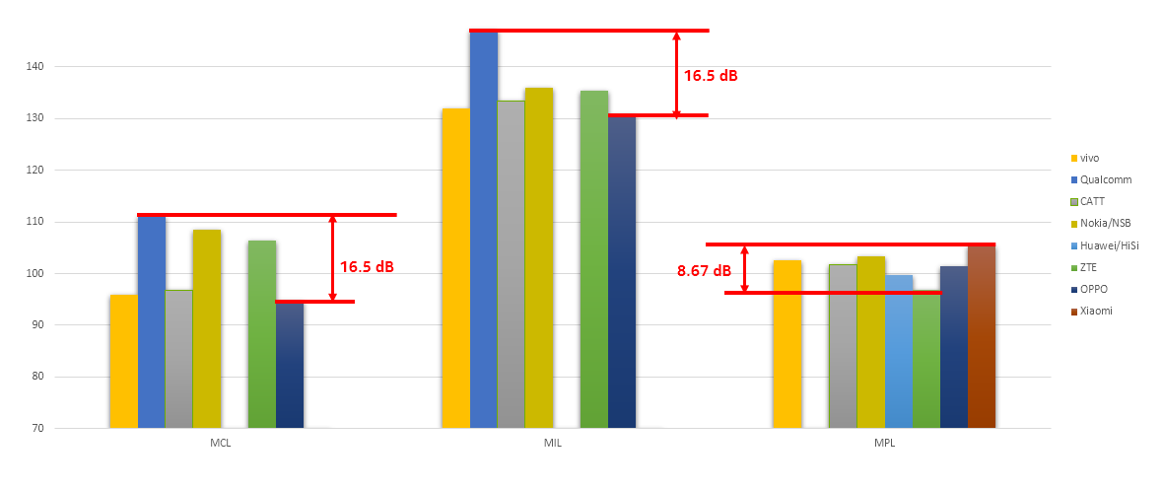

Figure 2.3.1-1-a. An example of companies’ evaluation result for PUSCH eMBB in Urban 28 GHz NLOS O2I (DDDSU) scenario with 23 dBm UE TRP.

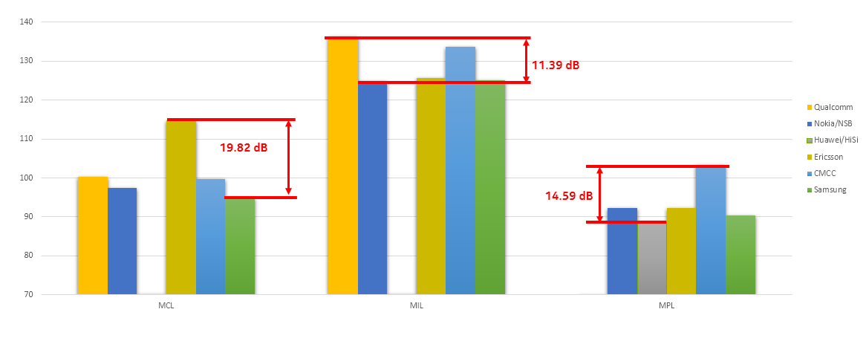

Figure 2.3.1-1-b. An example of companies’ evaluation result for PUSCH eMBB in Urban 28 GHz NLOS O2I (DDDSU) scenario with 12 dBm UE TRP.

Table 2.3.1-1. Summary of companies’ evaluation results for Urban 28 GHz NLOS O2I (DDDSU)

|  |  |  |  |  |  |  |  |  |  |
| --- | --- | --- | --- | --- | --- | --- | --- | --- | --- |
|  | MCL | | | MIL | | | MPL | | |
| mean | median | range | mean | median | range | mean | median | Range |
| PUSCH eMBB, 23dBm UE TRP | 102.2 | 101.6 | 16.5 | 135.8 | 134.4 | 16.5 | 101.6 | 101.8 | 8.7 |
| PUSCH eMBB, 12dBm UE TRP | 101.4 | 99.7 | 19.8 | 129.1 | 125.6 | 11.4 | 93.4 | 92.3 | 14.6 |
| PUSCH VoIP, 23dBm UE TRP | 113.5 | 113.2 | 2.9 | 149.9 | 149.3 | 1.9 | 119.8 | 119.9 | 4.1 |
| PUSCH VoIP, 12dBm UE TRP | 112.2 | 112.2 | 2.7 | 144.3 | 144.3 | 1.3 | 111.7 | 111.7 | 5.7 |
| PUSCH for CSI, 12 dBm UE TRP | 136.2 | 136.2 | 0.0 | 146.2 | 146.2 | 0.0 | 112.9 | 112.9 | 0.0 |
| PUCCH Format 1, 23dBm UE TRP | 120.9 | 114.8 | 23.4 | 154.4 | 150.9 | 29.1 | 115.7 | 116.7 | 10.2 |
| PUCCH Format 1, , 23dBm UE TRP | 117.9 | 116.5 | 15.7 | 150.4 | 150.6 | 24.3 | 109.5 | 109.5 | 13.9 |
| PUCCH Format 3, 11 bits, 23dBm UE TRP | 118.6 | 114.6 | 13.6 | 154.1 | 154.7 | 13.6 | 116.3 | 116.0 | 6.3 |
| PUCCH Format 3, 11 bits, 12dBm UE TRP | 117.5 | 114.4 | 21.6 | 144.8 | 143.9 | 11.7 | 107.4 | 107.0 | 11.4 |
| PUCCH Format 3, 22 bits, 23dBm UE TRP | 115.3 | 112.7 | 14.3 | 149.1 | 148.7 | 7.5 | 113.4 | 112.9 | 6.8 |
| PUCCH Format 3, 22 bits, 12dBm UE TRP | 110.6 | 110.2 | 2.1 | 141.1 | 139.8 | 8.1 | 105.2 | 102.0 | 9.8 |
| SSB | 132.9 | 131.1 | 17.3 | 156.2 | 154.4 | 16.1 | 120.6 | 120.9 | 26.2 |
| PRACH B4, 23dBm UE TRP | 121.5 | 124.4 | 22.4 | 147.2 | 146.7 | 24.4 | 107.2 | 105.2 | 11.5 |
| PRACH B4, 12dBm UE TRP | 121.5 | 119.1 | 22.4 | 145.6 | 146.7 | 18.0 | 111.2 | 111.2 | 16.5 |
| PDCCH of Msg2 | 133.4 | 131.2 | 16.8 | 153.1 | 152.0 | 8.4 | 117.9 | 118.6 | 16.0 |
| PDSCH of Msg2 | 136.4 | 136.4 | 22.0 | 153.9 | 153.9 | 7.1 | 122.6 | 122.6 | 3.2 |
| PUSCH of Msg3, 23dBm UE TRP | 118.9 | 122.4 | 16.4 | 146.9 | 145.4 | 18.4 | 110.9 | 109.4 | 10.2 |
| PUSCH of Msg3, 12dBm UE TRP | 119.7 | 115.1 | 25.6 | 144.0 | 146.6 | 13.9 | 107.9 | 107.8 | 19.6 |
| PDSCH of Msg4 | 133.6 | 129.9 | 21.3 | 151.5 | 150.0 | 9.5 | 118.8 | 122.4 | 14.7 |
| PUCCH with HARQ-ACK for Msg4 | 130.7 | 130.7 | 0.0 | 152.4 | 152.4 | 0.0 | 110.7 | 110.7 | 0.0 |
| PDCCH | 133.1 | 131.1 | 18.3 | 158.8 | 159.2 | 18.1 | 125.9 | 126.2 | 19.6 |
| PDSCH | 125.4 | 124.3 | 16.0 | 154.2 | 153.5 | 15.5 | 120.5 | 118.8 | 19.2 |

Note: Column “range” reports the gap between lowest and highest reported values for the channel.

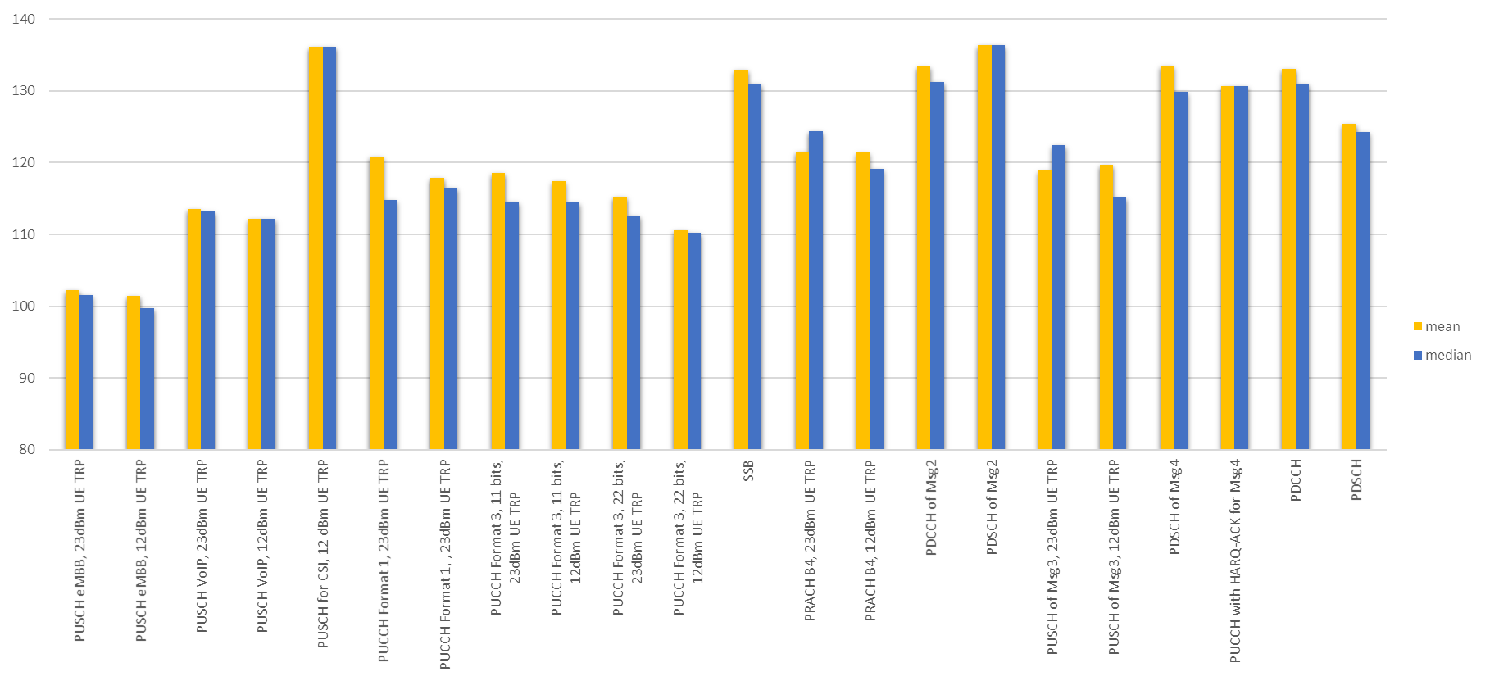

Figure 2.3.1-2-a. Summary of MCL from companies’ evaluation result for Urban 28 GHz NLOS O2I (DDDSU).

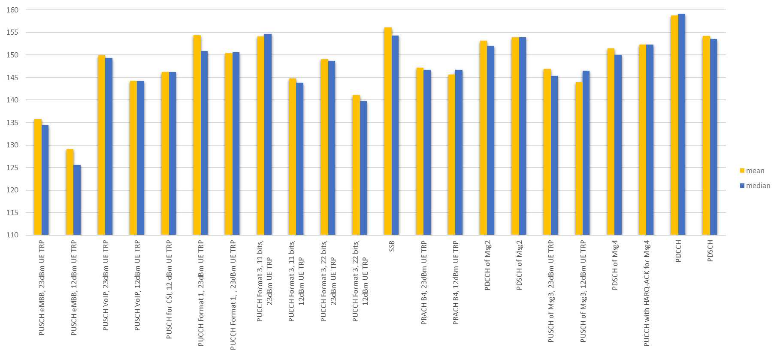

Figure 2.3.1-2-b. Summary of MIL from companies’ evaluation result for Urban 28 GHz NLOS O2I (DDDSU).

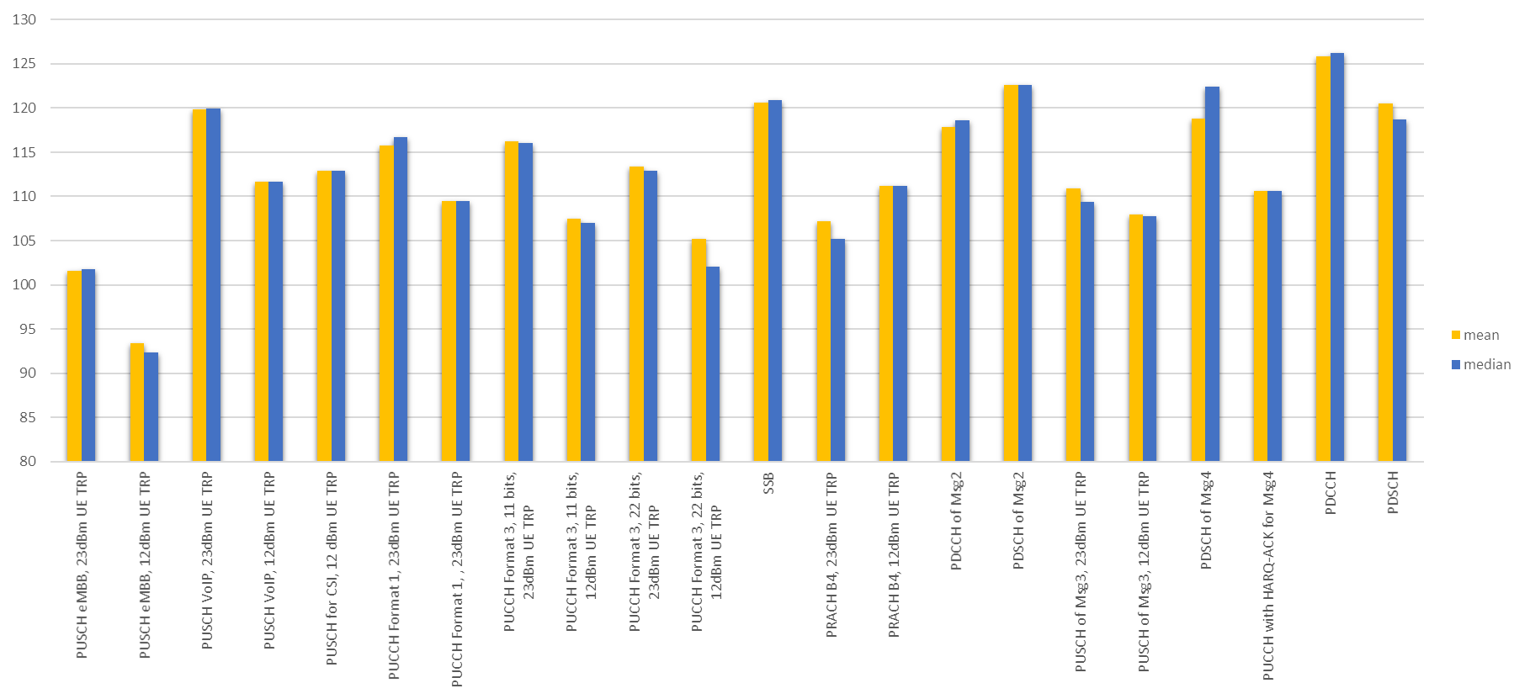

Figure 2.3.1-2-c. Summary of MPL from companies’ evaluation result for Urban 28 GHz NLOS O2I (DDDSU).

As discussed in the corresponding section of the [FL summary of AI 8.8.1.1](https://www.3gpp.org/ftp/TSG_RAN/WG1_RL1/TSGR1_103-e/Inbox/drafts/8.8.1.1/2nd_round/3rd_Summary_8.8.1.1_v002_FL_FL.docx), a meaningful comparison between the performance of each channel and target value(s) seems to be possible only if a single value is used to characterize the performance of each channel. Such value would be obtained from aggregating the evaluation results submitted by companies, however, RAN1 has not decided how such aggregation should be performed. In other words, a decision on how the single value (referred to as “representative value” in the following) can be derived from the evaluation results with different simulation assumptions/parameters must be taken by RAN1. In this context, it seems reasonable to consider its conclusion as valid for both FR1 and FR2.

**FL observation 1**

From FL’s perspective, the discussion on the representative value to represent the performance of each considered channel can be carried out in AI 8.8.1.1 and it is proposed that conclusions/agreements of said discussion are extended to AI 8.8.1.2.

**Aspect 2. Many scenarios for evaluation**

Bottleneck channels should be identified scenario by scenario, if possible. As for FR1, however, it can be noticed also for FR2 that the number of available results for different scenarios/frame structures is quite heterogeneous. The situation as per v043 of the result collection template is illustrated in the following table.

Table 2.3.1-2. Number of contributor(s) per scenario in FR2 for data channels (MIL).

|  |  |  |  |  |  |  |  |  |
| --- | --- | --- | --- | --- | --- | --- | --- | --- |
|  | Indoor | | Urban O2I | | Urban O2O | | Suburban | |
|  | DDDSU | DDSU | DDDSU | DDSU | DDDSU | DDSU | DDDSU | DDSU |
| PUSCH for eMBB | 7 | 3 | 7 | 3 | 6 | 3 | 4 | 2 |
| PUSCH for VoIP | 5 | 3 | 4 | 4 | 4 | 4 | 3 | 0 |
| PDSCH for eMBB | 9 | 2 | 10 | 3 | 8 | 3 | 3 | 1 |

As a result, and as proposed for [AI 8.8.1.1](https://www.3gpp.org/ftp/tsg_ran/WG1_RL1/TSGR1_103-e/Inbox/R1-2009341.zip), it may be reasonable to limit the number of scenarios/frame structures considered for coverage bottleneck identification. A representative scenario and/or frame structure for which enough evaluation results are present could be chosen.

**FL observation 2**

* Identification of bottleneck channels should be done by focusing on a limited number of scenarios/frame structures to accelerate the discussion in RAN1.
* Decisions taken when only a small number of results is available may lead to inaccurate conclusions.

**Aspect 3. Categorization**

Similarly, it is observed that a further categorization might be necessary for deriving a representative value. During the result collection phase, companies have been asked to report relevant assumptions when submitting their results. In this context, evaluations for both O2I/O2O pathloss have been performed for Urban scenarios in FR2. If we then focus on the results reported for PUSCH for eMBB (DDDSU) Urban 28 GHz TDD scenario, and draw relevant statistics, we obtain the situation summarized in the table below.

Table 2.3.1-3. Summary of companies’ evaluation results for PUSCH eMBB in Urban 28GHz (DDDSU) with 23dBm UE TRP.

|  |  |  |  |  |  |  |  |  |  |
| --- | --- | --- | --- | --- | --- | --- | --- | --- | --- |
|  | MCL | | | MIL | | | MPL | | |
| mean | median | range | mean | median | range | mean | median | Range |
| NLOS O2I | 105.6 | 105.7 | 41.6 | 135.5 | 135.5 | 22.3 | 102.6 | 101.6 | 34.4 |
| NLOS O2O | 104.5 | 100.5 | 42.4 | 133.7 | 133.6 | 16.3 | 118.3 | 120.6 | 28.1 |

Note: Column “range” mans the gap between the best and the worst value submitted by companies.

If we focus on MCL and MIL, we can observe that the difference between O2I/O2O mean and median values is never larger than ~5 dB. Conversely, the difference between lowest and highest values companies reported for the same scenario can be larger than 42 dB and 22 dB for MCL and MIL, respectively. Difference between O2I/O2O mean and median values in case of MPL is larger, and in the same order of magnitude between lowest and highest values companies reported for the same scenario. Statistical relevance of the mean and average for the three metrics is very similar (~10 companies provided results for all of them). These results may suggest that different categorizations may be necessary depending on the metric of interest.

Propagation and pathloss assumptions are not the only elements which could be used for categorization. Other parameters such as delta value, UL Tx power can potentially be used as well. However, too many categories would dramatically increase the workload and arguably reduce the accuracy of the conclusions, due to the low number of samples we would have in each category. For these reasons, FL’s view is that RAN1 should proceed with caution while introducing categorizations for the evaluation results, if any.

**FL observation 3**

* RAN1 needs to consider whether and how the evaluation results are categorized on top of scenario, frame structure, channel
  + Candidate categories are delta values, O2O/O2I, PUCCH format, UL Tx power etc.
    - Number of available results changes with the parameters. Hence different categorizations may provide very diverse statistical relevance of the results.
  + Focusing on a smaller number of categories can reduce the workload, i.e., the ones which can provide the largest statistical relevance of the results, may be advisable.
    - FL recommends discuss about this approach in parallel with the corresponding FR1 discussion at the beginning of RAN1#103e

Given the observations above, FL thinks the following approach can be considered at RAN1#103-e.

* Define a representative value for each channel/scenario/frame_structure/category from the submitted evaluation results, which is then used for the comparison with target value(s).
  + The following scenario/frame structure pairs, which have enough evaluation results, are used for the bottleneck identification
    - For FR2:
      * Urban 28 GHz (DDDSU, [DDSU: FL note – additional discussion is needed given the very low statistical relevance of the few available results])
      * Indoor 28 GHz (DDDSU, [DDSU: FL note – additional discussion is needed given the very low statistical relevance of the few available results])
      * [Suburban 28 GHz: FL note – this scenario has been deprioritized during RAN1 #102-e and very few results are available]
  + For each scenario, representative value(s) is/(are) derived for each channel/format, i.e.
    - PUSCH for eMBB
    - [PUSCH for VoIP: FL note – additional discussion is needed given the very low statistical relevance of the few available results]
    - [PUSCH for CSI: FL note – only one company submitted results for this channel configuration]
    - PUCCH Format 1 with 2bits
    - [PUCCH with 3-HARQ-ACK bits + SR: FL note - only one company submitted results for this channel configuration]
    - PUCCH Format 3 with 11bits
    - PUCCH Format 3 with 22bits
    - [PUCCH with HARQ-ACK for Msg.4: FL note - only one company submitted the results for this channel configuration]
    - SSB
    - PRACH format B4
    - [PRACH format C2 – FL note: the number of available results is quite small]
    - PDCCH for Msg.2
    - PDSCH for Msg.2
    - PUSCH for Msg.3
    - PDSCH for Msg.4
    - PDCCH
    - PDSCH for eMBB
  + For each channel/format of each scenario, apply the following approach for categorization to derive a representative value:
    - Option A-1: based on O2O/O2I
      * FL note – a per-metric categorization may be needed)
    - Option A-2: based on delta value (zero vs non-zero)
      * FL note – Not all results include this information as “key assumptions”.
    - Option A-3: transmission power
      * For UL: 23dBm and 12dBm
      * FL note: the number of available results for 12 dBm case may not be enough to achieve statistical relevance
    - Option A-4: no further categorization
      * FL note: in this case, summary provided by FL in Table 2.5-1 could be used a starting point
  + The means to derive a single representative value:
    - Option B-1: use mean value
      * For this case, it is also necessary to discuss how to handle outliers.
    - Option B-2: use median value

Companies are encouraged to provide their views on the FL perspective above.

|  |  |
| --- | --- |
| **Company** | **Comments** |
| CATT | We prefer Option A-1 to apply the following approach for categorization to derive a representative value because for FR2, shadowing and penetration loss are difference between O2O and O2I scenarios.  We prefer Option B-1 to derive a single representative value because the mean value can reflect the overall situation of evaluation performance. If we use mean value to drive the representative value from the performance evaluation, we need also consider how many samples for performance evaluation.  In addition, for channels with only one company or two companies’ input, the evaluation result is not enough to be persuasive. So we suggest no any conclusion on those channels with only one company or two companies’ input is made. |
| NTT DOCOMO | It is better to narrow down to scenarios and frame structure to identify the bottleneck channels. For the categorization, we prefer Option A-4 since the Tx power difference is large for FR2 UL (23 dBm or 12 dBm). |
| ZTE | For scenario/frame structure pairs, we prefer to not consider ‘Suburban 28 GHz:’.  For channel/signal, we suggest to at least consider one format for each channel/signal to get a full investigation.  For categorization, our thinking is:   * Option A-1 is not preferred. For absolute MPL target, we can use O2I, which causing more server coverage issue, for results comparison. For relative target, MIL could be used and there is no much difference between O2O and O2I, one of them could be chosen for results comparison. * Option A-2 is good categorization. The non-zero value reported could be very large for some of the scenarios, and causing a large deviation. * Option A-3 for UL is also fine for us.   Fine with B-1 for determination of the representative value. |
| Vivo | Same conclusion made in FR1 can be applied for FR2.  We suggest to limit the number of categories, and some of the scenarios can be down prioritized for drawing conclusions if sources are limited.  Besides, since there are very few samples for some of the scenarios and channels. Hence these scenarios can be excluded for further categorization. |
| Nokia/NSB | Agree with vivo. Discussion on representative value can be carried out for FR1 and extended to FR2.  Concerning the categorization, we have strong concerns about the feasibility of any categorization which is not related to pathloss/penetration assumption (O2I/O2O). Additionally, our view is that priority should be given to statistically relevant scenarios to identify bottlenecks. In other words, we are not proposing to ignore channels with only 1 or 2 results, but to consider them as lower-priority items to discuss about after discussion on more statically relevant channels is concluded. Thus, we think that:   * ideally no further categorization is necessary; * if a categorization must occur, then we should consider the typical distribution UEs have in urban scenarios and focus on O2I. Coincidentally, this is also the most challenging scenario for coverage; * We should consider different UE Tx power values, i.e., 12 and 23 dBm, and not use them as a criterion to categorize. Either way the effect of the power difference is additive, hence it is straightforward to derive one result from the other (as shown from the results proposed by companies who studied both cases); * Categorizing by delta could be a good approach as well. However, we fear this could make the aggregation of the results more difficult. |
| CMCC | For the scenarios without enough contributed samples, it should not be considered from the perspective to derive a solid conclusion.  And for the assumption of UE transmit power, the practical value should be prioritized. |
| Intel | One clarification: in Figure 2.3.1-1-a, our results for MPL is for O2O scenario, which is substantially different from O2I where large penetration loss is assumed. It may be good to remove our result in the MPL so that the gap can be smaller.  We also prefer same approach for both FR1 and FR2. We are fine with FL's proposal to define a representative value for each channel/scenario/frame structure/category, including the selected scenarios, frame structure and channel/format given the companies' input and collected results.  Regarding the categorization, for Option A-1, our view is that this is tightly coupled with the target performance metric. If MPL based performance metric is used for analysis, it is very clear that we need to distinguish the O2O and O2I scenarios as the penetration loss is substantially different between these two. We do not prefer Option A-3.  Regarding the single representative value for MCL/MPL/MIL, we are fine to take mean value and the number of samples should be >= 4 in order to have meaningful results. |
| Ericsson | Regarding the single representative value, in order to identify bottlenecks, it is best for companies to compare within their own simulations since these will be consistent. Otherwise, we will be averaging results with different simulation assumptions and for which there are different numbers of reporting companies, etc. So, **we suggest that at least relative MIL be used to compare a target channel to some baseline channel, and then the single representative value can be calculated on these relative values.**  Regarding categorization, focussing on O2I results should be sufficient to identify bottlenecks, as indoor UEs are the most coverage limited ones according to our study. **So we are OK with option A-1.** While we think option A-2 would be quite enlightening, we may not have time to do so. If results are refined and therefore there is more time, this may be considered. |
| OPPO | We prefer Option A-4 and Option B-1.  We can reduce the influence of different values of UE speed/ delta value/ transmission power by regarding relative MIL as the target metrics and use the mean value to define a representative value. |

**FL’s update on 10/29**

FL’s comments:

* Intel’s comment on the result included in Figure 2.3.1-1-a has been received. The figure has been updated (following figures will also take this correction into account).
* There seems to be lack of consensus on the approach to use for categorization, while most companies seem to agree that similar approach as FR1 can be used for FR2.
* From FL’s perspective, no categorization is probably the best way forward, to ensure no company has objections on the method, with the exception of O2I vs. O2O, which FL believes a common understanding can be achieved. In this regard, O2I seems be the preferred pathloss/penetration by most companies, due to the more challenging conditions it presents.
* Option B-1 is supported by most companies.
* No specific comment was given on the channels/frame structures/scenarios to consider with higher priority, aside from ZTE’s comment on Suburban.

During online session on 10/29 companies agreed that (details can be found in Section 4)

* No categorization by other simulation parameters (such as UE speed, antenna array gain correction factors, UE Tx power) will be introduced for FR2.
* For FR2, representative values are computed according to agreements made for FR1 related on representative value calculation method;

Given companies’ comments during the first round of discussion, the following recommendation is made.

**FL’s recommendation 8**

* Priority is given to O2I analysis, and O2O could be considered as 2nd priority.

Companies are invited to input their views in the table below.

|  |  |
| --- | --- |
| **Company** | **Comments** |
| Ericsson | Agree. In our understanding, O2I is the coverage limiting case. |
| CATT | We are fine with FL proposal. |
|  |  |

FL would like to proceed by proposing the result of an aggregation of all contributed results so far for both Urban and Indoor scenarios. Only O2I and O2O categorization is applied and representative values for MIL/MPL are obtained using mean value, excluding outliers, e.g., highest and lowest value. It is worth observing that MCL values can be obtained similarly and are not presented here for the sake of compactness. Concerning assumptions on UL Tx power, FL operated according to Recommendation 7 (below), whose corresponding proposal (cfr. Section 3) has been agree online on 10/29.

**FL’s recommendation 9 [corresponding proposal has already been agreed online on 10/29]**

The amount of available results for UL channels in FR2 should be considered as given by the total number of results available results for both 23 dBm and 12 dBm, given that they can be derived one from the other by simple subtraction, and where each company is counted only once.

Therefore, it is noted that only results for 12 dBm TRP will be shown in the following charts, for simplicity. According to the corresponding agreement (cfr. Section 4), the aggregated value for UL channels has then been obtained by considering

* results presented by companies assuming max TRP 12 dBm; and
* results presented by companies assuming max TRP 23 dBm, where corresponding MCL/MIL/MPL values have been reduced by 11 dB, and each company is counted only once (no double value is considered, if any).

As discussed online, this approach has the merit of increasing the statistical relevance of the presented results, thanks to a larger overall number of samples, while preserving the validity/reliability of results presented for max TRP 23 dBm.

Color codes in charts are used as follows:

* **Blue bars**:
  + mean value w/o outliers when the number of available results is larger than 3;
  + mean value using all available results when their number is smaller than 4.
* **Orange line**: number of available samples per channel.

2 charts per metric per scenario are included. Therefore, for each scenario we have:

* Aggregated MIL considering all the channels studied by at least one company for RAN1 #103-e are included in the charts, with no exclusion.
* Aggregated MIL considering only channels for which at least results are available studied by at least one company for RAN1 #103-e are included in the charts, with no exclusion.
* Aggregated MPL considering all the channels studied by at least one company for RAN1 #103-e are included in the charts, with no exclusion.
* Aggregated MPL considering only channels for which at least results are available studied by at least one company for RAN1 #103-e are included in the charts, with no exclusion.

The charts follow.

**Urban 28 GHz O2I (DDDSU and DDSU)**

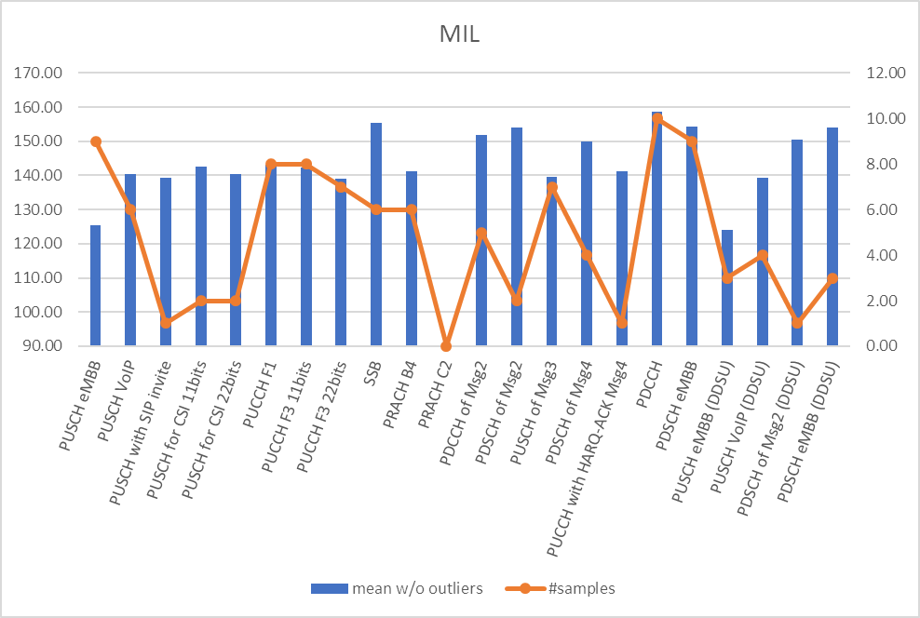

Figure 2.3.1-4. Urban O2I - Representative value for MIL – Overall chart including all considered frame structures according to results reported by companies.

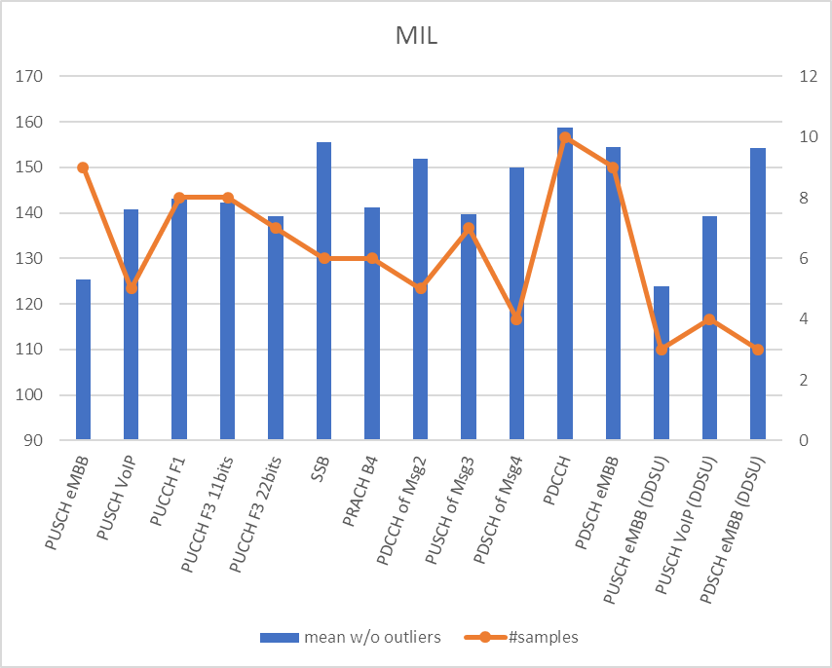

Figure 2.3.1-5. Urban O2I - Representative value for MIL – Chart including frame structures and channels for which results have been obtained by at least 3 companies.

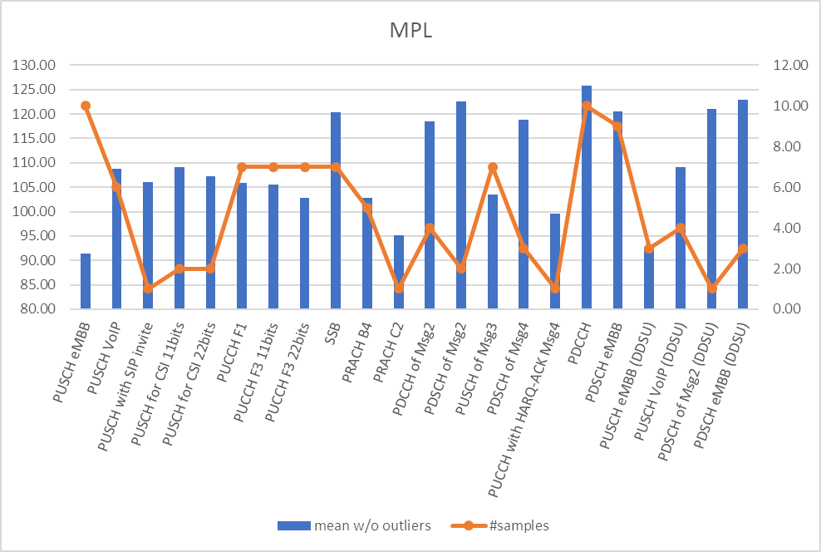

Figure 2.3.1-6. Urban O2I - Representative value for MPL – Overall chart including all considered frame structures according to results reported by companies.

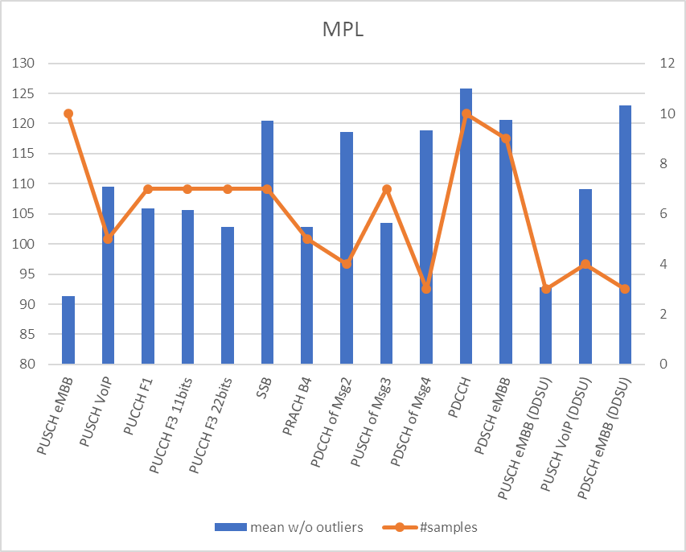

Figure 2.3.1-7. Urban O2I - Representative value for MPL – Chart including frame structures and channels for which results have been obtained by at least 3 companies.

**Urban 28 GHz O2O (DDDSU and DDSU)**

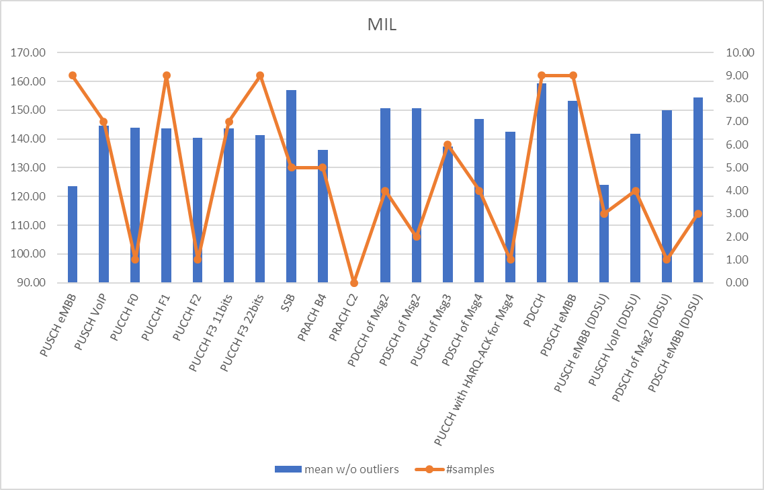

Figure 2.3.1-8. Urban O2O - Representative value for MIL – Overall chart including all considered frame structures according to results reported by companies.

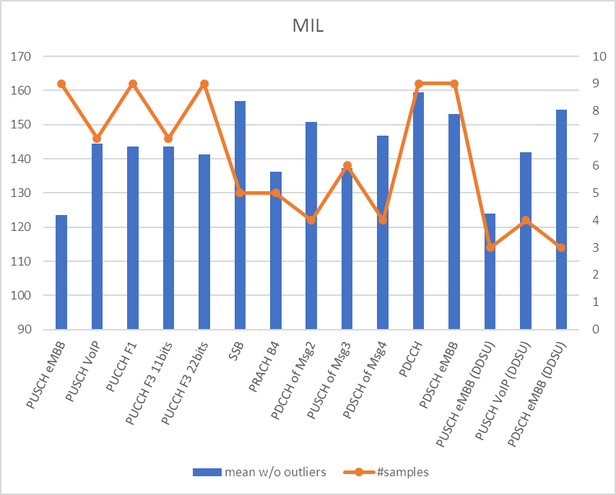

Figure 2.3.1-9. Urban O2O - Representative value for MIL – Chart including frame structures and channels for which results have been obtained by at least 3 companies.

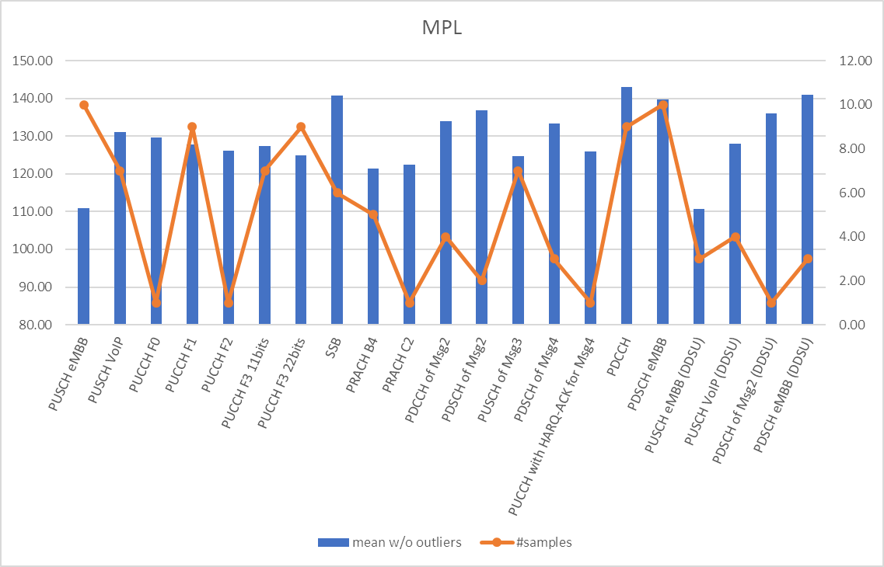

Figure 2.3.1-10. Urban O2O - Representative value for MPL – Overall chart including all considered frame structures according to results reported by companies.

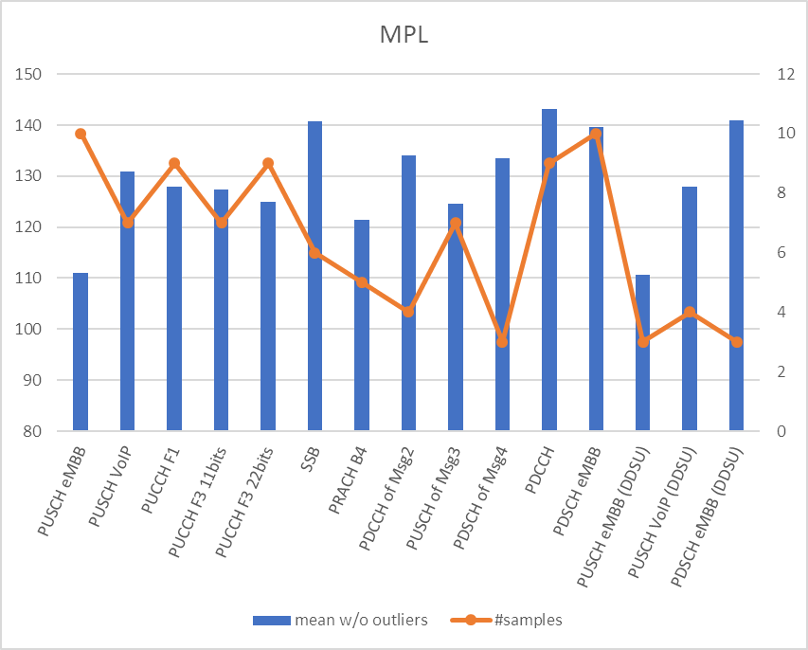

Figure 2.3.1-11. Urban O2O - Representative value for MPL – Chart including frame structures and channels for which results have been obtained by at least 3 companies.

**Indoor 28 GHz (DDDSU and DDSU)**

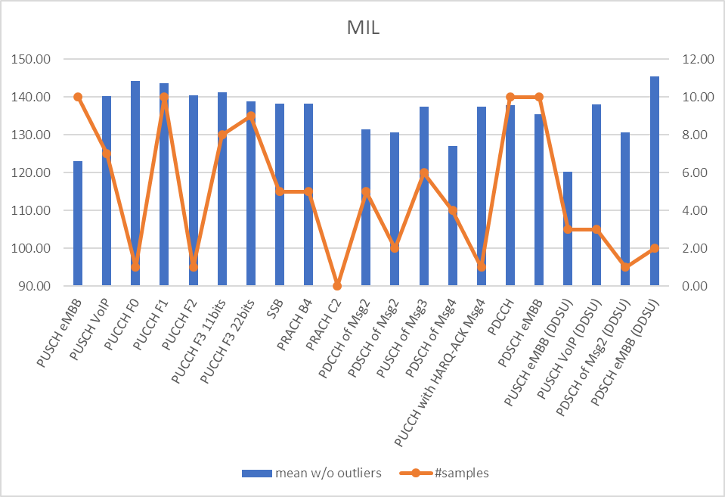

Figure 2.3.1-12. Indoor - Representative value for MIL – Overall chart including all considered frame structures according to results reported by companies.

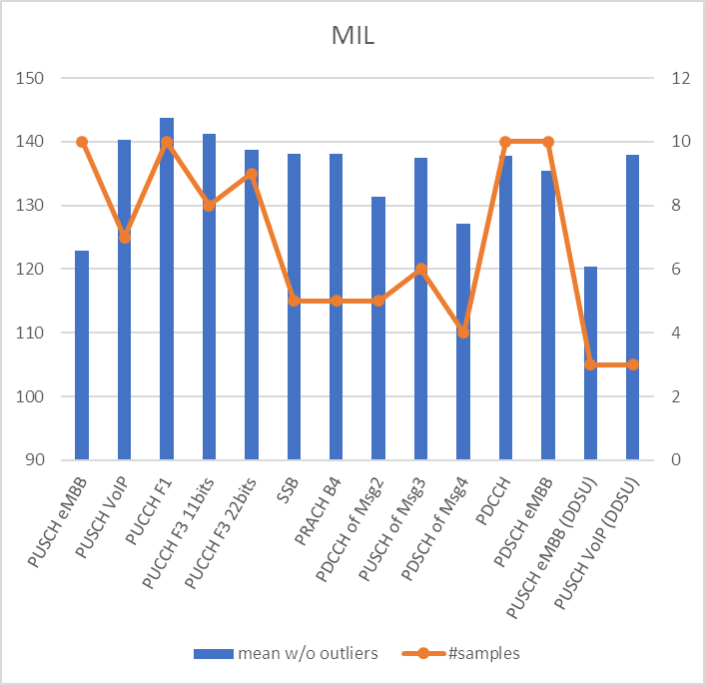

Figure 2.3.1-13. Indoor - Representative value for MIL – Chart including frame structures and channels for which results have been obtained by at least 3 companies.

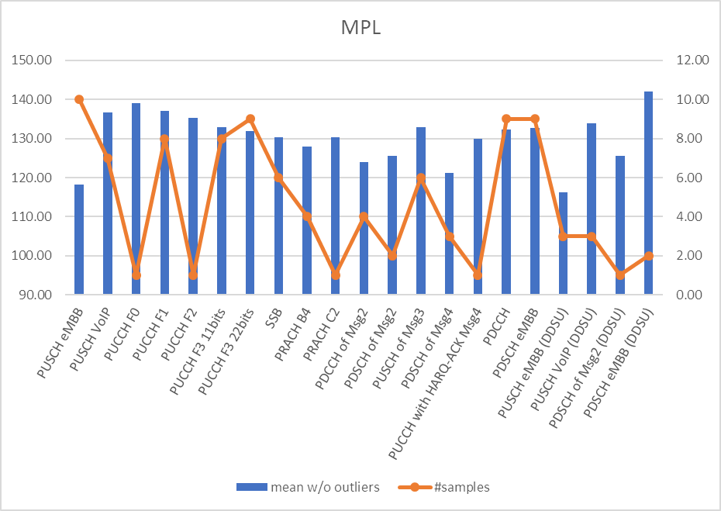

Figure 2.3.1-14. Indoor - Representative value for MPL – Overall chart including all considered frame structures according to results reported by companies.

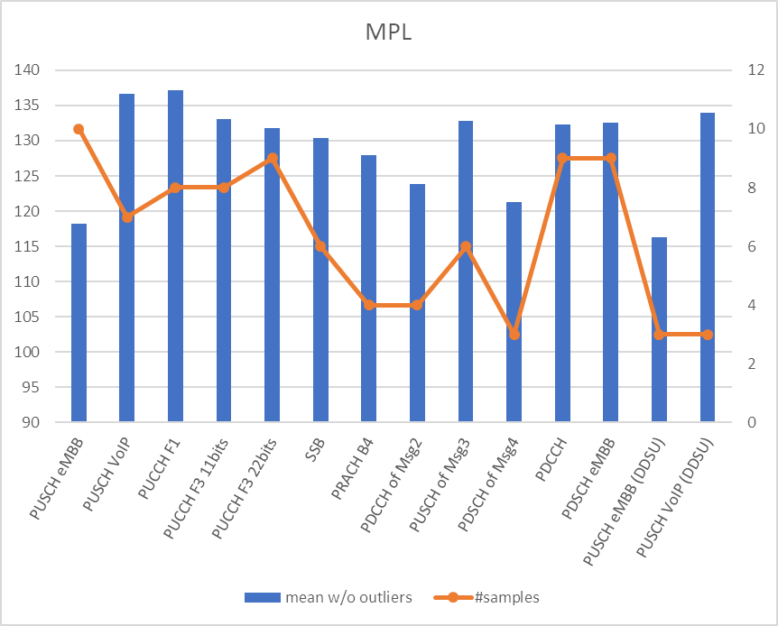

Figure 2.3.1-15. Indoor - Representative value for MPL – Chart including frame structures and channels for which results have been obtained by at least 3 companies.

Based on the above charts, and FL’s recommendation 7, the following FL’s recommendation is formulated. A corresponding proposal has been added in Section 3.

**FL’s recommendation 10 [Green part has already been agreed online on 10/29]**

* For FR2, representative values are computed according to agreements made for FR1 related on representative value calculation method;
* For FR2, classification of scenarios/channels/frame structures into 1st priority and 2nd priority as follows:
  + 1st priority has enough available results, i.e., larger than 2;
  + 2nd priority has less than 3 available results.
* No categorization by other simulation parameters (such as UE speed, antenna array gain correction factors, UE Tx power) will be introduced for FR2.
* At least for FR2
  + RAN1 discussion will focus on 1st priority scenarios/channels/frame structures for drawing observations and bottleneck identification.
  + RAN1 discussion will focus on 2nd priority scenarios/channels/frame structures on a low priority basis, i.e., after discussion on 1st priority scenarios/channels/frame structures.
  + If results presented for 2nd priority scenarios/channels/frame structures are used by RAN1 for neither representative value derivation nor coverage bottleneck identification, they
    - will still be captured in the Appendix of the TR for completeness;
    - can be used to make additional observations to be captured in the TR.
    - cannot be used to draw conclusions to be captured in the TR.

Based on the above:

**Scenarios, with corresponding frame structures, are classified as follows:**

* *1st priority*
  + Urban 28 GHz O2I, DDDSU
  + Urban 28 GHz, O2I, DDSU [Only for VoIP]
  + Indoor 28 GHz, DDDSU
* *2nd priority*
  + Indoor 28 GHz, DDSU
  + Urban 28 GHz, O2O DDDSU
  + Urban 28 GHz, O2O DDSU
  + Suburban 28 GHz, O2I DDDSU
  + Suburban 28 GHz, O2O DDSU

**Channels are classified as follows:**

* *1st priority*
  + PUSCH for eMBB (12 dBm and 23 dBm)
  + PUSCH for VoIP (12 dBm and 23 dBm) [DDDSU and DDSU (Only for Urban)]
  + PUCCH Format 1 with 2bits
  + PUCCH Format 3 with 11bits (12 dBm and 23 dBm)
  + PUCCH Format 3 with 22bits (12 dBm and 23 dBm)
  + SSB
  + PRACH format B4 (12 dBm and 23 dBm)
  + PDCCH for Msg.2
  + PUSCH for Msg.3 (12 dBm and 23 dBm)
  + PDSCH for Msg.4
  + PDCCH
  + PDSCH for eMBB
* *2nd priority*
  + PUSCH for CSI
  + PUCCH with 3-HARQ-ACK bits + SR
  + PUCCH with HARQ-ACK for Msg.4
  + PRACH format C2
  + PDSCH for Msg.2
  + PUSCH eMBB (12 dBm and 23 dBm) - DDSU
  + PUSCH for VoIP (12 dBm and 23 dBm) - DDSU [Indoor]
  + PDSCH of Msg2 - DDSU
  + PDSCH eMBB – DDSU

Companies are invited to input their views on the highlighted part of the recommendation, i.e., on the selection of 1st and 2nd priority scenarios/channels/frame structures, in the table below.

|  |  |
| --- | --- |
| **Company** | **Comments** |
| Ericsson | In our understanding, indoor scenarios have good coverage, and so we would like to discuss further before including them in representative value calculations.  Also, can the handling of second priority proposals be aligned to be the same as for FR1? In FR1, it is proposed:   * Representative values are computed for the following channels or signals for FR1   + PUSCH for CSI (if necessary number of evaluation results for representative value is submitted)   + PUCCH with HARQ-ACK for Msg.4 (if necessary number of evaluation results for representative value is submitted) * The evaluation results, which are used for neither representative value derivation nor coverage bottleneck identification, can be used to make additional observations to be captured in the TR.   Is this acceptable for FR2 as well?  Otherwise OK with FL proposal. |
| CATT | We are fine with FL proposal. We want to clarify whether performance evaluation results of PRACH format B4 represents only the PRACH B4 channel or not. |
| Samsung | Fine with FL proposal with following comment:  Suggest to classify “Urban 28GHz (O2O, DDDSU)” as 1st priority (good enough available results) so that TR can provide observation for FR2 O2O scenario as well. |
| Intel | We are in general fine with the FL’s proposal.  For “Urban 28 GHz, O2I, DDSU [Only for VoIP]”, it would be good to clarify whether only VoIP or other channels as well are considered for link budget analysis.  We share similar view as Samsung that it may be good to also consider “Urban 28GHz (O2O, DDDSU)” as 1st priority to draw observations. |

**FL’s update on 11/03**

FL’s responses to questions received after 10/29 follow:

* **Ericsson:**
  + On indoor scenario: FL reads results in the same way and indeed Indoor scenario does not seem to present any evident criticality. On the other hand, to have a “final” assessment we should first agree on the metrics (as per discussion in Section 2.2). Furthermore, and regardless of the conclusion RAN1 will draw about Indoor scenario, it would seem natural, and harmless, to use the charts with representative values in the TR, to support observations about Indoor scenario.
  + On the way PUSCH for CSI and PUCCH with HARQ-ACK for Msg.4 are captured:

Concerning the first part of the comment, i.e., the two bullets, isn’t the distinction between 1st priority and 2nd priority channels already made depending on the amount of submitted results? FL understanding is that current agreement on the definition of 1st priority and 2nd priority already addresses the concern. It should be noted that current agreement already covers the second part of the comment as well. Indeed, RAN1 already agreed that:

* + - If results presented for 2nd priority scenarios/channels/frame structures are used by RAN1 for neither representative value derivation nor coverage bottleneck identification, they
      * will still be captured in the Appendix of the TR for completeness;
      * can be used to make additional observations to be captured in the TR
      * cannot be used to draw conclusions to be captured in the TR.

Isn’t such agreement already addressing this part of the request? Do not hesitate to input additional views below if these explanations do not address the concerns.

* **CATT**:RAN1 agreed to study PRACH coverage for FR2 using at least B4, and C2 as optional preamble. The rationale of this selection during #101-e was that companies agreed that format B4 is arguably the most suitable for long range applications, and other formats may perform worse in this sense. FL’s understanding is that if RAN1 concludes that results reported by companies highlight a coverage bottleneck for PRACH in FR2, this will apply to PRACH, and not just to PRACH B4.
* **Samsung**: Proposal will be updated accordingly.
* **Intel**: On “Urban 28 GHz, O2I, DDSU [Only for VoIP]”: This is a very good point. Indeed, the proposal was vague in this regard, however FL’s intention was to refer to PUSCH, for which enough results have been reported by companies. On the other hand, recent additional results provided by some companies slightly changed the situation for DDSU case, for which PDSCH eMBB is also better represented now. Proposal is updated accordingly.

Given the above, FL’s recommendation (and corresponding proposal in Section 3) is modified as follows:

Based on the above:

**Scenarios, with corresponding frame structures, are classified as follows:**

* *1st priority*
  + Urban 28 GHz O2I, DDDSU
  + Urban 28 GHz, O2O DDDSU
  + Urban 28 GHz, O2I, DDSU [Only PUSCH VoIP, PUSCH and PDSCH]
  + Indoor 28 GHz, DDDSU
* *2nd priority*
  + Indoor 28 GHz, DDSU
  + Urban 28 GHz, O2I, DDSU [only PDSCH of msg2]
  + Urban 28 GHz, O2O DDSU
  + Suburban 28 GHz, O2I DDDSU
  + Suburban 28 GHz, O2O DDSU

**Channels are classified as follows:**

* *1st priority*
  + PUSCH for eMBB (12 dBm and 23 dBm) [DDDSU and DDSU]
  + PUSCH for VoIP (12 dBm and 23 dBm) [DDDSU and DDSU (Only for Urban)]
  + PUCCH Format 1 with 2bits (12 dBm and 23 dBm) [DDDSU]
  + PUCCH Format 3 with 11bits (12 dBm and 23 dBm) [DDSSU]
  + PUCCH Format 3 with 22bits (12 dBm and 23 dBm) [DDSSU]
  + SSB [DDSSU]
  + PRACH format B4 (12 dBm and 23 dBm) [DDDSU]
  + PDCCH for Msg.2 [DDSSU]
  + PUSCH for Msg.3 (12 dBm and 23 dBm) [DDDSU]
  + PDSCH for Msg.4 [DDSSU]
  + PDCCH [DDSSU]
  + PDSCH for eMBB [DDDSU and DDSU (Only for Urban)]
* *2nd priority*
  + PUSCH for CSI with 11 bits (12 dBm and 23 dBm)
  + PUSCH for CSI with 22 bits (12 dBm and 23 dBm)
  + PUCCH with 3-HARQ-ACK bits + SR (12 dBm and 23 dBm)
  + PUCCH with HARQ-ACK for Msg.4 (12 dBm and 23 dBm)
  + PRACH format C2 (12 dBm and 23 dBm)
  + PDSCH of Msg.2
  + PUCCH Format 0 (12 dBm and 23 dBm)
  + PUCCH Format 2 (12 dBm and 23 dBm)

Companies **who still have concerns** are invited to input their views on the new version of the recommendation, while accounting for the existing agreement, in the table below.

|  |  |
| --- | --- |
| **Company** | **Comments** |
| NTT DOCOMO | We apologise for our late input of the PUCCH short format results. We would like to add PUCCH format 0/2 in the list (might be the 2nd priority). |
| Ericsson | Can accept PUSCH on CSI as 2nd priority for the sake of progress.  For my understanding, is PF1 supposed to be both 12 and 23 dBm?  Minor comment: typos above: ‘DDSSU’ |

**FL’s update on 11/09**

After the GTW on Thursday 11/05, one company proposed results related to PUSCH with SIP invite. FL proposes to treat this channel as 2nd priority, according to existing agreements. A corresponding Proposal is formulated in Section 3.

The following three subsections will present tables where the result of the analysis of the representative values (as per agreement) obtained for each channel studied by at least one company, is provided including standard deviation of the sample. Channels highlighted in yellow are the ones who qualify as 1st priority channels according to the agreement on the number of available results to be part of 1st priority channels (see Section 4 for additional information). This analysis is carried out like what is done for FR1 in AI 8.8.1.1 and aims at

* showing how different candidate target metrics would highlight (or not) the presence of coverage bottlenecks.
* identifying a preliminary list of potential candidate bottleneck channels for FR2.

Both representative values of MPL and MIL are considered. The following comparison are performed for the sake of completeness:

* MPL
  + Absolute comparison with target ISD values (and corresponding MPL values) as per FL’s recommendation 6 (see above).
* MIL
  + Gap from best channel
  + Gap from worst channel + 6dB
  + Gap from 2nd worst channel
  + Gap from 3rd worst channel
  + Gap from SSB
  + Gap from PDCCH
  + Gap from PUCCH F1
  + Gap from worst “non-data” channel that has more than 3 samples + 3dB (as per Qualcomm’s second suggestion in FR1)
  + Gap from target MIL (as per vivo’s suggestion)

### [CLOSED] Urban 28 GHz O2I

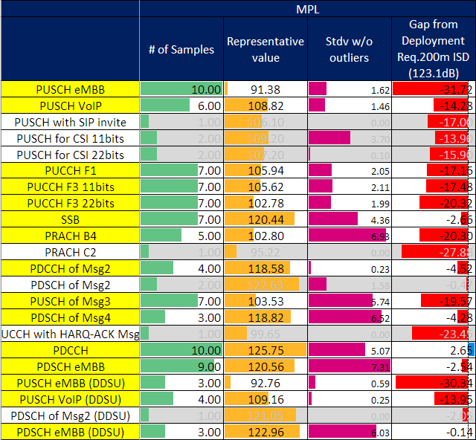

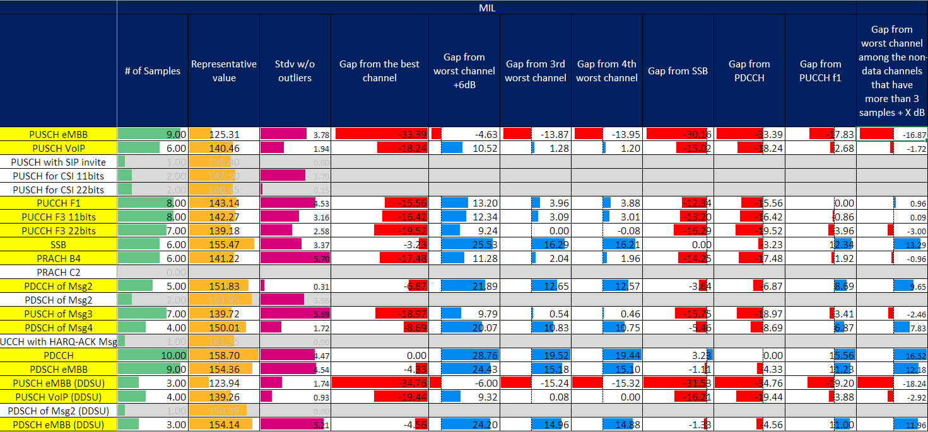

* **FL observations**
  + Only PDCCH can meet absolute MPL target of 200m ISD. Gaps for other channels seem too large to be realistically closed for all of them. With absolute MPL target associated to 200m ISD, the following channels would need enhancement:
    - PUSCH eMBB: 31.72dB
    - PUSCH VoIP: 14.28dB
    - PUCCH F1: 17.16dB
    - PUCCH F3 11bits: 17.48dB
    - PUCCH F3 22bits: 20.32dB
    - SSB: 2.66dB
    - PRACH B4: 20.30dB
    - PDCCH of Msg2: 4.52dB
    - PUSCH of Msg3: 19.57dB
    - PDSCH of Msg4: 4.28dB
    - PDSCH eMBB: 2.54
    - PUSCH eMBB (DDSU): 30.34dB
    - PUSCH VoIP (DDSU): 13.95dB
    - PDSCH eMBB (DDSU): 0.14dB
  + Considering ISD larger than 200m seems extremely challenging.
  + MIL of SSB and PDCCH may be too large to be considered as a reference channel to calculate the relative differential MIL for all channels.
  + Grouping channels depending on their role may give different outcomes, however workload to aggregate results would be much larger. Furthermore, and given the coverage unbalance between DL and UL channels/signals in FR2, this approach does not seem adapted to this FR.
  + PUCCH F1 seems a more reasonable reference if only one reference is to be chosen (albeit still very challenging for PUSCH eMBB). 1st priority channels displaying coverage issues in this case would be:
* PUSCH eMBB: 17.83dB
* PUSCH VoIP: 2.68dB
* PUCCH F3 11bits: 0.86dB
* PUCCH F3 22bits: 3.96dB
* PRACH B4: 1.92dB
* PUSCH of Msg3: 3.41dB
* PUSCH eMBB (DDSU): 19.20dB
* PUSCH VoIP (DDSU): 3.88dB

It should be noted that this includes all UL channels whose number of available samples is larger than 3, except for PUCCH F1 which, trivially, is absent from the list given its role of reference channel. Additionally, we may want to consider that a standard deviation larger than 1 dB exist for this channel, and that its relative MIL difference w.r.t. several channels of the list above would be lower than said standard deviation. Thus, it would not seem unreasonable to include PUCCH F1 in the list, as well.

* An alternative approach was suggested for FR1 to find a middle ground between diverging proposals. This approach proposes to consider the MIL gap from worst channel among the non-data channels that have more than 3 samples + X dB. It is interesting to focus on this approach a well, to have a further term of comparison for the approach used in the previous bullet, i.e., using PUCCH F1 a reference channel. With X = 3 dB, the following 1st priority channels would display coverage issues:
  + PUSCH eMBB: 16.87dB
  + PUSCH VoIP: 1.72dB
  + PUCCH F3 22bits: 3dB
  + PRACH B4: 0.96dB
  + PUSCH of Msg3: 2.46dB
  + PUSCH eMBB (DDSU): 18.24dB
  + PUSCH VoIP (DDSU): 2.92dB

It can be observed that this approach shows similar set of bottleneck channels as using gaps from PUCCH F1, except for PUCCH F3 with 11 bits. On the other hand, the relative values associated to PUCCH F1 and PUCCH F1 with 11 bits is less than 1 dB for both channels, in this case. Considering that a standard deviation larger than 1 dB exist for both channels, it may not be unreasonable to consider them in the list of bottleneck channels as well.

Accordingly, the following FL’s recommendation is formulated.

**FL’s recommendation 11**

The lists above include only UL channels. From FL’s perspective this confirms that UL coverage may generally be problematic at FR2 in Urban scenarios. Tx power difference between gNB and UE plays a significant role in this regard. Finally, and for the sake of completeness, it should be noted that performance of PUCCH F1 (and, at least for one of the adopted approaches, PUCCH format 3 with 11 bits) may also be considered insufficient as compared to DL channels. PUCCH F1 could also be included in the list of bottleneck channels (with an asterisk), which would then be the following (according to FL’s observations, and including for now only 1st priority channels, as per agreements)

* PUSCH eMBB (DDDSU and DDSU)
* PUSCH VoIP (DDDSU and DDSU)
* PUCCH F3 11bits
* PUCCH F3 22bits
* PRACH B4
* PUSCH of Msg3
* PUCCH F1*

This list is captured in Section 2.5.2 as well, for completeness. Companies can start adding views about this recommendation in Section 2.5.2, below the corresponding summary table. FL would like to remind everyone that available time is scarce and constructive attitude is highly appreciated. Please also remember that the sooner we complete analysis of 1st priority scenarios/channels/frame structures the better for the analysis of 2nd priority ones (which will start afterwards, if time allows it).

### [CLOSED] Urban 28 GHz O2O

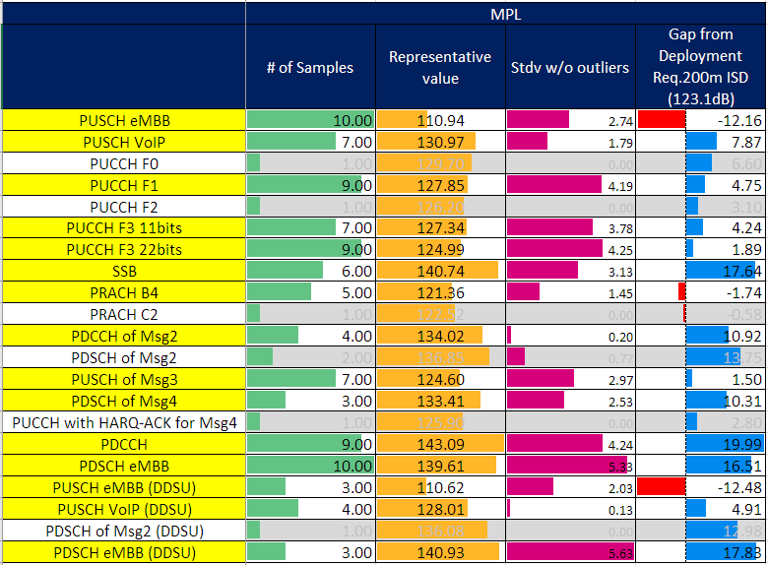

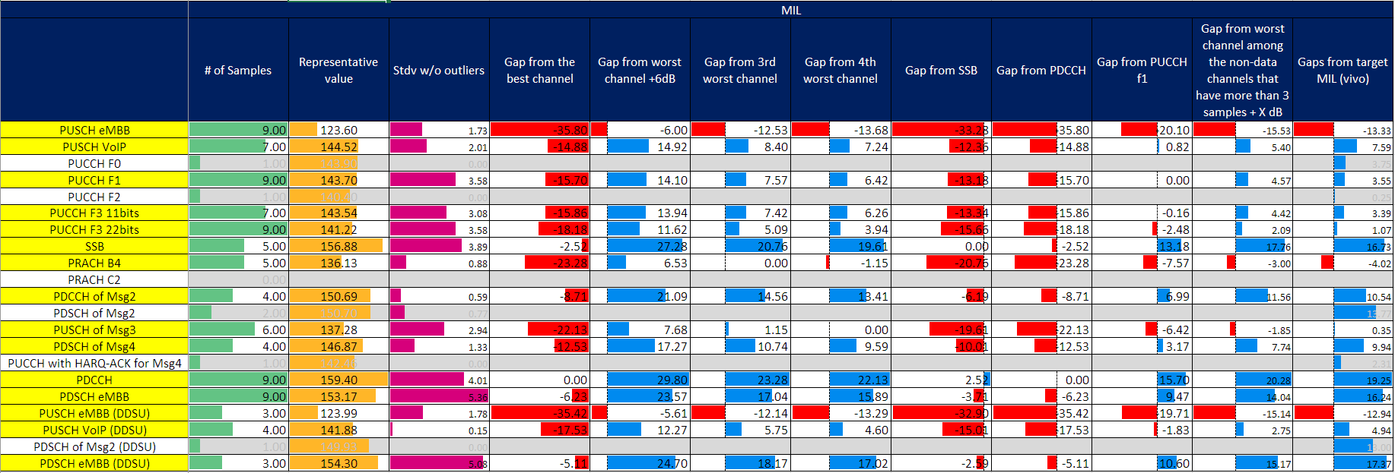

* **FL observations**
  + Absolute MPL target corresponding to ISD 200m is met by all channels except PUSCH and PRACH. More precisely, the following channels would need enhancement in this case:
    - PUSCH eMBB: 12.16dB
    - PUSCH eMBB (DDSU): 12.48dB
    - PRACH B4: 1.74dB
  + MIL of SSB and PDCCH may be large to be considered as a reference channel to calculate the relative differential MIL for all channels.
  + Grouping channels depending on their role may give different outcomes, however workload to aggregate results would be much larger. Furthermore, and given the coverage unbalance between DL and UL channels/signals in FR2, this approach does not seem adapted to this FR.
  + As for O2I case, and given the inherent challenges associated to FR2 propagation, one may claim PUCCH F1 is a more reasonable reference if only one reference is to be chosen (albeit still very challenging for PUSCH eMBB). This is not necessarily FL’s recommendation, but this would seem aligned with O2I case. 1st priority channels displaying coverage issues in this case would then be:
    - PUSCH eMBB: 20.1dB
    - PUCCH F3 11bits: 0.16dB
    - PUCCH F3 22bits: 2.48dB
    - PRACH B4: 7.57dB
    - PUSCH of Msg3: 6.42dB
    - PUSCH eMBB (DDSU): 19.71dB
    - PUSCH VoIP (DDSU): 1.83dB

It is interesting to observe that setting PUCCH F1 as reference channel yields the same set of channels displaying coverage issues in both O2I and O2O scenarios. As for O2I, it should be noted that this set includes all UL channels whose number of available samples is larger than 3, except for PUCCH F1 which, trivially, is absent from the list given its role of reference channel. Additionally, we may want to consider that a standard deviation larger than 1 dB exist for this channel, and that its relative MIL difference w.r.t. several channels of the list above would be lower than said standard deviation. Thus, it would not seem unreasonable to include PUCCH F1 in the list, as well, if this approach were chosen.

* + An alternative approach was suggested for FR1 to find a middle ground between diverging proposals. This approach proposes to consider the MIL gap from worst channel among the non-data channels that have more than 3 samples + X dB. It is interesting to focus on this approach a well, to have a further term of comparison for the approach used in the previous bullet, i.e., using PUCCH F1 a reference channel. With X = 3 dB, the 1st priority channels displaying coverage issues according to this approach would be:
    - PUSCH eMBB: 15.53dB
    - PRACH B4: 3dB
    - PUSCH of Msg3: 1.85dB
    - PUSCH eMBB (DDSU): 15.14dB

Accordingly, the following FL’s recommendation is formulated.

**FL’s recommendation 12**

As observed for the O2I analysis, the list above includes only UL channels. From FL’s perspective this confirms that UL coverage may generally be problematic at FR2 in Urban scenarios, regardless of the UE’s location. Tx power difference between gNB and UE plays a significant role in this regard. The list of bottleneck channels for O2O case (according to FL’s observations, and including for now only 1st priority channels, as per agreements) includes at least:

* PUSCH eMBB (DDDSU and DDSU)
* PRACH B4

Observations on other 1st priority UL channels such as

* PUSCH VoIP (DDDSU and DDSU)
* PUCCH F3 11bits
* PUCCH F3 22bits
* PUSCH of Msg3
* PUCCH F1*

can also be drawn for O2O scenario, when discussing enhancement, given their presence in the list of the candidate bottleneck channels for Urban O2I (i.e., their relative differential MIL is the same in the two cases).

This list is captured in Section 2.5.2 as well, for completeness. Companies can start adding views about this recommendation in Section 2.5.2, below the corresponding summary table. FL would like to remind everyone that available time is scarce and constructive attitude is highly appreciated. Please also remember that the sooner we complete analysis of 1st priority scenarios/channels/frame structures the better for the analysis of 2nd priority ones (which will start afterwards, if time allows it).

### [CLOSED] Indoor 28 GHz

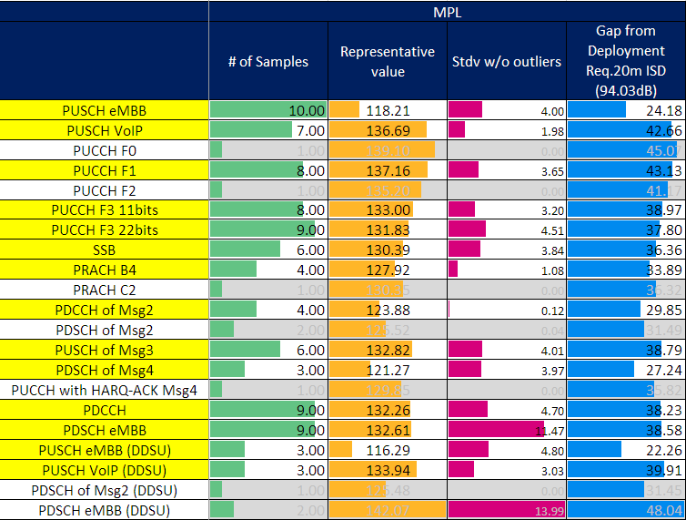

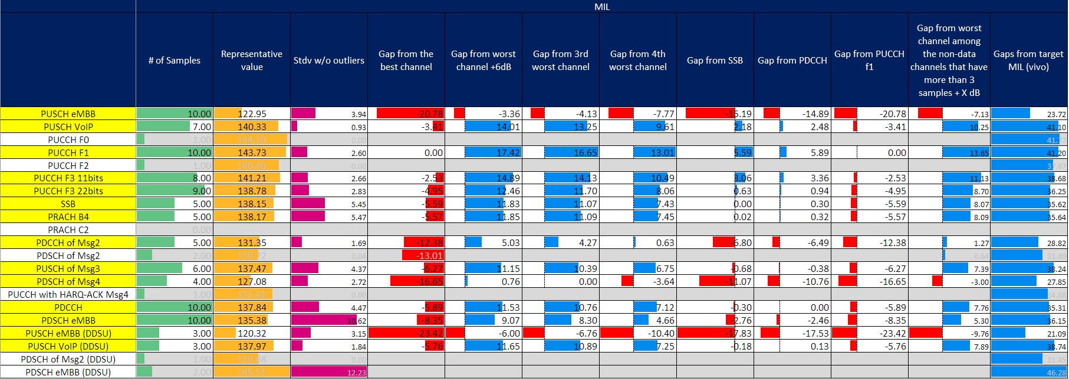

* **FL observations**
  + Absolute MPL target of 20m is met by all channels.
  + PUCCH F1 seems a more challenging channel to considered as a reference for the relative differential MIL calculation in this case. Indeed, all 1st priority channels would display coverage shortage as compared to PUCCH F1.
  + An alternative approach was suggested for FR1 to find a middle ground between diverging proposals. This approach proposes to consider the MIL gap from worst channel among the non-data channels that have more than 3 samples + X dB. It is interesting to focus on this approach a well, to have a further term of comparison for the approach used in the previous bullet, i.e., using PUCCH F1 a reference channel. With X = 3 dB, the 1st priority channels displaying coverage issues according to this approach would be:
    - PUSCH eMBB: 7.13dB
    - PUSCH eMBB (DDSU): 9.76dB
    - PDSCH of Msg4: 3dB

However, as said earlier, given that no channel displays coverage shortage w.r.t. to absolute MPL targets, the gaps above seem inconsequential.

**FL’s recommendation 13**

No channel displays evident coverage issues in indoor scenarios for FR2. It is recommended not to include any channel to the list of channel bottlenecks which will be compiled for Urban O2I and O2O.

### [L] Suburban 28 GHz O2I

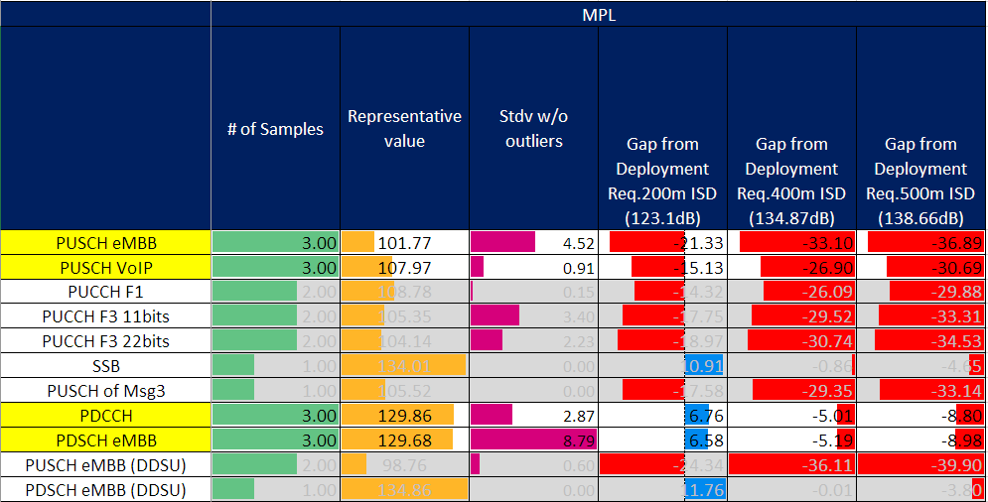

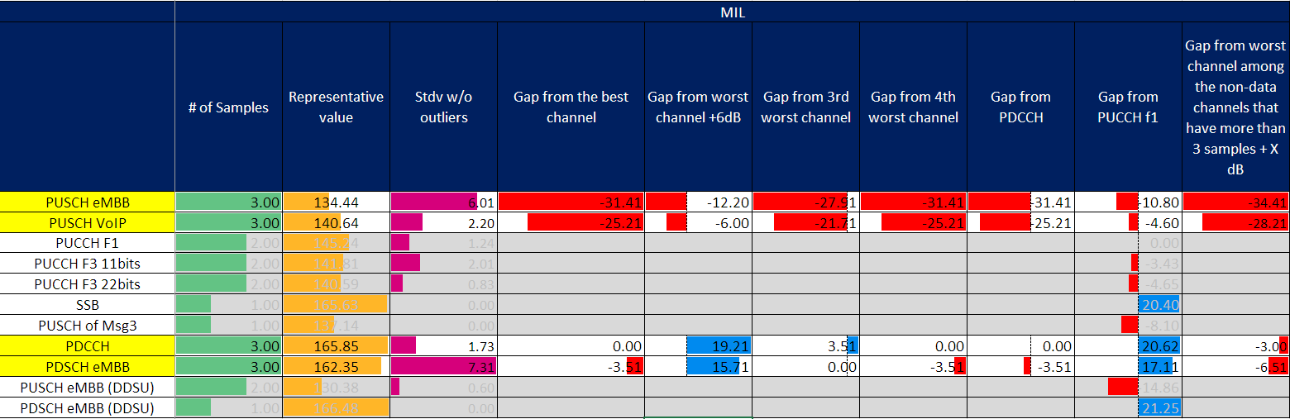

* **FL observations**
  + Path-loss equations as agreed for Urban scenario have been used to calculate target MPL
  + Three ISD targets have been considered for completeness: 200m, 400m and 500m
  + Only 4 channels have at least 3 samples. This is not surprising. This scenario was deprioritized and classified as 2nd priority as well.
  + No channel can meet the absolute ISD target if it is set to 400m and 500m. Conversely, if ISD target is set to 200m then only PUSCH eMBB (DDDSU) and PUSCH VoIP (DDDSU) do not meet the target.
  + Characterizing the relative differential MIL performance is harder in this case, due to the very few available results. Given that Suburban is already a 2nd priority scenario, it may be beneficial in this case to perform the same test as for other scenarios, i.e., use PUCCH F1 as a reference, nonetheless, while considering both 1st priority and 2nd priority channels. This could help observing if consistency exists in this sense, regardless of the statistical relevance of this channel. 1st priority and 2nd priority channels displaying coverage issues in this case would then be:
    - PUSCH eMBB (DDDSU): 10.8dB
    - PUSCH VoIP (DDDSU): 4.60dB
    - PUCCH F3 11bits: 3.43dB
    - PUCCH F3 22bits: 4.65dB
    - PUSCH of Msg3: 8.10dB
    - PUSCH eMBB (DDSU): 14.86dB

This list confirms that channels which display coverage issues for Suburban are a subset of channels which displays coverage issues for Urban scenario. In this sense, and considering Suburban a 2nd priority scenario, it may not make sense to discuss coverage bottleneck identification and simply focus on Urban scenario.

**FL’s recommendation 13**

As observed for the analysis of the Urban scenario, the list above includes only UL channels. From FL’s perspective this confirms that UL coverage may generally be problematic at FR2 in Suburban scenarios as well. Tx power difference between gNB and UE plays a significant role in this regard. This list confirms that channels which display coverage issues for Suburban are a subset of channels which displays coverage issues for Urban scenario. In this sense, and considering Suburban a 2nd priority scenario, discussing coverage bottleneck identification may not be meaningful for Suburban scenario and RAN1 should arguably focus only on Urban scenario. A corresponding proposal has been added in Section 2.5.2.

### [L] Suburban 28 GHz O2O

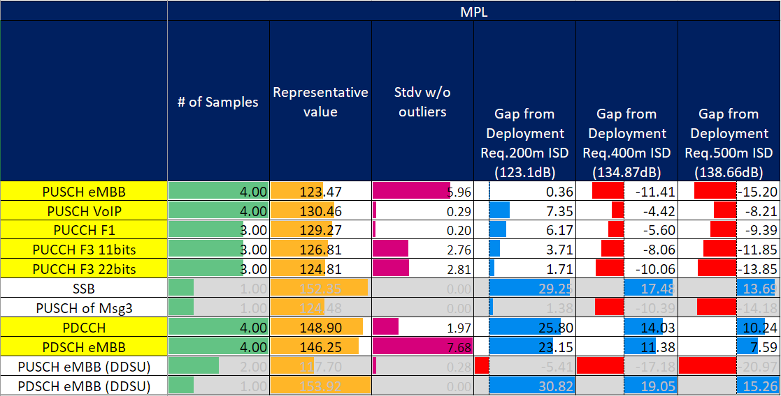

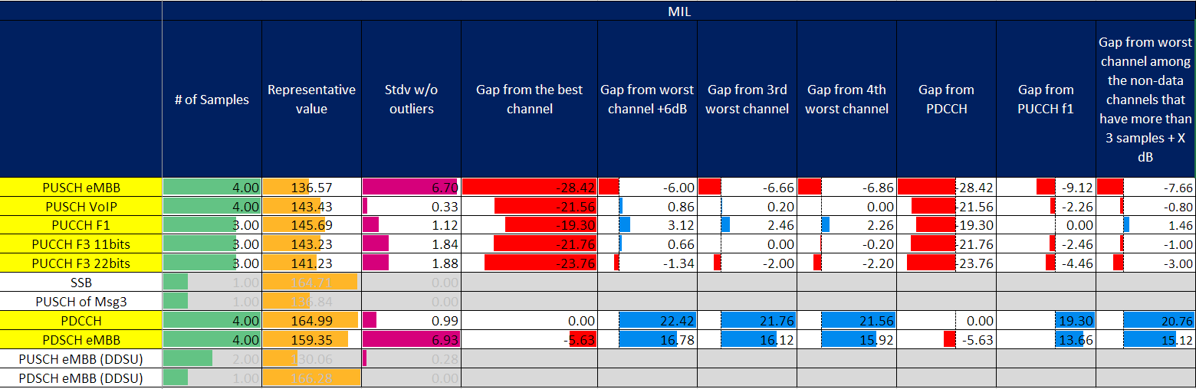

* **FL observations**
  + Path-loss equations as agreed for Urban scenario have been used to calculate target MPL
  + Three ISD targets have been considered for completeness: 200m, 400m and 500m
  + Absolute MPL targets of 200m is met by all channels with at least 3 samples.
  + No UL channel can meet the absolute ISD target if it is set to 400m and 500m.
  + As for Urban scenario, and given the inherent challenges associated to FR2 propagation, one may claim PUCCH F1 is a more reasonable reference if only one reference is to be chosen (albeit still very challenging for PUSCH eMBB). This is not necessarily FL’s recommendation, but this would seem aligned with O2I case. 1st priority channels displaying coverage issues in this case would then be:
    - PUSCH eMBB (DDDU): 9.12dB
    - PUSCH VoIP (DDDSU): 2.26dB
    - PUCCH F3 11bits: 2.46dB
    - PUCCH F3 22bits: 4.46dB

It is interesting to observe that setting PUCCH F1 as reference channel yields a subset of channels displaying coverage issues in both Urban O2I and O2O scenarios. This set includes all UL channels whose number of available samples is larger than 3, except for PUCCH F1 which, trivially, is absent from the list given its role of reference channel.

* + Similar observations can be drawn if we consider an alternative approach was suggested for FR1 to find a middle ground between diverging proposals. This approach proposes to consider the MIL gap from worst channel among the non-data channels that have more than 3 samples + X dB, where X = 3dB. In this case, in fact, the channels displaying coverage shortage would be:
    - PUSCH eMBB (DDDU): 7.66dB
    - PUSCH VoIP (DDDSU): 0.80dB
    - PUCCH F3 11bits: 1dB
    - PUCCH F3 22bits: 3dB
  + Both these lists confirm that channels which display coverage issues for Suburban are a subset of channels which displays coverage issues for Urban scenario. In this sense, and considering Suburban a 2nd priority scenario, it may not make sense to discuss coverage bottleneck identification and simply focus on Urban scenario.

**FL’s recommendation 14**

As observed for the analysis of both the Urban and Suburban O2I scenarios, the list above includes only UL channels. From FL’s perspective this confirms that UL coverage may generally be problematic at FR2 in Suburban scenarios as well, regardless of UE’s position. Tx power difference between gNB and UE plays a significant role in this regard. In this sense, discussing coverage bottleneck identification may not be meaningful for Suburban Scenario and RAN1 should arguably focus only on Urban scenario. A corresponding proposal has been added in Section 2.5.2

### [L] 2nd Priority channels

Urban 28GHz O2I

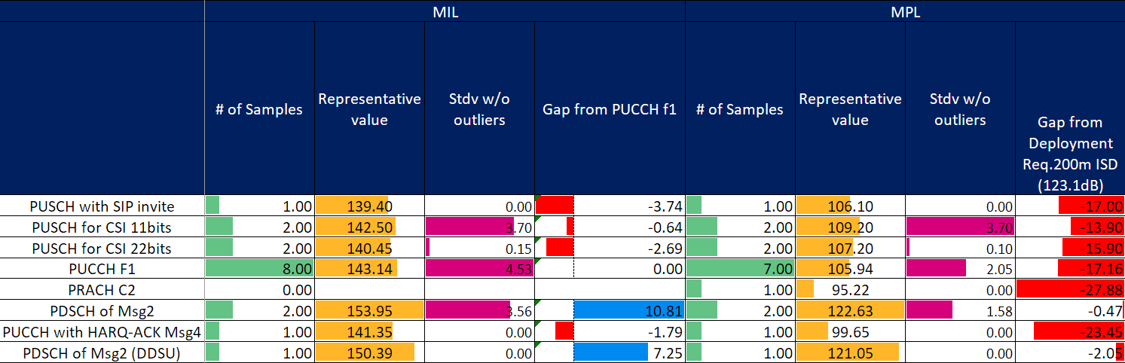

* **FL observations**
  + Absolute MPL target corresponding to ISD 200m is not met by any channel. Considering ISD larger than 200m is very challenging for 2nd priority channels. More precisely, the following gaps are observed:
    - PUSCH with SIP invite: 17dB
    - PUSCH for CSI 11bits: 13.90dB
    - PUSCH for CSI 22bits: 15.90dB
    - PRACH C2: 27.88dB
    - PDSCH of Msg2: 0.47dB
    - PUSCH for CSI 11 bits: 0.64dB
    - PUSCH for CSI 22 bits: 2.69dB
    - PUCCH with HARQ-ACK- Msg4: 23.45dB
    - PDSCH of Msg4 (DDSU): 2.05dB
  + Considering agreement made during GTW on 11/12 on how to calculate relative differential MIL value, we observe that the following channels all perform worse than PUCCH F1:
    - PUSCH with SIP invite: 3.74dB
    - PUSCH for CSI 11bits: 0.64dB
    - PUSCH for CSI 22bits: 2.69dB
    - PUCCH with HARQ-ACK Msg4: 1.79dB

It is worth observing that only two channels of the list above have more than one available result i.e., PUSCH for CSI (11 bits and 22 bits).

Urban 28GHz O2O

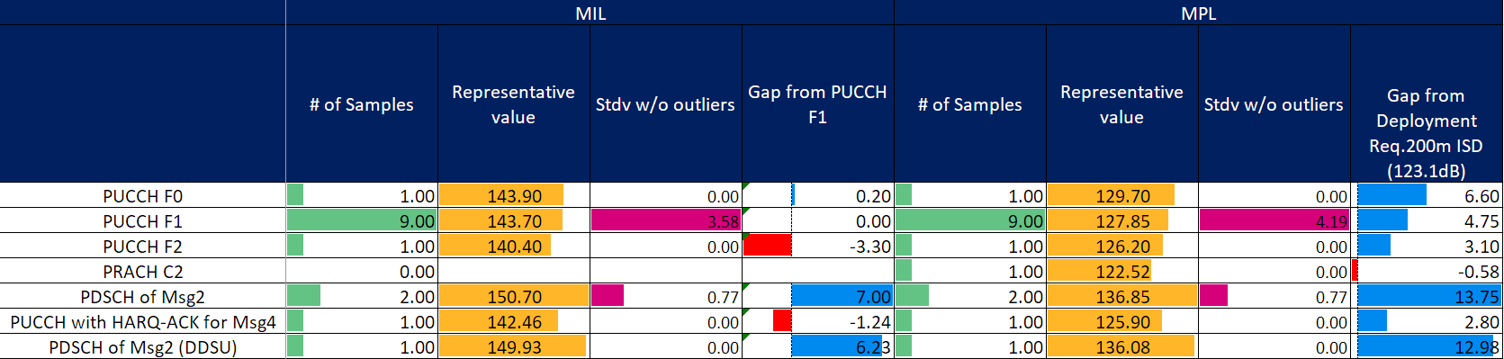

* **FL observations**
  + Absolute MPL target corresponding to ISD 200m is met by all channels in the 2nd priority group except PRACH C2. More precisely, the following gap is observed:
    - PRACH C2: 0.58dB
  + No MIL result is available for PRACH C2.
  + No evident potential bottleneck channel seems to exist according to the agreements.

Indoor 28GHz

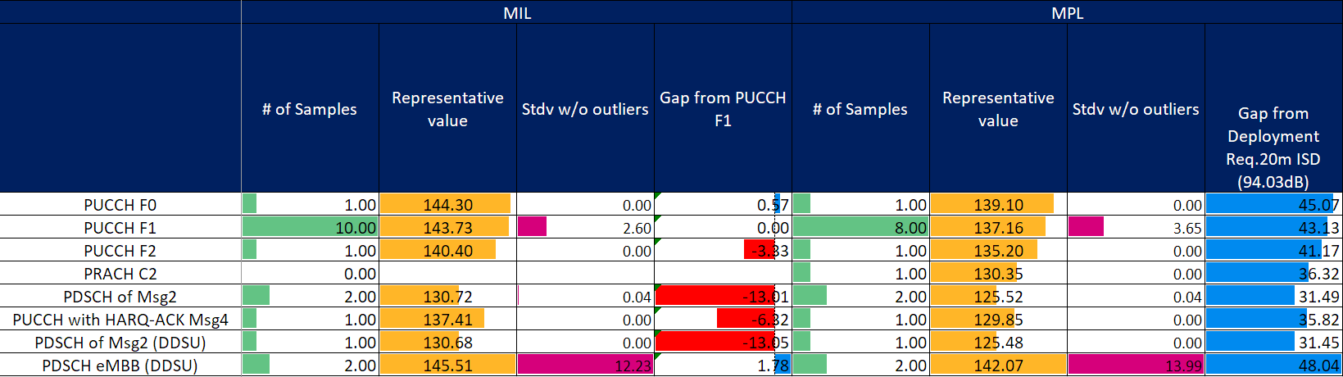

* **FL observations**
  + Absolute MPL target corresponding to ISD 20m is met by all channels.
  + No potential bottleneck channel seems to exist for this scenario.

Suburban 28GHz O2I

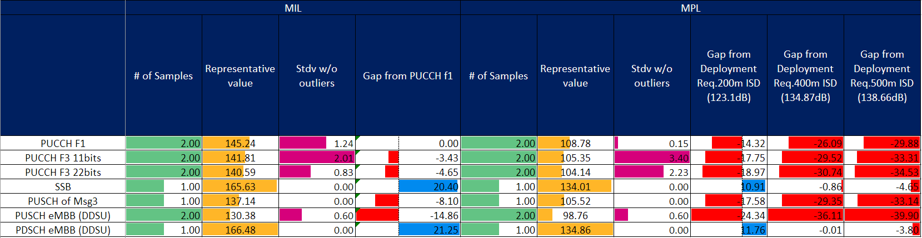

* **FL observations**
  + Similar observation as for 1st priority channels also applies for 2nd priority channels.
  + Path-loss equations as agreed for Urban scenario have been used to calculate target MPL
  + Three ISD targets have been considered for completeness: 200m, 400m and 500m
  + Absolute MPL target corresponding to ISD 200m cannot be met by any channel. Considering ISD larger than 200m is very challenging for 2nd priority channels as well. Larger ISD target are not met as well.
  + Considering agreement made during GTW on 11/12 on how to calculate relative differential MIL value, we observe that the following channels all perform worse than PUCCH F1:
    - PUSCH F3 11 bits: 3.43dB
    - PUSCH F3 22 bits: 4.65dB
    - PUSCH for Msg3: 8.10dB
    - PUSCH eMBB (DDSU): 14.86

All the channels above are already included in the list of potential bottleneck channels for Urban 28 GHz.

Suburban 28GHz O2O

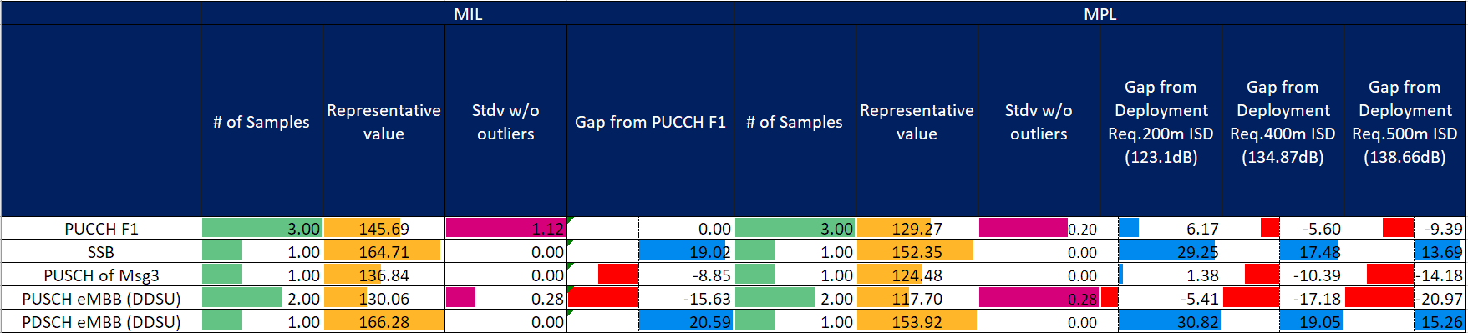

* **FL observations**
  + Absolute MPL targets of 200m is met by all channels.
  + No UL channel can meet the absolute ISD target if it is set to 400m and 500m.
  + Considering agreement made during GTW on 11/12 on how to calculate relative differential MIL value, we observe that the following channels all perform worse than PUCCH F1:
    - PUSCH for Msg3: 8.85dB
    - PUSCH eMBB (DDSU): 15.63

All the channels above are already included in the list of potential bottleneck channels for Urban 28 GHz.

Given all the results above, FL observes that the only 2nd priority channels which display coverage shortage, and have more than 2 results, are PUSCH for CSI 11 bits and PUSCH for CSI 22 bits, for Urban 28 GHz O2I. Other channels could be considered for drawing observations but they do not seem to qualify to be reliable candidates for being classified as potential coverage bottleneck channels.

Additional analysis on these channels is provided in Section 2.5.2.2, with a corresponding FL’s proposal.

## [CLOSED] Collection of simulation results

The collection of the simulation results is on-going by means of the email discussion [103-e-CovEnh-EvaluationResults]. Companies are encouraged to monitor this email thread and input the updated simulation results when available.

## [H] Identification of coverage bottleneck(s) and additional observations

### [CLOSED] Summary of the contributions submitted to RAN1#103-e

Initial proposals companies included in [1] to [14], illustrating the bottleneck channels identification, are summarized in the Table below.

Table 2.5-1. Summary of bottleneck channel identification according to companies’ initial proposals.

|  |  |  |  |  |
| --- | --- | --- | --- | --- |
|  | **eMBB** | | **VoIP** | |
| **PUSCH** | **13** | Docomo | **2** | CMCC (2nd priority [dense Urban O2I]) |
| Qualcomm (5 Mbps) | CATT |
| Ericsson |  |
| InterDigital ([Indoor]) |
| OPPO |
| Samsung |
| CMCC ([dense Urban O2I]) |
| Intel |
| CATT |
| ZTE |
| Vivo |
| Huawei ([Urban, 400m/500m ISD]) |
| Nokia ([Urban O2I]) |
|  | | | | |
| **PUCCH** | **8** | Qualcomm (L1-report) | **X** |  |
| OPPO (2nd priority) |
| Samsung |
| CMCC (format3 - 2nd priority, format1 – 3rd priority [dense urban O2I]) |
| CATT ([Urban/Suburban]) |
| ZTE (2/11/22 bit payload, msg4 ACK [Urban]) |
| Vivo |
| Nokia ([Urban O2I, TRP 12 dBm]) |
|  |  |  |  |  |
| **PDSCH** | **5** | Docomo | **1** | Docomo |
| Qualcomm (msg4) |  |
| Ericsson |
| ZTE (eMBB and msg4 [Urban]) |
| Huawei (SIB1 [Urban O2I, 400m/500m ISD]) |
|  |  |  |  |  |
| **PDCCH** | **2** | Qualcomm (Broadcast, RMSI Broadcast, msg2) | **1** | Docomo |
| ZTE (Broadcast, Unicast) |  |
|  |  |  |  |  |
| **Msg3 over PUSCH** | **7** | Qualcomm | **X** |  |
| CMCC (3rd priority [dense urban O2I]) |
| CATT |
| ZTE ([Urban]) |
| Vivo |
| Huawei ([Urban, 400m/500m ISD]) |
| Nokia ([Urban O2I]) |
|  |  |  |  |  |
| **PRACH** | **6** | Qualcomm | **X** |  |
| CMCC (3rd priority [B4 – dense Urban O2I]) |
| ZTE ([Urban]) |
| vivo |
| Huawei ([Urban, 400m/500m ISD]) |
| Nokia ([Urban O2I]) |
|  |  |  |  |  |
| **PBCH** | **2** | ZTE | **X** |  |
| Huawei ([Urban O2I, 400m/500m ISD]) |

Most of the companies propose to consider PUSCH, PUCCH, msg3 over PUSCH and PRACH as bottlenecks (mentioning different priorities, in some cases). Different views exist concerning the specific instance of the channel needs enhancement, and for which pathloss/ISD target. A large majority of such companies focus on eMBB service only. Two companies highlighted the need to focus on VoIP service as well.

Furthermore, some companies think that PDSCH and PDCCH should also be enhanced.

On the other hand, it is hard to draw any meaningful conclusion at this stage, without first achieving a stable outcome in section 2.2 and 2.3. Indeed, the identification of a bottleneck will eventually depend on the agreed target value, reference values (if any) and scenarios. Hence the discussion on this aspect will be initiated after discussions on 2.2 and 2.3 are concluded.

### [H] Coverage bottleneck identification using representative values

If the FL proposals in section 2.2 are agreed without any modification, the bottleneck channels are identified as follows:

|  |  |  |
| --- | --- | --- |
| **Scenario** | **Metric** | **Bottleneck Channles** |
| Urban 28 GHz [O2I/O2O] | ISD 200m | PUSCH eMBB (DDDSU and DDSU)  PUSCH VoIP (DDDSU and DDSU)  PUCCH F3 11bits  PUCCH F3 22bits  PRACH B4  PUSCH of Msg3  PUCCH F1 |
| Indoor | ISD 20 m | None |

**Potential FL proposal:**

* The following channels are identified as the bottleneck channels for FR2
  + PUSCH eMBB (DDDSU and DDSU)
  + PUSCH VoIP (DDDSU and DDSU)
  + PUCCH F3 11bits
  + PUCCH F3 22bits
  + PRACH B4
  + PUSCH of Msg3
  + PUCCH F1*

Companies are encouraged to consider FL’s proposal and invited to add views about this proposal in the table below. As done for the proposal on the calculation of performance targets for bottleneck identification, FL would like to remind everyone that

* Sections 2.3.2, 2.3.3 and 2.3.4 should be carefully checked before commenting.
* Available time is scarce and constructive attitude is highly appreciated. Please also remember that the sooner we complete analysis of 1st priority scenarios/channels/frame structures the better for the analysis of 2nd priority ones (which will start afterwards, if time allows it).

|  |  |
| --- | --- |
| **Company** | **Comments** |
| CATT | We want to clarify whether it means only PRACH B4 need be enhanced or not if PRACH B4 is bottleneck channel. |
| Samsung | We are fine with FL’s proposal in principal. As commented in section 2.2, we would like to point out that the necessary link budget increase would be challenging (19.20dB for PUSCH eMBB) if we take PUCCH F1 as reference channel (from sections 2.3.2/2.3.3/2.3.4). |
| Intel | We understand that we set the same target ISD for urban O2I and O2O. Due to the large penetration loss for FR2, it can be observed that almost all uplink channels need to be enhanced. It may be good to consider some realistic target for urban O2I scenario.  For the bottleneck channels, it may be good to consider some priorities similar to what was summarized for FR1. For instance, for PUSCH eMBB and PRACH which are identified as bottleneck channels in both urban O2I and O2O scenarios, we can consider these two as 1st priority while other UL channels listed above may be considered as 2nd priority. |
| Ericsson | It would be better to report a subset of these channels if possible as commented in section 2.3. However, if PUCCH and/or PRACH are identified as bottlenecks, it is important to clarify the error rate assumptions used, as these are not obvious values, and drive coverage.  Our understanding is that the PRACH coverage is driven by the missed detection requirement of 1% selected for the study. as we describe in R1-2008422. A reduced requirement of say 10% could improve coverage by e.g. 5.6 dB for 700 MHz FDD.  PUCCH carrying only CSI has a similar issue: using a 1% (rather than say 10%) BLER target drives the coverage limit. While PUCCH carrying A/N naturally needs lower error rates, CSI tends to be more robust to error. This could be clarified as follows:   * The following channels are identified as the bottleneck channels for FR2   + PUSCH eMBB (DDDSU and DDSU)   + PUSCH VoIP (DDDSU and DDSU)   + PUCCH F3 11bits (scenarios where each PUCCH with CSI must be received 99% of the time)   + PUCCH F3 22bits (scenarios where each PUCCH with CSI must be received 99% of the time)   + PRACH B4 (scenarios where each PRACH must be detected 99% of the time)   + PUSCH of Msg3   + PUCCH F1* |
| ZTE | Fine with the proposal. In our view, the methodology we used is only for identifying the bottleneck channels, while not for the compensation value needed for each channel. So, it doesn’t mean we will (actually no way) try to compensate 19.20dB for PUSCH eMBB as noted by Samsung. |
| FL | @CATT: As explained last week, from FL’s perspective, RAN1 agreed to study PRACH coverage for FR2 using at least B4, and C2 as optional preamble. The rationale of this selection during #101-e was that companies agreed that format B4 is arguably the most suitable for long range applications, and other formats may perform worse in this sense. FL’s understanding is that if RAN1 concludes that results reported by companies highlight a coverage bottleneck for PRACH in FR2, this will apply to PRACH, and not just to PRACH B4.  @Samsung: Please see reply in section 2.2. to the same comment.  @Intel: Thank you for the comment. I will ask the question on 1st and 2nd priority channels explicitly in the reflector to understand if a modified proposal can be accepted by everyone. Concerning O2I and O2O differentiation, I have two comments: (i) it may be a bit too late for this, (ii) even if it was not, it is not clear to me how this differentiation between ISD targets would reflect actual situation on the field where we do not have different Urban deployments for O2I and O2O.  @Ericsson: While I understand the principle, I am afraid this may not be capturing the global situation we have in FR2. There are mainly two reasons why this is the case.   1. Agreements for FR1 and FR2 are slightly different in terms of BLER targets and companies performed their investigations accordingly. Namely we have the following agreements (from RAN1 #102-e) concerning PUCCH and PRACH:   Agreements:   * For link level simulations in FR2, only PUCCH format 1 and format 3 are considered for baseline performance evaluation. * For link level simulations in FR2, only PUCCH duration of 14 OFDM symbols is considered for baseline performance evaluation. * For link level simulations in FR2, consider 4 DMRS symbol for PUCCH Format 3. * Only 1% BLER target should be considered for baseline performance evaluation of PUCCH in FR2, regardless of whether UCI includes CSI feedback or not.   Agreements:   * Consider only one panel at the UE in link budget in FR2. * For link level simulations, only 1% BLER should be considered for baseline performance evaluation of PDDCH in FR2. * Baseline performance evaluation of msg1 transmission is studied for 1% missed detection probability in FR2. * Simulation assumptions for SLS in FR2 are up to companies’ reports, i.e., no more clarification is needed, as per agreement during RAN1#101-e.   From FL’s perspective, any previously made agreement should be respected. It would be bad practice to agree on something and then act otherwise if one company so wishes. I hope you can understand.   1. The impact of antenna array gain in transmission at the UE is very important. Different assumptions have been made by different companies. This holds both in general and, more specifically, for RRC_idle and RRC_connected differences. It could be argued by anyone that if additional dBs can be obtained by reduced QoS requirements for a target channel, additional dBs could also be lost if more realistic assumptions were to be made for $Δ_{3}$. However, this exercise would lead to endless, and arguably sterile, discussions.   Having said this, I will modify the proposal in the reflector to account for Intel’s suggestion. From Fl’s perspective this seems to partially address your concern as well. I hope this can be considered sufficient to find a middle ground, if other companies agree to that. |

**FL’s update after GTW on Thursday, 12/11**

#### [L] Suburban Scenario

The following proposal is made with reference to FL’s recommendation on Suburban scenario in Sections 2.3.6 and 2.3.7.

**Potential FL proposal:**

Coverage bottleneck identification and discussion on enhancements will not include aspects related to the deprioritized Suburban scenario.

Companies are encouraged to consider FL’s proposal and invited to add views about this proposal in the table below, **only if concerns exist**. FL would like to remind everyone that

* Sections 2.3.6, 2.3.7 should be checked before commenting.
* Available time is scarce and constructive attitude is highly appreciated.

|  |  |
| --- | --- |
| **Company** | **Comments** |
|  |  |
|  |  |

#### [H] Urban and Indoor Scenario

According to the agreements made during GTW on Thursday 11/12, the following potential bottleneck (1st priority) channels are identified as follows:

|  |  |  |
| --- | --- | --- |
| **Scenario** | **Metric** | **Bottleneck Channles** |
| Urban 28 GHz [O2I/O2O] | ISD 200m | PUSCH eMBB (DDDSU and DDSU)  PUSCH VoIP (DDDSU and DDSU)  PUCCH F3 11bits  PUCCH F3 22bits  PRACH B4  PUSCH of Msg3 |
| Indoor | ISD 20 m | None |

From FL’s perspective we have 3 further aspects to clarify and elaborate on.

1. **Clarifications on PRACH and PUCCH F3 for FR2**

**PRACH**:

As explained last week, and during GTW, RAN1 agreed during #101-e to study PRACH coverage for FR2 using at least B4, and C2 as optional preamble. The rationale of this selection was that companies agreed that format B4 is arguably the most suitable for long range applications, and other formats may perform worse in this sense. The following observations are in order to further corroborate this statement:

* Only short formats, i.e., Formats A1, A2, A3, A4, B1, B2, B3, B4, C0, C2, can be used for FR2. Hence it cannot be argued that Formats 0,1,2 and 3 could be used to improve the coverage of PRACH.
* Format B4 is the longest format among the short format, and almost twice as long as the second largest formats (A3, B3 and C2), as can be seen from the following table.

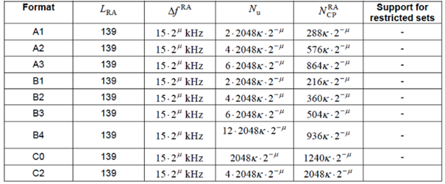

Now, by looking at the table, and with reference to what was said during the GTW, it is quite evident that:

* + FDRA of B4 and C2 is the same, thus so is the resulting PSD.
  + By the same logic used to say, rather intuitively actually, that longer format should provide better coverage, then if format B4 suffers coverage issues then so should other formats. As mentioned earlier, this is indeed the reason why preamble B4 was chosen in the first place, i.e., it is arguably the preamble for FR2 that offers the longest coverage by design.
* If we focus on scenarios which have potential coverage bottleneck channels, i.e., Urban 28 GHz O2I and O2O, and we look at available results for Urban 28 GHz O2I, MPL for C2 is 10 dB lower than MPL of B4.

For all the above reasons, FL’s understanding is that if RAN1 concludes that results reported by companies highlight a coverage bottleneck for PRACH B4 in Urban 28 GHz, it is expected that even worse problems will be observed other formats. Indeed, RAN1 could not test all the possible channel/signal configurations for obvious reasons and picked the most relevant ones based on sound technical considerations and discussions. In this context, the specific configurations RAN1 selected are very useful to characterize the desired LB increase, in dBs, any enhancements should target, and such enhancement may likely apply to any short preamble format in case of PRACH (same family of preambles).

From specification perspective, this would also be more natural, if applicable. In this regard, FL thinks that it is not very likely that, if any channel is considered a bottleneck for a specific configuration, then a specific enhancement targeting only a very precise configuration will be specified at the end of the WI.

In summary, FL’s recommendation would be to consider PRACH as potential coverage bottleneck channel, and PRACH B4 as reference to assess how many additional dBs over the baseline a PRACH enhancement should target.

**PUCCH F3**:

The same logic could apply, of course, to other potential bottleneck channels, such as PUCCH F3. In this case RAN1 tested two payload sizes, namely 11 bits and 22 bits. Both configurations displayed potential coverage issues and are thus considered potential coverage bottlenecks. On the other hand, it may be argued that this implies that PUCCH F3 is a potential coverage bottleneck and the discussion should be about how many additional dBs over the baseline a PUCCH F3 enhancement should target. In this sense, the choice for the baseline could be 11 bits, 22 bits or both.

In summary, FL’s recommendation would be the to consider PUCCH F3 as potential coverage bottleneck channel, and PUCCH F3 with either 11 bits or 22 bits or both as reference to assess how many additional dBs over the baseline a PUCCH F3 enhancement should target.

The following proposal is then formulated.

**FL’s proposal**:

* PRACH is a potential coverage bottleneck channel, and PRACH B4 as reference to assess how many additional dBs over the baseline a PRACH enhancement should target.
* PUCCH F3 is potential coverage bottleneck channel, and PUCCH F3 with either 11 bits or 22 bits or both as reference to assess how many additional dBs over the baseline a PUCCH F3 enhancement should target

Companies can input their views in the Table below.

Companies are encouraged to consider FL’s proposal and invited to add views about this proposal in the table below, **only if concerns exist**. FL would like to remind everyone that available time is scarce and constructive attitude is highly appreciated.

|  |  |
| --- | --- |
| **Company** | **Comments** |
|  |  |
|  |  |

1. **Further observations on potential coverage bottlenecks for 1st priority channels**

Following an observation received during the first round of discussions, the MIL charts for Urban 28 GHz scenario (O2I/O2O) are reproduced here, including a graphical representation of the standard deviation.

|  |  |
| --- | --- |
| O2I |  |
| O2O |  |

Several observations can be drawn from the table above:

* PUSCH eMBB is the channel which suffers most coverage issues for both O2I and O2O. Other channels than PUSCH have similar performance for O2I, whereas PRACH B4 and PUSCH for Msg3 have more coverage issues than other channels for O2O.
* Standard deviation of results of O2I is larger than the O2O counterpart for 5 channels out of 8. This is due to the largest heterogeneity among assumptions companies made for the modelling of channels for O2I setting (which has the largest amount of degrees of freedom in this sense).
* PUSCH for VoIP (DDDSU and DDSU) and PUSCH eMBB are the three channels for which standard deviation is the smallest for O2O.
* PUSCH for VoIP (DDSU), PRACH B4 and PUSCH eMBB are the three channels for which standard deviation is the smallest for O2O.
* Overall, the following 1st priority potential bottleneck channels display the largest coverage problems for Urban 28GHz both for O2I and O2O:
  + PUSCH eMBB (DDDSU, DDSU)
  + PUSCH for msg3
  + PRACH B4
  + PUCCH F3 22 bits
* Overall, the following potential bottleneck channels consistently display better coverage than the other potential bottleneck channels for Urban 28GHz both for O2I and O2O:
  + PUSCH VoIP (DDDSU)
  + PUCCH F3 11 bits
* PUSCH VoIP (DDSU) displays more coverage problems for O2I but is among the best performers (among the potential bottleneck channels) for O2O.

At this stage, it may be worth observing that VoIP service for FR2 was considered a high priority item in the SID only for FR1. RAN1 studied its performance, nonetheless. Given the above observations, and the consideration on the priority description in the SID. the following proposal is made.

**FL’s proposal**:

* The following 1st channels are recommended as bottleneck channels in Urban 28 GHz:
  + PUSCH eMBB (DDDSU, DDSU)
  + PUSCH for msg3
  + PRACH B4
  + PUCCH F3 22 bits
* FFS: PUCCH F3 11 bits
* Note: this proposal is formulated according to the usual terminology used so far. The terminology could be changed depending on what RAN1 decides with respect to the FL’s proposal in previous section.

Companies are encouraged to consider FL’s proposal and invited to add views about this proposal in the table below, **only if concerns exist**. FL would like to remind everyone that available time is scarce and constructive attitude is highly appreciated.

|  |  |
| --- | --- |
| **Company** | **Comments** |
|  |  |
|  |  |

1. **Observations and proposals for 2nd priority channels**

Similar to what has been done for 1st priority channels, the MIL charts for Urban 28 GHz scenario (O2I/O2O) are reproduced here, including a graphical representation of the standard deviation.

|  |  |
| --- | --- |
| O2I |  |
| O2O |  |

Few observations can be drawn from the table above:

* Only two 2nd priority channels have at least 2 samples. Those are PUSCH for CSI with 11 bits and PUSCH for CSI with 22 bits for O2I setting.
* As could be expected, given its larger payload, PUSCH for CSI with 22 bits is the channel who has the poorest coverage, out of the two with at least 2 sample. However, and with reference to the results for 1st priory channels, its performance is around 1 dB larger than what is observed for PUCCH F3 22 bits and around 2.5 dB worse than what is observed for PUCCH F3 11 bits.
* Other channels have only 1 sample and may lead to extremely inaccurate conclusions.

Given the above observations, and with reference to the FFS point of the previous proposal, the following proposal is made.

**FL’s proposal**:

If PUCCH F3 11 bits is recommended bottleneck channel in Urban 28 GHz, then following 2nd priority channel is recommended as bottleneck channel for Urban 28 GHz:

* + PUSCH for CSI with 22 bits

Note: this proposal is formulated according to the usual terminology used so far. The terminology could be changed depending on what RAN1 decides with respect to the FL’s proposal about terminology in previous section.

Companies are encouraged to consider FL’s proposal and invited to add views about this proposal in the table below, **only if concerns exist**. FL would like to remind everyone that available time is scarce and constructive attitude is highly appreciated.

|  |  |
| --- | --- |
| **Company** | **Comments** |
|  |  |
|  |  |

### [Will be open very soon] Estimation of LB increase enhancements may target

### [L] Additional observations from LLS

Companies willing to capture additional observations from LLS, are invited to input them in the table below. **Deadline for adding view is exceptionally set at 4 AM (UTC) on Friday 11/13**.

At the next round of email discussion, FL will ask other companies whether such observations should be captured or not. Please note that the proposals will be treated on best effort basis.

|  |  |
| --- | --- |
| **Company** | **Comments** |
|  |  |
|  |  |

## [L] Observations from SLS evaluations

Some results obtained through SLS were included in companies’ contributions. Companies who provided such results can input corresponding observations below, whenever their content is not already covered by the discussion in Section 2.2 and 2.3.

|  |  |
| --- | --- |
| **Company** | **Proposals on additional observations** |
| CATT | We are fine with FL observations. |
|  |  |

No comment was received for in the last 96 hours. Companies willing to capture additional specific observations from SLS, are invited to input them in the table below. **Deadline for adding view is exceptionally set at 4 AM (UTC) on Friday 11/13**.

At the next round of email discussion, FL will ask other companies whether such observations should be captured or not. Please note that the proposals will be treated on best effort basis.

|  |  |
| --- | --- |
| **Company** | **Comments** |
| ZTE | One source (ZTE, R1-2007742) evaluated the target performance, i.e. the 5th percentile geometry SINR value, based on system-level simulation. Compared to the baseline performance, i.e., required SNR based on link level simulation, the following is observed.   * In Indoor 28 GHz scenario, only PUSCH eMBB requires coverage compensation, and the compensation gap is 1.4 dB. * In Urban 28 GHz O2I scenario, PUSCH eMBB, Msg3, PRACH B4, PUCCH 11 bits, PUCCH 22 bits, PBCH, PDSCH eMBB and Msg4 require coverage compensation, and the compensation gap is 20.19 dB, 5.38 dB, 5.05 dB, 1.76 dB, 3.2 dB, 0.57 dB, 8.11 dB, 1.8 dB respectively. * In Urban 28 GHz O2O scenario, only PUSCH eMBB requires coverage compensation, and the compensation gap is 4.38 dB. |
|  |  |

## [L] Others

Additional proposals related to evaluations have been made in [10], [14] and [22].

* **(Item 1) Beamforming implementation constraints**
  + It is proposed in [10] that, as a starting point, neglect any constraints imposed by certain beamforming implementation such as the possibility to simultaneous receive or transmit with maximum gain in more than one direction.
* **(Item 2) Phase noise models and compensation algorithms**
  + It is proposed in [10] that PTRS overhead and compensation algorithms should be neglected.
* **(Item 3) Low spectral efficiency 64QAM table**
  + It is argued in [14] that the coverage of data channel can be improved by using qam64-LowSE MCS index table in TS 38.214, which yields more MCS indices with lower code rate as compared to its 256QAM and 64QAM counterparts. It is then proposed to capture the following observation in the TR of ReL-17 NR coverage enhancement SI:
    - *The coverage of data channel can be improved by using qam64-LowSE MCS index table (table 3), which yields more MCS indices with lower code rate as compared to its 256QAM and 64QAM counterparts, especially in scenarios with low(er) throughput requirements.*
* **(Item 4) Allocation of number of PRBs and MCS index**
  + It is argued in [14] that, in general, the optimal combination in terms of MPL maximization may not yield the most desirable operating point for the system, but simply the configuration for which the coverage would be maximized. It is then proposed to capture the following observation in the TR of ReL-17 NR coverage enhancement SI:
    - *The coverage of PUSCH can be enhanced by identifying the optimal combination of number of allocated PRBs and MCS index for PUSCH to meet the throughput target.*
* **(Item 5) Deployment-related FR2 coverage issues**
  + It is argued in [22] that deployment scenarios of 5G NR may affect the coverage of FR2 differently, e.g., DC and CA may be characterized by different coverage issues. It is thus proposed that:
    - *Different deployment modes of FR2 and their specific coverage issues should be investigated.*

Companies are invited to input views on items 1 to 5.

|  |  |  |
| --- | --- | --- |
| **Item** | **Company** | **Comment** |
| **1** | Samsung | Ok |
| CATT | OK |
|  |  |
|  |  |
| **2** | Samsung | Ok |
| CATT | OK |
|  |  |
|  |  |
| **3** | Samsung | Can be classified as enhancement (by proper gNB scheduling) rather than baseline coverage performance |
| CATT | Baseline performance evaluation needn’t consider potential enhancement method on MCS |
|  |  |
|  |  |
| **4** | Samsung | Can be classified as enhancement (by proper gNB scheduling) rather than baseline coverage performance |
| CATT | Baseline performance evaluation needn’t consider potential enhancement method on PRBs and MCS index |
|  |  |
|  |  |
| **5** | Samsung | Since we are closing the SI, we would like to see the explicit proposal (rather than “investigate…”) |
| CATT | Single FR2 deployment should be made as baseline for coverage performance evaluation. |
|  |  |
|  |  |

No additional comment was received for in the last 96 hours. FL has formulated TPs related to the 5 items above, considering the received comments during the first round of discussion. Companies are invited to check TPs in Section 2.8 and comment therein, if applicable.

## [H] Text Proposals

This first set of Text proposals covers items discussed in Section 2.7.

**Proposal 1**

Capture the following in the TR - Section 4 Evaluation Methodology

*Results in this document have been obtained by means of performance evaluations conducted neglecting:*

* *any constraints imposed by certain beamforming implementation, such as the possibility to simultaneous receive or transmit with maximum gain in more than one direction;*
* *PTRS overhead and compensation algorithms.*

Discussion on low priority items have been open at least for the last 48h. Companies are invited to comment on proposal 1 **only if they have concerns**.

|  |  |
| --- | --- |
| **Company** | **Comments** |
|  |  |
|  |  |

**Proposal 2**

Capture the following in the TR - Section 6.1 PUSCH coverage enhancements

*Coverage of PUSCH can be improved by*

* *using qam64-LowSE MCS index table in TS 38.214 (MCS index table 3), which yields more MCS indices with lower code rate as compared to its 256QAM and 64QAM counterparts, especially in scenarios with low(er) throughput requirements.*
* *identifying the optimal combination of number of allocated PRBs and MCS index for PUSCH to meet the throughput target.*

Discussion on low priority items have been open at least for the last 48h. Companies are invited to comment on proposal 2 **only if they have concerns**.

|  |  |
| --- | --- |
| **Company** | **Comments** |
|  |  |
|  |  |

**Proposal 3**

Capture the following in the TR - Section 6.3 Coverage enhancements for channels other than PUSCH and PUCCH

*Coverage of PDSCH can be improved by*

* *using qam64-LowSE MCS index table in TS 38.214 (MCS index table 3), which yields more MCS indices with lower code rate as compared to its 256QAM and 64QAM counterparts, especially in scenarios with low(er) throughput requirements.*

Discussion on low priority items have been open at least for the last 48h. Companies are invited to comment on proposal 3 **only if they have concerns**.

|  |  |
| --- | --- |
| **Company** | **Comments** |
|  |  |
|  |  |

# Proposals for GTW sessions

**FL’s Proposal 1 [Agreed online on 10/27]**

All the parameters/values/configurations related to FR2 modelling for which an agreement has not been reached among companies prior to RAN1 #103-e, will be henceforth treated according to the “reported by companies” principle. RAN1 will not spend further time during RAN1 #103-e on the resolution of these issues.

**FL’s Proposal 2 [Agreed online on 10/29]**

The amount of available results for UL channels in FR2 should be considered as given by the total number of results available results for both 23 dBm and 12 dBm, given that they can be derived one from the other by simple subtraction, and where each company is counted only once.

**FL’s Proposal 3 [Agreed online]**

* For FR2, representative values are computed according to agreements made for FR1 related on representative value calculation method;
* For FR2, classification of scenarios/channels/frame structures into 1st priority and 2nd priority as follows:
  + 1st priority has enough available results, i.e., larger than 2;
  + 2nd priority has less than 3 available results.
* No categorization by other simulation parameters (such as UE speed, antenna array gain correction factors, UE Tx power) will be introduced for FR2.
* At least for FR2
  + RAN1 discussion will focus on 1st priority scenarios/channels/frame structures for drawing observations and bottleneck identification.
  + RAN1 discussion will focus on 2nd priority scenarios/channels/frame structures on a low priority basis, i.e., after discussion on 1st priority scenarios/channels/frame structures.
  + If results presented for 2nd priority scenarios/channels/frame structures are used by RAN1 for neither representative value derivation nor coverage bottleneck identification, they
    - will still be captured in the Appendix of the TR for completeness;
    - can be used to make additional observations to be captured in the TR.
    - cannot be used to draw conclusions to be captured in the TR.

Based on the above:

**Scenarios, with corresponding frame structures, are classified as follows:**

* *1st priority*
  + Urban 28 GHz O2I, DDDSU
  + Urban 28 GHz, O2O DDDSU
  + Urban 28 GHz, O2I, DDSU [Only PUSCH VoIP, PUSCH and PDSCH]
  + Indoor 28 GHz, DDDSU
* *2nd priority*
  + Indoor 28 GHz, DDSU
  + Urban 28 GHz, O2I, DDSU [only PDSCH of msg2]
  + Urban 28 GHz, O2O DDSU
  + Suburban 28 GHz, O2I DDDSU
  + Suburban 28 GHz, O2O DDSU

**Channels are classified as follows:**

* *1st priority*
  + PUSCH for eMBB (12 dBm and 23 dBm) [DDDSU and DDSU]
  + PUSCH for VoIP (12 dBm and 23 dBm) [DDDSU and DDSU (Only for Urban)]
  + PUCCH Format 1 with 2bits (12 dBm and 23 dBm) [DDDSU]
  + PUCCH Format 3 with 11bits (12 dBm and 23 dBm) [DDDSU]
  + PUCCH Format 3 with 22bits (12 dBm and 23 dBm) [DDDSU]
  + SSB [DDDSU]
  + PRACH format B4 (12 dBm and 23 dBm) [DDDSU]
  + PDCCH for Msg.2 [DDDSU]
  + PUSCH for Msg.3 (12 dBm and 23 dBm) [DDDSU]
  + PDSCH for Msg.4 [DDDSU]
  + PDCCH [DDDSU]
  + PDSCH for eMBB [DDDSU and DDSU (Only for Urban)]
* *2nd priority*
  + PUSCH for CSI with 11 bits (12 dBm and 23 dBm)
  + PUSCH for CSI with 22 bits (12 dBm and 23 dBm)
  + PUCCH with 3-HARQ-ACK bits + SR (12 dBm and 23 dBm)
  + PUCCH with HARQ-ACK for Msg.4 (12 dBm and 23 dBm)
  + PRACH format C2 (12 dBm and 23 dBm)
  + PDSCH of Msg.2
  + PUCCH Format 0 (12 dBm and 23 dBm)
  + PUCCH Format 2 (12 dBm and 23 dBm)

**FL’s Proposal 4 [agreed]**

If absolute ISD/MPL targets are agreed to be used for coverage bottleneck identification then the following targets are considered for FR2:

* + **Dense Urban**: ISD = 200m; MPL = 123.1 dB;
  + **Indoor**: ISD = 20m; MPL = 94.03 dB;

Where MPL values are calculated from ISD targets using the following equations

|  |  |
| --- | --- |
| **URBAN** | **INDOOR** |
| TABLE A1-3 Path loss and shadow fading for Uma_x | TABLE A1-2 Path loss and shadow fading for InH_x |

With values of $f_{c}$, $h_{BS}$, $h_{UT}$ are set using the values in the following table

|  |  |  |
| --- | --- | --- |
|  | **Urban** | **Indoor** |
| $$f_{c}$$ | 28 | 28 |
| $h_{BS}$ | 25.00 | 3 |
| $h_{UT}$ | 1.5 | 1.5 |

FFS d3D with respect to ISD.

FFS: If absolute MIL targets are also considered for coverage bottleneck identification including possible different targets for data and control channels.

**FL’s proposal 5**

For target MPL calculation associated to agreed ISD targets, $d_{3D}$ is equal to the target range calculated by ISD/ $\sqrt{3}$.

**FL’s proposal 6**

PUSCH for SIP invite is added to the list of 2nd priority channels.

# Agreements

Agreements

All the parameters/values/configurations related to FR2 modelling for which an agreement has not been reached among companies prior to RAN1 #103-e, will be henceforth treated according to the “reported by companies” principle. RAN1 will not spend further time during RAN1 #103-e on the resolution of these issues

Agreements:

The amount of available results for UL channels in FR2 should be considered as given by the total number of available results for both 23 dBm and 12 dBm, given that they can be derived one from the other by simple subtraction, and where each company is counted only once.

Agreements :

* For FR2, representative values are computed according to agreements made for FR1 related on representative value calculation method;
* For FR2, classification of scenarios/channels/frame structures into 1st priority and 2nd priority as follows:
  + 1st priority has enough available results, i.e., larger than 2;
  + 2nd priority has less than 3 available results.
* No categorization by other simulation parameters (such as UE speed, antenna array gain correction factors, UE Tx power) will be introduced for FR2.
* At least for FR2
  + RAN1 discussion will focus on 1st priority scenarios/channels/frame structures for drawing observations and bottleneck identification.
  + RAN1 discussion will focus on 2nd priority scenarios/channels/frame structures on a low priority basis, i.e., after discussion on 1st priority scenarios/channels/frame structures.
  + If results presented for 2nd priority scenarios/channels/frame structures are used by RAN1 for neither representative value derivation nor coverage bottleneck identification, they
    - will still be captured in the Appendix of the TR for completeness;
    - can be used to make additional observations to be captured in the TR.
    - cannot be used to draw conclusions to be captured in the TR.

**Agreements :**

If absolute ISD/MPL targets are agreed to be used for coverage bottleneck identification then the following targets are considered for FR2:

* + **Dense Urban**: ISD = 200m; MPL = [123.1] dB;
  + **Indoor**: ISD = [20]m; MPL = [94.03] dB

FFS: If MIL targets are also considered for control and data channels.

Agreements:

Scenarios, with corresponding frame structures, are classified as follows:

* *1st priority*
  + Urban 28 GHz O2I, DDDSU
  + Urban 28 GHz, O2O DDDSU
  + Urban 28 GHz, O2I, DDSU [Only PUSCH VoIP, PUSCH and PDSCH]
  + Indoor 28 GHz, DDDSU
* *2nd priority*
  + Indoor 28 GHz, DDSU
  + Urban 28 GHz, O2I, DDSU [only PDSCH of msg2]
  + Urban 28 GHz, O2O DDSU
  + Suburban 28 GHz, O2I DDDSU
  + Suburban 28 GHz, O2O DDSU

**Channels are classified as follows:**

* *1st priority*
  + PUSCH for eMBB (12 dBm and 23 dBm) [DDDSU and DDSU]
  + PUSCH for VoIP (12 dBm and 23 dBm) [DDDSU and DDSU (Only for Urban)]
  + PUCCH Format 1 with 2bits (12 dBm and 23 dBm) [DDDSU]
  + PUCCH Format 3 with 11bits (12 dBm and 23 dBm) [DDDSU]
  + PUCCH Format 3 with 22bits (12 dBm and 23 dBm) [DDDSU]
  + SSB [DDDSU]
  + PRACH format B4 (12 dBm and 23 dBm) [DDDSU]
  + PDCCH for Msg.2 [DDDSU]
  + PUSCH for Msg.3 (12 dBm and 23 dBm) [DDDSU]
  + PDSCH for Msg.4 [DDDSU]
  + PDCCH [DDDSU]
  + PDSCH for eMBB [DDDSU and DDSU (Only for Urban)]
* *2nd priority*
  + PUSCH for CSI with 11 bits (12 dBm and 23 dBm)
  + PUSCH for CSI with 22 bits (12 dBm and 23 dBm)
  + PUCCH with 3-HARQ-ACK bits + SR (12 dBm and 23 dBm)
  + PUCCH with HARQ-ACK for Msg.4 (12 dBm and 23 dBm)
  + PRACH format C2 (12 dBm and 23 dBm)
  + PDSCH of Msg.2
  + PUCCH Format 0 (12 dBm and 23 dBm)
  + PUCCH Format 2 (12 dBm and 23 dBm)

Agreements:

If absolute ISD/MPL targets are agreed to be used for coverage bottleneck identification then the following targets are considered for FR2:

* + **Dense Urban**: ISD = 200m; MPL = 123.1 dB;
  + **Indoor**: ISD = 20m; MPL = 94.03 dB;

Where MPL values are calculated from ISD targets using the following equations (add reference when capturing into the TR)







FFS d3D with respect to ISD

FFS: If absolute MIL targets are also considered for coverage bottleneck identification including possible different targets for data and control channels.

# References

1. R1-2007582 Evaluation on the baseline performance for FR2 Huawei, HiSilicon
2. R1-2007679 Evaluation on NR coverage performance for FR2 vivo
3. R1-2007742 Discussion on baseline coverage performance for FR2 ZTE
4. R1-2007873 Baseline coverage performance for FR2 CATT
5. R1-2007953 On baseline coverage performance for FR2 Intel Corporation
6. R1-2008025 Discussion on the baseline performance in FR2 CMCC
7. R1-2008090 Baseline coverage performance for FR2 Xiaomi
8. R1-2008180 Baseline coverage performance using LLS for FR2 Samsung
9. R1-2008270 Evaluation on NR coverage performance for FR2 OPPO
10. R1-2008344 Link and System Evaluation of Coverage for FR2 Ericsson LM
11. R1-2008482 FR2 baseline coverage performance using LLS InterDigital, Inc.
12. R1-2008558 Baseline coverage performance for FR2 NTT DOCOMO, INC.
13. R1-2008625 Baseline FR2 coverage performance Qualcomm Incorporated
14. R1-2008702 Baseline coverage evaluation of UL and DL channels – FR2 Nokia, Nokia Shanghai Bell
15. R1-2007683 Considerations on Parameters for Coverage Evaluation vivo
16. R1-2007746 Discussion on target performance for NR coverage enhancements ZTE
17. R1-2007877 Discussion on remaining issues for coverage enhancement CATT
18. R1-2007957 On simulation assumptions for NR coverage enhancement Intel Corporation
19. R1-2008274 Functionality of Coverage Enhancement and other WI OPPO
20. R1-2008422 Coverage Parameter Sensitivity and Network Enhancement Ericsson
21. R1-2008487 Discussion on simulation assumptions for VoIP InterDigital, Inc.
22. R1-2008629 Other coverage enhancement aspects Qualcomm Incorporated
23. R1-2008706 Evaluation assumptions for NR coverage enhancement evaluation Nokia, Nokia Shanghai Bell

# Annex 1 – Agreements at RAN1#101e

Update on 6/1: to check 6/2

Update from 6/4 GTW:

Agreements:

* Adopt the following target data rates for eMBB performance evaluation for FR1.
* Urban scenario: DL 10Mbps, UL 1Mbps
* Rural scenario: DL 1Mbps, UL 100kbps
* Rural with long distance scenario: DL 1Mbps, UL 100kbps, ~~[~~30kbps~~]~~ (optional)

**Agreements:**

* For VoIP performance evaluation based on link-level simulation for FR1.
* A packet size of [320] bits with 20ms data arriving interval is adopted.
* ~~FFS~~TBD: TBS for SIP invite message. Payload of 1500 bytes can be a starting point.

Agreements:

* The basic evaluation methodology is based on link-level simulation for FR1.
* Step 1: Obtain the required SINR for the physical channels under target scenarios and service/reliability requirements.
* Step 2: Obtain the baseline performance based on required SINR and link budget template.
* Note: asepcts related to identifying target performance and coverage bottlenecks based on target performance metric is to be handled separately
* ~~FFS:~~ The evaluation methodology based on system-level simulation is optional for FR1.
* Note: The simulation assumptions for SLS are up to companies’ reports.

Agreements:

* For link level simulation, adopt the following table for PUSCH and PUCCH for FR1.

|  |  |
| --- | --- |
| **Parameters** | **Values** |
| Scenario and frequency | Urban: 4GHz (TDD), 2.6GHz (TDD)  Rural: 4GHz (TDD), 2.6GHz (TDD), 2GHz (FDD), 700MHz (FDD)  Rural with long distance: 700MHz (FDD), 4GHz (TDD) |
| Frame structure for TDD | DDDSU (S: 10D:2G:2U) only for 4GHz  DDDSUDDSUU (S: 10D:2G:2U) only for 4GHz  DDDDDDDSUU (S: 6D:4G:4U) only for 2.6GHz  Other frame structures can be reported by companies. |
| Pathloss model (select from LoS or NLoS) | Urban: NLoS  Rural: NLoS and LoS |
| BWP | 100MHz for 4GHz and 2.6GHz.  20MHz for 2GHz (FDD  20MHz (optional for 10MHz) for 700MHz. (FDD) |
| SCS | 30kHz for TDD, 15kHz for FDD. |
| Channel model for link-level simulation | TDL-C for NLOS, TDL-D for LOS.  [CDL] |
| UE velocity | Urban: 3km/h for indoor  Rural: 3km/h for indoor, 120km/h (optional 30km/h) for outdoor |
| Frequency hopping | w/ or w/o ~~Intra-slot~~ frequency hopping for PUSCH  w/ frequency hopping for PUCCH ~~is enabled~~. |

* FFS whether there are any additional simulation considerations for the extreme coverage scenarios (e.g., rural)

Update on 6/5:

Agreement:

* Down selection on the following options for the link budget template for FR1 in next meeting.
* Option 1: Adopt single link budget template based on IMT-2020 self-evaluation with necessary revisions, including adding/removing/revising some parameters.
  + FFS: The template provided by FL in Tdoc R1-2005005.
* Option 2: Adopt both templates, i.e. link budget template in IMT-2020 self-evaluation and link budget template in TR 36.824.
* Option 3: Adopt single link budget template in TR 36.824 with necessary revisions, including adding/revising some parameters.

Agreement:

Down selection on the following options for antenna array gain for LLS based methodology for FR1 in next meeting.

* Option 1: Antenna array gain is included in the link budget template.
* FFS: array gain = 10 * 1og10 (number of antenna elements/number of TxRUs)
* FFS: For TDL channel model
* FFS: Values reflective of realistic implementation and network operation.
* Option 2: Antenna array gain is included in LLS.
* FFS: For CDL channel model

Agreement:

* For link level simulation, adopt the following table for PDSCH for FR1.

|  |  |
| --- | --- |
| Parameters | Values |
| Waveform | CP-OFDM |
| PRBs/MCS/TBS | Reported by companies. |
| PDSCH duration | 12 OS |
| Other parameters | FFS |

Agreements:

* For link level simulation, adopt following TBS for Msg3 for FR1
* 56 bits

Agreements:

* For link level simulation, the packet size of VoIP for FR2 is the same as FR1.

Agreements:

* For link level simulation, TBS of Msg3 for FR2 is the same as FR1.

Agreements:

* The evaluation methodology for FR2 is the same as FR1.

Agreements:

* The link budget template for FR2 is the same as FR1.

Agreements:

* For link level simulation, adopt the following table for PUSCH and PDSCH for FR2.

|  |  |
| --- | --- |
| **Parameters** | **Values** |
| Scenario and frequency | 28GHz |
| Frame structure for TDD | DDDSU (S: 10D:2G:2U)  DDSU (S: 11D:3G:0U)  Other frame structures can be reported by companies. |
| Subcarrier Space | 120kHz |
| UE velocity | Indoor scenario:3km/h  Urban scenario: 3km/h for indoor, 30km/h for outdoor.  Suburban scenario: 3km/h for indoor, 30km/h, (optional: 120km/h) for outdoor. |
| Occupied channel bandwidth for | 100MHz, [400MHz] |
| Frequency hopping for PUSCH | w/ or w/o frequency hopping |

Final summary in R1-2005004.

**//Update on 6/7, post e-Meeting additional email approval**

**[101-e-Post-NR-Cov-Enh] Email discussion/approval focusing on remaining evaluation assumptions till 6/17 – Jianchi (CT)**

* **Focusing on high priority proposals first, target 6/11 for early approvals**
* **Followed by medium priority/low priority proposals**

Update on 6/11: check on 6/12 for potential agreements

Update on 6/12:

Agreements

* For link level simulation, adopt the following table for PUSCH for eMBB data or VoIP for FR1.

|  |  |
| --- | --- |
| **Parameters** | **Values** |
| BLER for PUSCH | For eMBB,  w/ HARQ, 10% iBLER;  w/o HARQ, 10% iBLER.  For VoIP, 2% rBLER. |
| Number of UE transmit chains for PUSCH | 1，2 (optional) |
| DMRS configuration for PUSCH | For 120km/h, (Optional: 30km/h): Type I, 2 or 3 DMRS symbol, no multiplexing with data.  For frequency hopping: Type I, 1 or 2 DMRS symbol for each hop, no multiplexing with data.  PUSCH mapping Type and DMRS position are reported by companies.  Working assumption:  For 3km/h: Type I, 1 or 2 DMRS symbol, no multiplexing with data. |
| Waveform for PUSCH | DFT-s-OFDM,  CP-OFDM (optional) |
| Repetitions for PUSCH | For eMBB,  w/o repetition as baseline,  w/ repetition (optional).  For VoIP, w/ repetition.  The actual number of repetitions is reported by companies.  FFS: Repetition type B |
| HARQ configuration for PUSCH | For eMBB, whether HARQ is adopted is reported by companies.  For VoIP, w/ HARQ.  The maximum number of HARQ transmission (limited by frame structure and latency requirements) can be reported by companies. |
| Latency requirements for voice | 50ms/100ms |
| PUSCH duration | 14 OS |

Agreements

* For link level simulation, adopt the following table for PUCCH for FR1.

|  |  |
| --- | --- |
| **Parameters** | **Values** |
| PUCCH format type | Format 1, 2bits UCI.  Format 3, [4bits (3 bits A/N + 1 bit SR)]/11/22 bits UCI |
| BLER for PUCCH | For PUCCH format 1:  DTX to ACK probability: 1%. NACK to ACK probability: 0.1%.  ACK missed detection probability: 1%.  For PUCCH format 3:  BLER for Ack/Nack, SR: 1%  FFS: BLER for CSI (10% or 1%) |
| Number of PRBs for PUCCH | 1 PRB |
| Number of UE transmit chains for PUCCH | 1 |
| Number of repetitions for PUCCH | w/ repetition (optional), w/o repetition for PUCCH.  The maximum number of repetitions is 8. |
| PUCCH duration | 14 OS |
| DMRS configuration for PUCCH | FFS: number of DMRS symbols for PUCCH Format 3. |

Agreements:

* For link level simulation, adopt the following table for eMBB data or VoIP on PUSCH and for PUCCH for FR1.

|  |  |
| --- | --- |
| **Parameters** | **Values** |
| Number of ~~receive~~ antenna elements for BS | Urban: 192 antenna elements for 4GHz and 2.6GHz,  (M,N,P,Mg,Ng) = (12,8,2,1,1)  (optional) 128 antenna elements for 4GHz,  (M,N,P,Mg,Ng) = (8,8,2,1,1)  Rural: 64 antenna elements for 4GHz and 2.6GHz  (M,N,P,Mg,Ng) = (8,4,2,1,1)  32 antenna elements for 2GHz  (M,N,P,Mg,Ng) = (8,2,2,1,1)  16 antenna elements for 700MHz  (M,N,P,Mg,Ng) = (4,2,2,1,1) |
| Number of ~~receive~~ TxRUs for BS | ~~TBD~~  gNB architectures to study ~~for TDL~~:   * 2 or 4 TXRUs for 2GHz, 700 MHz * 64TxRUs for 2.6 and 4 GHz. * Optional: 32 TXRUs at 2 GHz   ~~[~~gNB modeling in LLS for TDL:   * Option 1: 2 or 4 gNB receive chains in LLS ~~(as starting point)~~. FFS: correlation * Option 2: Number of gNB receive chains = number of TXRUs in LLS. FFS: correlation.~~]~~   [gNB architectures to study for CDL:   * Urban: 64 receive chains for 2.6 and 4 GHz in LLS * Rural: 8 receive chains for 4GHz and 2.6GHz in LLS * 4 receive chains for 2GHz and 700MHz in LLS.]   [gNB modeling in LLS for CDL:   Number of gNB receive chains = number of TXRUs in LLS.] |
| Delay spread | Urban: 300ns  Rural: 300ns  Rural with long distance: 30ns |
| PRBs/TBS/MCS for eMBB for PUSCH | Any value of PRBs, and corresponding MCS index, reported by companies will be considered in the discussion. Companies are encouraged to use 30 PRBs for 1Mbps, 4 PRBs for 100kbps, 1 PRB for 30kbps as a starting point.  TBS can be calculated based on e.g. the number of PRBs, target data rate, frame structure and overhead. |
| PRBs/MCS for VoIP for PUSCH | [4 PRBs] for VoIP as starting point.  Other values of PRBs can be reported by companies.  QPSK, pi/2 BPSK (optional) |

Note: For TDL models, companies report whether antenna array gain, ~~obtained from mapping antenna elements to TXRU,~~ is included in LLS or link budget template. Array gain calculation method and how channel estimation is accounted for is reported by companies

Agreements:

* Adopt the following target data rates for eMBB performance evaluation for FR2.
* Indoor: DL: 25Mbps, UL:5Mbps
* Urban: DL: 25Mbps, UL: 5Mbps
* Suburban: FFS: (DL: 1Mbps, UL: 50kbps)

Other proposals?

* # Number of receive TxRUs for BS – 6/15
* Others?

Update on 6/17

Regarding # Number of receive TxRUs for BS – see the update of the agreement above.

Agreements:

* ~~For link level simulation, adopt the following table for SSB for FR1.~~

|  |  |
| --- | --- |
| **~~Parameters~~** | **~~Values~~** |
| ~~Periodicity~~ | ~~20ms~~ |
| ~~Performance metric~~ | ~~Combination of 4 SSBs in 80ms.~~ |
| ~~Other parameters~~ | ~~Reported by companies.~~ |

* For link level simulation, adopt the following table for Msg.3 for FR1.

|  |  |
| --- | --- |
| **Parameters** | **Values** |
| Number of PRBs | 2 |
| Waveform | DFT-s-OFDM |
| Number of DMRS symbol | w/o frequency hopping: 3,  w/ frequency hopping: 2 for each hop |
| PUSCH duration | 14 OS |
| Other parameters | Reported by companies. |

Other proposals 6/18

Update on 6/18:

Agreements:

* For link level simulation, adopt the following table for PDCCH for FR1.

|  |  |
| --- | --- |
| **Parameters** | **Values** |
| Aggregation level | 16 |
| Payload | 40 bits |
| CORESET size | 2 symbols, 48 PRBs |
| Tx Diversity | Reported by companies |
| BLER for PDCCH | 1% BLER  FFS: 10% BLER |
| Number of SSB for broadcast PDCCH of Msg.2 | Reported by companies |
| Other parameters | Reported by companies |

Agreements:

* For link level simulation, adopt the following table for SSB for FR1.

|  |  |
| --- | --- |
| **Parameters** | **Values** |
| Periodicity | 20ms |
| Performance metric | Combination of 4 SSBs in 80ms.  Note: UE is not assumed to know the SS/PBCH block index |
| Other parameters | Reported by companies. |

Agreements:

* For link level simulation, adopt the following table for PRACH for FR1.

|  |  |
| --- | --- |
| **Parameters** | **Values** |
| Format | Format 0, Format B4, or Format C2 |
| SCS | Reported by companies. |
| Performance metric | 1% missed detection at 0.1% false alarm probability  FFS: 10% missed detection. |
| Other parameters | Reported by companies. |

Agreements:

* For link level simulation, for PDSCH of Msg.4 for FR1.
  + Reuse the following simulation assumption for PDSCH
    - Waveform, [PDSCH duration]
  + FFS: Payload size: [3000bits].
  + Other parameters: Reported by companies.

Agreements:

* For link level simulation, for SSB, PDCCH, PDSCH and PDCCH of Msg.2, PDSCH of Msg.4 and PDSCH for FR1.
  + Reuse following simulation assumptions agreed for PUSCH.
    - Scenario and frequency, frame structure, SCS, pathloss model, channel model, delay spread, UE velocity, number of antenna elements and TxRUs for BS.
  + The number of UE receive chains: ~~is 2.~~
    - 4 for 4GHz/2.6GHz
    - 2 or 4 for 2GHz
    - 2 for 700MHz
  + For PDSCH, reuse ~~DM-RS configuration,~~ BLER, HARQ, Latency requirements for voice agreed for PUSCH.
    - Reuse DM-RS configuration agreed for PUSCH except that 3 DMRS symbols is used for Msg2.
* For link level simulation, for PRACH and Msg.3 for FR1.
  + Reuse following simulation assumptions agreed for PUSCH
    - Scenario and frequency, frame structure, pathloss model, channel model, delay spread, UE velocity, number of antenna elements and TxRUs for BS and Number of UE transmit chains.
  + For Msg.3, reuse SCS, HARQ configuration, frequency hopping agreed for PUSCH.

Agreements:

* For link level simulation, adopt the following table for eMBB data or VoIP on PUSCH and on PDSCH for FR2.

|  |  |
| --- | --- |
| **Parameters** | **Values** |
| BLER | For eMBB,  w/ HARQ, 10% iBLER, Optional: companies report rBLER.  w/o HARQ, 10% iBLER.  For VoIP, 2% rBLER. |
| DMRS configuration | For 30km/h (optional: 120km/h): Type I, 2 or 3 DMRS symbol, no multiplexing with data.  For frequency hopping for PUSCH: Type I, 1 or 2 DMRS symbol for each hop, no multiplexing with data.  PUSCH/PDSCH mapping Type and DMRS position are reported by companies.  Working assumption:  For 3km/h: Type I, 1 or 2 DMRS symbol, no multiplexing with data. |
| Waveform | DFT-s-OFDM for PUSCH, CP-OFDM for PDSCH  FFS: CP-OFDM for PUSCH |
| Repetitions for PUSCH/PDSCH | For eMBB,  w/o repetition as baseline,  w/ repetition (optional).  For VoIP, w/ repetition.  The actual number of repetitions is reported by companies.  FFS: Repetition type B for PUSCH. |
| HARQ configuration for PUSCH/PDSCH | For eMBB, whether HARQ is adopted is reported by companies.  For VoIP, w/ HARQ.  The maximum number of HARQ transmission (limited by frame structure and latency requirements) can be reported by companies. |
| PUSCH/PDSCH duration | 14 OS for PUSCH, 12 OS for PDSCH |

Agreements:

* For link level simulation, adopt the following table for eMBB data or VoIP on PUSCH and on PDSCH for FR2.

|  |  |
| --- | --- |
| **Parameters** | **Values** |
| Number of antenna elements for BS | Indoor scenario: 128  (M, N, P, Mg, Ng) = (8, 8, 2, 1, 1)  Urban/suburban scenario:  256, (M,N,P,Mg,Ng) = (4, 8, 2, 2, 2)  Optional: 512, (M,N,P,Mg,Ng) = (8,8,2,2,2) |
| Number of TxRUs for BS | 2  Note: Analog beamforming is assumed. |
| Number of UE Tx/Rx chains | 1T2R, 2T2R |
| Channel model for link-level simulation | CDL- A, TDL-A, [urban/suburban: TDL-C]  Note: company can provide simulation results based on either TDL channel or CDL model |
| Delay spread | Indoor scenario: 30ns  Urban scenario: 100ns  Suburban scenario: 100ns |
| Latency requirements for voice | 50ms/100ms |
| PRBs/TBS/MCS for eMBB for PUSCH/PDSCH | Any value of PRBs, and corresponding MCS index, reported by companies will be considered in the discussion. Companies are encouraged to use [30] PRBs for 5Mbps for PUSCH and full bandwidth for 25Mbps for PDSCH as a starting point.  TBS can be calculated based on e.g. the number of PRBs, target data rate, frame structure and overhead. |
| PRBs/MCS for VoIP for PUSCH/PDSCH | [4 PRBs] for VoIP as starting point. Other values of PRBs can be reported by companies.  QPSK for PDSCH/PUSCH  Optional: pi/2 BPSK for PUSCH |

Agreements:

* For link level simulation, adopt the following simulation assumption for eMBB data or VoIP on PUSCH and on PDSCH for FR2.

|  |  |
| --- | --- |
| **Parameters** | **Values** |
| Number of UE antenna elements | 8, one panel:(M, N, P) = (2,2,2),  FFS: Two panels in link budget, one panel in LLS, 16 for each panel: (M, N, P) = (4,2,2) |

Agreements:

* For link level simulation, adopt the following table for PUCCH for FR2.

|  |  |
| --- | --- |
| **Parameters** | **Values** |
| Format | Format 1, 2bits UCI.  Format 3, [4bits (3 bits A/N + 1 bit SR)]/11/22 bits UCI  FFS: Format 0, 2 |
| BLER for PUCCH | The same as FR1 |
| Number of PRBs for PUCCH | The same as FR1 |
| Number of UE transmit chains for PUCCH | The same as FR1 |
| Number of repetitions for PUCCH | The same as FR1 |
| PUCCH duration | 14 OFDM symbols  FFS: 4 OFDM symbols |
| DMRS configuration for PUCCH | FFS: [4] DMRS symbols for PUCCH Format 3. |

Agreements:

* For link level simulation, adopt the following table for PDCCH for FR2.

|  |  |
| --- | --- |
| **Parameters** | **Values** |
| Aggregation level | 16 |
| Payload | 40 bits |
| CORESET size | 2 symbols, 48PRBs |
| Tx Diversity | Reported by companies |
| BLER for PDCCH | 1% BLER.  FFS: 10% BLER |
| Number of SSB for broadcast PDCCH of Msg.2 | Reported by companies |
| Other parameters | Reported by companies |

Agreements:

* For link level simulation, adopt the following table for PRACH for FR2.

|  |  |
| --- | --- |
| **Parameters** | **Values** |
| Format | Format B4, (Optional: Format C2) |
| SCS | Reported by companies. |
| Performance metric | 0.1% false alarm, 1% miss-detection  FFS: 10% missed detection. |
| Number of SSB beams | Reported by companies |
| Other parameters | Reported by companies. |

Agreements:

* For link level simulation, for SSB, PDCCH, PDSCH and PDCCH of Msg.2, PDSCH of Msg.4 for FR2.
  + Reuse following simulation assumptions for PDSCH
    - Scenario and frequency, frame structure, SCS, channel model, delay spread, UE velocity, number of antenna elements and TxRUs for BS, number of UE Tx/Rx chains and UE antenna elements.
* For link level simulation, for PUCCH, PRACH and Msg.3 for FR2.
  + Reuse following simulation assumptions for PUSCH
    - Scenario and frequency, frame structure, channel model, delay spread, UE velocity, number of antenna elements and TxRUs for BS, number of UE antenna elements for PUSCH.
  + For PRACH and Msg.3, reuse number of UE Tx chains for PUSCH.
  + For PUCCH, reuse SCS for PUSCH.
  + For Msg.3, reuse SCS, HARQ configuration, frequency hopping for PUSCH.

Final summary in R1-2005192.

# Annex 2 – Agreements at RAN1#102e

Agreements:

* TDL models are used to generate results in the link budget templates for FR1
  + This does not preclude companies from performing the link-level simulations using CDL

Agreements (for both FR1 & FR2):

* For the definition of antenna array gain, adopt option 1, i.e. Antenna array gain is included in the link budget template, where there are four antenna gain components
  + Note: the four components are illustrated below – the figure is for illustration purpose only
  + FFS which component(s) are NOT part of the definition of antenna array gain
* 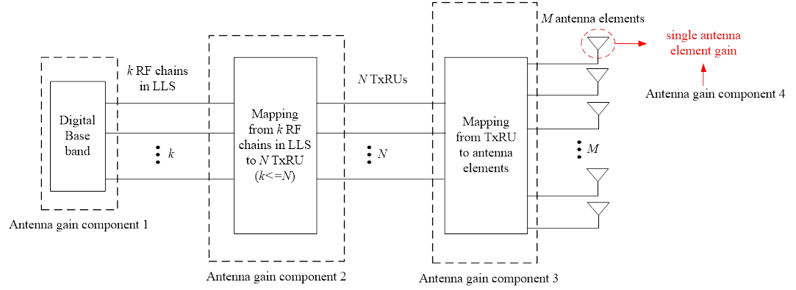

Agreements:

* For TDL Option 1
  + Definition of MCL
    - Total transmit power - Receiver sensitivity + gNB antenna gain (component 2)
  + Definition of MIL
    - Total transmit power - Receiver sensitivity + gNB antenna gain (component 2 + 3 + 4) + UE antenna gain
  + Definition of MPL
    - Further discussion offline the definition using below as a starting point:
      * Total transmit power - Receiver sensitivity + gNB antenna array gain (component 2+3+4 for TDL option 1) + UE antenna gain - (8) Cable, connector, combiner, body losses (Tx side) - (20) Receiver implementation margin + (21a/b) H-ARQ gain - (25a/b) Shadow fading margin + (26) BS selection/macro-diversity gain - (27) Penetration margin + (28) Other gains – (12) Cable, connector, combiner, body losses (Rx side)
  + Note: whether/how to use the above definitions is to be discussed

Update on 8/20: to check on 8/21

Update on 8/21: to check on 8/24

Update from GTW on 8/24

Agreements:

* Adopt single link budget template for both FR1 and FR2 based on IMT-2020 self-evaluation with rows for MIL, MCL, MPL, and necessary revisions, including adding/removing/revising/simplifying some parameters
  + [For LLS based methodology, ]coverage bottleneck(s) identification is performed using at least [MCL and] MIL.
  + [MCL values can also be considered to compare channels with similar antenna (and antenna array) gain]

Agreements:

* MPL can be used as supplemental information for coverage bottleneck(s) identification
* The results based on MPL are to be captured in TR
  + Note: this is uself to show the achievable ISD.
* The definition of MPL shall be determined in RAN1
* RAN1 will not further discuss on specific values for the parameters related to MPL
  + IMT-2020 values are as a starting point, but:
    - companies may use other values, and
    - for the parameters that companies think IMT-2020 self-evaluation does not clearly define the values for some scenarios, it is up to companies to report

Agreements:

* RAN1 strives for satisfying appropriate targets identified by companies particularly operators
  + The targets may be in the form of one or more of the following:
    - 1. Scenario dependent targets, e.g., ISD/MPL
    - 2. Service dependent targets, e.g., [MCL=147] dB for VoIP;
    - 3. Relative difference between channels, e.g, MIL(/[MCL])
  + Further values and details of such targets will be clarified at RAN1#103-e
  + Note: there is no intention in RAN1 to update the study item objectives due to the identified targets.

Agreements:

* Adopt single link budget template for both FR1 and FR2 based on IMT-2020 self-evaluation with rows for MIL, MCL, MPL, and necessary revisions, including adding/removing/revising/simplifying some parameters
  + For LLS based methodology, coverage bottleneck(s) identification is performed using at least MIL or MCL (assuming the set of simuation assumptions)
    - Even when SLS is used to obtain some components of MIL or MCL, it is categorized as LLS based methodology.
    - MCL values can also be used to identify the coverage bottleneck(s) when applicable
      * “applicable” above means the following situation:
        + [comparing channels with similar antenna (and antenna array) gain, and/or
        + the simulation results with MIL from companies are diverse, and the comparison with MIL is not easy]

Update on 8/27:

Agreements:

* for SIP invite message
  + Payload of 1500 bytes can be a starting point.
  + The assumptions (TB size, time period etc.) are reported by companies.
  + Contributions R1-2003464 and R1-2005259 are taken into account for the evaluation.
    - In addition, 1 second time period can also be considered.

Agreements:

For PDSCH, other parameters are reported by companies.

Agreements:

* Confirm the working assumption on DMRS configuration for PUSCH:
  + For 3km/h: Type I, 1 or 2 DMRS symbol, no multiplexing with data.
* The number of DMRS symbols is reported by companies

Agreements:

* Update the description on Repetitions for PUSCH as follows:
  + For VoIP, w/ type A repetition. (optional for type B repetition)  
    The actual number of repetitions is reported by companies.  
    ~~FFS: Repetition type B~~

Agreements:

* Update the row for BLER for PUCCH as follows:
  + ~~FFS:~~ BLER for CSI (~~10% or~~ 1%, (optional for 10%) )

Agreements:

|  |  |
| --- | --- |
| Number of TxRUs for BS | gNB modelling in LLS for TDL:   * ~~Option 1:~~ 2 or 4 gNB receive chains in LLS. ~~FFS:~~ * Optional ~~Option 2~~: Number of gNB receive chains = number of TXRUs in LLS~~. FFS: correlation.~~ * Companies can report if and how correlation is modelled |

Agreements:

* Remove the whole bullets about gNB architectures to study for CDL and gNB modelling in LLS for CDL
* Note: if CDL is used for link level simulation for a certain purpose, the assumption for the number of TxRUs for BS is reported by companies, which implies that the assumption will be captured in the TR.

Agreements:

* The same PDSCH duration as PDSCH is used for Msg.4 PDSCH (i.e. remove the square bracket)
  + Note: this does not preclude Msg4 with retransmission as a baseline.

Agreements:

* Update the BLER for PDCCH as follows:

|  |  |
| --- | --- |
| BLER for PDCCH | 1% BLER  ~~FFS:~~ (optional for 10% BLER) |

Agreements:

* The agreement at RAN1#101-e remains: the simulation assumptions for SLS are up to companies’ reports
* The target performance of SLS based methodology, it is recommended to refer the agreements for LLS based methodology as much as possible.
* Note: these proposals are not necessary to be captured in the chairman’s note.

Update from 8/28 GTW

Agreements:

Update the agreements as follows:

* For VoIP performance evaluation based on link-level simulation for FR1

A packet size of ~~[~~320bits~~]~~ with 20ms data arriving interval is adopted, ~~which component is as follows~~:

|  |  |
| --- | --- |
|  | Size (bits) |
| Payload | 256 |
| CRC | 16 (TBS size lower than 3824 bits) |
| MAC | 16 (with 12 bits SN size) |
| RLC | 8 (with 6 bits SN size) |
| PDCP | 16 |
| RTP/UDP/IP | 24 (w RoHC) |
|  |  |

~~­      The following packet component for AMR-WB 12.65 (kbit/s) is optionally adopted.~~

|  |  |
| --- | --- |
|  | ~~Size (bits)~~ |
| ~~Payload~~ | ~~264~~ |
| ~~CRC~~ | ~~16 (TBS size lower than 3824 bits)~~ |
| ~~MAC~~ | ~~16 (with 12 bits SN size)~~ |
| ~~RLC~~ | ~~8 (with 6 bits SN size)~~ |
| ~~PDCP~~ | ~~16~~ |
| ~~RTP/UDP/IP~~ | ~~32 (w RoHC)~~ |
|  |  |

~~­      [A packet size of 160 bits with 20ms data arriving interval is optionally adopted for rural scenario with long distance]~~

­      If applicable, companies report TB size assumed in evaluation

Agreements:

* For the evualation, it is assumed that Msg. 4 PDSCH payload size is 1040 bits.

Agreements:

* For receiver interference density
  + Up to each company to report for all scenarios as baseline
    - E.g. obtained by SLS, the ones for ITU self-evulation, etc.

Agreements:

Further clarify the agreement on antenna gain and antenna gain components including antenna gain correction factors as follows:

* For both TDL option 1 (table A below) and TDL option 2 & CDL (table B below)
  + The gain of antenna gain component 1 is included in LLS results
  + The gain of antenna gain component 2 is included in link budget template
    - The gain is expressed by 10 * log 10( N/k ) - Δ1
    - For TDL option 2 & CDL, the gain is 0 dB
  + The gain of antenna gain component 3 is included in link budget template
  + The gain of antenna gain component 4 is included in link budget template
    - The gain of antenna gain components 3 and 4 is expressed by Antenna Element Gain + 10 * log 10( M/N ) -Δ2
    - For Tx, One row is used represent the gain of antenna gain component 3 + 4, i.e. row No. (4)
    - For Rx, One row is used represent the gain of antenna gain component 3 + 4, i.e. row No. (11)
    - Note: more appropriate name or explanation will be added to row No.(4) and (11). Details can be discussed when the link budget template is updated.

Agreements:

* Define PSD for DL Tx power, which is depend on deployment scenario
  + For 4GHz frequency,
    - For rural with long distance scenario, PSD is 24 and 33 dBm/MHz
    - For rural scenario, PSD is 24 and 33 dBm/MHz
    - For urban scenario, PSD is 24 and 33 dBm/MHz
  + For 2.6 GHz frequency,
    - For rural with long distance scenario, PSD is 33 dBm/MHz
    - For rural scenario, PSD is 33 dBm/MHz
    - For urban scenario, PSD is 33 dBm/MHz
  + For 700MHz, 2GHz frequency
    - For rural with long distance scenario, PSD is 36 dBm/MHz
    - For rural scenario, PSD is 36 dBm/MHz
    - For urban scenario, PSD is 36 dBm/MHz
* Modify the description of row(s) of link budget template:
  + Keep the meaning of Total transmit power (row (3) ) and adding a new row (3 bis):
    - (3bis) means the transmit power for occupied channel bandwidth for control channel (17a) or data channel (17b)
* Companies are requested to set appropriate values for parameters, which is used to determine total transmit power ( row (3) and/or (3bis) ), to satisfy the PSD value above
* Note: RAN1 will further check the consistency of the definition of row(s) in link budget table when the IMT-2020 based link budget tale is updated

Agreements:

For FR1 and FR2:

* Further clarify the Definition of MCL for downlink
  + Total transmit power – Receiver sensitivity + gNB antenna gain (component 2), where
    - Total transmit power corresponds to row No.(3) + {(6) or -(7)} (for control & data channels)
    - Receiver sensitivity corresponds to row No.(22a/22b)
* Further clarify the Definition of MIL for downlink
  + Total transmit power – Receiver sensitivity + gNB antenna gain (component 2 + 3 + 4) + UE antenna gain, where
    - Total transmit power + gNB antenna gain (component 2 + 3 + 4) corresponds to row No.(9a/9b), i.e.
      * (3) + (4) + (5) + (6) – (8) for control channel
      * (3) + (4) + (5) – (7) – (8) for data channel
      * Note: the derivation of (9a/9b) will be modified depending on the discussion on antenna gain & antenna gain correction
    - Receiver sensitivity corresponds to row No.(22a/22b)
    - (Working assumption for FR2) UE antenna gain corresponds to row No.(11)+No(11bis)
* Note: further refinement/definition of (3) and/or (22a/22b) can be discussed when link budget table is updated.

Agreements:

Definition of MPL for TDL option 1

* MPL = MIL + [(21a/b) H-ARQ gain] – [ (25a/b) Shadow fading margin – (27) Penetration margin ] + [(26) BS selection/macro-diversity gain ] + [(28) Other gains] – [(12) Cable, connector, combiner, body losses (Rx side) ]
* Note1: (8) is not necessary because it is included in the definition of MIL
* Note2: (20) is not necessary because it is included in receiver sensitivity, which is used to derive MIL

Update on 8/28:

Agreements:

·         As for the agreement on antenna gain and antenna gain components including antenna gain correction factors, Table A and Table B are defined as below

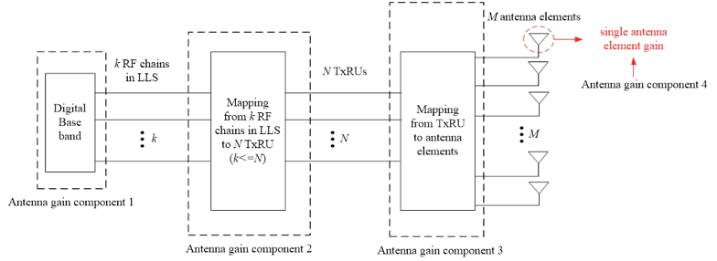

Table A. antenna gain components for TDL option 1

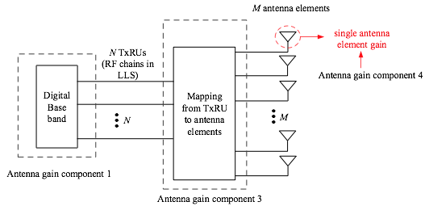

Table B. antenna gain components for TDL option 2 and CDL

Agreements:

* Latency requirements assumed in VoIP evaluation for TDD and FDD are reported by companies

Agreements:

* For link level simulations in FR2, only PUCCH format 1 and format 3 are considered for baseline performance evaluation.
* For link level simulations in FR2, only PUCCH duration of 14 OFDM symbols is considered for baseline performance evaluation.
* For link level simulations in FR2, consider 4 DMRS symbol for PUCCH Format 3.
* Consider only one panel at the UE in link budget in FR2.
* For link budget calculation in FR2, downlink transmit power is scaled by the occupied bandwidth. The following downlink transmit power vs occupied bandwidth values are considered as baseline for the calculations:
  + 40 dBm for 100 MHz Urban scenario,
  + 23 dBm for 100 MHz Indoor scenario.
* For link budget calculation in FR2, an uplink transmit power of 23dBm is considered for baseline performance evaluations. Other values can be reported by companies.
* Confirm the target throughput values of the REL-17 SID for the suburban scenario:
  + DL: 1 Mbps, UL: 50 kbps
* Study performance of PUSCH in FR2 only for DFT-s-OFDM.
* For link level simulations, only 1% BLER should be considered for baseline performance evaluation of PDDCH in FR2.
* For link level simulations in FR2, only PUSCH repetition type A is considered for baseline performance evaluation.
  + Note: companies are not precluded to report results for repetition type B.
* Suburban scenario is deprioritized for NR coverage enhancement SI.
* Baseline performance evaluation of msg1 transmission is studied for 1% missed detection probability in FR2.
* Only 1% BLER target should be considered for baseline performance evaluation of PUCCH in FR2, regardless of whether UCI includes CSI feedback or not.
* Simulation assumptions for SLS in FR2 are up to companies’ reports, i.e., no more clarification is needed, as per agreement during RAN1#101-e.

# Annex 3 – Agreements at post-email discussion of RAN1#102e

**Agreement:**

* Antenna array gain at a UE for FR1 and FR2 is clarified as follows:
  + The meaning of *k, N* and *M:*
    - $k$ is the number of Tx/Rx chains, e.g., number of SRS/CSI-RS ports to be simulated in LLS.
    - $M$ is the number of antenna elements used both for transmission and reception, i.e., $\frac{M}{2}$ xpol antenna elements.
    - A formal definition of *N* is not necessary for UE antenna array gain modeling.
  + The values for *k* and the relationship between *k* and *M* are clarified as follows:
    - For FR1, *k* = *M* is assumed for the simulations, and
      * $k=1$ for Tx (optional *k* = 2)
      * $k∈\{2,4\}$ for Rx
    - For FR2, there are two possibilities for simulations:
      * $k∈\{1,2\}$; for Tx and $k=2$ for Rx; or
      * $k=M$.
  + Antenna array gain in transmission/reception to input in link budget template is given by
    - $Antenna Element Gain+10*\log_{10}\left(\frac{M}{k}\right)-Δ3$, where
      * $Δ3(≥0 \left[dB\right])$ is a correction factor to account for various non-idealities impacting the actual antenna array gain, if any
        + For FR1, $Δ3=0$.
        + For FR2, 3 is channel procedure/dependent, and reported by companies.
* The values for antenna element gain:
  + 0 dBi for FR1
  + 5 dBi for FR2

**Agreement:**

* The working assumption for FR2 is updated as follows:
  + UE receive antenna gain ~~corresponds to row~~ is given by row No.(11) + row No. (11bis) - $Δ3$
* UE transmit antenna gain is given by row No. (4) + row No. (5) - $Δ3$

**Agreement**

* The agreement on the definition of MIL for downlink is updated by adding Rx loss as follows:
  + Total transmit power – Receiver sensitivity – Rx loss + gNB antenna gain (component 2 + 3 + 4) + UE antenna gain, where
    - Rx loss corresponds to row No. (12)
* MPL = MIL – (25a/b) Shadow fading margin + (26) BS selection/macro-diversity gain – (27) Penetration margin + (28) Other gains ~~[– (12) Cable, connector, combiner, body losses (Rx side) ]~~
* It is confirmed that H-ARQ gain is included in sensitivity
  + H-ARQ gain should be included in LLS. In this case, “(21a/b) H-ARQ gain” is set to zero
  + If not, “(21a/b) H-ARQ gain” can be used for companies report
* Note: as per the former agreement, the values for rows (25a/b) (26) (27) (28) and (12) are left to companies’ report, which includes the values for IMT-2020 self evaluation and/or using 0 dB
* Note: (12) Cable, connector, combiner, body losses (Rx side) is not included in MCL, but included in MIL and MPL
* The definition of MCL, MIL and MPL for TDL Option 2 & CDL is the same as that for TDL option 1
* Note: The agreements on MIL, MCL and MPL definition is used to show which components of link budget template are included / not included. The sophistication of MIL, MCL and MPL formula will be discussed under [102-e-Post-NR-CovEnh-02] email discussion by using draft link budget template prepared by the FL.
* ~~Note: Companies are encouraged to further check the values for (12) Rx losses proposed by a company, in addition to the values used for IMT-2020 self-evaluation~~
  + ~~feeder loss at gNB (1dB for 700MHz, 0dB for 4GHz with AAS)~~
  + ~~0dB for the loss at UE~~

**proposal 1:**

* Agree the following link budget template

|  |
| --- |
| **Transmitter** |
| (1) Number of transmit antenna elements. |
| (2) Number of [~~(~~transmit TxRUs~~) or (modelled transmit chains)~~]Note: this row is void (left empty) for uplink |
| (2a) Number of transmit chains modelled in LLS |
| (3) Total transmit power (dBm) Note: total transmit power for system bandwidth |
| (3a) System bandwidth for downlink, or occupied bandwidth for uplink (Hz) |
| (3b) Power Spectrum Density = (3) - 10 log( (3a) / 1000000 ) (dBm/MHz)  Note: For FR1 downlink, (3b) should satisfy the following:   For 4GHz frequency, 24 and 33  For 2.6 GHz frequency, 33  For 700MH and 2GHz frequency, 36 Note: For FR2 downlink, the following should be satisfied:  40 dBm for 100 MHz Urban scenario,  23 dBm for 100 MHz Indoor scenario. Note: no PSD constraint for uplink |
| (3c) Bandwidth used for the evaluated channel (Hz) Note: (3c) is identical to the number of PRBs assigned to the channel evaluated.  For uplink, (3a) = (3c) |
| (3bis) Total transmit power for occupied bandwidth = (3b) + 10 log ( (3c) / 1000000 ) (dBm) |
| (4) Total antenna gain at antenna gain component 3 & antenna gain component 4 of transmitter = (4a) – (4b) (dB) |
| (4a) Antenna gain at antenna gain component 3 & antenna gain component 4 of transmitter  = (4c) + 10 log ( (1) / (2) ) (dB) for downlink, and  = (4c) + 10 log ( (1) / (2a) ) (dB) for uplink |
| (4b) Antenna gain correction factor at antenna gain component 3 & antenna gain component 4 of transmitter (dB) |
| (4c) Gain of antenna element (dBi) |
| (5) Total antenna gain at antenna gain component 2 of transmitter = (5a) - (5b) (dB) Note: zero for uplink |
| (5a) Antenna gain at antenna gain component 2 of transmitter = 10 log( (2)/(2a)) (dB) Note: zero for uplink |
| (5b) Antenna gain correction factor at antenna gain component 2 of transmitter (dB) Note: zero for uplink |
| (8) Cable, connector, combiner, body losses, etc. (enumerate sources) (dB) (feeder loss must be included for and only for downlink) |
| (9) EIRP = (3bis) + (4) + (5) – (8) dBm |
| **Receiver** |
| (10) Number of receive antenna elements |
| (10a) Number of [ ~~(~~receive TxRUs~~) or (modelled receive chains)~~] Note: this row is void (empty) for downlink |
| (10b) Number of receive chains modelled in LLS |
| (11) Total antenna gain at antenna gain component 3 & antenna gain component 4 of receiver = (11a) - (11b) (dB) |
| (11a) Antenna gain at antenna gain component 3 & antenna gain component 4 of receiver   = (11c) + 10 log ( (10)/(10a) ) (dB) for uplink  = (11c) + 10 log ( (10)/(10b) ) (dB) for downlink |
| (11b) Antenna gain correction factor at antenna gain component 3 & antenna gain component 4 of receiver (dB) |
| (11c) Gain of antenna element (dBi) |
| (11bis) Total antenna gain at antenna gain component 2 of receiver = (11bis-a) - (11bis-b) (dB) Note: zero for downlink |
| (11bis-a) Antenna gain at antenna gain component 2 of receiver = 10 log( (10a)/(10b)) (dB) Note: zero for downlink |
| (11bis-b) Antenna gain correction factor at antenna gain component 2 of receiver (dB) Note: zero for downlink |
| (12) Cable, connector, combiner, body losses, etc. (enumerate sources) (dB) (feeder loss must be included for and only for uplink) |
| (13) Receiver noise figure (dB) |
| (14) Thermal noise density (dBm/Hz) |
| (15) Receiver interference density (dBm/Hz) |
| (16) Total noise plus interference density = 10 log (10^(( (13) + (14))/10) + 10^((15)/10)) (dBm/Hz) |
| (18) Effective noise power = (16) + 10 log ((3c)) (dBm) |
| (19) Required SNR (dB) |
| (20) Receiver implementation margin (dB) |
| (21) H-ARQ gain (dB) Note: Only applicable if HARQ is not considered in LLS |
| (22) Receiver sensitivity = (18) + (19) + (20) – (21) (dBm) |
| (22bis) MCL = (3bis) – (22) + (5) + (11bis) (dB) |
| (23) Hardware link budget, a.k.a. MIL = (9) + (11) + (11bis) − (12) − (22) (dB) Note: MIL can also be derived by (22bis) + (4) – (8) + (11) − (12) |
| **Calculation of available pathloss** |
| (25) Shadow fading margin (function of the cell area reliability and lognormal shadow fading std deviation) (dB) |
| (26) BS selection/macro-diversity gain (dB) |
| (27) Penetration margin (dB) |
| (28) Other gains (dB) (if any please specify) |
| (29) Available path loss = (23) – (25) + (26) – (27) + (28) (dB) |
| **Range/coverage efficiency calculation** |
| (30) Maximum range (based on (29) and according to the system configuration section of the link budget) (m) |

**proposal 2:**

* The values for following parameters are provided together with the link budget template
  + The details how to provide the values (i.e. by introducing rows in the same/different tab, by different excel file, by different tabs, etc. ) is up to rapporteur and feature leads.

|  |
| --- |
| Scenarios |
| Carrier frequency (GHz) |
| BS antenna heights (m) |
| UT antenna heights (m) |
| Cell area reliability (%) |
| Lognormal shadow fading std deviation (dB) |
| Pathloss model (select from LoS or NLoS) |
| UE speed (km/h) |
| Channel for evaluation |
| UL-DL configuration for TDD |
| Subcarrier Spacing |
| Channel model for link level simulation |
| Frequency hopping |
| Number of PRBs, TBS and MCS |
| BWP size |
| DMRS configuration |
| Waveform |
| Repetition |
| HARQ configuration |
| Latency requirements for voice |
| PUCCH format type |
| Tx Diversity |
| Target error rate (BLER, miss detection, false alarm, etc.) |
| PRACH format |
| Number of SSB |
| Correlation for TxRU at BS |
| Description on how the value in antenna gain correction factor in (4b) is derived |
| Description on how the value in antenna gain correction factor in (5b) is derived |
| Description on how the value in antenna gain correction factor in (11b) is derived |
| Description on how the value in antenna gain correction factor in (11bis-b) is derived |
| Description on how the value in (8) is derived |
| Description on how the value in (12) is derived |
| Other parameters |

**proposal 3:**

* ~~For (13) Receiver noise figure, the following values are adopted~~
  + ~~For FR1: 7dB for UE and 5dB for BS~~
  + ~~For FR2: 10dB for UE and 7dB for BS~~
* For ~~other~~ parameters/values with FFS, square bracket or no agreement, interested companies are encouraged to continue their assessment aiming at the final resolution at RAN1#103-e.
  + Detailed information can be find in the attached excel spreadsheet, i.e. link-budget-template-v013
  + Note: link-budget-template-v013 is found from the following link:  
    https://www.3gpp.org/ftp/tsg_ran/WG1_RL1/TSGR1_102-e/Inbox/drafts/8.8.1.1/post_meeting/102-e-Post-NR-CovEnh-02/1-link_budget_template/fine_tuning/link-budget-template-v013.xlsx