**3GPP TSG RAN WG1 Meeting #102-e                     R1-20xxxxx**

**e-Meeting,** **August 17th – 28th, 2020**

**Agenda Item: 7.2.2.2.3**

**Source: Moderator (Huawei)**

**Title: Feature lead summary#1 on 102-e-NR-unlic-NRU-HARQ-02**

**Document for: Discussion and Decision**

# Introduction

This document will be used to collect views on the two proposals for corrections submitted at RAN1#102e on issue D1 for multi-PUSCH scheduling maintenance [1], and to continue discussing out-of-order PDSCH-to-HARQ cases with enhanced type2 codebook and type3 codebook (issues C3, C4).

[102-e-NR-unlic-NRU-HARQ-02] TPs for the following from R1-2006983 until 8/19; if necessary, endorse associated TPs by 8/25 – David (Huawei)

* Correction on multi-PUSCH scheduling (issue D1): correct ambiguity on TDRA table for DCI format 0_1 when multiple PUSCH scheduling is configured to the UE. Correction to include pusch-TimeDomainAllocationListForMultiPUSCH-r16 in TS38.214 Table 6.1.2.1.1-1A, and potentially also a TP for 38.212 clause 7.3.1.1.2.
* Discussion on out-of-order PDSCH-to-HARQ issues (C3, C4): in case of HARQ-ACK information retransmission and in case of scheduling with NNK1, aim to at least clarify which cases (C3, C4-case1 and C4-case2) are OOO and which cases are not OOO. Cases may be redefined during the discussion. It is TBD whether any correction would be needed after that clarification

Comments on the two issues will be collected in sections 2 and 3, respectively. D1 is to be discussed with priority since it has been identified as an essential correction, while this is still TBD for C3 and C4.

# Issue D1

A FL proposal is provided in the table below, as a merged solution between the proposals in [2] and [3]. Companies are invited to provide their comments using the table below.

|  |  |
| --- | --- |
| **Company** | **Summary of proposals and comments** |
| Vivo  [2] | Proposal for 38.214 Table 6.1.2.1.1-1A assumes that TDRA tables for multi-PUSCH scheduling and PUSCH repetition Type B are not configured for a same serving cell at the same time.  **Table 6.1.2.1.1-1A: Applicable PUSCH time domain resource allocation for DCI format 0_1 in UE specific search space scrambled with C-RNTI, MCS-C-RNTI, CS-RNTI or SP-CSI-RNTI**   |  |  |  |  |  | | --- | --- | --- | --- | --- | | ***pusch-ConfigCommon* includes *pusch-TimeDomainAllocationList*** | ***pusch-Config* includes *pusch-TimeDomainAllocationList*** | ***pusch-Config* includes *pusch-TimeDomainAllocationList* *-ForDCIformat0_1*** | ***pusch-Config* includes *pusch-TimeDomainAllocationListForMultiPUSCH-r16*** | **PUSCH time domain resource allocation to apply** | | No | No | No | No | Default A | | Yes | No | No | No | *pusch-TimeDomainAllocationList* provided in *pusch-ConfigCommon* | | No/Yes | Yes | No | No | *pusch-TimeDomainAllocationList* provided in *pusch-Config* | | No/Yes | No/Yes | Yes | No | *pusch-TimeDomainAllocationList-ForDCIformat0_1* provided in *pusch-Config* | | No/Yes | No/Yes | No | Yes | *pusch-TimeDomainAllocationListForMultiPUSCH-r16* provided in *pusch-Config* | |
| Sharp  [3] | Proposal TP1 for 38.214 Table 6.1.2.1.1-1A also assumes that *TimeDomainAllocationList -ForDCIformat0_1* and *pusch-TimeDomainAllocationListForMultiPUSCH-r16* cannot be configured simultaneously. Additionally, corrections are proposed for TP2 for 38.212 clause 7.3.1.1.2**.**  **Text proposal#1 for TS 38.214**  **Table 6.1.2.1.1-1A: Applicable PUSCH time domain resource allocation for DCI format 0_1 in UE specific search space scrambled with C-RNTI, MCS-C-RNTI, CS-RNTI or SP-CSI-RNTI**   |  |  |  |  | | --- | --- | --- | --- | | ***pusch-ConfigCommon* includes *pusch-TimeDomainAllocationList*** | ***pusch-Config* includes *pusch-TimeDomainAllocationList*** | ***pusch-Config* includes *pusch-TimeDomainAllocationList* *-ForDCIformat0_1* or *pusch-TimeDomainAllocationListForMultiPUSCH-r16*** | **PUSCH time domain resource allocation to apply** | | No | No | No | Default A | | Yes | No | No | *pusch-TimeDomainAllocationList* provided in *pusch-ConfigCommon* | | No/Yes | Yes | No | *pusch-TimeDomainAllocationList* provided in *pusch-Config* | | No/Yes | No/Yes | Yes | *pusch-TimeDomainAllocationList-ForDCIformat0_1* **or *pusch-TimeDomainAllocationListForMultiPUSCH-r16***provided in *pusch-Config* |   **Text proposal#2 for TS 38.212** 7.3.1.1.2 Format 0_1 -------- Unchanged contents are omitted  - Time domain resource assignment – 0, 1, 2, 3, 4, 5, or 6 bits  - If the higher layer parameter neither of *PUSCH-TimeDomainResourceAllocationList-ForDCIformat0_1* nor *pusch-TimeDomainAllocationListForMultiPUSCH-r16* is configured and if the higher layer parameter *pusch-TimeDomainAllocationList* is configured, 0, 1, 2, 3, or 4 bits as defined in Clause 6.1.2.1 of [6, TS38.214]. The bitwidth for this field is determined as bits, where *I* is the number of entries in the higher layer parameter *pusch-TimeDomainAllocationList*;  - If the higher layer parameter either of *PUSCH-TimeDomainResourceAllocationList-ForDCIformat0_1* or *pusch-TimeDomainAllocationListForMultiPUSCH-r16* is configured, 0, 1, 2, 3, 4, 5 or 6 bits as defined in Clause 6.1.2.1 of [6, TS38.214]. The bitwidth for this field is determined as bits, where *I* is the number of entries in the higher layer parameter *PUSCH-TimeDomainResourceAllocationList-ForDCIformat0_1* or *pusch-TimeDomainAllocationListForMultiPUSCH-r16*;  - otherwise the bitwidth for this field is determined as $\left\lceil \log_{2}{(I)}\right\rceil$ bits, where *I* is the number of entries in the default table*.*  -------- Unchanged contents are omitted  --------- end of text proposal |
| FL proposal | The changes proposed to Table 6.1.2.1.1-1A in the two proposals above are equivalent. The format proposed in [2] seems closer to the current format of the table, where a different column is used for each RRC parameter. So we could start from the proposal for Table 6.1.2.1.1-1A in [2]. Revisions to the TDRA field description of DCI format 0_1 also seems needed, as proposed in [3]. Some editorial work on the proposal may be needed. The following is therefore proposed for discussion:  **TS 38.214**  **Table 6.1.2.1.1-1A: Applicable PUSCH time domain resource allocation for DCI format 0_1 in UE specific search space scrambled with C-RNTI, MCS-C-RNTI, CS-RNTI or SP-CSI-RNTI**   |  |  |  |  |  | | --- | --- | --- | --- | --- | | ***pusch-ConfigCommon* includes *pusch-TimeDomainAllocationList*** | ***pusch-Config* includes *pusch-TimeDomainAllocationList*** | ***pusch-Config* includes *pusch-TimeDomainAllocationList* *-ForDCIformat0_1*** | ***pusch-Config* includes *pusch-TimeDomainAllocationListForMultiPUSCH-r16*** | **PUSCH time domain resource allocation to apply** | | No | No | No | No | Default A | | Yes | No | No | No | *pusch-TimeDomainAllocationList* provided in *pusch-ConfigCommon* | | No/Yes | Yes | No | No | *pusch-TimeDomainAllocationList* provided in *pusch-Config* | | No/Yes | No/Yes | Yes | No | *pusch-TimeDomainAllocationList-ForDCIformat0_1* provided in *pusch-Config* | | No/Yes | No/Yes | No | Yes | *pusch-TimeDomainAllocationListForMultiPUSCH-r16* provided in *pusch-Config* |   **TS 38.212** 7.3.1.1.2 Format 0_1 -------- Unchanged contents are omitted  - Time domain resource assignment – 0, 1, 2, 3, 4, 5, or 6 bits  - If the higher layer parameter *PUSCH-TimeDomainResourceAllocationList-ForDCIformat0_1* is not configured and if the higher layer parameter *pusch-TimeDomainAllocationListForMultiPUSCH-r16* is not configuredand if the higher layer parameter *pusch-TimeDomainAllocationList* is configured, 0, 1, 2, 3, or 4 bits as defined in Clause 6.1.2.1 of [6, TS38.214]. The bitwidth for this field is determined as bits, where *I* is the number of entries in the higher layer parameter *pusch-TimeDomainAllocationList*;  - If the higher layer parameter *PUSCH-TimeDomainResourceAllocationList-ForDCIformat0_1* is configured or if the higher layer parameter *pusch-TimeDomainAllocationListForMultiPUSCH-r16 is configured*, 0, 1, 2, 3, 4, 5 or 6 bits as defined in Clause 6.1.2.1 of [6, TS38.214]. The bitwidth for this field is determined as bits, where *I* is the number of entries in the higher layer parameter *PUSCH-TimeDomainResourceAllocationList-ForDCIformat0_1* or *pusch-TimeDomainAllocationListForMultiPUSCH-r16*;  - otherwise the bitwidth for this field is determined as $\left\lceil \log_{2}{(I)}\right\rceil$ bits, where *I* is the number of entries in the default table*.*  -------- Unchanged contents are omitted  --------- end of text proposal |
|  |  |

# Issues C3 and C4

|  |  |
| --- | --- |
| C3 | Out-of-Order issue for NNK1 involving DL SPS |
| C4 | Out-of-Order issue with HARQ-ACK retransmission |

The following examples have been discussed for issues C3 and C4 in order to improve the understanding on out of order issue for PDSCH-to-HARQ-ACK (simply referred to as OOO in the following).

**C3-case1**: example from R1-2004445 (with NNK1, missed DCI and DL SPS).

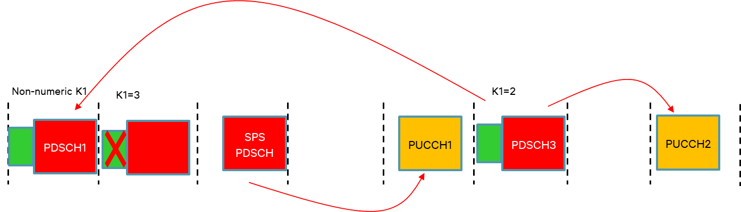

**C3-case2**: example in Fig 1 in R1-2005907 (with NNK1, DL SPS but without a missed DCI).



**C4-case1**: example in Fig 2 in R1-2005811 (HARQ-ACK retransmission using enhanced type-2 codebook due to a missed PUCCH, no DL SPS) where PUCCH3 includes re-transmission for both groups (and the same example where PUCCH3 carries a type-3 codebook instead of enhanced type-2 codebook).

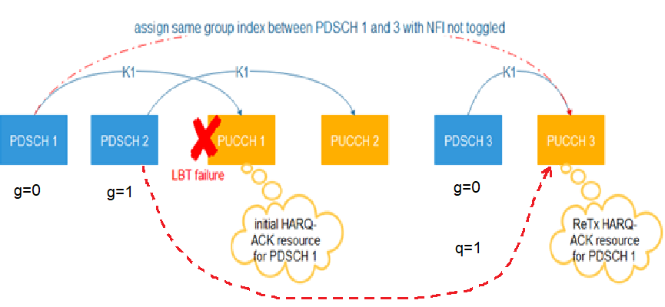

**C4-case2**: example in Fig 2 in R1-2005811 (HARQ-ACK retransmission using enhanced type-2 codebook due to a missed PUCCH, no DL SPS) where only the missed group is re-transmitted.

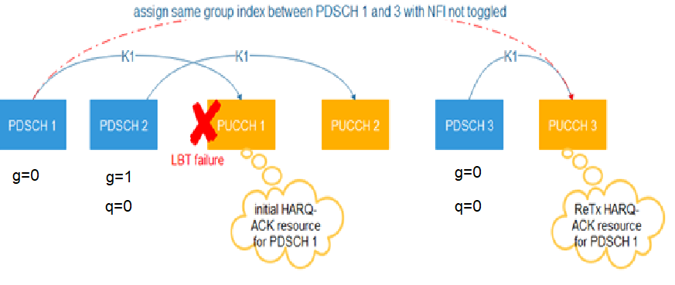

Views in the preparation phase of RAN1#102e are summarized below:

* Companies who agree that C3-case1 and C3-case2 are OOO: Qualcomm, Huawei, Sharp, Ericsson, LG
* Companies who disagree with the statement: Nokia (if C4-case2 is not also OOO)
* Companies who agree that C4-case1 and C4-case2 are not OOO: Qualcomm, Huawei, Sharp, Ericsson, LG
* Companies who disagree with the statement for C4-case1: none
* Companies who disagree with the statement for C4-case2: Nokia

We might add other examples for completeness, in particular examples involving NNK1 but no DL SPS.

**C4-case3**: example where a PDSCH scheduled with a NNK1 value is not assigned a PUCCH by the next DCI, which only schedules another PDSCH group without requesting feedback for both groups (with NNK1, enhanced Type-2 codebook, no DL SPS, no missed DCI, no missed PUCCH).

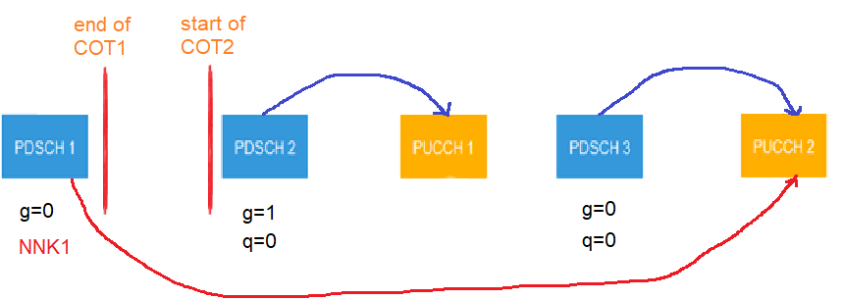

Should C4-case3 be considered OOO or not OOO by the UE?

**Companies are invited to provide their comments on the cases above by adding rows to the table below.**

|  |  |
| --- | --- |
| **Company** | **Summary of proposals and comments during the preparation phase** |
| Huawei (R1-2005811) | Observation 1: Issue C3 is an out of order issue for PDSCH-to-HARQ-ACK, which should follow rules defined for OOO in TS38.214 section 5.1.  Proposal 1: No correction is needed for issue C3. |
| Intel (R1-2005845) | Proposal 2:  - If there is a previous PDSCH for which HARQ-ACK transmission timing is not determined until UE receives a SPS PDSCH, UE expects the HARQ-ACK timing for the previous PDSCH is no latter than the PUCCH configured for the HARQ-ACK transmission of the SPS PDSCH.  - No TP is needed |
| Nokia (R1-2005907) | Proposal-1: If RAN1 cannot find a consensus that PDSCH received with NN-K1 value does not violate the OOO HARQ clause in TS38.214, consider introducing a behavior where if UE has at least one PDSCH with inapplicable K1 value in the buffer and receives DL SPS PDSCH, then UE reports HARQ-ACK for the DL SPS only according to the applicable value of the second DCI. |
| Ericsson (R1-2005916) | Our understanding of the rel-15 behaviour is that the UE is not expected to send out of order HARQ. If the UE misses PDCCH for PDSCH2, the UE is not expected to include the feedback in PUCCH2 when there is another PDSCH (SPS PDSCH) that points to an earlier PUCCH (PUCCH1). Hence, the error should not propagate to the second PUCCH.  In fact, if the missed PDCCH indicated a PUCCH that is earlier in time than PUCCH 1, the proposed solution will yield to erroneous codebook in PUCCH1. In our view, there is no need to do any changes to the specification to cover those cases.  Proposal 1: No specification changes are needed to handle C3 issue |
| Huawei  (R1-2005811) | Proposal 2 (R1-2005811): HARQ-ACK retransmission should not be considered as OOO.  **TP#1 for TS 38.214 Clause 5.1**  ==================== Unchanged part omitted ====================  A UE shall upon detection of a PDCCH with a configured DCI format 1_0, 1_1 or 1_2 decode the corresponding PDSCHs as indicated by that DCI. For any HARQ process ID(s) in a given scheduled cell, the UE is not expected to receive a PDSCH that overlaps in time with another PDSCH. The UE is not expected to receive another PDSCH for a given HARQ process until after the end of the expected transmission of HARQ-ACK for that HARQ process, where the timing is given by Clause 9.2.3 of [6]. In a given scheduled cell, the UE is not expected to receive a first PDSCH and a second PDSCH, starting later than the first PDSCH, with its corresponding HARQ-ACK initially assigned to be transmitted on a resource ending before the start of a different resource for the HARQ-ACK initially assigned to be transmitted for the first PDSCH, where the two resources are in different slots for the associated HARQ-ACK transmissions, each slot is composed of symbols [4] or a number of symbols indicated by *subslotLength-ForPUCCH* if provided, and the HARQ-ACK for the two PDSCHs are associated with the HARQ-ACK codebook of the same priority. In a given scheduled cell, the UE is not expected to receive a first PDSCH, and a second PDSCH, starting later than the first PDSCH, with its corresponding HARQ-ACK initially assigned to be transmitted on a resource ending before the start of a different resource for the HARQ-ACK initially assigned to be transmitted for the first PDSCH if the HARQ-ACK for the two PDSCHs are associated with HARQ-ACK codebooks of different priorities. For any two HARQ process IDs in a given scheduled cell, if the UE is scheduled to start receiving a first PDSCH starting in symbol *j* by a PDCCH ending in symbol *i*, the UE is not expected to be scheduled to receive a PDSCH starting earlier than the end of the first PDSCH with a PDCCH that ends later than symbol *i*. In a given scheduled cell, for any PDSCH corresponding to SI-RNTI, the UE is not expected to decode a re-transmission of an earlier PDSCH with a starting symbol less than *N* symbols after the last symbol of that PDSCH, where the value of *N* depends on the PDSCH subcarrier spacing configuration *μ,* with *N*=13 for *μ*=0, *N*=13 for *μ*=1, *N*=20 for *μ*=2, and *N*=24 for *μ*=3.  ================== Unchanged part omitted ==================== |
| Nokia | Dear David, All    thanks for the summary     * C3 there seems to be no consensus to discuss a correction or clarification on the UE behaviour for this issue, but it may be good to conclude that the case discussed (example with missed DCI from R1-2004445, and example in Fig 1 in R1-2005907 with DL SPS but without a missed DCI) is indeed an OOO issue.     Karol:  Would be good to conclude. But I have read that companies have different opinion. Some saying that UE  will drop HARQ-ACK for DL SPS and that would be it.  At least last meeting QC had different opinion and was talking about dropping both PUCCH that are involved.   * C4 a large majority of companies consider that there is no ambiguity in the specifications, but it may be good to conclude (as in C3) that the case discussed (example in Fig 2 in R1-2005811) is NOT an OOO issue.   Karol: We know Huawei opinion here 😉. But do companies agree with  this opinion?    PUCCH 1 did not happen, so what I see is    PUSCH 1 is received before PUSCH 2  PUSCH 2 HARQ is transmitted before PUSCH 1 HARQ-ACK    Moreover, this re-tx situation is no different to NN-K1 for which NN-K1 is stored in buffer until second DCI scheduling PUCCH gives  K1 to the PDSCH.    So I think it would be good to come up with conclusion on both C3 and C4 cases. |
| Qualcomm | Regarding issues C3 and C4, it is not clear to me why they are proposed for Email discussions. From the summary, it looks like majority of companies think that there is no need for discussions. From Qualcomm side, we brought up issue C3 in the previous meeting. Based on the discussions, it seemed to us that a good number of companies think the error case does not need especial handling (e.g. gNB can avoid using NNK1 when there is upcoming SPS, etc.). Hence, it may not be the best use of time to discuss the same topic again. |
| Huawei | Dear Mostafa, Karol,  I am not really proposing to have an email discussion on C3 and C4. Nokia asked for a conclusion so I thought it might be possible to reach a conclusion on C3 in the preparation phase. If a conclusion on C4 is discussed then I think a conclusion on C3 should also be targeted. The conclusion should only be about whether or not these examples as OOO cases.  I understand that there are differences in opinions on the UE behaviour, but isn't the common understanding that C3 is an OOO case? If so can we simply reach that conclusion and stop there?  C4 should actually be rather straightforward because considering it as an OOO case would imply that the enhanced HARQ codebook cannot be used for its intended purpose. Karol may see this as a Huawei view but I think it should really be the common understanding, since the HARQ re-transmission was designed to cope with such example as in Fig 2 of 5811 where a PUCCH cannot be transmitted due to LBT. Karol, do you think this should be considered as an OOO case?  So I would like to check once again if the following two statements below are the common understanding. Please respond especially if this is not your understanding.  C3 The example from R1-2004445 (with NNK1, missed DCI and DL SPS), and the example in Fig 1 in R1-2005907 (with NNK1, DL SPS but without a missed DCI) are out of order issues for PDSCH-to-HARQ-ACK.  C4 The example in Fig 2 in R1-2005811 (HARQ-ACK retransmission due to a missed PUCCH, no DL SPS) is not an out of order issue for PDSCH-to-HARQ-ACK.  Best regards,  David |
| Sharp | Dear David and all,    Thank you for the discussions.    We agree with the majority view that issue C3 is an OOO issue. Regarding issue C4, our view is that scheduling flexibility of HARQ-ACK retransmission should not be limited by current OOO rules.  To be specific, the figure on HARQ-ACK retransmission is reused here. Firstly, we believe such scheduling (HARQ-ACK for PDSCH2 is transmitted before HARQ-ACK for PDSCH1) is needed for flexible HARQ-ACK retransmission. Otherwise, following the current OOO rule, HARQ-ACK retransmission for PDSCH1 can only happen before PUCCH2. Therefore, recognizing this scheduling as OOO is a problem. One solution is to modify the current OOO rule, which is the intention of HW's TP to our understanding. |
| Huawei | Thanks to Huifa for the feedback on issue C4. To keep the discussion in one thread, I have copied below again the two statements on C3 and C4 to see if this is the common understanding (note that I have slightly rephrased the statement for C4 compared to my previous email, based on Huifa’s feedback).    C3 The example from R1-2004445 (with NNK1, missed DCI and DL SPS), and the example in Fig 1 in R1-2005907 (with NNK1, DL SPS but without a missed DCI) are out of order issues for PDSCH-to-HARQ-ACK.  C4 The example in Fig 2 in R1-2005811 (HARQ-ACK retransmission due to a missed PUCCH, no DL SPS) should not be considered as an out of order issue for PDSCH-to-HARQ-ACK. |
| Ericsson | Hi all,    Thank you for the discussion. I would like to understand the difference between the figure below from HW’s contribution    And another example where PUCCH3 is triggered by one shot feedback. In both cases there is a retransmission of feedback for PDSCH1, and that feedback is in some sense out of order because PDSCH 2 feedback was requested earlier. What will happen in case of one shot feedback ? and how is that different from the example above ?    would requesting the feedback for all the HARQ processes resolve the OOO issue ? I mean lets say that the gNB requested in PUCCH 3 the feedback for both groups (regardless if PUCCH 2 was correctly received), will that solve the issue ?    I tend to agree with David, if we tag feedback retransmission cases as OOO, the usage of enhanced dynamic codebook is quite limited. In principle, the assigned timing for the PDSCH 1 and PDSCH2 are not OOO, and  requesting the feedback again is a new feature that maybe should not full directly under the OOO conditions. It would be good to understand what is the main issue from UE perspective that make the UE unable to handle the feedback re-transmission properly in the example above.    BR  Reem |
| Huawei | Hi Reem,    From my perspective the exact same question applies in case PUCCH3 carries a Type-3 codebook including a re-transmission of HARQ-ACK information for PDSCH1 (and PDSCH2), and I also think that this should not count as an out-of-order case.    Best regards,  David |
| Nokia | Hi Reem, David,    thanks for technical discussion.      for TYPE-3, since HARQ-ACK is transmitted for all PDSCH at the same time,  then OOO should not happen.    *OOO HARQ: In a given scheduled cell, the UE is not expected to receive a first PDSCH and a second PDSCH, starting later than the first PDSCH, with its corresponding HARQ-ACK assigned to be transmitted on a resource ending before the start of a different resource for the HARQ-ACK assigned to be transmitted for the first PDSCH…*      Or, it depends how do you interpret  “HARQ-ACK assigned to be transmitted”. In case of TYPE-3 CB, you re-assign HARQ-ACK to be transmitted to all PDSCH. So should this be OK?      Also in David’s picture it is not clear what are the  PDSCH’s groups.  I think OOO definition currently does not differentiate between PDSCH groups, however. So better to trigger feedback always for all groups should comply?      In case of NN-K1,  HARQ-ACK is not assigned until second DCI is received. Which was my understanding in previous meeting.      Cheers,  -Karol |
| Huawei | Hi Karol,    I agree that different interpretations are possible based on the current specifications, but probably the most reasonable interpretation is that an OOO condition should never be declared because of a HARQ-ACK information retransmission, because this would happen in almost all cases of a HARQ-ACK information retransmission.    Maybe it is so obvious that everyone knows that already. That's why I was trying to see if we can have that sort of common understanding captured in a conclusion at least for clarity. We could, of course, also decide to provide a clarification in that sense in the specifications and it may be fairly easy to come up with a sentence clarifying this, or stop here and hope that nobody else will have another interpretation.    The difference with NNK1 is that the gNB has more control on handling the case of NNK1 to avoid artificially creating an OOO condition, although it may result in a scheduling restriction or restrict the choice of PDSCH group assignment.    Best regards,  David |
| LG | Dear David, Karol, Reem, and all,    Thank you for this technical and intensive discussion on the OOO issue.  In principle, I agree and share the same view with David that: Case 1) the retransmission of HARQ-ACK should not be considered as the OOO, and Case 2) the OOO created by combination of NNK1 and SPS could be avoided by gNB.    On the above Case 1, the wording in current spec “HARQ-ACK assigned to be transmitted” could be commonly understood among the group as “HARQ-ACK **initially** assigned to be transmitted”, and consequently the OOO wouldn’t happen.  And on the above Case 2, as an example to avoid such OOO situation, the gNB could select a numerical K1 (rather than NNK1) pointing to the same slot with SPS PUCCH transmission or a slot in between SPS PDSCH slot and SPS PUCCH slot.  I think such handling would probably make sense since anyhow, gNB would make COT (by LBT) to transmit SPS PDSCH in deterministic timing, and then the gNB could indicate K1 so that the corresponding slot is to be within the COT.    BR,  Sukchel |
| Qualcomm | Dear David, all,    Thank you for the discussions. I think there is no disagreement that C3 is OoO and should be avoided by gNB scheduling. Otherwise, this is an error case and UE behavior is not defined. It is not correct to say that UE drops A/N for SPS PDSCH and the next PUCCH (PUCCH 2 in the example) is just fine. It is simply undefined UE behavior.    For C4, there are two cases:   * Case 1: One-shot feedback, or enhanced type 2 but feedback for both groups is requested (In David’s example, PUCCH 3 has feedback for both groups) * Case 2: Enhanced type 2 as in David’s example.     I agree with Karol that Case 1 is not OOO, since feedback for both PDSCHs are requested gain, and Case 2 depends on how we interpret the sentence. I also agree with David that the design of eType2 implicitly assumed that such examples should be allowed if UE supports eType2.    Hence, we are fine with this common understanding that Case 1 and Case 2 for C4 are not OOO but C3 is indeed OOO.    Best Regards,  Mostafa |
| Nokia | Dear David, Mostafa, Sukchel, Reem, All      Sukchel: And on the above Case 2, as an example to avoid such OOO situation, the gNB could select a numerical K1 (rather than NNK1) pointing to the same slot with SPS PUCCH transmission or a slot in between SPS PDSCH slot and SPS PUCCH slot.    Karol:  gNB uses NN-K1 not from its own will, but because of insufficient processing time at the end of DL portion of COT.      Mostafa: Thank you for the discussions. I think there is no disagreement that C3 is OoO and should be avoided by gNB scheduling    Karol: So you say gNB should drop COT (by not scheduling NN-K1 PDSCH) if DL SPS HARQ-ACK happens to be occurring at wrong place.      So I do not think it is right that we are willing to  bend wording for C4, but not for C3.  NN-K1 was also designed such that  HARQ-ACK  value is not assigned until second DCI, and second DCI is similar to scheduling re-tx. Physically there is no difference to C4 Case 2.      So I strongly disagree to declare C3 to be OOO, but C4 case 2 not to be OOO.    Cheers,  -Karol |
| Qualcomm | Dear Karol, David, all,    Regarding this “So I do not think it is right that we are willing to  bend wording for C4, but not for C3.  NN-K1 was also designed such that  HARQ-ACK  value is not assigned until second DCI, and second DCI is similar to scheduling re-tx. Physically there is no difference to C4 Case 2.”    Physically, the difference is that UE already prepared A/N (just the actual transmission did not occur or was not received) in C4, but UE is still waiting in C3. Also, I do not think NNK1 was designed to handle C3 type of examples (at least I do not remember such examples before).    So, are you suggesting to only allow C4-Case 1 but not allow C4-Case 2?    Thanks,  Mostafa |
| FL summary for C3 and C4 | The following examples have been discussed for issues C3 and C4 in order to improve the understanding on out of order issue for PDSCH-to-HARQ-ACK (simply referred to as OOO in the following).  **C3**: example from R1-2004445 (with NNK1, missed DCI and DL SPS), and example in Fig 1 in R1-2005907 (with NNK1, DL SPS but without a missed DCI)   * Companies who agree that C3 are OOO: Qualcomm, Huawei, Sharp, Ericsson, LG * Companies who disagree with the statement: Nokia (if C4-case2 is not also OOO)   **C4-case1**: example in Fig 2 in R1-2005811 (HARQ-ACK retransmission using enhanced type-2 codebook due to a missed PUCCH, no DL SPS) where PUCCH3 includes re-transmission for both groups, and the same example where PUCCH3 carries a type-3 codebook instead of enhanced type-2 codebook  **C4-case2**: example in Fig 2 in R1-2005811 (HARQ-ACK retransmission using enhanced type-2 codebook due to a missed PUCCH, no DL SPS) where only the missed group is re-transmitted   * Companies who agree that C4-case1 and C4-case2 are not OOO: Qualcomm, Huawei, Sharp, Ericsson, LG * Companies who disagree with the statement for C4-case1: none * Companies who disagree with the statement for C4-case2: Nokia |
|  |  |

# References

1. R1-2006983 Feature lead summary#1 on NR-U HARQ maintenance at RAN1#102-e
2. R1-2005335 Remaining issues on HARQ operation for NR-U vivo
3. R1-2006555 Remaining issues and corrections on HARQ enhancement for NR-U Sharp