3GPP TSG-RAN Meeting #95e RP-220xxx
Electronic meeting, March 17 – 23, 2022

Title: draft LS to ISED-Canada to clarify the RSS-195 requirement related to wireless communication service equipment operating in 2305-2320 MHz / 2345-2360MHz frequency range

Response to:

Source: Apple (TSG-RAN)
To: ISED-Canada
Cc: 3GPP RAN4

Contact Person:

Name: Anatoliy Ioffe

E-mail Address: aioffe(at)apple(dot)com

Send any reply LS to: 3GPP Liaisons Coordinator, mailto:3GPPLiaison@etsi.org

Attachments: None

1. Overall Description:
TSG RAN would like to request clarification from ISED-Canada regarding the RSS-195 regulatory requirements related to Wireless Communication Service (WCS) equipment operating in the Bands 2305-2320 MHz and 2345-2360 MHz.
Band n30 (2305 - 2315 MHz UL / 2350 - 2360 MHz DL) was introduced by 3GPP to the LTE specification in Rel-12, NR specification in Rel-16, with A-MPR and NS_21 specified according to the US regulatory FCC 27.53 requirements. After analyzing both ISED and FCC sets of regulatory requirements, 3GPP has arrived at the following apparent contradiction:
- FCC 27.53 requirements state that a narrower resolution bandwidth (RBW) is permissible if RBW is >= 1% of the channel BW. Consequently, the specification can be -13dBm / (1% channel BW) for 0-1MHz from channel edge. Only if RBW < 1% of channel BW, the power is integrated over 1MHz.
- RSS-195 requirements state that RBW must be >= 1% of the channel BW (cannot be < 1%), and power must be integrated over 1MHz. Consequently, the specification is -13dBm/1MHz for 0-1MHz from the channel edge.
The figure below illustrates this comparison in emission limits:
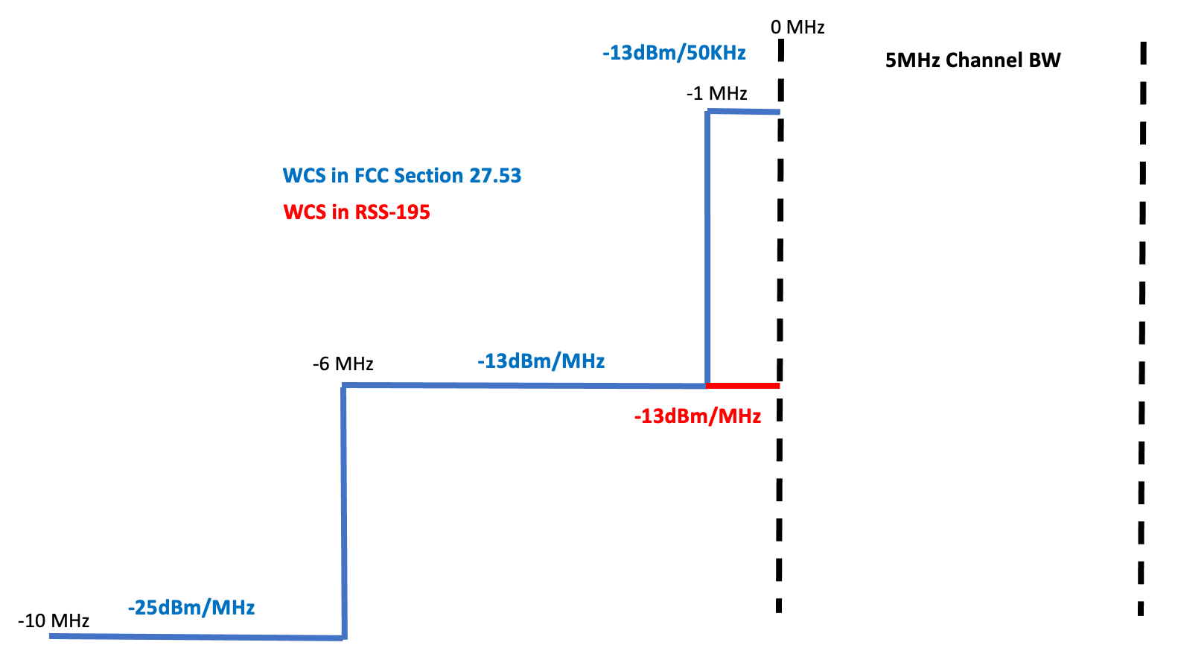

Since 3GPP requirements for LTE Band 30 and NR Band n30 with NS_21 have been written in consideration of FCC 27.53 emissions, there is a risk that existing LTE Band 30 or NR Band n30 devices may not be compatible with the Canadian rules.
TSG RAN would like to kindly invite ISED-Canada to provide clarification and any additional guidance of the RSS-195 requirements. . Also, why does RSS-195 differ from other ISED mobile emission specifications such as RSS-132, RSS-133, and RSS_139, which all seem to follow the same emission requirement as FCC 27.53 for the 1MHz just outside the channel BW.

2. Actions:
TSG RAN asks ISED-Canada for clarification and feedback as described above..

3. Date of Next TSG-RAN Meetings:
TSG-RAN Meeting #96 6. – 9. June 2022 Budapest, TBC
TSG-RAN Meeting #97 12. – 15. September 2022 USA, TBC

