3GPP TSG GERAN ERAN Adhoc GAHW- 000018  Adhoc on release 2000 and beyond #2 Agenda Item 6.1.1  Munich, Germany  9th September –13th September 2000 |  | Tdoc GAHW-000030  Agenda Item 6.1.1
Source: Nortel networks

TITLE : Proposal for change to the Draft GERAN Stage 2 document

Introduction:
The following modifications are proposed for the stage2 document (based on Tdoc GP00-0471):

- Section 5.2.1
Restauration of the figure describing the protocol stack over the Um interface. This should reflect the last agreement about header compression / removal.
- Section 6.4.3.2
Addition of description for the "No header adaptation" function of PDCP.
See ref [1]

Legacy transceivers:

In order to comply to the operator's requirement, see ref [2], about the support of the conversational Qos class via the Iu Ps, the list of traffic channel (TCH and PDTCH) is proposed.

Regarding the proposal to modify this requirement [4], since the UMTS Core Network in the packet domain does not specify any mandatory speech transcoders, we can not identify any gain in having a restriction to the support of AMR. Moreover, current legacy (i.e. in the field) transceivers do not support AMR yet. In particular because FR is the speech codec which is provided by every GSM mobile and then can be used on every cell. The flexibility given to the networks, by allowing the support of AMR, FR, EFR, and HR in this context, will not have a major impact on the MS side and will enable a fast support of speech services through packet domain.

Regarding the other traffic class (streaming, background and interactive), the proposal includes the support of CS-1 to CS-4 GPRS coding schemes as well as TCH/F14.4 and TCH/F9.6 coding schemes for the streaming bearers. (see ref [3])

- section 6.8.3.1
Addition of the list of TCH and PDTCH coding schemes.

References:
[1] ETSI SMG2 #35 T doc 2-00-746 : GERAN Radio Access Bearers presented in Schaumburg, Illinois , USA. Source : Nokia

[2] SMG2/SMG12 T doc 2g00-021 : Requirement and agreements for the GERAN to CN packet switched domain , Source : GERAN ad hoc.
[3] TSG GERAN #1 T doc GP-00272 : Initial requirements for legacy transceivers; source : Nortel Networks.

[4] TSG GERAN #1 T doc GP -00162: legacy transceivers ; source : Ericsson.
.

GERAN Overall Description, Stage 2

<Workitem> V<m.t.e> (2000-05>)
Technical Specification
Digital cellular telecommunications system (Phase 2+);
GSM/EDGE Radio Access Network (GERAN);
Overall Description;
Stage 2;
(GSM 03.51 version 0.0.1 Release 2000)

Reference
<Workitem>
Keywords
<keyword[, keyword]>
ETSI Secretariat
Postal address
F-06921 Sophia Antipolis Cedex - FRANCE
Office address
650 Route des Lucioles - Sophia Antipolis
Valbonne - FRANCE
Tel.: +33 4 92 94 42 00 Fax: +33 4 93 65 47 16
Siret N° 348 623 562 00017 - NAF 742 C
Association à but non lucratif enregistrée à la
Sous-Préfecture de Grasse (06) N° 7803/88
X.400
c= fr; a=atlas; p=etsi; s=secretariat
Internet
secretariat@etsi.fr
http://www.etsi.fr
Copyright Notification
Reproduction is only permitted for the purpose of standardization work undertaken within ETSI.
The copyright and the foregoing restrictions extend to reproduction in all media.

© European Telecommunications Standards Institute yyyy.
All rights reserved.
Contents
Intellectual Property Rights 2
Foreword 2
Introduction 2
1 Scope 2
2 References 2
2.1 Normative references 2
2.2 Informative references 2
3 Definitions, symbols and abbreviations 2
3.1 Definitions 2
3.2 Symbols 2
3.3 Abbreviations 2
4 GERAN Architecture 2
4.1 Overall network architecture 2
4.2 GERAN Reference Architecture 2
4.3 Assumed UMTS Architecture 2
4.4 User plane protocol architecture in PS domain 2
4.4 Control plane protocol architecture in PS domain 2
4.5 User plane protocol architecture in CS domain 2
4.6 Control plane protocol architecture in CS domain 2
4.7 Iur-g protocol architecture 2
5 Radio Interface Protocol Architecture 2
5.1 Protocol Structure when connecting through Iu 2
5.2 Multiplexing Principles 2
5.2.1 Multiplexing of different types of radio access bearers 2
5.2.2 Multiplexing of user plane data from different core network interfaces 2
6 User and Control Plane Protocols 2
6.1 Identifiers in GERAN 2
6.1.1 IMSI and P-TMSI 2
6.1.2 G-RNTI 2
6.1.3 NSAPI, RAB ID and RB ID 2
6.1.4 RB ID and TFI 2
6.1.5 USF 2
6.1.6 ARI 2
6.2 Relay 2
6.3 Radio Resource Control (RRC) 2
6.3.1 RRC Functions 2
6.3.2 Handover and Cell Reselection 2
6.4 Packet Data Convergence Protocol (PDCP) 2
6.4.1 Services provided to upper layers 2
6.4.2 Services expected from RLC layer 2
6.4.3 PDCP Functions 2
6.4.3.1 Transparent Mode 2
6.4.3.2 Non-Transparent Mode 2
6.5 Radio Link Control (RLC) 2
6.5.1 Services provided to upper layer 2
6.5.2 RLC Functions 2
6.5.2.1 Transparent Mode 2
6.5.2.2 Non-Transparent Mode 2
6.5.2.2.1 Acknowledged Mode 2
6.5.2.2.2 Unacknowledged Mode 2
6.6 Medium Access Control (MAC) 2
6.6.1 Services provided to upper layers 2
6.6.2 MAC Functions 2
6.6.2.1 Dedicated Mode 2
6.6.2.2 Shared Mode 2
6.7 RLC/MAC PDU Formats for different protocol modes 2
6.7.1 Acknowledged RLC mode 2
6.7.1.1 Shared MAC mode 2
6.7.1.2 Dedicated MAC mode 2
6.7.2 Unacknowledged RLC mode 2
6.7.2.1 Shared MAC mode 2
6.7.2.2 Dedicated MAC mode 2
6.7.3 Transparent RLC mode 2
6.7.3.1 Dedicated MAC mode 2
6.8 Physical Layer (Phy) 2
6.8.1 Definitions 2
6.8.2 Services provided to upper layer 2
6.8.2.1 Specific services of the physical layer in the MS 2
6.8.3 Logical Channels 2
6.8.3.1 Traffic channels 2
6.8.3.2 Control channels 2
6.8.3.2.1 Broadcast channels 2
6.8.3.2.2 Common control type channels 2
6.8.3.2.3 Dedicated control channels 2
6.8.3.2.4 Cell Broadcast Channel (CBCH) 2
6.8.4 Physical Subchannels 2
6.8.4.1 DPSCH - Dedicated Physical SubCHannel 2
6.8.4.2 SPSCH - Shared Physical SubCHannel 2
6.8.5 Mapping of logical channels onto physical subchannels 2
6.8.5.1 DPSCH full rate 2
6.8.5.1.1 Multiframe mapping of logical channels onto DPSCH/F 2
6.8.5.2 DPSCH half rate 2
6.8.5.2.1 Multiframe mapping of logical channels onto DPSCH/H 2
6.8.5.3 DPSCH quarter rate 2
6.8.5.3.1 Multiframe mapping of logical channels onto DPSCH/Q 2
6.8.5.4 SPSCH full rate 2
6.8.5.4.1 Multiframe mapping of logical channels onto SPSCH/F 2
6.8.5.5 SPSCH half rate 2
6.8.5.5.1 Multiframe mapping of logical channels onto SPSCH/H 2
6.8.6 Physical Layer Functions 2
6.8.7 Channel Coding 2
7 Ciphering 2
7.1 Location of ciphering in the GERAN protocol architecture 2
7.2 Inputs to the ciphering algorithm 2
7.2.1 Ciphering Key 2
7.2.2 Bearer 2
7.2.3 Direction 2
7.2.4 Length 2
7.2.5 Parameter Settings 2
8 Mobility Management and Session Management (MM and SM) 2
A.1 Conversational Radio Access Bearer 2
A.2 Streaming, Interactive, Background Radio Access Bearers 2
A.2.1 Streaming 2
A.2.2 Interactive 2
A.2.3 Background 2
Annex B (informative): Bibliography 2
Annex C (informative): Document Change History 2

Intellectual Property Rights

Foreword

Introduction

1 Scope
This specification defines the stage-2 service description for a GSM/EDGE Radio Access Network (GERAN). CCITT I.130 describes a three-stage method for characterisation of telecommunication services, and CCITT Q.65 defines stage 2 of the method.
This document illustrates how the services requested by a GSM/UMTS Core Network are realized by the GERAN. There is no detailed description of the interfaces towards the core network and only references are given to the appropriate specifications.
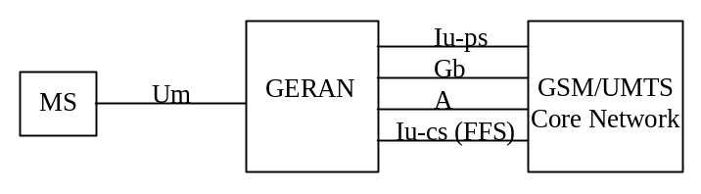
Figure 1. GSM/EDGE Radio Access Network.

2 References
References may be made to:
a) specific versions of publications (identified by date of publication, edition number, version number, etc.), in which case, subsequent revisions to the referenced document do not apply; or
b) all versions up to and including the identified version (identified by "up to and including" before the version identity); or
c) all versions subsequent to and including the identified version (identified by "onwards" following the version identity); or
d) publications without mention of a specific version, in which case the latest version applies.
A non-specific reference to an ETS shall also be taken to refer to later versions published as an EN with the same number.

2.1 Normative references

[1] UMTS 25.410: “UTRAN Iu Interface: General Aspects and Principles”.
[2] UMTS 25.411: “UTRAN Iu interface Layer 1”.
[3] UMTS 25.412: “UTRAN Iu interface signalling transport”.
[4] UMTS 25.413: “UTRAN Iu interface RANAP signalling”.
[5] UMTS 25.414: “UTRAN Iu interface data transport & transport signalling”.
[6] UMTS 25.415 “UTRAN Iu interface user plane protocols”.
[7] GSM 08.14: “General Packet Radio Service (GPRS); Base Station System (BSS) - Serving GPRS Support Node (SGSN) interface; Gb interface Layer 1”.
[8] GSM 08.16: “General Packet Radio Service (GPRS); Base Station System (BSS) - Serving GPRS Support Node (SGSN) interface; Network Service”.
[9] GSM 08.18: “General Packet Radio Service (GPRS); Base Station System (BSS) - Serving GPRS Support Node (SGSN); BSS GPRS Protocol (BSSGP)”
[10] GSM 05.01: “Digital cellular telecommunications system (Phase 2+); Physical layer on the radio path; General description”
[11] GSM 05.02: “Digital cellular telecommunications system (Phase 2+); Multiplexing and multiple access on the radio path”

Informative references
[12] UMTS 23.060: “General Packet Radio Service (GPRS); Service Description; Stage 2”
[13] GSM 03.64: “General Packet Radio Service (GPRS); Overall description of the GPRS radio interface; Stage 2”
[14] GSM 23.034: “High Speed Circuit Switched Data (HSCSD); Stage 2”

3 Definitions, symbols and abbreviations

3.1 Definitions

For the purposes of the present document, the following definitions apply:
<defined term>: <Definition>.
example: The text serving as an example.

3.2 Symbols

For the purposes of the present document, the following symbols apply:
<symbol> <Explanation>
<2nd symbol> <2nd Explanation>

3.3 Abbreviations

For the purposes of the present document, the following abbreviations apply:
<ACRONYM1> <Explanation>
<ACRONYM2> <Explanation>

4 GERAN Architecture

4.1 Overall network architecture
Editor's note: Insert text and figure on reference architecture from S2 report on all-IP.

4.2 GERAN Reference Architecture
The reference architecture of GERAN is illustrated in Figure 2. GERAN connects with an Iu-ps, Gb and A interface to the core network. It is for further study if an Iu-cs is needed. The Base Station Controllers (BSCs) may be connected to each other with an Iur-g interface.

Iu-ps
Gb
A
Iu-cs (ffs)
MS
Um
GSM/UMTS
Core Network
BTS

BSC
BTS

BSC
Iur-g
GERAN

Figure 2. GERAN reference architecture.

Assumed UMTS Architecture
This section describes the assumed UMTS architecture when GERAN connects to the core network through an Iu interface. Figure 3a shows the assumed UMTS architecture as outlined in TS 23.110. GERAN is showed instead of UTRAN. The figure below shows the UMTS architecture in terms of its entities User Equipment (UE) or Mobile Station, GERAN and Core Network. The respective reference points Um (Radio Interface) and Iu (CN-RAN reference) are shown. The figure illustrates furthermore the high-level functional grouping into the Access Stratum and the Non-Access Stratum. If the figures below are also applicable for an evolved A interface is for further study.
The Access Stratum offers services through the following Service Access Points (SAP) to the Non-Access Stratum:
- General Control (GC) SAPs;
- Notification (Nt) SAPs; and
- Dedicated Control (DC) SAPs.
The SAPs are marked with circles in Figure 3a.
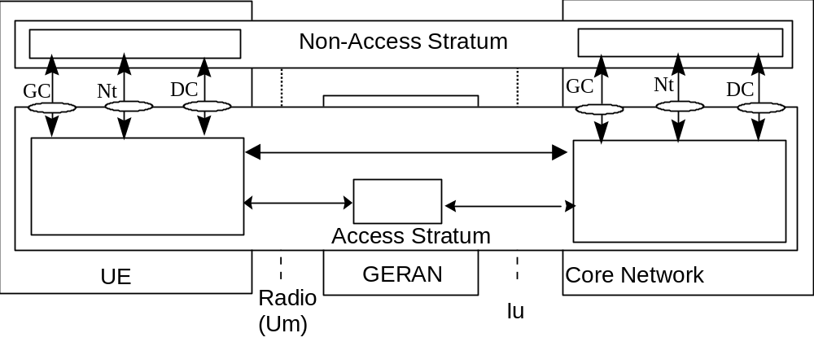
Figure 3a. Assumed UMTS Architecture
This model can be further refined to distinguish the end AS entities, which provide the services to higher layers, from the local entities, which provide services over respectively the Um and the Iu reference point. Figure 3b presents the refined model.
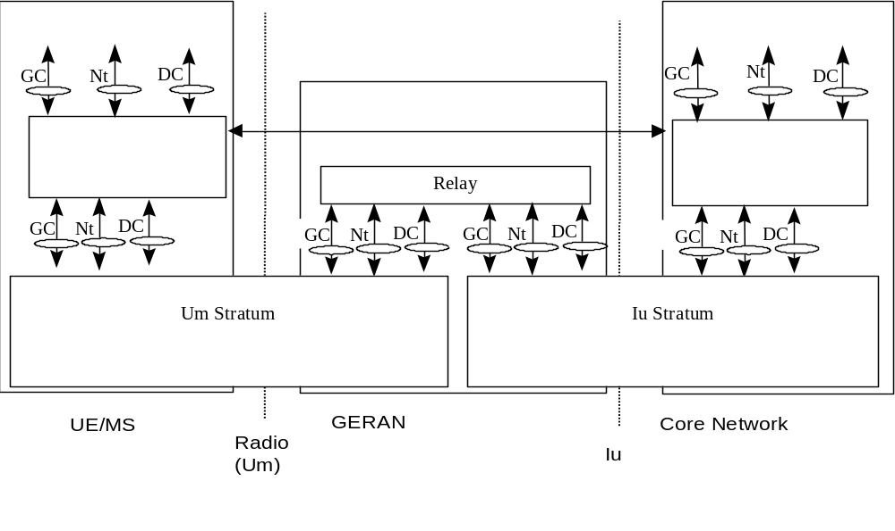
Figure 3b. Assumed GERAN Model
The Um Stratum block can be further refined as shown in Figure 3c.
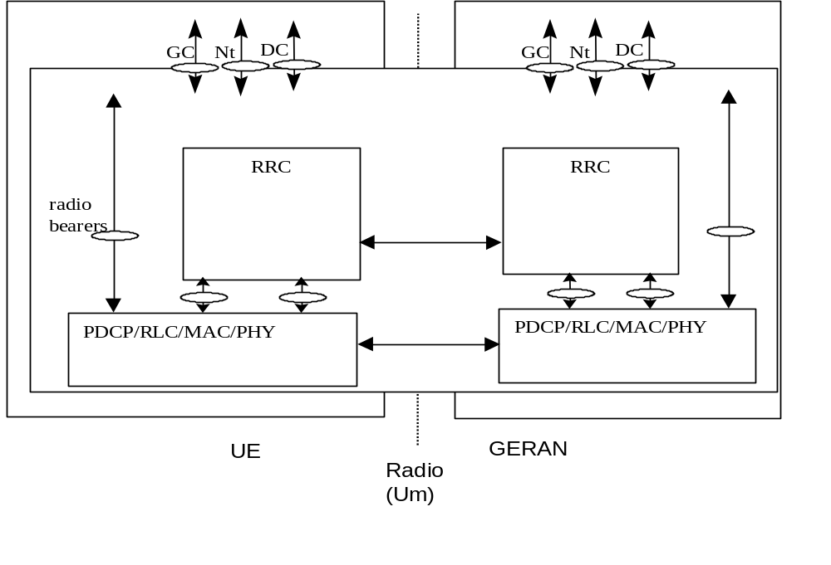
Figure 3c Assumed Um Stratum Model

User plane protocol architecture in PS domain
Figure 3 shows the user plane for GERAN connected to a packet switched core network domain. For reference, GPRS and UMTS protocol stacks when connected to the packet switched core network domain are depicted in Figures 4 of [12] and 6 of [12] respectively.
Specifications and more detailed descriptions of the Iu-ps interface protocols and architecture can be found in [1-6].
Specifications and more detailed descriptions of the Gb interface protocols and architecture can be found in [7-9].
The Um interface protocols are described in section 5 and 6.
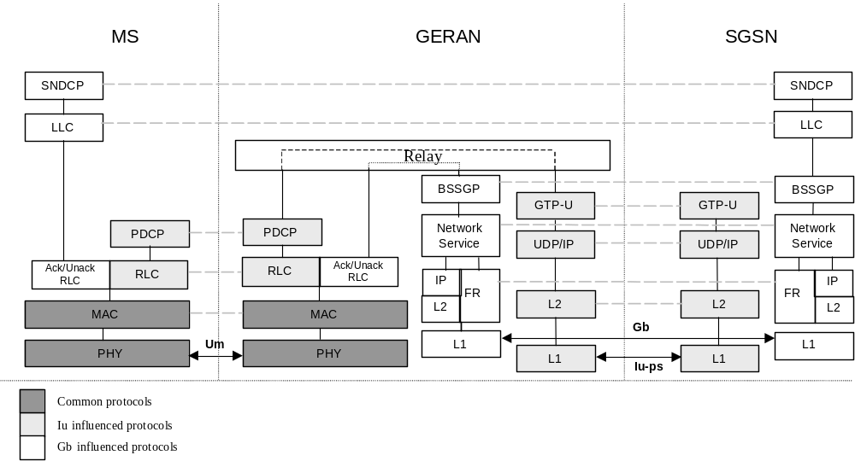
Figure 3. User Plane protocols towards Packet Switched Core Network domain.

Control plane protocol architecture in PS domain
The control plane protocol architecture in the PS domain is FFS.

User plane protocol architecture in CS domain
The user plane protocol architecture in the CS domain is FFS.

Control plane protocol architecture in CS domain
The control plane protocol architecture in the CS domain is FFS.

Iur-g protocol architecture
The architecture and functionality of Iur-g is FFS.

5 Radio Interface Protocol Architecture

The radio interface protocol architetcture when GERAN connects to A or Gb is the same as defined in earlier releases. The subsection below describes the protocol architecture when connecting through an Iu interface to the CN. If the protocol structure described in this section below are also applicable for an evolved A interface is for further study. The multiplexing principles of data coming from the different CN interfaces (A, Gb and Iu) are illustrated in section 5.3.

Protocol Structure when connecting through Iu
The radio interface is layered into three protocol layers:
- the physical layer (L1);
- the data link layer (L2);
- the network layer (L3).
Layer 2 is split into following sublayers: Radio Link Control (RLC), Medium Access Control (MAC) protocol and Packet Data Convergence Protocol (PDCP). The usage of data link protocols (abbreviated DL in figure 5) as specified in 04.06 is for further study when connecting to an Iu interface. If the Broadcast/Multicast Control (BMC) protocol described in 25.301 is needed is for further study.
The protocol architecture is divided into Control (C-) and User (U-) planes. The RLC and MAC protocols and the physical layer carries data from both C- and U-plane. PDCP exists in the U-plane only.
In the C-plane, Layer 3 is partitioned into sublayers where the lowest sublayer, denoted as Radio Resource Control (RRC), interfaces with layer 2 and terminates in the GERAN. The next sublayer provides 'Duplication avoidance' functionality as specified in TS 24.007. It terminates in the CN but is part of the Access Stratum; it provides the Access Stratum Services to higher layers. The higher layer signalling such as Mobility Management (MM) and Call Control (CC) are assumed to belong to the non-access stratum, and therefore not in the scope of 3GPP TSG GERAN. On the general level, the protocol architecture is similar to the current ITU-R protocol architecture, ITU-R M.1035.
Figure 5 shows the radio interface protocol architecture. Each block in Figure 5 represents an instance of the respective protocol. Service Access Points (SAP) for peer-to-peer communication are marked with circles at the interface between sublayers. The SAP between MAC and the physical layer provides the logical channels. In the C-plane, the interface between 'Duplication avoidance' and higher L3 sublayers (CC, MM) is defined by the General Control (GC), Notification (Nt) and Dedicated Control (DC) SAPs. A description of these SAPs can be found in TS 23.110.
Also shown in the figure are connections between RRC and MAC as well as RRC and L1 providing local inter-layer control services. An equivalent control interface exists between RRC and the RLC sublayer, between RRC and the PDCP sublayer. These interfaces allow the RRC to control the configuration of the lower layers. For this purpose separate Control SAPs are defined between RRC and each lower layer (PDCP, RLC, MAC, and L1).
The GERAN can be requested by the CN to prevent all loss of data (i.e. independently of the handovers on the radio interface), as long as an inter-BSS handover does not take place. This is a basic requirement to be fulfilled by the GERAN retransmission functionality as provided by the RLC sublayer. However, in case of the inter-BSS handover, the prevention of the loss of data may not be guaranteed autonomously by the GERAN but relies on 'Duplication avoidance' functions in the CN.

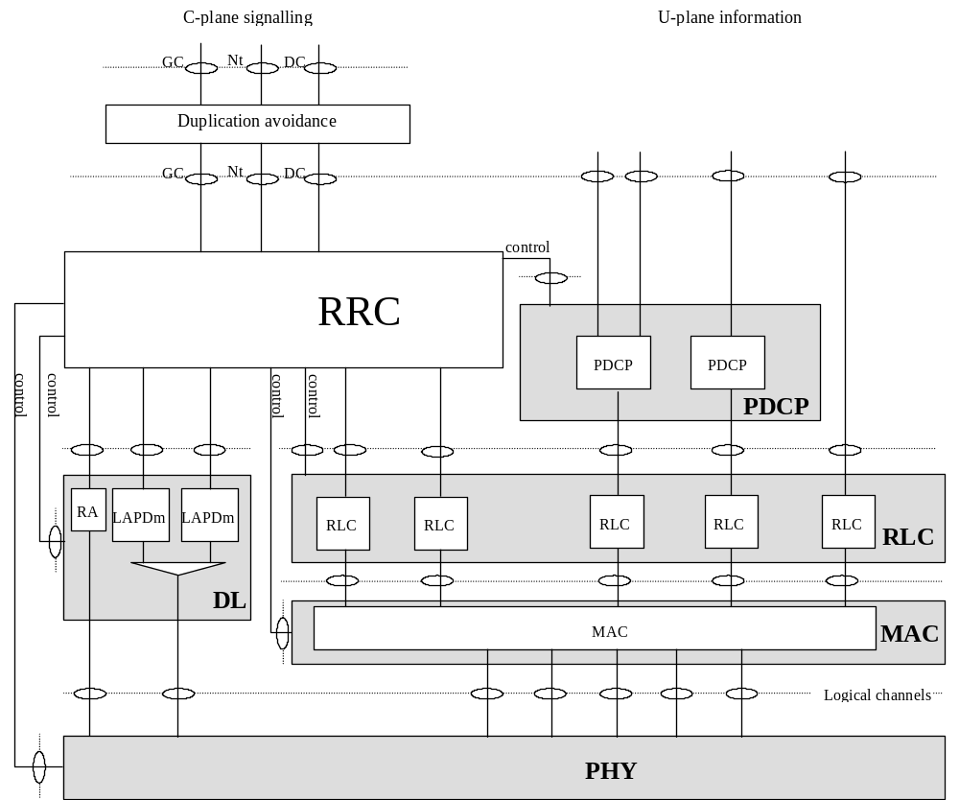
Figure 5. Radio Interface protocol architecture
Figure 5 reflects the radio interface protocol architecture as defined specifically in release 2000 connecting to the Iu interface.

Multiplexing Principles

Multiplexing of different types of radio access bearers
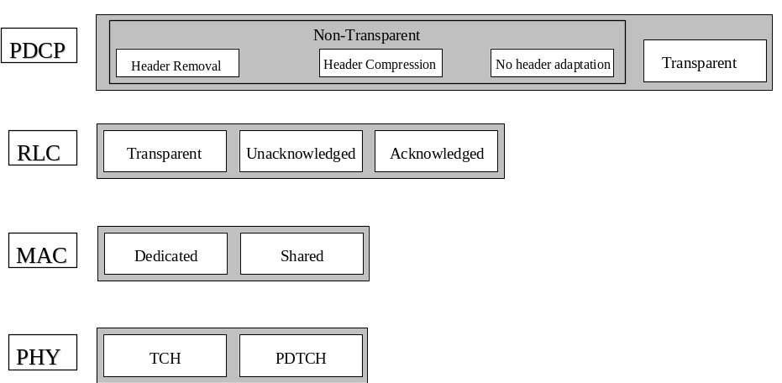
Figure 4. GERAN user plane protocol stack over Um interface. Different protocol modes may be combined to create different radio bearer types.
For a conversational class call, the GERAN offers the following multiplexing scenarios on the radio interface:
- Operational Scenario 1. Permanent allocation of a physical subchannel to a conversational class call, without any multiplexing capability.
- Operational Scenario 2. Permanent allocation of a physical subchannel to a conversational class call and multiplexing of best effort data from the same mobile station.

Multiplexing of user plane data from different core network interfaces
Figure 6 below shows the multiplexing principles on the network side of user plane data coming from different type of core network interfaces. User data from Iu and Gb is multiplexed on MAC level, i.e. when using shared channels, or on the physical layer, i.e. using different physical subchannels. User data coming from the A interface is multiplexed with user data from Gb and Iu on the physical layer through different physical subchannels.
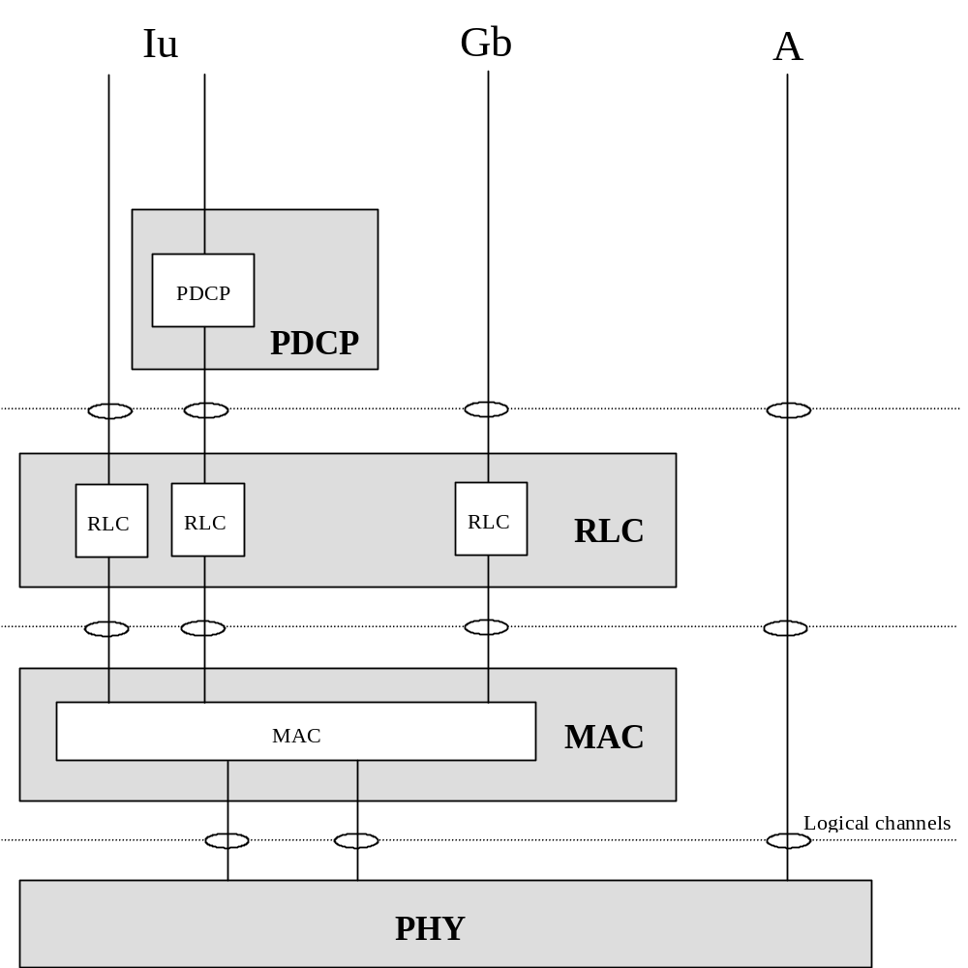
Figure 6. Multiplexing principles of user plane data flows coming from different interfaces.

6 User and Control Plane Protocols
This section provides an overview on the user and control plane protocols of GERAN. For detailed description of each of the layer, please refer to the corresponding specification (see below).

6.1 Identifiers in GERAN
The identities listed below shall be used for an MS connected, via GERAN through an Iu interface, to the CN. The identities for an MS connected, via GERAN through a Gb interface, to the CN are defined in Release 99 and can be found in UMTS 23.060.

IMSI and P-TMSI
A unique International Mobile Subscriber Identity (IMSI) shall be allocated to each packet-domain subscribers.
A Packet Temporary Mobile Subscriber Identity (P-TMSI) shall be allocated to each (E)GPRS-attached MS.
IMSI and P-TMSI are defined in UMTS 23.003.

G-RNTI
A GERAN Radio Network Temporary Identity (G-RNTI) shall be allocated by the BSS when an RRC connection is established between the MS and GERAN. It identifies the MS within GERAN and may be used the same way TLLI is currently used over the radio interface in (E)GPRS. How the G-RNTI is constructed and the size of it is FFS.

NSAPI, RAB ID and RB ID
The UMTS definitions and mapping amongst NSAPI, RAB ID and RB ID shall be used for GERAN.
The Network layer Service Access Point Identifier (NSAPI) and IMSI are used for network layer routing. In the MS, NSAPI identifies the PDP-SAP. In the SGSN and GGSN, NSAPI identifies the PDP context associated with a MM context.
In communication with BSC across the Iu-ps and Um interfaces, the RAB ID is used to identify the radio access bearer and that information element shall be identical to the NSAPI value. In the BSS, RAB ID identifies the BSS RAB context. The RAB ID shall uniquely identify the RAB for a specific CN domain and a particular MS.
In GERAN, radio bearers are established to realize a RAB over the radio interface. Whether only one RB is needed to support a RAB is FFS
How RB ID is used over the GERAN radio interface is FFS.

RB ID and TFI
The relationship between RB ID and TFI is FFS.

USF
An Up-link State Flag (USF) is used on PDCHs to allow multiplexing of uplink radio blocks from different MSs. USF and its usage need not to be changed, compared to previous releases, on shared MAC. It is, however, not needed when dedicated MAC is used.

ARI
The ARI (Access Request Identifier) is used for optional fast random access on random access channel(s) to uniquely identify an MS and associated bearer(s) that are already established. Design details are ffs.

Relay
The relay function of GERAN functionality and whether some functions need to be standardized are for FFS.

Radio Resource Control (RRC)
RRC is a control plane protocol for radio resource management. RRC design is FFS.

RRC Functions
The Radio Resource Control (RRC) layer handles the control plane signalling of Layer 3 between the MSs and GERAN. The RRC performs the following functions:
- Broadcast of information provided by the non-access stratum (Core Network). The RRC layer performs system information broadcasting from the network to all MSs. The system information is normally repeated on a regular basis. The RRC layer performs the scheduling, segmentation and repetition. This function supports broadcast of higher layer (above RRC) information. This information may be cell specific or not. As an example RRC may broadcast Core Network location service area information related to some specific cells.
- Broadcast of information related to the access stratum. The RRC layer performs system information broadcasting from the network to all MSs. The system information is normally repeated on a regular basis. The RRC layer performs the scheduling, segmentation and repetition. This function supports broadcast of typically cell-specific information.
- Establishment, re-establishment, maintenance and release of an RRC connection between the MS and GERAN. The establishment of an RRC connection is initiated by a request from higher layers at the MS side to establish the first Signalling Connection for the MS. The establishment of an RRC connection includes an optional cell re-selection, an admission control, and a layer 2 signalling link establishment. The release of an RRC connection can be initiated by a request from higher layers to release the last Signalling Connection for the MS or by the RRC layer itself in case of RRC connection failure. In case of connection loss, the MS requests re-establishment of the RRC connection. In case of RRC connection failure, RRC releases resources associated with the RRC connection.
- Establishment, reconfiguration and release of Radio Bearers. The RRC layer can, on request from higher layers, perform the establishment, reconfiguration and release of Radio Bearers in the user plane. A number of Radio Bearers can be established to an MS at the same time. At establishment and reconfiguration, the RRC layer performs admission control and selects parameters describing the Radio Bearer processing in layer 2 and layer 1, based on information from higher layers.
- Assignment, reconfiguration and release of radio resources for the RRC connection. The RRC layer handles the assignment of radio resources needed for the RRC connection including needs from both the control and user plane. The RRC layer may reconfigure radio resources during an established RRC connection. RRC signals to the MS to indicate resource allocations for purposes of inter system handovers.
- RRC connection mobility functions. The RRC layer performs evaluation, decision and execution related to RRC connection mobility during an established RRC connection, such as handover, preparation of handover to UMTS or other systems, cell re-selection and cell/GRA update procedures, based on e.g. measurements done by the MS.
- Paging/notification. The RRC layer can broadcast paging information from the network to selected MSs. Higher layers on the network side can request paging and notification. The RRC layer can also initiate paging during an established RRC connection.
- Routing of higher layer PDUs. This function performs at the MS side routing of higher layer PDUs to the correct higher layer entity, at the GERAN side to the correct RANAP entity.
- Control of requested QoS. This function shall ensure that the QoS requested for the Radio Bearers can be met. This includes the allocation of a sufficient number of radio resources.
- MS measurement reporting and control of the reporting. The measurements performed by the MS are controlled by the RRC layer including both GSM/EDGE air interface and other systems. The RRC layer also performs the reporting of the measurements from the MS to the network.
- Power control. The RRC layer controls parameters for normal power control and fast power control.
- Control of ciphering. The RRC layer provides procedures for setting of ciphering (on/off) between the MS and GERAN.
- Initial cell selection and re-selection in idle mode. Selection of the most suitable cell based on idle mode measurements and cell selection criteria.
- Integrity protection. This function controls integrity protection and performs integrity protection those RRC messages that are considered sensitive and/or contain sensitive information. Integrity protection in GERAN is FFS.
- Support for Location Services. Signaling between MS and GERAN to support positioning of a MS.
- Timing advance control. The RRC controls the operation of timing advance.

Handover and Cell Reselection
This section is FFS.
See UMTS TR 25.936 for handover for real-time services from PS domain.

Packet Data Convergence Protocol (PDCP)
This section provides an overview on services and functions provided by the Packet Data Convergence Protocol (PDCP). A detailed description of the PDCP is given in [Ref: GERAN'00 PDCP – 25.323].

Services provided to upper layers
The following services are provided by PDCP to upper layers:
- PDCP SDU delivery

Services expected from RLC layer
- Data transfer in acknowledged mode.
- Data transfer in unacknowledged mode.
- Data transfer in transparent mode.
- Segmentation and reassembly.
- In-Sequence delivery.

PDCP Functions
For clarity reason, two PDCP modes are defined in this TS: transparent and non-transparent. The transparent and non-transparent modes relate respectively to the PDCP-no-header PDU and the PDCP-data PDU cases described in UMTS 25.323.
The functions performed by the PDCP are dependent on the PDCP mode used.

Transparent Mode
The name "transparent" means that the PDCP layer does not change the incoming service data units (SDU), i.e. no header is added and possible TCP/IP or RTP/UDP/IP headers in the data are left untouched.
The functionalities of the transparent mode of PDCP are:
- Transfer of user data
- Relocation of PDCP buffer
- PDCP SDU buffering

Non-Transparent Mode
The functionalities of the non-transparent mode of PDCP are:
- Header adaptation of the IP data streams
- Transfer of user data
- PDCP SDU buffering
- Relocation support appropriate to applicable QoS requirements
- Multiplexing of radio bearers onto RLC entities
Different header adaptation mechanisms may be used by the PDCP:
- Header compression. Transport and network level headers (e.g. RTP/UDP/IP) are compressed in such a way that the decompressed headers are semantically identical to the original uncompressed headers. The IETF ROHC WG is responsible for standardising header compression schemes. Header compression is suited for standard internet applications that are not designed to work only with GERAN and especially for multimedia applications therefore the scheme will be used with generic realtime multimedia bearers.
- Header removal. Transport and network level headers (e.g. RTP/UDP/IP) headers are completely removed. Based on information submitted at call setup and based on information derived from lower layer (link & physical), the receiving entity can regenerate the headers. The primary application of header removal is the optimized speech bearer, and the regenerated header may not always be semantically identical to the original header.
- No header adaptation. Transport and network level headers (e.g. RTP/UDP/IP) headers are forwarded.

Radio Link Control (RLC)
This section provides an overview on services and functions provided by the Radio Link Control (RLC). A detailed description of the RLC is given in [Ref: GERAN'00 RLC – 04.60 + ffs].

Services provided to upper layer
- Transparent data transfer. This service transmits higher layer PDUs without adding any protocol information.
- Acknowledged data transfer. This service transmits higher layer PDUs and guarantees delivery to the peer entity.
- Unacknowledged data transfer. This service transmits higher layer PDUs without guaranteeing delivery to the peer entity.
- Notification of unrecoverable errors. RLC notifies the upper layer of errors that cannot be resolved by RLC itself by normal exception handling procedures, e.g. by adjusting the maximum number of retransmissions according to delay requirements.
There is a single RLC connection per Radio Bearer.

RLC Functions

Transparent Mode
RLC has no functionality when operating in transparent mode. The incoming SDUs are transfered to the MAC layer without being altered. No upper layer protocol information is removed. No RLC protocol information is added. All necessary signalling is made out of band.

Non-Transparent Mode
In non transparent mode, the RLC is responsible for ciphering user data blocks (RLC PDUs). This function prevents unauthorized acquisition of data.

Acknowledged Mode
RLC has support for the following functions in acknowledged mode. For a detailed description, see GSM 04.60. In addition the RLC offers the possibility for adjusting the maximum number of retransmissions according to the delay requirements.
- Segmentation of upper layer PDUs into RLC data blocks.
- Concatenation of upper layer PDUs into RLC data blocks.
- Padding to fill out an RLC data block.
- Backward Error Correction (BEC) procedures enabling the selective retransmission of RLC data blocks. As for EGPRS R’99, either selective type I ARQ or selective type II hybrid ARQ (incremental redundancy) is used.
- Reassembly of RLC data blocks into upper layer PDUs.
- In-sequence delivery of upper layer PDUs.
- Link Adaptation
- Ciphering
New services towards the Iu-ps interface using acknowledged RLC mode is based on the existing EGPRS R’99 modulation and coding schemes (MCS-1 to 9) if mapped on the PDTCH.

Unacknowledged Mode
RLC has support for the following fuctions in unacknowledged mode. For a detailed description, see GSM 04.60. No backward error correction procedure is supported in this mode.
- Segmentation of upper layer PDUs into RLC data blocks.
- Concatenation of upper layer PDUs into RLC data blocks.
- Padding to fill out an RLC data block
- Reassembly of RLC data blocks into upper layer PDUs
- Sequence number check to detect lost RLC blocks.
- Link Adaptation
- Ciphering
The unacknowledged RLC mode is based on MCS-1 to 9 if mapped onto a PDTCH. If the RAB is mapped onto a TCH or E-TCH new coding schemes could be considered. Examples of bitrates supported per timeslot for these coding schemes are 9.6, 14.4, 28.8, 43.2. and 32 kbps. Other timeslot bitrates are for FFS. Higher bitrates can be achieved by combining several timeslots.
For control signalling unacknowledged RLC is used as for (E)GPRS release 97/99 if the radio access bearer uses PDTCH. If a TCH or E-TCH is used control signalling is performed via the FACCH and SACCH.

Medium Access Control (MAC)
This section provides an overview on services and functions provided by the Medium Access Control (MAC). A detailed description of the MAC is given in [Ref: ffs].

Services provided to upper layers
The MAC layer allows the transmission over the physical layer of upper layer PDUs from one mobile station when operating in dedicated mode, or one or more mobile stations when operating in shared mode. A MAC mode is associated with a physical subchannel for use by one or more mobile stations (dedicated or shared mode respectively). The MAC layer handles the access to and multiplexing onto the physical subchannels.
- Data transfer. This service provides unacknowledged transfer of MAC SDUs between peer MAC entities. This service does not provide any data segmentation. Therefore, segmentation/reassembly function should be achieved by upper layer.

MAC Functions
The functions of MAC include:
- Configuring the mapping between logical channels and physical subchannels. The MAC is responsible for configuring the mapping of logical channel(s) onto the appropriate physical subchannel(s).
- Defining logical channels to be used for each radio bearer service.
- Ciphering. In transparent RLC mode, the MAC is responsible for ciphering user data blocks (MAC SDUs). In non-transparent RLC mode, the MAC is responsible for ciphering layer 2 control data blocks (RLC/MAC PDUs). This function prevents unauthorized acquisition of data.

Dedicated Mode
In dedicated mode, the MS is allocated a dedicated physical subchannel for exclusive use of the bearers it supports.
- Priority handling between data flows of one mobile station. Priorities are e.g. given by attributes of Radio Bearer services.
- Multiplexing/demultiplexing of higher layer PDUs delivered to/from the physical layer on dedicated physical subchannels. This function can be utilised when several upper layer services (e.g. RLC instances) can be mapped efficiently on the same physical subchannel (operational scenario 2).

Shared Mode
In shared mode, traffic flows to/from one or more MSs may be multiplexed on the same physical subchannel.
- Identification of different traffic flows of one or more MSs on the shared physical subchannels. Inband identification is needed to address a flow to an MS in the downlink or identify a flow from an MS in the uplink.
- Multiplexing/demultiplexing of higher layer PDUs delivered to/from the physical layer on shared physical subchannels.
An optional Fast Random Access scheme shall be supported in Shared MAC mode of operation. Details are ffs.
[Editor's Note: The control plane is for FFS.]

RLC/MAC PDU Formats for different protocol modes

Acknowledged RLC mode

Shared MAC mode
In shared MAC mode one or more radio bearers of one or more mobile stations can be multiplexed to the same physical subchannel.
The RLC/MAC header is already defined in GSM 04.60. Which RLC/MAC headers and channel coding schemes of GPRS/EGPRS to be supported is FFS.

Dedicated MAC mode
On dedicated channels, Operational Scenario 2 (OS 2), in which for example one voice RAB and one best effort RAB of one mobile station are mapped onto one physical subchannel, can be obtained by either layer 1 or MAC multiplexing (or a combination of both).
The current working assumption is to use the RLC/MAC protocol of GSM 04.60 as a basis. The channel coding for this protocol mode combination is for further study. Potential channel coding schemes to be used are GPRS/EGPRS and CSD/ECSD coding schemes.

Unacknowledged RLC mode

Shared MAC mode
To preserve compatibility between GERAN Release 99 and GERAN Release 00 this protocol mode combination is evolved from what are defined in R99.
The RLC/MAC header is already defined in 04.60. Which RLC/MAC headers and channel coding schemes of GPRS/EGPRS to be supported is FFS.

Dedicated MAC mode
The current working assumption is to use the RLC/MAC protocol of 04.60 as a basis. The channel coding for this protocol mode combination is for further study. Potential channel coding schemes to be used are GPRS/EGPRS and CSD/ECSD coding schemes.

Transparent RLC mode

Dedicated MAC mode
The transparent mode is used for example to transmit voice in GERAN. The different channel coding schemes used for voice in GSM are used. New coding schemes for 8-PSK quarter rate, half rate and possibly full rate speech are also required. Other coding schemes like e.g. CSD/ECSD is FFS.

Physical Layer (Phy)
The physical layer (layer 1) is the lowest layer in the OSI Reference Model and it supports all functions required for the transmission of bit streams on the physical medium. This section provides an overview on services and functions provided by the Physical Layer. A detailed description of the physical layer is given in [Ref: 05 series].

Definitions
A physical channel uses a combination of frequency and time division multiplexing and is defined as a sequence of radio frequency channels and time slots. The complete definition of a particular physical channel consists of a description in the frequency domain, and a description in the time domain (see GSM 05.02).
A logical channel is defined by the type of data which is transferred and characterized by parameters such as channel coding and interleaving. It can be uni-directional or bi-directional [05.02]. Example: PDTCH/U, TCH/FS
A channel combination is defined as the combination of logical channels that is mapped on a certain physical channel [05.02]. Example: TCH/FS+FACCH/F+SACCH/TF
A physical subchannel is defined as a physical channel or a part of a physical channel and an associated multiframe structure. Example: PDCH, DPSCH/F.

Services provided to upper layer
The physical layer interfaces the Medium Access Control (MAC) sub-layer of Layer 2 and the Radio Resource Control (RRC) sub-layer of Layer 3. Through Service Access Points (SAP), the physical layer offers services described below:
- Access capabilities:
The physical layer offers logical channels and the transmission services associated to higher layers. Logical channels are multiplexed either in a fixed predefined manner (multiframe structure) or dynamically by the MAC on physical subchannels. Physical subchannels are the units scheduled on the radio medium. Some are reserved by the network for common use (e.g. for use by a combination of CCCH and BCCH), others are assigned to dedicated connections with MSs (dedicated physical subchannels), or are assigned to a shared usage between MSs (shared physical subchannels).
- Error detection:
The physical layer offers an error protected transmission service, it includes error detection functions and to a lower level, error correction functions. Erroneous received frames may be notified to upper layer and, depending on the need of the upper layer, offered to it. The probability of one or more errors in a physical block transferred by the physical layer is defined in [Ref: GERAN'00 Phy - 05.05]. Due to non specified methods of quality detection, the probability of residual errors in transferred blocks may vary between implementations.
Editor's note: Encryption is ffs (location; function/service).

Specific services of the physical layer in the MS
- Measurement of the signal strength of neighbouring base stations. Measurements are transferred to layer 3.
- Measurement of the signal quality of the physical subchannel used. Measurements are transferred to the MAC layer for reporting to the base station.
- Cell/PLMN selection in idle mode or in packet mode. In idle mode or in packet mode, the physical layer selects the best cell with its BCCH/CCCH (CPBCCH/CCCCH only for COMPACT and for packet mode only) in close co-operation with layer 3, meeting requirements for PLMN selection specified in [Ref: GERAN'00 Phy - 02.11].

Logical Channels

Traffic channels
Traffic channels of type TCH are intended to carry either encoded speech or user data on physical subchannel in dedicated MAC mode. TCH can be either full rate (TCH/F), half rate (TCH/H) or quarter rate TCH (TCH/Q). The list of TCH type traffic channels is given in table 1.
Table 1: TCH type of traffic channels
Logical channel | Traffic channel | Modulation | Corresponding physical sub-channel | Description
TCH | TCH/AFS | GMSK | DPSCH/F | AMR Full rate
TCH | TCH/EFS | GMSK | DPSCH/F | EFR
TCH | TCH/FS | GMSK | DPSCH/F | Full Speech
TCH | TCH/WFS | 8PSK | DPSCH/F | Wideband AMR Full rate [tbd]
TCH | TCH/AHS | 8PSK | DPSCH/H | AMR Half rate
TCH | TCH/WHS | 8PSK | DPSCH/H | Wideband AMR Half rate [tbd]
TCH | TCH/AHS | GMSK | DPSCH/H | AMR Half rate
TCH | TCH/HS | GMSK | DPSCH/H | Half speech
TCH | TCH/AQS | 8PSK | DPSCH/Q | AMR Quarter rate
TCH | E-TCH/F43.2 | 8PSK | DPSCH/F | ECSD [tbd]
TCH | E-TCH/F32.0 | 8PSK | DPSCH/F | ECSD [tbd]
TCH | E-TCH/F28.8 | 8PSK | DPSCH/F | ECSD [tbd]
TCH | TCH/F14.4 | GMSK | DPSCH/F | DATA Full rate
TCH | TCH/F9.6 | GMSK | DPSCH/F | DATA Full rate

Packet data traffic channels (PDTCH) are intended to carry user data on physical subchannels in either dedicated or shared MAC mode. PDTCH’s can be either full rate (PDTCH/F) or half rate (PDTCH/H). The list PDTCH type of traffci channels is given in table 2.
Table 2: PDTCH type of traffic channels
Logical channel | Traffic channel | Modulation | Corresponding physical sub-channel | Description
PDTCH | CS1 to CS4 | GMSK | PDCH, DPSCH/F, DPSCH/H, SPSCH/F, SPSCH/H | GPRS
PDTCH | MCS1 to MCS4 | GMSK | PDCH, DPSCH/F, DPSCH/H, SPSCH/F, SPSCH/H | E-GPRS
PDTCH | MCS5 to MCS9 | 8PSK | PDCH, DPSCH/F, DPSCH/H, SPSCH/F, SPSCH/H | E-GPRS
PDTCH | repeated MCS1 to MCS4 | GMSK | PDCH, DPSCH/F, DPSCH/H, SPSCH/F, SPSCH/H | [tbd]
PDTCH | repeated MCS5 to MCS9 | 8PSK | PDCH, DPSCH/F, DPSCH/H, SPSCH/F, SPSCH/H | [tbd]

Control channels
Control channels carry signalling or synchronization data. Four categories of control channels are defined: broadcast, common, dedicated control channels and cell broadcast channels. Specific channels within these categories are defined in the subclauses following.

Broadcast channels
GERAN shall reuse R99 broadcast channels. Any addition shall be made in a backwards compatible manner.

Common control type channels
GERAN common control type channels shall be based on R99 common control type channels. Any addition shall be made in a backwards compatible manner.

Dedicated control channels
On a dedicated physical subchannel:
- The Fast Associated Control channel (FACCH) associated to one TCH. FACCH can either be full rate (FACCH/F), half rate (FACCH/H) or quarter rate (FACCH/Q) depending whether it is associated to a full rate, half rate or quarter rate TCH.
- The Packet Associated Control channel (PACCH) associated to one PDTCH: The PACCH is bi-directional. PACCH/U is used for the uplink and PACCH/D for the downlink. PACCH can either be full rate (PACCH/F) or half rate (PACCH/H) depending whether it is associated to a full rate or half rate PDTCH.
- The Slow Associated Control channel (SACCH) associated to one TCH and/or PDTCH. SACCH can either be full rate (SACCH/TF), half rate (SACCH/TH) or quarter rate (SACCH/TQ) depending whether it is associated to a full rate, half rate or quarter rate traffic channel.
- Inband signalling associated to one TCH is for FFS.
On a shared physical subchannel:
i) The Packet Associated Control channel (PACCH): The PACCH is bi-directional. PACCH/U is used for the uplink and PACCH/D for the downlink. PACCH can either be full rate (PACCH) or half rate (PACCH/H) depending whether it is associated to a full rate or half rate PDTCH.
ii) The Packet Timing advance Control CHannel uplink (PTCCH/U): Used to transmit random access bursts to allow estimation of the timing advance for one MS in packet transfer mode.
iii) The Packet Timing advance Control CHannel downlink (PTCCH/D): Used to transmit timing advance updates for several MS. One PTCCH/D is paired with several PTCCH/U's.

Cell Broadcast Channel (CBCH)
GERAN shall reuse R99 cell broadcast channel.

Physical Subchannels
Depending on the MAC mode, a physical subchannel can either be dedicated or shared.
All physical subchannels are bi-directional unless otherwise stated.

DPSCH - Dedicated Physical SubCHannel
A DPSCH can either be full rate, half rate or quarter rate.

SPSCH - Shared Physical SubCHannel
A SPSCH can either be full rate or half rate.

Mapping of logical channels onto physical subchannels

DPSCH full rate
Excluding CBCH, broadcast channels and common control type channels, the following channel combinations are possible for a DPSCH full rate:
- TCH/F + FACCH/F + SACCH/TF
- TCH/F + FACCH/F + SACCH/TF + PDTCH/F + PACCH/F
PDTCH and PACCH can occur only within the silent periods of a TCH
- PDTCH/F + PACCH/F + SACCH/TF

Multiframe mapping of logical channels onto DPSCH/F
Figure 5 shows the multiframe mapping of the logical channels for DPSCH/F.
frame number
0 | 1 | 2 | 3 | 4 | 5 | 6 | 7 | 8 | 9 | 10 | 11 | 12 | 13 | 14 | 15 | 16 | 17 | 18 | 19 | 20 | 21 | 22 | 23 | 24 | 25
D | D | D | D | D | D | D | D | D | D | D | D | S | D | D | D | D | D | D | D | D | D | D | D | D | i
D | User Traffic |  |  | S | SACCH |  |  | i | Idle
Figure 5. DPSCH/F – Multiframe mapping of logical channels

DPSCH half rate
The following channel combinations are possible for a DPSCH half rate:
- TCH/H + FACCH/H + SACCH/TH
- TCH/H + FACCH/H + SACCH/TH + PDTCH/H + PACCH/H
PDTCH and PACCH can occur only within the silent periods of a TCH
- PDTCH/H + PACCH/H + SACCH/TH

Multiframe mapping of logical channels onto DPSCH/H
Figure 6 shows the multiframe mapping of the logical channels for DPSCH/H.
frame number - subchannel 0
0 | 1 | 2 | 3 | 4 | 5 | 6 | 7 | 8 | 9 | 10 | 11 | 12 | 13 | 14 | 15 | 16 | 17 | 18 | 19 | 20 | 21 | 22 | 23 | 24 | 25
D | i | D | i | D | i | D | i | D | i | D | i | S | D | i | D | i | D | i | D | i | D | i | D | i | i
frame number - subchannel 1
0 | 1 | 2 | 3 | 4 | 5 | 6 | 7 | 8 | 9 | 10 | 11 | 12 | 13 | 14 | 15 | 16 | 17 | 18 | 19 | 20 | 21 | 22 | 23 | 24 | 25
i | D | i | D | i | D | i | D | i | D | i | D | i | i | D | i | D | i | D | i | D | i | D | i | D | S
D | User Traffic |  |  | S | SACCH |  |  | i | Idle
Figure 6. DPSCH/H – Multiframe mapping of logical channels

DPSCH quarter rate
The following channel combination is possible for a DPSCH quarter rate:
TCH/Q + FACCH/Q + SACCH/TQ

Multiframe mapping of logical channels onto DPSCH/Q
Figure 7 shows the multiframe mapping of the logical channels for DPSCH/Q.
Note: The SACCH mapping for DPSCH/Q is FFS. The SACCH mapping shown below is an example.
frame number - subchannel 0
0 | 1 | 2 | 3 | 4 | 5 | 6 | 7 | 8 | 9 | 10 | 11 | 12 | 13 | 14 | 15 | 16 | 17 | 18 | 19 | 20 | 21 | 22 | 23 | 24 | 25
D | i | i | i | D | i | i | i | D | i | i | i | S | D | i | i | i | D | i | i | i | D | i | i | i | i
26 | 27 | 28 | 29 | 30 | 31 | 32 | 33 | 34 | 35 | 36 | 37 | 38 | 39 | 40 | 41 | 42 | 43 | 44 | 45 | 46 | 47 | 48 | 49 | 50 | 51
D | i | i | i | D | i | i | i | D | i | i | i | S | D | i | i | i | D | i | i | i | D | i | i | i | i
52 | 53 | 54 | 55 | 56 | 57 | 58 | 59 | 60 | 61 | 62 | 63 | 64 | 65 | 66 | 67 | 68 | 69 | 70 | 71 | 72 | 73 | 74 | 75 | 76 | 77
D | i | i | i | D | i | i | i | D | i | i | i | i | D | i | i | i | D | i | i | i | D | i | i | i | i
78 | 79 | 80 | 81 | 82 | 83 | 84 | 85 | 86 | 87 | 88 | 89 | 90 | 91 | 92 | 93 | 94 | 95 | 96 | 97 | 98 | 99 | 100 | 101 | 102 | 103
D | i | i | i | D | i | i | i | D | i | i | i | i | D | i | i | i | D | i | i | i | D | i | i | i | i
frame number - subchannel 1
0 | 1 | 2 | 3 | 4 | 5 | 6 | 7 | 8 | 9 | 10 | 11 | 12 | 13 | 14 | 15 | 16 | 17 | 18 | 19 | 20 | 21 | 22 | 23 | 24 | 25
i | D | i | i | i | D | i | i | i | D | i | i | i | i | D | i | i | i | D | i | i | i | D | i | i | S
26 | 27 | 28 | 29 | 30 | 31 | 32 | 33 | 34 | 35 | 36 | 37 | 38 | 39 | 40 | 41 | 42 | 43 | 44 | 45 | 46 | 47 | 48 | 49 | 50 | 51
i | D | i | i | i | D | i | i | i | D | i | i | i | i | D | i | i | i | D | i | i | i | D | i | i | S
52 | 53 | 54 | 55 | 56 | 57 | 58 | 59 | 60 | 61 | 62 | 63 | 64 | 65 | 66 | 67 | 68 | 69 | 70 | 71 | 72 | 73 | 74 | 75 | 76 | 77
i | D | i | i | i | D | i | i | i | D | i | i | i | i | D | i | i | i | D | i | i | i | D | i | i | i
78 | 79 | 80 | 81 | 82 | 83 | 84 | 85 | 86 | 87 | 88 | 89 | 90 | 91 | 92 | 93 | 94 | 95 | 96 | 97 | 98 | 99 | 100 | 101 | 102 | 103
i | D | i | i | i | D | i | i | i | D | i | i | i | i | D | i | i | i | D | i | i | i | D | i | i | i
frame number - subchannel 2
0 | 1 | 2 | 3 | 4 | 5 | 6 | 7 | 8 | 9 | 10 | 11 | 12 | 13 | 14 | 15 | 16 | 17 | 18 | 19 | 20 | 21 | 22 | 23 | 24 | 25
i | i | D | i | i | i | D | i | i | i | D | i | i | i | i | D | i | i | i | D | i | i | i | D | i | i
26 | 27 | 28 | 29 | 30 | 31 | 32 | 33 | 34 | 35 | 36 | 37 | 38 | 39 | 40 | 41 | 42 | 43 | 44 | 45 | 46 | 47 | 48 | 49 | 50 | 51
i | i | D | i | i | i | D | i | i | i | D | i | i | i | i | D | i | i | i | D | i | i | i | D | i | i
52 | 53 | 54 | 55 | 56 | 57 | 58 | 59 | 60 | 61 | 62 | 63 | 64 | 65 | 66 | 67 | 68 | 69 | 70 | 71 | 72 | 73 | 74 | 75 | 76 | 77
i | i | D | i | i | i | D | i | i | i | D | i | S | i | i | D | i | i | i | D | i | i | i | D | i | i
78 | 79 | 80 | 81 | 82 | 83 | 84 | 85 | 86 | 87 | 88 | 89 | 90 | 91 | 92 | 93 | 94 | 95 | 96 | 97 | 98 | 99 | 100 | 101 | 102 | 103
i | i | D | i | i | i | D | i | i | i | D | i | S | i | i | D | i | i | i | D | i | i | i | D | i | i
frame number - subchannel 3
0 | 1 | 2 | 3 | 4 | 5 | 6 | 7 | 8 | 9 | 10 | 11 | 12 | 13 | 14 | 15 | 16 | 17 | 18 | 19 | 20 | 21 | 22 | 23 | 24 | 25
i | i | i | D | i | i | i | D | i | i | i | D | i | i | i | i | D | i | i | i | D | i | i | i | D | i
26 | 27 | 28 | 29 | 30 | 31 | 32 | 33 | 34 | 35 | 36 | 37 | 38 | 39 | 40 | 41 | 42 | 43 | 44 | 45 | 46 | 47 | 48 | 49 | 50 | 51
i | i | i | D | i | i | i | D | i | i | i | D | i | i | i | i | D | i | i | i | D | i | i | i | D | i
52 | 53 | 54 | 55 | 56 | 57 | 58 | 59 | 60 | 61 | 62 | 63 | 64 | 65 | 66 | 67 | 68 | 69 | 70 | 71 | 72 | 73 | 74 | 75 | 76 | 77
i | i | i | D | i | i | i | D | i | i | i | D | i | i | i | i | D | i | i | i | D | i | i | i | D | S
78 | 79 | 80 | 81 | 82 | 83 | 84 | 85 | 86 | 87 | 88 | 89 | 90 | 91 | 92 | 93 | 94 | 95 | 96 | 97 | 98 | 99 | 100 | 101 | 102 | 103
i | i | i | D | i | i | i | D | i | i | i | D | i | i | i | i | D | i | i | i | D | i | i | i | D | S
D | User Traffic |  |  | S | SACCH |  |  | i | Idle
Figure 7. DPSCH/Q – Multiframe mapping of logical channels

SPSCH full rate
Excluding CBCH, broadcast channels and common control type channels, the following channel combination is possible for a SPSCH full rate:
PDTCH/F + PACCH/F + PTCCH/F

Multiframe mapping of logical channels onto SPSCH/F
Figure 8 shows the multiframe mapping of the logical channels for SPSCH/F. Only half of the 52-multiframe is shown, the second half being identical to the first one.
frame number
0 | 1 | 2 | 3 | 4 | 5 | 6 | 7 | 8 | 9 | 10 | 11 | 12 | 13 | 14 | 15 | 16 | 17 | 18 | 19 | 20 | 21 | 22 | 23 | 24 | 25
D | D | D | D | D | D | D | D | D | D | D | D | T | D | D | D | D | D | D | D | D | D | D | D | D | i
D | User Traffic |  |  | T | PTCCH |  |  | i | Idle
Figure 8. SPSCH/F – Multiframe mapping of logical channels

SPSCH half rate
The following channel combination is possible for a SPSCH half rate:
PDTCH/H + PACCH/H + PTCCH/H

Multiframe mapping of logical channels onto SPSCH/H
Figure 9 shows the multiframe mapping of the logical channels for SPSCH/F. Only half of the 52-multiframe is shown, the second half being identical to the first one.
frame number - subchannel 0
0 | 1 | 2 | 3 | 4 | 5 | 6 | 7 | 8 | 9 | 10 | 11 | 12 | 13 | 14 | 15 | 16 | 17 | 18 | 19 | 20 | 21 | 22 | 23 | 24 | 25
D | i | D | i | D | i | D | i | D | i | D | i | T | D | i | D | i | D | i | D | i | D | i | D | i | i
frame number - subchannel 1
0 | 1 | 2 | 3 | 4 | 5 | 6 | 7 | 8 | 9 | 10 | 11 | 12 | 13 | 14 | 15 | 16 | 17 | 18 | 19 | 20 | 21 | 22 | 23 | 24 | 25
i | D | i | D | i | D | i | D | i | D | i | D | i | i | D | i | D | i | D | i | D | i | D | i | D | T
D | User Traffic |  |  | T | PTCCH |  |  | i | Idle
Figure 9. SPSCH/H – Multiframe mapping of logical channels

Physical Layer Functions
An overview of the functions which create the services of the physical layer can be found in [Ref: GERAN'00 Phy - 05.01].

Channel Coding
Table 3: Channel Coding
Logical Channel | Mod. | Radio Block / Frame Size (Bits) | SB (1) | Channel Coding |  | Interleaving |  |  |  | Physical Subchannel
 |  |  |  | Type | Rate | Type | Depth (bursts) |  |  | Physical Subchannel
TCH/AFS | GMSK | 464 | 8 | CC | See GSM 05.03 | diag | 8 |  |  | DPSCH/F
TCH/AFS | 8PSK | 1392 | 24 | CC | See GSM 05.03 | diag | 8 |  |  | DPSCH/F
TCH/AHS | GMSK | 232 | 4 | CC | See GSM 05.03 | diag | 4 |  |  | DPSCH/H
TCH/AHS | 8PSK | 696 | 12 | CC | See GSM 05.03 | diag | 4 |  |  | DPSCH/H
TCH/AQS | 8PSK | 348 | 6 | CC | See GSM 05.03 | diag | 2 |  |  | DPSCH/Q
TCH/F | GMSK | 464 | 8 | CC | See GSM 05.03 | diag | 19 |  |  | DPSCH/F (2)
TCH/F | 8PSK | 1392 | 24 | RS+CC | See GSM 05.03 | diag | 19 |  |  | DPSCH/F (2)
TCH/H | GMSK | 464 | 8 | CC | See GSM 05.03 | diag | 19 |  |  | DPSCH/H (2)
TCH/H | 8PSK | 1392 | 12 | RS+CC | See GSM 05.03 | diag | 19 |  |  | DPSCH/H (2)
PDTCH/F | GMSK | 464 | 12 | CC | See GSM 03.64 | rect | 4 |  |  | SPSCH/F
PDTCH/F | GMSK | 464 |  |  |  |  |  |  |  | DPSCH/F
PDTCH/F | GMSK | 464 | 12 | CC | See GSM 03.64 | ffs | ffs |  |  | SPSCH/F
PDTCH/F | GMSK | 464 |  |  |  |  |  |  |  | DPSCH/F (2)
PDTCH/F | 8PSK | 1392 | 8 | CC | See GSM 03.64 | rect | 4 |  |  | SPSCH/F
PDTCH/F | 8PSK | 1392 |  |  |  |  |  |  |  | DPSCH/F
PDTCH/F | 8PSK | 1392 | 8 | CC | See GSM 03.64 | ffs | ffs |  |  | SPSCH/F
PDTCH/F | 8PSK | 1392 |  |  |  |  |  |  |  | DPSCH/F (2)
PDTCH/H | GMSK | 464 | 12 | CC | See GSM 03.64 | rect | 4 |  |  | SPSCH/H
PDTCH/H | GMSK | 464 |  |  |  |  |  |  |  | DPSCH/H
PDTCH/H | GMSK | 464 | 12 | CC | See GSM 03.64 | ffs | ffs |  |  | SPSCH/H
PDTCH/H | GMSK | 464 |  |  |  |  |  |  |  | DPSCH/H (2)
PDTCH/H | 8PSK | 1392 | 8 | CC | See GSM 03.64 | rect | 4 |  |  | SPSCH/H
PDTCH/H | 8PSK | 1392 |  |  |  |  |  |  |  | DPSCH/H
PDTCH/H | 8PSK | 1392 | 8 | CC | See GSM 03.64 | ffs | ffs |  |  | SPSCH/H
PDTCH/H | 8PSK | 1392 |  |  |  |  |  |  |  | DPSCH/H (2)
- The number of Stealing Bits (SB) is ffs
- For DPSCH, whether TCH or PDTCH or both may be used is ffs.
CC: Convolutional Code
RS: Reed Solomon code
Editor's Note: the table above remains to be completed.

Ciphering
The ciphering architecture is specified in TS 33.102 and is identical to that of UTRAN (f8). The ciphering principle with input parameters to the algorithm is illustrated below.
Mask Generator
Count

Direction

Bearer

Ciphering
Key

Mask (Length L)
L

XOR
Plain Text (Length L)
Ciphered Text (Length L)

Figure 10. Ciphering Principle

Location of ciphering in the GERAN protocol architecture
The ciphering function is performed either in the RLC sub-layer or in the MAC sub-layer, according to the following rules:
- In case of non-transparent RLC mode (acknowledged or unacknowledged), ciphering is performed in the RLC sub-layer for layer 2 user data blocks only. Layer 2 signalling is ciphered in the MAC sub-layer.
- In case of transparent RLC mode, ciphering is performed in the MAC sub-layer.
According to this model, ciphering when applied is performed in the BSS and the MS, and the context needed for ciphering (input parameters) is only known in BSS and the MS.

Inputs to the ciphering algorithm

Ciphering Key
The ciphering key is 128 bit long.
The ciphering key is established between the MS and BSS during the authentication phase. In the two-key solution, the CS-domain bearers are ciphered with the most recent cipher key agreed between the user and the MSC (CK-CS). The PS-domain bearers are ciphered with the most recent cipher key agreed between the user and the SGSN (CK-PS).
To ensure performing the right ciphering function at the RLC and MAC layers, three conditions must be met:
- A Radio Bearer is either from CS-domain or PS-domain, but not from both.
- RRC maps a given Radio Bearer to a given domain in order to derive the correct key to utilise for each RB.
- The RLC and MAC layers receive the Radio Bearer IDs and CKs they should use from RRC.

Bearer
This parameter indicates the radio bearer identity (when available), which shall be unique within a RRC connection. It is used as input parameter to the ciphering algorithm to ensure that the same ciphering mask is not applied to two or more parallel Radio Bearers having the same ciphering key and count. Each Radio Bearer is ciphered independently.
In case no radio bearer identity is available (layer 2 signalling), the data id shall be equal to a unique value.
To ensure that the same ciphering mask is not applied to layer 2 signalling (no RBid available) and layer 2 user data (RBid available), RBid indicator is used in the count parameter to inform whether RBid is available or not.

Direction
This parameter indicates the direction of transmission (uplink/downlink)

Length
This parameter indicates the length of the mask to be generated by the algorithm (this length is equal to that of the data to be ciphered). It is not an input to the mask generator.

Parameter Settings
The following tables defines how to set the input parameters to the ciphering algorithm that applies to layer 2 user data blocks and layer 2 signalling respectively:
Table 4: Input parameters for user data blocks
Input parameters | Size (bits) | Non-transparent RLC Mode | Transparent RLC Mode
Count | 32 | RLC Sequence Number: a) 7 bits or b) 11 bits  a) 0…127 or b) 0…2047 | Slot number: 3 bits  0…7
Count | 32 | RBid indicator: 1 bit  1 (RBid available)
Count | 32 | HFN: 24 or 20 bits  a) 0…16777215 or b) 0…1048575 | Extended TDMA Frame Number: 28 bits or HFN (see NOTE 2)  0…268435455
Direction | 1 | 1 bit  0 (Uplink) or 1 (Downlink)
Bearer | 5 | Radio Bearer Identifier (RBid)  0…31
Length | 16 | Length of the input data to be ciphered: the fields included in the input parameters shall not be ciphered.  0…65535 | Full block size
NOTE 1: Whether RBid is carried in RLC PDUs is ffs.
NOTE 2: Whether GSM time numbering (TDMA frame number) or HFN similar to UTRAN is used is ffs.

Table 5: Input Parameters for layer 2 signalling
Input parameters | Size (bits) | Non-transparent RLC mode
Count | 32 | Slot number: 3 bits  0…7
Count | 32 | RBid indicator: 1 bit  0 (RBid not available)
Count | 32 | Extended TDMA Frame Number: 28 bits or HFN (see NOTE 2 in the previous table)  0…268435455
Direction | 1 | 1 bit  0 (Uplink) or 1 (Downlink)
Bearer | 5 | "00000"
Length | L | Full block size

Mobility Management and Session Management (MM and SM)
This section is ffs.
Annex A (informative):
Radio Access Bearer Realization
This annex describes how the different protocols of the GERAN User Plane protocol stack are configured to provide the desired radio access bearer classes (conversational, streaming, interactive and background). Only the traffic over Iu-ps interface is considered.

A.1 Conversational Radio Access Bearer
In the table below, case A represents optimized conversational RAB further described in section A.1.2. Case B represents the generic conversational RAB.
Table A1: Conversational RAB
PDCP | RLC | MAC | Physical Layer |  |  |  |  |  |  | OS
PDCP | RLC | MAC | Physical  SubChannel | Traffic Channel |  |  |  |  | Dedicated  Control Channel | OS
 |  |  |  | Type | Interleav. | Mod. | Coding |  | Dedicated  Control Channel | OS
Non Transparent  Header Removal | Transp. | Dedicated | DPSCH/F | TCH/F | 8 diag | GMSK | UEP | As TCH/AFS | FACCH/F (2)  SACCH/TF | 1 - 2 | A
 |  |  |  |  |  | 8PSK (1) | UEP | ffs | FACCH/F (2)  SACCH/TF | 1 - 2 | A
Non Transparent  Header Removal | Transp. | Dedicated | DPSCH/H | TCH/H | 4 diag | GMSK | UEP | As TCH/AHS | FACCH/H (2)  SACCH/TH | 1 - 2 | A
 |  |  |  |  |  | 8PSK | UEP | As TCH/AHS | FACCH/H (2)  SACCH/TH | 1 - 2 | A
Non Transparent  Header Removal | Transp. | Dedicated | DPSCH/Q | TCH/Q | 2 diag | 8PSK | UEP | TCH/QS | FACCH/Q  SACCH/TQ | 1 | A
Non Transparent  Header  Compression  or No Adaptation  Transparent | Unack | Dedicated | DPSCH/F | PDTCH/F | 4 rect | GMSK | EEP |  | SACCH/TF  PACCH/F | 1 - 2 | B
 |  |  |  |  |  | 8PSK | EEP |  | SACCH/TF  PACCH/F | 1 - 2 | B
 |  |  |  | TCH/F (2) | ffs | GMSK | EEP |  | FACCH/F (2)  SACCH/TF | 1 - 2 | B
 |  |  |  |  |  | 8PSK | EEP |  | FACCH/F (2)  SACCH/TF | 1 - 2 | B
 | Unack | Dedicated | DPSCH/H | PDTCH/H | 4 rect | GMSK | EEP |  | SACCH/TH  PACCH/H | 1 - 2 | B
 |  |  |  |  |  | 8PSK | EEP |  | SACCH/TH  PACCH/H | 1 - 2 | B
 |  |  |  | TCH/H | ffs | GMSK | EEP |  | FACCH/H  SACCH/TH | 1 - 2 | B
UEP Unequal Error Protection - EEP Equal Error Protection - OS Operational Scenario Supported
- This row is intended for the realization of wide-band speech codec and is ffs
- Whether FACCH and PACCH are both needed for OS 2 multiplexing is ffs

A.2 Streaming, Interactive, Background Radio Access Bearers

A.2.1 Streaming
Table A2: Streaming RAB
PDCP | RLC | MAC | Physical Layer |  |  |  |  |  | OS
PDCP | RLC | MAC | Physical  SubChannel | Traffic Channel |  |  |  | Dedicated  Control Channel | OS
 |  |  |  | Type | Interleav. | Mod. | Coding | Dedicated  Control Channel | OS
Non Transparent  Header Compression  or No Adaptation  Transparent | Unack | Dedicated | DPSCH/F | PDTCH/F | 4 rect | GMSK | EEP | SACCH/TF  PACCH/F | NA (2) | A
 |  |  |  |  |  | 8PSK | EEP | SACCH/TF  PACCH/F | NA (2) | A
 |  |  |  | TCH/F | ffs | GMSK | EEP | FACCH/F (1)  SACCH/TF | NA (2) | A
 |  |  |  |  |  | 8PSK | EEP | FACCH/F (1)  SACCH/TF | NA (2) | A
 | Unack | Dedicated | DPSCH/H | PDTCH/H | 4 rect | GMSK | EEP | SACCH/TH  PACCH/H | NA (2) | A
 |  |  |  |  |  | 8PSK | EEP | SACCH/TH  PACCH/H | NA (2) | A
 |  |  |  | TCH/H | ffs | GMSK | EEP | FACCH/H (1)  SACCH/TH | NA (2)
Non Transparent  Header Compression  or No Adaptation  Transparent | Ack | Dedicated | DPSCH/F | PDTCH/F | 4 rect | GMSK | EEP | SACCH/TF  PACCH/F | NA (2) | B
 |  |  |  |  |  | 8PSK | EEP | SACCH/TF  PACCH/F | NA (2) | B
 | Ack | Dedicated | DPSCH/H | PDTCH/H | 4 rect | GMSK | EEP | SACCH/TH  PACCH/H | NA (2) | B
 |  |  |  |  |  | 8PSK | EEP | SACCH/TH  PACCH/H | NA (2) | B
Non Transparent  Header Compression  or No Adaptation  Transparent | Unack | Shared | SPSCH/F | PDTCH/F | 4 rect | GMSK | EEP | PACCH/F  PTCCH/F | NA | C
 |  |  |  |  |  | 8PSK | EEP | PACCH/F PTCCH/F | NA | C
 | Unack | Shared | SPSCH/H | PDTCH/H | 4 rect | GMSK | EEP | PACCH/H PTCCH/H | NA | C
 |  |  |  |  |  | 8PSK | EEP | PACCH/H PTCCH/H | NA | C
Non Transparent  Header Compression  or No Adaptation  Transparent | Ack | Shared | SPSCH/F | PDTCH/F | 4 rect | GMSK | EEP | PACCH/F  PTCCH/F | NA | D
 |  |  |  |  |  | 8PSK | EEP | PACCH/F PTCCH/F | NA | D
 | Ack | Shared | SPSCH/H | PDTCH/H | 4 rect | GMSK | EEP | PACCH/H PTCCH/H | NA | D
 |  |  |  |  |  | 8PSK | EEP | PACCH/H PTCCH/H | NA | D
UEP Unequal Error Protection - EEP Equal Error Protection - OS Operational Scenario Supported
(1) Whether FACCH and PACCH are both needed when multiplexing PDTCH and TCH is FFS
(2) It should be possible to multiplex other RABs with Case A and Case B Streaming RABs.

A.2.2 Interactive
Table A3: Interactive RAB
PDCP | RLC | MAC | Physical Layer |  |  |  |  |  | OS
PDCP | RLC | MAC | Physical  SubChannel | Traffic Channel |  |  |  | Dedicated  Control Channel | OS
 |  |  |  | Type | Interleav. | Mod. | Coding | Dedicated  Control Channel | OS
Non Transparent  Header Compression  No Adaptation  Transparent | Ack | Dedicated | DPSCH/F | PDTCH/F | 4 rect. | GMSK | EEP | PACCH/F SACCH/TF | FFS | A
 |  |  |  |  |  | 8PSK | EEP | PACCH/F SACCH/TF | FFS | A
 | Ack | Dedicated | DPSCH/H | PDTCH/H | 4 rect. | GMSK | EEP | PACCH/FH  SACCH/TH | FFS | A
 |  |  |  |  |  | 8PSK | EEP | PACCH/H  SACCH/TH | FFS | A
Non Transparent  Header Compression  No Adaptation  Transparent | Ack | Shared | SPSCH/F | PDTCH/F | 4 rect. | GMSK | EEP | PACCH/F  PTCCH/F | NA | B
 |  |  |  |  |  | 8PSK | EEP | PACCH/F PTCCH/F | NA | B
 | Ack | Shared | SPSCH/H | PDTCH/H | 4 rect. | GMSK | EEP | PACCH/H PTCCH/H | NA | B
 |  |  |  |  |  | 8PSK | EEP | PACCH/H  PTCCH/H | NA | B
UEP Unequal Error Protection - EEP Equal Error Protection - OS Operational Scenario Supported

A.2.3 Background
Table A4: Background RAB
PDCP | RLC | MAC | Physical Layer |  |  |  |  |  | OS
PDCP | RLC | MAC | Physical  SubChannel | Traffic Channel |  |  |  | Dedicated  Control Channel | OS
 |  |  |  | Type | Interleav. | Mod. | Coding | Dedicated  Control Channel | OS
Non Transparent  Header Compression  No Adaptation  Transparent | Ack | Dedicated | DPSCH/F | PDTCH/F | 4 rect. | GMSK | EEP | PACCH/F SACCH/TF | 2 | A
 |  |  |  |  |  | 8PSK | EEP | PACCH/F SACCH/TF | 2 | A
 | Ack | Dedicated | DPSCH/H | PDTCH/H | 4 rect. | GMSK | EEP | PACCH/FH  SACCH/TH | 2 | A
 |  |  |  |  |  | 8PSK | EEP | PACCH/H  SACCH/TH | 2 | A
Non Transparent  Header Compression  No Adaptation  Transparent | Ack | Shared | SPSCH/F | PDTCH/F | 4 rect. | GMSK | EEP | PACCH/F  PTCCH/F | NA | B
 |  |  |  |  |  | 8PSK | EEP | PACCH/F  PTCCH/F | NA | B
 | Ack | Shared | SPSCH/H | PDTCH/H | 4 rect. | GMSK | EEP | PACCH/H  PTCCH/H | NA | B
 |  |  |  |  |  | 8PSK | EEP | PACCH/H  PTCCH/H | NA | B
UEP Unequal Error Protection - EEP Equal Error Protection - OS Operational Scenario Supported

Annex B (informative):
Bibliography

The following material, though not specifically referenced in the body of the present document, gives supporting information.
- <Publication>: "<Title>".

Annex C (informative):
Document Change History

Document history
0.0.1 | 2000-05-05 | First version

