3GPP TSG-CT WG4 Meeting #101e C4-205416

E-Meeting, 03rd – 13th November 2020
CR-Form-v12.1
CHANGE REQUEST
 | 29.503 | CR | 0554 | rev | - | Current version: | 17.0.0
For HELP on using this form: comprehensive instructions can be found at
http://www.3gpp.org/Change-Requests.

Proposed change affects: | UICC apps |  | ME |  | Radio Access Network |  | Core Network | X

Title: | NSSAA Slice configuration for 1-to-many mapping in roaming scenario
Source to WG: | NEC
Source to TSG: | CT4
Work item code: | eNS |  |  |  |  |  | Date: |  |  | 2020-10-21
Category: | B |  |  |  |  |  | Release: |  |  | Rel-17
 | Use one of the following categories:  F (correction)  A (mirror corresponding to a change in an earlier release)  B (addition of feature),  C (functional modification of feature)  D (editorial modification)  Detailed explanations of the above categories can  be found in 3GPP TR 21.900. |  |  |  |  |  |  |  | Use one of the following releases:  Rel-8 (Release 8)  Rel-9 (Release 9)  Rel-10 (Release 10)  Rel-11 (Release 11)  …  Rel-15 (Release 15)  Rel-16 (Release 16)  Rel-17 (Release 17)  Rel-18 (Release 18)
Reason for change: |  | [Background]  CT1 identified following issue(Fig1) and agreed a resolution (C1-205232(CR2420))(Fig2).  In case where  - One VPLMN slice can connect to more than one HPLMN slice;  - One of the above HPLMN slices subject to NSSAA; and  - UE does not support NSSAA.  If UE requests the VPLMN and HPLMN S-NSSAI subject to NSSAA, AMF will include the VPLMN S-NSSAI in the rejected NSSAI.  However, this will prevent UE from using the other HPLMN slices not subject to NSSAA mapped the rejected VPLMN slice (red circle below).  Fig1  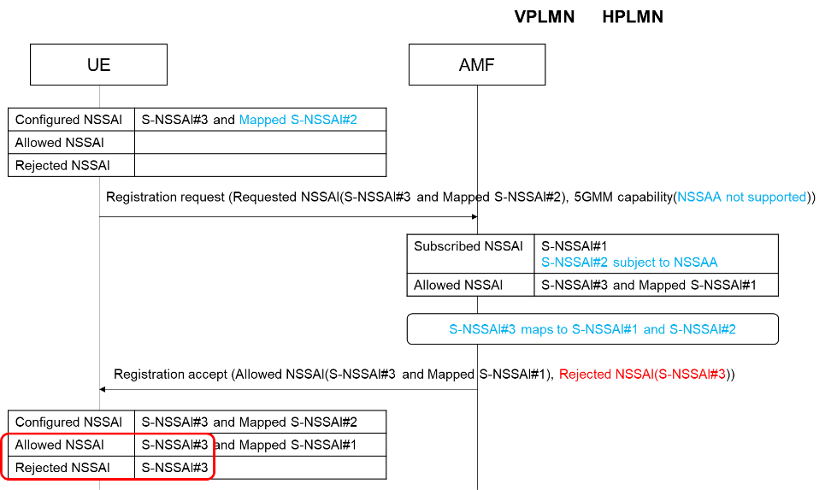  Hence, CT1 came up with a resolution that rejected NSSAI for the current PLMN shall not include an S-NSSAI for the current PLMN which is associated to multiple mapped S-NSSAIs and some of these mapped S-NSSAIs are not allowed (fig below).  Fig2  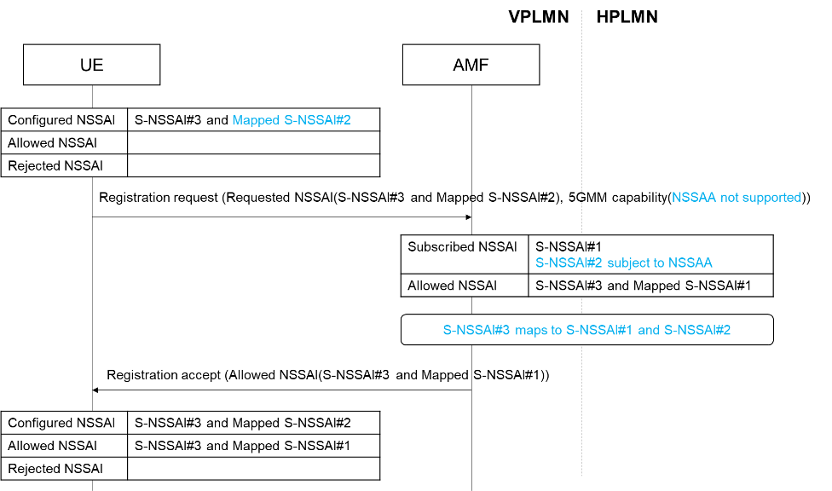  [Discussion]  With this, the concerning situation#1 is that UE still can request S-NSSAI#2 in subsequent registration, which should be avoided because S-NSSAI#2 will never be allowed (i.e., S-NSSAI subject to NSSAA requested by UE not supporting NSSAA requesting will never be allowed).  For this, CT1 also defined a following NOTE (as an implementation guideline)  NOTE 6: The UE can avoid requesting an S-NSSAI associated with a mapped S-NSSAI, which was included in the previous requested NSSAI but neither in the allowed NSSAI nor in the rejected NSSAI in the consequent registration procedures.  For this NOTE, the remark worth to pay attention is that stage2 requirement defines as follows.  S-NSSAIs that the UE provides in the Requested NSSAI which are neither in the Allowed NSSAI nor provided as a rejected S-NSSAI, shall, by the UE, not be regarded as rejected, i.e. the UE may request to register these S-NSSAIs again next time the UE sends a Requested NSSAI.  Thus, under the same situation where allowed NSSAI and rejected NSSAI does not include the S-NSSAI requested,  - stage3 says UE can avoid requesting the S-NSSAI in subsequent registration.  - stage2 says UE may request the S-NSSAI in subsequent registration.  In our view this will create ambiguity to the UE implementation because simply saying it is not clear how(on what condition) UE determines which requirement (stage2 or stage3) to implement.  So, this paper intends to propose a resolution which resolve the concerning situation#1 without ambiguity.  The objective is to prohibit the UE from using an S-NSSAI that UE is not supposed to use.  Following facts are used as a base of the resolution.  - If an S-NSSAI is neither included in Configured NSSAI nor Allowed NSSAI, UE will not request the S-NSSAI.  - Basically Configured NSSAI derived from Subscribed NSSAI.  The resolution is to update the Configured NSSAI by excluding the S-NSSAI(s) from Subscribed NSSAI if those S-NSSAI(s) are not applicable to UE based on UE capability.
Summary of change: |  | The resolution is to update the Configured NSSAI by excluding the S-NSSAI(s) from Subscribed NSSAI if those S-NSSAI(s) are not applicable to UE based on UE capability.
Consequences if not approved: |  | Bad user experience for UE not supporting NSSAA where UE keeps requesting S-NSSAI which the UE is not supposed to use.
Clauses affected: |  | 6.1.6.2.2, 6.2.6.2.2, 6.2.6.2.3, A.3
 |  | Y | N
Other specs |  |  | X | Other core specifications |  |  |  | TS/TR ... CR ...
affected: |  |  | X | Test specifications |  |  |  | TS/TR ... CR ...
(show related CRs) |  |  | X | O&M Specifications |  |  |  | TS/TR ... CR ...
Other comments:
This CR's revision history:

***** 1st change *****

6.1.6.2.2 Type: Nssai
Table 6.1.6.2.2-1: Definition of type Nssai
Attribute name | Data type | P | Cardinality | Description | Applicability
supportedFeatures | SupportedFeatures | O | 0..1 | See clause 6.1.8
defaultSingleNssais | array(Snssai) | M | 1..N | A list of Single Nssais used as default  (NOTE 1)) | Nssaa
singleNssais | array(Snssai) | O | 1..N | List of non default Single Nssais.  (NOTE 1)) | Nssaa
provisioningTime | DateTime | C | 0..1 | This attribute shall be present if the Nssai is sent to the AMF while reception has not yet been acknowledged from the UE; otherwise shall be absent.  This attribute serves as Network Slicing Subscription Change Indication.
additionalSnssaiData | map(AdditionalSnssaiData) | O | 1..N | A map (list of key-value pairs where singleNssai converted to string serves as key) of additional information related to this single Nssai.
NOTE 1: If AMF updated UDM that UE does not support NSSAA, this attribute shall not include S-NSSAI(s) subject to Network Slice-Specific Authentication and Authorization.

***** Next change *****

6.2.6.2.2 Type: Amf3GppAccessRegistration
Table 6.2.6.2.2-1: Definition of type Amf3GppAccessRegistration
 | Attribute name |  |  |  |  | Data type |  |  |  |  | P |  |  |  |  | Cardinality |  |  |  |  | Description
 | amfInstanceId |  |  |  |  | NfInstanceId |  |  |  |  | M |  |  |  |  | 1 |  |  |  |  | The identity the AMF uses to register in the NRF.
 | deregCallbackUri |  |  |  |  | Uri |  |  |  |  | M |  |  |  |  | 1 |  |  |  |  | A URI provided by the AMF to receive (implicitly subscribed) notifications on deregistration.  The deregistration callback URI shall have unique information within AMF set to identify the UE to be deregistered.
 | guami |  |  |  |  | Guami |  |  |  |  | M |  |  |  |  | 1 |  |  |  |  | This IE shall contain the serving AMF's GUAMI.
 | ratType |  |  |  |  | RatType |  |  |  |  | M |  |  |  |  | 1 |  |  |  |  | This IE shall indicate the current RAT type of the UE.
 | supportedFeatures |  |  |  |  | SupportedFeatures |  |  |  |  | O |  |  |  |  | 0..1 |  |  |  |  | See clause 6.2.8  These are the features supported by the AMF.
 | purgeFlag |  |  |  |  | PurgeFlag |  |  |  |  | O |  |  |  |  | 0..1 |  |  |  |  | This flag indicates whether or not the AMF has deregistered. It shall not be included in the Registration service operation.
 | pei |  |  |  |  | Pei |  |  |  |  | O |  |  |  |  | 0..1 |  |  |  |  | Permanent Equipment Identifier.  Absence of PEI indicates that the PEI is not available at the AMF. In this case the UDM/UDR shall not delete the PEI value stored from a previous registration.
 | imsVoPs |  |  |  |  | ImsVoPs |  |  |  |  | O |  |  |  |  | 0..1 |  |  |  |  | Indicates per UE if "IMS Voice over PS Sessions" is homogeneously supported in all TAs in the serving AMF, or homogeneously not supported, or if support is non-homogeneous/unknown. Absence of this attribute shall be interpreted as "non homogenous or unknown" support.
 | amfServiceNameDereg |  |  |  |  | ServiceName |  |  |  |  | O |  |  |  |  | 0..1 |  |  |  |  | When present, this IE shall contain the name of the AMF service to which the Deregistration Notification is to be sent (see clause 6.5.2.2 of 3GPP TS 29.500 [4]).
 | pcscfRestorationCallbackUri |  |  |  |  | Uri |  |  |  |  | O |  |  |  |  | 0..1 |  |  |  |  | A URI provided by the AMF to receive (implicitly subscribed) notifications on the need for P-CSCF Restoration.
 | amfServiceNamePcscfRest |  |  |  |  | ServiceName |  |  |  |  | O |  |  |  |  | 0..1 |  |  |  |  | When present, this IE shall contain the name of the AMF service to which P-CSCF Restoration Notifications are to be sent (see clause 6.5.2.2 of 3GPP TS 29.500 [4]). This IE may be included if pcscfRestorationCallbackUri is present.
 | initialRegistrationInd |  |  |  |  | boolean |  |  |  |  | C |  |  |  |  | 0..1 |  |  |  |  | This IE shall be included by the AMF and set to true if the UE performs an Initial Registration. If the UE does not perform initial registration it shall be absent or set to false. When present and true, the UDM+HSS is requested to cancel previous registration in SGSN, if any.  Not applicable for Nudr and Nudm_UECM GET operation.  (NOTE 2)
 | backupAmfInfo |  |  |  |  | array(BackupAmfInfo) |  |  |  |  | C |  |  |  |  | 1..N |  |  |  |  | This IE shall be included if the NF service consumer is an AMF and the AMF supports the AMF management without UDSF for the first interaction with UDM.  The UDM uses this attribute to do an NRF query in order to invoke later services in a backup AMF, e.g. Namf_EventExposure.
 | drFlag |  |  |  |  | DualRegistrationFlag |  |  |  |  | O |  |  |  |  | 0..1 |  |  |  |  | Dual Registration flag. When present and true, this flag indicates that the UDM+HSS is requested not to send S6a-CLR to the registered MME/SGSN (if any). Otherwise, the registered MME (if any) shall be cancelled.  Not applicable for Nudr and Nudm_UECM GET operation.
 | urrpIndicator |  |  |  |  | boolean |  |  |  |  | O |  |  |  |  | 0..1 |  |  |  |  | This IE indicates whether "UE_REACHABILITY_FOR_SMS" event for this user has been subscribed or not:  - true: the event has been subscribed  - false, or absence of this attribute: the event for this user is currently not subscribed  (NOTE 1)
 | amfEeSubscriptionId |  |  |  |  | string |  |  |  |  | C |  |  |  |  | 0..1 |  |  |  |  | Shall be present if urrpIndicator is true and the UDM has subscribed to ReachabilityReport event for "UE Reachability for DL Traffic" at the AMF to receive One-Time UE Activity notification. It contains the subscription Id allocated by the AMF as received by the UDM as part of the HTTP "Location" header of the Namf_EventExposure_Subscribe response.  The UDM shall make use of the Nudr_DataRepository Update service operation (see 3GPP TS 29.504 [9]) to store the amfEeSubscription Id in the UDR.
epsInterworkingInfo |  |  |  |  | EpsInterworkingInfo |  |  |  |  | C |  |  |  |  | 0..1 |  |  |  |  | This IE shall be included if the AMF has determined per APN/DNN which PGW-C+SMF is selected for EPS interworking with N26 and the AMF supports EPS interworking of non-3GPP access. For each APN/DNN, only one PGW-C+SMF shall be selected by the AMF for EPS interworking.
 |  | ueSrvccCapability |  |  |  |  | boolean |  |  |  |  | O |  |  |  |  | 0..1 |  |  |  |  | This IE indicates whether the UE supports 5G SRVCC:  - true: 5G SRVCC is supported by the UE and AMF;  - false, or absence of this attribute: 5G SRVCC is not supported.
 |  | registrationTime |  |  |  |  | DateTime |  |  |  |  | C |  |  |  |  | 0..1 |  |  |  |  | Time of Amf3GppAccessRegistration. Shall be present when used on Nudr.
 |  |  | vgmlcAddress |  |  |  |  | VgmlcAddress |  |  |  |  | O |  |  |  |  | 0..1 |  |  |  |  | Address of the VGMLC
 |  |  | contextInfo |  |  |  |  | ContextInfo |  |  |  |  | C |  |  |  |  | 0..1 |  |  |  |  | This IE if present may contain e.g. the headers received by the UDM along with the 3GppAccessRegistration.  Shall be absent on Nudm and may be present on Nudr
 |  |  |  | singleNssais |  |  |  |  | array(Snssai) |  |  |  |  | O |  |  |  |  | 1..N |  |  |  |  | List of S-NSSAIs identifying the network slices the subscriber is registered to.
 |  |  |  | ueNssaaCapability |  |  |  |  | boolean |  |  |  |  | O |  |  |  |  | 0..1 |  |  |  |  | This IE indicates whether the UE supports NSSAA:  - true: NSSAA is supported by the UE;  - false, or absence of this attribute: NSSAA is not supported.
NOTE 1: The urrpIndicator attribute shall only be exposed over the Nudr SBI, and it shall not be included by the AMF.
NOTE 2: Regardless of the Dual Registration Flag, the SGSN, if any, is required to be cancelled (see 3GPP TS 23.502 [3] clause 4.11.5.2)

***** next change *****

6.2.6.2.3 Type: AmfNon3GppAccessRegistration
Table 6.2.6.2.3-1: Definition of type AmfNon3GppAccessRegistration
Attribute name |  |  | Data type |  |  | P |  |  | Cardinality |  |  | Description
amfInstanceId |  |  | NfInstanceId |  |  | M |  |  | 1 |  |  | The identity the AMF uses to register in the NRF.
deregCallbackUri |  |  | Uri |  |  | M |  |  | 1 |  |  | A URI provided by the AMF to receive (implicitly subscribed) notifications on deregistration.  The deregistration callback URI shall have unique information within AMF set to identify the UE to be deregistered.
guami |  |  | Guami |  |  | M |  |  | 1 |  |  | This IE shall contain the serving AMF's GUAMI.
ratType |  |  | RatType |  |  | M |  |  | 1 |  |  | This IE shall indicate the current RAT type of the UE.
supportedFeatures |  |  | SupportedFeatures |  |  | O |  |  | 0..1 |  |  | See clause 6.2.8  These are the features supported by the AMF.
purgeFlag |  |  | PurgeFlag |  |  | O |  |  | 0..1 |  |  | This flag indicates whether or not the AMF has deregistered. It shall not be included in the Registration service operation.
pei |  |  | Pei |  |  | O |  |  | 0..1 |  |  | Permanent Equipment Identifier  Absence of PEI indicates that the PEI is not available at the AMF. In this case the UDM/UDR shall not delete the PEI value stored from a previous registration.
imsVoPs |  |  | ImsVoPs |  |  | M |  |  | 1 |  |  | Indicates per UE if "IMS Voice over PS Sessions" is supported, or not supported.  The value NON_HOMOGENEOUS_OR_UNKNOWN is not applicable.
amfServiceNameDereg |  |  | ServiceName |  |  | O |  |  | 0..1 |  |  | When present, this IE shall contain the name of the AMF service to which the Deregistration Notification is to be sent (see clause 6.5.2.2 of 3GPP TS 29.500 [4]).
pcscfRestorationCallbackUri |  |  | Uri |  |  | O |  |  | 0..1 |  |  | A URI provided by the AMF to receive (implicitly subscribed) notifications on the need for P-CSCF Restoration.
amfServiceNamePcscfRest |  |  | ServiceName |  |  | O |  |  | 0..1 |  |  | When present, this IE shall contain the name of the AMF service to which P-CSCF Restoration Notifications are to be sent (see clause 6.5.2.2 of 3GPP TS 29.500 [4]). This IE may be included if pcscfRestorationCallbackUri is present.
backupAmfInfo |  |  | array(BackupAmfInfo) |  |  | C |  |  | 1..N |  |  | This IE shall be included if the NF service consumer is an AMF and the AMF supports the AMF management without UDSF for the first interaction with UDM.  The UDM uses this attribute to do an NRF query in order to invoke later services in a backup AMF, e.g. Namf_EventExposure.
urrpIndicator |  |  | boolean |  |  | O |  |  | 0..1 |  |  | This IE indicates whether "UE_REACHABILITY_FOR_SMS" event for this user has been subscribed or not:  - true: the event has been subscribed  - false, or absence of this attribute: the event for this user is currently not subscribed
amfEeSubscriptionId |  |  | string |  |  | C |  |  | 0..1 |  |  | Shall be present if urrpIndicator is true and the UDM has subscribed to Reachability-Report event for "UE Reachable for DL Traffic" at the AMFto receive One-Time UE Activity notification. It contains the subscription Id allocated by the AMF as received by the UDM as part of the HTTP "Location" header of the Namf_EventExposure_Subscribe response.  The UDM shall make use of the Nudr_DataRepository Update service operation (see 3GPP TS 29.504 [9]) to store the amfEeSubscription Id in the UDR.
registrationTime |  |  | DateTime |  |  | C |  |  | 0..1 |  |  | Time of AmfNon3GppAccessRegistration. Shall be present when used on Nudr.
 | vgmlcAddress |  |  | VgmlcAddress |  |  | O |  |  | 0..1 |  |  | Address of the VGMLC
 | contextInfo |  |  | ContextInfo |  |  | C |  |  | 0..1 |  |  | This IE if present may contain e.g. the headers received by the UDM along with AmfNon3GppRegistration.  Shall be absent on Nudm and may be present on Nudr.
 |  | singleNssais |  |  | array(Snssai) |  |  | O |  |  | 1..N |  |  | List of S-NSSAIs identifying the network slices the subscriber is registered to.
 |  | ueNssaaCapability |  |  | boolean |  |  | O |  |  | 0..1 |  |  | This IE indicates whether the UE supports NSSAA:  - true: NSSAA is supported by the UE;  - false, or absence of this attribute: NSSAA is not supported.
NOTE: The urrpIndicator attribute shall only be exposed over the Nudr SBI, and it shall not be included by the AMF.

***** next change *****

A.3 Nudm_UECM API
[..]

Amf3GppAccessRegistration:
type: object
required:
- amfInstanceId
- deregCallbackUri
- guami
- ratType
properties:
amfInstanceId:
$ref: 'TS29571_CommonData.yaml#/components/schemas/NfInstanceId'
supportedFeatures:
$ref: 'TS29571_CommonData.yaml#/components/schemas/SupportedFeatures'
purgeFlag:
$ref: '#/components/schemas/PurgeFlag'
pei:
$ref: 'TS29571_CommonData.yaml#/components/schemas/Pei'
imsVoPs:
$ref: '#/components/schemas/ImsVoPs'
deregCallbackUri:
$ref: 'TS29571_CommonData.yaml#/components/schemas/Uri'
amfServiceNameDereg:
$ref: 'TS29510_Nnrf_NFManagement.yaml#/components/schemas/ServiceName'
pcscfRestorationCallbackUri:
$ref: 'TS29571_CommonData.yaml#/components/schemas/Uri'
amfServiceNamePcscfRest:
$ref: 'TS29510_Nnrf_NFManagement.yaml#/components/schemas/ServiceName'
initialRegistrationInd:
type: boolean
guami:
$ref: 'TS29571_CommonData.yaml#/components/schemas/Guami'
backupAmfInfo:
type: array
items:
$ref: 'TS29571_CommonData.yaml#/components/schemas/BackupAmfInfo'
minItems: 1
drFlag:
$ref: '#/components/schemas/DualRegistrationFlag'
ratType:
$ref: 'TS29571_CommonData.yaml#/components/schemas/RatType'
urrpIndicator:
type: boolean
amfEeSubscriptionId:
type: string
epsInterworkingInfo:
$ref: '#/components/schemas/EpsInterworkingInfo'
ueSrvccCapability:
type: boolean
registrationTime:
$ref: 'TS29571_CommonData.yaml#/components/schemas/DateTime'
vgmlcAddress:
$ref: '#/components/schemas/VgmlcAddress'
contextInfo:
$ref: 'TS29503_Nudm_SDM.yaml#/components/schemas/ContextInfo'
singleNssais:
type: array
items:
$ref: 'TS29571_CommonData.yaml#/components/schemas/Snssai'
minItems: 1
ueNssaaCapability:
type: boolean

***** next change *****

A.3 Nudm_UECM API
[..]

AmfNon3GppAccessRegistration:
type: object
required:
- amfInstanceId
- imsVoPs
- deregCallbackUri
- guami
- ratType
properties:
amfInstanceId:
$ref: 'TS29571_CommonData.yaml#/components/schemas/NfInstanceId'
supportedFeatures:
$ref: 'TS29571_CommonData.yaml#/components/schemas/SupportedFeatures'
purgeFlag:
$ref: '#/components/schemas/PurgeFlag'
pei:
$ref: 'TS29571_CommonData.yaml#/components/schemas/Pei'
imsVoPs:
$ref: '#/components/schemas/ImsVoPs'
deregCallbackUri:
$ref: 'TS29571_CommonData.yaml#/components/schemas/Uri'
amfServiceNameDereg:
$ref: 'TS29510_Nnrf_NFManagement.yaml#/components/schemas/ServiceName'
pcscfRestorationCallbackUri:
$ref: 'TS29571_CommonData.yaml#/components/schemas/Uri'
amfServiceNamePcscfRest:
$ref: 'TS29510_Nnrf_NFManagement.yaml#/components/schemas/ServiceName'
guami:
$ref: 'TS29571_CommonData.yaml#/components/schemas/Guami'
backupAmfInfo:
type: array
items:
$ref: 'TS29571_CommonData.yaml#/components/schemas/BackupAmfInfo'
minItems: 1
ratType:
$ref: 'TS29571_CommonData.yaml#/components/schemas/RatType'
urrpIndicator:
type: boolean
amfEeSubscriptionId:
type: string
registrationTime:
$ref: 'TS29571_CommonData.yaml#/components/schemas/DateTime'
vgmlcAddress:
$ref: '#/components/schemas/VgmlcAddress'
contextInfo:
$ref: 'TS29503_Nudm_SDM.yaml#/components/schemas/ContextInfo'
singleNssais:
type: array
items:
$ref: 'TS29571_CommonData.yaml#/components/schemas/Snssai'
minItems: 1
ueNssaaCapability:
type: boolean

