Invitation to the
3GPP TSG-SA/CT#101 (Sep 11-15, 2023)
Meetings At Bengaluru (Bangalore), India

Dear 3GPP Delegates,

Telecommunication Standards Development Society, India (TSDSI) and 5G Industry Forum (5GIF) are pleased to invite you to the 3GPP SA#101, and 3GPP CT#101 meetings in Bengaluru, India (“Silicon Valley” of India).

Meeting Venue
3GPP SA#101/CT#101 Meetings

Bengaluru Marriott Hotel Whitefield
Plot No 75, 8th Rd, Whitefield, EPIP Zone, Bengaluru, Karnataka 560066
T: +91.80.4943.5000 | M: +91 95139.74335 | Debanjan.Mukherjee@marriotthotels.com

Single Occupancy room at INR 16000 (~195 USD) + taxes
Doube Occupancy room at INR 19000 (~230 USD) + taxes
[***Includes BREAKFAST, LUNCH, INTERNET***]

*****HOTEL RESERVATION LINK****

Meeting Registration
Please register to the 3GPP meetings online with your 3GU account:
3GPP SA#101
3GPP CT#101

Accomodation

- A block of rooms have been reserved for 3GPP delegates at discounted rates that includes complimentary BREAKFAST, LUNCH and INTERNET. This was possible with the hosts guaranteeing a minimum number of rooms.
- The hosts highly recommended that you stay at the meeting hotel for your comfort, convenience and the sustainability of 3GPP meeting hosting model.
- Hotel reservations must be made using reservation link provided, to ensure that the hotel recognizes you as a 3GPP delegate.
- The CUT-OFF DATE for reserving rooms at negotiated price is June 30, 2023. The negotiated block of rooms will be released after this date.

Note: The weather in Bengaluru is generally pleasant and moderate with temperatures around 28°C (High) / 20° (Low). However, September is part of the rainy season, therefore please carry an umbrella!

Cancellations:
Cancellation policy is governed by the hotel (please read carefully) as follows:
- At the time of booking, the guest will be charged for one night (as a deposit)
- Room cancellation within 7 days of the meeting (Sep 03, 2023 or later), the full amount of the stay will be charged directly to the guest
- Room cancellation 7 days prior to the meeting (before Sep 03, 2023), will be fully refunded to the guest.

TSDSI, 5GIF and 3GPP are not responsible for reservation confirmations, cancelled or changed reservations, or no-shows.

Airport/Transportation

Kempegowda International Airport, Bengaluru (Airport Code: BLR). This airport is served by several leading international carriers and is operational throughout the day/night. Visit official website for more information: https://www.bengaluruairport.com/

Transportation from/to Airport and the Meeting Venue:

Google Maps: The hotel/meeting venue is approximately 46KM, and takes anywhere between 60-90mins by Taxi (which is the most convenient/recommended mode of transportation).

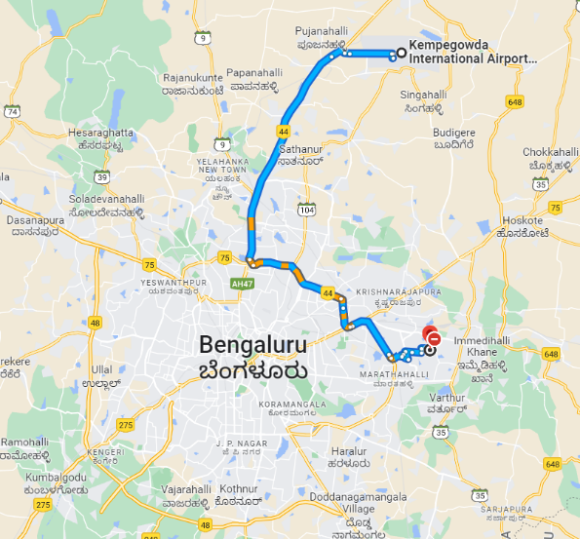

The airport has a well-developed Airport Taxi services (cost is approximately 1500 INR = ~18 USD):
- Airport Taxi: Bangalore Airport has Walk-in Taxi service (Airport Taxi) outside the Arrival Gates. Please follow the sign board of “Airport Taxi” once you exit the Arrival lobby area.
- App Based Taxi Services: There are various App based service providers such as Uber and Ola. There are dedicated Uber zones and Ola zones to pick up their passengers.

For your convenience, TSDSI has also partnered with a private transportation service “Travel Bell”, who has offered to provide transportation to/from airport and the meeting hotel. Requests can be made online using the following URL: https://travelbell.in/airport-service/, which allows you to reserve a taxi in advance at no upfront cost (and making the payment only 7 days in advance of your travel by credit card after re-confirmation of your flight information). The costs are 1800 INR/~22 USD (Sedan) and 2600 INR/~32 USD (MPV), which includes personalized service.

Power Adapter/Voltage
Please be sure you have the correct adapter. Voltage converters will not be provided at the meeting. India's A/C supply is 230V-50Hz. The plug is a "Type D." The image below is a visual representation of the adapter you will need if your equipment does not have the correct plug.

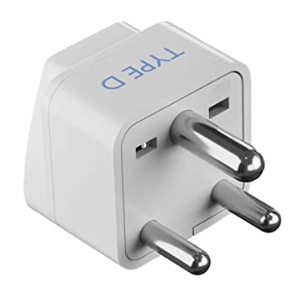

Visa Information

****VISA LETTER****
Delegates needing a visa support letter in order to attend meeting hosted in India should register to the meeting on 3GU portal and make their hotel reservation (through meeting reseration link provided above) where the meeting will take place. Subsequently, they can request the Visa Support Letter by filling their personal details along with the hotel confirmation number at the following portal (automated tool):
Visa Support Letter Portal: https://www.5gindiaforum.in/3gpp2023
Please request the visa support letter at the earliest, to allow us to work with Indian Embassy to expedite and/or resolve any visa concerns you may have. Should you need hard copy of the visa letter, or any visa queries, please email 3GPP_Visa_Support@tsdsi.in with your mailing address and also attach the Visa Support Letter (soft copy) received from the Visa Support Letter Portal, with the subject line “3GPP Visa Support Sep 2023 Bengaluru”. Please do account sufficient time for the processing such requests and TSDSI is NOT responsible for any shipment delays beyond our control.

Authorized Portal for Visa Application to India: https://indianvisaonline.gov.in/

As of date, Government of India allows citizens from 166 countries to obtain an e-VISA. This is generally a convenient process and covers citizens from most countries. The recommended visa type is “Conference Visa”. Please check with the Indian embassy website of your country for further information. The delegates from the countries that do not qualify for e-Visa, must undergo the standard visa application process.

Tourism

Bengaluru (popularly known as Bangalore) is the capital and largest city of the southern Indian state of Karnataka. It is known as the Silicon Valley of India due to its booming IT industry, which is one of the largest in the world. Bangalore is known for its pleasant climate and lush green spaces that make for a great quality of life. The city has a vibrant nightlife, with plenty of bars, pubs, restaurants, and clubs that cater to the young and vibrant population. It is also home to a number of cultural attractions, including temples, parks, museums and world-class infrastructure. While in the city, one can explore the beautiful Lal Bagh gardens, Cubbon Park, the famous Bangalore Palace, Nandi Hills, etc. In addition to this, the city also offers a wide range of shopping and dining experiences, with some of the most popular restaurants and malls in the country. With its vibrant and cosmopolitan culture, Bengaluru is sure to leave a lasting impression on its visitors. For more tourism information, please visit: https://karnatakatourism.org/.

We are looking forward to seeing you in Bengaluru.

Sincerely,
Kuljit Singh
Executive Director, TSDSI
On behalf of the TSDSI and 5GIF

Hosts of the meeting:
The TSDSI and 5GIF
- TSDSI is an Organization Partner (OP) of 3GPP, and the primary hosting organization.
- 5GIF is the logistical partner and comprises of Ericsson India, Huawei India, Intel India, Nokia India, Qualcomm India, and Samsung India.

