To Members of ETSI 3GPP -- Invitation to the
3GPP CT6 AdHoc on USAT Test Specification split with SCP
APRIL 19 (AT 9:30) – 21 (BY 17:00), 2006
in La Ciotat, France

Dear Colleagues,
Gemplus has the pleasure to invite you to “La Vigie” Gemplus building, in La Ciotat for the Ad-Hoc meeting on the split of the USAT/CAT Test Specifications (3GPP TS 31.124 / ETSI TS 102 384).
Meeting directions and general information are provided in the following pages.

Address of the Meeting
GEMPLUS S.A.

Avenue du Jujubier
ZI Athelia IV
13705 La Ciotat Cedex
France

Please direct any questions regarding the logistical arrangements of this meeting to the meeting coordinators:

For hotels arrangements :
- Maguie DONNINI, tel. +33 4 4236 2439, maguie.donnini@gemplus.com

For the 3GPP-CT6 AH 31.124 Test split meeting :
- Alexandra GALIMARD, tel. +33 4 4236 3155, alexandra.galimard@gemplus.com
- Eric LAFFONT, tel. +33 (0)4 4236 6202, eric.laffont@gemplus.com

****ON-LINE REGISTRATION****
 All registration for 3GPP meetings is carried out on-line. To register to this meeting please click on the link below:
http://webapp.etsi.org/MeetingCalendar/MeetingDetails.asp?mid=25753
 You are kindly requested to register by 7th April 2006

****DOCUMENTS AND INFORMATION SOURCES****

Server location for documents:

ftp://ftp.3gpp.org/tsg_ct/WG6_smartcard_Ex-T3/Ad-hocs/121-0604-LaCiotat/Docs/

****DEADLINES****

Meeting registration: 7th April 2006

We are looking forward to seeing you in La Ciotat.

Best regards,

Alexandra Galimard
Gemplus
General Meeting Information

Meeting
3GPP CT6 AH 31.124 Test splitting

Dates
April 19 – 21 2006.

Location – Host – Access

GEMPLUS La Vigie
Avenue du Jujubier
ZI Athélia IV
13705 LA CIOTAT
FRANCE

Host

GEMPLUS

Access

Location of Gemplus Building: approximately 60 km from the airports. A one-way taxi ride would cost you around € 60, so the best solution is probably to rent a car.

FROM THE MARSEILLE-PROVENCE AIRPORT | FROM TOULON-HYERES AIRPORT
- Take the A55 freeway (Autoroute du Littoral), following the signs to Marseille/Vieux-Port  - Take the Prado-Carenage toll tunnel (€ 2.30, major credit cards accepted)  - Upon leaving the tunnel, follow the A50 freeway toward Toulon/Aubagne  - Keep following the signs to Toulon | - Take the A570 then the A57 freeways, following the signs to Toulon  - Arriving at Toulon, take the tunnel, following the signs to Marseille  - Upon leaving the tunnel, follow the A50 tollway toward Marseille(€ 1.50, major credit cards accepted)  - Keep following the signs to Marseille

- Exit at "La Ciotat" (toll is € 1, major credit cards accepted)
- At the roundabout after the toll booth, follow the signs for “Athelia IV” and then “R&D Center”
- Pass beneath the bridge
- Take the 2nd street to your left (avenue Jujubier)
- Gemplus “La Vigie” building is located at the top of the street
- 1st gate “Gemplus” entrance
- 2nd gate “Visitors” entrance
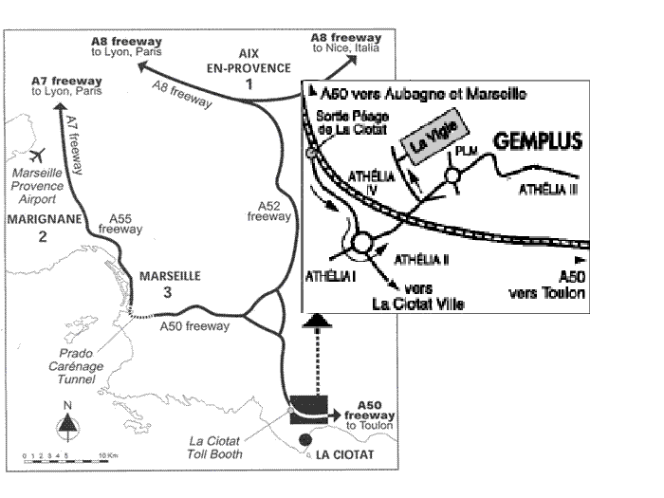

Airport

Marseille-Provence Airport (MRS) – 60 km-
http://www.marseille.aeroport.fr/English/index.html

Alternatively :

Toulon-Hyeres Airport (TLN) – 55 km -
Nice-Cote d’Azur Airport (NCE) – 170 km -

Taxi

A one-way trip from Marseille Airport or Toulon-Hyeres Airport to La Ciotat will cost you approximately € 60 (day tarif). Taxis don’t accept credit cards.

Rental Car

At the Marseille airport, you’ll find the following companies:
Hertz, Avis, ADA, Europcar, Budget, Sixt, National/Citer.

Hotels

Note: IBIS hotel is located at 5 minutes by walking to the meeting place (Gemplus office "La VIGIE" building).

IBIS Hotel
Avenue de la tramontane
Athelia IV
13600 LA CIOTAT (France)
Tel : +33 4 42 71 34 00
Fax : +33 4 42 71 34 01
http://www.accorhotels.com/accorhotels/fichehotel/gb/ibi/5484/fiche_hotel.shtml

Reservations:
Please, mention “GEMPLUS 3GPP Ad-Hoc Meeting”.
Room: 66,50 € per night / 7 € for breakfast.

Note:See below for the reservation of hotels near the beach.

“Le Miramar” Hotel
3 av Beaurivage 13600 LA CIOTAT
Tél/Fax : .+33 4 42 83 33 79
www.miramarlaciotat.com
Reservation:
Please, mention “GEMPLUS 3GPP Ad-Hoc Meeting”.
Room: 65 € per night and 8 € for breakfast.

Golf d’Azur – “Le King” Hotel
40 av St Jean 13600 LA CIOTAT
Tel: +33 4 42 83 12 95
Fax : +33 4 42 71 51 39

“Ciotel Le Cap” Hotel
Corniche Liouquet 13600 LA CIOTAT
Tel: +33 4 42 83 90 30
Fax : +33 4 42 08 04 17
www.leciotel.com/index_us.php
Reservation:
Please, mention “GEMPLUS 3GPP Ad-Hoc Meeting”.
Room: 86 to 125 € per night and 11 € for breakfast.

“Victoria Garden Suites” Hotel
Arène Cros – Baie des Anges 13600 LA CIOTAT
Tel: +33 4 42 08 85 85
Fax: +33 4 42 08 85 86
Reservation:
Please, mention “GEMPLUS 3GPP Ad-Hoc Meeting”.
Room: 70 € per night with breakfast.

Local Information

Please visit :
http://www.mairie-laciotat.fr/
http://www.provenceweb.com/e/bouches/laciotat/laciotat.htm

Weather

The weather in La Ciotat at the time of the meetings should be sunny, and the temperature approximately 16 degrees C. For weather forecasts visit:
http://weather.yahoo.com/forecast/Marseille_FR_c.html

Driving directions to Hotels

Location of hotels: approximately 60 km from the airports. A one-way taxi ride would cost you around € 60, so the best solution is probably to rent a car.

FROM THE MARSEILLE-PROVENCE AIRPORT | FROM TOULON-HYERES AIRPORT
- Take the A55 freeway (Autoroute du Littoral), following the signs to Marseille/Vieux-Port  - Take the Prado-Carenage toll tunnel (€ 2.30, major credit cards accepted)  - Upon leaving the tunnel, follow the A50 freeway toward Toulon/Aubagne  - Keep following the signs to Toulon | - Take the A570 then the A57 freeways, following the signs to Toulon  - Arriving at Toulon, take the tunnel, following the signs to Marseille  - Upon leaving the tunnel, follow the A50 tollway toward Marseille(€ 1.50, major credit cards accepted)  - Keep following the signs to Marseille

IBIS Hotel:

- Exit at "La Ciotat" (toll is € 1, major credit cards accepted)
- At the roundabout after the toll booth, follow the signs for “Athelia IV” and then “R&D Center”
- Pass beneath the bridge
- At the next roundabout, take right
- 100 m after the roundabout, turn right toward "IBIS hotel"

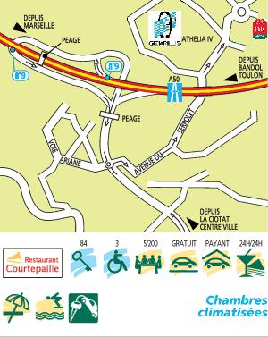

MIRAMAR Hotel:

- Exit at "La Ciotat" (toll is € 1, major credit cards accepted)
- At the roundabout after the toll both, follow the signs toward "La Ciotat – centre ville".
- See below.
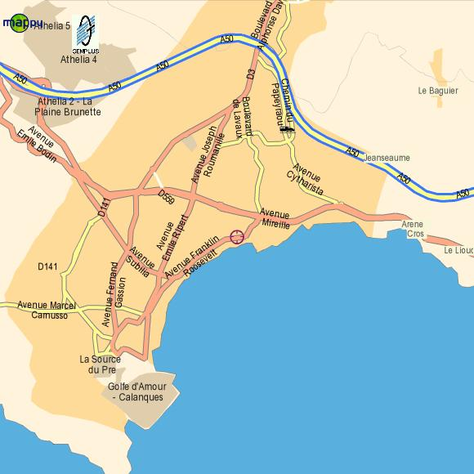

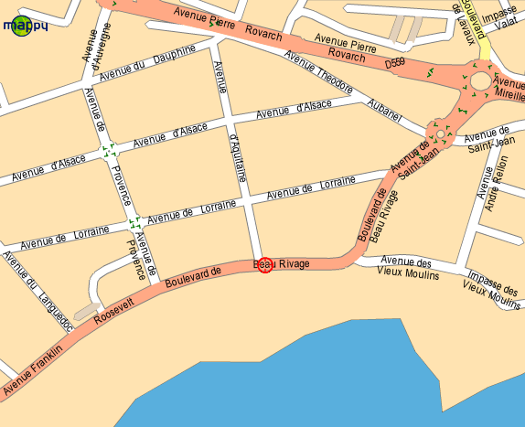

LE KING Hotel:

- Exit at "La Ciotat" (toll is € 1, major credit cards accepted)
- At the roundabout after the toll both, follow the signs toward "La Ciotat – centre ville"
- At the next roundabout, take left toward "Bandol-St Cyr"
- See below.
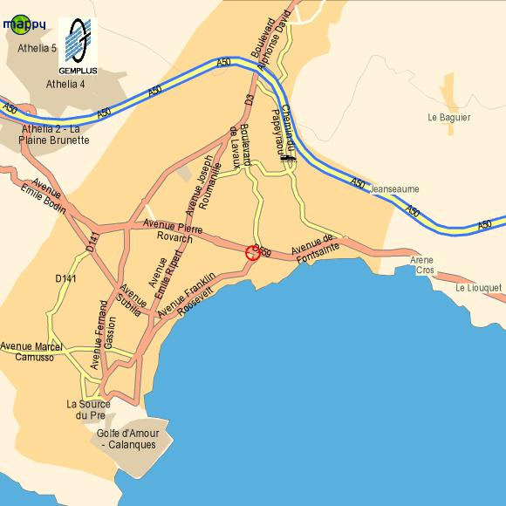
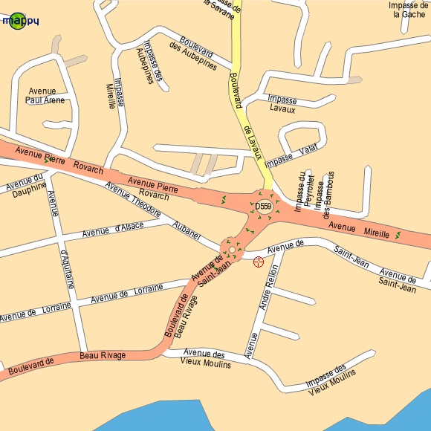

Ciotel LE CAP Hotel:

- Exit at "La Ciotat" (toll is € 1, major credit cards accepted)
- At the roundabout after the toll both, follow the signs toward "La Ciotat – centre ville"
- At the next roundabout, take left toward "Bandol-St Cyr"
- 2 km after the exit of the town, turn right toward "Le Liouquet"
- The hotel is just on the right.

Victoria Garden Suites Hotel:

- Exit at "La Ciotat" (toll is € 1, major credit cards accepted)
- At the roundabout after the toll both, follow the signs toward "La Ciotat – centre ville"
- At the next roundabout, take left toward "Bandol-St Cyr"
- See below.

