3GPP CT6 #38 Meeting

From 31st January to 3rd February 2006
In Tokyo, Japan

Dear Colleagues,

It’s a great pleasure for NEC, Panasonic, Mitsubishi, Fujitsu, SHARP, Sony Ericsson, TOSHIBA, DNP and NTT DoCoMo to invite you to the 38th 3GPP CT6 meeting in Tokyo, Japan.
Meeting will be held from January 31st to February 3rd.

Meeting directions and general information are provided in the following pages.

Please take a few minutes and register for the meeting at the time of hotel reservation. Your on-time, completed registration is very important for the accurate planning of the meetings. This can be done on-line at the following URL.

http://webapp.etsi.org/MeetingCalendar/MeetingDetails.asp?mid=25100

Feel free to direct any questions to the meeting coordinator:

- Motoi Minami, to minami@cet.yrp.nttdocomo.co.jp

I’m looking forward to seeing you all in Tokyo.

Best regards

Motoi Minami
NTT DoCoMo, Inc.

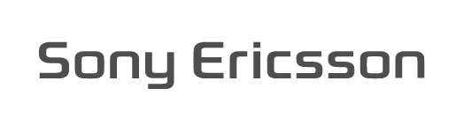






General Meeting Information

Meetings details:
3GPP CT6 #38 meeting
Starting: 09:00 on 31st January 2006 on the 26th floor of the hotel
Closing: 17:00 on 3rd February 2006

Meeting location:
ASAKUSA VIEW HOTEL
3-17-1 Nishiasakusa, Taito-ku, Tokyo 111-8765 Japan
Phone: (+81) 3 3847 1111
FAX: (+81) 3 3842 2117
URL: http://www.viewhotels.co.jp/asakusa/english/index.html

Reservation:
Room rate per night (including breakfast, tax, service charge):

Twin room (Single use) JPY 13,000
Twin room (Double use) JPY 18,000
Double room JPY 20,000

Block booking has been made and the deadline for the hotel reservation is 12th of January.
Attendees are requested to make an individual reservation by the deadline using the form attached at the end of this invitation.

Welcome Dinner: (Social Event)
NEC, Panasonic, Mitsubishi, Fujitsu, SHARP, Sony Ericsson, TOSHIBA, DNP and NTT DoCoMo have the pleasure of inviting participants to a dinner that will be served on Wednesday, 1st Feb 2005.

Meeting Documents:

Meeting documents can be found at the 3GPP web site at:
http://www.3gpp.org/ftp/tsg_ct/WG6_Smartcard_Ex-T3/CT6-38/Docs/

Please respect the DEADLINE for input documents:
Documents received after the deadline may receive a lower priority during the meeting.

This will be a paperless meeting. Documents will be provided by a wireless LAN (IEEE 802.11b).

Hotel information:
・ASAKUSA VIEW HOTEL
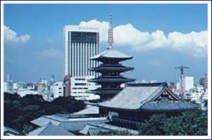
3-17-1 Nishiasakusa,Taito-ku,Tokyo
111-8765 Japan
Phone: (+81) 3 3847 1111
FAX: (+81) 3 3842 2117
URL: http://www.viewhotels.co.jp/asakusa/english/index.html

Location
Asakusa View Hotel is located in the heart of Asakusa, and is only 15 minutes by subway of Ginza line from famous Ginza area. New railway station Asakusa of Tsukuba express opened on 24th August 2005 and it connects Asakusa to Electric City Akihabara, where you can find an Akihabara Denki Street - stretch of electric shoppers which is an internationally well-known place for guests to visit. Akihabara is 2 stations from Asakusa by Tsukuba express train. Exciting town called Ueno is very close to Asakusa, and guests can enjoy a big market. Keisei Skyliner is an ideal transport from Narita airport to Ueno. It is a super express train designed to transfer travelers to Ueno.

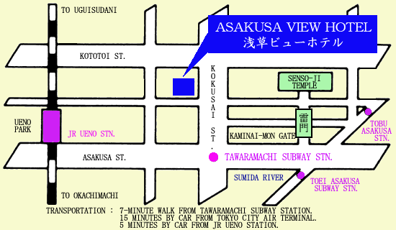

Airport:
Narita International Airport
http://www.narita-airport.or.jp/airport_e/index.html

Narita Airport/Terminal Building I
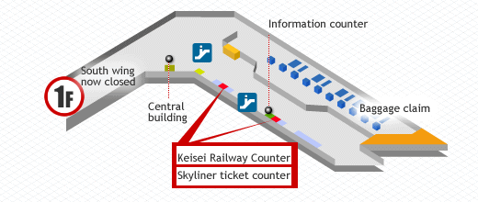
Airport Terminal 2/Terminal building II
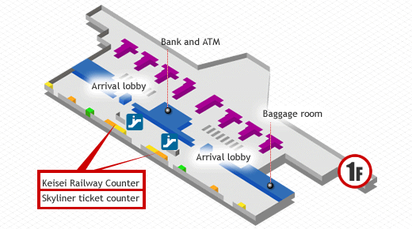

<Directions to the hotel >
Taking a Taxi from the Airport to the hotel is not recommended, as it costs you extremely high. (Approximately 20,000 yen and 100 minutes)

There is no limousine bus operated between airport and hotel. Taking Express train is most recommended.
Take a Keisei Skyliner that connects Narita Airport directly to downtown. It takes 60 minutes from Airport Terminal 2 to Keisei Ueno Station.
Then, take a taxi from Ueno Station to the hotel. It usually costs you less than 1,000 yen and 5 minutes.
A flat sum of 1,000 yen will be reimbursed to all the delegates at the hotel check-in desk, regardless of whether or not a taxi is taken.

Keisei Skyliner Airport Express Information

Total fare is 1,920 yen including express ticket and standard fare | Express ticket | Standard fare | Total fare
Keisei Ueno ← → Airport Terminal 2/Narita Airport | 920 yen  (460 yen) | 1000 yen  (500 yen) | 1920 yen  (960 yen)
Children's fares are in parentheses
Above fares are for one-way trip

<weekday timetable>
 | Narita Airport | Terminal 2 | Keisei Narita | Nippori | Keisei Ueno
2nd | 9:23 | 9:26 | 9:33 | 10:21 | 10:26
4th | 9:56 | 9:58 | 10:05 | 10:52 | 10:57
6th | 10:36 | 10:38 | 10:45 | 11:32 | 11:37
8th | 11:16 | 11:18 | 11:25 | 12:12 | 12:17
10th | 11:56 | 11:58 | 12:05 | 12:52 | 12:57
12th | 12:36 | 12:38 | 12:45 | 13:32 | 13:37
14th | 13:16 | 13:18 | 13:25 | 14:12 | 14:17
16th | 13:56 | 13:58 | 14:05 | 14:52 | 14:57
18th | 14:36 | 14:38 | 14:45 | 15:32 | 15:37
20th | 15:16 | 15:18 | 15:25 | 16:12 | 16:17
22nd | 15:55 | 15:58 | 16:05 | 16:53 | 16:58
24th | 16:33 | 16:36 | 16:43 | 17:32 | 17:37
26th | 17:13 | 17:16 | 17:23 | 18:12 | 18:17
28th | 17:35 | 17:37 | 17:44 | 18:31 | 18:36
30th | 18:04 | 18:07 | 18:14 | 19:01 | 19:06
32nd | 18:46 | 18:49 | 18:56 | 19:43 | 19:48
34th | 19:26 | 19:28 | 19:35 | 20:24 | 20:29
36th | 20:00 | 20:02 | 20:09 | 20:57 | 21:02
38th | 20:30 | 20:32 | 20:39 | 21:27 | 21:32
40th | 21:00 | 21:02 | 21:09 | 21:56 | 22:02
42nd | 21:30 | 21:32 | 21:39 | 22:25 | 22:30
44th | 22:00 | 22:02 | 22:09 | 22:56 | 23:00

Timetable for weekend and a timetable to the airport can be found at the following URL
http://www.keisei.co.jp/keisei/tetudou/keisei_us/html/st_ueno_end.html

<Directions to the Airport>
For your way back to the airport, 3 Shuttle Buses will be operated by the hotel free of charge for the delegates. Departing time is to be determined depending on the delegates’ flight schedule. If you plan to take a shuttle bus, please tick ‘yes’ and write down your departing time in the reservation form. If you do not need a shuttle bus, and goes back to the airport by yourself, another 1,000 yen will be provided as a taxi fare to the Keisei Ueno Station.

<Keisei Ueno Station>

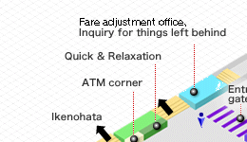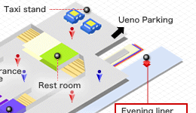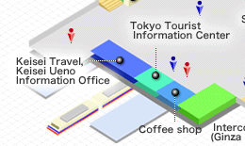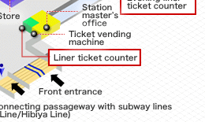

Maps:
< Ueno Station and Hotel>
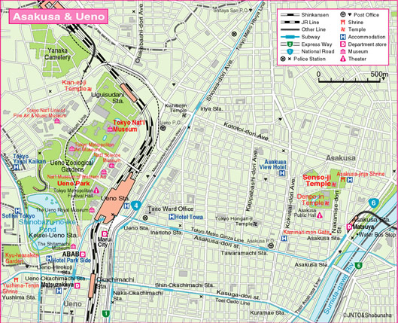
Keisei Ueno Station

ASAKUSA VIEW HOTEL
JR Ueno Station

<JR Yamanote line and Keisei Line>
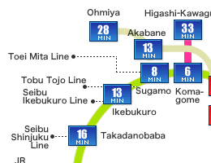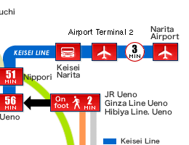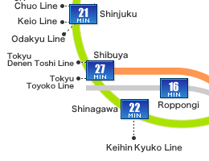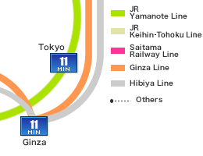

Complete JR map can be found at http://www.jreast.co.jp/e/info/map_a4ol.pdf

<Metro>

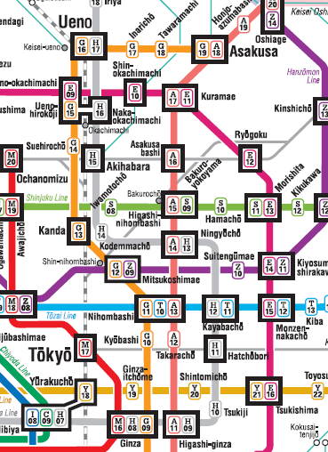
ASAKUSA
VIEW HOTEL

Complete metro map can be found at http://www.tokyometro.jp/rosen/rosenzu/pdf/rosen_eng.pdf

Useful Information about TOKYO(Asakusa)

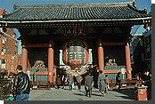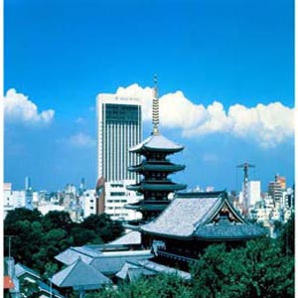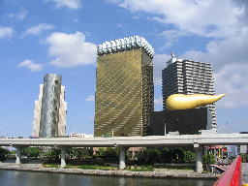

Asakusa is on the north-east fringe of Central Tokyo, at the Eastern end of the Ginza subway line, approximately one mile east of the major Ueno railway/subway interchange. It is central to the area referred to as Shitamachi, which literally means "downtown". As the name suggests, the area has a less frenetic and more traditional Japanese atmosphere than other neighbourhoods of Tokyo. One of the most famous, must-see things in Asakusa is Sensoji (also known as Asakusa Kannon Temple), which is very close to the hotel.

Sensoji
http://www.japan-guide.com/e/e3001.html

Transportation in Tokyo
http://www.japan-guide.com/e/e2017.html

Tokyo Guide Map from Tokyo Convention and Visitors Association
http://www.tcvb.or.jp/en/index_en.htm

Weather
http://weather.yahoo.com/forecast/JAXX0085.html

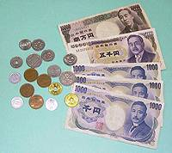
Money & Foreign Exchange
Japan's currency, the yen, is available in 1, 5, 10, 50, 100 & 500 coins, as well as 1000, 2000, 5000 and 10,000 notes. (Note that some vending and ticket machines do not accept new 500 yen coins or 2000 yen notes.) Most major currencies can be exchanged (into yen) at the airport and banks, hotels, and the Central Post Office

Tax and Tipping
Tipping is not customary in Japan. Restaurants' bills are usually paid at a cash register on the way out and the service charge is included in the price. Taxi fares are usually displayed on a meter in the front of the cab and drivers do not expect to receive any more than the displayed amount. However, when shopping or eating out, 5% consumer tax will be charged.

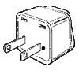
Electricity
The electricity supply in Tokyo is 100V AC 50Hz, with a two-pronged plug / socket arrangement.

Mobile phones
No GSM services available in Japan. W-CDMA, CDMA 2000 1x, cdmaOne and PDC services available.

Hotel Reservation Form
3GPP CT6/#38 – Tokyo Meeting, 31January - 3 February 2006
ASAKUSA VIEW HOTEL
Please FAX or e-mail this reservation form to the hotel.
CUT OFF DATE 12th January 2006 (Japan time)
Tel: +81-3-3847-1111 FAX: +81-3-3842-2117 e-mail: as.shukuhak@viewhotels.co.jp
Title: | Miss Ms Mrs Mr Dr
Family Name:
Forename:
Company:
Mailing address:
Telephone:
Fax:
E-mail:
Accompanied by:
Room rate per night:  (including breakfast) | Twin room (Single use): JPY 13,000  Twin room (Double use): JPY 18,000  Double room JPY 20,000
Reservation: | Twin(Single use) Twin(Double use) Double room for _night(s)  Smoking / No smoking
Date and time of arrival:
Date and time of departure:
Any special arrangements:
Credit Card: | AMEX DINERS MASTER VISA others ( )
Number of Credit Card:
Expiry date:
Cardholder’s Name:
Need a shuttle bus to the airport? (See page 5 of this invitation) | YES NO (If yes, what time is your flight?) Date_______ Time_______  (Please note that the buses may not be arranged so that it suits your schedule.)

Please make your reservations before the cut-off date to insure the reduced group rate.
Reservations must be made using this form in order to avail of this special conference rate.

In the event of cancellation and avoiding cancellation charges. Please cancel accommodation directly with hotel and acquire a cancellation number. Delegates may cancel their booking up until 7 days prior to arrival, without penalty.
Following cancellation fee will apply to any bookings cancelled by delegates in advance.
10% of the first day fee: between 2-6 prior to arrival, 50% of the first day fee: the day before arrival,
100% of the first day fee: the day of arrival, 100% of the first day fee: no show.
Signature: ______________________________ Date: ___ / ___ / ___
Social Event Reservation Form
3GPPCT6/#38 – Tokyo Meeting, 1 February 2006
Please FAX or e-mail this reservation form to the hotel.
CUT OFF DATE 12th January 2006 (Japan time)
Asakusa View Hotel
Tel: +81-3-3847-1111 FAX: +81-3-3842-2117 e-mail: as.shukuhak@viewhotels.co.jp

Title: | Miss Ms Mrs Mr Dr
Family Name:
Forename:
Company:
Accompanied by:
Special food request:

