Invitation to 3GPP CT1#62/CT3#56/CT4#47/CT6#53
November 9 – 13, 2009 Beijing, P. R. China

Dear Colleagues,

Huawei Technologies Co., LTD is pleased to invite you to the 3GPP CT1#62/CT3#56/CT4#47/
CT6#53 meeting in Beijing, P. R. China.

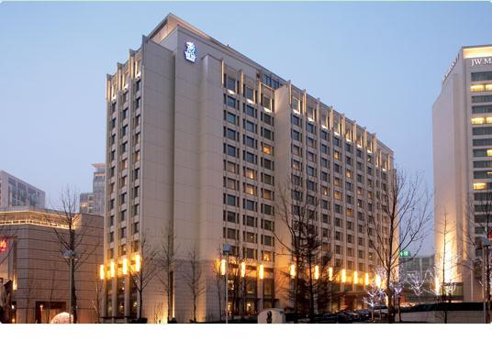

The meeting will be held at the Ritz-Carlton, Beijing. A block of rooms has been reserved at the hotel under the name 3GPP CT. The reduced rate for superior room is ￥1350 CNY (~US$198) per night (full breakfast buffet, service charge and taxes included, free broadband Internet access). Delegates are responsible for their own hotel reservations. Please send the reservation form (Appendix B) to the hotel by fax or email before the cutoff date, Friday, October 02, 2009 (Note that reservation beyond this point may be considerably high and subject to availability).

In addition to hotel reservation, it is important to perform the online meeting registration at the following website: 3GPP Online Registration before 11 October 2009. This provides meeting organizers with important planning information.

For entering China, it is required to hold either tourism or business visa. Should you require a letter of invitation for your business visa application, please contact the host. Your email should attach the form in Appendix A filled with all necessary information and be sent out before 30 September 2009. For Chinese Embassy or Consulate information, please visit website http://www.fmprc.gov.cn/eng/.

Delegates can walk to the CBD near by the hotel during lunch time, the general information as following:
Restaurants | Location | Phone No. | Price(per person) | Remarks
La Paleta  (彩色盘茶餐厅) | A | +86 10 6533 1202 | ￥50 | /
WXY Gourmet Restaurant  (味兴源港式私房菜 ) | B | +86 10 5203 6680 | ￥50 | /
Seigo  (成城日本料理 ) | C | +86 106533 1570 | ￥80 | /
South Beauty  (俏江南) | D | +86 10 6533 1879 | ￥80 | /
Dingtaifeng  (鼎泰丰 ) | E | +86 10 6533 1536 | ￥60 | 6th Floor in Shin Kong Place
Bellagio  (鹿港小镇 ) | F | +86 10 6530 5658 | ￥50 | 6th Floor in Shin Kong Place
Hotpot Paradise  (鼎鼎香) | G | +86 10 6530 5997 | ￥70 | 6th Floor in Shin Kong Place
Pizza Hut | H | +86 10 6533 1072 | ￥50 | B1 in Shin Kong Place
KFC | I | +86 10 6533 1151 | ￥25 | B1 in Shin Kong Place
Subway | J | +86 10 6533 1205 | ￥30 | B1 in Shin Kong Place
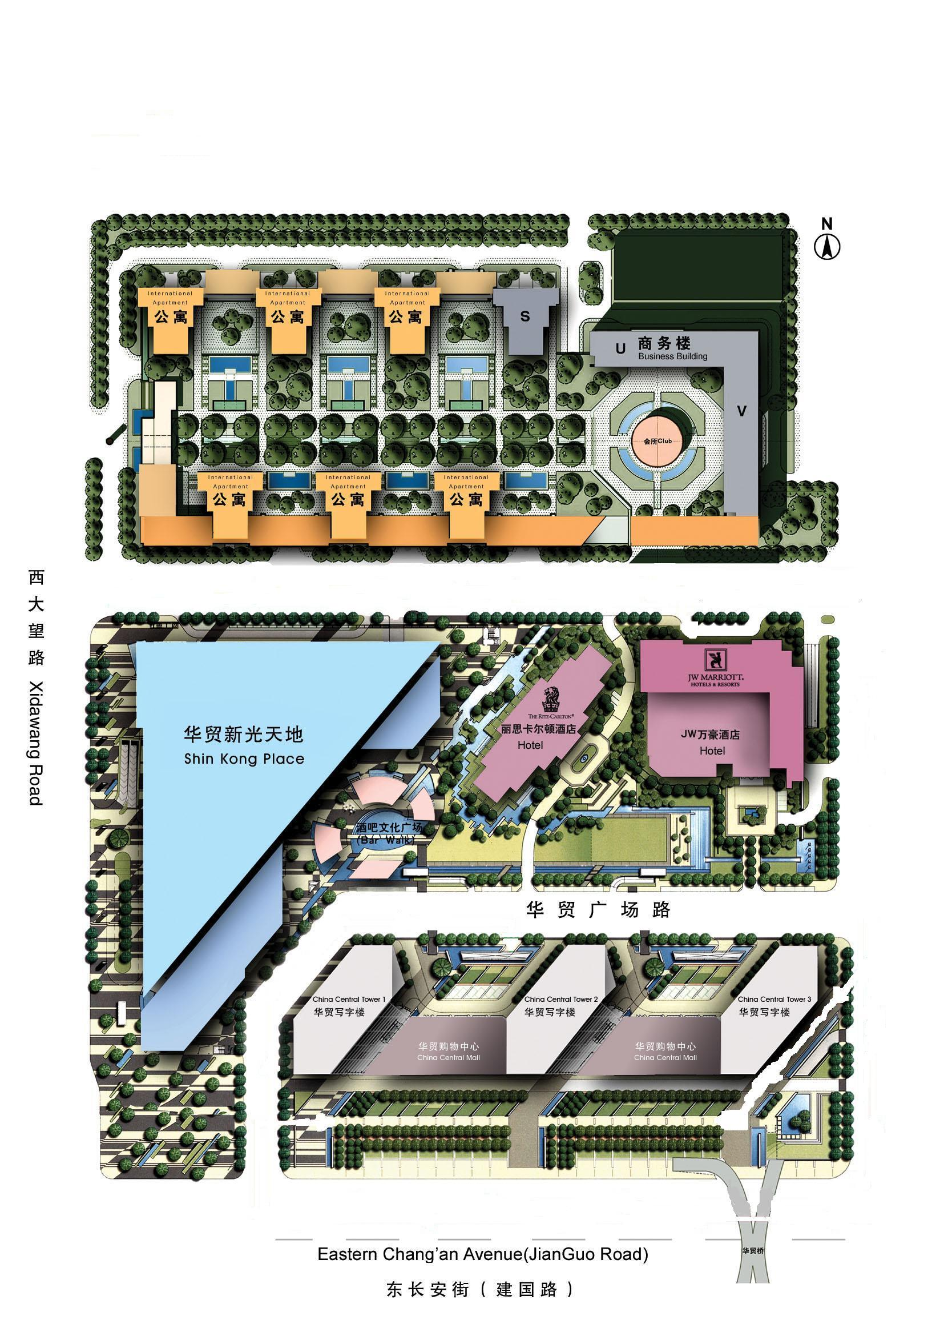
A-D
E-J
hotel

Meeting directions and general information are provided in the following pages.

We are looking forward to seeing you in Beijing, China.

Sincerely yours,

Ms. Xu Yan
On behalf of Huawei Technologies Co., Ltd.

General Meeting Information

Meeting & Date:
3GPP CT1 #62 November 9 ~ 13, 2009
3GPP CT3 #56 November 9 ~ 13, 2009
3GPP CT4 #47 November 9 ~ 13, 2009
3GPP CT6 #53 November 10 ~ 12, 2009

Location:
Beijing, P. R. China

Contact from the host:
Ms. Xu Yan
Tel: +86 755 28423361
Fax: +86 755 28420413
Email: x114594@huawei.com

Ms. Lili Yang
Tel: +86 755 28421635
Fax: +86 755 28420413
Email: kadyyang@huawei.com

Hotel Information:
Ritz-Carlton, Beijing
Address: No. 83A Jian Guo Road, Chaoyang District, Beijing 100025 China

Tel: + 86 10 5908 8888
Website: http://www.ritzcarlton.com/en/Properties/Beijing/Default.htm

EDH requirements:
This will be a paperless meeting. Participants are requested to bring a wireless LAN card for their laptops. For your convenience, please be sure you have Oblique flat blades (inverted V-shape) with ground or Flat blade attachment plug to use in hotel guest room.
In meeting rooms, the host will provide power extensions with outlets fit for the power plug types illustrated in following picture.
Reservation Information

The meeting will be held at the Ritz-Carlton, Beijing.

Group Rate:
Deluxe room (King/Twin) ￥1350 CNY (~US$ 198) per night inclusive of full breakfast buffet, taxes and service charge. Broadband Internet access is complimentary.

Cut-off Date: 2 October 2009
Please make your reservation before the cut off date to insure the reduced group rate. Reservation beyond this point may be considerably high and subject to availability.

Check-in/Check-out Time:
Check in after 02:00 PM
Check out before 12:00 PM

Reservations:
Please fill out the form in Appendix B and return the completed form to the hotel by fax or email.

Cancellation Policy:
Please refer to Appendix B.

Please Note:
Huawei Technologies Co., Ltd is not responsible for reservation confirmations, cancelled or changed reservations, or no-shows. Please contact the hotel directly to make any changes.

Transportation Information

The Ritz-Carlton, Beijing, located at the CBD in the heart of the commercial Chaoyang District, boasts a convenient traffic and a quiet environment.

- Capital Airport 27km
- Tian'anmen Square 8km
- The Forbidden City 9km
- World Trade Center 1.8 km

Airport:
It is about 30 minutes by car driving from Beijing Capital International Airport to the Ritz-Carlton, Beijing. Taxis are always available. The fare will be approximately ￥ 150 CNY (~US $ 22).

The information of Beijing Capital International Airport could be found at http://en.bcia.com.cn/.

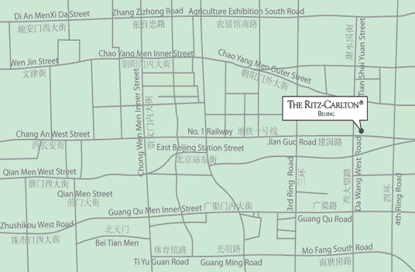

Please Note: Taxi drivers may not speak English, so make sure you have the name of your hotel or address written in Chinese. The following is the name, address and phone number of the Ritz-Carlton, Beijing in Chinese; please print it for your convenience:

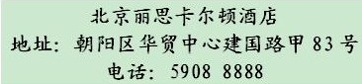

General Information for Stay in Beijing

GSM/CDMA Coverage:
There is GSM / CDMA coverage in Beijing.

Currency:
Until August 2009, 1 U.S. dollar was worth ￥ 6.83 CNY and 1 Euro is worth ￥ 9.84 CNY. Most foreign currencies are easily changed at banks or hotels.

Time Zone:
GMT +8 hours

Voltage:
Commercial power in China is 220V. Please be sure you have the correct adapter. Voltage converters will not be provided at the meeting.

About Beijing

General Information
http://www.beijinghighlights.com/cityguide/general.htm

Area Attractions
http://www.beijinghighlights.com/cityguide/attractions.htm

Weather & Clothing
http://www.beijinghighlights.com/tools/weather.htm

Shopping
http://www.beijinghighlights.com/cityguide/shopping.htm

Please don’t hesitate to direct any questions regarding the logistical arrangements of this meeting to the Meeting Coordinators:

Ms. Xu Yan

Have a great meeting and enjoy your stay in Beijing!

Appendix A

3GPP CT1#62/CT3#56/CT4#47/CT6#53

November 9-13, 2009
Beijing, China

INVITATION LETTER REQUEST FORM

To enter China for the meetings indicated above, you may need a letter of invitation from the Chinese host, which you will need to present to the Chinese Embassy/Consulate in your area in order to obtain your visa. In order to obtain the invitation letter, please:

- fill out the form below;
- a copy of your passport (the name, date of birth, nationality, passport number, valid date of passport, etc. must be seen clearly; to ensure readability, a scanned photograph page is preferred.);
- a copy of previous Chinese visa and records if your entry is not the first time;
- Send all of the above to Ms. Xu Yan before 30 September 2009.

Ms. Xu Yan
Huawei Technologies Co., LTD
x114594@huawei.com
(It’s recommended to scan your passport page and email to Ms. Xu Yan in the case it needs to be used to help the visa process.)

Company
Applicant Information | [ Click and Type in your full name ] |  |  | rMr rDr rMs rMrs
Applicant Information | [ Nationality ] |  |  | [ Passport No.]
Applicant Information | Date of birth : [ Year ] [ Month] [ Day ] |  |  | [ Job Title ]
Applicant Information | If the country in which you'll obtain your visa is different from your nationality, please indicate it here:  [ Country to obtain your visa]
Address | [Click and Type in your address and ZIP code]  Telephone Number: [Click and Type in phone number]  Fax Number: [Click and Type in fax number]  E-mail: [Click and Type in email]
Places to visit after entry | (In this case, it is Beijing by default; if you want to visit other places than Beijing, please indicate here.)
Date of arrive at China |  |  | Date of departure from China
End of form

(Please do not forget to attach a copy of your passport photograph page before sending.)

Appendix B: 3GPP CT Hotel Reservation Form
3GPP CT1#62/CT3#56/CT4#47/CT6#53, November 9 to 13, 2009

The Ritz-Carlton, Beijing has been chosen as the official hotel for 3GPP CT1#62/CT3#56/CT4#47/CT6#53, November 9 to 13, 2009. Please complete this form and return to us by FAX (+86 10 5908 8977 / 8978) or EMAIL (rc.bjsrz.groups@ritzcarlton.com) on or before (Friday, October 02, 2009).For any reservations received after the cut-off day (Friday, October 02, 2009), both rooms and rates will be subject to hotel’s availability. The special group rate may be adjusted to our Best Available Rate should all rooms be sold out within the room block held between Hua Wei Technologies Co., Ltd and The Ritz-Carlton, Beijing.
(For the Reservation to be made, all fields marked by an asterisk “*” must be filled out.)

(Circle One) Mr./Ms./Mrs. Surname*:__________________________First Name*:_____________________________
Company:_________________________________________________Title:___________________________________ Address:__________________________________________________________________________________________
Telephone*:_____________________________________Fax number*:______________________________________
E-mail*:________________________________________
Arrive on*: ____________________________ Flight/Time:________________________________________________
Depart on*:____________________________ Flight/Time:________________________________________________

------------------------------------------------------------------------  Room Rates extended to this particular function*:  The Deluxe Room (Guest) : RMB1,350 per room per night  **The above rates are inclusive of 15% service charge, applicable to single or double occupancy, and government taxes and fees  **Complimentary Breakfast is served daily  **Complimentary Internet Services inside the guestroom  ---------------------------------------------------------------------  Preferred Room Category:  Bed Type Room Type  King-sized bed: Non-smoking room:  Two double beds: Smoking room: |  |  | -------------------------------------------------------------------------  CANCELLATION POLICY  - Any cancellation, after Friday, October 9, 2009 but before Friday, October 30, 2009 will be subject to a thirty percent (30%) charge of the entire length of period booked based on the arrival / departure date as above. This will be charged to the individual guest’s credit card.  - Any cancellation, on or after Friday, October 30, 2009 or a no-show on the day of arrival will be subject to a fifty percent (50%) charge of the entire length of period booked based on the arrival / departure date as above. This will be charged to the individual guest’s credit card.  - All bookings must be guaranteed by Credit Card. Any non-guaranteed booking room will be released 1 day prior to the day of your arrival without notice.  -----------------------------------------------------------------------  Please arrange Limousine service: (Please select)  Arrival limousine per car at Departure limousine per car at  RMB580 net (AUDI A6L) RMB580 net (AUDI A6L)  Arrival limousine per car at Departure limousine per car at  RMB880 net (Benz S350) RMB880 net (Benz S350)  The above price may be changed without prior notice  -----------------------------------------------------------------------  To guarantee your reservation, please submit this form before  Friday, October 02, 2009to:  Reservation Department  Group Coordinator  The Ritz-Carlton, Beijing  Tel: (86 10) 5908 8955  Simply Fax it to us at (86 10) 5908 8977 / 8978  Or Reservation E-mail: rc.bjsrz.groups@ritzcarlton.com  Your reservation will be confirmed ONLY when you receive a final confirmation message with confirmation number from the hotel.
Special Request:
Check In: 14:00 hr / Check Out: 12:00 hr

------------------------------------------------------------------------
I would like to guarantee my reservations by:
Credit Card Type*:

Credit Card Number*:

Expiry Date*:

Cardholder's Signature*
and Name*:

