3GPP TS 29.594 V15.1.0 (2018-09)
Technical Specification
3rd Generation Partnership Project;
Technical Specification Group Core Network and Terminals;
5G System; Spending Limit Control Service;
Stage 3
(Release 15)


The present document has been developed within the 3rd Generation Partnership Project (3GPP TM) and may be further elaborated for the purposes of 3GPP.
The present document has not been subject to any approval process by the 3GPP Organisational Partners and shall not be implemented.
This Specification is provided for future development work within 3GPP only. The Organisational Partners accept no liability for any use of this Specification.
Specifications and reports for implementation of the 3GPP TM system should be obtained via the 3GPP Organisational Partners' Publications Offices.

Keywords

3GPP
Postal address

3GPP support office address
650 Route des Lucioles - Sophia Antipolis
Valbonne - FRANCE
Tel.: +33 4 92 94 42 00 Fax: +33 4 93 65 47 16
Internet
http://www.3gpp.org
Copyright Notification
No part may be reproduced except as authorized by written permission.
The copyright and the foregoing restriction extend to reproduction in all media.

© 2018, 3GPP Organizational Partners (ARIB, ATIS, CCSA, ETSI, TSDSI, TTA, TTC).
All rights reserved.

UMTS™ is a Trade Mark of ETSI registered for the benefit of its members
3GPP™ is a Trade Mark of ETSI registered for the benefit of its Members and of the 3GPP Organizational Partners
LTE™ is a Trade Mark of ETSI registered for the benefit of its Members and of the 3GPP Organizational Partners
GSM® and the GSM logo are registered and owned by the GSM Association
Contents
Foreword 5
1 Scope 6
2 References 6
3 Definitions and abbreviations 7
3.1 Definitions 7
3.2 Abbreviations 7
4 Nchf_SpendingLimitControl Service 7
4.1 Service Description 7
4.1.1 Overview 7
4.1.2 Service Architecture 7
4.1.3 Network Functions 8
4.1.3.1 Charging Function (CHF) 8
4.1.3.2 NF Service Consumers 8
4.2 Service Operations 8
4.2.1 Introduction 8
4.2.2 Nchf_SpendingLimitControl_Subscribe service operation 9
4.2.2.1 General 9
4.2.2.2 Initial spending limit retrieval 9
4.2.2.3 Intermediate spending limit report retrieval 10
4.2.3 Nchf_SpendingLimitControl_Unsubscribe service operation 11
4.2.3.1 General 11
4.2.3.2 Unsubscribe from spending limit reporting 11
4.2.4 Nchf_SpendingLimitControl_Notify service operation 12
4.2.4.1 General 12
4.2.4.2 Spending limit report 12
4.2.4.3 Subscription termination request by CHF 13
5 Nchf_SpendingLimitControl Service API 13
5.1 Introduction 13
5.2 Usage of HTTP 14
5.2.1 General 14
5.2.2 HTTP standard headers 14
5.2.2.1 General 14
5.2.2.2 Content type 14
5.2.3 HTTP custom headers 14
5.2.3.1 General 14
5.3 Resources 14
5.3.1 Resource Structure 14
5.3.2 Resource: Spending Limit Retrieval Subscriptions (Collection) 15
5.3.2.1 Description 15
5.3.2.2 Resource definition 15
5.3.2.3 Resource Standard Methods 15
5.3.2.3.1 POST 15
5.3.2.4 Resource Custom Operations 16
5.3.3 Resource: Individual Spending Limit Retrieval Subscription (Document) 16
5.3.3.1 Description 16
5.3.3.2 Resource definition 16
5.3.3.3 Resource Standard Methods 16
5.3.3.3.1 PUT 16
5.3.3.3.2 DELETE 17
5.4 Custom Operations without associated resources 17
5.5 Notifications 17
5.5.1 General 17
5.5.2 Spending limit notification 18
5.5.2.1 Description 18
5.5.2.2 Target URI 18
5.5.2.3 Standard Methods 18
5.5.2.3.1 POST 18
5.5.3 Subscription Termination 18
5.5.3.1 Description 18
5.5.3.2 Target URI 18
5.5.3.3 Standard Methods 19
5.5.3.3.1 POST 19
5.6 Data Model 19
5.6.1 General 19
5.6.2 Structured data types 20
5.6.2.1 Introduction 20
5.6.2.2 Type SpendingLimitContext 21
5.6.2.3 Type SpendingLimitStatus 21
5.6.2.4 Type PolicyCounterInfo 22
5.6.2.5 Type PendingPolicyCounterStatus 22
5.6.2.6 Type SubscriptionTerminationInfo 22
5.6.3 Simple data types and enumerations 22
5.6.3.1 Introduction 22
5.6.3.2 Simple data types 22
5.6.3.3 Enumeration: TerminationCause 23
5.7 Error handling 23
5.7.1 General 23
5.7.2 Protocol Errors 23
5.7.3 Application Errors 23
5.8 Feature negotiation 23
Annex A (normative): OpenAPI specification 25
A.1 General 25
A.2 Nchf_SpendingLimitControl Service API 25
Annex B (informative): Change history 29

Foreword
This Technical Specification has been produced by the 3rd Generation Partnership Project (3GPP).
The contents of the present document are subject to continuing work within the TSG and may change following formal TSG approval. Should the TSG modify the contents of the present document, it will be re-released by the TSG with an identifying change of release date and an increase in version number as follows:
Version x.y.z
where:
x the first digit:
1 presented to TSG for information;
2 presented to TSG for approval;
3 or greater indicates TSG approved document under change control.
y the second digit is incremented for all changes of substance, i.e. technical enhancements, corrections, updates, etc.
z the third digit is incremented when editorial only changes have been incorporated in the document.

1 Scope
The present specification provides the stage 3 definition of the Spending Limit Control Service of the 5G System.
The 5G System Architecture is defined in 3GPP TS 23.501 [2]. The stage 2 definition and related procedures for the Spending Limit Control Service are specified in 3GPP TS 23.502 [3] and 3GPP TS 23.503 [6].
The 5G System stage 3 call flows are provided in 3GPP TS 29.513 [12].
The Technical Realization of the Service Based Architecture and the Principles and Guidelines for Services Definition are specified in 3GPP TS 29.500 [4] and 3GPP TS 29.501 [5].
The Spending Limit Control Service is provided by the Charging Function (CHF) and enables the NF service consumer to retrieve policy counter status information. The internal CHF functionality for policy counter management provisioning is specified in 3GPP TS 32.240 [7].

2 References
The following documents contain provisions which, through reference in this text, constitute provisions of the present document.
- References are either specific (identified by date of publication, edition number, version number, etc.) or non-specific.
- For a specific reference, subsequent revisions do not apply.
- For a non-specific reference, the latest version applies. In the case of a reference to a 3GPP document (including a GSM document), a non-specific reference implicitly refers to the latest version of that document in the same Release as the present document.
[1] 3GPP TR 21.905: "Vocabulary for 3GPP Specifications".
[2] 3GPP TS 23.501: "System Architecture for the 5G System; Stage 2".
[3] 3GPP TS 23.502: "Procedures for the 5G System; Stage 2".
[4] 3GPP TS 29.500: "5G System; Technical Realization of Service Based Architecture; Stage 3".
[5] 3GPP TS 29.501: "5G System; Principles and Guidelines for Services Definition; Stage 3".
[6] 3GPP TS 23.503: "Policy and Charging Control Framework for the 5G System; Stage 2".
[7] 3GPP TS 32.240: "Charging architecture and principles; Stage 2".
[8] IETF RFC 7540: "Hypertext Transfer Protocol Version 2 (HTTP/2)".
[9] OpenAPI: "OpenAPI 3.0.0 Specification", https://github.com/OAI/OpenAPI-Specification/blob/master/versions/3.0.0.md.
[10] IETF RFC 8259: "The JavaScript Object Notation (JSON) Data Interchange Format".
[11] 3GPP TS 29.571: "5G System; Common Data Types for Service Based Interfaces".
[12] 3GPP TS 29.513: "5G System; Policy and Charging Control signalling flows and QoS parameter mapping; Stage 3".

3 Definitions and abbreviations

3.1 Definitions
For the purposes of the present document, the terms and definitions given in 3GPP TR 21.905 [1] and the following apply. A term defined in the present document takes precedence over the definition of the same term, if any, in 3GPP TR 21.905 [1].
Nchf: Service-based interface exhibited by Charging Function.

3.2 Abbreviations
For the purposes of the present document, the abbreviations given in 3GPP TR 21.905 [1] and the following apply. An abbreviation defined in the present document takes precedence over the definition of the same abbreviation, if any, in 3GPP TR 21.905 [1].
CCS Converged Charging System
CHF Charging Function
CTS Charging Trigger Function
NF Network Function
PCF Policy Control Function

4 Nchf_SpendingLimitControl Service

4.1 Service Description

4.1.1 Overview
The Nchf_SpendingLimitControl service, as defined in 3GPP TS23.502 [3] and 3GPP TS23.503 [6], is provided by the Charging Function (CHF).
The Nchf_SpendingLimitControl service enables the NF service consumer to retrieve policy counter status information per UE from the CHF by subscribing to spending limit reporting (i.e. notifications of policy counter status changes).
If the spending limit reporting is no more required the Nchf_SpendingLimitControl service enables the NF service consumer to unsubscribe from the reporting.

4.1.2 Service Architecture
The Nchf_SpendingLimitControl service is provided by the CHF and consumed by the PCF, as shown in figure 4.1.2-1 for the SBI representation model and in figure 4.1.2-2 for the reference point representation model.
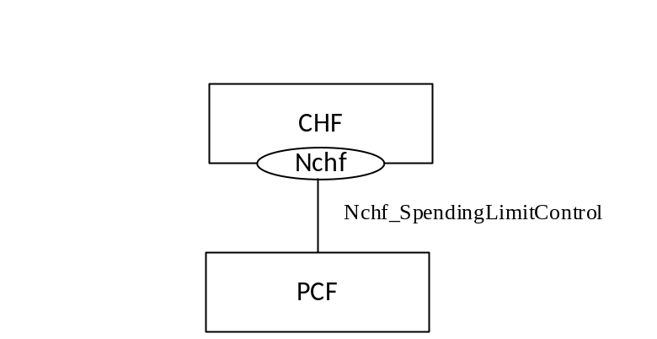
Figure 4.1.2-1: Nchf_SpendingLimitContol service architecture, SBI representation
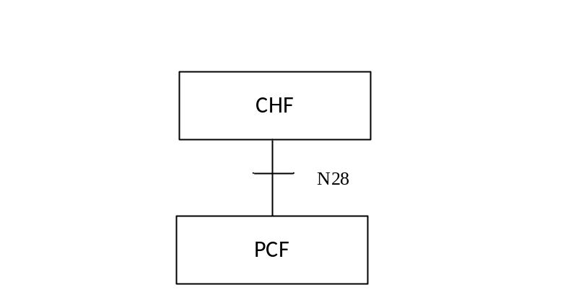
Figure 4.1.2-2: Nchf_SpendingLimitContol service architecture, reference point representation

4.1.3 Network Functions

4.1.3.1 Charging Function (CHF)
The Charging Function (CHF) is part of the Converged Charging System (CCS). The CHF provides the Nchf_SpendingLimitControl service and is specified in 3GPP TS 32.240 [7].

4.1.3.2 NF Service Consumers
The PCF is the known NF service consumer, as defined in 3GPP TS 23.502 [3]. The NF service consumer accesses policy counter status information relating to the subscriber spending from the CHF and uses the status of each relevant policy counter as input to its policy decision as required by the decision logic.

4.2 Service Operations

4.2.1 Introduction
The service operations defined for the Nchf_SpendingLimitControl service are shown in table 4.2.1-1.
Table 4.2.1-1: Nchf_SpendingLimitControl Service Operations
Service operation name | Description | Initiated by
Nchf_SpendingLimitControl_Subscribe | This service operation is used by an NF service consumer to subscribe to notification of changes in the status of the policy counters available and retrieval of the status of the policy counters for which subscription is accepted. | NF service consumer (PCF)
Nchf_SpendingLimitControl_Unsubscribe | This service operation is used by an NF service consumer to unsubscribe from notification of changes in the status of all policy counters. | NF service consumer (PCF)
Nchf_SpendingLimitControl_Notify | This service operation is used by the CHF to notify the NF service consumers about the change of the status of the subscribed policy counters. Alternatively, it can be used by the CHF to notify that the status for one or multiple subscribed policy counter will change in the future, indicating the time when this change shall be applied. Alternatively, it is also used to notify the NF service consumer of the removal of a subscriber from the CHF system for the purpose that the NF service consumer can terminate the subscriptions of all policy counters of the subscriber. | CHF

4.2.2 Nchf_SpendingLimitControl_Subscribe service operation

4.2.2.1 General
The Nchf_SpendingLimitControl_Subscribe service operation is used by the NF service consumer to subscribe to notification of changes in the status of the policy counters available and to retrieve the status of the policy counters for which the subscription is accepted. The following procedures are related to the subscribe service operation:
- initial spending limit retrieval; and
- intermediate spending limit report retrieval.

4.2.2.2 Initial spending limit retrieval
Figure 4.2.2.2-1 shows the scenario where the NF service consumer sends a request to the CHF to retrieve the status of policy counters available at the CHF and to subscribe to spending limit reporting (see also 3GPP TS 23.502 [3], figure 4.16.8.2.1).
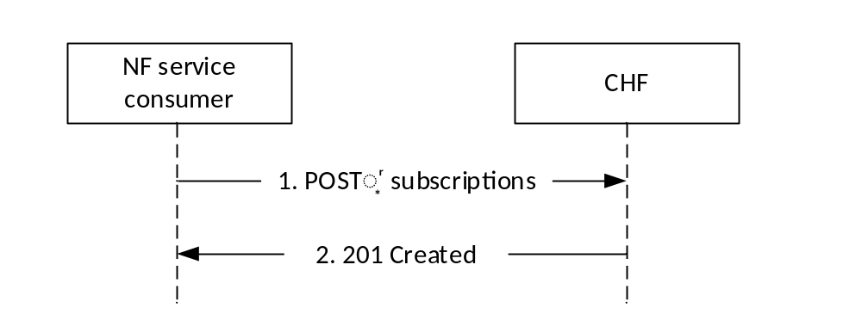
Figure 4.2.2.2-1: NF service consumer subscribes to retrieve policy counter status and spending limit reporting
The NF service consumer shall send an HTTP POST request to the resource "{apiRoot}/nchf-spendinglimitcontrol/v1/subscriptions" representing the "CHF Subscriptions", as shown in figure 4.2.2.2-1, step 1, to create a subscription for retrieval of the policy counter status and spending limit reporting.
The data structure provided in the request body shall include:
- the subscriber Id; and the
- notification correlation target address.
The data structure provided in the request body may include:
- Event Filter information "list of policy counter identifier(s)".
If the CHF cannot successfully fulfil the received HTTP POST request due to an internal CHF error or due to the error in the HTTP POST request, the CHF shall send the HTTP error response as specified in subclause 5.7. If the subscriber specified in the request is unknown to the CHF, the CHF shall indicate in an HTTP "400 Bad Request" response the cause for the rejection with the cause attribute set to "USER_UNKNOWN". If the CHF has no available policy counters specified for the subscriber, the CHF shall indicate in an HTTP "400 Bad Request" response the cause for the rejection with the cause attribute set to "NO_AVAILABLE_POLICY_COUNTERS ".
Otherwise, upon the reception of an HTTP POST request the CHF shall:
- create a new subscription;
- assign a subscriptionCorrelationId; and
- store the subscription.
After the CHF created an "Individual CHF Subscription" resource, the CHF shall respond with "201 Created" with the message body containing a representation of the created subscription, as shown in figure 4.2.2.2-1, step 2.
The data structure provided in the response body shall include:
- the status of the requested subscribed policy counters to the subscriber in the event information.
The data structure provided in the response body may include:
- pending policy counter statuses and their activation times for all policy counter(s) available for the subscriber;
- if a list of policy counter identifier(s) was provided, the CHF returns only the pending policy counter statuses and their activation times, per required policy counter identifier in the event Information

4.2.2.3 Intermediate spending limit report retrieval
Figure 4.2.2.3-1 shows the scenario where the NF service consumer sends a request to the CHF to modify the existing subscription to the retrieval of spending limit reports (see also 3GPP TS 23.502 [3], figure 4.16.8.3.1). The NF service consumer can add or remove policy counters to retrieve the status of the counters.
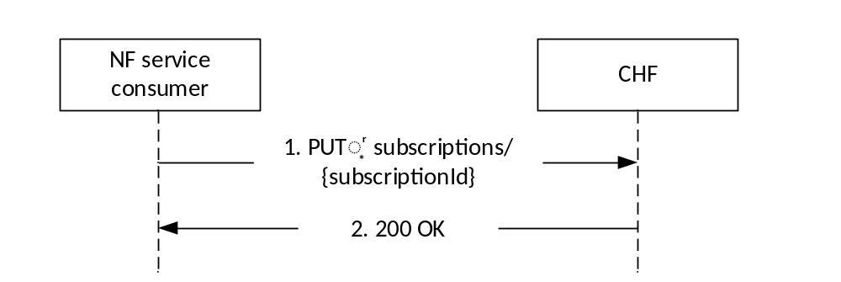
Figure 4.2.2.3-1: NF service consumer modifies the subscription to retrieve policy counter status and spending limit reporting
The NF service consumer shall send an HTTP PUT request to the resource "{apiRoot}/nchf-spendinglimitcontrol/v1/subscriptions/{subscriptionId}" representing an existing "CHF Subscriptions", as shown in figure 4.2.2.3-1, step 1, to modify the subscription for retrieval of the policy counter status and spending limit reporting.
The data structure provided in the request body may include:
- Event Filter information "list of policy counter identifier(s)"; and
- a new notification correlation target address.
After the CHF modified an "Individual CHF Subscription" resource, the CHF shall respond with "200 OK" with the message body containing a representation of the created subscription, as shown in figure 4.2.2.3-1, step 2.
The data structure provided in the response body shall include:
- the status of the requested subscribed policy counters to the subscriber in the event information.
The data structure provided in the response body may include:
- pending policy counter statuses and their activation times for all policy counter(s) available for the subscriber;
- if a list of policy counter identifier(s) was provided, the CHF returns only the pending policy counter statuses and their activation times, per required policy counter identifier in the event Information
If the HTTP PUT request is not accepted by the CHF, it shall indicate the appropriate cause for the rejection in the HTTP response code to the NF service consumer. If the CHF has no available policy counters specified for the subscriber, the CHF shall indicate in an HTTP "400 Bad Request" response the cause for the rejection with the cause attribute set to "NO_AVAILABLE_POLICY_COUNTERS ".

4.2.3 Nchf_SpendingLimitControl_Unsubscribe service operation

4.2.3.1 General
The Nchf_SpendingLimitControl_Unsubscribe service operation is used by the NF service consumer to cancel the subscription of status changes for all the policy counters available at the CHF. That means the complete cancellation of the spending limit reporting procedure.

4.2.3.2 Unsubscribe from spending limit reporting
Figure 4.2.3.2-1 shows the scenario where the NF service consumer sends a request to the CHF to unsubscribe from spending limit reporting (see also 3GPP TS 23.502 [3] figure 4.16.8.4.1).
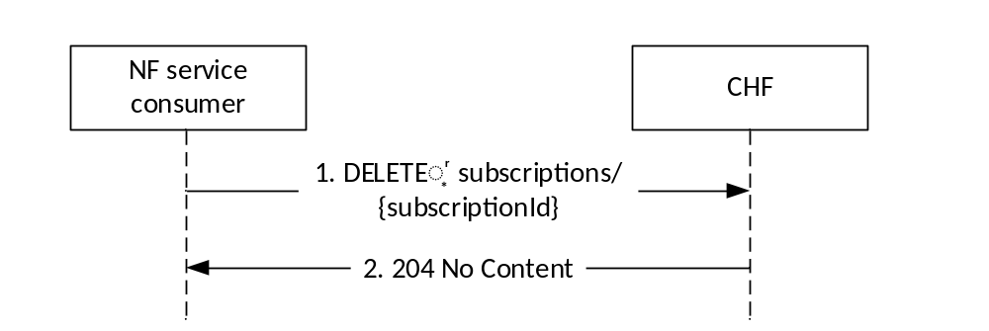
Figure 4.2.3.2-1: NF service consumer unsubscribes from spending limit reporting
The NF service consumer shall invoke the Nchf_SpendingLimitControl_Unsubscribe service operation to unsubscribe from the spending limit reporting (status change for all policy counters available is no more required). The NF service consumer shall send an HTTP DELETE request to the resource "{apiRoot}/nchf-spendinglimitcontrol/v1/subscriptions /{subscriptionId}", whereby the "{subscriptionId}" is the identification of the existing subscription to be deleted. Upon the reception of an HTTP DELETE request the CHF removes the corresponding subscription.
If the HTTP DELETE request is accepted by the CHF, it shall respond with "204 No Content" as shown in figure 4.2.3.2-1, step 2.
If the HTTP DELETE request is not accepted by the CHF, it shall indicate the appropriate cause for the rejection in the HTTP response code to the NF service consumer.

4.2.4 Nchf_SpendingLimitControl_Notify service operation

4.2.4.1 General
The Nchf_SpendingLimitControl_Notify service operation is used by the CHF:
- to notify the change of the status of the subscribed policy counters available at the CHF for that subscriber; and/or
- to provide one or more pending statuses for a subscribed policy counter together with the time they shall be applied; and/or
- to request the termination of the subscription of status changes for all policy counters for a subscriber (e.g. the subscriber is removed from the CHF system).
NOTE: The SUPI represents the subscription Id.

4.2.4.2 Spending limit report
Figure 4.2.4.2-1 shows the scenario where the CHF sends a notification to the NF service consumer, when it detects that the status of a policy counter(s) has changed and the NF service consumer has subscribed to notifications of changes in the status of this policy counter(s). The CHF can also notify the NF service consumer that the status for one or multiple subscribed policy counter will change and indicate this by providing the time when this change shall be applied (see also 3GPP TS 23.502 [3], figure 4.16.8.5.1).

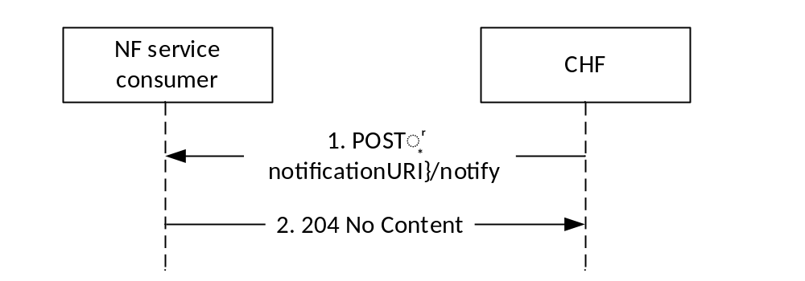
Figure 4.2.4.2-1: Spending limit reporting
The CHF shall send an HTTP POST request to the resource notification target address (notificationURI) of the NF service consumer received in the subscription creation or modification, and shall append the "notify" segment path at the end of the URI, to indicate the NF service consumer the notification of a policy counter status change.
The data structure provided in the request body shall include:
- Subscriber Id; and
- Policy counter status as event information.
The data structure provided in the request body may include:
- Pending policy counter statuses and their activation times as event information.
If the HTTP POST notification request message is accepted by the NF service consumer, it shall acknowledge the receipt of the event notification with a "204 No Content" response, as shown in figure 4.2.4.2-1, step 2.
If the HTTP POST request is not accepted and the information received is not considered by the NF service consumer, the NF service consumer shall indicate the appropriate cause for the rejection in the HTTP response code to the CHF.

4.2.4.3 Subscription termination request by CHF
Figure 4.2.4.3-1 shows the scenario where the CHF sends a notification to the NF service consumer, when it requests the termination of the subscription of status changes for all policy counters for a subscriber.
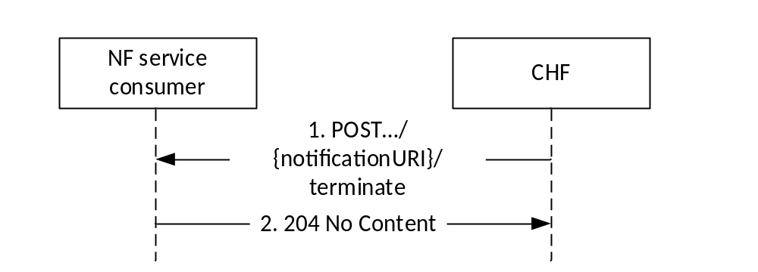
Figure 4.2.4.3-1: Subscription termination request by CHF
The CHF shall send an HTTP POST request to the resource notification target address (notificationURI) of the NF service consumer received in the subscription creation or modification and shall append the "terminate" segment path at the end of the URI, to indicate the subscription termination to the NF service consumer.
The data structure provided in the request body shall include:
- Subscriber Id; and
- subscription termination information.
If the HTTP POST notification request message is accepted by the NF service consumer, it shall remove the subscription to notifications of all policy counters for a subscriber and shall acknowledge the receipt of the event notification with a "204 No Content" response, as shown in figure 4.2.4.3-1, step 2.
If the HTTP POST request is not accepted and the information received is not considered by the NF service consumer, the NF service consumer shall indicate the appropriate cause for the rejection in the HTTP response code to the CHF.

5 Nchf_SpendingLimitControl Service API

5.1 Introduction
The Nchf_SpendingLimitControl service shall use the Nchf_SpendingLimitControl API.
The request URI used in each HTTP request from the NF service consumer towards the CHF shall have the structure defined in subclause 4.4.1 of 3GPP TS 29.501 [5], i.e.:
{apiRoot}/{apiName}/{apiVersion}/{apiSpecificResourceUriPart}
with the following components:
- The {apiRoot} shall be set as described in 3GPP TS29.501 [5].
- The {apiName} shall be "nchf-spendinglimitcontrol".
- The {apiVersion} shall be "v1".
- The {apiSpecificResourceUriPart} shall be set as described in subclause 5.3.

5.2 Usage of HTTP

5.2.1 General
HTTP/2, IETF RFC 7540 [8], shall be used as specified in subclause 5.2 of 3GPP TS 29.500 [4].
HTTP/2 shall be transported as specified in subclause 5.3 of 3GPP TS 29.500 [4].
The OpenAPI [9] specification of HTTP messages and content bodies for the Nchf_SpendingLimitControl service is contained in Annex A.

5.2.2 HTTP standard headers

5.2.2.1 General
See subclause 5.2.2 of 3GPP TS 29.500 [4] for the usage of HTTP standard headers.

5.2.2.2 Content type
JSON, IETF RFC 8259 [10], shall be used as content type of the HTTP bodies specified in the present specification, as specified in subclause 5.4 of 3GPP TS 29.500 [4].

5.2.3 HTTP custom headers

5.2.3.1 General
The Nchf_SpendingLimitControl API shall support HTTP custom header fields specified in subclause 5.2.3.2 of 3GPP TS 29.500 [4].
In this Release of the specification, no specific custom headers are defined for the Nchf_SpendingLimitControl API.

5.3 Resources

5.3.1 Resource Structure
Figure 5.3.1-1 shows the resource structure of the Nchf_SpendingLimitControl API.
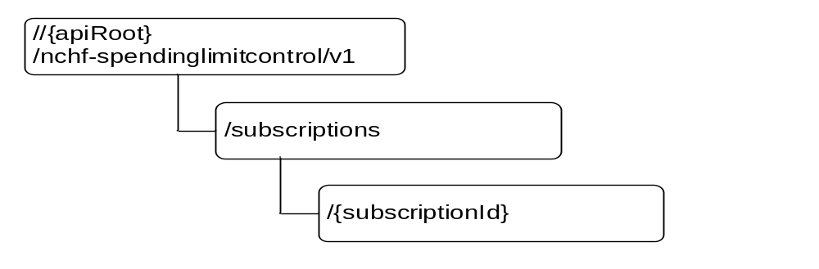
Figure 5.3.1-1: Resource URI structure of the Nchf_SpendingLimitControl API
Table 5.3.1-1 provides an overview of the resources and applicable HTTP methods.
Table 5.3.1-1: Resources and methods overview
Resource name | Resource URI | HTTP method or custom operation | Description
Spending Limit Retrieval Subscriptions | {apiRoot}/  nchf-spendinglimitcontrol/v1  /subscriptions | POST | Creates a new individual spending limit retrieval subscription.
Individual Spending Limit Retrieval Subscription | apiRoot}/  nchf-spendinglimitcontrol/v1  /subscriptions/{subscriptionId} | PUT | Modifies an existing subscription (e.g. addition of additional policy counters).
Individual Spending Limit Retrieval Subscription |  | DELETE | Deletes an individual subscription.

5.3.2 Resource: Spending Limit Retrieval Subscriptions (Collection)

5.3.2.1 Description
This resource represents the collection of Nchf_SpendingLimitControl service subscriptions at a given CHF.

5.3.2.2 Resource definition
Resource URI: {apiRoot}/nchf-spendinglimitcontrol/v1/subscriptions
This resource shall support the resource URI variables defined in table 5.3.2.2-1.
Table 5.3.2.2-1: Resource URI variables for this resource
Name | Definition
apiRoot | See subclause 5.1

5.3.2.3 Resource Standard Methods

5.3.2.3.1 POST
This method shall support the URI query parameters specified in table 5.3.2.3.1-1.
Table 5.3.2.3.1-1: URI query parameters supported by the POST method on this resource
Name | Data type | P | Cardinality | Description
n/a

This method shall support the request data structures specified in table 5.3.2.3.1-2 and the response data structures and response codes specified in table 5.3.2.3.1-3.
Table 5.3.2.3.1-2: Data structures supported by the POST Request Body on this resource
Data type | P | Cardinality | Description
SpendingLimitContext | M | 1 | Contains the information for the creation of a new individual spending limit retrieval subscription.

Table 5.3.2.3.1-3: Data structures supported by the POST Response Body on this resource
Data type | P | Cardinality | Response codes | Description
SpendingLimitStatus | M | 1 | 201 Created | The spending limit subscription was created and spending limit reports are provided.
ProblemDetails | M | 1 | 400 Bad Request | (NOTE 2)
NOTE 1: In addition, the HTTP status codes which are specified as mandatory in table 5.2.7.1-1 of 3GPP TS 29.500 [4] for the POST method shall also apply.
NOTE 2: In addition to protocol and application errors which are specified in subclause 5.2.7.2 of 3GPP TS 29.500 [4], specific errors are described in subclause 5.7.

5.3.2.4 Resource Custom Operations
None.

5.3.3 Resource: Individual Spending Limit Retrieval Subscription (Document)

5.3.3.1 Description
This resource represents an individual Nchf_SpendingLimitControl service subscription at a given CHF.

5.3.3.2 Resource definition
Resource URI: {apiRoot}/nchf-spendinglimitcontrol/v1/subscriptions/{subscriptionId}
This resource shall support the resource URI variables defined in table 5.3.3.2-1.
Table 5.3.3.2-1: Resource URI variables for this resource
Name | Definition
apiRoot | See subclause 5.1
subscriptionId | String identifying a subscription to the CHF spending limit control retrieval service.

5.3.3.3 Resource Standard Methods

5.3.3.3.1 PUT
This method shall support the URI query parameters specified in table 5.3.3.3.1-1.
Table 5.3.3.3.1-1: URI query parameters supported by the PUT method on this resource
Name | Data type | P | Cardinality | Description
n/a

This method shall support the request data structures specified in table 5.3.3.3.1-2 and the response data structures and response codes specified in table 5.3.3.3.1-3.
Table 5.3.3.3.1-2: Data structures supported by the PUT Request Body on this resource
Data type | P | Cardinality | Description
SpendingLimitContext | M | 1 | Modifies the existing individual spending limit retrieval subscription.

Table 5.3.3.3.1-3: Data structures supported by the PUT Response Body on this resource
Data type | P | Cardinality | Response codes | Description
SpendingLimitStatus | M | 1 | 200 OK | Successful case: The individual spending limit subscription was modified and spending limit reports are provided.
ProblemDetails | M | 1 | 400 Bad Request | (NOTE 2)
NOTE 1: In addition, the HTTP status codes which are specified as mandatory in table 5.2.7.1-1 of 3GPP TS 29.500 [4] for the PUT method shall also apply.
NOTE 2: In addition to protocol and application errors which are specified in subclause 5.2.7.2 of 3GPP TS 29.500 [4], specific errors are described in subclause 5.7.

5.3.3.3.2 DELETE
This method shall support the URI query parameters specified in table 5.3.3.3.2-1.
Table 5.3.3.3.3-1: URI query parameters supported by the DELETE method on this resource
Name | Data type | P | Cardinality | Description
n/a

This method shall support the request data structures specified in table 5.3.3.3.2-2 and the response data structures and response codes specified in table 5.3.3.3.2-3.
Table 5.3.3.3.2-2: Data structures supported by the DELETE Request Body on this resource
Data type | P | Cardinality | Description
n/a

Table 5.3.3.3.2-3: Data structures supported by the DELETE Response Body on this resource
Data type | P | Cardinality | Response codes | Description
n/a |  |  | 204 No Content | Successful case: The individual spending limit subscription matching the subscriptionId was deleted.
NOTE: In addition, the HTTP status codes which are specified as mandatory in table 5.2.7.1-1 of 3GPP TS 29.500 [4] for the DELETE method shall also apply.

5.4 Custom Operations without associated resources
None.

5.5 Notifications

5.5.1 General
Notification shall comply with subclause 6.2 of 3GPP TS 29.500 [4] and subclause 4.6.2.3 of 3GPP TS 29.501 [5].
Table 5.5.1-1: Notifications
Custom operation URI | Mapped HTTP method | Description
{notifUri}/notify | POST | Counter Status changes notification.
{notifUri}/terminate | POST | Indication of subscription termination.

5.5.2 Spending limit notification

5.5.2.1 Description
The spending limit notification is used by the CHF to notify the change of the status of the subscribed policy counters for a subscriber and/or to provide one or more pending statuses for a subscribed policy counter together with the time they shall be applied.

5.5.2.2 Target URI
The URI {notifUri}/notify shall be used with the resource URI variables defined in table 5.5.2.2-1.
Table 5.5.2.2-1: Resource URI variables for this resource
Name | Definition
notifUri | String formatted as URI with the Notification Uri as assigned by the NF service consumer during the subscription service operation and described within the Nchf_SpendingLimitRequest type (see table 5.6.2.2-1).

5.5.2.3 Standard Methods

5.5.2.3.1 POST
This method shall support the URI query parameters specified in table 5.5.2.3.1-1.
Table 5.5.2.3.1-1: URI query parameters supported by the POST method on this resource
Name | Data type | P | Cardinality | Description
n/a

This method shall support the request data structures specified in table 5.5.2.3.1-2 and the response data structures and response codes specified in table 5.5.2.3.1-3.
Table 5.5.2.3.1-2: Data structures supported by the POST Request Body on this resource
Data type | P | Cardinality | Description
SpendingLimitStatus | M | 1 | Provides information about the statuses of policy counters.

Table 5.5.2.3.1-3: Data structures supported by the POST Response Body on this resource
Data type | P | Cardinality | Response codes | Description
n/a |  |  | 204 No Content | The receipt of the notification is acknowledged.
NOTE: In addition, the HTTP status codes which are specified as mandatory in table 5.2.7.1-1 of 3GPP TS 29.500 [4] for the POST method shall also apply.

5.5.3 Subscription Termination

5.5.3.1 Description
The Subscription Termination request is used by the CHF to request the NF service consumer the termination of the subscription to policy counter status changes.

5.5.3.2 Target URI
The Notification URI {notifUri}/terminate shall be used with the URI variables defined in table 5.5.3.2-1.
Table 5.5.3.2-1: URI variables
Name | Definition
notifUri | String formatted as URI with the Notification Uri as assigned by the NF service consumer during the subscription service operation and described within the Nchf_SpendingLimitRequest type (see table 5.6.2.2-1).

5.5.3.3 Standard Methods

5.5.3.3.1 POST
This method shall support the URI query parameters specified in table 5.5.3.3.1-1.
Table 5.5.3.3.1-1: URI query parameters supported by the POST method on this resource
Name | Data type | P | Cardinality | Description
n/a

This method shall support the request data structures specified in table 5.5.3.3.1-2 and the response data structures and response codes specified in table 5.5.3.3.1-3.
Table 5.5.3.3.1-2: Data structures supported by the POST Request Body on this resource
Data type | P | Cardinality | Description
SubscriptionTerminationInfo | M | 1 | Provides information about the deletion of the resource.

Table 5.5.3.3.1-3: Data structures supported by the POST Response Body on this resource
Data type | P | Cardinality | Response codes | Description
n/a |  |  | 204 No Content | The receipt of the Notification is acknowledged.

HTTP response codes shall be supported as specified in subclause 5.2.7 of 3GPP TS 29.500 [4] and as defined in subclause 5.7.

5.6 Data Model

5.6.1 General
This subclause specifies the application data model supported by the API.
Table 5.6.1-1 specifies the data types defined for the Nchf_SpendingLimitControl service based interface protocol.
Table 5.6.1-1: Nchf_SpendingLimitControl specific Data Types
Data type | Section defined | Description | Applicability
SpendingLimitContext | 5.6.2.2 | Describes the subscription data structure required for an individual CHF spending limit subscription.
SpendingLimitStatus | 5.6.2.3 | Describes the data structure presenting the statuses of policy counters.
PolicyCounterInfo | 5.6.2.4 | Describes the data structure presenting the policy counter status.
PendingPolicyCounterStatus | 5.6.2.5 | Describes the data structure presenting the pending policy counter status.
PolicyCounterId | 5.6.3.2 | Identifies a policy counter.
SubscriptionTerminationInfo | 5.6.2.6 | Describes the data structure presenting the indication of the termination of the subscription.
TerminationCause | 5.6.3.3 | Represents the types of causes for requesting the termination of the subscription.

Table 5.6.1-2 specifies data types re-used by the Nchf_SpendingLimitControl service based interface protocol from other specifications, including a reference to their respective specifications and when needed, a short description of their use within the Nchf_SpendingLimitControl service based interface.
Table 5.6.1-2: Nchf_SpendingLimitControl re-used Data Types
Data type | Reference | Comments | Applicability
Uri | 3GPP TS 29.571 [11]
Supi | 3GPP TS 29.571 [11]
SupportedFeatures | 3GPP TS 29.571 [11] | Used to negotiate the applicability of the optional features defined in table 5.8-1.

5.6.2 Structured data types

5.6.2.1 Introduction
This subclause defines the structures to be used in resource representations.

5.6.2.2 Type SpendingLimitContext
Table 5.6.2.2-1: Definition of type SpendingLimitContext
Attribute name | Data type | P | Cardinality | Description | Applicability
supi | Supi | C | 0..1 | The Subscription Permanent Identifier (Supi) shall be present within the initial spending limit retrieval procedure (creation of a new individual subscription).
policyCounterIds | array(PolicyCounterId) | O | 0..N | This is a list of policy counter identifier(s), which identifies policy counters maintained per subscriber within the CHF.
notificationUri | Uri | C | 0..1 | This attribute identifies the recipient of spending limit notifications sent to the NF service consumer by the CHF. The notificationUri shall be present within the initial spending limit retrieval procedure (creation of a new individual subscription). It may be present within the intermediate spending limit retrieval procedure (modification of an existing subscription).
supportedFeatures | SupportedFeatures | C | 0..1 | The list of supported features as described in subclause 5.8 shall be supplied by the NF service consumer in the POST request that request the creation of a spending limit report resource.

5.6.2.3 Type SpendingLimitStatus
Table 5.6.2.3-1: Definition of type SpendingLimitStatus
Attribute name | Data type | P | Cardinality | Description | Applicability
supi | Supi | O | 0..1 | The Subscription Permanent Identifier (Supi) shall be present within the callback notify service operation (notification of the status of subscribed policy counters).
statusInfos | map(PolicyCounterInfo) | M | 1..N | Status of the requested policy counters. The key of the map is the attribute "policyCounterId".
supportedFeatures | SupportedFeatures | C | 0..1 | If the supportedFeatures is included in the request by the NF service consumer, it shall be supplied in the reply of the corresponding request by the CHF.

5.6.2.4 Type PolicyCounterInfo
Table 5.6.2.4-1: Definition of type PolicyCounterInfo
Attribute name | Data type | P | Cardinality | Description | Applicability
policyCounterId | PolicyCounterId | M | 1 | Identifies the requested policy counter.
currentStatus | string | M | 1 | Identifies the policy counter status applicable for a specific policy counter identified by the policyCounterId. The values (e.g. valid, invalid or any other status) are not specified. The interpretation and actions related to the defined values are out of scope of 3GPP.
penPolCounterStatuses | array(PendingPolicyCounterStatus) | O | 0..N | Provides the pending policy counter status.

5.6.2.5 Type PendingPolicyCounterStatus
Table 5.6.2.4-1: Definition of type PendingPolicyCounterStatus
Attribute name | Data type | P | Cardinality | Description | Applicability
policyCounterStatus | string | M | 1 | Identifies the policy counter status applicable for a specific policy counter identified by the PolicyCounterId. The values (e.g. valid, invalid or any other status) are not specified. The interpretation and actions related to the defined values are out of scope of 3GPP.
activationTime | DateTime | M | 1 | Indicates the activation times per required policy counter.

5.6.2.6 Type SubscriptionTerminationInfo
Table 5.6.2.6-1: Definition of type SubscriptionTerminationInfo
Attribute name | Data type | P | Cardinality | Description | Applicability
supi | Supi | M | 1 | Subscription Permanent Identifier.
termCause | TerminationCause | O | 0..1 | Indicates the cause for requesting the termination of the subscription to policy counter status changes.

5.6.3 Simple data types and enumerations

5.6.3.1 Introduction
This subclause defines simple data types and enumerations that can be referenced from data structures defined in the previous subclauses.

5.6.3.2 Simple data types
The simple data types defined in table 5.6.3.2-1 shall be supported.
Table 5.6.3.2-1: Simple data types
Type Name | Type Definition | Description | Applicability
PolicyCounterId | string | Identifies a policy counter.

5.6.3.3 Enumeration: TerminationCause
The enumeration "TerminationCause" represents the types of causes the CHF can report when requesting the termination of the subscription.
Table 5.6.3.3-1: Enumeration TerminationCause
Enumeration value | Description | Applicability
REMOVED_SUBSCRIBER | The subscriber identified by the SUPI has been removed from the CHF.

5.7 Error handling

5.7.1 General
HTTP error handling shall be supported as specified in subclause 5.2.4 of 3GPP TS 29.500 [4].
For the Nchf_SpendingLimitControl service API, HTTP error responses shall be supported as specified in subclause 4.8 of 3GPP TS 29.501 [2]. Protocol errors and application errors specified in table 5.2.7.2-1 of 3GPP TS 29.500 [4] shall be supported for an HTTP method if the corresponding HTTP status codes are specified as mandatory for that HTTP method in table 5.2.7.1-1 of 3GPP TS 29.500 [4]. In addition, the requirements in the following subclauses shall apply.

5.7.2 Protocol Errors
In this Release of the specification, there are no additional protocol errors applicable for the Nchf_SpendingLimitControl service API.

5.7.3 Application Errors
The application errors defined for the Nchf_SpendingLimitControl service API are listed in table 5.7.3-1. The PCF shall include in the HTTP status code a "ProblemDetails" data structure with the "cause" attribute indicating the application error as listed in table 5.7.3-1.
Table 5.7.3-1: Application errors
Application Error | HTTP status code | Description
USER_UNKOWN | 400 Bad Request | The subscriber specified in the request is not known at the CHF and the subscription cannot be created.
NO_AVAILABLE_POLICY_COUNTERS | 400 Bad Request | There are no policy counters available for the subscriber at the CHF

5.8 Feature negotiation
The optional features in table 5.8-1 are defined for the Nchf_SpendingLimitControl Service API. They shall be negotiated using the extensibility mechanism defined in subclause 6.6 of 3GPP TS 29.500 [4].
Table 5.8-1: Supported Features
Feature number | Feature Name | Description

Annex A (normative):
OpenAPI specification

A.1 General
The present Annex contains an OpenAPI [9] specification of HTTP messages and content bodies used by the Nchf_SpendingLimitControl Service API.
In case of conflicts between the main body of the present document and the present Annex, the information in the main body shall be applicable.

A.2 Nchf_SpendingLimitControl Service API
openapi: 3.0.0
info:
description: Spending Limit Control Service API
version: "1.PreR15.1.0"
title: Nchf_SpendingLimitControl

servers:
- url: '{apiRoot}/nchf-spendinglimitcontrol/v1'
variables:
apiRoot:
default: https://demohost.com
description: apiRoot as defined in subclause subclause 4.4 of 3GPP TS 29.501
paths:
/subscriptions:
post:
requestBody:
required: true
content:
application/json:
schema:
$ref: '#/components/schemas/SpendingLimitContext'
responses:
'201':
description: Success
content:
application/json:
schema:
$ref: '#/components/schemas/SpendingLimitStatus'
'400':
$ref: 'TS29571_CommonData.yaml#/components/responses/400'
'401':
$ref: 'TS29571_CommonData.yaml#/components/responses/401'
'411':
$ref: 'TS29571_CommonData.yaml#/components/responses/411'
'413':
$ref: 'TS29571_CommonData.yaml#/components/responses/413'
'415':
$ref: 'TS29571_CommonData.yaml#/components/responses/415'
'500':
$ref: 'TS29571_CommonData.yaml#/components/responses/500'
'503':
$ref: 'TS29571_CommonData.yaml#/components/responses/503'
default:
$ref: 'TS29571_CommonData.yaml#/components/responses/default'
callbacks:
statusNotification:
'{$request.body#/notifUri}/notify':
post:
requestBody:
required: true
content:
application/json:
schema:
$ref: '#/components/schemas/SpendingLimitStatus'
responses:
'204':
description: No Content, Notification was succesfull
'400':
$ref: 'TS29571_CommonData.yaml#/components/responses/400'
'401':
$ref: 'TS29571_CommonData.yaml#/components/responses/401'
'411':
$ref: 'TS29571_CommonData.yaml#/components/responses/411'
'413':
$ref: 'TS29571_CommonData.yaml#/components/responses/413'
'415':
$ref: 'TS29571_CommonData.yaml#/components/responses/415'
'500':
$ref: 'TS29571_CommonData.yaml#/components/responses/500'
'503':
$ref: 'TS29571_CommonData.yaml#/components/responses/503'
default:
$ref: 'TS29571_CommonData.yaml#/components/responses/default'
subscriptionTermination:
'{$request.body#/notifUri}/terminate':
post:
requestBody:
required: true
content:
application/json:
schema:
$ref: '#/components/schemas/SubscriptionTerminationInfo'
responses:
'204':
description: No Content, Notification was succesfull
'400':
$ref: 'TS29571_CommonData.yaml#/components/responses/400'
'500':
$ref: 'TS29571_CommonData.yaml#/components/responses/500'
default:
$ref: 'TS29571_CommonData.yaml#/components/responses/default'
/subscriptions/{subscriptionId}:
parameters:
- in: path
name: subscriptionId
description: Identifies an individual spending limit retrieval subscription.
required: true
schema:
type: string
put:
requestBody:
required: true
content:
application/json:
schema:
$ref: '#/components/schemas/SpendingLimitContext'
responses:
'200':
description: OK. Resource was succesfully modified and representation is returned
content:
application/json:
schema:
$ref: '#/components/schemas/SpendingLimitStatus'
'400':
$ref: 'TS29571_CommonData.yaml#/components/responses/400'
'401':
$ref: 'TS29571_CommonData.yaml#/components/responses/401'
'411':
$ref: 'TS29571_CommonData.yaml#/components/responses/411'
'413':
$ref: 'TS29571_CommonData.yaml#/components/responses/413'
'415':
$ref: 'TS29571_CommonData.yaml#/components/responses/415'
'500':
$ref: 'TS29571_CommonData.yaml#/components/responses/500'
'503':
$ref: 'TS29571_CommonData.yaml#/components/responses/503'
default:
$ref: 'TS29571_CommonData.yaml#/components/responses/default'
delete:
responses:
'204':
description: No Content. Resource was succesfully deleted
'400':
$ref: 'TS29571_CommonData.yaml#/components/responses/400'
'401':
$ref: 'TS29571_CommonData.yaml#/components/responses/401'
'500':
$ref: 'TS29571_CommonData.yaml#/components/responses/500'
'503':
$ref: 'TS29571_CommonData.yaml#/components/responses/503'
default:
$ref: 'TS29571_CommonData.yaml#/components/responses/default'
components:
schemas:
SpendingLimitContext:
type: object
properties:
supi:
description: The Subscription Permanent Identifier (Supi) shall be present within the initial spending limit retrieval procedure (creation of a new individual subscription).
items:
$ref: 'TS29.571_CommonData.yaml#/components/schemas/Supi'
policyCounterIds:
type: array
items:
$ref: '#/components/schemas/PolicyCounterId'
minItems: 0
description: This is a list of policy counter identifier(s), which identifies policy counters maintained per subscriber within the CHF.
notificationUri:
description: This attribute identifies the recipient of spending limit notifications sent to the NF service consumer by the CHF. The notificationUri shall be present within the initial spending limit retrieval procedure (creation of a new individual subscription). It may be present within the intermediate spending limit retrieval procedure (modification of an existing subscription).
items:
$ref: 'TS29.571_CommonData.yaml#/components/schemas/Uri'
supportedFeatures:
description: The list of supported features as described in subclause 5.8 shall be supplied by the NF service consumer in the POST request that request the creation of a spending limit report resource.
items:
$ref: 'TS29.571_CommonData.yaml#/components/schemas/SupportedFeatures'
SpendingLimitStatus:
type: object
properties:
supi:
description: The Subscription Permanent Identifier (Supi) shall be present within the callback notify service operation (notification of the status of subscribed policy counters).
items:
$ref: 'TS29.571_CommonData.yaml#/components/schemas/Supi'
statusInfos:
type: object
additionalProperties:
$ref: '#/components/schemas/PolicyCounterInfo'
minProperties: 1
description: Status of the requested policy counters. The key of the map is the attribute "policyCounterId".
supportedFeatures:
description: If the supportedFeatures is included in the request by the NF service consumer, it shall be supplied in the reply of the corresponding request by the CHF.
items:
$ref: 'TS29.571_CommonData.yaml#/components/schemas/SupportedFeatures'
required:
- statusInfos
PolicyCounterInfo:
type: object
properties:
policyCounterId:
items:
$ref: '#/components/schemas/PolicyCounterId'

currentStatus:
type: string
description: Identifies the policy counter status applicable for a specific policy counter identified by the policyCounterId. The values (e.g. valid, invalid or any other status) are not specified. The interpretation and actions related to the defined values are out of scope of 3GPP.
penPolCounterStatuses:
type: array
items:
$ref: '#/components/schemas/PendingPolicyCounterStatus'
minItems: 0
description: Provides the pending policy counter status.
required:
- policyCounterId
- currentStatus
PendingPolicyCounterStatus:
type: object
properties:
policyCounterStatus:
type: string
description: Identifies the policy counter status applicable for a specific policy counter identified by the policyCounterId. The values (e.g. valid, invalid or any other status) are not specified. The interpretation and actions related to the defined values are out of scope of 3GPP.
activationTime:
description: Indicates the activation times per required policy counter.
items:
$ref: 'TS29.571_CommonData.yaml#/components/schemas/DateTime'
required:
- policyCounterStatus
- activationTime

PolicyCounterId:
type: string
description: Identifies a policy counter.
SubscriptionTerminationInfo:
type: object
properties:
supi:
$ref: 'TS29.571_CommonData.yaml#/components/schemas/DateTime'
termCause:
$ref: '#/components/schemas/TerminationCause'
required:
- supi
TerminationCause:
anyOf:
- type: string
enum:
- REMOVED_SUBSCRIBER
- type: string

Annex B (informative):
Change history
Date | TSG # | TSG Doc. | CR | Rev | Cat | Subject/Comment | New
2018-04 |  |  |  |  |  | TS skeleton of Spending Limit Control Service specification | 0.0.0
2018-04 | CT3#96 |  |  |  |  | Inclusion of documents agreed in CT3#96: C3-182160, C3-182161, C3-182167, C3-182432, C3-182433, C3-182434, C3-182435, C3-182436, C3-182437, C3-182479 | 0.1.0
2018-05 | CT3#97 |  |  |  |  | Inclusion of documents agreed in CT3#97: C3-183138, C3-183288, C3-183538, C3-183539, C3-183541, C3-183543, C3-183544, C3-183545, C3-183546, C3-183547, C3-183548, C3-183550, C3-183552, C3-183780, C3-183782, C3-183830, C3-183831 | 0.2.0
2018-06 | CT#80 | CP-181026 |  |  |  | TS sent for approval to TSG | 1.0.0
2018-06 | CT#80 | CP-181026 |  |  |  | TS approved by plenary | 15.0.0
2018-09 | CT#81 | CP-182015 | 0001 | 1 | F | Removal of possibility of confusion related to 3GPP TS 29.513, custom headers, verbal forms and OpenAPI corrections | 15.1.0
2018-09 | CT#81 | CP-182221 | 0002 | 4 | F | Introduction of the simple data type "policyCounterId" | 15.1.0
2018-09 | CT#81 | CP-182098 | 0003 | 3 | F | Update and corrections of the data model | 15.1.0
2018-09 | CT#81 | CP-182015 | 0004 | 2 | F | Integration of error handling | 15.1.0
2018-09 | CT#81 | CP-182015 | 0007 | - | F | ED – Continuous reporting and policy counter status change | 15.1.0
2018-09 | CT#81 | CP-182099 | 0008 | 3 | F | Termination of the subscription of status changes for all policy counters by CHF | 15.1.0

