3GPP TS 29.215 V13.5.0 (2016-03)
Technical Specification
3rd Generation Partnership Project;
Technical Specification Group Core Network and Terminals;
Policy and Charging Control (PCC) over S9 reference point;
Stage 3
(Release 13)



The present document has been developed within the 3rd Generation Partnership Project (3GPP TM) and may be further elaborated for the purposes of 3GPP.
The present document has not been subject to any approval process by the 3GPP Organizational Partners and shall not be implemented.
This Specification is provided for future development work within 3GPP only. The Organizational Partners accept no liability for any use of this Specification.
Specifications and reports for implementation of the 3GPP TM system should be obtained via the 3GPP Organizational Partners' Publications Offices.

Keywords
GSM, GPRS, UMTS, LTE, Charging, Quality, Roaming
3GPP
Postal address

3GPP support office address
650 Route des Lucioles - Sophia Antipolis
Valbonne - FRANCE
Tel.: +33 4 92 94 42 00 Fax: +33 4 93 65 47 16
Internet
http://www.3gpp.org
Copyright Notification
No part may be reproduced except as authorized by written permission.
The copyright and the foregoing restriction extend to reproduction in all media.

© 2015, 3GPP Organizational Partners (ARIB, ATIS, CCSA, ETSI, TSDSI, TTA, TTC).
All rights reserved.

UMTS™ is a Trade Mark of ETSI registered for the benefit of its members
3GPP™ is a Trade Mark of ETSI registered for the benefit of its Members and of the 3GPP Organizational Partners
LTE™ is a Trade Mark of ETSI registered for the benefit of its Members and of the 3GPP Organizational Partners
GSM® and the GSM logo are registered and owned by the GSM Association
Contents
Foreword 8
1 Scope 9
2 References 9
3 Definitions and abbreviations 10
3.1 Definitions 10
3.2 Abbreviations 10
4 S9 Reference Point 11
4.1 Overview 11
4.2 Reference model 11
4.3 Functional elements 12
4.3.1 H-PCRF 12
4.3.1.0 General 12
4.3.1.1 Home routed access 12
4.3.1.2 Visited Access 13
4.3.2 V-PCRF 13
4.3.2.0 General 13
4.3.2.1 Home routed access 13
4.3.2.2 Visited access 13
4.4 PCC, QoS, and IP flow mobility routing Rules and NBIFOM routing Rules 14
4.4.1 PCC Rule definition 14
4.4.2 QoS Rule definition 15
4.4.2a IP flow mobility routing Rule definition 15
4.4.2b Void 15
4.4.2c NBIFOM routing Rule definition 15
4.4.3 Operations on PCC rules 15
4.4.4 Operations on QoS Rules 15
4.4.5 Operations on IP flow mobility routing Rules 15
4.4.6 Void 16
4.4.7 Operations on NBIFOM routing Rules 16
4.5 PCC procedures over S9 Reference Point 16
4.5.1 General 16
4.5.1.1 S9 Session Establishment 16
4.5.1.2 S9 Session Termination 17
4.5.1.3 Event Triggers 17
4.5.1.3.1 Provisioning of Event Triggers 17
4.5.1.3.2 Reporting of deployed Event Triggers 18
4.5.1.4 Multiple BBERF scenarios 18
4.5.1.5 Provisioning and validation of Default EPS Bearer authorized QoS 18
4.5.1.6 Provisioning of Authorized QoS per APN 19
4.5.1.7 Bearer Control Mode Selection 20
4.5.1.8 Access Network Information Reporting 20
4.5.2 Home-Routed access 20
4.5.2.1 S9 Session/Subsession establishment/modification 20
4.5.2.2 Provision of QoS Rules by the H-PCRF 22
4.5.2.3 S9 Session/Subsession Termination Initiated by the V-PCRF 23
4.5.2.4 S9 Session/Subsession Termination Initiated by the H-PCRF 23
4.5.2.5 Multiple BBERF Handling 24
4.5.2.5.1 General 24
4.5.2.5.2 Handling of multiple BBERFs associated with the same IP-CAN session during handover 24
4.5.2.5.3 Handling of two BBERFs with flow mobility within the same IP-CAN session 25
4.5.2.6 Deferred Session Linking Handling 25
4.5.2.7 Session Linking Handling When Multiple PDN Connection to a single APN is supported 26
4.5.3 Visited Access 26
4.5.3.1 Request PCC and QoS Rules 26
4.5.3.2 PCC and QoS Rules Provisioning 29
4.5.3.3 S9 Session/Subsession Termination Initiated by V-PCRF. 30
4.5.3.4 S9 Session/Subsession Termination Initiated by the H-PCRF. 31
4.5.3.5 Multiple BBERF Handling 31
4.5.3.6 Rx Over S9 32
4.5.3.6.1 General 32
4.5.3.6.2 Event Handling 32
4.5.3.6.2.1 V-AF Subscription to Notification of Signalling Path Status 32
4.5.3.6.2.2 Reporting of Signalling Path Status 32
4.5.3.6.2.3 Reporting IP-CAN Type Change Notification 32
4.5.3.7 Deferred Session Linking Handling 33
4.5.3.8 Session Linking Handling When Multiple PDN Connection to a single APN is supported 33
4.5.3.9 IP flow mobility support 34
4.5.3.10 Application Detection and Control 34
4.5.3.10.1 General 34
4.5.3.10.2 Void 35
4.5.3.10.3. Void 35
4.5.3.10.4. Application Detection Information 35
4.5.3.10.5. ADC Rule Derivation 35
4.5.3.11 NBIFOM support 36
4.5.4 IMS Emergency services 36
5. S9 Protocol 36
5.1 Protocol Support 36
5.2 Initialization, maintenance and termination of connection and session 37
5.3 S9 specific AVPs 37
5.3.0 General 37
5.3.1 Subsession-Decision-Info 38
5.3.2 Subsession-Enforcement-Info 39
5.3.3 Subsession-Id 40
5.3.4 Subsession-Operation 40
5.3.5 Void 40
5.3.6 Multiple-BBERF-Action 40
5.3.7 DRA-Deployment 40
5.3.8 DRA-Binding 41
5.4 S9 re-used AVPs 41
5.4.0 General 41
5.4.1 Use of the Supported-Features AVP on the S9 reference point 41
5.5 S9 Messages 44
5.5.1 S9 Application 44
5.5.2 CC-Request (CCR) Command 44
5.5.3 CC-Answer (CCA) Command 45
5.5.4 Re-Auth-Request (RAR) Command 45
5.5.5 Re-Auth-Answer (RAA) Command 46
5.5.7 Trigger-Establishment-Request (TER) Command 46
5.5.8 Trigger-Establishment-Answer (TEA) Command 47
5.6 S9 specific Experimental-Result-Code AVP values 47
5.6.1 General 47
5.6.2 Success 47
5.6.3 Permanent Failures 47
5.6.4 Transient Failures 47
Annex A (normative): Access specific aspects, Fixed Broadband Access interworking with EPC 49
A.1 Scope 49
A.2 Definitions and abbreviations 49
A.2.1 Definitions 49
A.2.2 Abbreviations 49
A.3 Reference points and Reference model 49
A.3.0 General 49
A.3.1 S9a Reference Point 50
A.3.2 S9 Reference Point 50
A.3.3 Reference Model 50
A.4 Functional Elements 59
A.4.0 PCRF 59
A.4.1 V-PCRF 60
A.4.2 H-PCRF 61
A.4.3 BPCF 61
A.5 PCC procedures over S9a Reference Point 62
A.5.1 Session Establishment over S9a 62
A.5.1.1 EPC-Routed traffic 62
A.5.1.1.1 S9a Session Establishment Trigger by PCRF 62
A.5.1.1.2 S9a Session Establishment 63
A.5.1.2 NSWO traffic 63
A.5.1.2.1 S9a* Session Establishment 63
A.5.2 Session Termination over S9a 63
A.5.2.1 EPC-Routed Traffic 63
A.5.2.1.1 S9a Session Termination initiated by the (V-) PCRF 63
A.5.2.2 NSWO Traffic 64
A.5.2.2.1 S9a* Session Termination initiated by the BPCF 64
A.5.2.2.2 S9a* Session Termination initiated by the (V-) PCRF 64
A.5.3 Session Modification over S9a 65
A.5.3.1 EPC-Routed traffic 65
A.5.3.1.1 S9a Session Modification initiated by the (V-) PCRF 65
A.5.3.1.2 S9a Session Modification initiated by the BPCF 65
A.5.3.2 NSWO traffic 66
A.5.3.2.1 S9a* Session Modification initiated by the (V-) PCRF 66
A.5.3.2.2 S9a* Session Modification initiated by the BPCF 66
A.5.4 Handling of QoS information 66
A.5.4.1 EPC-routed traffic 66
A.5.4.2 NSWO traffic 66
A.6 PCC procedures over S9 Reference Point 67
A.6.1 Session Establishment over S9 67
A.6.1.1 EPC-Routed Traffic 67
A.6.1.1.1 S9 Session Establishment Triggered by H-PCRF 67
A.6.1.1.2 S9 Session Establishment 67
A.6.1.2 NSWO Traffic 68
A.6.2 Session Termination over S9 68
A.6.2.1 EPC-Routed traffic 68
A.6.2.1.1 S9 Session Termination initiated by the H-PCRF 68
A.6.2.1.2 S9 Session Termination initiated by the V-PCRF 68
A.6.2.2 NSWO Traffic 69
A.6.2.2.1 S9 Session Termination initiated by the V-PCRF 69
A.6.2.2.2 S9 Session Termination initiated by the H-PCRF 69
A.6.3 Session Modification over S9 69
A.6.3.1 EPC-Routed traffic 69
A.6.3.1.0 S9 subsession establishment triggered by H-PCRF 69
A.6.3.1.1 S9 Session Modification initiated by the H-PCRF 69
A.6.3.1.2 S9 Session Modification initiated by the V-PCRF 70
A.6.3.2 NSWO traffic 70
A.6.3.2.1 S9 Session Modification initiated by the H-PCRF 70
A.6.3.2.2 S9 Session Modification initiated by the V-PCRF 70
A.6.4 Provisioning and validation of QoS information 71
A.6.4.1 EPC-Routed traffic 71
A.6.4.2 NSWO traffic 71
A.7 S9a Protocol 71
A.7.1 Protocol support 71
A.7.2 Initialization, maintenance and termination of connection and session 71
A.7.3 S9a specific AVPs 72
A.7.3.1 General 72
A.7.3.1.1 PCRF-Address 72
A.7.4 S9a re-used AVPs 72
A.7.4.1 General 72
A.7.5 S9a specific Experimental-Result-Code AVP values 74
A.7.5.1 General 74
A.7.5.2 Success 74
A.7.5.3 Permanent Failures 74
A.7.5.4 Transient Failures 74
A.7.6 S9a Messages 74
A.7.6.1 S9a Application 74
A.7.6.2 CC-Request (CCR) Command 75
A.7.6.3 CC-Answer (CCA) Command 75
A.7.6.4 Re-Authorization-Request (RAR) Command 76
A.7.6.5 Re-Authorization-Answer (RAA) Command 76
A.7.6.6 Trigger-Establishment-Request (TER) Command 76
A.7.6.7 Trigger-Establishment-Answer (TEA) Command 77
A.8 S9a* Protocol 77
A.8.1 Protocol support 77
A.8.2 Initialization, maintenance and termination of connection and session 77
A.8.3 S9a* specific AVPs 78
A.8.3.1 General 78
A.8.3.1.1 UE-Local-IPv6-Prefix AVP 78
A.8.4 S9a* re-used AVPs 78
A.8.4.1 General 78
A.8.5 S9a* specific Experimental-Result-Code AVP values 79
A.8.5.1 General 79
A.8.5.2 Success 79
A.8.5.3 Permanent Failures 80
A.8.5.4 Transient Failures 80
A.8.6 S9a* Messages 80
A.8.6.1 S9a* Application 80
A.8.6.2 CC-Request (CCR) Command 80
A.8.6.3 CC-Answer (CCA) Command 81
A.8.6.4 Re-Authorization-Request (RAR) Command 81
A.8.6.5 Re-Authorization-Answer (RAA) Command 81
Annex B (normative): Access specific aspects, Fixed Broadband Access network convergence 83
B.1 Scope 83
B.2 Definitions and abbreviations 83
B.2.1 Definitions 83
B.2.2 Abbreviations 83
B.3 Reference points and Reference model 83
B.3.1 General 83
B.3.2 S9 Reference Point 83
B.3.3 Reference Model 84
B.4 Functional Elements 85
B.4.1 V-PCRF 85
B.4.2 H-PCRF 85
B.5 PCC procedures over S9 Reference Point 86
B.5.0 General 86
B.5.1 Session Establishment over S9 86
B.5.2 Session Termination over S9 86
B.5.3 Session Modification over S9 86
B.5.4 Provisioning and validation of QoS information 86
Annex C (normative): Access specific aspects, EPC-based eHRPD Access 87
C.1 General 87
C.2 IPv6 prefix provisioning 87
Annex D (informative): Change history 88

Foreword
This Technical Specification has been produced by the 3rd Generation Partnership Project (3GPP).
The contents of the present document are subject to continuing work within the TSG and may change following formal TSG approval. Should the TSG modify the contents of the present document, it will be re-released by the TSG with an identifying change of release date and an increase in version number as follows:
Version x.y.z
where:
x the first digit:
1 presented to TSG for information;
2 presented to TSG for approval;
3 or greater indicates TSG approved document under change control.
y the second digit is incremented for all changes of substance, i.e. technical enhancements, corrections, updates, etc.
z the third digit is incremented when editorial only changes have been incorporated in the document.

1 Scope
The present document provides the Stage 3 specification of the S9 reference point for the present release. The functional requirements of Stage 2 specification for the S9 reference point are contained in 3GPP TS 23.203 [2]. The S9 reference point lies between the PCRF in the home PLMN (also known as H-PCRF) and the PCRF in the visited PLMN (also known as V-PCRF).
Whenever it is possible the present document specifies the requirements for the protocols by reference to specifications produced by the IETF within the scope of Diameter. Where this is not possible extensions to Diameter are defined within the present document.

2 References
The following documents contain provisions which, through reference in this text, constitute provisions of the present document.
- References are either specific (identified by date of publication, edition number, version number, etc.) or non-specific.
- For a specific reference, subsequent revisions do not apply.
- For a non-specific reference, the latest version applies. In the case of a reference to a 3GPP document (including a GSM document), a non-specific reference implicitly refers to the latest version of that document in the same Release as the present document.
[1] 3GPP TR 21.905: "Vocabulary for 3GPP Specifications".
[2] 3GPP TS 23.203: "Policy and Charging Control Architecture"
[3] 3GPP TS 29.212: "Policy and Charging Control (PCC); Reference points".
[4] 3GPP TS 29.213: "Policy and charging control signalling flows and Quality of Service (QoS) parameter mapping"
[5] 3GPP TS 29.214: "Policy and charging control over Rx reference point"
[6] IETF RFC 3588: "Diameter Base Protocol".
[7] 3GPP TS 29.229: "Cx and Dx interfaces based on the Diameter protocol; Protocol details"
[8] IETF RFC 4960: "Stream Control Transmission Protocol".
[9] 3GPP TS23.003: "Numbering, addressing and identification".
[10] 3GPP TS 23.261: "IP flow mobility and seamless Wireless Local Area Network (WLAN) offload; Stage 2".
[11] Void.
[12] Void.
[13] 3GPP TS 23.216: "Single Radio Voice Call Continuity (SRVCC); Stage 2".
[14] Broadband Forum TR-203: "Interworking between Next Generation Fixed and 3GPP Wireless Access".
[15] Broadband Forum TR-134: "Policy Control Framework".
[16] Broadband Forum TR-146: "Subscriber Sessions".
[17] DSL Forum TR-059: "DSL Evolution – Architecture. Requirements for the Support of QoS-Enabled IP Services", September 2003
[18] 3GPP TS 23.402: "Architecture Enhancements for non-3GPP accesses".
[19] IETF RFC 4006: "Diameter Credit Control Application".
[20] 3GPP TS 23.007: "Restoration Procedures".
[21] Void.
[22] 3GPP TS 29.274: "3GPP Evolved Packet System. Evolved GPRS Tunnelling Protocol for EPS (GTPv2)".
[23] 3GPP2 X.S0057-B: "E-UTRAN – eHRPD Connectivity and Interworking: Core Network Aspects".
[24] IETF RFC 7683: "Diameter Overload Indication Conveyance".
[25] IETF RFC 4005: "Diameter Network Access Server Application".
[26] 3GPP TS 23.161: "Network-based IP flow mobility and Wireless Local Area Network (WLAN) offload; Stage 2".
[27] IETF draft-ietf-dime-drmp-02: "Diameter Routing Message Priority".
Editor's note: The above document cannot be formally referenced until it is published as an RFC.

3 Definitions and abbreviations

3.1 Definitions
For the purposes of the present document, the terms and definitions given in 3GPP TR 21.905 [1] and the following apply. A term defined in the present document takes precedence over the definition of the same term, if any, in 3GPP TR 21.905 [1].
Home Routed Access: Roaming scenario where the PCEF is located in the HPLMN. In a Home Routed roaming scenario, the UE obtains access to the packet data network from the HPLMN.
IP-CAN session: association between a UE and an IP network.
The association is identified by one or more UE IPv4 addresses/ and/or IPv6 prefix together with a UE identity information, if available, and a PDN represented by a PDN ID (e.g. an APN). An IP-CAN session incorporates one or more IP-CAN bearers. Support for multiple IP-CAN bearers per IP-CAN session is IP-CAN specific. An IP-CAN session exists as long as the related UE IPv4 address and/or IPv6 prefix are assigned and announced to the IP network.
Visited Access (also known as local breakout): Roaming scenario where the PCEF is located in the VPLMN. In a Visited Access Roaming scenario, the UE obtains access to the packet data network from the VPLMN.

3.2 Abbreviations
For the purposes of the present document, the abbreviations given in 3GPP TR 21.905 [1] and the following apply. An abbreviation defined in the present document takes precedence over the definition of the same abbreviation, if any, in 3GPP TR 21.905 [1].
ADC Application Detection and Control
AF Application Function
AN-Gateway Access Network Gateway
AVP Attribute-Value Pair
BBERF Bearer Binding and Event Reporting Function
DRMP Diameter Routing Message Priority
H-AF Home AF
H-PCRF Home PCRF
HPLMN Home PLMN
HR Home-Routed
HRPD High Rate Packet Data
HSGW HRPD Serving Gateway
NBIFOM Network-based IP flow mobility
OCS Online charging system
OFCS Offline charging system
PCC Policy and Charging Control
PCEF Policy and Charging Enforcement Function
PCRF Policy and Charging Rule Function
RCAF RAN Congestion Awareness Function
S-GW Serving Gateway
TDF Traffic Detection Function
UDC User Data Convergence
UDR User Data Repository
VA Visited Access
V-AF Visited AF
V-PCRF Visited PCRF
VPLMN Visited PLMN

4 S9 Reference Point

4.1 Overview
The S9 reference point is used in roaming scenarios involving a HPLMN and a VPLMN. Two main roaming scenarios are considered: visited access (PCEF in VPLMN and AF in VPLMN or HPLMN) and home-routed access (PCEF in HPLMN and AF in the HPLMN).
Two Diameter applications are used over the S9 reference point: S9 and Rx. The purpose of the S9 Diameter application is to install PCC rules or QoS rules generated in the HPLMN into the VPLMN and transport the events that may occur in the VPLMN to the HPLMN. Additionally, the S9 Diameter application is used to install ADC rules generated in the HPLMN into the VPLMN and transport the application detection and control information from the VPLMN to the HPLMN, when the H-PCRF and the V-PCRF both support the Application Detection and Control feature. When the AF is in the VPLMN, Rx is used over the S9 reference point to exchange service session information from the V-PCRF to the H-PCRF.
The AF exchanges session information with the H-PCRF or V-PCRF as specified in 3GPP TS 29.214 [5]. The PCRF (H-PCRF and/or V-PCRF) exchanges PCC rules and QoS rules with the PCEF and BBERF respectively as specified in 3GPP TS 29.212 [3]. Additionally, the PCRF (H-PCRF and/or V-PCRF) exchanges ADC rules (for solicited application reporting) and application detection notifications with the TDF as specified in 3GPP TS 29.212 [3].
NOTE: In case of TDF and visited access, the V-PCRF extracts ADC Rules from the received PCC Rules.
Signalling flows related to all the PCC reference points (Gx, Gxx, Rx, Sd and S9) are specified in 3GPP TS 29.213 [4].
Diameter messages over the S9 reference point shall make use of SCTP [8].
Refer to Annex G of 3GPP TS 29.213 [4] for Diameter overload control procedures over the S9 interface.
Refer to Annex J of 3GPP TS 29.213 [4] for Diameter message priority mechanism procedures over the S9 interface.

4.2 Reference model
The S9 reference point is defined between the V-PCRF and the H-PCRF for home routed access and visited access.
The relationships between the different functional entities involved in the home routed access and visited access are depicted in figure 4.2.1. The overall PCC architecture is depicted in clause 3a of 3GPP TS 29.213 [4].
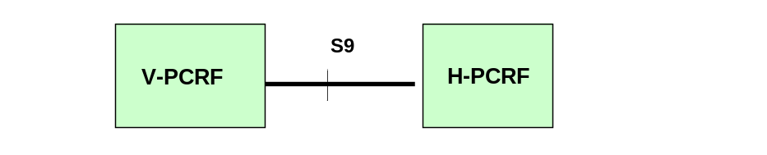
Figure 4.2.1: S9 reference model
Figure 4.2.1a: Void
Figure 4.2.2: Void
Figure 4.2.2a: Void

4.3 Functional elements

4.3.1 H-PCRF

4.3.1.0 General
The H-PCRF (Home Policy and Charging Rules Function) is a functional element that encompasses policy control decision and flow based charging control functionalities in the HPLMN.
The H-PCRF provides functions for both home routed access and visited access.
The H-PCRF selects the bearer control mode applicable for the user or IP-CAN session. Policy decisions based on the bearer control mode are made in the H-PCRF.
Usage monitoring as defined in 3GPP TS 29.212 [3] is controlled by the H-PCRF.
The H-PCRF shall check whether PCC Rules or QoS Rules have to be provided based on the information received from the V-PCRF.
NOTE: The H-PCRF can use the Called-Station-Id AVP for that purpose. When this AVP is absent, the H-PCRF provides QoS rules that are not related to any IP-CAN session. When it is present, if it identifies a Visited Network, the PCC rules will be provided. If it is present and identifies a Home Network, the QoS rules will be provided. When looking up policies for an APN from the SPR or internal storage, the H-PCRF can apply the APN matching procedures in Annex I of 3GPP TS 29.213 [4].
When provisioning PCC/QoS rules over the S9 reference point, the H-PCRF is responsible for assigning packet filter identifiers for rules provisioned as a result of UE initiated resource modification. For E-UTRAN access with UE initiated resource modification procedure, the H-PCRF shall either authorize the same QoS as requested or reject the request if the requested QoS cannot be authorized.

4.3.1.1 Home routed access
The H-PCRF shall provision QoS Rules to the V-PCRF via the S9 reference point, PCC Rules to the PCEF via the Gx reference point, and if applicable, provision ADC rules to the TDF via the Sd reference point. The H-PCRF ensures that the QoS Rules provisioned are aligned with the PCC Rules. It is PCRF's responsibility to coordinate the PCC rules and QoS rules, if applicable, with ADC rules in order to ensure consistent service delivery.
Based on home operator policy, the H-PCRF may allow a request for ponsored data connectivity, reject a request for sponsored data connectivity, or terminate the AF session associated with sponsored data connectivity.
The H-PCRF PCC Rule decisions may be based on one or more of the following:
- Information obtained from the AF via the Rx reference point.
- Information obtained from the V-PCRF via the S9 reference point.
NOTE: The above may include information obtained from the BBERF via the Gxx reference point.
- Information obtained from the PCEF via the Gx reference point.
- Information obtained from the SPR via the Sp reference point.
- Information obtained from the TDF via the Sd reference point.
- PCRF pre-configured information.
The H-PCRF provisions event triggers to the V-PCRF, PCEF and TDF.

4.3.1.2 Visited Access
The H-PCRF shall provision PCC Rules to the V-PCRF via the S9 reference point. The H-PCRF may provision QoS Rules to the V-PCRF via the S9 reference point for case 2a when the available QoS Rules are not related to any IP-CAN session.
The H-PCRF shall reject request for sponsored data connectivity when the AF is located in the HPLMN.
NOTE 0: Sponsored connectivity for a roaming subscriber with visited access is not supported in this release as specified in 3GPP TS 23.203 [2].
The H-PCRF PCC/QoS Rule decisions may be based on one or more of the following:
- Information obtained from the AF when located in the home network.
- Information obtained from the V-PCRF via the S9 reference point.
NOTE 1: The above may include information obtained from the AF when the AF is located in the VPLMN and information obtained from the PCEF, BBERF and TDF.
NOTE 2: Information obtained from the AF only applies for PCC Rule decisions.
- Information obtained from the SPR via the Sp reference point.
- PCRF pre-configured information.
The H-PCRF provisions event triggers to the V-PCRF.

4.3.2 V-PCRF

4.3.2.0 General
The V-PCRF (Visited Policy and Charging Rules Function) is a functional element that encompasses policy control decision and flow based charging control functionalities in the VPLMN.
The V-PCRF provides functions for both home routed access and visited access.
For E-UTRAN access with UE initiated resource modification procedure, the V-PCRF shall validate the QoS based on operator policies in the request from the BBERF/PCEF before interacting with the H-PCRF.

4.3.2.1 Home routed access
The V-PCRF shall request QoS Rules and report events to the H-PCRF via the S9 interface.
The V-PCRF validates the QoS parameters received within the QoS Rules based on operator policies. The V-PCRF informs the H-PCRF if the QoS validation failed.
The V-PCRF shall provision QoS Rules to the BBERF via the Gxx reference point.

4.3.2.2 Visited access
The V-PCRF shall request PCC Rules from and report events to the H-PCRF using the S9 reference point.
The V-PCRF may request QoS Rules from the H-PCRF using the S9 reference point when the available QoS Rules are not related to any IP-CAN session.
If the V-PCRF receives the PCC Rules from the H-PCRF, the V-PCRF extracts the QoS Rules from the PCC Rules, validates the former, and if QoS validation is successful, the V-PCRF shall provision the PCC Rules to the PCEF via the Gx reference point and the QoS Rules to the BBERF via the Gxx reference point. If the QoS validation fails the V-PCRF shall provide the acceptable QoS to the H-PCRF. The H-PCRF may provide back an acceptable QoS to the V-PCRF or may reject the request. Upon reception of the successful response from the H-PCRF, the V-PCRF shall provision the PCC Rules to the PCEF and the QoS Rules to the BBERF, if H-PCRF reject the request the V-PCRF shall reject the corresponding request from the PCEF/BBERF. If the QoS validation applies to the Default Bearer QoS or APN-AMBR, the procedures described in clauses 4.5.1.5 and 4.5.1.6 shall apply respectively. For case 2a, there may be additional specific rules to be installed at the BBERF for the sole purpose of allowing the tunnel between the BBERF and the PCEF not directly related with any service.
If the V-PCRF receives the PCC Rules containing application identifiers from the H-PCRF, and there is a TDF deployed in the visited network, the V-PCRF shall derive corresponding ADC rules and provide those ADC rules to the TDF. If the V-PCRF receives PCC Rules containing application identifiers from the H-PCRF and the PCEF in the visited network supports Application and Detection Control feature, the V-PCRF shall provide those PCC rules to the PCEF supporting Application Detection and Control feature.
If the V-PCRF receives application detection notifications from a PCEF or a TDF, the V-PCRF shall provide those notifications to the H-PCRF if the H-PCRF has subscribed to the Event-Trigger AVP with the value APPLICATION_START/APPLICATION_STOP and the Mute-Notification AVP is not included in the corresponding PCC rule with application identifier; otherwise, the V-PCRF may handle it locally.
When the AF is located in the VPLMN, the V-PCRF shall exchange Rx messages with the H-PCRF over the S9 reference point.
The V-PCRF shall reject request for sponsored data connectivity when the AF is located in the VPLMN.
NOTE:1 Sponsored connectivity for a roaming subscriber with visited access is not supported in this release as specified in 3GPP TS 23.203 [2].
NOTE 2: Through roaming agreement, the HPLMN operator may allow the VPLMN operator to operate the V-PCRF without interaction with H-PCRF (i.e. no S9 is used). In such case, only static policies will be applied in V-PCRF based on roaming agreements. The VPCRF may also interact with the AF in the VPLMN in order to generate PCC Rules for services delivered via the VPLMN. V-PCRF uses locally configured policies according to the roaming agreement with the HPLMN operator as input for PCC Rule decision.

4.4 PCC, QoS, and IP flow mobility routing Rules and NBIFOM routing Rules

4.4.1 PCC Rule definition
The purpose of the PCC Rule is defined in 3GPP TS 29.212 [3]. PCC Rules are sent over S9 interface for visited access.
There are two different types of PCC rules as defined in 3GPP TS 29.212 [3]:
- Dynamic PCC rules. Dynamically provisioned by the H-PCRF to the V-PCRF via the S9 interface. These PCC rules may be either predefined or dynamically generated in the H-PCRF. Dynamic PCC rules can be installed, modified and removed at any time.
- Predefined PCC rules. Preconfigured in the PCEF. Predefined PCC rules can be activated or deactivated by the H-PCRF at any time via the V-PCRF using S9 interface. Predefined PCC rules may be grouped allowing the H-PCRF to dynamically activate a set of PCC rules in the PCEF via the V-PCRF using S9 interface. The H-PCRF should activate the predefined PCC rules based on the roaming agreement. The V-PCRF may accept or reject the H-PCRF decision according to visited operator policy.
The content of a PCC Rule is the same as defined in 3GPP TS 29.212 [3]. The rule name within a PCC Rule shall be used to reference to a PCC Rule in the communication between the H-PCRF and the V-PCRF.

4.4.2 QoS Rule definition
The purpose of the QoS Rule is defined in clause 4.3a of 3GPP TS 29.212 [3]. QoS Rules are sent over S9 interface for home routed access and visited access.
The content of a QoS Rule is the same as defined in clause 4.3a of 3GPP TS 29.212 [3]. The rule name within a QoS Rule shall be used to reference to a QoS Rule in the communication between the H-PCRF and the V-PCRF.

4.4.2a IP flow mobility routing Rule definition
The purpose of the IP flow mobility routing Rule is defined in 3GPP TS 29.212 [3]. IP flow mobility routing Rules are sent over S9 interface for visited access.
The content of an IP flow mobility routing Rule is the same as defined in 3GPP TS 29.212 [3]. The routing rule identifier within an IP flow mobility routing Rule generated by the PCEF shall be used to reference to an IP flow mobility routing Rule in the communication between the H-PCRF and the V-PCRF.

4.4.2b Void

4.4.2c NBIFOM routing Rule definition
The purpose of the NBIFOM routing Rule is defined in clause 4.3x of 3GPP TS 29.212 [3]. NBIFOM routing Rules are sent over S9 interface for visited access.
The content of a NBIFOM routing Rule is the same as defined in clause 4.3c of 3GPP TS 29.212 [3]. The routing rule identifier within a NBIFOM routing Rule generated by the PCEF shall be used to reference to a NBIFOM routing Rule in the communication between the H-PCRF and the V-PCRF.

4.4.3 Operations on PCC rules
PCC Rules operations are defined in 3GPP TS 29.212 [3]. This clause clarifies how those operations are implemented on the S9 interface.
For dynamic PCC rules, the V-PCRF validates the QoS parameters requested within the PCC Rules, before accepting the installation or modification of PCC Rules. If the QoS validation fails the V-PCRF shall provide the acceptable QoS to the H-PCRF. Upon reception of the successful response from the H-PCRF, the V-PCRF shall provision the PCC Rules to the PCEF, if H-PCRF reject the request the V-PCRF shall reject the corresponding request from the PCEF/BBERF.
For the Visited Access case, the H-PCRF may activate predefined PCC rules in the V-PLMN’s PCEF. In that case, the V-PCRF shall validate, based on roaming agreements, that the H-PCRF is allowed to perform a particular operation on a particular PCC Rule.

4.4.4 Operations on QoS Rules
Dynamic QoS Rules operations are defined in 3GPP TS 29.212 [3].
For QoS rules, the V-PCRF validates the QoS parameters requested within the QoS Rules, before accepting the installation or modification of QoS Rules. If the QoS validation fails the V-PCRF shall provide the acceptable QoS to the H-PCRF. Upon reception of the successful response from the H-PCRF, the V-PCRF shall provision the QoS Rules to the BBERF, if H-PCRF reject the request the V-PCRF shall reject the corresponding request from the PCEF/BBERF.

4.4.5 Operations on IP flow mobility routing Rules
IP flow mobility routing Rules operations are defined in clause 4.3a of 3GPP TS 29.212 [3]. This clause clarifies how those operations are implemented on the S9 interface.
For the Visited Access case, the H-PCRF receives IP flow mobility routing rules from the V-PCRF if and only if the H-PCRF has subscribed either the AN_GW_CHANGE or the IP-CAN_CHANGE event trigger at the V-PCRF. In that case, the H-PCRF shall update the affected PCC rules based on the IP flow mobility routing rules and provide them to the V-PCRF.

4.4.6 Void

4.4.7 Operations on NBIFOM routing Rules
NBIFOM routing Rules operations are defined in clause 4.3c of 3GPP TS 29.212 [3]. This clause clarifies how those operations are implemented on the S9 interface.
For the Visited Access case, the H-PCRF receives NBIFOM routing rules from the V-PCRF if and only if the H-PCRF has confirmed that the NBIFOM applies to the IP-CAN session to the V-PCRF. In that case, the H-PCRF shall update the affected PCC rules based on the NBIFOM routing rules and provide them to the V-PCRF.

4.5 PCC procedures over S9 Reference Point

4.5.1 General
In this release, there are two protocols running over the S9 interface: the S9 protocol and the Rx protocol.
- The Rx protocol is working as specified in 3GPP TS 29.214 [5].
- The S9 protocol is defined in clause 5 in this document. The S9 protocol allows establishment, modification and termination of Diameter S9 sessions. There is an S9 session per UE between each H-PCRF and V-PCRF pair. An S9 session can contain zero, one or several S9 subsessions. The S9 subsession scope is per PDN connection. An S9 subsession can be established, modified and terminated.
When the V-PCRF receives a request that should be sent to the HPLMN, the V-PCRF places the information within a S9 subsession level if it only applies to a particular PDN connection. Otherwise, the information is placed at S9 session level.
There are three distinct network scenarios for an IP-CAN as defined in 3GPP TS 29.213 [4]:
1. No Gateway Control session is needed. GTP is used for S5/S8, S2a and S2b reference points.
2. Gateway Control session is needed. Two subcases can be distinguished:
2a) S2c reference point (and then DSMIPv6 protocol) is used by a trusted non-3GPP access to access the EPC. Each Gateway Control Session applies for all IP-CAN sessions using the same CoA.
2b) Trusted non-3GPP accesses that use S2a reference point (PMIPv6 or MIPv4 protocol is used) or 3GPP access that uses PMIPv6 over S5/S8 reference points. Each Gateway Control Session applies for one IP-CAN session.
The S9 reference point is used for case 1 in VA scenario and, for cases 2a and 2b for both HR and VA scenarios.
NOTE: The cases described above are often referred through the document as cases 1, 2a or 2b.

4.5.1.1 S9 Session Establishment
When the V-PCRF receives a CCR command with CC-Request-type AVP set to the value "INITIAL_REQUEST" from the PCEF/BBERF that can not be associated with any existing S9 session to the H-PCRF for that UE (based on the Subscription-Id AVP), the V-PCRF shall establish a new S9 session according to the procedures specified in clause 4.5.2.1 or 4.5.3.1 for home-routed and visited access respectively.
NOTE: In a network scenario that deploys case 1 as defined in clause 4.5.1, S9 session is only needed in the visited access case and the procedures described in clause 4.5.3 apply.

4.5.1.2 S9 Session Termination
The V-PCRF shall initiate a termination of the S9 session when it receives a trigger that originates the removal of the last existing S9 subsession associated with the referred S9 session. The V-PCRF terminates the S9 session following the procedures described in clause 4.5.2.3 or clause 4.5.3.3.
When the H-PCRF determines that the S9 session shall be terminated, the procedures described in clause 4.5.2.4 and 4.5.3.4 apply.
NOTE: In a network scenario that deploys case 1 as defined in clause 4.5.1, only the procedures described in clause 4.5.3 apply.

4.5.1.3 Event Triggers

4.5.1.3.1 Provisioning of Event Triggers
Provisioning of event triggers may be performed by either the V-PCRF or the H-PCRF. The V-PCRF may receive requests to subscribe to event triggers from the H-PCRF, from the PCEF (VA case) , from the TDF (VA case) or due to an internal or other external event. The H-PCRF may receive subscription request from the PCEF (i.e. In the HR case, the H-PCRF derives the event triggers from the Event-Report-Indication AVP from the PCEF), or due to an internal or external event (e.g. due to an Rx interaction with the AF).
When the H-PCRF wants to subscribe or unsubscribe to event trigger(s) in the VPLMN, the H-PCRF shall provide to the V-PCRF one or several event triggers by including them within the Event-Trigger AVP. Event Triggers may apply to a specific S9 Subsession(s) or to a specific S9 session. Event Triggers provided for a specific S9 session apply to S9 subsession(s) within the specified S9 session.
- When Event Triggers are provided for a specific S9 subsession(s), the H-PCRF includes Subsession-Decision-Info AVP for each of the affected S9 subsession. Each Subsession-Decision-Info AVP includes the Subsession-Id AVP and the list of event triggers within the Event-Trigger AVP.
- When Event Triggers are provided for a specific S9 session(s), the H-PCRF includes the list of event triggers within the Event-Trigger AVP at command level.
The H-PCRF adds new event triggers or removes previously provided event triggers to the V-PCRF by providing the new complete list of applicable event triggers.
The H-PCRF may provision event triggers to the V-PCRF using both a RAR and a CCA command. However, for the Home Routed case, the H-PCRF shall provision the IP-CAN_CHANGE event trigger to the V-PCRF at the command level in the initial CCA command.
When the V-PCRF receives event triggers from the H-PCRF, the V-PCRF stores them locally as S9-related and proceeds as follows:
- In both the Home-Routed and Visited Access cases, the V-PCRF shall provision the event triggers over the associated Gxx session to the BBERF using the Gateway Control and QoS Rules Provisioning or Gateway Control Session Establishment procedure described in 3GPP TS 29.212 [3] clauses 4a.5.1 and 4a.5.2.
- Additionally, in the Visited Access case, the V-PCRF may also provision the event triggers over the associated Gx session to the PCEF using the PCC Provisioning procedures described in 3GPP TS 29.212 [3] clause 4.5.3. The V-PCRF may also provision the corresponding relevant event triggers over the associated TDF session to the TDF using the ADC Rule Provisioning procedure as described in 3GPP TS 29.212 [3] clause 4b.5.3.
For the Visited Access case, the H-PCRF may remove all previously provided event triggers by providing the Event-Trigger AVP set to the value NO_EVENT_TRIGGERS. The H-PCRF includes within the Subsession-Decision-Info AVP the affected Subsession-Id AVP and the list of event triggers within the Event-Trigger AVP. When an Event-Trigger AVP is provided with this value, no other Event-Trigger AVP shall be provided in the CCA or RAR command. Upon reception of an Event-Trigger AVP with this value from the H-PCRF, if there are no other locally handled event triggers, the V-PCRF shall provide the Event-Trigger AVP set to the value NO_EVENT_TRIGGERS to the BBERF and PCEF; if there are locally handled event triggers, the V-PCRF shall update the event triggers at the BBERF and the PCEF to remove those triggers previously installed based on requests from the H-PCRF. The V-PCRF shall not inform H-PCRF of any subsequent event except for those events that are always subscribed with no provision.
When the PCEF in the Visited Access case subscribes or unsubscribes to one or several event triggers with the V-PCRF, the V-PCRF stores them locally as Gx-related events and then provision them over the associated Gxx session (identified using the Gateway Control Session to IP-CAN session linking procedure described in 3GPP TS 29.212 [3] clause 4a.5.6) to the BBERF using the Gateway Control and QoS Rules Provisioning procedure described in 3GPP TS 29.212 [3] clause 4a.5.2.
When the TDF in theVisited Access case subscribes or unsubscribes to one or several event triggers with the V-PCRF, the V-PCRF stores them locally as Sd-related events and then provision them over the associa ted Gxx session to the BBERF using the Gateway Control and QoS Rules Provisioning procedure described in 3GPP TS 29.212 [3] clause 4a.5.2 or Gx session to the PCEF using the PCC rules Provisioning procedure described in 3GPP TS 29.212 [3] clause 4.5.2.
The V-PCRF may also provision event triggers to the BBERF/PCEF/TDF due to an internal or external trigger or using the Provisioning of Event Triggers procedure as described in 3GPP TS 29.212 [3] clauses 4a.5.3, clause 4.5.3 and clause 4b.5.3.

4.5.1.3.2 Reporting of deployed Event Triggers
The V-PCRF may receive a report of an event trigger that is deployed at the BBERF or at the PCEF (VA case) or at the TDF (VA case).
In the VA case, when the event trigger reported by the BBERF corresponds to a Gx-related event trigger (i.e. a subscription from the PCEF), the V-PCRF notifies the PCEF as described in 3GPP TS 29.212 [3] clause 4.5.2.1.
In the VA case, when the event trigger reported by the BBERF or PCEF corresponds to an Sd-related event trigger (i.e. a subscription from the TDF), the V-PCRF notifies the TDF as described in 3GPP TS 29.212 [3] clause 4b.5.8.
NOTE: The V-PCRF always reports the UE_IP_ADDRESS_ALLOCATE and UE_IP_ADDRESS_RELEASE to the TDF.
When the event trigger reported by the BBERF, the PCEF (in VA case) or TDF (in VA case) corresponds to a S9-related (i.e. a subscription from the H-PCRF) event trigger or is always reported even though the V-PCRF has not provisioned it and the value is applicable for the S9 reference point as indicated in clause 5.4, the V-PCRF notifies the H-PCRF using the procedures as described in clause 4.5.2.1 in home routed case or the PCC Rule Request procedure as described in clause 4.5.3.1 for visited access case.
When the event trigger reported by the BBERF/PCEF corresponds to a V-AF-related event trigger, the V-PCRF shall inform the V-AF using the RAR command including the Specific-Action AVP as described in 3GPP TS 29.214 [5] clauses 4.4.6.1, 4.4.6.2 and 4.4.6.3.

4.5.1.4 Multiple BBERF scenarios
The multiple BBERF scenarios happen when there is a change or an addition of BBERF and the H-PCRF and the V-PCRF needs to handle more than one BBERF related with the sameIP-CAN session.
The V-PCRF shall follow the procedures defined in clauses 4.5.2.5 and 4.5.3.5 respectively for the home routed and visited access cases.

4.5.1.5 Provisioning and validation of Default EPS Bearer authorized QoS
The default EPS Bearer QoS handling only applies to case 2b in HR scenario, and case 1, case 2a and case 2b in the VA scenario.
For IP-CAN types that support multiple IP-CAN bearers, the V-PCRF may provide the Default-EPS-Bearer-QoS AVP in the Subsession-Enforcement-Info AVP within the CCR command to the H-PCRF.
The H-PCRF may provision the authorized QoS for the default EPS bearer within the corresponding S9 subsession in the CCA command including the Subsession-Decision-Info AVP for the S9 subsession within the S9 session. The S9 Subsession-Decision-Info AVP contains the Default-EPS-Bearer-QoS AVP.
Besides the H-PCRF may provision the authorized QoS for the default EPS bearer without receiving a request from the V-PCRF, e.g. in response to an internal trigger within the H-PCRF or upon interaction with the SPR. The H-PCRF shall send a RAR command including the Subsession-Decision-Info AVP with the Default-EPS-Bearer-QoS AVP for the S9 subsession within the S9 session.
The V-PCRF shall validate the Default-EPS-Bearer-QoS AVP in case it is received in the CCA or RAR command.
If the QoS validation fails and there is a default EPS bearer QoS value already authorized for that IP-CAN session, the V-PCRF shall retain the existing default EPS bearer QoS without any modification and reject the request using a CCR/RAA command respectively to the H-PCRF. The CCR/RAA shall include the Subsession-Enforcement-Info AVP for the affected S9 subsession that includes the S9 subsession identifier within the Subsession-Id AVP, the Default-EPS-Bearer-QoS AVP to indicate the retained value, and the Event Trigger set to DEFAULT-EPS-BEARER-QOS_MODIFICATION_FAILURE.
If the QoS validation fails as part of the IP-CAN session establishment procedure, the V-PCRF shall derive the acceptable default EPS bearer QoS based on operator policies and reject the request using a CCR command to the H-PCRF. The CCR shall include the Subsession-Enforcement-Info AVP for the affected S9 subsession that includes the S9 subsession identifier within the Subsession-Id AVP, the Default-EPS-Bearer-QoS AVP to indicate the acceptable value, and the Event Trigger set to DEFAULT-EPS-BEARER-QOS_MODIFICATION_FAILURE.
The H-PCRF may provide back an acceptable default EPS bearer QoS or may reject the request. If the H-PCRF rejects the request the V-PCRF shall reject the corresponding request from the PCEF/BBERF.
Upon reception of the subsequent CCA command, if the procedure was initiated by the PCEF/BBERF and default EPS bearer QoS is acceptable, the V-PCRF shall provide the negotiated default EPS bearer QoS in the response to the PCEF/BBERF.
NOTE: In order to avoid loops in the QoS negotiation process, it is recommended that the H-PCRF provides a default EPS bearer QoS acceptable by the Visited Network.

4.5.1.6 Provisioning of Authorized QoS per APN
The Authorized QoS per APN handling only applies to case 2b in HR scenario, and case 1, case 2a and case 2b in the VA scenario.
At S9 Session/Subsession Establishment/Modification, the V-PCRF may include the APN-AMBR (if received from the BBERF for case 2b or PCEF for case 1 and case 2a in VA scenario) in the QoS-Information AVP of the Subsession-Enforcement-Info AVP, using the APN-Aggregate-Max-Bitrate-UL AVP and/or the APN-Aggregate-Max-Bitrate-DL AVP within the CCR command to the H-PCRF.
Upon receiving the subscribed APN-AMBR from the V-PCRF, the H-PCRF shall provision the authorized QoS per APN within the CCA command. The authorized QoS per APN shall be provisioned in the QoS-Information AVP of Subsession-Decision-Info AVP, using the APN-Aggregate-Max-Bitrate-UL AVP and/or the APN-Aggregate-Max-Bitrate-DL AVP. When APN-Aggregate-Max-Bitrate-UL AVP and/or the APN-Aggregate-Max-Bitrate-DL AVP are provided, the Max-Requested-Bandwidth values, and the Guaranteed-Bitrate values shall not be included.
Besides the H-PCRF may provision the authorized APN-AMBR without receiving a request from the V-PCRF, e.g. in response to an internal trigger within the H-PCRF or upon interaction with the SPR. The H-PCRF shall send a RAR command including the Subsession-Decision-Info AVP with the QoS-Information AVP for the S9 subsession.
If the APN-AMBR is changed, the H-PCRF shall provision the authorized APN-AMBR for each IP-CAN session for that APN by including the Subsession-Decision-Info AVP with the QoS-Information AVP for each affected S9 subsession.
The V-PCRF shall validate the APN-AMBR in case it is received in the CCA or RAR command. If the QoS validation fails and there is an APN-AMBR value already authorized for that IP-CAN session, the V-PCRF shall retain the existing APN-AMBR without any modification and reject the request using a CCR/RAA command respectively to the H-PCRF. The CCR/RAA shall include the Subsession-Enforcement-Info AVP for the affected S9 subsession that includes the S9 subsession identifier within the Subsession-Id AVP, the QoS-Information AVP to indicate the retained value, and the Event Trigger set to APN-AMBR_MODIFICATION_FAILURE.
If the QoS validation fails as part of the IP-CAN session establishment procedure, the V-PCRF shall derive the acceptable APN-AMBR based on operator policies and reject the request using a CCR command to the H-PCRF. The CCR shall include the Subsession-Enforcement-Info AVP for the affected S9 subsession that includes the S9 subsession identifier within the Subsession-Id AVP, the QoS-Information AVP to indicate the acceptable value, and the Event Trigger set to APN-AMBR_MODIFICATION_FAILURE.
The H-PCRF may provide back an acceptable APN-AMBR or may reject the request. If the H-PCRF rejects the request the V-PCRF shall reject the corresponding request from the PCEF/BBERF.
Upon reception of the subsequent CCA command, if the procedure was initiated by the PCEF/BBERF and the APN-AMBR is acceptable, the V-PCRF shall provide the negotiated APN-AMBR in the response to the PCEF/BBERF.
NOTE: In order to avoid loops in the QoS negotiation process, it is recommended that the H-PCRF provides an APN-AMBR acceptable by the Visited Network.

4.5.1.7 Bearer Control Mode Selection
The H-PCRF derives the selected bearer control mode based on the received Network-Request-Support AVP, access network information, subscriber information and operator policy.
- If the bearer control mode that H-PCRF derives is applicable for the S9 session of the user, the H-PCRF includes the bearer control mode within Bearer-Control-Mode AVP at the command level.
- If the bearer control mode that H-PCRF derives is applicable for a specific IP-CAN session, the H-PCRF includes the Subsession-Decision-Info AVP for the affected S9 subsession corresponding to the IP-CAN session. The subsession-Decision-Info AVP includes allocated S9 subsession identifier within the Subsesssion-Id AVP and the bearer control mode within the Bearer-Control-Mode AVP.

4.5.1.8 Access Network Information Reporting
This procedure takes place when the multi access PDN connectivity is supported.
The V-PCRF shall report the access network information of the UE to the H-PCRF, e.g. the IP-CAN type, RAT type (if applicable), at the command level for case 2a and if there is no S9 subsession established.
Otherwise, the V-PCRF shall report the access network information of the IP-CAN session to the H-PCRF only in the corresponding S9 subsession except during S9 session establishment where the V-PCRF shall report the access network information at both the command and S9 subsession levels.
NOTE : The V-PCRF provides the access network information at the command level during S9 session establishment for backwards compatibility reasons, in case the H-PCRF does not support the multi access PDN connectivity.

4.5.2 Home-Routed access

4.5.2.1 S9 Session/Subsession establishment/modification
The V-PCRF interacts with the H-PCRF in the following instances:
1) Upon Gateway Control Session establishment over Gxx:
When the V-PCRF receives a CCR command with a CC-Request-Type AVP set to "INITIAL_REQUEST" from the BBERF over Gxx, the V-PCRF determines whether case 2a or case 2b applies as defined in 3GPP TS 29.213 [4] and applies the following procedures apply:
- If case 2a applies,
- If there is not an already established S9 session for this roaming user, the V-PCRF shall send to the H-PCRF a CCR command with the CC-Request-Type AVP set to the value "INITIAL_REQUEST" to establish a new S9 session. The CCR command from the V-PCRF to the H-PCRF shall include those attributes provided by the BBERF to the V-PCRF at the Diameter CCR command level, defined in clause 4a.5.1 of 3GPP TS 29.212 [3].
- Otherwise, if there is an already established S9 session for this roaming user, the procedures in clause 4.5.2.5 shall be applied.
- If case 2b applies,
- If there is not an already established S9 session for this roaming user, the V-PCRF shall send to the H-PCRF a CCR command with the CC-Request-Type AVP set to the value "INITIAL_REQUEST" to establish a new S9 session. The V-PCRF shall include the Subsession-Enforcement-Info AVP within the CCR command with a new S9 subsession identifier assigned by the V-PCRF within the Subsession-Id AVP, the Subsession-Operation AVP set to the value "ESTABLISHMENT". The V-PCRF shall map the Gxx session-id(s) to the corresponding subsession-id(s) in the S9 session. In addition, the V-PCRF shall include those attributes provided by the BBERF that allows the H-PCRF to identify the Subsession as defined in 3GPP TS 29.212 [3].
- If an existing S9 session for the roaming user is already established with the H-PCRF, the V-PCRF shall update the existing session by sending a CCR with the CC-Request-Type AVP set to the value “UPDATE_REQUEST” to the H-PCRF.
- If an S9 subsession does not exist for the PDN connection corresponding to the gateway control session establishment, the V-PCRF shall include the Subsession-Enforcement-Info AVP within the CCR command with a new S9 subsession identifier assigned by the V-PCRF within the Subsession-Id AVP, the Subsession-Operation AVP set to the value "ESTABLISHMENT". The V-PCRF shall map the Gxx session-id(s) to the corresponding subsession-id(s) in the S9 session.
- In all cases, the CCR command from the V-PCRF to the H-PCRF shall include, at subsession level, those attributes provided by the BBERF to the V-PCRF, as defined in clause 4a.5.1 of 3GPP TS 29.212 [3].
- If the V-PCRF detects that an S9 subsession already exists for a particular PDN connection linked to a different gateway control session (i.e. different Gxx session-id), the V-PCRF shall follow the procedures in clause 4.5.2.5.
2) Upon Gateway Control Session modification over Gxx by receiving a Gateway Control and QoS rules request
If the V-PCRF receives a CCR command with a CC-Request-Type AVP set to "UPDATE_REQUEST" from the BBERF over Gxx, the V-PCRF shall send a CCR command with a CC-Request-Type AVP set to "UPDATE_REQUEST" to the H-PCRF including the updated information.
In case 2a, the V-PCRF shall include the attributes provided by the BBERF at the CCR command level.
In case 2b, the V-PCRF shall modify the corresponding S9 subsession by including the Subsession-Enforcement-Info AVP within the CCR command that contains the allocated S9 subsession identifier within the Subsession-Id AVP, the Subsession-Operation AVP set to the value "MODIFICATION". In addition, the V-PCRF shall provide the Subsession-Id AVP to allow the H-PCRF to identify the subsession for which QoS Rules are requested. The V-PCRF shall include the attributes provided by the BBERF within the Subsession-Enforcement-Info AVP.
If the V-PCRF receives a CCR command with a CC-Request-Type AVP set to "UPDATE_REQUEST" and the Event-Trigger AVP set to "RESOURCE_MODIFICATION_REQUEST", the V-PCRF may validate the QoS in the request. If the QoS validation fails, the V-PCRF shall reply to the BBERF over Gxx with a CCA command including the Gx experimental result code DIAMETER_ERROR_INITIAL_PARAMETERS.
The QoS rules are provisioned by the H-PCRF as follows:
- In case 2a, the H-PCRF shall provision QoS Rules in the CCA command by the QoS-Rule-Install AVP at the command level.
- In case 2b, the H-PCRF shall provision QoS Rules within the corresponding S9 subsession by issuing the CCA command and including the Subsession-Decision-Info AVP for the S9 subsession within the S9 session. Each S9 Subsession-Decision-Info AVP contains the QoS-Rule-Install AVP.
If the H-PCRF is, due to incomplete, erroneous or missing information (e.g. subscription related information not available or authorized QoS exceeding the subscribed bandwidth) not able to:
1) Provision a policy decision to a specific subsession as response to the request sent by the V-PCRF, the H-PCRF shall send a CCA command including the Experimental-Result AVP at the command level with the Experimental-Result-Code AVP set to DIAMETER_ERROR_SUBSESSION (5470), including the Subsession-Decision-Info AVP with the rejected Subsession-Id(s) within the Subsession-Id AVP and the appropriate error within either the Experimental-Result-Code AVP or Result-Code AVP.
2) Provision a policy decision to any of the S9 subsession(s) or provision a policy decision at the command level, the H-PCRF shall reject the request using a CCA command with the DIAMETER_ERROR_INITIAL_PARAMETERS (5140) within the Experimental-Result-Code AVP.
When the V-PCRF receives a CCA command where S9 specific subsession(s) contain a specific Result-Code or Experimental-Result-Code AVP from the H-PCRF, the V-PCRF shall reply to the BBERF over the respective Gxx with a CCA command including the same result code.
When the V-PCRF receives a CCA command with an error code within the Experimental-Result-Code AVP or Result-Code AVP at the command level, the V-PCRF shall reply to the BBERF over the respective Gxx interface with a CCA command including the same result code.
The V-PCRF shall validate the QoS Rules contained in the CCA. If the QoS validation fails the V-PCRF shall perform the following:
1) Send a CCR command to the H-PCRF with the CC-Request-Type AVP set to “UPDATE_REQUEST” and
a) In case 2a, include the QoS-Rule-Report AVP to indicate the QoS Rules that were not accepted, including Rule-Failure-Code AVP set to UNSUCCESSFUL_QOS_VALIDATION value and the QoS-Information AVP to indicate the acceptable QoS.
b) In case 2b, include the QoS-Rule-Report AVP within the Subsession-Enforcement-Info AVP to indicate the QoS Rules that were not accepted, including Rule-Failure-Code AVP set to UNSUCCESSFUL_QOS_VALIDATION value and the QoS-Information AVP to indicate the acceptable QoS. The V-PCRF shall include the S9 subsession specific information within the CCR command that includes the S9 subsession identifier within the Subsession-Id AVP.
2) Upon reception of the subsequent CCA command from the H-PCRF, the V-PCRF shall reply to the BBERF over Gxx with a CCA command. If the validation of the answer from the H-PCRF is successful, the V-PCRF shall include the acceptable QoS in the QoS rules. Otherwise, the V-PCRF shall reply to the BBERF over Gxx with a CCA command including the Gx experimental result code DIAMETER_ERROR_INITIAL_PARAMETERS.
NOTE: In order to avoid loops in the QoS negotiation process, it is recommended that the H-PCRF provides a QoS acceptable by the Visited Network.

4.5.2.2 Provision of QoS Rules by the H-PCRF
The H-PCRF may decide to provision QoS Rules without obtaining a request from the V-PCRF, e.g. in response to information provided to the H-PCRF via the Rx reference point, or in response to an internal trigger within the H-PCRF, or from a trigger by the SPR. The H-PCRF may also decide to provision QoS rules in response to a request for PCC Rules received by the H-PCRF from the PCEF that is linked with a former Gateway Control session establishment.
To provision QoS Rules without a request from the V-PCRF, the H-PCRF shall do the following:
- In case 2a, send a RAR command including the QoS rules to be provisioned within the QoS-Rule-Install AVP at the command level.
- In case 2b, send a RAR command including the Subsession-Decision-Info AVP for each of the S9 subsessions within the S9 session. Each Subsession-Decision-Info AVP contains the QoS rules to be provisioned within the QoS-Rule-Install AVPs.
The V-PCRF shall validate the QoS Rules contained within each S9 subsession within the RAR command.
If the QoS validation fails the V-PCRF shall send a reject in the RAA command to the H-PCRF. The V-PCRF includes:
- In case 2a, a DIAMETER_PCC_RULE_EVENT (5142) experimental result code, the QoS-Rule-Report AVP to indicate the QoS Rules that were not accepted, including Rule-Failure-Code AVP set to UNSUCCESSFUL_QOS_VALIDATION value and the QoS-Information AVP to indicate the acceptable QoS.
- In case 2b, the Subsession-Enforcement-Info AVP for each rejected S9 subsession. The Subsession-Enforcement-Info AVP with the rejected Subsession-Id(s) and a DIAMETER_PCC_RULE_EVENT (5142) experimental result code, including the QoS-Rule-Report AVP to indicate the QoS Rules that were not accepted, including Rule-Failure-Code AVP set to UNSUCCESSFUL_QOS_VALIDATION value and the QoS-Information AVP to indicate the acceptable QoS.
If the QoS validation succeeds, the V-PCRF shall initiate the Gateway Control and QoS Rules Provision procedure over Gxx as defined in 3GPP TS 29.212 [3] by sending an RAR command to the BBERF including the parameters from the RAR command received from the H-PCRF. When the V-PCRF receives the RAA from the BBERF(s), the V-PCRF responds to the H-PCRF as follows:
- in case 2a, the V-PCRF shall send a corresponding RAA command to the H-PCRF including the corresponding result code.
- in case 2b, the V-PCRF shall send a corresponding RAA command to the H-PCRF including the S9 Subsession-Enforcement-Info AVP for each specific S9 subsession with the corresponding result code.

4.5.2.3 S9 Session/Subsession Termination Initiated by the V-PCRF
This procedure is triggered by a Gateway Control Session Termination procedure over Gxx interface. When the V-PCRF receives a CCR command with a CC-Request-Type AVP set to “TERMINATION_REQUEST” from the BBERF over Gxx, it shall acknowledge this message by sending the CCA command to the BBERF as defined in 3GPP TS 29.212 [3]. If in addition to the Gateway Control Session being terminated, one or more Gateway Control Sessions corresponding to the PDN connection for case 2b or to the user for case 2a exist the V-PCRF shall follow the procedures for Multiple BBERF Handling described in clause 4.5.2.5; otherwise the V-PCRF shall do the following:
1) Terminate the S9 session, if as a consequence of the Gateway Control Session Termination over Gxx, the last S9 subsession for that roaming user is terminated. In order to do that, the V-PCRF shall terminate the related S9 session by sending a CCR command with a CC-Request-Type AVP set to “TERMINATE_REQUEST” to the H-PCRF.
When the H-PCRF receives the CCR, it shall acknowledge this message by sending a CCA to the V-PCRF.
2) Update the S9 session, if there are remaining S9 subsessions for the roaming user. The V-PCRF shall modify the related S9 session by sending a CCR with a CC-Request-Type AVP set to “UPDATE_REQUEST” to the H-PCRF. The V-PCRF shall include in the CCR the Subsession-Enforcement-Info and set the Subsession-Operation AVP to “TERMINATION” for each S9 subsession of a particular UE that is terminated.
When the H-PCRF receives the CCR, it shall acknowledge this message by sending a CCA to the V-PCRF. The H-PCRF shall include the Subsession-Decision-Info AVP within the CCA command with the removed Subsession-Id AVP and the Result-Code AVP.
On receipt of the CCA command, the V-PCRF shall remove the session information stored for that Gateway Control Session.

4.5.2.4 S9 Session/Subsession Termination Initiated by the H-PCRF
The H-PCRF may request the termination of a S9 session/subsession to the V-PCRF.
The H-PCRF decides to terminate a S9 session/subsession due to an internal trigger or trigger from the SPR. The following cases can be distinguished:
- If the H-PCRF considers that the S9 session has to be terminated, the H-PCRF shall send an RAR command to the V-PCRF indicating the termination of the S9 session by including the Session-Release-Cause AVP at command level. The V-PCRF shall send a corresponding RAA command to the H-PCRF.
- If the H-PCRF considers that the S9 subsession has to be terminated, the H-PCRF shall send an RAR command to the V-PCRF indicating the termination of the S9 subsession by including the Session-Release-Cause AVP within the Subsession-Decision-Info AVP. When the V-PCRF receives the RAR command it shall answer it by issuing the corresponding RAA command.
The V-PCRF shall trigger the termination of the corresponding Gateway Control session(s) over Gxx interface by applying the Request of Gateway Control session termination procedures as defined in 3GPP TS 29.212 [3] clause 4a.5.4.

4.5.2.5 Multiple BBERF Handling

4.5.2.5.1 General
In the management of multiple BBERF for home routed scenario, the H-PCRF distinguishes between the case of handover and the case of IP flow mobility. If the H-PCRF receives the indication of IP flow mobility (e.g. ROUTING_RULE_CHANGE event trigger) from the active Gx session, then the clause 4.5.2.5.3 will apply, otherwise the clause 4.5.2.5.2 will apply.

4.5.2.5.2 Handling of multiple BBERFs associated with the same IP-CAN session during handover
The H-PCRF distinguishes two types of BBERFs: primary and non-primary according to 3GPP TS 29.212 [3]. The V-PCRF interacts with the H-PCRF in the following instances:
1) Upon Gateway Control Session establishment over Gxx:
When the V-PCRF has received a CCR for Gateway Control Session Establishment from a new BBERF that is related with an existing gateway control session, the V-PCRF modifies the S9 session by sending a CCR command to inform the H-PCRF of the new Gateway Control Session. The V-PCRF shall include the Multiple-BBERF-Action AVP set to the value "ESTABLISHMENT" and the AN-GW-Address AVP to distinguish the information from the new BBERF and to allow the H-PCRF operating on any of the BBERF separately.
- If case 2a applies, the Multiple-BBERF-Action AVP and the AN-GW-Address AVP are included at command level.
- If case 2b applies, the Multiple-BBERF-Action AVP and the AN-GW-Address AVP are included in the Subsession-Enforcement-Info AVP that contains the allocated S9 subsession identifier within the Subsession-Id AVP and the Subsession-Operation AVP set to the value "MODIFICATION".
When the H-PCRF receives the CCR command, the H-PCRF shall apply the procedures defined in 3GPP TS 29.212 [3] to detect if the new BBERF is primary or not and will act accordingly by answering with a CCA command. Within the CCA command the H-PCRF may include new decisions at either the command level for case 2a or at the subsession level for case 2b for the affected BBERF.
If the same changes are applied to all BBERFs, the H-PCRF shall not include AN-GW-Address AVP within the CCA command. If different decisions are applied to different BBERFs, the H-PCRF shall include, in the CCA command, the AN-GW-Address AVP that was included in the CCR command and the associated QoS rules and event triggers for that BBERF. The H-PCRF shall provide the updated QoS rules and event triggers to the remaining BBERF(s) within RAR command(s) by initiating the QoS rule provision procedure for each of the remaining BBERF(s). In each RAR command, the H-PCRF shall include the AN-GW-Address AVP in order to identify the target BBERF.
2) Upon Gateway Control Session modification over Gxx:
When the V-PCRF receives a CCR command from any of the BBERFs for Gateway Control Session modification, the V-PCRF shall follow the same procedures as described above for Gateway Control Session Establishment case and include AN-GW-Address AVP within the CCR command to the H-PCRF. The H-PCRF also follows the same procedures in determining whether to include AN-GW-Address AVP or not in the CCA command.
3) Upon QoS rule provisioning:
When provisioning different QoS rules, the H-PCRF shall include the different QoS rules within separate RAR commands, and shall also include the AN-GW-Address AVP with the value set to the BBERF address to indicate the actual BBERF where the rules are to be applied. The H-PCRF may also include subscription for any event trigger by including the Event-Trigger AVP with the corresponding value. For case 2a, the AN-GW-Address AVP is included at the command level; for case 2b, the AN-GW-Address AVP is included at the subsession level.
When provisioning the same QoS rules to all the BBERFs, the H-PCRF shall include the QoS rules within the same RAR command without including the AN-GW-Address AVP.
4) Upon Gateway Control Session termination over Gxx:
When the V-PCRF receives a CCR command from any of the BBERFs for Gateway Control Session Termination, the V-PCRF shall modify the S9 session by sending CCR command to inform the H-PCRF the Gateway Control Session terminated. The V-PCRF shall include the Multiple-BBERF-Action AVP set to the value "TERMINATION" and the AN-GW-Address AVP to identify the BBERF initiating the termination.
- For case 2a, the Multiple-BBERF-Action AVP and the AN-GW-Address AVP are included at the command level.
- For case 2b, the Multiple-BBERF-Action AVP and the AN-GW-Address AVP are included in the Subsession-Enforcement-Info AVP that contains the allocated S9 subsession identifier within the Subsession-Id AVP and the Subsession-Operation AVP set to the value "MODIFICATION".
When the H-PCRF receives the CCR command, the H-PCRF shall delete the QoS rules related to the BBERF identified by the AN-GW-Address AVP.
NOTE: For case 2b the old BBERF always initiates the termination of the Gateway Control Session.
5) Upon Request of Gateway Control Session Termination:
When the H-PCRF decides to request the termination of a Gateway Control Session in the VPLMN for case 2a, the H-PCRF shall send an RAR command to request the V-PCRF terminated the Gateway Control session. The H-PCRF shall include the Multiple-BBERF-Action AVP set to the value "TERMINATION" and the AN-GW-Address AVP to identify the BBERF corresponding to the Gateway Control Session at the command level. The V-PCRF acknowledges this request by sending the RAA command.
The V-PCRF shall trigger the termination of the corresponding Gateway Control session(s) over Gxx interface by applying the Request of Gateway Control session termination procedures as defined in 3GPP TS 29.212 [3] clause 4a.5.4. Then the V-PCRF shall apply the procedure "Upon Gateway Control Session termination over Gxx" in this clause.

4.5.2.5.3 Handling of two BBERFs with flow mobility within the same IP-CAN session
For IP flow mobility, the H-PCRF does not distinguish primary and non-primary BBERF according to 3GPP TS 29.212 [3]. The H-PCRF and V-PCRF behaves as described in clause 4.5.2.5.2 with the exception that the H-PCRF does not perform any procedure to detect if the new BBERF is primary or not and applies the procedure described in 3GPP TS 29.212 [3] to detect that IP flow mobility applies and that the UE is connected to multiple BBERF.
NOTE: IP flow mobility routing rules can be defined in case 2b only for PMIP-based 3GPP accesses.

4.5.2.6 Deferred Session Linking Handling
This procedure takes place at Initial IP-CAN Session Establishment and during the inter-system BBERF relocation for case 2b.
NOTE: The deferred leg linking indication assists the PCRF to avoid linking the Gateway Control Session with an obsolete Gx Session at initial IP-CAN Session Establishment.
When the V-PCRF receives a CCR for Gateway Control Session Establishment including Session-Linking-Indicator AVP set to the value "SESSION_LINKING_DEFERRED" from a new BBERF related with an existing Gateway Control session (i.e. the new Gateway Control session has the same values in the Subscription-Id AVP and Called-Station-Id AVP as the existing Gateway Control session), the V-PCRF shall establish a new S9 subsession by sending a CCR command including the Subsession-Enforcement-Info AVP with a new S9 subsession identifier assigned by the V-PCRF within the Subsession-Id AVP, the Subsession-Operation AVP set to the value "ESTABLISHMENT" and the Session-Linking-Indicator AVP set to the value "SESSION_LINKING_DEFERRED". The V-PCRF shall keep the mapping between the new Gateway Control session and the new S9 subsession.
When the V-PCRF checks if APNs within Called-Station-Id AVPs match each other, the V-PCRF shall apply the APN matching procedures in Annex I of 3GPP TS 29.213 [4].
After the H-PCRF receives the CCR command as described above from the V-PCRF, the H-PCRF applies the same deferred session linking procedure as described in clause 4a.5.6 of 3GPP TS 29.212 [3] except that the Gateway Control Session is replaced by the S9 subsession.

4.5.2.7 Session Linking Handling When Multiple PDN Connection to a single APN is supported
This procedure takes place in case 2b.
When the V-PCRF receives a CCR for Gateway Control Session Establishment with the PDN Connection ID included in the PDN-Connection-ID AVP in addition to the user identity included in Subscription-Id AVP and the PDN ID included in Called-Station-Id AVP, the following procedures are applied:
- If there is not an already established S9 session for this roaming user, the V-PCRF shall send to the H-PCRF a CCR command with the CC-Request-Type set to the value "INITIAL_REQUEST" to establish a new S9 session. The V-PCRF shall include the Subsession-Enforcement-Info AVP within the CCR command with a new S9 subsession identifier assigned by the V-PCRF within the Subsession-Id AVP, PDN Connection ID within the PDN-Connection-ID AVP, the user identity within the Subscription-Id AVP, the PDN ID within the Called-Station-Id AVP and the Subsession-Operation AVP set to the value "ESTABLISHMENT". The V-PCRF shall keep the mapping between new Gateway Control Session and the new S9 subsession. When the H-PCRF receives the CCR for IP-CAN Session Establishment from the PCEF that has the same values in the Subscription-Id AVP, Called-Station-Id AVP and PDN-Connection-ID AVP as the new S9 subsession, the H-PCRF shall link the Gx session with the new S9 subsession.
- If an existing S9 session for the roaming user is already established and if no Gateway Control Session for the same PDN ID exists or at least one Gateway Control Session for same PDN ID exists but the IP-CAN type received in the the CCR command has not been modified, the V-PCRF sends a CCR command to the H-PCRF to establish a new S9 subsession by including the Subsession-Enforcement-Info AVP that contains a new S9 subsession identifier within the Subsession-Id AVP, PDN Connection ID within the PDN-Connection-ID AVP, the user identity within the Subscription-Id AVP, the PDN ID within the Called-Station-Id AVP and the Subession-Operation AVP set to the value "ESTABLISHMENT". The V-PCRF shall keep the mapping between new Gateway Control Session and the new S9 subsession. When the H-PCRF receives the CCR for IP-CAN Session Establishment from the PCEF that has the same values in the Subscription-Id AVP, Called-Station-Id AVP and PDN-Connection-ID AVP as the new S9 subsession, the H-PCRF shall link the Gx session with the new S9 subsession.
- If at least one Gateway Control Session for same PDN ID exists and the IP-CAN type received in the CCR command has been modified, the V-PCRF assumes that this constitutes an inter-system BBERF relocation. The V-PCRF sends a CCR command to the H-PCRF to establish a new S9 subsession by including the Subsession-Enforcement-Info AVP that contains a new S9 subsession identifier within the Subsession-Id AVP, PDN Connection ID within the PDN-Connection-ID AVP, the user identity within the Subscription-Id AVP, the PDN ID within the Called-Station-Id AVP and the Subession-Operation AVP set to the value "ESTABLISHMENT". The V-PCRF shall keep the mapping between the new Gateway Control Session and the new S9 subsession. When the H-PCRF receives the CCR for IP-CAN Session Modification from the PCEF that has the same values in the Subscription-Id AVP, Called-Station-Id AVP and PDN-Connection-ID AVP as the new S9 subsession, the H-PCRF shall link the Gx session with the new S9 subsession.
When the V-PCRF checks if APNs within Called-Station-Id AVPs match each other, the V-PCRF shall apply the APN matching procedures in Annex I of 3GPP TS 29.213 [4].

4.5.3 Visited Access

4.5.3.1 Request PCC and QoS Rules
The V-PCRF shall request for PCC or QoS rules from the H-PCRF in the following instances:
1) A Diameter CCR command as defined in clause 4.5.1 of 3GPP TS 29.212 [3] is received by the V-PCRF from the PCEF requesting PCC for a roaming user and/or informing that an installed event trigger has been detected in this case the affected PCC Rules are included by the PCEF.
2) A Diameter CCR command as defined in clause 4a.5.1 of 3GPP TS 29.212 [3] is received by the V-PCRF from the BBERF requesting QoS Rules for a roaming user and/or informing that an installed event trigger has been detected in this case the affected QoS Rules are included by the BBERF. The procedures within clause 4.5.3.5 shall be applied if during a multiple BBERF scenario the request is coming from a non-primary BBERF.
3) A Diameter CCR command as defined in clause 4b.5.1 of 3GPP TS 29.212 [3] is received by the V-PCRF from the TDF requesting ADC Rules for a roaming user and/or informing that an installed event trigger has been detected; in this case the affected ADC Rules are included by the TDF.
If the CCR command also includes the Event-Trigger AVP set to "RESOURCE_MODIFICATION_REQUEST", the V-PCRF may validate the QoS in the request. If the QoS validation fails, the V-PCRF shall reply to the PCEF/BBERF over Gx/Gxx with a CCA command including the Gx experimental result code DIAMETER_ERROR_INITIAL_PARAMETERS. Otherwise, the V-PCRF shall store the information received in the CCR command from the BBERF/PCEF and send a new request over S9 as follows:
- If an existing S9 session for the roaming user does not already exist with the H-PCRF, the V-PCRF shall establish a new S9 session with the H-PCRF by sending a CCR command with the CC-Request-Type AVP set to the value “INITIAL_REQUEST”, to the H-PCRF.
- If an existing S9 session for the roaming user is already established with the H-PCRF, the V-PCRF shall update the existing session by sending a CCR command with the CC-Request-Type AVP set to the value "UPDATE_REQUEST" to the H-PCRF.
The V-PCRF shall include within the CCR command those attributes provided by the BBERF and PCEF and TDF as defined in clause 4a.5.1 and 4.5.1 and 4b.5.1 of 3GPP TS 29.212 [3] respectively.
- In case 2a if the original CCR command is received from the BBERF, the V-PCRF shall include the attributes provided by the BBERF at the Diameter CCR command level. If the original CCR command is received from the PCEF, the V-PCRF shall include the attributes provided by the PCEF at the S9 subsession level by including the Subsession-Enforcement-Info AVP with the corresponding Subsession-Id AVP.
- In case 1 or case 2b, the V-PCRF shall refer the request to the corresponding S9 subsession by including, within the CCR command the Subsession-Enforcement-Info AVP with the corresponding Subsession-Id AVP and shall also include those attributes provided by the BBERF (for case 2b)/PCEF (for case 1).
For case1, case 2a and case 2b,
- If new subsessions are created the V-PCRF shall include within the Subsession-Enforcement-Info AVP, the Subsession-Id AVP set to the value of a new subsession identifier, the Subsession-Operation AVP set to the value "ESTABLISHMENT". For case 1, the V-PCRF shall map the Gx session-id(s) to the corresponding subsession-id(s) in the S9 session. For case 2a and case 2b, the V-PCRF shall map the Gxx and Gx session-id(s) to the corresponding subsession-id(s) in the S9 session.
NOTE: For case 2a, a new subsession will be created only when the original received Diameter CCR from the PCEF indicates an establishment request for a new Gx session. This is applicable also to case 2b although alternatively, the new subsession might be created upon the reception of the gateway control session establishment and be further modified when the corresponding IP-CAN session establishment arrives to the V-PCRF.
- If already existing subsessions are modified the V-PCRF shall set the Subsession-Operation AVP value within the Subsession-Enforcement-Info AVP to "MODIFICATION".
If the H-PCRF is, due to incomplete, erroneous or missing information (e.g. subscription related information not available or authorized QoS exceeding the subscribed bandwidth) not able to:
1) Provision a policy decision to one or more of the S9 subsession(s) within the CCR command sent by the V-PCRF, the H-PCRF shall send a CCA command including the S9 specific experimental result code DIAMETER_ERROR_SUBSESSION (5470) at the command level. For each of the rejected subsessions, the H-PCRF shall include the Subsession-Decision-Info AVP with the rejected Subsession-Id within the Subsession-Id AVP and the appropriate error code within either the Experimental-Result-Code AVP or Result-Code AVP. For each of the successful subsessions, the H-PCRF shall include the Subsession-Decision-Info AVP with the corresponding Subsession-Id AVP and any PCC rules to be provisioned.
2) Provision a policy decision to a CCR command sent by the V-PCRF with no S9 subsession information, the H-PCRF shall reject the request using a CCA command with the DIAMETER_ERROR_INITIAL_PARAMETERS (5140) within the Experimental-Result-Code AVP.
NOTE: CCR command with no subsession information is only used in case 2a.
When the V-PCRF receives a CCA command with an error code within the Experimental-Result-Code AVP or Result-Code AVP at the command level, the V-PCRF shall reply to the BBERF over the corresponding gateway control session with a CCA command including the same result code.
When the V-PCRF receives a CCA command including QoS rules at command level, with no subsession information and indicating success status at the command level, the V-PCRF shall validate the QoS rules contained in the CCA. If the QoS validation fails the V-PCRF shall send a CCR command to the H-PCRF including the QoS-Rule-Report AVP to indicate the QoS Rules that were not accepted, the Rule-Failure-Code AVP set to UNSUCCESSFUL_QOS_VALIDATION and the QoS-Information AVP to indicate the acceptable QoS. Upon reception of the subsequent CCA command from the H-PCRF, the V-PCRF shall reply to the BBERF over Gxx with a CCA command. If the validation of the answer from the H-PCRF is successful, the V-PCRF shall include the acceptable QoS in the QoS rules. Otherwise, the V-PCRF shall reply to the BBERF over Gxx with a CCA command including the Gx experimental result code DIAMETER_ERROR_INITIAL_PARAMETERS.
NOTE: In order to avoid loops in the QoS negotiation process, it is recommended that the H-PCRF provides a QoS acceptable by the Visited Network.
When the V-PCRF receives a CCA command including QoS rules at command level, with no subsession information and indicating success status at the command level and if the QoS validation is successful, the V-PCRF shall follow the procedures described in 3GPP TS 29.212 [3] to provision the QoS rules to the BBERF. If after provisioning the QoS rules to the BBERF, the V-PCRF receives a notification from the BBERF informing that an operation on one or more QoS rule has failed, the V-PCRF shall immediately inform the H-PCRF. The V-PCRF shall send a CCR command with the CC-Request-Type AVP set to the value UPDATE_REQUEST to the H-PCRF including the QoS-Rule-Report AVP to indicate the QoS rules that were affected at the command level. The H-PCRF may decide to reinstall, modify or remove the affected QoS rules as described in this clause or terminate the S9 session/subsession as described in clause 4.5.3.4.
When the V-PCRF receives a CCA command where the S9 specific subsession contains a specific error code within a Result-Code or Experimental-Result-Code AVP from the H-PCRF, the V-PCRF shall inform the trigger(s) of the related CCR command (i.e. BBERF and/or PCEF and/or TDF) with a CCA command including the same result code.
When the V-PCRF receives a CCA command where the S9 specific subsession indicates success status, the V-PCRF shall validate the PCC rules contained in the CCA. If the validation fails, the V-PCRF shall send a CCR command to the H-PCRF including Subsession-Enforcement-Info AVP with the corresponding Subsession-Id and include the Charging-Rule-Report AVP to indicate the PCC Rules that were not accepted, the Rule-Failure-Code AVP set to UNSUCCESSFUL_QOS_VALIDATION, and the QoS-Information AVP to indicate the acceptable QoS. Upon reception of the subsequent CCA command, if the validation of the answer is not successful, the V-PCRF shall reply to the PCEF over Gx and the BBERF if applicable over Gxx with a CCA command including the Gx experimental result code DIAMETER_ERROR_INITIAL_PARAMETERS. Otherwise, the V-PCRF shall act as if the QoS validation is successful.
NOTE: In order to avoid loops in the QoS negotiation process, it is recommended that the H-PCRF provides a QoS acceptable by the Visited Network.
When the V-PCRF receives a CCA command where the S9 specific subsession indicates success status and if the QoS validation is successful, the V-PCRF shall derive QoS rules based on the PCC rules received for case 2a and case 2b. The V-PCRF shall map the S9 subsession to the corresponding Gx and Gxx and follow the procedures described in 3GPP TS 29.212 [3] to provision the PCC/QoS rules to the PCEF and BBERF respectively using, if the PCEF/BBERF sent the original CCR command, CCA command or, if the PCEF/BBERF did not send the original CCR command, RAR command.
NOTE: Provisioning rules within RAR command can be needed for those cases when the V-PCRF receives CCR command related with a particular event from only the BBERF or only the PCEF or the TDF. For example, an event-trigger such as QOS_CHANGE can trigger only the BBERF to send the CCR command while an event-trigger such as OUT_OF_CREDIT can trigger only the PCEF to send the CCR command.
When there is a TDF deployed in the visited network and the V-PCRF receives a CCA command where the S9 specific subsession indicates success status, the V-PCRF shall derive ADC rules based on the received PCC rules with application identifiers as defined in clause 4.5.3.10.5. The V-PCRF shall map the S9 subsession to the corresponding TDF session and follow the procedures described in 3GPP TS 29.212 [3] to provision the ADC rules to the TDF respectively using, if the TDF sent the original CCR command, CCA command or, if the TDF did not send the original CCR command, RAR command.
If after provisioning the rules to the PCEF/BBERF/TDF, the V-PCRF receives a notification from the PCEF (case 1, 2a, 2b) or the BBERF (case 2a and 2b) or TDF or all the PCEF, the BBERF and the TDF informing that an operation on a PCC/Qo/ADC S rule has failed, the V-PCRF shall inform the H-PCRF. The V-PCRF shall send a CCR command with the CC-Request-Type AVP set to the value UPDATE_REQUEST to the H-PCRF including the Charging-Rule-Report AVP to indicate the PCC rules that were affected at the subsession level by including the Subsession-Enforcement-Info AVP identifying the affected S9 subsession within the Subsession-Id AVP, the Subsession-Operation AVP set to the value “MODIFICATION”. The H-PCRF may decide to reinstall, modify or remove the affected PCC rules as described in this clause or terminate the S9 session/subsession as described in clause 4.5.3.4.

4.5.3.2 PCC and QoS Rules Provisioning
The H-PCRF shall provision, via the S9 reference point, PCC and QoS rules rules, using one of the following procedures:
- PULL procedure (Provisioning solicited by the V-PCRF): In response to a request for PCC rules being made by the V-PCRF, as described in the preceding section, to provide QoS rules for case 2a where no corresponding PCC rules are sent, the H-PCRF shall provision QoS rules in the CCA by including the QoS-Rule-Install AVP at the command level; for other cases, the H-PCRF shall provision PCC rules and in the CCA command by including the Charging-Rule-Install AVP within the Subsession-Decision-Info AVP on the S9 subsession(s) that requested for PCC rules or in response to a request for PCC Rules being made by the V-PCRF, as described in the preceding section instance.
- PUSH procedure (Unsolicited provisioning from the H-PCRF). The H-PCRF may decide to provision (install, modify ore remove) PCC Rules without obtaining a request from the V-PCRF, e.g. in response to information provided to the H-PCRF from the AF (either in the visited or in the home network), or in response to an internal trigger within the H-PCRF, or from a trigger by the SPR. To install or modify QoS Rules without a request from the V-PCRF for case 2a when there are no related PCC rules, the H-PCRF shall provision QoS rules in the RAR by including the QoS-Rule-Install AVP at the command level; to provision PCC Rules without a request from the V-PCRF, the H-PCRF shall include these PCC Rules in an RAR command by including the Charging-Rule-Install AVP on the related S9 subsessions within the Subsession-Decision-Info AVP. To remove installed PCC Rules without a request from the V-PCRF, the H-PCRF shall include these PCC Rules in a RAR command by including the Charging-Rule-Remove AVP on the related S9 subsessions within the Subsession-Decision-Info AVP.
The V-PCRF shall validate the QoS information contained within the PCC rules of the CCA/RAR command. If the QoS validation fails or other error conditions occur for PCC rules provisioned within the CCA command from the H-PCRF, the V-PCRF shall follow the procedures specified in clause 4.5.3.1 for error handling. Otherwise, if the QoS validation fails or other error conditions occur when provisioning PCC rules using the RAR command, the procedures below apply.
If the QoS information is provisioned at the command level and the validation fails, the V-PCRF shall respond back to the H-PCRF by issuing an RAA command that includes, at the command level, the DIAMETER_PCC_RULE_EVENT (5142) experimental result code, the QoS-Rule-Report AVP to indicate the QoS Rules that were not accepted, the Rule-Failure-Code AVP set to UNSUCCESSFUL_QOS_VALIDATION, and the QoS-Information AVP to indicate the acceptable QoS.
If the QoS information is provisioned at the command level and the validation is successful, the V-PCRF shall follow the procedures described in 3GPP TS 29.212 [3] to provision the QoS rules to the BBERF. If after provisioning the rules to the BBERF, the V-PCRF receives a notification from the BBERF informing that an operation on a QoS rule has failed, the V-PCRF shall immediately inform the H-PCRF. The V-PCRF shall send a RAA command to the H-PCRF including the QoS-Rule-Report AVP to indicate the QoS rules that were affected at the command level. The H-PCRF may decide to reinstall, modify or remove the affected Rules as described in this clause or terminate the S9 session/subsession as described in clause 4.5.3.4. If the provisioning of the rules was successful, the V-PCRF shall inform the H-PCRF by sending a RAA command containing, at the command level, the information included in the notification received from the BBERF.
If the QoS information is provisioned at the subsession level and the validation for all subsession fails, the V-PCRF shall send a RAA command to the H-PCRF, including the Subsession-Enforcement-Info AVP for each rejected S9 subsession. Each Subsession-Enforcement-Info AVP includes the rejected Subsession-Id, a DIAMETER_PCC_RULE_EVENT (5142) experimental result code, the Charging-Rule-Report AVP to indicate the PCC Rules that were not accepted, the Rule-Failure-Code AVP set to UNSUCCESSFUL_QOS_VALIDATION, and the QoS-Information AVP to indicate the acceptable QoS.
If the QoS information is provisioned at the subsession level and the validation for one or more subsession is successful, the V-PCRF shall provision the validated rules to the PCEF/BBERF first. For all validated PCC rules, the V-PCRF derives QoS rules based on the PCC rules for case 2a and case 2b. The V-PCRF follows the procedures specified in 3GPP TS 29.212 [3] to provision the rules to the BBERF/PCEF.
If after provisioning the rules to the PCEF/BBERF, the V-PCRF receives a notification from either the PCEF (case 1, 2a, 2b) or the BBERF (case 2a and 2b) informing that an operation on a PCC/QoS rule has failed, the V-PCRF shall inform the H-PCRF.
After obtaining the QoS validation and rules installation (if applicable) result, the V-PCRF shall send a RAA command to the H-PCRF and for each subsession, include the Subsession-Enforcement-Info AVP with the Subsession-Id AVP. In addition, for each subsession, the Subsession-Enforcement-Info shall include,
- if the QoS validation failed at the V-PCRF, a DIAMETER_PCC_RULE_EVENT (5142) experimental result code, the Charging-Rule-Report AVP to indicate the PCC Rules that were not accepted, the Rule-Failure-Code AVP set to UNSUCCESSFUL_QOS_VALIDATION, and the QoS-Information AVP to indicate the acceptable QoS.
- if the V-PCRF received notification from the BBERF/PCEF indicating failure in provision, the Experimental-Result-Code AVP or Result-Code AVP received from the PCEF if available or from the BBERF otherwise, the Charging-Rule-Report AVP to indicate the failed PCC Rules and any other additional information received from the BBERF/PCEF.
- if the provision was successful, the result-code and other information received from the PCEF/BBERF.
If the TDF is deployed in the visited network and the V-PCRF receives PCC rule(s) with application identifier(s) from the H-PCRF within CCA command, and if a Sd session towards the TDF in the VPLMN is already established, the V-PCRF shall map the S9 subsession to the corresponding Sd session and follow the procedures specified in 3GPP TS 29.212 [3] to provision the ADC rules extracted from the PCC rules as defined in clause 4.5.3.10.5. to the TDF. If a Sd session towards the TDF in the VPLMN is not yet established, the V-PCRF shall also initiate Sd session establishment specified in clause 4.5.3.10.1 before ADC rule provisioning.
NOTE: PCC Rules provisioning in this case is only applicable to the solicited application reporting.
After obtaining the ADC rules installation result from the TDF, the V-PCRF shall send a RAA command to the H-PCRF and, for each subsession, shall include the Subsession-Enforcement-Info AVP with the Subsession-Id AVP. In addition, for each subsession, the Subsession-Enforcement-Info shall include:
- if the V-PCRF received a notification from the TDF indicating a provisioning failure within the ADC-Rule-Report, the V-PCRF shall include this information within the Charging-Rule-Report AVP to indicate the failed PCC Rules, and any other additional information received from the TDF.
- if the provisioning was successful, the result-code and other information received from the TDF.
The result code or the experimental result code at the RAA command level shall be set to the following value:
- DIAMETER_SUCCESS (2001), if all subsessions have been provisioned successfully;
- DIAMETER_ERROR_SUBSESSION (5470), if one or more S9 subsessions have failed.
For failed PCC rules, the H-PCRF may decide to reinstall, modify or remove the affected PCC Rules as described in this clause or terminate the S9 session/subsession as described in clause 4.5.3.4.

4.5.3.3 S9 Session/Subsession Termination Initiated by V-PCRF.
When the V-PCRF receives an indication of an IP-CAN Session Termination from the PCEF or an indication of Gxx session termination from the BBERF, the V-PCRF shall acknowledge the received message by sending the CCA command to the PCEF or the BBERF as defined in 3GPP TS 29.212 [3]. In addition, the V-PCRF shall indicate to the H-PCRF one of the following actions:
1) Terminate the S9 session, if in case 2a, the Gxx session is removed or in case 1 or case 2b, the last S9 subsession for the roaming user is removed. The V-PCRF shall terminate the S9 session with the H-PCRF by sending a CCR with the CC-Request-Type AVP set to the value ‘TERMINATION_REQUEST”.
2) Update the S9 session for the roaming user, if there are remaining S9 subsessions for the roaming user. The V-PCRF shall update the existing S9 session with the H-PCRF by sending a CCR command with CC-Request-type AVP set to value “UPDATE-REQUEST” that includes the Subsession-Enforcement-Info AVP with the removed S9 subsession identifier within the Subsession-Id AVP, the Subsession-Operation AVP set to the value “TERMINATION”.
NOTE: In case 2b, when the V-PCRF receives a Gxx session termination request from the BBERF (i.e. a CCR command with CC-Request-Type AVP set to value “TERMINATION_REQUEST”) , it handles it as specified in 3GPP TS 29.212 [3] without impacting S9.
When receiving the CCR command, the H-PCRF shall perform the following steps:
1) Identify the removed PCC Rules associated to the terminated S9 session or S9 subsession;
2) If an IP-CAN session is terminated, check whether the H-AF and/or V-AF shall be informed and if the H-AF and/or V-AF needs to be informed, send an ASR command as defined in clause 4.4.6.1 of 3GPP TS 29.214 [5]
The H-PCRF answers to the V-PCRF by issuing a CCA command.

4.5.3.4 S9 Session/Subsession Termination Initiated by the H-PCRF.
The H-PCRF may decide to terminate an S9 session or S9 subsession based on an internal trigger or a trigger from the SPR. When any of these triggers are met, the H-PCRF shall initiate a S9 session or S9 subsession termination by sending an RAR command to the V-PCRF as defined in clause 4.5.2.4.
The V-PCRF shall trigger the termination of corresponding IP-CAN session(s) by applying the PCRF-Initiated IP-CAN session termination procedure for non-roaming case as defined in 3GPP TS 29.213 [4] clause 4.2.3.1.

4.5.3.5 Multiple BBERF Handling
The V-PCRF distinguishes two types of BBERF: primary and non-primary according to 3GPP TS 29.212 [3].
The V-PCRF shall ensure that the QoS rules are aligned with the PCC rules on all BBERFs as specified in 3GPP TS 29.212 [3] clause 4a.5.7.
When the V-PCRF receives a CCR command for Gateway Control Session Establishment from a new BBERF that is related with an existing Gateway Control Session, the V-PCRF determines whether case 2a or case 2b applies as defined in 3GPP TS 29.213 [4] and applies the following procedures:
- If case 2a applies, the V-PCRF modifies the S9 session by sending a CCR command including the attributes provided by the new BBERF at the Diameter CCR command level.
- If case 2b applies and if the H-PCRF has subscribed to either the AN_GW_CHANGE or the IP-CAN_CHANGE event trigger, the V-PCRF modifies the S9 session by sending a CCR command including the attributes provided by the new BBERF in the Subsession-Enforcement-Info AVP that contains the allocated S9 subsession identifier within the Subsession-Id AVP and the Subsession-Operation AVP set to the value "MODIFICATION"; otherwise, the V-PCRF shall not contact the H-PCRF.
When, due to handover, the V-PCRF receives an IP CAN session modification from the PCEF with the event trigger set to AN_GW_CHANGE the V-PCRF shall send a CCR message to the H-PCRF with the Event-Trigger AVP at subsession level set to AN_GW_CHANGE, provided the H-PCRF has subscribed to this event-trigger. If the CCR message from the PCEF also includes the IP-CAN_CHANGE event-trigger, the V-PCRF shall reclassify the primary/ non-primary BBERFs based on the received IP-CAN type, and shall include this trigger as well at subsession level in the CCR message sent to the H-PCRF, provided the H-PCRF has subscribed to it. If there is any subsequent request coming from the primary BBERF, the V-PCRF shall act according to the normal procedures specified in clause 4.5.3 and corresponding subclauses.
If the H-PCRF has not subscribed to either the AN_GW_CHANGE or the IP-CAN_CHANGE event, the V-PCRF shall not inform the H-PCRF of this scenario and should solve it according to local policies and roaming agreements.

4.5.3.6 Rx Over S9

4.5.3.6.1 General
The interaction between the V-AF and the V-PCRF is in accordance with 3GPP TS 29.214 [5]. The V-PCRF may act as a Diameter Proxy or client/server to send the Rx messages between the V-AF and the H-PCRF except as noted below.
If the Subscription-Id AVP is received in the AAR command and the IMSI can not be extracted or if the Subscription-ID AVP is not received in the AAR command, the V-PCRF may alternatively determine the Destination-Realm based on session binding within the V-PCRF.
NOTE: With the session binding, for Rx over S9 reference point interactions the V-PCRF can find the UE Identity that is received from Gx/Gxx reference point and use it to construct the EPC Home Network Realm/Domain, as indicated in 3GPP TS 23.003 [9], clause 19.2, and use it as Destination-Realm.
If the IP-Domain-Id is received in the AAR command from the V-AF, the V-PCRF may remove it from the AAR command before forwarding the AAR command to the H-PCRF if the session binding is performed. In this case, if the Subscription-Id AVP is used to assist in the session binding, in order to allow the H-PCRF to perform session binding, the V-PCRF may add Subscription-Id AVP and Called-Station-Id AVP received over Gx/Gxx reference point to the AAR command before sending the AAR command to the H-PCRF.
The V-PCRF may process the initial or modified Service Information received from the V-AF according to the operator policy to decide whether the request is accepted or not. If the service information provided by the V-AF is rejected, the V-PCRF shall send the AAA to reject the request with the Experimental-Result-Code AVP set to the value REQUESTED_SERVICE_NOT_AUTHORIZED. In this case, the V-PCRF shall not forward the AAR to the H-PCRF.
The V-PCRF shall not forward the AAR message from the V-AF to the H-PCRF if the processing of the request results in any of the specific values of the "Rx specific Experimental-Result-Code" per clause. 5.5 of 3GPP TS 29.214 [5].

4.5.3.6.2 Event Handling

4.5.3.6.2.1 V-AF Subscription to Notification of Signalling Path Status
A V-AF may subscribe to notifications of the status of the AF Signalling transmission path by including the Specific-Action AVP with the corresponding value as described in section 4.4.5 of 3GPP TS 29.214 [5].
When the V-PCRF receives an AAR command for the establishment of the AF signalling session from the V-AF, the V-PCRF, depending on operator policy, may not forward the AAR message to the H-PCRF. In this case, the V-PCRF handles the AF signalling session locally and shall acknowledge the AAR command by sending an AAA command to the V-AF and follow the procedures described in clause 4.4.5 of 3GPP TS 29.214 [5]. Otherwise, the V-PCRF proxies the AAR to the H-PCRF.

4.5.3.6.2.2 Reporting of Signalling Path Status
If the V-PCRF is handling the AF signalling session locally with the V-AF (i.e. the V-PCRF is not proxying the AF signalling session to the H-PCRF) and subscribed to the signalling path status specific actions ("INDICATION_OF_LOSS_OF_BEARER" and/or “INDICATION_OF_RELEASE_OF_BEARER”), and the V-PCRF is notified of the loss or release of resources associated to the PCC Rules corresponding with V-AF Signalling IP Flows, the V-PCRF shall inform the V-AF about the Loss of the Signalling Transmission Path by sending a Re-Authorization Request (RAR) command to the V-AF per section 4.4.6.3 of 3GPP TS 29.214 [5].
The V-PCRF shall send a CCR message to the H-PCRF over the S9 interface reporting this event trigger only if the H-PCRF has previously subscribed to the corresponding event trigger.

4.5.3.6.2.3 Reporting IP-CAN Type Change Notification
If the V-PCRF is handling the AF signalling session locally with the V-AF (i.e. the V-PCRF is not proxying the AF signalling session to the H-PCRF) and the V-AF has subscribed for change notification in UE's IP-CAN type and RAT type, then the V-PCRF shall send a RAR command when there is a change in the UE's IP-CAN type or RAT type (if the IP-CAN type is 3GPP-GPRS) per section 4.4.6.4 of 3GPP TS 29.214 [5].
The V-PCRF shall send a CCR message to the H-PCRF over the S9 interface reporting this event trigger only if the H-PCRF has previously subscribed to the corresponding event trigger.

4.5.3.7 Deferred Session Linking Handling
This procedure takes place at initial IP-CAN Session Establishment and during the inter-system BBERF relocation for case 2b.
NOTE: The deferred leg linking indication assists the PCRF to avoid linking the Gateway Control Session with an obsolete Gx Session at initial IP-CAN Session Establishment.
When the V-PCRF receives a CCR for Gateway Control Session Establishment including Session-Linking-Indicator AVP set to the value "SESSION_LINKING_DEFERRED" from a new BBERF related with an existing Gateway Control session (i.e. the new Gateway Control session has the same values in the Subscription-Id AVP and Called-Station-Id AVP as the existing Gateway Control session), the V-PCRF shall acknowledage by sending a CCA to the BBERF and shall not send the CCR to the H-PCRF to update the S9 session immediately.
If the V-PCRF receives the CCR for IP-CAN session modification that has the same values in the Subscription-Id AVP and Called-Station-Id AVP as the new Gateway Control session, the V-PCRF shall link the new Gateway Control session with the existing Gx session, and then send a CCR to H-PCRF to modify the S9 subsession by including the Subsession-Enforcement-Info AVP within the CCR command that contains the already allocated S9 subsession identifier within the Subsession-Id AVP, the Subsession-Operation AVP set to the value "MODIFICATION". The V-PCRF shall keep the mapping between the new Gateway Control session, the existing Gx session and the S9 subsession. The Multiple BBERF handling procedures described in clause 4.5.3.5 are also applicable now.
If the V-PCRF receives the CCR for IP-CAN session establishment that has the same values in the Subscription-Id AVP and Called-Station-Id AVP as the new Gateway Control session, the V-PCRF shall link the new Gateway Control session with the new Gx session, and then send a CCR command to H-PCRF to establish a new S9 subsession by including the Subsession-Enforcement-Info AVP within the CCR command that contains a new S9 subsession identifier within the Subsession-Id AVP, the Subsession-Operation AVP set to the value "ESTABLISHMENT". The V-PCRF shall keep the mapping between the new Gateway Control session, the new Gx session and the new S9 subsession.
When the V-PCRF checks if APNs within Called-Station-Id AVPs match each other, the V-PCRF shall apply the APN matching procedures in Annex I of 3GPP TS 29.213 [4].

4.5.3.8 Session Linking Handling When Multiple PDN Connection to a single APN is supported
This procedure takes place in case 2b.
When the V-PCRF receives a CCR for Gateway Control Session Establishment with the PDN Connection ID included in the PDN-Connection-ID AVP in addition to the user identity included in Subscription-Id AVP and the PDN ID included in Called-Station-Id AVP, the following procedures are applied:
- If there is not an already established S9 session for this roaming user, the V-PCRF shall send to the H-PCRF a CCR command with the CC-Request-Type set to the value "INITIAL_REQUEST" to establish a new S9 session. The V-PCRF shall include the Subsession-Enforcement-Info AVP within the CCR command with a new S9 subsession identifier assigned by the V-PCRF within the Subsession-Id AVP and the Subsession-Operation AVP set to the value "ESTABLISHMENT". The PDN Connection ID shall not be sent to the H-PCRF. When the V-PCRF receives the CCR for IP-CAN Session Establishment from the PCEF that has the same values in the Subscription-Id AVP, Called-Station-Id AVP and PDN-Connection-ID AVP as the new Gateway Control Session, the V-PCRF shall link the new Gateway Control Session with the Gx session. The V-PCRF shall keep the mapping between the new Gateway Control Session, the new Gx session and the new S9 subsession.
- If an existing S9 session for the roaming user is already established and if no Gateway Control Session for the same PDN ID exists or at least one Gateway Control Session for same PDN ID exists but the IP-CAN type received in the CCR command has not been modified, and the PDN Connection ID received in the CCR command is different the V-PCRF sends a CCR command to H-PCRF to establish a new S9 subsession by including the Subsession-Enforcement-Info AVP within the CCR command that contains a new S9 subsession identifier within the Subsession-Id AVP and the Subsession-Operation AVP set to the value "ESTABLISHMENT". The PDN Connection ID shall not be sent to the H-PCRF. When the V-PCRF receives the CCR for IP-CAN Session Establishment from the PCEF that has the same values in the Subscription-Id AVP, Called-Station-Id AVP and PDN-Connection-ID AVP as the new Gateway Control Session, the V-PCRF shall link the new Gateway Control Session with the Gx session. The V-PCRF shall keep the mapping between the new Gateway Control Session, the new Gx session and the new S9 subsession.
- If at least one Gateway Control Session for same PDN ID exists and the IP-CAN type received in the CCR command has been modified, the V-PCRF assumes that this constitutes an inter-system BBERF relocation.
- If the Framed-IP-Address AVP and/or Framed-IPv6-Prefix AVP are received, the V-PCRF link the new Gateway Control session with the existing Gx session where the Framed-IP-Address AVP and/or Framed-IPv6-Prefix AVP are equal and the PDN ID are matched and then shall send a CCR command to H-PCRF to modify the S9 subsession by including the Subsession-Enforcement-Info AVP within the CCR command that contains the already allocated S9 subsession identifier within the Subsession-Id AVP and the Subsession-Operation AVP set to the value "MODIFICATION". The V-PCRF shall keep the mapping between the new Gateway Control session, the Gx session and the S9 subsession.
- If the Framed-IP-Address AVP and/or Framed-IPv6-Prefix AVP are not received, the V-PCRF shall not link the new Gateway Control Session with any Gx session and shall not contact with the H-PCRF immediately. When the V-PCRF receives a CCR command for IP-CAN Session Modification that has the same values in the Subscription-Id AVP, Called-Station-Id AVP and PDN-Connection-ID AVP as the new Gateway Control Session, the V-PCRF shall link the new Gateway Control Session with the Gx sesssion, and then shall send a CCR command to H-PCRF to modify the S9 subsession by including the Subsession-Enforcement-Info AVP within the CCR command that contains the already allocated S9 subsession identifier within the Subsession-Id AVP and the Subsession-Operation AVP set to the value "MODIFICATION". The V-PCRF shall keep the mapping between the new Gateway Control session, the Gx session and the S9 subsession.
When the V-PCRF checks if APNs within Called-Station-Id AVPs match each other, the V-PCRF shall apply the APN matching procedures in Annex I of 3GPP TS 29.213 [4].

4.5.3.9 IP flow mobility support
This procedure takes place if the IP flow mobility is applied as described in 3GPP TS 23.261 [10]
When the V-PCRF receives a CCR command for IP-CAN Session establishment with the Routing-Rule-Install AVP from the PCEF, the V-PCRF shall send a CCR command to H-PCRF to establish a new S9 subsession by including the Subsession-Enforcement-Info AVP within the CCR command that contains a new S9 subsession identifier within the Subsession-Id AVP and the Subsession-Operation AVP set to the value "ESTABLISHMENT". If and only if the H-PCRF has subscribed either the AN_GW_CHANGE or the IP-CAN_CHANGE event trigger, the Routing-Rule-Install AVP is included in the Subsession-Enforcement-Info.
When the V-PCRF receives a CCR command for IP-CAN Session modification with the Routing-Rule-Install AVP and/or Routing-Rule-Remove AVP, the Event-Trigger AVP set to ROUTING_RULE_CHANGE from the PCEF, if and only if the H-PCRF has subscribed either the AN_GW_CHANGE or the IP-CAN_CHANGE event trigger, the V-PCRF shall send a CCR command to H-PCRF to modify the S9 subsession by including the Subsession-Enforcement-Info AVP within the CCR command that contains the Routing-Rule-Install AVP and/or Routing-Rule-Remove AVP, the Event-Trigger AVP set to ROUTING_RULE_CHANGE, the already allocated S9 subsession identifier within the Subsession-Id AVP and the Subsession-Operation AVP set to the value "MODIFICATION".
If the H-PCRF has not subscribed either the AN_GW_CHANGE or the IP-CAN_CHANGE event trigger, the V-PCRF shall handle the IP flow mobility locally as described in 3GPP TS 29.212 [3].

4.5.3.10 Application Detection and Control
This procedure takes place if Application Detection and Control feature with solicited or unsolicited application reporting is support as defined in clause 5.4.1.

4.5.3.10.1 General
For the solicited application reporting, the H-PCRF may decide that the application detection and control shall be initiated based on roaming policies. In order to do that, the H-PCRF shall provision new PCC rules as described in clause 4.5.3.2.
If the PCEF indicates support of Application Detection and Control feature during the IP-CAN session establishment, the V-PCRF shall provision the PCC rules received from the H-PCRF as described in 3GPP TS 29.212 [3], clause 4.5.2 by sending RAR/CCA command.
Otherwise, if the TDF is deployed in the visited network, the V-PCRF shall initiate the TDF session establishment by sending TSR command as defined in 3GPP TS 29.212 [3], clause 4b.5.1.1 and provision ADC rules extracted from the PCC Rules received from the H-PCRF as defined in clause 4.5.3.10.5. The V-PCRF shall keep the mapping between the TDF session and S9 subsession.
If the H-PCRF removes all the PCC rules, from which the corresponding ADC Rules were extracted, with the Charging-Rule-Remove AVP of the IP-CAN session(e.g. subscriber profile changes) , the V-PCRF shall initiate the TDF session termination by sending RAR command as defined in 3GPP TS 29.212 [3], clause 4b.5.4.
If the ABC feature as described in clause 5b.4.1 of 3GPP TS 29.212 [3] applies, the V-PCRF may provide the maximum allowed bit rate which applies to the TDF session to the TDF at the command level by including the QoS-Information AVP in the TSR, CCA or RAR. Only the Max-Requested-Bandwidth-UL AVP and the Max-Requested-Bandwidth-DL AVP shall be used.
NOTE: In order to avoid down-link packets being discarded in PCEF when TDF performs charging, the V-PCRF will set the Maximum downlink bit rate to the DL APN-AMBR.
If the V-PCRF receives the Charging-Information AVP, Online AVP, Offline AVP from the H-PCRF and/or 3GPP-Charging-Characteristics AVP from the PCEF, the V-PCRF shall provide them to the TDF in the TSR command.
For unsolicited application reporting, the TDF initiates the TDF session establishment by sending a CCR command as defined in 3GPP TS 29.212 [3] if the TDF session correponding to the detected application does not exist. The parameters described in clause 4b.5.1.1 of 3GPP TS 29.212 [3] may also be included in the CCR command. The V-PCRF shall keep the mapping between the TDF session and S9 subsession. If the S9 subsession is terminated by the V-PCRF or the H-PCRF or the IPv4 address of a dual stack IP-CAN session is released and there is an active IPv4 address related TDF session for the corresponding S9 subsession, the V-PCRF shall initiate the TDF session termination by sending RAR command as defined in 3GPP TS 29.212 [3].

4.5.3.10.2 Void

4.5.3.10.3. Void

4.5.3.10.4. Application Detection Information

If the V-PCRF receives a notification from the PCEF supporting Application Detection and Control feature or the TDF with the Application-Detection-Information AVP, informing that the corresponding application has been detected and, if the H-PCRF has subscribed the APPLICATION_START/APPLICATION_STOP and Mute-Notification AVP is not included in the corresponding PCC rule with application identifier, the V-PCRF shall inform the H-PCRF. The V-PCRF shall send a CCR command with the CC-Request-Type AVP set to the value UPDATE_REQUEST to the H-PCRF including the Application-Detection-Information AVP, as received from the PCEF or TDF, at the subsession level by including the Subsession-Enforcement-Info AVP identifying the affected S9 subsession within the Subsession-Id AVP, the Subsession-Operation AVP set to the value “MODIFICATION”. The H-PCRF may then decide to reinstall, modify or remove the PCC rules as described in clause 4.5.3.1. Otherwise, if the Flow-Information AVP is included in the Application-Detection-Information, the V-PCRF may provision a new PCC rule to the PCEF and a corresponding QoS rule to the BBERF, if applicable, based on service data flow descriptions in the Flow-Information and the QoS information from the corresponding PCC rule previously provisioned by the H-PCRF.
When the V-PCRF receives a CCA command where the S9 specific subsession contains a specific error code within a Result-Code or Experimental-Result-Code AVP from the H-PCRF, the V-PCRF shall inform the trigger(s) of the related CCR command (i.e. PCEF and/or TDF) with a CCA command including the same result code.
For unsolicited application reporting, the Application Detection Information is only reported from the TDF.

4.5.3.10.5. ADC Rule Derivation
If the TDF is deployed in the VPLMN, when the V-PCRF receives the PCC rule with application identifier from the H-PCRF, the V-PCRF shall derive the ADC rule from the PCC rule as follows:
- The V-PCRF allocates the value of ADC-Rule-Name AVP and keeps the mapping between the value of ADC-Rule-Name AVP and value of PCC-Rule-Name AVP.
- The V-PCRF sets the TDF-Application-Identifier AVP, the Flow-Status AVP, the Monitoring-Key AVP, the Max-Requested-Bandwidth-UL AVP, the Max-Requested-Bandwidth-DL AVP, the Redirect-Information AVP, the Service-Identifier AVP, the Rating-Group AVP, the Reporting-Level AVP, the Online AVP, the Offline AVP and the Metering-Method AVP as the values in the corresponding AVPs of the PCC rule if available.
- The V-PCRF sets the Precedence AVP based on the value received in the PCC rule.
- The V-PCRF does not include the Qos-Class-Identifier AVP, Allocation-Retention-Priority AVP, the Guaranteed-Bitrate-UL AVP and the Guaranteed-Bitrate-DL AVP in the QoS-Information AVP of the ADC rule regardless if they are included in the PCC rule.
- The V-PCRF may include the Mute-Notification AVP in the ADC rule if it is included in the PCC rule.

4.5.3.11 NBIFOM support
This procedure takes place if NBIFOM is applied as described in 3GPP TS 23.161 [26]
If the HPLMN operator allows the VPLMN operator to autonomously handle the NBIFOM procedures through roaming agreements, the V-PCRF shall handle the NBIFOM locally as defined in subclause 4.5.25 of 3GPP TS 29.212 [3]; otherwise, following procedures shall apply:
When the V-PCRF receives a CCR command for IP-CAN Session establishment as defined in clause 4.5.25.2.1 of 3GPP TS 29.212 [3] from the PCEF, the V-PCRF shall send a CCR command to H-PCRF to establish a new S9 subsession by including the Subsession-Enforcement-Info AVP and within the CCR command that contains a new S9 subsession identifier within the Subsession-Id AVP, the Subsession-Operation AVP set to the value "ESTABLISHMENT", the NBIFOM-Support AVP and NBIFOM-Mode AVP. If the H-PCRF supports the NBIFOM feature, the H-PCRF shall include the NBIFOM-Support AVP, NBIFOM-Mode AVP if applicable and RAN-Rule-Support AVP if applicable in the Subsession-Decision-Info AVP in the CCA command and the V-PCRF shall forward this information to the PCEF. If the H-PCRF does not support NBIFOM feature, the V-PCRF shall locally add the NBIFOM-Support AVP set to the value NBIFOM_NOT_SUPPORTED (0) to the CCA command.

As part of the IP-CAN session modification procedures, if the H-PCRF supports the NBIFOM feature, the V-PCRF shall proxy the NBIFOM information received from the PCEF to the H-PCRF or the NBIFOM decision from the H-PCRF to the PCEF.

4.5.4 IMS Emergency services
The S9 interface is not applicable for IMS Emergency services.
In case 2a, the V-PCRF upon reception of a CCR command with a CC-Request-Type AVP set to "INITIAL_REQUEST" from the PCEF over Gx shall check if the Called-Station-Id AVP includes a PDN identifier that matches one of the Emergency APNs from the configurable list specified in 3GPP TS 29.212 [3]. If the V-PCRF identifies that the request for PCC Rules is restricted to Emergency services then shall send a CCA command to the PCEF to provision PCC Rules and then the V-PCRF may provision QoS Rules to the BBERF as specified in 3GPP TS 29.212 [3].
NOTE: In case 2a, the V-PCRF detects that an IP-CAN session is for Emergency Services at reception of the request for PCC Rules for Emergency purposes over Gx.

5. S9 Protocol

5.1 Protocol Support
The S9 application is defined as a vendor specific Diameter application, where the vendor is 3GPP and the Application-ID for the S9 Application in the present release is 16777267. The vendor identifier assigned by IANA to 3GPP (http://www.iana.org/assignments/enterprise-numbers) is 10415.
NOTE: A route entry can have a different destination based on the application identification AVP of the message. Therefore, Diameter agents (relay, proxy, redirection, translation agents) must be configured appropriately to identify the 3GPP S9 application within the Auth-Application-Id AVP in order to create suitable routeing tables.
Due to the definition of the commands used in the S9 protocol, there is no possibility to skip the Auth-Application-Id AVP and use the Vendor-Specific-Application-Id AVP instead. Therefore the S9 application identification shall be included in the Auth-Application-Id AVP.
With regard to the Diameter protocol defined over the S9 interface, the H-PCRF acts as a Diameter server, in the sense that it is the network element that handles PCC/QoS rule requests for a particular realm. The V-PCRF acts as the Diameter client, in the sense that it is the network element requesting PCC/QoS rules to the H-PCRF.
A Diameter S9 session used in the S9 protocol shall combine all Gx and Gxx Diameter sessions for a particular UE.

5.2 Initialization, maintenance and termination of connection and session
The initialization and maintenance of the connection between each V-PCRF/H-PCRF pair is defined by the underlying protocol. Establishment and maintenance of connections between Diameter nodes is described in IETF RFC 3588 [6].
After establishing the transport connection, the V-PCRF and the H-PCRF shall advertise the support of the S9 specific Application by including the value of the application identifier in the Auth-Application-Id AVP and the value of the 3GPP (10415) in the Vendor-Id AVP of the Vendor-Specific-Application-Id AVP contained in the Capabilities-Exchange-Request and Capabilities-Exchange-Answer commands. The Capabilities-Exchange-Request and Capabilities-Exchange-Answer commands are specified in the Diameter Base Protocol (RFC 3588 [6]).
The termination of the S9 Diameter session can be initiated either by the V-PCRF or H-PCRF, as specified in subclauses 4.5.2 and 4.5.3.
In case of roaming, when S9 protocol is used for 3GPP accesses, a V-PCRF shall use, by default, the IMSI (MNC and MCC values) of the user provided over Gxc/Gx to construct the EPC Home Network Realm/Domain, as indicated in 3GPP TS 23.003 [9], clause 19.2, and use it as Destination-Realm. However the V-PCRF may alternatively determine the Destination-Realm based on slocal configuration within the V-PCRF. This configuration follows specific roaming agreement between the visited and the home operators.

5.3 S9 specific AVPs

5.3.0 General
Table 5.3.0.1 describes the Diameter AVPs defined for the S9 reference point, their AVP Code values, types, possible flag values, whether or not the AVP may be encrypted and the applicability of the AVPs to charging control, policy control or both. The Vendor-Id header of all AVPs defined in the present document shall be set to 3GPP (10415).
Table 5.3.0.1: S9 specific Diameter AVPs
 |  |  |  | AVP Flag rules (note 1)
Attribute Name | AVP Code | Clause defined | Value Type (note 2) | Must | May | Should not | Must not | May Encr. | Acc. type | Applicability (note 3)
DRA-Deployment | 2206 | 5.3.7 | Enumerated | V | P |  | M | Y | Non-3GPP-EPS  3GPP-EPS | PC  EPC-routed
Multiple-BBERF-Action | 2204 | 5.3.6 | Enumerated | M,V | P |  |  | Y | All | PC
Subsession-Decision-Info | 2200 | 5.3.1 | Grouped | M,V | P |  |  | Y | All | Both
Subsession-Enforcement-Info | 2201 | 5.3.2 | Grouped | M,V | P |  |  | Y | All | Both
Subsession-Id | 2202 | 5.3.3 | Unsigned32 | M,V | P |  |  | Y | All | Both
Subsession-Operation | 2203 | 5.3.4 | Enumerated | M,V | P |  |  | Y | All | Both
DRA-Binding | 2208 | 5.3.x | Enumerated | V | P |  | M | Y | Non-3GPP-EPS  3GPP-EPS | PC  EPC-routed
NOTE 1: The AVP header bit denoted as 'M', indicates whether support of the AVP is required. The AVP header bit denoted as 'V', indicates whether the optional Vendor-ID field is present in the AVP header. For further details, see RFC 3588 [6].
NOTE 2: The value types are defined in RFC 3588 [6].
NOTE 3: AVPs marked with “CC” are applicable to charging control, AVPs marked with “PC” are applicable to policy control and AVPs marked with “Both” are applicable to both charging control and policy control.

5.3.1 Subsession-Decision-Info
The Subsession-Decision-Info AVP (AVP code 2204) is of type Grouped, and it is used to manage PCC/QoS rules and event information within an S9 subsession from the H-PCRF to the V-PCRF.
The information contained within this grouped AVP pertains only to the subsession identified by the Subsession-Id AVP.
The Session-Release-Cause AVP is only applicable when the Subsession-Decision-Info AVP is provided in a RAR.
The Result-Code AVP and Experimental-Result-Code AVP are only applicable when the Subsession-Decision-Info AVP is provided in a CCA. The Result-Code AVP or Experimental-Result-Code AVP may be provided to inform the V-PCRF of possible errors when processing subsession information that was provided in a corresponding CCR command.
AVP Format:
Subsession-Decision-Info ::= < AVP Header: 2200 >
{ Subsession-Id }
0*2[ AN-GW-Address ]
[ Result-Code ]
[ Experimental-Result-Code ]
*[ Charging-Rule-Remove ]
*[ Charging-Rule-Install ]
[ Event-Report-Indication ]
*[ QoS-Rule-Install ]
*[ QoS-Rule-Remove ]
[ Default-EPS-Bearer-QoS ]
[ Framed-Ipv6-Prefix ]
*[ Usage-Monitoring-Information ]
[ Session-Release-Cause ]
[ Bearer-Control-Mode ]
*[ Event-Trigger ]
[ Revalidation-Time ]
[ Default-Access ]
[ NBIFOM-Support ]
[ NBIFOM-Mode ]
[ RAN-Rule-Support ]
*[ Routing-Rule-Report]
[ Removal-Of-Access ]
[ IP-CAN-Type ]
[ Online ]
[ Offline ]
*[ QoS-Information ]
*[ AVP ]

5.3.2 Subsession-Enforcement-Info
The Subsession-Enforcement-Info AVP (AVP code 2201) is of type Grouped, and it is used to set up and tear down subsessions, provide information about the subsession, request PCC/QoS rules and report on PCC/QoS rules and related events. This information is sent from the V-PCRF to the H-PCRF. The information contained within this grouped AVP pertains only to the subsession identified by the Subsession-Id AVP.
The following AVPs are only applicable when the Subsession-Enforcement-Info AVP is provided within a CCR: Subsession-Operation AVP, Bearer-Identifier AVP, Bearer-Operation AVP, Packet-Filter-Information AVP, Packet-Filter-Operation AVP, Framed-IP-Address AVP, Framed-IPv6-Prefix AVP, Called-Station-ID AVP, PDN-Connection-ID AVP, Bearer-Usage AVP, TFT-Packet-Filter-Information AVP, Online AVP, Offline AVP, Charging-Rule-Report AVP, Application-Detection-Information AVP, Routing-Rule-Install AVP, Routing-Rule-Remove AVP, NBIFOM-Support AVP, NBIFOM-Mode AVP, Default-Access AVP, Access-Availability-Change-Reason AVP and Credit-Management-Status AVP.
The following AVPs are only applicable when the Subsession-Enforcement-Info AVP is provided within an RAA: Result-Code AVP and Experimental-Result-Code AVP.
The other AVPs are applicable when the Subsession-Enforcement-Info AVP is provided in either a CCR or RAA.
IP-CAN-Type AVP, RAT-Type AVP, 3GPP-SGSN-MCC-MNC AVP, 3GPP-SGSN-Address AVP, 3GPP-SGSN-IPv6-Address AVP, RAI AVP, 3GPP-User-Location-Info AVP, 3GPP2-BSID AVP and User-CSG-Information AVP are only applicable when the MAPCON feature is supported as described in clause 5.4.1.
The Result-Code AVP or Experimental-Result-Code AVP may be provided to inform the H-PCRF of possible errors when processing subsession information that was provided in a corresponding RAR command.
Subsession-Enforcement-Info ::= < AVP Header: 2201 >
{ Subsession-Id }
[ Subsession-Operation ]
0*2[ AN-GW-Address ]
[ Bearer-Identifier ]
[ Bearer-Operation ]
*[ Packet-Filter-Information ]
[ Packet-Filter-Operation ]
[ QoS-Information ]
[ Framed-IP-Address ]
[ Framed-IPv6-Prefix ]
*[ CoA-Information ]
[ Called-Station-Id ]
[ PDN-Connection-ID ]
[ Bearer-Usage ]
*[ TFT-Packet-Filter-Information ]
[ Online ]
[ Offline ]
[ Result-Code ]
[ Experimental-Result-Code ]
*[ Charging-Rule-Report ]
[ Credit-Management-Status ]
*[ QoS-Rule-Report ]
*[ Application-Detection-Information ]
[ IP-CAN-Type ]
[ RAT-Type ]
[ 3GPP-SGSN-MCC-MNC ]
[ 3GPP-SGSN-Address ]
[ 3GPP-SGSN-IPv6-Address ]
[ RAI ]
[ 3GPP-User-Location-Info]
[ 3GPP2-BSID ]
[ User-CSG-Information ]
[ Default-EPS-Bearer-QoS ]
[ Default-Access ]
[ NBIFOM-Support ]
[ NBIFOM-Mode ]
[ Access-Availability-Change-Reason ]
[ Network-Request-Support ]
[ Routing-Rule-Install ]
[ Routing-Rule-Remove ]
[ User-Location-Info-Time ]
[ Logical-Access-ID ]
[ Physical-Access-ID ]
*[ Usage-Monitoring-Information ]
[ Multiple-BBERF-Action ]
*[ Event-Trigger ]
[ Access-Network-Charging-Address ]
*[ Access-Network-Charging-Identifier-Gx ]
[ Session-Linking-Indicator ]
[ HeNB-Local-IP-Address ]
[ UE-Local-IP-Address ]
[ UE-Local-IPv6-Prefix ]
[ UDP-Source-Port ]
[ AN-GW-Status ]
*[ AVP ]

5.3.3 Subsession-Id
The Subsession-Id AVP (AVP code 2202) is of type Unsigned32, and it is used to uniquely identify a subsession within the S9 session. The Subsession-Id AVP shall be selected by the V-PCRF.

5.3.4 Subsession-Operation
The Subsession-Operation AVP (AVP code 2203) is of type of Enumerated, and it indicates the operation to be performed on the subsession.
The following values are defined:
TERMINATION (0)
This value is used to indicate that a subsession is being terminated.
ESTABLISHMENT (1)
This value is used to indicate that a new subsession is being established.
MODIFICATION (2)
This value is used to indicate that an existing subsession is being modified.

5.3.5 Void

5.3.6 Multiple-BBERF-Action
The Multiple-BBERF-Action AVP (AVP code 2204) is of type Enumerated, and it indicates that the Gateway Control Session in the VPLMN is established or terminated in the multiple BBERFs scenario.
The following values are defined:
ESTABLISHMENT (0)
This value shall be used to indicate that the Gateway Control Session in the VPLMN is established in the multiple BBERFs scenario.
TERMINATION (1)
This value shall be used to indicate that the Gateway Control Session in the VPLMN is terminated in the multiple BBERFs scenario.

5.3.7 DRA-Deployment
The DRA-Deployment AVP (AVP code 2206) is of type Enumerated and is used by the V-DRA (proxy) to indicate to the H-PCRF that whether the DRA is deployed in the visited network.
The following values are defined:

DRA_Deployed (0)
This value indicates that the DRA is deployed.

5.3.8 DRA-Binding
The DRA-Binding AVP (AVP code 2208) is of type of Enumerated, and it indicates that the action to be done on the DRA binding information.
The following values are defined:

DRA_BINDING_DELETION (0)
This value is used to indicate the DRA binding information in the DRA shall be deleted.

5.4 S9 re-used AVPs

5.4.0 General
The S9 reference point re-uses all of the Gx and Gxx AVPs specified in 3GPP TS 29.212 [3], including the AVPs re-used by Gx and Gxx as specified in clauses 5.4.0 and 5a.4.0 of 3GPP TS 29.212 [3] with exceptions noted below.
3GPP-RAT-Type AVP, QoS-Rule-Base-Name AVP and TDF-Information AVP are not applicable for the S9 reference point.
The event trigger value PGW_TRACE_CONTROL is not applicable for the S9 reference point.
Reused AVPs marked with a supported feature (e.g. "Rel9", "Rel10", "MAPCON", "IFOM", "SADC", "USADC", "vSRVCC", "EPC-routed" or "NSWO") are applicable as described in clause 5.4.1.

5.4.1 Use of the Supported-Features AVP on the S9 reference point
The Supported-Features AVP is used during session establishment to inform the destination host about the required and optional features that the origin host supports. The client shall, in the first request of a Diameter session indicate the set of supported features.. The server shall, in the first answer within the Diameter session indicate the set of features that it has in common with the client and that the server shall support within the same Diameter session. Any further command messages shall always be compliant with the list of supported features indicated in the Supported-Features AVPs during session establishment. Features that are not advertised as supported shall not be used to construct command messages for that Diameter session. Unless otherwise stated, the use of the Supported-Features AVP on the S9 reference point shall be compliant with the requirements for dynamic discovery of supported features on the Cx reference point as defined in clause 7.2.1 of 3GPP TS 29.229 [7].
The base functionality for the S9 reference point is the 3GPP Rel-8 standard and a feature is an extension to that functionality. If the origin host does not support any features beyond the base functionality, the Supported-Features AVP shall be absent from the S9 commands. As defined in clause 7.1.1 of 3GPP TS 29.229 [7], when extending the application by adding new AVPs for a feature, the new AVPs shall have the 'M' bit cleared and the AVP shall not be defined mandatory in the command ABNF.
As defined in 3GPP TS 29.229 [7], the Supported-Features AVP is of type grouped and contains the Vendor-Id, Feature-List-ID and Feature-List AVPs. On the S9 reference point, the Supported-Features AVP is used to identify features that have been defined by 3GPP and hence, for features that are defined in this document, the Vendor-Id AVP shall contain the vendor ID of 3GPP (10415). If there are multiple feature lists defined for the S9 reference point, the Feature-List-ID AVP shall differentiate those lists from one another.
On receiving an initial request application message, the destination host shall act as defined in clause 7.2.1 of 3GPP TS 29.229 [7]. The following exceptions apply to the initial CCR/CCA command pair:
- If the V-PCRF supports post-Rel-8 S9 functionality,the CCR shall include the features supported by the V-PCRF within Supported-Features AVP(s) with the 'M' bit cleared.
NOTE 1: One instance of Supported-Features AVP is needed per Feature-List-ID
- If the CCR command does not contain any Supported-Features AVP(s) and the H-PCRF supports Rel-8 S9 functionality, the CCA command shall not include the Supported-Features AVP. In this case, both V-PCRF and H-PCRF shall behave as specified in this document.
- If the CCR command contains the Supported-Features AVP(s), the H-PCRF shall include the Supported-Features AVP(s) in the CCA command, with the 'M' bit cleared, indicating only the features that both the V-PCRF and H-PCRF support.
NOTE 2: The client will always declare all features that are supported according to table 5.4.1.1. When more than one feature identifying a release is supported by both V-PCRF and H-PCRF, the V-PCRF will work according to the latest common supported release.
Once the V-PCRF and H-PCRF have negotiated the set of supported features during session establishment, the set of common features shall be used during the lifetime of the Diameter session.
The table below defines the features applicable to the S9 interfaces for the feature list with a Feature-List-ID of 1.
Table 5.4.1.1: Features of Feature-List-ID 1 used in S9
Feature bit | Feature | M/O | Description
0 | Rel9 | M | This feature indicates the support of base 3GPP Rel-9 S9 functionality, including the AVPs and corresponding procedures supported by the base 3GPP Rel-8 S9 standard, but excluding those features represented by separate feature bits. AVPs introduced with this feature are marked with "Rel9" as described in clause 5.4.
1 | Rel10 | M | This feature indicates the support of base 3GPP Rel-10 S9 functionality, including the AVPs and corresponding procedures supported by the Rel8 and Rel9 standard, but excluding those features represented by separate feature bits. AVPs introduced with this feature are marked with "Rel10" as described in clause 5.4.
2 | MAPCON | O | This feature indicates support for the feature of multi access PDN connectivity as described in clause 4.5.1.8
3 | IFOM | O | This feature indicates support for the feature of IP flow mobility as described in clause 4.5.2.5
4 | SADC | O | This feature indicates support for Application Detection and Control feature with solicited application reporting. This shall be set in case either "ADC" feature bit is set over the Gx interface as described in clause 5.4.1 of TS 29.212 [3] or there is TDF supporting solicited application reporting in the network.
5 | USADC | O | This feature indicates support for Application Detection and Control feature with unsolicited application reporting. This shall be set in case there is TDF supporting unsolicited application reporting in the network.
6 | vSRVCC | O | This feature indicates support for the vSRVCC feature (see TS 23.216 [13]).
7 | EPC-routed | O | This feature indicates support for interworking with Fixed Broadband Access networks when the traffic is routed via the EPC network as defined in Annex A.
8 | NSWO | O | This feature indicates support for interworking with Fixed Broadband Access networks when the traffic is offloaded to the Fixed Broadband access network as defined in Annex A.
9 | NetLoc | O | This feature indicates the support of the Access Network Information Reporting.
10 | TimeBasedUM | O | This feature indicates support for Time based Usage Monitoring Control. This shall be set in case the "TimeBasedUM" feature bit is set either over the Gx interface as described in clause 5.4.1 of TS 29.212 [3] or over the Sd interface as described in clause 5b.4.1 of TS 29.212 [3]. If the PCEF or TDF supports this feature, the behaviour shall be as specified in corresponding subclauses of TS 29.212 [3].
11 | PendingTransaction | O | This feature indicates support for the race condition handling as defined in TS 29.213 [4]
12 | ABC | O | This feature indicates support for Application Based Charging as defined in the TS 29.212 [3]. This shall only be set in case “ABC” feature is set over the Sd and/or Gx interface as described in the TS 29.212 [3].
13 | SGW-Rest | O | This feature indicates the support of SGW Restoration procedures as defined in TS 23.007 [20].
14 | ExUsage |  | This feature indicates support for excluding the corresponding Service data flow or application for the volume and/or time measurement on IP-CAN session or TDF session level. This shall be set in case the "ExUsage" feature bit is set either over the Gx interface as described in clause 5.4.1 of TS 29.212 [3] or over the Sd interface as described in clause 5b.4.1 of TS 29.212 [3].
15 | ResShare | O | This feature indicates the support of resource sharing among several AF sessions as defined in TS 29.212 [3] and TS 29.214 [5].
16 | NBIFOM | O | This feature indicates support for the feature of NBIFOM as described in clause 4.5.3.11
Feature bit: The order number of the bit within the Feature-List AVP where the least significant bit is assigned number “0”.
Feature: A short name that can be used to refer to the bit and to the feature, e.g. "EPS".
M/O: Defines if the implementation of the feature is mandatory ("M") or optional ("O") in this 3GPP Release.
Description: A clear textual description of the feature.

5.5 S9 Messages

5.5.1 S9 Application
S9 Messages are carried within the Diameter Application(s) described in clause 5.1.
Existing Diameter command codes from the Diameter base protocol RFC 3588 [6] and the Diameter Credit Control Application RFC 4006 [19] are used with the S9 specific AVPs specified in clause 5.3. The Diameter Credit Control Application AVPs and AVPs from other Diameter applications that are re-used are defined in clause 5.4. Due to the definition of these commands there is no possibility to skip the Auth-Application-Id AVP and use the Vendor-Specific-Application-Id AVP instead. Therefore the S9 application identifier shall be included in the Auth-Application-Id AVP.
NOTE: Some of the AVPs included in the messages formats below are in bold to highlight that these AVPs are used by this specific protocol and do not belong to the original message definition in the DCC Application RFC 4006 [19] or Diameter Base Protocol RFC 3588 [6].

5.5.2 CC-Request (CCR) Command
The CCR command, indicated by the Command-Code field set to 272 and the 'R' bit set in the Command Flags field, is sent by the V-PCRF to the H-PCRF in order to request PCC or QoS rules. The CCR command is also sent by the V-PCRF to the H-PCRF in order to indicate bearer or PCC/QoS rule related events.
Message Format:
<CC-Request> ::= < Diameter Header: 272, REQ, PXY >
< Session-Id >
[ DRMP ]
{ Auth-Application-Id }
{ Origin-Host }
{ Origin-Realm }
{ Destination-Realm }
{ CC-Request-Type }
{ CC-Request-Number }
[ Destination-Host ]
[ Origin-State-Id ]
*[ Subscription-Id ]
[ Framed-IP-Address ]
[ Framed-IPv6-Prefix ]
*[ Supported-Features ]
[ OC-Supported-Features ]
[ QoS-Information ]
*[ QoS-Rule-Report ]
0*2 [ AN-GW-Address ]
[ Network-Request-Support ]
*[ Packet-Filter-Information ]
[ Packet-Filter-Operation ]
*[ Subsession-Enforcement-Info ]
[ IP-CAN-Type ]
[ RAT-Type ]
[ Termination-Cause ]
[ User-Equipment-Info ]
[ QoS-Negotiation ]
[ QoS-Upgrade ]
[ 3GPP-SGSN-MCC-MNC ]
[ 3GPP-SGSN-Address ]
[ 3GPP-SGSN-IPv6-Address ]
[ RAI ]
[ 3GPP-User-Location-Info]
[ 3GPP-MS-TimeZone ]
[ 3GPP2-BSID ]
*[ Event-Trigger]
[ Multiple-BBERF-Action ]
[ User-CSG-Information ]
*[ Proxy-Info ]
*[ Route-Record ]
*[ AVP ]

NOTE: Multiple instances of the Subscription-Id AVP in the CCR command correspond to multiple types of identifier for the same subscriber, for example IMSI and MSISDN.

5.5.3 CC-Answer (CCA) Command
The CCA command, indicated by the Command-Code field set to 272 and the 'R' bit cleared in the Command Flags field, is sent by the H-PCRF to the V-PCRF in response to the CCR command. It is used to provision PCC/QoS rules and event triggers for the subsession/session
Message Format:
<CC-Answer> ::= < Diameter Header: 272, PXY >
< Session-Id >
[ DRMP ]
{ Auth-Application-Id }
{ Origin-Host }
{ Origin-Realm }
[ Result-Code ]
[ Experimental-Result ]
{ CC-Request-Type }
{ CC-Request-Number }
*[ Supported-Features]
[ OC-Supported-Features ]
[ OC-OLR ]
*[ QoS-Rule-Install ]
*[ QoS-Rule-Remove ]
*[ QoS-Information ]
[ Bearer-Control-Mode ]
*[ Event-Trigger ]
[ Charging-Information ]
*[ Subsession-Decision-Info ]
*[ CSG-Information-Reporting ]
0*2[ AN-GW-Address ]
[ Origin-State-Id ]
[ Error-Message ]
[ Error-Reporting-Host ]
*[ Failed-AVP ]
*[ Proxy-Info ]
*[ Route-Record ]
*[ AVP ]

5.5.4 Re-Auth-Request (RAR) Command
The RAR command, indicated by the Command-Code field set to 258 and the 'R' bit set in the Command Flags field, is sent by the H-PCRF to the V-PCRF in order to provision QoS/PCC rules and event triggers for the subsession/session.
Message Format:
<RA-Request> ::= < Diameter Header: 258, REQ, PXY >
< Session-Id >
[ DRMP ]
{ Auth-Application-Id }
{ Origin-Host }
{ Origin-Realm }
{ Destination-Realm }
{ Destination-Host }
{ Re-Auth-Request-Type }
[ Origin-State-Id ]
[ OC-Supported-Features ]
*[ QoS-Rule-Install ]
*[ QoS-Rule-Remove ]
*[ QoS-Information ]
*[ Event-Trigger ]
*[ Subsession-Decision-Info ]
0*2[ AN-GW-Address ]
[ Session-Release-Cause ]
[ HeNB-Local-IP-Address ]
[ UE-Local-IP-Address ]
[ UDP-Source-Port ]
*[ Proxy-Info ]
[ Called-Station-Id ]
*[ Route-Record ]
*[ AVP]

5.5.5 Re-Auth-Answer (RAA) Command
The RAA command, indicated by the Command-Code field set to 258 and the 'R' bit cleared in the Command Flags field, is sent by the V-PCRF to the H-PCRF in response to the RAR command.
Message Format:
<RA-Answer> ::= < Diameter Header: 258, PXY >
< Session-Id >
[ DRMP ]
{ Origin-Host }
{ Origin-Realm }
[ Result-Code ]
[ Experimental-Result ]
[ Origin-State-Id ]
[ Framed-IP-Address ]
[ Framed-IPv6-Prefix ]
[ IP-CAN-Type ]
[ RAT-Type ]
[ 3GPP-SGSN-MCC-MNC ]
[ 3GPP-SGSN-Address ]
[ 3GPP-SGSN-IPv6-Address ]
[ RAI ]
[ 3GPP-User-Location-Info ]
[ 3GPP-MS-TimeZone ]
[ 3GPP2-BSID ]
[ OC-Supported-Features ]
[ OC-OLR ]
[ QoS-Information ]
*[ QoS-Rule-Report ]
0*2[ AN-GW-Address ]
*[ Subsession-Enforcement-Info ]
[ User-CSG-Information ]
[ Error-Message ]
[ Error-Reporting-Host ]
*[ Failed-AVP ]
*[ Proxy-Info ]
*[ AVP ]

5.5.7 Trigger-Establishment-Request (TER) Command
The TER command, indicated by the Command-Code field set to 8388656 and the 'R' bit set in the Command Flags field, is sent by the H-PCRF to the V-PCRF in order to trigger the S9 Session Establishment. It is also sent by the H-PCRF to the V-DRA in order to remove the DRA binding information created during the S9 Session Establishment Trigger procedure.
Message Format:

<TE-Request> ::= < Diameter Header: 8388656, REQ, PXY >
< Session-Id >
[ DRMP ]
{ Auth-Application-Id }
{ Origin-Host }
{ Origin-Realm }
{ Destination-Realm }
{ Destination-Host }
[ Auth-Session-State ]
[ Origin-State-Id ]
[ Subscription-Id ]
[ OC-Supported-Features ]
[ Called-Station-Id ]
[ UE-Local-IP-Address ]
[ HeNB-Local-IP-Address ]
[DRA-Binding ]
[ UDP-Source-Port ]
*[ Proxy-Info ]
*[ Route-Record ]
*[ AVP ]

5.5.8 Trigger-Establishment-Answer (TEA) Command
The TEA command, indicated by the Command-Code field set to 8388656 and the 'R' bit cleared in the Command Flags field, is sent by the V-PCRF to the H-PCRF in response to the TER command.
Message Format:

<TE-Answer> ::= < Diameter Header: 8388656, PXY >
< Session-Id >
[ DRMP ]
{ Origin-Host }
{ Origin-Realm }
[ Result-Code ]
[ Experimental-Result ]
[ Origin-State-Id ]
[ DRA-Deployment ]
[ OC-Supported-Features ]
[ OC-OLR ]
[ Error-Message ]
[ Error-Reporting-Host ]
*[ Failed-AVP ]
*[ Proxy-Info ]
*[ AVP ]

5.6 S9 specific Experimental-Result-Code AVP values

5.6.1 General
RFC 3588 [6] specifies the Experimental-Result AVP containing Vendor-ID AVP and Experimental-Result-Code AVP. The Experimental-Result-Code AVP (AVP Code 298) is of type Unsigned32 and contains a vendor-assigned value representing the result of processing a request. The Vendor-ID AVP shall be set to 3GPP (10415).

5.6.2 Success
Result Codes that fall within the Success category are used to inform a peer that a request has been successfully completed.
The Result-Code AVP values defined in Diameter BASE RFC 3588 [6] shall be applied.

5.6.3 Permanent Failures
Errors that fall within the Permanent Failures category shall be used to inform the peer that the request failed, and should not be attempted again.
The Result-Code AVP values defined in Diameter BASE RFC 3588 [6] and 3GPP TS 29.212 [3] are applicable. Also the following specific S9 Experimental-Result-Codes values are defined:

DIAMETER_ERROR_SUBSESSION (5470)
This error shall be used when one or more S9 subsessions within the answer contains an unsuccessful Result-Code or Experimental-Result-Code value. The Result Code specific to the request related to the subsession is specified within the corresponding Subsession-Decision-Info or Subsession-Enforcement-Info AVP.

DIAMETER_ERROR_ONGOING_SESSION_ESTABLISHMENT (5471)
This error shall be used within the TEA command by the V-PCRF when the V-PCRF receives a TER command from the H-PCRF to trigger an S9 session establishment for the EPC-routed traffic while the S9 session is being established for the NSWO traffic by the V-PCRF initiated by the BPCF.

5.6.4 Transient Failures
Errors that fall within the transient failures category are used to inform a peer that the request could not be satisfied at the time it was received, but may be able to satisfy the request in the future.
The Result-Code AVP values defined in Diameter Base RFC 3588 [6] and 3GPP TS 29.212 [3] are applicable.
Additional handling for the following Experimental-Result-Code defined in 3GPP TS 29.212 [3] is specified:
DIAMETER_PENDING_TRANSACTION (4144)
This error shall be used when a PCRF that supports the PendingTransaction feature receives an incoming request on a session while it has an ongoing transaction on the same session and cannot handle the request as described in clause 8.2 of 3GPP TS 29.213 [4]. If the error is specific to a subset of the S9 subsessions, this Experimental-Result-Code shall be included within the corresponding Subsession-Decision-Info or Subsession-Enforcement-Info AVP. In this case, the DIAMETER_ERROR_SUBSESSION Experimental-Result-Code shall be included at the command level. Otherwise, if this error is applicable to the session level, this Experimental-Result-Code shall be included at the command level.

Annex A (normative):
Access specific aspects, Fixed Broadband Access interworking with EPC

A.1 Scope
This annex defines access specific aspects procedures for the use of S9a between the BPCF and the PCRF in the non-roaming case or between the BPCF and the V-PCRF in the roaming case and the S9 between V-PCRF and H-PCRF.

A.2 Definitions and abbreviations

A.2.1 Definitions
UE local IP address is defined as: either the public IPv4 address and/or IPv6 address/IPv6 network prefix assigned to the UE by the BBF domain in the no-NAT case, or the public IPv4 address assigned by the BBF domain to the NATed RG that is used for this UE.
H(e)NB local IP address is defined as: either the public IPv4 address and/or IPv6 address/IPv6 network prefix assigned to the H(e)NB by the BBF domain in the no-NAT case, or the public IPv4 address assigned by the BBF domain to the NATed RG that is used for this H(e)NB.
Non-seamless WLAN offload (NSWO) is defined as: a capability of routing specific IP flows over the WLAN access without traversing the EPC as defined in clause 4.1.5 of 3GPP TS 23.402 [18].
Non-seamless WLAN offload APN (NSWO-APN) is defined as: an APN allowing the BPCF to indicate to PCRF that for subscribers of a certain HPLMN the IP-CAN session is related to NSWO traffic.
EPC-routed traffic is defined as: User plane traffic that is routed via a PDN GW in EPC as part of a PDN Connection. EPC-routed traffic applies to non-roaming, roaming with home routed and roaming with visited access cases.

A.2.2 Abbreviations
The following abbreviations are relevant for this annex only:
BBF Broadband Forum
BPCF Broadband Policy Control Function
NA(P)T Network Address (Port) Translation
NSWO Non-Seamless WLAN offload
NSWO-APN Non-Seamless WLAN offload APN
RG Residential Gateway

A.3 Reference points and Reference model

A.3.0 General
For Fixed Broadband Access network interworking, the applied scenarios of case 1, case 2a and case 2b are defined in clause E.4.1 in 3GPP TS 29.213 [4].

A.3.1 S9a Reference Point
The S9a reference point is located between the PCRF in the PLMN and BPCF in the Fixed Broadband Access Network (BPCF) for the non-roaming case and between the the PCRF in the VPLMN (V-PCRF) and the BPCF in the Fixed Broadband Access Network (BPCF) for the roaming case. The S9a reference point enables transfer of dynamic QoS control policies from the (V-)PCRF to the BPCF for the purpose of allocation of QoS resources in the Fixed Broadband Access Network.
Two Diameter applications are used over the S9a reference point: S9a and S9a*. The purpose of the S9a Diameter application is to transfer QoS rules from the (V-)PCRF to the BPCF in the EPC-Routed scenario. The purpose of the S9a* Diameter application is to transfer PCC rules from the (V-)PCRF to the BPCF in the NSWO scenario.
Refer to Annex G of 3GPP TS 29.213 [4] for Diameter overload control procedures over the S9a interface.
Refer to Annex J of 3GPP TS 29.213 [4] for Diameter message priority mechanism procedures over the S9a interface.

A.3.2 S9 Reference Point
In addition to the specification of the S9 reference point defined in clause 4, this reference point is used to trigger the V-PCRF to initiate the S9a session establishment. The S9 interface is enhanced to carry from the H-PCRF to the V-PCRF the UE local IP address, the H(e)NB local IP address the UDP source port number, if available, and the ePDG IP address derived from the ePDG IP address IE as defined in clause 7.2.1 of 3GPP TS 29.274 [22] (for GTP-based S2b access) or used as the IPSec tunnel endpoint with the UE (for untrusted S2c access), or the PDN GW IP address used as the endpoint of the DSMIPv6 IPv4 user plane tunnel or the DSMIPv6 IPv6 user plane tunnel with the UE (for trusted S2c access).

A.3.3 Reference Model
The relationships between the different functional entities involved in the non-roaming for EPC-routed are depicted in figure A.3.3.1 and A.3.3.2.
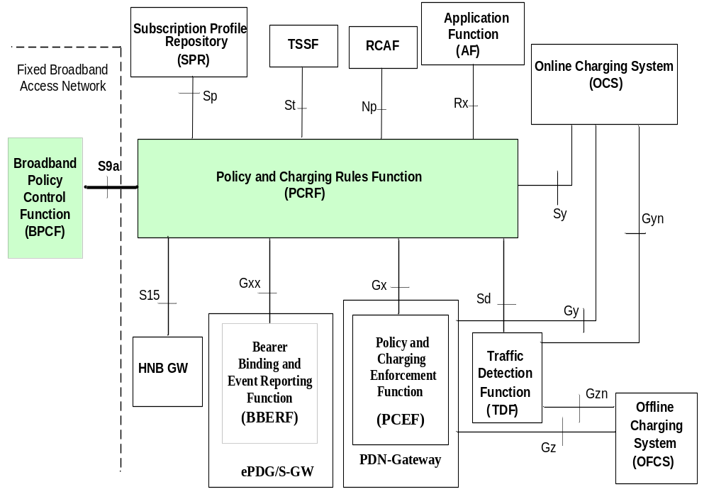
Figure A.3.3.1: S9a reference point at the Policy and Charging Control (PCC) architecture for non-roaming case with SPR
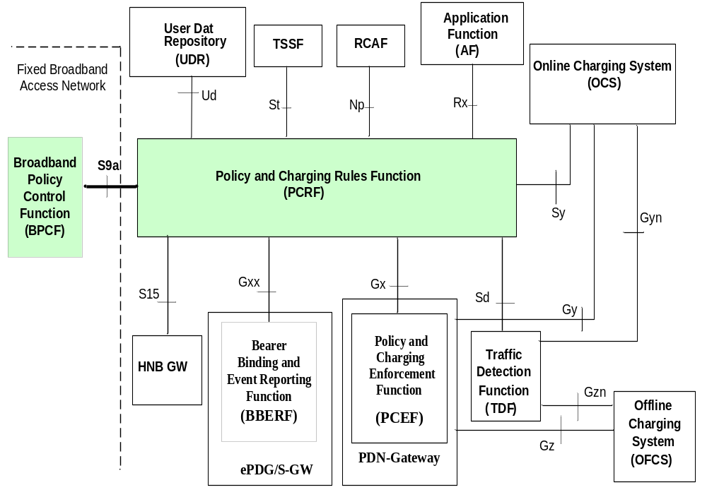
Figure A.3.3.2: S9a reference point at the Policy and Charging Control (PCC) architecture for non-roaming case with UDR
The relationships between the different functional entities involved in the home routed access for EPC-routed traffic are depicted in figure A.3.3.3 and A.3.3.4.
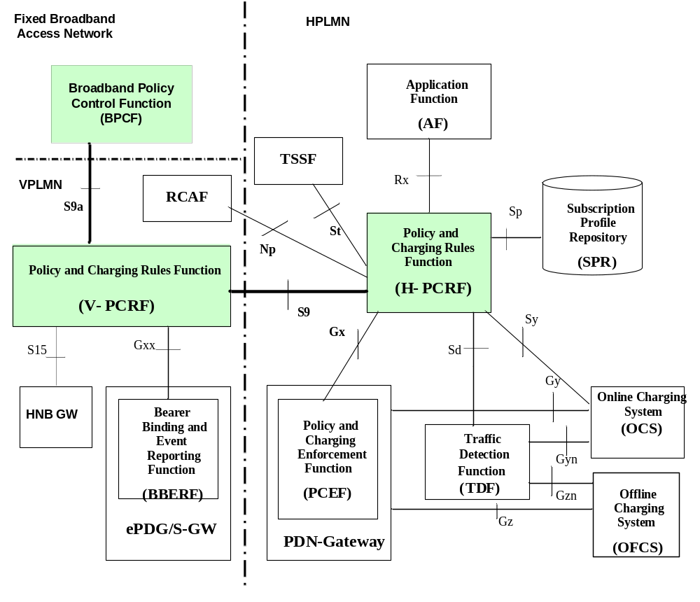
Figure A.3.3.3: S9, S9a reference points at the PCC architecture for roaming with home routed access with SPR
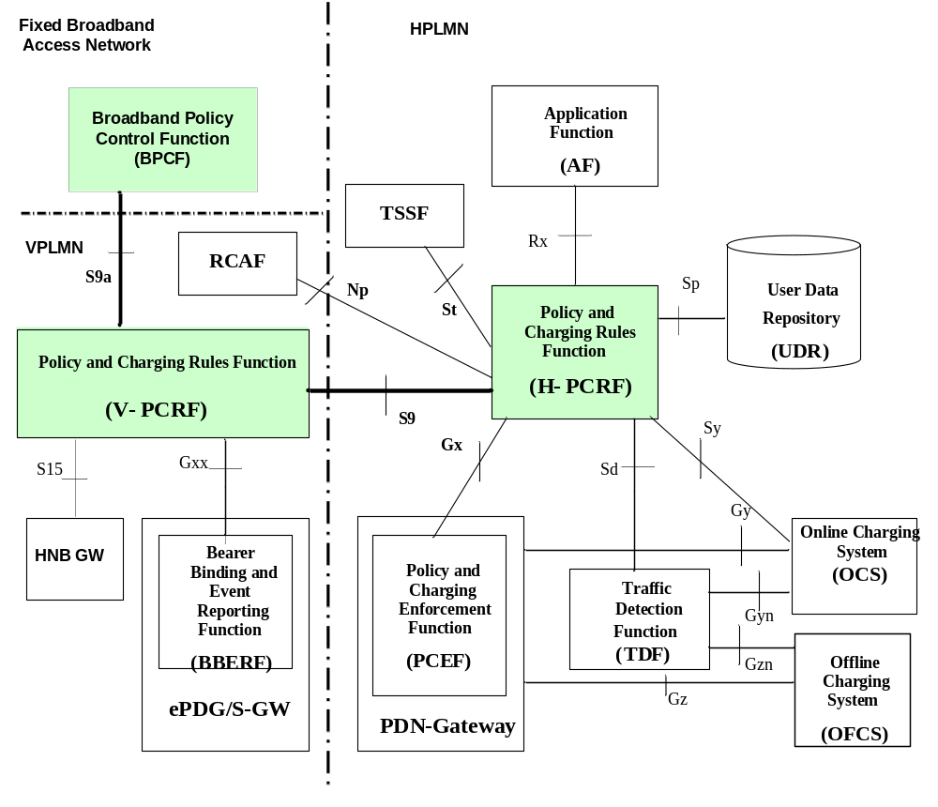
Figure A.3.3.4: S9, S9a reference points at the PCC architecture for roaming with home routed access with UDR
The relationships between the different functional entities involved in the visited access for EPC routed traffic are depicted in figure A.3.3.5 and figure A.3.3.6.
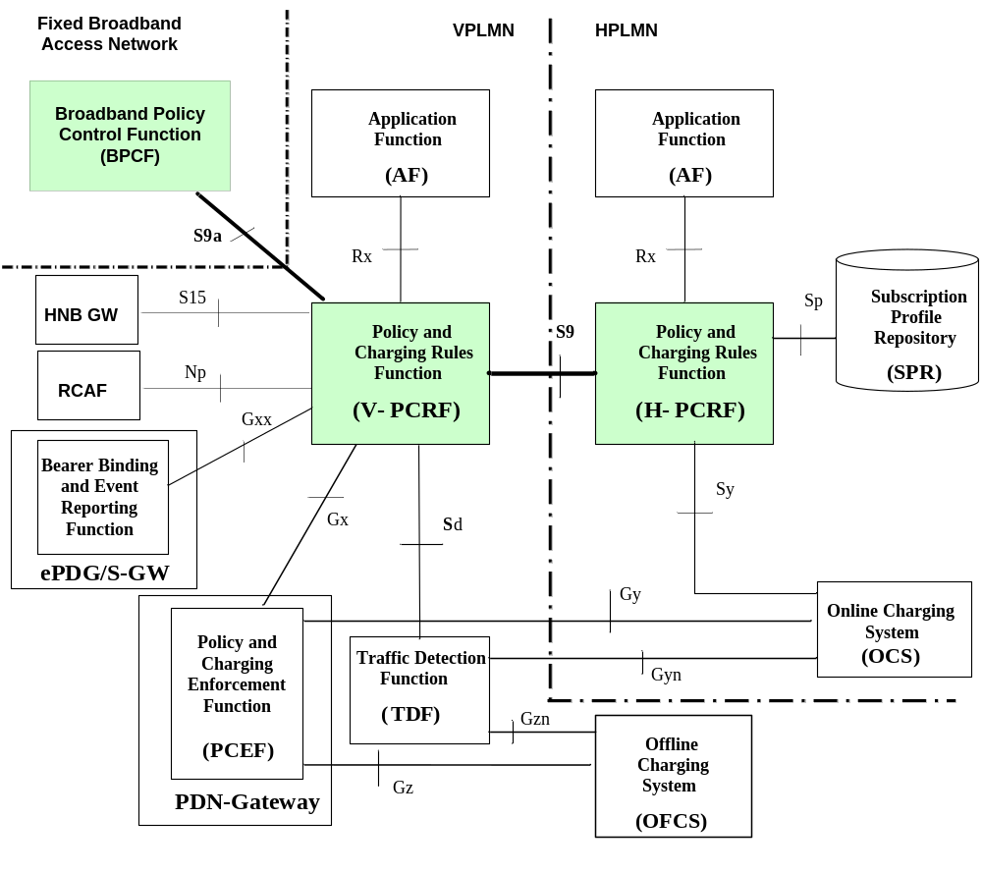
Figure A.3.3.5: S9, S9a reference points at the PCC architecture for roaming with visited access with SPR
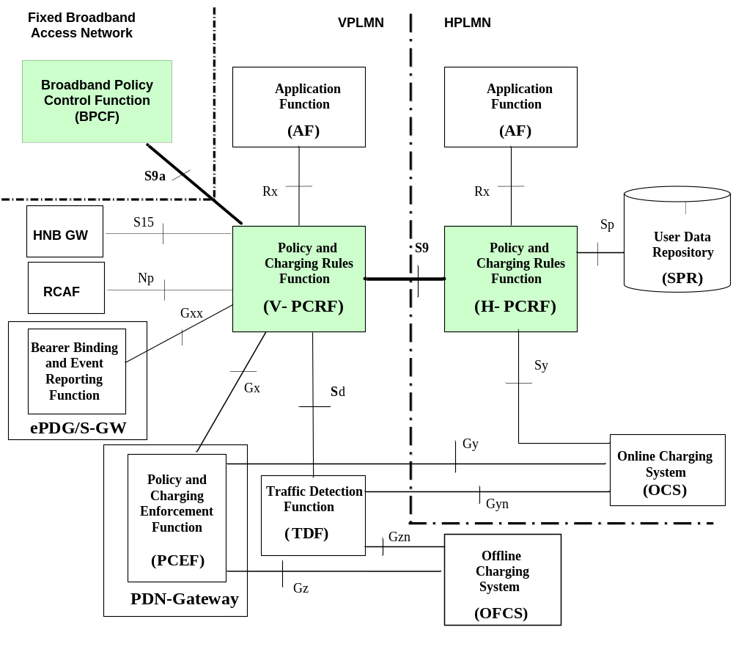
Figure A.3.3.6: S9, S9a reference points at the PCC architecture for roaming with visited access with UDR
The relationships between the different functional entities involved in the non-roaming for NSWO traffic are depicted in figure A.3.3.7 and A.3.3.8.
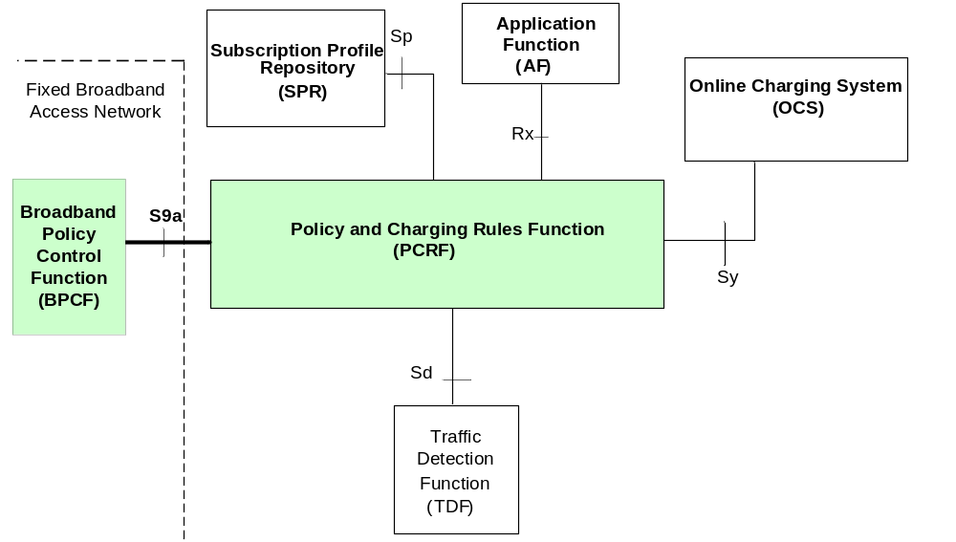
Figure A.3.3.7: S9a reference points at the PCC architecture for non-roaming with SPR
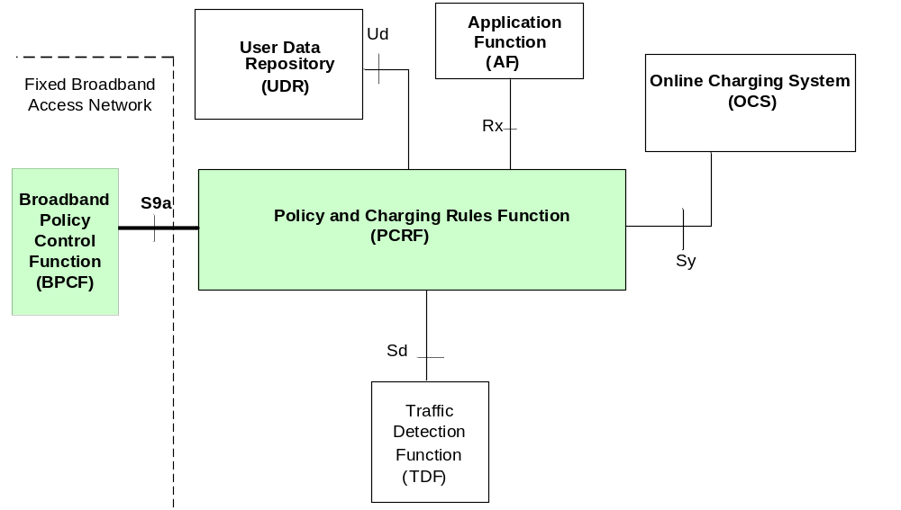
Figure A.3.3.8: S9a reference points at the PCC architecture for non-roaming with UDR
The relationships between the different functional entities involved in the roaming case for NSWO traffic are depicted in figure A.3.3.9 and A.3.3.10.
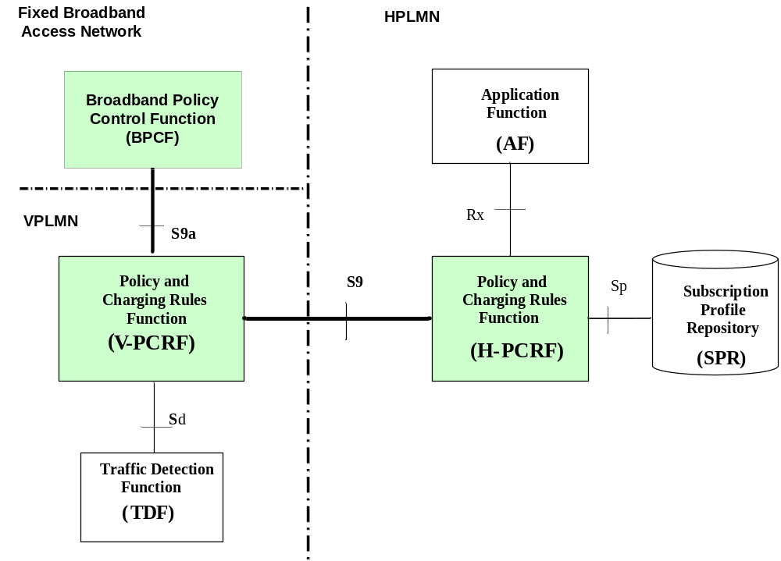
Figure A.3.3.9: S9, S9a reference points at the PCC architecture for roaming with SPR
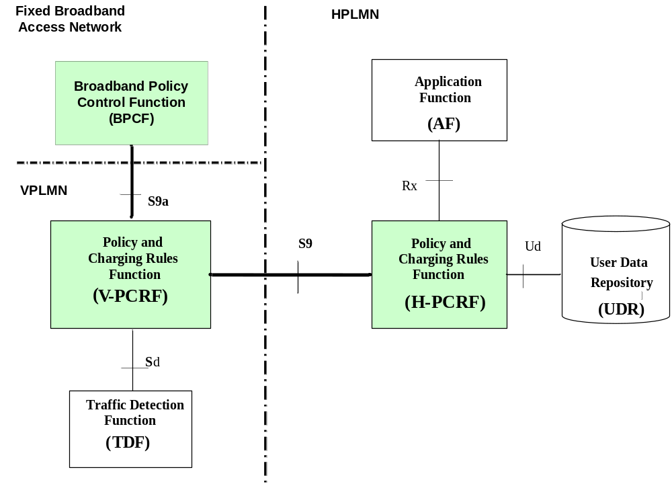
Figure A.3.3.10: S9, S9a reference points at the PCC architecture for roaming with UDR

A.4 Functional Elements

A.4.0 PCRF
The PCRF functionality defined in clause E.4.1 of 3GPP TS 29.212 [3] shall apply. For the purpose of Fixed Broadband Access Interworking for EPC-routed traffic the PCRF functionalities defined here are applicable:
- Send the QoS rules to the BPCF over S9a to request admission control in the fixed broadband access network.
- Send to the BPCF the UE local IP address, UDP source port number if available, ePDG IP Address used as IPSec tunnel endpoint with the UE and P-GW IP address for the WLAN scenario to allow the Fixed Broadband Access network to identify UE traffic.
- Send to the BPCF the H(e)NB Local IP address and UDP source port number if available for the H(e)NB scenario. This allows the Fixed Broadband Access network to identify IP flows corresponding to the IPSec tunnel from the H(e)NB to the SeGW which transports H(e)NB UE traffic.
- Be able to be configured with the relation of IP address ranges to Fixed Broadband Access network, to allow BPCF discovery.
For the NSWO scenario, the following PCRF functionalities are applicable:
- Handle incoming request of S9a* session establishment.
- Perform session binding of the AF session information received via Rx with an existing S9a* session using the UE local IP address and the IMSI (if available).
- For the unsolicited application reporting, link the TDF session with an existing S9a* session using the UE local IP address and PDN information if available.
- Send the PCC rules to the BPCF over S9a to allocated QoS resources in the fixed broadband access network.

A.4.1 V-PCRF
The V-PCRF functionality defined in clause 4.3.2 shall apply. For the purpose of Fixed Broadband Access Interworking for the EPC-routed traffic the V-PCRF functionalities defined here are applicable:
- If an S9a Session Establishment request is received from the BPCF, the V-PCRF shall initiate an S9 Session/Subsession Establishment procedure towards the H-PCRF.
- If an S9a Session Termination is received from the BPCF, the V-PCRF shall initiate an S9 Session/Subsession Termination towards the H-PCRF.
- For home routed roaming case, in case 1:
- If an S9 Session/Subsession Establishment trigger is received from the H-PCRF, then the V-PCRF shall initiate an S9a Session Establishment trigger towards the BPCF and an S9 Session/Subsession Establishment towards the H-PCRF.
- For the WLAN scenario, if an S9 Session/Subsession Termination is received from the H-PCRF, then the V-PCRF shall initiate an S9a Session Termination procedure towards the BPCF.
- For the H(e)NB scenario, if an S9 Session Termination is received from the H-PCRF for the last UE connected to a H(e)NB local IP address and there is no S15 session linked with the S9a session, then the V-PCRF shall initiate an S9a Session Termination procedure towards the BPCF. Otherwise it shall initiate an S9a Session Modification procedure.
- If an S9 Session Modification is received from the H-PCRF, then the V-PCRF shall trigger an S9a Session Establishment, Modification or Termination towards the BPCF.
NOTE: For H(e)NB scenario, when the V-PCRF receives an S9 Session Modification that corresponds to a change of the H(e)NB local IP address and there are no more UEs connected to the previous H(e)NB the V-PCRF will terminate the S9a session related to that H(e)NB address
- For both home routed and visited access roaming cases, in case 2a, case 2b:
- If a Gateway Control Session establishment from the BBERF (ePDG) occurs and there is no S9a session established, then the V-PCRF shall initiate an S9a session establishment with the BPCF and an S9 session establishment with the H-PCRF.
- If the last Gateway Control Session from the BBERF (ePDG) is terminated, then the V-PCRF shall initiate an S9a Session Termination towards the BPCF and an S9 Session Termination towards the H-PCRF.
- For visited access roaming case, in case 1:
- If an IP-CAN Session Establishment from the PCEF occurs and there is no S9a session established, then the V-PCRF shall initiate an S9a session establishment with the BPCF and an S9 session establishment with the H-PCRF.
- For the WLAN scenario, if the last IP-CAN Session from the PCEF is terminated, then the V-PCRF shall initiate an S9a Session Termination towards the BPCF and an S9 Session Termination towards the H-PCRF.
- For the H(e)NB scenario, if the last IP-CAN Session for the last UE connected to a H(e)NB is terminated and there is no S15 session linked to the S9a session, then the V-PCRF shall initiate an S9a Session Termination towards the BPCF and an S9 Session Termination towards the H-PCRF. Otherwise, the V-PCRF shall initiate an S9a Session Modification Request towards the BPCF.
For the NSWO scenario, the following V-PCRF functionalities are applicable:
- For the roaming scenario, the V-PCRF shall handle incoming request of S9a* session procedures;
- If an S9a* Session Establishment request is received for a roaming user over the S9a reference point, then the V-PCRF shall conclude that the IP-CAN session is used for NSWO.

A.4.2 H-PCRF
The H-PCRF functionality defined in clause 4.3.1 shall apply. For the purpose of Fixed Broadband Access interworking for the EPC-routed traffic, the H-PCRF functionalities defined here are applicable:
- For case 1, if an IP-CAN Session Establishment is received over Gx then, if this is the first IP-CAN session for this UE, the H-PCRF shall trigger an S9 Session Establishment to the V-PCRF.
- For case 1, if an IP-CAN Session Termination is received over Gx then if this is the last IP-CAN session for this UE, the H-PCRF shall initiate an S9 session Termination Request to the V-PCRF.
- If PCC Rules are generated, the H-PCRF shall send QoS rules to the V-PCRF to request admission control over S9.
- If a PCEF-Initiated IP-CAN Session Modification Procedure occurs over Gx to update the UE local IP Address and UDP port number for WLAN scenario, then the H-PCRF shall initiate an S9 Session Modification procedure including these data towards the V-PCRF.
- If a PCEF-Initiated IP-CAN Session Modification Procedure occurs over Gx to update the H(e)NB local IP Address and UDP port number for H(e)NB scenario, then the H-PCRF shall check whether there is an S9 Session already established for that subscriber based on H(e)NB local IP Address. If it is already established, the H-PCRF shall link the Gx session to the S9 Session corresponding to the H(e)NB local IP Address. Otherwise, H-PCRF shall initiate an S9 Session Establishment procedure including these data towards the V-PCRF.
For the NSWO scenario, in case of roaming, the H-PCRF shall determine the applicable PCC rules based on home operator policy for the specific UE when it receives the S9 session establishment/modification request from V-PCRF with the NSWO-APN.

A.4.3 BPCF
The BPCF is the policy control entity in the Fixed Broadband Access network. The complete specification of the BPCF is defined in BBF TR-134 [15] and BBF TR-203 [14] and it is out of the scope of 3GPP.
For the purpose of interworking with 3GPP network for the EPC-routed traffic the BPCF is expected to:
- Perform admission control in fixed access or delegate admission control decision to other BBF nodes. Based on the admission control, the BPCF accepts or rejects the request received over S9a reference point. The BPCF may include the acceptable QoS in the reply if the request is rejected.
- Translate the 3GPP QoS rules as received over the S9a reference point into access specific QoS parameters applicable in the Fixed Broadband access network.
- Support PCRF-triggered establishment of S9a session.
- Support BPCF-initiated establishment of S9a session.
NOTE: Admission control, QoS and IP-flow support in the Fixed Broadband Access Network are described in DSL TR-059 [17] and BBF TR-146 [16] and are out of the scope of 3GPP.
The functionality of the BPCF in a roaming scenario is the same as in a non-roaming scenario.
For the NSWO traffic, the BPCF is expected to:
- Perform admission control in fixed access or delegate admission control decision to other BBF nodes. Based on the admission control, the BPCF accepts or rejects the request received over S9a reference point. The BPCF may include the acceptable QoS in the reply if the request is rejected.
- Translate the 3GPP PCC rules as received over the S9a reference point into access specific QoS parameters applicable in the Fixed Broadband access network.
- Support BPCF-initiated establishment, modification and termination of S9a* session.
NOTE: Admission control, QoS and IP-flow support in the Fixed Broadband Access Network are described in DSL TR-059 [17] and BBF TR-146 [16] and are out of the scope of 3GPP.
The functionality of the BPCF in a roaming scenario is the same as in a non-roaming scenario.

A.5 PCC procedures over S9a Reference Point

A.5.1 Session Establishment over S9a

A.5.1.1 EPC-Routed traffic

A.5.1.1.1 S9a Session Establishment Trigger by PCRF
For GTP/PMIP-based S2b of the WLAN scenario, when PCRF or V-PCRF receives the Gateway Control Session Establishment from the BBERF (ePDG) or IP-CAN session establishment from the PCEF, (V-) PCRF shall trigger an S9a session establishment procedure from the BPCF.
For trusted and untrusted S2c of the WLAN scenario, when PCRF or V-PCRF receives the Gateway Control Session Establishment from the BBERF (ePDG) or IP-CAN session establishment from the PCEF, (V-) PCRF determines if an S9a session is already present for this user. If not, the (V-) PCRF shall trigger an S9a session establishment procedure from the BPCF.
For case 1, when the UE is roaming with the home routed case and GTP-based S2b is used, if the V-PCRF receives the S9 Session/Subsession Establishment Trigger from the H-PCRF, the V-PCRF shall trigger S9a session establishment procedure from the BPCF.
For case 2a, when the UE is roaming with the home routed case and trusted S2c is used, if the V-PCRF receives the S9 Session Establishment Trigger from the H-PCRF, the V-PCRF shall trigger S9a session establishment procedure from the BPCF.
For H(e)NB scenario, when (V-)PCRF receives the Gateway Control Session Establishment from the BBERF or IP-CAN session establishment from the PCEF, or S15 Session Establishment from the HNB (for CS Support), (V-)PCRF determines if an S9a session is already present for this H(e)NB Local IP Address. If not, the V-PCRF shall trigger an S9a session establishment procedure from BPCF. For case 1 when the UE is roaming with the home routed case and, the V-PCRF receives the S9 Session/Subsession Establishment Trigger from the H-PCRF, the V-PCRF determines if an S9a session is already present for that H(e)NB Local IP Address. If an S9a session is not already established, the (V-) PCRF shall trigger an S9a session establishment procedure from the BPCF. If an S9a session is already established and the UE is connected to the network via the H(e)NB, the (V-) PCRF shall update the S9a session with the QoS rules if they were provided from the H-PCRF.
NOTE: Depending on the deployment there can be one or multiple H-PCRF(s) that establish an S9 session for a given H(e)NB address. The V-PCRF can link more than one S9 session to the same S9a session, i.e. upon reception of a TER command, the V-PCRF can generate a RAR command when the S9a session exists. Upon reception of a TER command or a RAR command, that does not include QoS rules it is expected that the BPCF will generate a CCR command in order to ask for the QoS rules related to that S9a session.
NOTE: How the BPCF relates S9a sessions received from different PCRFs.is out of the scope of 3GPP.
The (V-) PCRF shall send a TER command to BPCF to trigger S9a session establishment procedure. The (V-) PCRF shall include the Auth-Session-State AVP set to NO_STATE_MAINTAINED. The (V-) PCRF may include its own address within the PCRF-Address AVP.
For WLAN scenario the (V-) PCRF shall include the UE local IP address, within the UE-Local-IP-Address AVP the UDP Source Port within the UDP-Source-Port AVP if available, the PDN information within the Called-Station-ID AVP if available and the IMSI within the Subscription-Id.
For the H(e)NB scenario the (V-) PCRF shall include H(e)NB Local IP address within the HeNB-Local-IP-Address AVP, the UDP Source Port within the UDP-Source-Port AVP if available and the PDN information within the Called-Station-ID AVP if available.
The BPCF shall reply (V-) PCRF with a TEA command, and initiate the S9a Session establishment procedure as described in clause A.5.1.1.2. PCRF determines whether the S9a session triggered by the TER command has been established based on the identification information (i.e. the UE Local IP address and UDP Source Port if NA(P) T is detected for WLAN scenario or H(e)NB Local IP address and UDP Source Port if NA(P)T is detected for the H(e)NB scenario).

A.5.1.1.2 S9a Session Establishment
Upon request of an S9a Session Establishment Trigger by the (V-) PCRF, the BPCF shall send a CCR command with the CC-Request-Type AVP set to the value "INITIAL_REQUEST".
For WLAN scenario the BPCF shall include the UE local IP address within UE-Local-IP-Address AVP, the UDP Source Port within UDP-Source-Port AVP, if available, the PDN information within the Called-Station-ID AVP if available and the IMSI within the Subscription-Id AVP.
For the H(e)NB scenario the BPCF shall include H(e)NB Local IP address within HeNB-Local-IP-Address AVP, the UDP Source Port within UDP-Source-Port AVP, if available and the PDN information within the Called-Station-ID AVP if available.
For the roaming case, the V-PCRF shall initiate the S9 Session Establishment procedure according to clause A.6.1.1.2.
To acknowledge the CCR command initiated by the BPCF, the (V-) PCRF shall send a CCA command including the result code within Result-Code AVP. The (V-) PCRF provides the QoS-Rule-Install AVP to include the applicable QoS Rules and, if available, the ePDG IP address derived from the ePDG IP address IE as defined in clause 7.2.1 of 3GPP TS 29.274 [22] (for GTP-based S2b acces) or used as the IPSec tunnel endpoint with the UE (for untrusted S2c access) within AN-GW-Address AVP or, if available, the PDN GW IP address (for trusted S2c access) used as the endpoint of the DSMIPv6 IPv4 user plane tunnel with the UE within 3GPP-GGSN-Address AVP (IPv4 address) or used as the endpoint of the DSMIPv6 IPv6 user plane tunnel with the UE within the 3GPP-GGSN-IPv6-Address AVP (IPv6 address).

A.5.1.2 NSWO traffic

A.5.1.2.1 S9a* Session Establishment
For NSWO scenario, when the BPCF receives the trigger that a UE is accessing over Fixed Broadband access network and policy interworking with PCRF is supported, the BPCF shall send a CCR command with the CC-Request-Type AVP set to the value "INITIAL_REQUEST".
The BPCF shall include the local UE IP address within UE-Local-IP-Address AVP or UE-Local-IPv6-Prefix AVP, the NSWO-APN within Called-Station-Id AVP and the IMSI within the Subscription-Id AVP.
The PCRF shall check if the policy control is performed for NSWO traffic for that UE based on operator policies (e.g. network where the UE is offloading). The PCRF shall provide the result in a CCA command within Result-Code AVP. If policy control is not performed, then the PCRF shall indicate DIAMETER_AUTHORIZATION_REJECTED in the CCA command.

A.5.2 Session Termination over S9a

A.5.2.1 EPC-Routed Traffic

A.5.2.1.1 S9a Session Termination initiated by the (V-) PCRF
This procedure is performed when the (V-) PCRF knows that the 3GPP UE released the last PDN connection and request the BPCF to release the S9a session for the WLAN scenario and for the H(e)NB scenario. This occurs in the following cases:
- When the (V-) PCRF receives a Gateway Control Session Termination from the BBERF that corresponds to the last Gxx session linked to the S9a session.
NOTE: BBERF refers to both ePDG and S-GW.
- For the WLAN scenario, when the PCRF receives an IP-CAN session termination from the PCEF or decides to terminate the IP-CAN session that corresponds to the last active IP-CAN session.
For the H(e)NB scenario, when the PCRF receives an IP-CAN session termination from the PCEF or decides to terminate the IP-CAN session that corresponds to the last active IP-CAN session for the last subscriber connected to the H(e)NB and there is no S15 session linked to the S9a session.
- For the H(e)NB scenario, when the ( V-)PCRF receives an S15 Session Termination that corresponds to a H(e)NB address for which an S9a session exists.
- For the roaming case in WLAN scenario, when the V-PCRF receives an S9 Session/Subsession Termination initiated by the H-PCRF.
- For the roaming case in H(e)NB scenario, when the V-PCRF receives an S9 Session Termination that corresponds to the last UE connected to that H(e)NB.
- For the roaming case in H(e)NB scenario, when the V-PCRF receives an S9 Session Modification that corresponds to a change of the H(e)NB local IP address and there are no more UEs connected to the previous H(e)NB.
NOTE: In this case the V-PCRF will initiate a new S9a Session Establishment if there is no S9a Session related to the new H(e)NB local IP address.
The PCRF shall send an RAR command including the Session-Release-Cause AVP to the BPCF. When the BPC Freceives the RAR command, it shall acknowledge the command by sending an RAA command to the PCRF.
The BPCF shall send a CCR command with the CC-Request-Type AVP set to the value "TERMINATION_REQUEST".
To acknowledge the CCR command, the (V-) PCRF shall send a CCA command including the result code within Result-Code AVP.

A.5.2.2 NSWO Traffic

A.5.2.2.1 S9a* Session Termination initiated by the BPCF
This procedure is initiated by the BPCF to terminate an S9a* session when the BPCF knows that the 3GPP UE is no longer attached via Fixed Broadband access network.
The BPCF shall send a CCR command with the CC-Request-Type AVP set to the value "TERMINATION_REQUEST".
To acknowledge the CCR command, the (V-) PCRF shall send a CCA command including the result code within Result-Code AVP.

A.5.2.2.2 S9a* Session Termination initiated by the (V-) PCRF
If the PCRF decides to terminate the S9a* session due to an internal trigger or trigger from the SPR, the PCRF shall send an RAR command including the Session-Release-Cause AVP to the BPCF. The BPCF shall acknowledge the command by sending an RAA command to the PCRF.
The BPCF shall send a CCR command with the CC-Request-Type AVP set to the value "TERMINATION_REQUEST".
To acknowledge the CCR command, the (V-) PCRF shall send a CCA command including the result code within Result-Code AVP.

A.5.3 Session Modification over S9a

A.5.3.1 EPC-Routed traffic

A.5.3.1.1 S9a Session Modification initiated by the (V-) PCRF
The (V-) PCRF may initiate an S9a Session Modification by sending a RAR command to the BPCF in the following conditions.
- For WLAN scenario in the non-roaming case, solicited by the BBERF/PCEF when the Local IP Address and or UDP port is changed or
- For H(e)NB scenario for CS services, solicited by the HNB GW, when the (V-) PCRF receives an S15 Session Modification or
- For both WLAN scenario and H(e)NB scenario in the non-roaming case, the PCRF decides to update the QoS information to the BPCF (e.g. subscription change, AF requests, etc) or
- When the (V-) PCRF receives a Gateway Control Session Termination from the BBERF (ePDG) that does not correspond to the last Gxx session linked to the S9a session or
- When the PCRF receives an IP-CAN session termination from the PCEF or decides to terminate the IP-CAN session and it does not corresponds to the last active IP-CAN session linked to that S9a session or
- For the H(e)NB scenario, when the PCRF receives an IP-CAN session termination from the PCEF or decides to terminate the IP-CAN session that corresponds to the last active IP-CAN session for the last subscriber connected to the H(e)NB and there is an active S15 session linked to the S9a session. or
- For WLAN scenario in the roaming case, the H-PCRF initiates an S9 Session Modification procedure or
- For H(e)NB scenario in the roaming case, the H-PCRF initiates an S9 Session Establishment and there is an S9a session already created for that H(e)NB or
- For H(e)NB scenario in the roaming case, the H-PCRF initiates an S9 SessionTermination procedure and there are more UEs already connected to the network via the related H(e)NB or there is an S15 session active for that H(e)NB.
NOTE: For H(e)NB scenario, the V-PCRF will not initiate an S9a Session Modification upon reception of an S9 Session Modification if only the HeNB-Local-IP-Address AVP and/or UDP-Source-Port AVP is changed.
NOTE: For H(e)NB scenario, the V-PCRF will initiate an S9a Session Modification upon reception of an S9 Session Establishment Trigger if there is an existing S9a session already established for that H(e)NB address.
The (V-) PCRF may provide the local UE IP Address within UE-Local-IP-Address AVP (WLAN scenario) or the H(e)NB Local IP address within HeNB-Local-IP-Address AVP (H(e)NB scenario), the UDP source port within UDP-Source-Port AVP and corresponding event triggers, if available by including the Event-Report-Indication AVP in the RAR command. If the QoS information needs to be updated to the BPCF, the PCRF shall include QoS-Rule-Install AVP and/or QoS-Rule-Remove AVP.
The BPCF shall perform QoS validation and shall include the result of the procedure in the RAA command in a Result-Code or Experimental-Result-Code AVP.

A.5.3.1.2 S9a Session Modification initiated by the BPCF
The BPCF may initiate an S9a Session Modification by sending a CCR command in order to indicate a QoS Rule failure (e.g. release of resources) to the (V-) PCRF.
The CCR shall include the QoS-Rule-Report AVP indicating the QoS rules that were not accepted and the Rule-Failure-Code AVP indicating the failure cause at command level.
The (V-) PCRF shall include the result of the procedure in the CCA command.

A.5.3.2 NSWO traffic

A.5.3.2.1 S9a* Session Modification initiated by the (V-) PCRF
The (V-) PCRF may initiate an S9a* Session Modification by sending a RAR command to the BPCF in the following conditions:
- The (H-) PCRF decides to update the policy information to the BPCF based on operator policies, subscription change or an AF request or
- The (V-) PCRF decides to update the policy information to the BPCF based on a TDF request.
The (V-) PCRF may include in the RAR command the Charging-Rule-Install AVP and/or Charging-Rule-Remove AVP.
The BPCF shall perform QoS validation and shall include the result of the procedure in the RAA command in a Result-Code or Experimental-Result-Code AVP.

A.5.3.2.2 S9a* Session Modification initiated by the BPCF
The BPCF may initiate an S9a* Session Modification by sending a CCR command in order to indicate a PCC Rule failure (e.g. release of resources) to the (V-) PCRF.
The CCR shall include the Charging-Rule-Report AVP indicating the PCC rules that were not accepted and the Rule-Failure-Code AVP indicating the failure cause at command level.
The (V-) PCRF shall include the result of the procedure in the CCA command.

A.5.4 Handling of QoS information

A.5.4.1 EPC-routed traffic
When the (V-) PCRF provides QoS rules in a CCA/RAR command to the BPCF, and if the Fixed Broadband access network cannot accept the QoS required for the QoS rules, the BPCF includes the QoS-Rule-Report AVP to indicate the QoS Rules that were not accepted including Rule-Failure-Code AVP set to UNSUCCESSFUL_QOS_VALIDATION value and may additionally provide the acceptable QoS to the (V-) PCRF in the CCR/RAA command.
The BPCF shall include the DIAMETER_PCC_RULE_EVENT (5142) experimental result code, the QoS-Rule-Report AVP to indicate the QoS Rules that were not accepted, including Rule-Failure-Code AVP set to UNSUCCESSFUL_QOS_VALIDATION value. The BPCF may also include the QoS-Information AVP to indicate the acceptable QoS.

A.5.4.2 NSWO traffic
When the (V-) PCRF provides PCC rules in a CCA/RAR command to the BPCF, and if the Fixed Broadband access network cannot accept the QoS required for the PCC rules, the BPCF includes the Charging -Rule-Report AVP to indicate the PCC Rules that were not accepted including Rule-Failure-Code AVP set to UNSUCCESSFUL_QOS_VALIDATION value and may additionally provide the acceptable QoS to the (V-) PCRF in the CCR/RAA command.
The BPCF shall include the DIAMETER_PCC_RULE_EVENT (5142) experimental result code, the Charging-Rule-Report AVP to indicate the PCC Rules that were not accepted, including Rule-Failure-Code AVP set to UNSUCCESSFUL_QOS_VALIDATION value. The BPCF may also include the QoS-Information AVP to indicate the acceptable QoS.

A.6 PCC procedures over S9 Reference Point

A.6.1 Session Establishment over S9

A.6.1.1 EPC-Routed Traffic

A.6.1.1.1 S9 Session Establishment Triggered by H-PCRF
When the H-PCRF receives an IP-CAN Session establishment from the PCEF including either the H(e)NB-Local-IP-Address AVP or UE-Local-IP-Address AVP and the user is roaming in a Visited Network, the H-PCRF determines if an S9 session exists for this IP-CAN session. If the S9 session is not already established, the H-PCRF shall trigger an S9 session establishment procedure from the V-PCRF.
The H-PCRF shall send a TER command to V-PCRF to trigger the S9 session establishment procedure. The H-PCRF shall include in the TER command the IMSI within the Subscription-Id AVP, the UDP port within UDP-Source-Port AVP if available and the PDN information within the Called-Station-ID AVP if available. The H-PCRF shall include the Auth-Session-State AVP set to NO_STATE_MAINTAINED.
For WLAN scenario, the H-PCRF shall also include the UE local IP address within the UE-Local-IP-Address AVP.
For H(e)NB scenario, the H-PCRF shall also include the H(e)NB Local IP address within the HeNB-Local-IP-Address AVP.
The V-PCRF shall reply the H-PCRF with a TEA command, and initiate the S9a Session establishment procedure as described in clause A,5,1.1 (when no S9a session exists) or the S9a Session modification procedure as described in clause A.5.3.1.1 (when there already exists an S9a session).
When the V-PCRF receives a TER command from the H-PCRF to trigger an S9 session establishment procedure for the EPC-routed traffic for a user, if the V-PCRF determines that the S9 session is being established for the NSWO traffic for the user by the V-PCRF, the V-PCRF.shall send a TEA command including the Experimental-Result AVP with the Experimental-Result. Code AVP set to DIAMETER_ERROR_ONGOING_SESSION_ESTABLISHMENT (5471) to the H-PCRF. When the H-PCRF receives this error, it shall send a RAR command to V-PCRF to trigger an S9 subsession establishment procedure after the S9 session of the user is established as defined in clause A.6.3.1.0.

A.6.1.1.2 S9 Session Establishment
When the V-PCRF receives one of the following triggers:
- a Gateway Control Session Establishment from the BBERF (ePDG) with UE Local IP address
- an IP-CAN Session Establishment from the PCEF with UE Local IP address
- a Gateway Control Session Establishment from the BBERF(S-GW) with H(e)NB IP address
- an IP-CAN Session Establishment from the PCEF with H(e)NB IP address
- an S9a Session Establishment from the BPCF.
then the V-PCRF determines if an S9 session is already present for that subscriber. If the S9 session is not already established, the V-PCRF initiates an S9 Session Establishment Procedure. Otherwise, it initiates an S9 Subsession Establishment Procedure as described in clause A.6.3.1.2.
The V-PCRF shall send a CCR command following current S9 procedures including the information received over Gx, Gxx or S9a.
If the procedure is initiated by the BPCF the V-PCRF shall map the S9a session-id to the corresponding S9 session-id. If the procedure is initiated by the BBERF/PCEF, the V-PCRF shall map the Gxx/Gx session-id to the corresponding S9 session-id (case 2a) or S9 subsession-id (case 1 and case 2b).
If the procedure is initiated by the BBERF or PCEF, the V-PCRF shall initiate the S9a session establishment trigger procedures as described in clause A.5.1.1.1 and keep the mapping between the S9a session-id and the S9 session-id (case 2a) or S9 subsession-id (case 2b and H(e)NB scenario).
To acknowledge the CCR command, the H-PCRF shall send a CCA command including the result code within Result-Code AVP. The H-PCRF provides the QoS-Rule-Install AVP to include the applicable QoS Rules and, if available, the ePDG IP address derived from the ePDG IP address IE as defined in clause 7.2.1 of 3GPP TS 29.274 [22] (for S2b access) or used as the IPSec tunnel endpoint with the UE (for untrusted S2c access) within AN-GW-Address AVP or, if available, the PDN GW IP address (for trusted S2c access) within 3GPP-GGSN-Address AVP used as the endpoint of the DSMIPv6 IPv4 user plane tunnel with the UE (IPv4 address) or used as the endpoint of the DSMIPv6 IPv6 user plane tunnel with the UE within the 3GPP-GGSN-IPv6-Address AVP (IPv6 address).

A.6.1.2 NSWO Traffic
When the V-PCRF receives an S9a* Session Establishment from the BPCF, then the V-PCRF determines if an S9 session is already present for that subscriber. If the S9 session is not already established, the V-PCRF initiates an S9 Session Establishment Procedure in order to establish an S9 subsession below; otherwise, the V-PCRF initiates an S9 Session Modification Procedure as described in clause A.6.3.2.2.
The V-PCRF shall send a CCR command following current S9 session establishment procedures including the information received over S9a reference point.
The V-PCRF shall map the S9a* session to the corresponding S9 subsession.
The H-PCRF shall acknowledge the request using a CCA command.

A.6.2 Session Termination over S9

A.6.2.1 EPC-Routed traffic

A.6.2.1.1 S9 Session Termination initiated by the H-PCRF
This procedure is initiated by the H-PCRF to terminate an S9 session when the last IP-CAN session related to a subscriber is terminated. The procedure described in clause 4.5.2.4 shall apply. The V-PCRF shall apply the corresponding S9a session procedure according to clause A.5.
The V-PCRF shall send a CCR command with the CC-Request-Type AVP set to the value "TERMINATION_REQUEST".
To acknowledge the CCR command, the H-PCRF shall send a CCA command including the result code within Result-Code AVP.

A.6.2.1.2 S9 Session Termination initiated by the V-PCRF
This procedure is initiated by the V-PCRF to terminate an S9 session when the V-PCRF receives a Gateway Control Session Termination from the BBERF corresponding to the last PDN connection related to a subscriber. The procedure described in clause 4.5.2.3 shall apply. The V-PCRF shall initiate the corresponding S9a session procedure as described in clause A.5.
The V-PCRF shall send a CCR command with the CC-Request-Type AVP set to the value "TERMINATION_REQUEST".
To acknowledge the CCR command, the H-PCRF shall send a CCA command including the result code within Result-Code AVP.

A.6.2.2 NSWO Traffic

A.6.2.2.1 S9 Session Termination initiated by the V-PCRF
This procedure is initiated by the V-PCRF to terminate an S9 session when the V-PCRF receives an S9a* Session Termination procedure from the BPCF and it corresponds to the last S9 subsession for the roaming user.
The V-PCRF shall send a CCR command with the CC-Request-Type AVP set to the value "TERMINATION_REQUEST".
To acknowledge the CCR command, the H-PCRF shall send a CCA command including the result code within Result-Code AVP.

A.6.2.2.2 S9 Session Termination initiated by the H-PCRF
If the H-PCRF decides to terminate the IP-CAN session for the NSWO traffic due to an internal trigger or trigger from the SPR, and if the H-PCRF considers that the S9 session has to be terminated, the H-PCRF shall send an RAR command to the V-PCRF indicating the termination of the S9 session by including the Session-Release-Cause AVP at command level. The V-PCRF shall send a corresponding RAA command to the H-PCRF.
The V-PCRF shall trigger S9a* Session Termination procedure as defined in clause A.5.2.2.2.

A.6.3 Session Modification over S9

A.6.3.1 EPC-Routed traffic

A.6.3.1.0 S9 subsession establishment triggered by H-PCRF
When the H-PCRF receives an IP-CAN Session establishment from the PCEF including either the H(e)NB-Local-IP-Address AVP or UE-Local-IP-Address AVP and the user is roaming in a Visited Network, the H-PCRF determines if an S9 session exists for this IP-CAN session. If the S9 session is not established, the S9 session establishment procedure as described in clause A.6.1.1.1 applies. If the S9 session is already established, the H-PCRF shall trigger an S9 subsession establishment procedure from the V-PCRF.
The H-PCRF shall send a RAR command to V-PCRF to trigger the S9 subsession establishment procedure. The H-PCRF shall include in the RAR command the IMSI within the Subscription-Id AVP, the PDN information within the Called-Station-ID AVP if available and the UDP port within UDP-Source-Port AVP if available.
For WLAN scenario, the H-PCRF shall also include the UE local IP address within the UE-Local-IP-Address AVP.
For H(e)NB scenario, the H-PCRF shall also include the H(e)NB Local IP address within the HeNB-Local-IP-Address AVP.
The V-PCRF shall reply the H-PCRF with a RAA command, and initiate the S9a Session establishment procedure as described in clause A,5,1.1 (when no S9a session exists) or the S9a Session modification procedure as described in clause A.5.3.1.1 (when there already exists an S9a session).

A.6.3.1.1 S9 Session Modification initiated by the H-PCRF
The H-PCRF may initiate an S9 Session Modification by sending a RAR command in the following cases:
- An IP-CAN Session Modification is triggered by the PCEF
- In response to information provided to the H-PCRF via the Rx reference point
- From a trigger from the SPR
- Based on internal policies
- An IP-CAN Session Establishment. In this case, the procedure described in clause A.6.3.1.0 applies.
The H-PCRF may provide the local UE IP Address (WLAN scenario), the H(e)NB Local IP address (H(e)NB scenario), the UDP port and corresponding event triggers, if provided by the PCEF by including the Event-Report-Indication AVP within the Subsession-Decision-Info AVP (case 1) when this information has changed in the RAR command.
If the QoS information is changed, the H-PCRF may include QoS rules within the QoS-Rule-Install AVP at command level (case 2a) or within the Subsession-Decision-Info AVP (case 1, case 2b).
The V-PCRF shall initiate the corresponding S9a session procedure according to clause A.5.
When the RAR command includes QoS rules, the V-PCRF shall validate the QoS information contained within the QoS rules using the current procedures.

A.6.3.1.2 S9 Session Modification initiated by the V-PCRF
When the V-PCRF receives one of the following triggers:
- an S9a Session Establishment from the BPCF.
- an S9a Session Modification from the BPCF (e.g. when the BBF network cannot sustain the allocated bandwidth) according to clause A.5.3.1.2
- a Gateway Control Session Establishment from the BBERF (case 2b, case 2a) and there is an S9 Session established
- a Gateway Control Session Modification from the BBERF (case 2b, case 2a)
- a Gateway Control Session Termination from the BBERF that does not correspond to the last S9 subsession (applicable only to WLAN, case 2b)
NOTE: In the above scenarios, BBERF refers to both ePDG and SGW.
- an IP-CAN Session Establishment from the PCEF and there is an S9 session established
- an IP-CAN Session Modification from the PCEF
- an IP-CAN Session Termination from the PCEF that does not correspond to the last S9 subsession
then the V-PCRF shall send a CCR command following current S9 procedures including the information received over Gx, Gxx or S9a.
NOTE: For H(e)NB scenario, when the S9 Session Modification is generated by the BPCF, the V-PCRF modifies all the S9 sessions affected by the S9a session modification.

A.6.3.2 NSWO traffic

A.6.3.2.1 S9 Session Modification initiated by the H-PCRF
Solicited in response to information provided to the H-PCRF via the Rx reference point or from a trigger from the SPR or based on internal policies, the H-PCRF may initiate an S9 Session Modification procedure by sending a RAR command.
If the H-PCRF considers that the S9 subsession has to be terminated, the H-PCRF shall send an RAR command to the V-PCRF indicating the termination of the S9 subsession by including the Session-Release-Cause AVP within the Subsession-Decision-Info AVP.
If the QoS information is changed, the H-PCRF may install or modify PCC rules by including the Charging-Rule-Install AVP or remove the PCC rules by including the Charging-Rule-Remove AVP within the Subsession-Decision-Info AVP.

A.6.3.2.2 S9 Session Modification initiated by the V-PCRF
The V-PCRF initiates an S9 session modification by sending a CCR command following the current S9 session modification procedures including the information received over S9a reference point in the following cases:
- the V-PCRF receives an S9a* Session Establishment from the BPCF as described in clause A.5.1.2.1 and an existing S9 session for the roaming user already exists with the H-PCRF;
- the V-PCRF receives an S9a* Session Modification from the BPCF (e.g. when the BBF network cannot sustain the allocated bandwidth) according to clause A.5.3.2.2;
- the V-PCRF receives an S9a* Session Termination from the BPCF as described in clause A.5.2.2.1 and it does not correspond to the last S9 subsession.

A.6.4 Provisioning and validation of QoS information

A.6.4.1 EPC-Routed traffic
When the H-PCRF provides QoS rules to the V-PCRF and the V-PCRF cannot accept the QoS required for the QoS rules, the V-PCRF includes the QoS-Rule-Report AVP to indicate the QoS Rules that were not accepted including Rule-Failure-Code AVP set to UNSUCCESSFUL_QOS_VALIDATION value and may additionally propose the acceptable QoS to the H-PCRF as per normal S9 procedures.

A.6.4.2 NSWO traffic
When the H-PCRF provides PCC rules to the V-PCRF and the V-PCRF cannot accept the QoS required for the PCC rules, the V-PCRF includes the Charging -Rule-Report AVP to indicate the PCC Rules that were not accepted including Rule-Failure-Code AVP set to UNSUCCESSFUL_QOS_VALIDATION value and may additionally propose the acceptable QoS to the H-PCRF as per normal S9 procedures.

A.7 S9a Protocol

A.7.1 Protocol support
The S9a application is defined as a vendor specific Diameter application, where the vendor is 3GPP and the Application-ID for the S9a Application in the present release is 16777319. The vendor identifier assigned by IANA to 3GPP (http://www.iana.org/assignments/enterprise-numbers) is 10415.
NOTE: A route entry can have a different destination based on the application identification AVP of the message. Therefore, Diameter agents (relay, proxy, redirection, translation agents) must be configured appropriately to identify the 3GPP S9a application within the Auth-Application-Id AVP in order to create suitable routeing tables.
Due to the definition of the commands used in the S9a protocol, there is no possibility to skip the Auth-Application-Id AVP and use the Vendor-Specific-Application-Id AVP instead. Therefore the S9a application identification shall be included in the Auth-Application-Id AVP.

A.7.2 Initialization, maintenance and termination of connection and session
The initialization and maintenance of the connection between each BPCF/(V-)PCRF pair is defined by the underlying protocol. Establishment and maintenance of connections between Diameter nodes is described in IETF RFC 3588 [6].
After establishing the transport connection, the BPCF and the (V-)PCRF shall advertise the support of the S9a specific Application by including the value of the application identifier in the Auth-Application-Id AVP and the value of the 3GPP (10415) in the Vendor-Id AVP of the Vendor-Specific-Application-Id AVP contained in the Capabilities-Exchange-Request and Capabilities-Exchange-Answer commands. The Capabilities-Exchange-Request and Capabilities-Exchange-Answer commands are specified in the Diameter base protocol (IETF RFC 3588 [6]).
The termination of the Diameter S9a session over S9a reference point can be initiated by the (V-)PCRF, as specified in clause A.5.2.1.1.

A.7.3 S9a specific AVPs

A.7.3.1 General
Table A.7.3.1.1 describes the Diameter AVPs defined for the S9a Diameter application over S9a reference point, their AVP Code values, types, possible flag values, whether or not the AVP may be encrypted, what access types (e.g. 3GPP-GPRS, etc.) the AVP is applicable to, the applicability of the AVPs to charging control, policy control or both, and which supported features the AVP is applicable to. The Vendor-Id header of all AVPs defined in the present document shall be set to 3GPP (10415).

Table A.7.3.1.1: S9a specific Diameter AVPs
 |  |  |  | AVP Flag rules (NOTE 1)
Attribute Name | AVP Code | Clause defined | Value Type (NOTE 2) | Must | May | Should not | Must not | May Encr. | Acc. type  (NOTE 3) | Applicability
PCRF-Address | 2207 | A.7.3.1.1 | DiameterIdentity | V,M | P |  |  | Y |  | PC  EPC-routed
NOTE 1: The AVP header bit denoted as 'M', indicates whether support of the AVP is required. The AVP header bit denoted as 'V', indicates whether the optional Vendor-ID field is present in the AVP header. For further details, see IETF RFC 3588 [6].
NOTE 2: The value types are defined in IETF RFC 3588 [6].
NOTE 3: S9a protocol applies only when the UE is making use of a fixed broadband access network.

A.7.3.1.1 PCRF-Address
The PCRF-Address AVP (AVP code 2207) is of type DiameterIdentity and is used by the (V)-PCRF to indicate its own address in the TER command so that the BPCF can address the (V)-PCRF during the S9a session establishment procedure.
NOTE: The value in the Origin-Host AVP of the TER command can be replaced by the proxy agent between the (V)-PCRF and the BPCF.

A.7.4 S9a re-used AVPs

A.7.4.1 General
Table A.7.4.1.1 lists the Diameter AVPs re-used by the S9a reference point from other reference points (e.g. Gx, Gxx, S9 reference points) and other existing Diameter Applications, reference to their respective specifications, short description of their usage within the S9a reference point, the applicability of the AVPs to a specific access, and which supported features the AVP is applicable to. When reused from S9 reference point, the specific clause in the present specification is referred. Other AVPs from existing Diameter Applications, except for the AVPs from Diameter base protocol, do not need to be supported. The AVPs from Diameter base protocol are not included in table A.7.4.1.1, but they are re-used for the S9a reference point. Unless otherwise stated, re-used AVPs shall maintain their 'M', 'P' and 'V' flag settings. Where RADIUS VSAs are re-used, unless otherwise stated, they shall be translated to Diameter AVPs as described in IETF RFC 4005 [25] with the exception that the ‘M’ flag shall be set and the ‘P’ flag may be set.
Table A.7.4.1.1: S9a re-used Diameter AVPs
Attribute Name | Reference | Description | Acc. type | Applicability  Note 1
Called-Station-Id | IETF RFC 4005 [25] | The address the user is connected to in the 3GPP network (i.e. the PDN identifier). For EPS the APN. When used to contain the APN, the APN is composed of the APN Network Identifier only, or the APN Network Identifier and the APN Operator Identifier as specified in TS 23.003 [9], clause 9.1. | Non-3GPP-EPS  3GPP-EPS | PC
CC-Request-Number | IETF RFC 4006 [19] | The number of the request for mapping requests and answers | Non-3GPP-EPS  3GPP-EPS | PC
CC-Request-Type | IETF RFC 4006 [19] | The type of the request (initial, update, termination) | Non-3GPP-EPS  3GPP-EPS | PC
DRMP | IETF draft-ietf-dime-drmp [27] | Allows Diameter endpoints to indicate the relative priority of Diameter transactions. | Non-3GPP-EPS  3GPP-EPS | PC
Event-Report-Indication | TS 29.212 [3] | When sent from the PCRF to the BPCF, it is used to report an event coming from the PCEF or BBERF and the relevant info to the BPCF.  The following values for the included Event-Trigger are applicable: UE_LOCAL_IP_ADDRESS_CHANGE (43), H(E)NB_LOCAL_IP_ADDRESS_CHANGE (44).  The following AVPs which are included in Event-Report-Indication are applicable to S9a interface:  UE-Local-IP-Address, HeNB-Local-IP-Address and UDP-Source-Port.  BPCF does not subscribe the notification of following event trigger values: UE_LOCAL_IP_ADDRESS_CHANGE, H(E)NB_LOCAL_IP_ADDRESS_CHANGE. | Non-3GPP-EPS  3GPP-EPS  (NOTE x) | PC
OC-OLR | IETF RFC 7683 [24] | Contains the necessary information to convey an overload report. | Non-3GPP-EPS  3GPP-EPS | PC
OC-Supported-Features | IETFRFC 7683 [24] | Defines the support for the Diameter overload indication conveyence by the sending node. | Non-3GPP-EPS  3GPP-EPS | PC
QoS-Information | TS 29.212 [3] | Defines the QoS information that can be accepted by the BPCF. | Non-3GPP-EPS | PC
QoS-Rule-Install | TS 29.212 [3] | It is used to activate, install or modify QoS rules as instructed from the PCRF to the BPCF. Only QoS-Rule-Definition, QoS-Rule-Name, QoS-Rule-Base-Name , 3GPP-GGSN-Address, 3GPP-GGSN-IPv6-Address, AN-GW-Address and UDP-Source-Port are applicable. | Non-3GPP-EPS  3GPP-EPS | PC
QoS-Rule-Remove | TS 29.212 [3] | It is used to deactivate or remove QoS rules in the BPCF. | Non-3GPP-EPS  3GPP-EPS | PC
QoS-Rule-Report | TS 29.212 [3] | It is used to report the status of the QoS Rules. | Non-3GPP-EPS  3GPP-EPS | PC
Session-Release-Cause | TS 29.212 [3] | Indicate the reason of termination initiated by the PCRF. | Non-3GPP-EPS  3GPP-EPS | PC
Subscription-Id | IETF RFC 4006 [19] | The identification of the subscription (i.e. IMSI) | Non-3GPP-EPS | PC
Supported-Features | TS 29.229 [7] | If present, this AVP informs the destination host about the features that the origin host requires to successfully complete this command exchange | Non-3GPP-EPS  3GPP-EPS | PC
HeNB-Local-IP-Address | TS 29.212 [3] | Contains the H(e)NB local IP address | 3GPP-EPS | PC
UE-Local-IP-Address | TS 29.212 [3] | Contains the UE local IP address | Non-3GPP-EPS | PC
UDP-Source-Port | TS 29.212 [3] | Contains the UDP source port number in the case that NA(P)T is detected for supporting interworking with Fixed Broadband access network | Non-3GPP-EPS  3GPP-EPS | PC
NOTE 1: AVPs marked with “PC” are applicable to policy control.
NOTE 2: Event trigger value UE_LOCAL_IP_ADDRESS_CHANGE, UE-Local-IP-Address AVP and UDP-Source-Port AVP are applicable to the Non-3GPP-EPS. Event trigger value H(E)NB_LOCAL_IP_ADDRESS_CHANGE, H(e)NB-Local-IP-Address AVP and UDP-Source-Port AVP are applicable to the 3GPP-EPS.

A.7.5 S9a specific Experimental-Result-Code AVP values

A.7.5.1 General
IETF RFC 3588 [6] specifies the Experimental-Result AVP containing Vendor-ID AVP and Experimental-Result-Code AVP. The Experimental-Result-Code AVP (AVP Code 298) is of type Unsigned32 and contains a vendor-assigned value representing the result of processing a request. The Vendor-ID AVP shall be set to 3GPP (10415).

A.7.5.2 Success
Result Codes that fall within the Success category are used to inform a peer that a request has been successfully completed.
The Result-Code AVP values defined in Diameter base protocol, IETF RFC 3588 [6], shall be applied.

A.7.5.3 Permanent Failures
Errors that fall within the Permanent Failures category shall be used to inform the peer that the request failed, and should not be attempted again.
The Result-Code AVP values defined in Diameter base protocol, IETF RFC 3588 [6], and 3GPP TS 29.212 [3] are applicable.

A.7.5.4 Transient Failures
Errors that fall within the transient failures category are used to inform a peer that the request could not be satisfied at the time it was received, but may be able to satisfy the request in the future.
No transient failure is identified in this release.

A.7.6 S9a Messages

A.7.6.1 S9a Application
S9a Messages are carried within the Diameter Application(s) described in clause A.7.1.
Existing Diameter command codes from the Diameter base protocol, IETF RFC 3588 [6], and the Diameter Credit Control Application, IETF RFC 4006 [19], are used with the S9a specific AVPs specified in clause A.7.3. The Diameter Credit Control Application AVPs and AVPs from other Diameter applications that are re-used are defined in clause A.7.4. Due to the definition of these commands there is no possibility to skip the Auth-Application-Id AVP and use the Vendor-Specific-Application-Id AVP instead. Therefore the S9a application identifier shall be included in the Auth-Application-Id AVP.
NOTE: Some of the AVPs included in the messages formats below are in bold to highlight that these AVPs are used by this specific protocol and do not belong to the original message definition in the DCC Application, IETF RFC 4006 [19], or Diameter base protocol, IETF RFC 3588 [6].

A.7.6.2 CC-Request (CCR) Command
The CCR command, indicated by the Command-Code field set to 272 and the 'R' bit set in the Command Flags field, is sent by the BPCF to the PCRF in order to initiate an S9a session establishment and to request QoS rules. The CCR command is also sent by the BPCF to the PCRF in order to indicate QoS rule related events.
Message Format:
<CC-Request> ::= < Diameter Header: 272, REQ, PXY >
< Session-Id >
[ DRMP ]
{ Auth-Application-Id }
{ Origin-Host }
{ Origin-Realm }
{ Destination-Realm }
{ CC-Request-Type }
{ CC-Request-Number }
[ Destination-Host ]
[ Origin-State-Id ]
[ Subscription-Id ]
[ Called-Station-Id ]
[ OC-Supported-Features ]
*[ Supported-Features ]
[ QoS-Information ]
*[ QoS-Rule-Report ]
[ UE-Local-IP-Address ]
[ HeNB-Local-IP-Address ]
[ Termination-Cause ]
*[ Proxy-Info ]
*[ Route-Record ]
*[ AVP ]

A.7.6.3 CC-Answer (CCA) Command
The CCA command, indicated by the Command-Code field set to 272 and the 'R' bit cleared in the Command Flags field, is sent by the PCRF to the BPCF in response to the CCR command. It is used to provision QoS rules for the S9a session
Message Format:
<CC-Answer> ::= < Diameter Header: 272, PXY >
< Session-Id >
[ DRMP ]
{ Auth-Application-Id }
{ Origin-Host }
{ Origin-Realm }
[ Result-Code ]
[ Experimental-Result ]
{ CC-Request-Type }
{ CC-Request-Number }
[ OC-Supported-Features ]
[ OC-OLR ]
*[ Supported-Features]
*[ QoS-Rule-Install ]
*[ QoS-Rule-Remove ]
[ Event-Report-Indication ]
[ Origin-State-Id ]
[ Error-Message ]
[ Error-Reporting-Host ]
*[ Failed-AVP ]
*[ Proxy-Info ]
*[ Route-Record ]
*[ AVP ]

A.7.6.4 Re-Authorization-Request (RAR) Command
The RAR command, indicated by the Command-Code field set to 258 and the 'R' bit set in the Command Flags field, is sent by the PCRF to the BPCF in order to provision QoS rules and address information for the S9a session.
Message Format:
<RA-Request> ::= < Diameter Header: 258, REQ, PXY >
< Session-Id >
[ DRMP ]
{ Auth-Application-Id }
{ Origin-Host }
{ Origin-Realm }
{ Destination-Realm }
{ Destination-Host }
{ Re-Auth-Request-Type }
[ Origin-State-Id ]
[ OC-Supported-Features ]
*[ QoS-Rule-Install ]
*[ QoS-Rule-Remove ]
[ Event-Report-Indication ]
[ Session-Release-Cause ]
*[ Proxy-Info ]
*[ Route-Record ]
*[ AVP ]

A.7.6.5 Re-Authorization-Answer (RAA) Command
The RAA command, indicated by the Command-Code field set to 258 and the 'R' bit cleared in the Command Flags field, is sent by the BPCF to the PCRF in response to the RAR command.
Message Format:
<RA-Answer> ::= < Diameter Header: 258, PXY >
< Session-Id >
[ DRMP ]
{ Origin-Host }
{ Origin-Realm }
[ Result-Code ]
[ Experimental-Result ]
[ Origin-State-Id ]
[ OC-Supported-Features ]
[ OC-OLR ]
[ QoS-Information ]
*[ QoS-Rule-Report ]
[ Error-Message ]
[ Error-Reporting-Host ]
*[ Failed-AVP ]
*[ Proxy-Info ]
*[ AVP ]

A.7.6.6 Trigger-Establishment-Request (TER) Command
The TER command, indicated by the Command-Code field set to 8388656 and the 'R' bit set in the Command Flags field, is sent by the PCRF to the BPCF in order to trigger the S9a Session Establishment.
Message Format:
<TE-Request> ::= < Diameter Header: 8388656, REQ, PXY >
< Session-Id >
[ DRMP ]
{ Auth-Application-Id }
{ Origin-Host }
{ Origin-Realm }
{ Destination-Realm }
{ Destination-Host }
[ Auth-Session-State ]
[ Origin-State-Id ]
[ OC-Supported-Features ]
[ Subscription-Id ]
[ Called-Station-Id ]
[ PCRF-Address ]
[ UE-Local-IP-Address ]
[ HeNB-Local-IP-Address ]
[ UDP-Source-Port ]
*[ Proxy-Info ]
*[ Route-Record ]
*[ AVP ]

A.7.6.7 Trigger-Establishment-Answer (TEA) Command
The TEA command, indicated by the Command-Code field set to 8388656 and the 'R' bit cleared in the Command Flags field, is sent by the BPCF to the PCRF in response to the TER command.
Message Format:
<TE-Answer> ::= < Diameter Header: 8388656, PXY >
< Session-Id >
[ DRMP ]
{ Origin-Host }
{ Origin-Realm }
[ Result-Code ]
[ Experimental-Result ]
[ Origin-State-Id ]
[ OC-Supported-Features ]
[ OC-OLR ]
[ Error-Message ]
[ Error-Reporting-Host ]
*[ Failed-AVP ]
*[ Proxy-Info ]
*[ AVP ]

A.8 S9a* Protocol

A.8.1 Protocol support
The S9a* application is defined as a vendor specific Diameter application, where the vendor is 3GPP and the Application-ID for the S9a* Application in the present release is 16777320. The vendor identifier assigned by IANA to 3GPP (http://www.iana.org/assignments/enterprise-numbers) is 10415.
NOTE: A route entry can have a different destination based on the application identification AVP of the message. Therefore, Diameter agents (relay, proxy, redirection, translation agents) must be configured appropriately to identify the 3GPP S9a* application within the Auth-Application-Id AVP in order to create suitable routeing tables.
Due to the definition of the commands used in the S9a* protocol, there is no possibility to skip the Auth-Application-Id AVP and use the Vendor-Specific-Application-Id AVP instead. Therefore the S9a* application identification shall be included in the Auth-Application-Id AVP.

A.8.2 Initialization, maintenance and termination of connection and session
The initialization and maintenance of the connection between each BPCF/(V-)PCRF pair is defined by the underlying protocol. Establishment and maintenance of connections between Diameter nodes is described in IETF RFC 3588 [6].
After establishing the transport connection, the BPCF and the (V-)PCRF shall advertise the support of the S9a* specific Application by including the value of the application identifier in the Auth-Application-Id AVP and the value of the 3GPP (10415) in the Vendor-Id AVP of the Vendor-Specific-Application-Id AVP contained in the Capabilities-Exchange-Request and Capabilities-Exchange-Answer commands. The Capabilities-Exchange-Request and Capabilities-Exchange-Answer commands are specified in the Diameter base protocol (IETF RFC 3588 [6]).
The termination of the Diameter S9a* session over S9a reference point may be initiated by the BPCF and PCRF, as specified in subclauses A.5.2.2.1 and A.5.2.2.2.

A.8.3 S9a* specific AVPs

A.8.3.1 General
Table A.8.3.1.1 describes the Diameter AVPs defined for the S9a* Diameter application over S9a reference point, their AVP Code values, types, possible flag values, whether or not the AVP may be encrypted, what access types (e.g. 3GPP-GPRS, etc.) the AVP is applicable to, the applicability of the AVPs to charging control, policy control or both, and which supported features the AVP is applicable to. The Vendor-Id header of all AVPs defined in the present document shall be set to 3GPP (10415).
Table A.8.3.1.1: S9a* specific Diameter AVPs
 |  |  |  | AVP Flag rules (NOTE 1)
Attribute Name | AVP Code | Clause defined | Value Type (NOTE 2) | Must | May | Should not | Must not | May Encr. | Acc. type  (NOTE 3) | Applicability
UE-Local-IPv6-Prefix | 2205 | A.8.3.1 | Octetstring | V,M | P |  |  | Y |  | PC  NSWO
NOTE 1: The AVP header bit denoted as 'M', indicates whether support of the AVP is required. The AVP header bit denoted as 'V', indicates whether the optional Vendor-ID field is present in the AVP header. For further details, see RFC 3588 [6].
NOTE 2: The value types are defined in RFC 3588 [6].
NOTE 3: S9a* protocol applies only when the UE is making use of a fixed broadband access network.

A.8.3.1.1 UE-Local-IPv6-Prefix AVP
The UE-Local-IPv6-Prefix AVP (AVP code 2205) is of type OctetString, and it indicates the UE local IPv6 prefix allocated to the user. The encoding of the value within this AVP shall be as defined for Framed-IPv6-Prefix AVP in IETF RFC 3162 [15], clause 2.3. The "Reserved", "Prefix-Length" and "Prefix" fields shall be included in this order.

A.8.4 S9a* re-used AVPs

A.8.4.1 General
Table A.8.4.1.1 lists the Diameter AVPs re-used by the S9a* Diameter Application from other reference points (e.g. Gx, Gxx, S9 reference points) and other existing Diameter Applications, reference to their respective specifications, short description of their usage within the S9a reference point, the applicability of the AVPs to a specific access, and which supported features the AVP is applicable to. When reused from S9 reference point, the specific clause in the present specification is referred. Other AVPs from existing Diameter Applications, except for the AVPs from Diameter base protocol, do not need to be supported. The AVPs from Diameter base protocol are not included in table A.8.4.1.1, but they are re-used for the S9a reference point. Unless otherwise stated, re-used AVPs shall maintain their 'M', 'P' and 'V' flag settings. Where RADIUS VSAs are re-used, unless otherwise stated, they shall be translated to Diameter AVPs as described in IETF RFC 4005 [25] with the exception that the ‘M’ flag shall be set and the ‘P’ flag may be set.
Table A.8.4.1.1: S9a* re-used Diameter AVPs
Attribute Name | Reference | Description | Acc. type | Applicability  Note 1
Called-Station-Id | IETF RFC 4005 [25] | It is set to a fixed value and indicates that the S9a* session is related to NSWO traffic (i.e. conveys the NSWO-APN). It is a fixed value set by the operator. The naming convention is left to operator’s implementation decision. |  | PC
CC-Request-Number | IETF RFC 4006 [19] | The number of the request for mapping requests and answers |  | PC
CC-Request-Type | IETF RFC 4006 [19] | The type of the request (initial, update, termination) |  | PC
DRMP | IETF draft-ietf-dime-drmp [27] | Allows Diameter endpoints to indicate the relative priority of Diameter transactions. |  | PC
OC-OLR | IETF RFC 7683 [24] | Contains the necessary information to convey an overload report |  | PC
OC-Supported-Features | IETF RFC 7683 [24] | Defines the support for the Diameter overload indication conveyence by the sending node |  | PC
QoS-Information | TS 29.212 [3] | Defines the QoS information that can be accepted by the BPCF. |  | PC
Charging-Rule-Install | TS 29.212 [3] | It is used to activate, install or modify PCC rules at Fixed Broadband access network. Only Charging-Rule-Definition, Charging-Rule-Name, Charging-Rule-Base-Name are applicable. |  | PC
Charging-Rule-Remove | TS 29.212 [3] | It is used to deactivate or remove PCC rules in the BPCF. |  | PC
Charging-Rule-Report | TS 29.212 [3] | It is used to report the status of the PCC Rules. |  | PC
Session-Release-Cause | TS 29.212 [3] | Indicate the reason of termination initiated by the PCRF. |  | PC
Subscription-Id | IETF RFC 4006 [19] | The identification of the subscription (i.e. IMSI) |  | PC
Supported-Features | TS 29.229 [7] | If present, this AVP informs the destination host about the features that the origin host requires to successfully complete this command exchange |  | PC
TDF-Information | TS 29.212 [3] | It contains the information about the TDF that shall handle the application detection and reporting for that IP-CAN Session |  | PC
UE-Local-IP-Address | TS 29.212 [3] | Contains the UE local IP address |  | PC
NOTE 1: AVPs marked with “PC” are applicable to policy control.
NOTE 2: S9a* protocol applies only when the UE is making use of a fixed broadband access network to offload the traffic. This is not notified over the interface.

A.8.5 S9a* specific Experimental-Result-Code AVP values

A.8.5.1 General
IETF RFC 3588 [6] specifies the Experimental-Result AVP containing Vendor-ID AVP and Experimental-Result-Code AVP. The Experimental-Result-Code AVP (AVP Code 298) is of type Unsigned32 and contains a vendor-assigned value representing the result of processing a request. The Vendor-ID AVP shall be set to 3GPP (10415).

A.8.5.2 Success
Result Codes that fall within the Success category are used to inform a peer that a request has been successfully completed.
The Result-Code AVP values defined in Diameter base protocol, IETF RFC 3588 [6], shall be applied.

A.8.5.3 Permanent Failures
Errors that fall within the Permanent Failures category shall be used to inform the peer that the request failed, and should not be attempted again.
The Result-Code AVP values defined in Diameter base protocol, IETF RFC 3588 [6], and 3GPP TS 29.212 [3] are applicable.

A.8.5.4 Transient Failures
Errors that fall within the transient failures category are used to inform a peer that the request could not be satisfied at the time it was received, but may be able to satisfy the request in the future.
No transient failure is identified in this release.

A.8.6 S9a* Messages

A.8.6.1 S9a* Application
S9a* Messages are carried within the Diameter Application(s) described in clause A.8.1.
Existing Diameter command codes from the Diameter base protocol, IETF RFC 3588 [6], and the Diameter Credit Control Application, IETF RFC 4006 [19], are used with the S9a* specific AVPs specified in clause A.8.3. The Diameter Credit Control Application AVPs and AVPs from other Diameter applications that are re-used are defined in clause A.8.4. Due to the definition of these commands there is no possibility to skip the Auth-Application-Id AVP and use the Vendor-Specific-Application-Id AVP instead. Therefore the S9a* application identifier shall be included in the Auth-Application-Id AVP.
NOTE: Some of the AVPs included in the messages formats below are in bold to highlight that these AVPs are used by this specific protocol and do not belong to the original message definition in the DCC Application, IETF RFC 4006 [19], or Diameter base protocol, IETF RFC 3588 [5].

A.8.6.2 CC-Request (CCR) Command
The CCR command, indicated by the Command-Code field set to 272 and the 'R' bit set in the Command Flags field, is sent by the BPCF to the PCRF in order to initiate an S9a* session establishment and to request PCC rules. The CCR command is also sent by the BPCF to the PCRF in order to indicate PCC rule related events.
Message Format:
<CC-Request> ::= < Diameter Header: 272, REQ, PXY >
< Session-Id >
[ DRMP ]
{ Auth-Application-Id }
{ Origin-Host }
{ Origin-Realm }
{ Destination-Realm }
{ CC-Request-Type }
{ CC-Request-Number }
[ Destination-Host ]
[ Origin-State-Id ]
[ Subscription-Id ]
[ Called-Station-Id ]
[ OC-Supported-Features ]
*[ Supported-Features ]
*[ Charging-Rule-Report ]
[ UE-Local-IP-Address ]
[ UE-Local-IPv6-Prefix ]
[ QoS-Information ]
[ TDF-Information ]
[ Termination-Cause ]
*[ Proxy-Info ]
*[ Route-Record ]
*[ AVP ]

A.8.6.3 CC-Answer (CCA) Command
The CCA command, indicated by the Command-Code field set to 272 and the 'R' bit cleared in the Command Flags field, is sent by the PCRF to the BPCF in response to the CCR command. It is used to provision PCC rules for the S9a session.
Message Format:
<CC-Answer> ::= < Diameter Header: 272, PXY >
< Session-Id >
[ DRMP ]
{ Auth-Application-Id }
{ Origin-Host }
{ Origin-Realm }
[ Result-Code ]
[ Experimental-Result ]
{ CC-Request-Type }
{ CC-Request-Number }
[ OC-Supported-Features ]
[ OC-OLR ]
*[ Supported-Features]
*[ Charging-Rule-Install ]
*[ Charging-Rule-Remove ]
[ Origin-State-Id ]
[ Error-Message ]
[ Error-Reporting-Host ]
*[ Failed-AVP ]
*[ Proxy-Info ]
*[ Route-Record ]
*[ AVP ]

A.8.6.4 Re-Authorization-Request (RAR) Command
The RAR command, indicated by the Command-Code field set to 258 and the 'R' bit set in the Command Flags field, is sent by the PCRF to the BPCF in order to provision PCC rules and address information for the S9a session.
Message Format:
<RA-Request> ::= < Diameter Header: 258, REQ, PXY >
< Session-Id >
[ DRMP ]
{ Auth-Application-Id }
{ Origin-Host }
{ Origin-Realm }
{ Destination-Realm }
{ Destination-Host }
{ Re-Auth-Request-Type }
[ Origin-State-Id ]
[ OC-Supported-Features ]
*[ Charging-Rule-Install ]
*[ Charging-Rule-Remove ]
[ Session-Release-Cause ]
*[ Proxy-Info ]
*[ Route-Record ]
*[ AVP ]

A.8.6.5 Re-Authorization-Answer (RAA) Command
The RAA command, indicated by the Command-Code field set to 258 and the 'R' bit cleared in the Command Flags field, is sent by the BPCF to the PCRF in response to the RAR command.
Message Format:
<RA-Answer> ::= < Diameter Header: 258, PXY >
< Session-Id >
[ DRMP ]
{ Origin-Host }
{ Origin-Realm }
[ Result-Code ]
[ Experimental-Result ]
[ Origin-State-Id ]
[ OC-Supported-Features ]
[ OC-OLR ]
[ QoS-Information ]
*[ Charging-Rule-Report ]
[ Error-Message ]
[ Error-Reporting-Host ]
*[ Failed-AVP ]
*[ Proxy-Info ]
*[ AVP ]

Annex B (normative):
Access specific aspects, Fixed Broadband Access network convergence

B.1 Scope
This annex defines access specific aspects of S9 procedures for supporting Non-Seamless WLAN Offload (NSWO) traffic from a 3GPP UE in the fixed broadband access network convergent scenario. In the convergent scenario, the PCRF controls directly the network element(s) in the fixed broadband access without the mediation of a different policy server, such as the Broadband Policy Control Function (BPCF).

B.2 Definitions and abbreviations

B.2.1 Definitions
The definitions in the following are relevant for this Annex only.
UE local IP address is defined as either the public IP address assigned to the UE by the Broadband Forum domain in the no-NAT case, or the public IP address assigned by the Broadband Forum domain to the NATed RG.
IP-CAN session as defined in clause 3.1 applies with the following clarifications for fixed broadband access. The term UE corresponds to the device that accesses the services provided by the network (i.e. either RG, or 3GPP UE or fixed end-device), the PDN identifies the IP network where the device gets IP connectivity and the UE identity information may be the IMSI, the user-name or the access line identifier (if available). In a Fixed Broadband Access an IP-CAN session corresponds to a Subscriber IP Session defined in Broadband Forum TR-146 [16].
NOTE: The PDN connection concept and APN are not applicable to a Subscriber IP session for a fixed device.

B.2.2 Abbreviations
The following abbreviations are relevant for this annex only:
BBF Broadband Forum
NSWO Non-Seamless WLAN offload
NSWO-APN Non-Seamless WLAN offload APN
RG Residential Gateway

B.3 Reference points and Reference model

B.3.1 General
For Fixed Broadband Access network convergence, the applied scenarios are defined in Annex F, clause F.4.1 in 3GPP TS 29.213 [4].

B.3.2 S9 Reference Point
The S9 reference point defined in clause 4.1 applies.

B.3.3 Reference Model
For Fixed Broadband Access network convergence, the reference architecture in Figures B.3.3-1 and Figure B.3.3-2 applies with the following conditions:
- The roaming architecture is not applicable to fixed devices and RGs in the scenario of Fixed Broadband Access network convergence.
- PCEF resides in the IP Edge in the Fixed Broadband Access network.
NOTE 1: Either SPR or UDR is used in this architecture.
NOTE 2: Gxx reference point is not used.
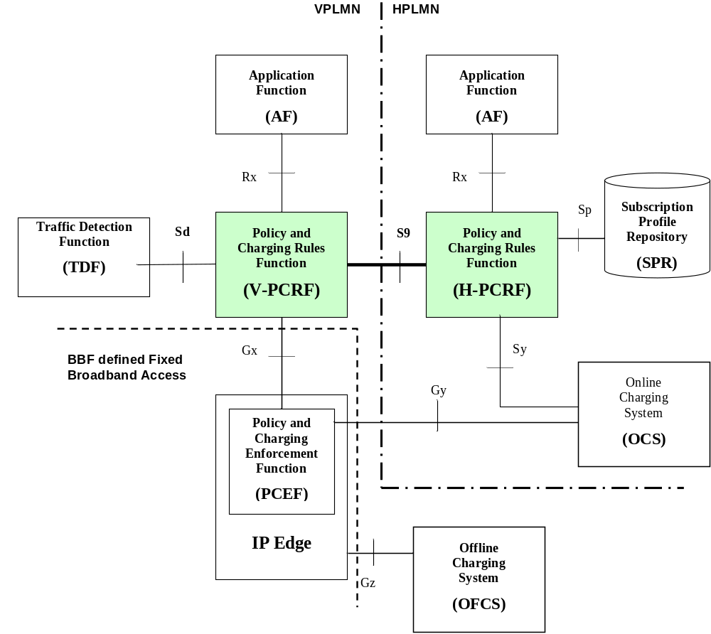
Figure B.3.3-1: S9 reference point at the PCC architecture for roaming with SPR
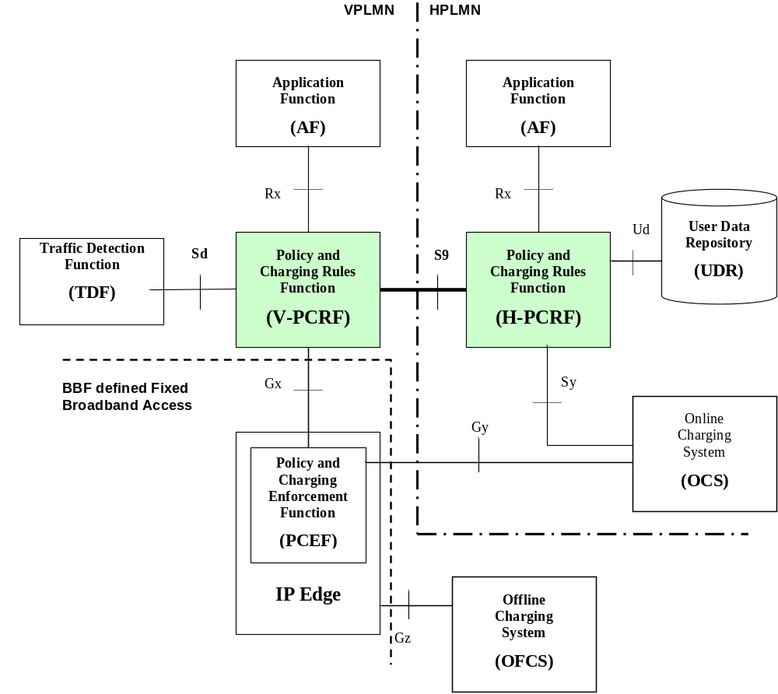
Figure B.3.3-2: S9 reference point at the PCC architecture for roaming with UDR

B.4 Functional Elements

B.4.1 V-PCRF
The V-PCRF functionality defined in clause 4.3.2.0 and clause 4.3.2.2 for case 1 and visited access shall apply.

B.4.2 H-PCRF
The H-PCRF functionality defined in clause 4.3.1.0 and clause 4.3.1.2 for case 1 and visited access shall apply with following exceptions:
- No negotiation of IP-CAN bearer control mode applies.
- Subscriptions to changes of IP-CAN type, RAT type or Access Network Information do not apply.

B.5 PCC procedures over S9 Reference Point

B.5.0 General
The following exceptions apply for S9 session procedures in the scenario of Fixed Broadband Access network convergence:
- Gxx reference point is not used.
- S9 reference point is only applicable for the NSWO traffic from the 3GPP UE.
- No provisioning of IP flow mobility routing information over S9 reference point is performed.

B.5.1 Session Establishment over S9
The S9 session establishment procedure in clause 4.5.1.1 applies with the following exceptions or restrictions as described in clause B.5.0.

B.5.2 Session Termination over S9
The procedures for case 1 described in clause 4.5.1.2 apply with the exceptions or restrictions as described in clause B.5.0.

B.5.3 Session Modification over S9
S9 session modification procedures described in clause 4.5.3.1 and clause 4.5.3.2 for case 1 apply with the exceptions or restrictions as described in clause B.5.0.
S9 subsession termination procedures described in clause 4.5.3.3 and clause 4.5.3.4 for case 1 apply with the exceptions or restrictions as described in clause B.5.0

B.5.4 Provisioning and validation of QoS information
The provisioning and validation of QoS information in clause 4.5.3.1 and clause 4.5.3.2 applies with the exceptions or restrictions as described in clause B.5.0.

Annex C (normative):
Access specific aspects, EPC-based eHRPD Access

C.1 General
In case of EPC-based eHRPD access the BBERF is located in the HRPD Serving Gateway (HSGW) as defined in 3GPP2 X.S0057 [23].

C.2 IPv6 prefix provisioning
For the home-routed access scenario, when the H-PCRF receives a CCR command with the CC-Request-Type set to the value "UPDATE_REQUEST", the IP-CAN-Type AVP set to the value "Non-3GPP-EPS", the RAT-Type AVP set to the value "EHRPD" and the Multiple-BBERF-Action AVP set to the value "ESTABLISHMENT" from the V-PCRF, and if the UE has acquired an IPv6 prefix via the 3GPP access, the H-PCRF shall provide the IPv6 prefix of the UE to the V-PCRF by including the Framed-Ipv6-Prefix AVP in Subsession-Decision-Info AVP within the CCA command.
For the visited access scenario, when the V-PCRF receives a CCR command with the CC-Request-Type set to the value "INITIAL_REQUEST", the IP-CAN-Type AVP set to the value "Non-3GPP-EPS", the RAT-Type AVP set to the value "EHRPD" from a new BBERF and at least one Gateway Control Session for the same user identity and PDN ID exists, and if the UE has acquired an IPv6 prefix via the 3GPP access, the V-PCRF shall provide the IPv6 prefix of the UE to the BBERF by including the Framed-Ipv6-Prefix AVP in the CCA command after the V-PCRF receives the CCA command from the H-PCRF.
NOTE: In order to allow the V-PCRF to link the new Gateway Control session to an S9 subsession based on the information received in the CCR command from the BBERF, it is assumed that there is only a single IP-CAN session per PDN ID and user identity.

Annex D (informative):
Change history
Change history
Date | TSG # | TSG Doc. | CR | Rev | Subject/Comment | Old | New
12/2014 | CT-66 | CP-140922 | 0359 | 1 | Update PCC architecture diagrams to include Np reference point | 12.5.0 | 13.0.0
03/2015 | CT-67 | CP-150135 | 0367 |  | Precedence derivation for ADC rule | 13.0.0 | 13.1.0
03/2015 | CT-67 | CP-150132 | 0368 |  | Support for IPv6 prefix retrieve by the HSGW during the eHRPD pre-registration procedure | 13.0.0 | 13.1.0
03/2015 | CT-67 | CP-150112 | 0370 | 2 | Reference update to align with the published BBF documents | 13.0.0 | 13.1.0
03/2015 | CT-67 | CP-150128 | 0371 | 1 | Excluding Usage of a Service/Application from IP-CAN session/TDF session Usage for roaming case | 13.0.0 | 13.1.0
03/2015 | CT-67 | CP-150127 | 0367 |  | Double resource reuse support over S9 | 13.0.0 | 13.1.0
06/2015 | CT-68 | CP-150362 | 0375 | 5 | Clarification of the Called-Station-Id | 13.1.0 | 13.2.0
06/2015 | CT-68 | CP-150360 | 0377 | 1 | Diameter overload control over S9 | 13.1.0 | 13.2.0
06/2015 | CT-68 | CP-150360 | 0380 | 1 | Diameter overload control over S9a interface | 13.1.0 | 13.2.0
06/2015 | CT-68 | CP-150361 | 0381 | - | Correcting Hanging Paragraphs | 13.1.0 | 13.2.0
09/2015 | CT-69 | CP-150472 | 0384 | 2 | Remove the IP domain Id by the V-PCRF | 13.2.0 | 13.3.0
09/2015 | CT-69 | CP-150485 | 0386 | 1 | Removel of OCS proxy in LBO roaming scenario | 13.2.0 | 13.3.0
09/2015 | CT-69 | CP-150491 | 0387 | 3 | PCC related update over S9 to support NBIFOM | 13.2.0 | 13.3.0
12/2015 | CT-70 | CP-150661 | 0389 | 1 | NBIFOM update | 13.3.0 | 13.4.0
12/2015 | CT-70 | CP-150797 | 0390 | 1 | Update the PCC architecture figures in 29.215 | 13.3.0 | 13.4.0
12/2015 | CT-70 | CP-150630 | 0392 | 1 | Update draft-ietf-dime-ovli reference to RFC 7683 | 13.3.0 | 13.4.0
12/2015 | CT-70 | CP-150730 | 0394 | 1 | Diameter Message Priority over S9, S9a | 13.3.0 | 13.4.0

Change history
Date | TSG # | TSG Doc. | CR | Rev | Cat | Subject/Comment | New
03/2016 | CT#71 | CP-160091 | 0400 | 1 | B | Include TSSF and RCAF in the EPC-routed architecture | 13.5.0
03/2016 | CT#71 | CP-160107 | 0401 | - | F | Network-initiated removal of one access from the PDN connection | 13.5.0
03/2016 | CT#71 | CP-160090 | 0402 | 4 | F | Correction to NBIFOM handling in roaming case | 13.5.0

