Invitation to 3GPP CT1#72 Meeting
June 27 - July 1, 2011
Shanghai, P. R. China

Dear Colleagues,

Huawei Technologies Co., LTD is pleased to invite you to the 3GPP CT1#72 meeting in Shanghai, P. R. China.

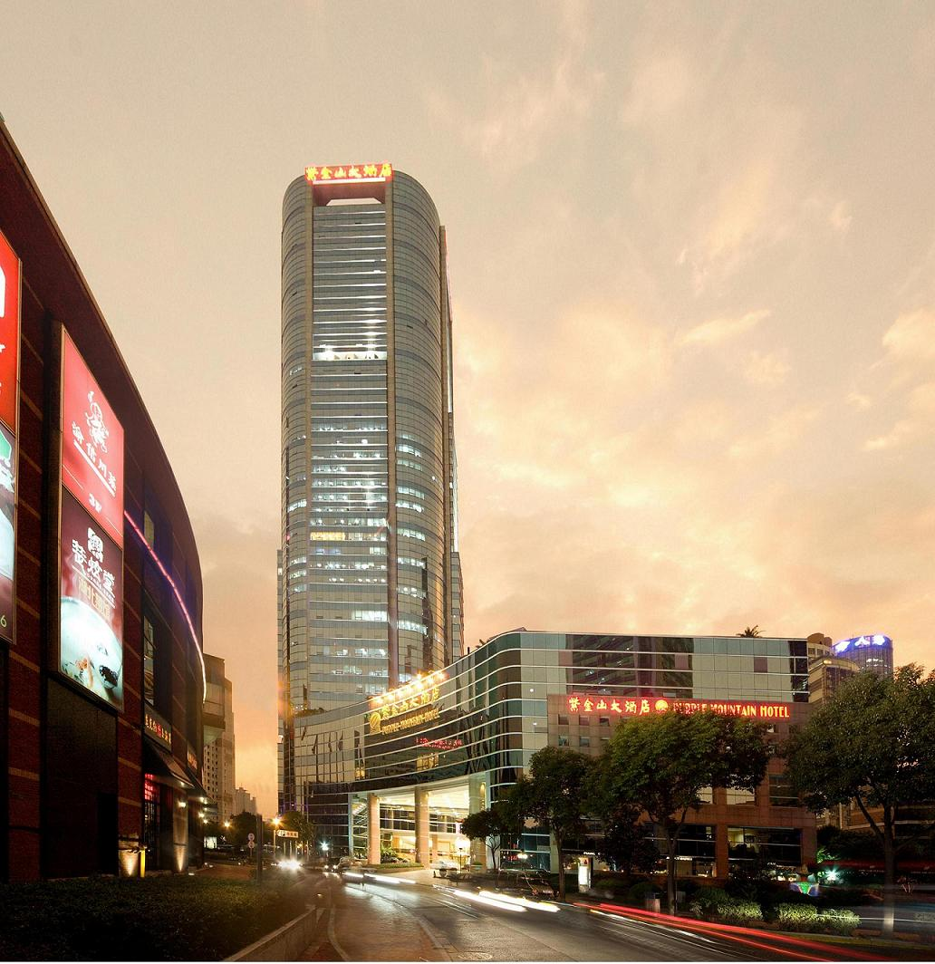

The meeting will be held at the SHANGHAI PURPLE MOUNTAIN HOTEL. A block of rooms have been reserved at the hotel under the name 3GPP. The reduced 3GPP group room rate is RMB 1000 for Deluxe Single-Room, RMB 1100 for Deluxe Double-Room, and RMB 1400 for Executive Room per night (breakfast buffet, service charge and tax included). Broadband Internet access in guest rooms is free. Delegates are responsible for their own hotel reservations. Please send the reservation form (Appendix B) to the hotel by fax or email by the cut-off date of 5 June 2011 (Note that reservation beyond this point may be subject to higher rate and availability).

In addition to hotel reservation, it is important to perform online meeting registration at the website http://webapp.etsi.org/3GPPRegistration/ before 12 June 2011. This provides the host with important planning information.

For entering China, it is required to hold either tourism or business visa. Should you require a personal letter of invitation for your business visa application, please contact the host via email. Your email should attach the form as in Appendix A filled with all necessary information and be sent out before 20 May 2011. For Chinese Embassy or Consulate information, please visit the website http://www.fmprc.gov.cn/eng/.

The meeting will start on Monday 27 June at 09:00 and end on Friday 1 July by no later than 18:00. Meeting directions and general information are provided in the following pages.

We are looking forward to seeing you in Shanghai, China.

Yours sincerely,
Ms. Li huifei
On behalf of Huawei Technologies Co., Ltd.
General Meeting Information

Meeting & Dates:
3GPP CT1#72 June 27 - July 1, 2011

Location:
Shanghai, P. R. China

Contact from the host:
Ms. Li Huifei
Huawei Technologies co., LTD
Tel : +86 755 28422719
Fax : +86 755 28420413
Email: lihuifei@huawei.com

Mrs. Shi Shufeng
Huawei Technologies co., LTD
Tel: +86 29 87674036
Fax : +86 29 88822168
Email: susan.shishufeng@huawei.com

Hotel Information:
SHANGHAI PURPLE MOUNTAIN HOTEL
Address: 778 Dongfang Road, Pudong, Shanghai, 200122, P.R. China

Tel: +86 21 68868888
Fax: +86 21 68868866
Email: mail@pmhotel.com.cn
Website: http://www.pmhotel.com.cn/

EDH requirements:
This will be a paperless meeting. Participants are requested to bring a wireless LAN card for their laptops. For your convenience, please be sure you have Oblique flat blades (inverted V-shape) with ground or Flat blade attachment plug to use in hotel guest room.
In meeting rooms, the host will provide power extensions with outlets fit for the power plug types illustrated in following picture.

Reservation Information
The meeting will be held at the SHANGHAI PURPLE MOUNTAIN HOTEL.

Group Rate:
RMB 1000 for Deluxe Single-Room, RMB 1100 for Deluxe Double-Room, and RMB 1400 for Executive Room per night. Breakfast, service charge and tax are all included.
Broadband Internet access in guest rooms is free. Complementary use of gym and swimming pool, and 20% discount for laundry service are offered.

Cut-off Date: 5 June 2011
Please make your reservation before the cut-off date to ensure the reduced group rate.
Rate beyond this point may be considerably higher and subject to availability.

Check-in/Check-out Time:
Check in after 12:00 AM
Check out before 12:00 PM

Reservations:
Please fill out the form as in Appendix B and return the completed form to the hotel by fax or email.

Cancellation Policy:
The reservation is guaranteed by credit card provided. In case of no-show, one night room charge will be taken from the provided credit card.
No penalty for room cancellation if received fax or email 24 hours before the arrival date.

Please Note:
Huawei Technologies Co., Ltd is not responsible for reservation confirmations, cancelled or changed reservations, or no-shows. Please contact the hotel directly to make any changes.

Transportation Information

- Shanghai Purple Mountain Hotel is located at the centre of Pudong Lujiazui Finance & Trade Zone, within walking distance to Metro Century Avenue Station and 5-min drive to three cross river tunnels.

Airport information: http://www.shanghaiairport.com/en/index.jsp

Pudong International Airport
40 minutes by taxi to/from the Hotel; about ￥150 CNY per trip depending on the traffic.

Please Note: Taxi drivers may not speak English, so make sure you have the name of your hotel or address written in Chinese. The following is the name, address, phone number and location map of the Shanghai Purple Mountain Hotel in Chinese, please print it out for your convenience:

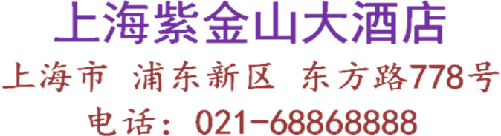

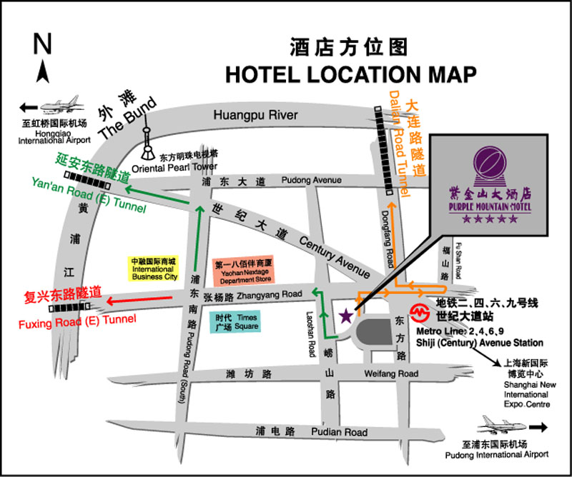

General Information for Stay in Shanghai

GSM/CDMA Coverage:
There is GSM/CDMA/3G (WCDMA/TD-SCDMA/CDMA 2000) coverage in Shanghai.

Currency:
On April 8, 2011, 1 U.S. dollar was worth ￥ 6.53 CNY and 1 Euro was worth ￥ 9.42 CNY. Most foreign currencies can be easily exchanged at banks or hotels.

Time Zone:
GMT +8 hours

Voltage:
Commercial power in China is 220V. Please be sure you have the correct adapter. Voltage converters will not be provided at the meeting.

General Information
http://www.travelchinaguide.com/cityguides/shanghai/

Area Attractions
http://www.travelchinaguide.com/attraction/shanghai/

Weather
http://www.travelchinaguide.com/climate/shanghai.htm

Shopping
http://www.travelchinaguide.com/cityguides/shanghai/shopping.htm

Please don’t hesitate to direct any questions regarding the logistical arrangements of this meeting to the Meeting Coordinator:

Ms. Li huifei

Have a great meeting and enjoy your stay in Shanghai!
Appendix A
3GPP CT1#72 Meeting
June 27 - July 1, 2011
Shanghai, China
INVITATION LETTER REQUEST FORM

To enter China for the meeting indicated above, you may need a letter of invitation from the Chinese host, which you need to present to the Chinese Embassy/Consulate in your area in order to apply your visa. To obtain the invitation letter, please:

- fill out the form below
- prepare a copy of your passport (the name, date of birth, nationality, passport number, valid date of passport, etc. must be seen clearly; to ensure readability, a scanned photograph page is preferred.)
- prepare copies of previous Chinese visas and records if your entry is not the first time
- send all of the above to Ms. Li Huifei before 20 May 2011

Ms. Li Huifei
Huawei Technologies co., LTD
Email: lihuifei@huawei.com

Full name
Family name (Last name)
Given name (First name)
Gender (Male/Female)
Nationality
Date of Birth (dd/mm/yy)
Age (Western Count)
Passport number and issuing country
Passport Valid until (dd/mm/yy)
Name of Company/Organization
Occupation and Job title
Mailing address
Postal Code
Telephone number
Fax number
If the country in which you'll obtain your visa is different from your nationality, please indicate it here.
Home Address
Email address
Visiting City
(In this case, it is Shanghai by default; If you want to visit other places than Shanghai, please indicate here.)
Ever been to China before?
Date of arrival in China
Date of departure from China

End of form

Appendix B

3GPP Hotel Reservation Form
Please fax or E-mail the completed form to Purple Mountain Hotel at + 86 021-6886-8899 /6886-8866(ados@pmhotel.com.cn/rsvn@pmhotel.com.cn) before 5 June 2011 for room reservation.
If you have not received a confirmation via fax or email within 72 hours after faxing this form, please call the hotel contact Ms. Mary Han at: + 86 021-68868888 ext. 8203 MP:13501911137 or Ms. Holly Wang at: + 86 021-68868888 ext. 71 or send Email to ados@pmhotel.com.cn /rsvn@pmhotel.com.cn.

Guest Information

Title: □Mr. □Ms.

Name: Fax number: ___ _

Email address: Telephone number: _ __

Room Type
Smoking□ Non-Smoking□
□ Deluxe Single Room ￥1000CNY (1 ABF)
□ Deluxe Double Room ￥1100CNY (2 ABF)
□ Executive Room ￥1400CNY (1 or 2 ABF)
Note: The group rate per night includes breakfast, service charge and tax. Broadband Internet access in guest rooms is free.

Period of Stay
CHECK-IN：June CHECK-OUT：July Nights

Billing information to be used as a guarantee

Credit Card Type: □VISA □American Express □Diners □Master □JCB
Credit Card Number: _____________________________________________________
Expiration Date: _________________________________________________________
Billing Address of Credit Card Holder: _______________________________________
_________________________________________

Authorization Signature___________________________________________________

Pick-up ( Buick Car RMB500 Per Way ) Need ___ No Need ___
Flight NO. ___
Special diet_______________________________________________

Please make your reservations before the cut-off date (5 June 2011) to insure the reduced group rate and room availability.
- The reservation is guaranteed by credit card provided, in case of no-show, one night room charge will be taken from the above credit card.
- No penalty for room cancellation if received fax or email 24 hours before arrival date.

