3GPP TSG-CT WG1 Meeting #141e C1-232683

Online 17– 21 April 2023 (was C1-232051)
CR-Form-v12.2
CHANGE REQUEST
 | 24.575 | CR | 0002 | rev | 1 | Current version: | 18.0.0
For HELP on using this form: comprehensive instructions can be found at
http://www.3gpp.org/Change-Requests.

Proposed change affects: | UICC apps |  | ME | X | Radio Access Network |  | Core Network

Title: | Wrong format of the <X> node
Source to WG: | Huawei, HiSilicon
Source to TSG: | CT1
Work item code: | UEConfig5MBS |  |  |  |  |  | Date: |  | 2023-04-01
Category: | F |  |  |  |  |  | Release: |  | Rel-18
 | Use one of the following categories:  F (correction)  A (mirror corresponding to a change in an earlier release)  B (addition of feature),  C (functional modification of feature)  D (editorial modification)  Detailed explanations of the above categories can  be found in 3GPP TR 21.900. |  |  |  |  |  |  | Use one of the following releases:  Rel-8 (Release 8)  Rel-9 (Release 9)  Rel-10 (Release 10)  Rel-11 (Release 11)  …  Rel-16 (Release 16)  Rel-17 (Release 17)  Rel-18 (Release 18)  Rel-19 (Release 19)
Reason for change: |  | The specification provides a number of <X> nodes as a placeholder for one or more of other nodes providing necessary information. Hence, this <X> node does not carry any value/information itself.  However, the specification indicates in several places that <X> nodes are of character (i.e., “chr”) format instead of node (i.e., “node”) which is incorrect:  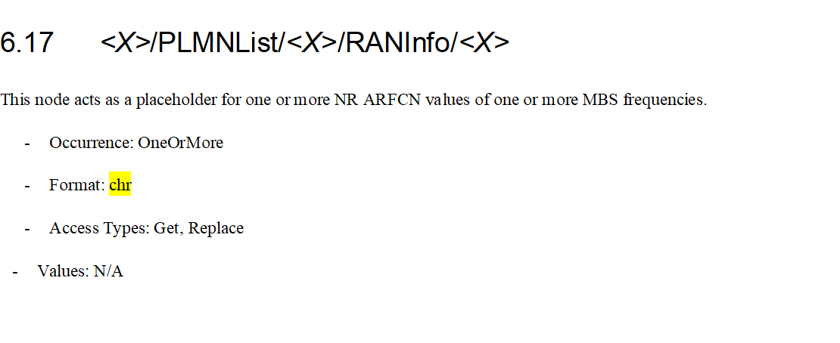
Summary of change: |  | The format of the <X> nodes of the RANInfo node and the PDUInfo node is corrected.
Consequences if not approved: |  | Wrong format of <X> nodes which leads to wrong implementation.
Clauses affected: |  |  | 6.17, 6.21
 |  |  | Y | N
Other specs |  |  |  | X | Other core specifications |  |  | TS/TR ... CR ...
affected: |  |  |  | X | Test specifications |  |  | TS/TR ... CR ...
(show related CRs) |  |  |  | X | O&M Specifications |  |  | TS/TR ... CR ...
Other comments:
This CR's revision history: |  |  | V1: cover sheet updated; work item field.

* * * First Change * * * *

6.17 <X>/PLMNList/<X>/RANInfo/<X>
This node acts as a placeholder for one or more NR ARFCN values of one or more MBS frequencies.
- Occurrence: OneOrMore
- Format: node
- Access Types: Get, Replace
- Values: N/A
* * * Next Change * * * *

6.21 <X>/PLMNList/<X>/PDUInfo/PDUInfoList/<X>
This node acts as a placeholder for one or more PDU session-specific information values.
- Occurrence: OneOrMore
- Format: node
- Access Types: Get, Replace
- Values: N/A
* * * End of Changes * * * *

