3GPP TSG-CT WG1 Meeting #137-e C1-225abc

E-Meeting, 18th – 26th August 2022 (was C1-224765)
CR-Form-v12.2
CHANGE REQUEST
 | 24.558 | CR | 0010 | rev | 1 | Current version: | 17.0.0
For HELP on using this form: comprehensive instructions can be found at
http://www.3gpp.org/Change-Requests.

Proposed change affects: | UICC apps |  | ME | X | Radio Access Network |  | Core Network | X

Title: | Correction to the ACR request message
Source to WG: | Huawei, HiSilicon
Source to TSG: | CT1
Work item code: | EDGEAPP |  |  |  |  |  | Date: |  |  | 2022-08-23
Category: | F |  |  |  |  |  | Release: |  |  | Rel-17
 | Use one of the following categories:  F (correction)  A (mirror corresponding to a change in an earlier release)  B (addition of feature),  C (functional modification of feature)  D (editorial modification)  Detailed explanations of the above categories can  be found in 3GPP TR 21.900. |  |  |  |  |  |  |  | Use one of the following releases:  Rel-8 (Release 8)  Rel-9 (Release 9)  Rel-10 (Release 10)  Rel-11 (Release 11)  …  Rel-16 (Release 16)  Rel-17 (Release 17)  Rel-18 (Release 18)  Rel-19 (Release 19)
Reason for change: |  | The specification provides specification of the ACR request message, i.e., operation Initiate of the Eees_AppContextRelocation API.  However, there is need to update the attribute “easNotifInd” of the type “AcrInitReq” of the Eees_AppContextRelocation as it is not aligned with stage 2 in TS 23.558. Quote of TS 23.558, clause 8.8.4.4:  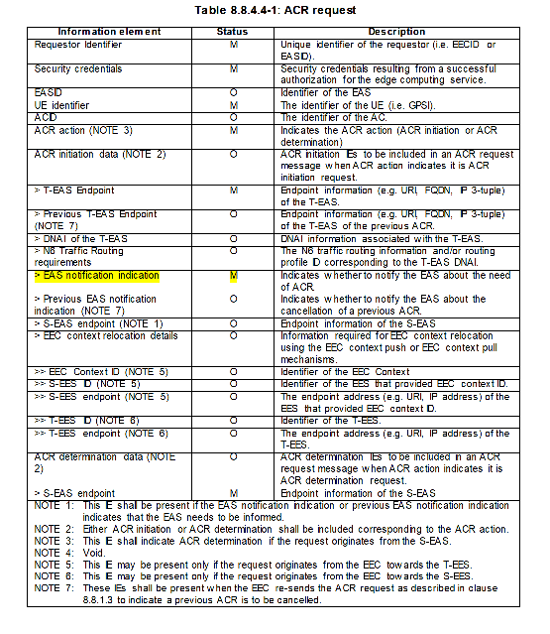
Summary of change: |  | The “easNotifInd” attribute of the type “AcrInitReq” is made mandatory.
Consequences if not approved: |  | Specification not aligned with stage 2.
Clauses affected: |  | 6.5.5.2.3
 |  | Y | N
Other specs |  |  | X | Other core specifications |  |  |  | TS/TR ... CR ...
affected: |  |  | X | Test specifications |  |  |  | TS/TR ... CR ...
(show related CRs) |  |  | X | O&M Specifications |  |  |  | TS/TR ... CR ...
Other comments:
This CR's revision history:

* * * First Change * * * *

6.5.5.2.3 Type: AcrInitReq
Table 6.5.5.2.3-1: Definition of type AcrInitReq
Attribute name | Data type | P | Cardinality | Description | Applicability
requestorId | string | M | 1 | Contains the identifier of the EEC that is sending the request.
easId | string | O | 0..1 | Contains the identifier of the EAS.
ueId | Gpsi | M | 1 | Contains the identifier of the concerned UE.
acId | string | O | 0..1 | Contains the identifier of the AC.
tEasEndpoint | EndPoint | M | 1 | Contains the endpoint information of the T-EAS.
sEasEndpoint | EndPoint | C | 0..1 | Contains the endpoint information of the S-EAS.  This attribute shall be provided when the "easNotifInd" attribute is set to "true" or when the "prevEasNotifInd" attribute is present and set to "true".
prevTEasEndpoint | EndPoint | C | 0..1 | Contains the endpoint information of the previous T-EAS.  This attribute shall be provided when the EEC re-sends the ACR request to indicate that a previous ACR is to be cancelled.
routeReq | RouteToLocation | O | 0..1 | Contains the T-EAS's DNAI information and the corresponding N6 traffic routing information and/or routing profile ID.
easNotifInd | boolean | M | 1 | Indicates whether the EAS should be notified about the need for ACR or ACR cancellation.  "true": Notification required.  "false" (default): Notification not required.
prevEasNotifInd | boolean | C | 0..1 | Indicates whether the EAS should be notified about ACR cancellation.  "true": Notification required.  "false" (default): Notification not required.  This attribute shall be provided when the EEC re-sends the ACR request to indicate that a previous ACR is to be cancelled.
eecCtxtReloc | EecCtxtReloc | O | 0..1 | Contains EEC context relocation information.

* * * End of Changes * * * *

