3GPP TSG-CT WG1 Meeting #130-e C1-213343
Electronic meeting, 20 – 28 May 2021
CR-Form-v12.0
CHANGE REQUEST
 | 24.501 | CR | 3050 | rev | 3 | Current version: | 17.2.1
For HELP on using this form: comprehensive instructions can be found at
http://www.3gpp.org/Change-Requests.

Proposed change affects: | UICC apps |  | ME | x | Radio Access Network |  | Core Network

Title: | MMTEL Voice and MMTEL Video in non-3GPP
Source to WG: | Huawei, HiSilicon
Source to TSG: | C1
Work item code: | 5GProtoc17-non3GPP |  |  |  |  |  | Date: |  |  | 2021-05-13
Category: | F |  |  |  |  |  | Release: |  |  | Rel-17
 | Use one of the following categories:  F (correction)  A (mirror corresponding to a change in an earlier release)  B (addition of feature),  C (functional modification of feature)  D (editorial modification)  Detailed explanations of the above categories can  be found in 3GPP TR 21.900. |  |  |  |  |  |  |  | Use one of the following releases:  Rel-8 (Release 8)  Rel-9 (Release 9)  Rel-10 (Release 10)  Rel-11 (Release 11)  ...  Rel-15 (Release 15)  Rel-16 (Release 16)  Rel-17 (Release 17)  Rel-18 (Release 18)
Reason for change: |  | According to the following text quoted from M 2.1.1 of TS 24.173 shows, the MMTEL layer may provide the “handover of ongoing MMTEL voice call from non-3GPP access” or “handover of ongoing MMTEL video call from non-3GPP access” relevant information to NAS layer. The ongoing MMTEL voice/video call can be handover from non-3GPP access, that also means the MMTEL voice/video call was performed over non-3GPP access. However there is no corresponding establishment cause for MMTEL voice call and MMTEL video call over non-3GPP access  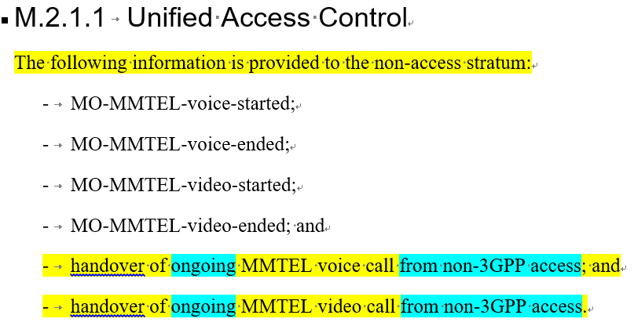
Summary of change: |  | Add the establishment causes for MMTEL voice call and MMTEL video call over non-3GPP access
Consequences if not approved: |  | Lack of establishment causes for MMTEL voice call and MMTEL video call over non-3GPP access
Clauses affected: |  | 4.7.2.2
 |  | Y | N
Other specs |  | X |  | Other core specifications |  |  |  | TS 24.502 CR 0186 and TS 24.173 CR 0146
affected: |  |  | X | Test specifications |  |  |  | TS/TR ... CR ...
(show related CRs) |  |  | X | O&M Specifications |  |  |  | TS/TR ... CR ...
Other comments:
This CR's revision history: |  | Was C1-211457  Update cover page, and add change text for mapping access attempt to AC

***** start of change*****

4.7.2.2 Establishment cause for non-3GPP access
When establishment of an N1 NAS signalling connection over non-3GPP access is initiated, the UE shall:
a) determine one or more access identities to be associated with the establishment of the N1 NAS signalling connection as specified in subclause 4.5.2 and table 4.5.2.1;
b) select the establishment cause for non-3GPP access from the determined one or more access identities and the event which triggered initiation of the N1 NAS signalling connection over non-3GPP access by checking the rules specified in table 4.7.2.2.1; and
c) provide the selected establishment cause for non-3GPP access to the lower layers.
While an MMTEL voice call is ongoing:
- any:
1) service request procedure; or
2) registration procedure;
initiated in 5GMM-IDLE mode is mapped to "MO MMTel voice call" type access attempt.
While an MMTEL video call is ongoing and no MMTEL voice call is ongoing:
- any:
1) service request procedure; or
2) registration procedure;
initiated in 5GMM-IDLE mode is mapped to "MO MMTel video call" type access attempt.
If the access attempt matches more than one rule, the establishment cause for non-3GPP access of the lowest rule number shall be used.
Table 4.7.2.2.1: Mapping table for determination of establishment cause for non-3GPP access
Rule # | Access identities | Type of access attempt | Requirements to be met | Establishment cause for non-3GPP access
1 | 1 | Any | Any | mps-PriorityAccess
2 | 2 | Any | Any | mcs-PriorityAccess
3 | 11, 15 | Any | Any | highPriorityAccess
4 | 12,13,14, | Any | Any | highPriorityAccess
5 | 0 | Emergency | UE is attempting access for an emergency session (NOTE 1) | emergency
 |  | UE NAS initiated 5GMM specific procedures | Access attempt is for MO signalling | mo-Signalling
 |  | UE NAS initiated 5GMM connection management procedures or 5GMM NAS transport procedure | Access attempt is for MO data | mo-Data
 |  | MO SMS over NAS | Access attempt is for MO SMS over NAS | mo-SMS
 |  | MO MMTel voice call | Access attempt is for MO MMTel voice call | mo-VoiceCall
 |  | MO MMTel video call | Access attempt is for MO MMTel video call | mo-Videocall
NOTE 1: This includes 5GMM specific procedures while the service is ongoing and 5GMM connection management procedures required to establish a PDU session with request type = "initial emergency request" or "existing emergency PDU session", or to re-establish user-plane resources for such a PDU session.
NOTE 2: See subclause 4.5.2, table 4.5.2.1 for use of the access identities of 0, 1, 2, and 11-15.
***** end of change*****

