3GPP TSG-CT WG1 Meeting #130-e C1-21XXXX
Electronic meeting, 20-28 May 2021
CR-Form-v12.1
CHANGE REQUEST
 | 24.501 | CR | 3187 | rev | 1 | Current version: | 17.2.1
For HELP on using this form: comprehensive instructions can be found at
http://www.3gpp.org/Change-Requests.

Proposed change affects: | UICC apps |  | ME |  | Radio Access Network |  | Core Network | X

Title: | Clarification on UE initialted MA PDU deactivation
Source to WG: | Mediatek Inc.
Source to TSG: | C1
Work item code: | 5GProtoc17 |  |  |  |  |  | Date: |  |  | 2021/05/27
Category: | F |  |  |  |  |  | Release: |  |  | Rel-17
 | Use one of the following categories:  F (correction)  A (mirror corresponding to a change in an earlier release)  B (addition of feature),  C (functional modification of feature)  D (editorial modification)  Detailed explanations of the above categories can  be found in 3GPP TR 21.900. |  |  |  |  |  |  |  | Use one of the following releases:  Rel-8 (Release 8)  Rel-9 (Release 9)  Rel-10 (Release 10)  Rel-11 (Release 11)  ...  Rel-15 (Release 15)  Rel-16 (Release 16)  Rel-17 (Release 17)  Rel-18 (Release 18)
Reason for change: |  | In current design the UE can trigger the UE-requested PDU session release procedure to release a 2 legged MA PDU session. But it is up to NW's decision to:  (1) release the whole MA PDU (Access type IE not included in the PDU SESSION RELEASE COMMAND) or  (2) just release a single leg of the MA PDU (Access type IE included in the PDU SESSION RELEASE COMMAND).  This means when the UE wants to release an MA PDU session (e.g., disable IMS, or turn off internet mobile data…etc), worst case MT need to trigger two time of UE-requested PDU session release procedure to completely release it.  Examples (not exhaustive) flows as below:  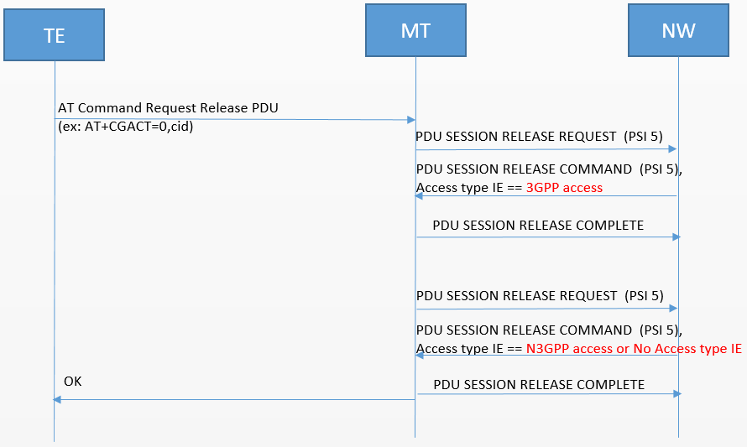  or  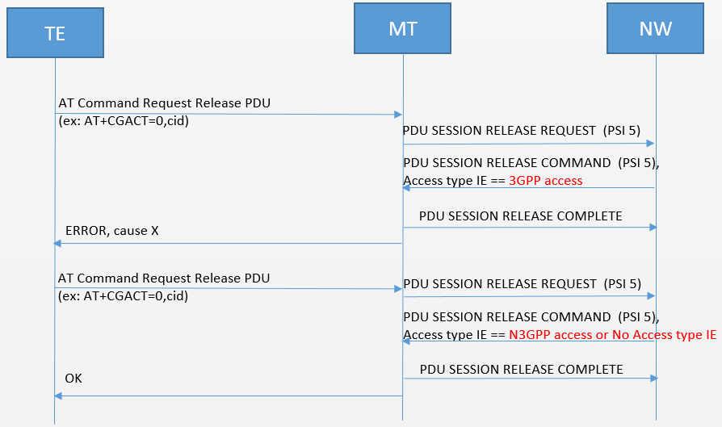  From the TE's point of view, it is not needed to remove just one leg of an MA PDU (The TE keeps the MA PDU, or destroy the whole MA PDU, not just remove one leg). To simplify the interaction between TE and MT, and also to improve the procedure efficiency (ex: redue the time needed when the UE needs to release a PDU session in order to request an emergency PDU session, as specified in 6.4.1.5 Handling the maximum number of established PDU sessions), we propose that if the release procedure is requested by UE, the NW responds with "release the whole MA PDU", i.e., not include the Access type IE in the PDU SESSION RELEASE COMMAND.
Summary of change: |  | If the release procedure is requested by UE, the NW responds with "release the whole MA PDU", i.e., not include the Access type IE in the PDU SESSION RELEASE COMMAND
Consequences if not approved: |  | UE needs to trigger two time UE-requested PDU session release procedure to release an MA PDU session
Clauses affected: |  | 6.3.3.2
 |  | Y | N
Other specs |  |  | X | Other core specifications |  |  |  | TS/TR ... CR ...
affected: |  |  | X | Test specifications |  |  |  | TS/TR ... CR ...
(show related CRs) |  |  | X | O&M Specifications |  |  |  | TS/TR ... CR ...
Other comments:
This CR's revision history:

*** change ***

6.3.3.2 Network-requested PDU session release procedure initiation
In order to initiate the network-requested PDU session release procedure, the SMF shall create a PDU SESSION RELEASE COMMAND message.
The SMF shall set the 5GSM cause IE of the PDU SESSION RELEASE COMMAND message to indicate the reason for releasing the PDU session.
The 5GSM cause IE typically indicates one of the following 5GSM cause values:
#8 operator determined barring;
#26 insufficient resources;
#29 user authentication or authorization failed;
#36 regular deactivation;
#38 network failure;
#39 reactivation requested;
#46 out of LADN service area;
#67 insufficient resources for specific slice and DNN;
#69 insufficient resources for specific slice.
If the selected SSC mode of the PDU session is "SSC mode 2" and the SMF requests the relocation of SSC mode 2 PDU session anchor with different PDU sessions as specified in 3GPP TS 23.502 [9], the SMF shall include 5GSM cause #39 "reactivation requested".
If the network-requested PDU session release procedure is triggered by a UE-requested PDU session release procedure, the SMF shall set the PTI IE of the PDU SESSION RELEASE COMMAND message to the PTI of the PDU SESSION RELEASE REQUEST message received as part of the UE-requested PDU session release procedure and shall not include the Access type IE in the PDU SESSION RELEASE COMMAND.
If the network-requested PDU session release procedure is not triggered by a UE-requested PDU session release procedure, the SMF shall set the PTI IE of the PDU SESSION RELEASE COMMAND message to "No procedure transaction identity assigned".
Based on the local policy and user's subscription data, if the SMF decides to release the PDU session after determining:
a) the UE has moved between a tracking area in NB-N1 mode and a tracking area in WB-N1 mode;
b) the UE has moved between a tracking area in NB-S1 mode and a tracking area in WB-N1 mode;
c) the UE has moved between a tracking area in WB-S1 mode and a tracking area in NB-N1 mode; or
d) a PDU session is not only for control plane CIoT 5GS optimization any more,
the SMF shall:
a) include the 5GSM cause value #39 "reactivation requested" in the 5GSM cause IE of the PDU SESSION RELEASE COMMAND message; or
b) include a 5GSM cause value other than #39 "reactivation requested" in the 5GSM cause IE of the PDU SESSION RELEASE COMMAND message.
NOTE: The included 5GSM cause value is up to the network implementation.
If the SMF receives UE presence in LADN service area from the AMF indicating that the UE is out of the LADN service area and the SMF decides to release the PDU session, the SMF shall include the 5GSM cause value #46 "out of LADN service area" in the 5GSM cause IE of the PDU SESSION RELEASE COMMAND message. Upon receipt of the 5GSM cause value #46 "out of LADN service area" in the 5GSM cause IE of the PDU SESSION RELEASE COMMAND message, the UE shall release the PDU session.
The SMF may include a Back-off timer value IE in the PDU SESSION RELEASE COMMAND message when the 5GSM cause value #26 "insufficient resources" is included in the PDU SESSION RELEASE COMMAND message. If the 5GSM cause value is #26 "insufficient resources" and the PDU SESSION RELEASE COMMAND message is sent to a UE configured for high priority access in selected PLMN or the request type was set to "initial emergency request" or "existing emergency PDU session" for the establishment of the PDU session, the network shall not include a Back-off timer value IE.
The SMF may include a Back-off timer value IE in the PDU SESSION RELEASE COMMAND message when the 5GSM cause value #67 "insufficient resources for specific slice and DNN" is included in the PDU SESSION RELEASE COMMAND message. If the 5GSM cause value is #67 "insufficient resources for specific slice and DNN" and the PDU SESSION RELEASE COMMAND message is sent to a UE configured for high priority access in selected PLMN or the request type was set to "initial emergency request" or "existing emergency PDU session" for the establishment of the PDU session, the network shall not include a Back-off timer value IE.
The SMF may include a Back-off timer value IE in the PDU SESSION RELEASE COMMAND message when the 5GSM cause #69 "insufficient resources for specific slice" is included in the PDU SESSION RELEASE COMMAND message. If the 5GSM cause value is #69 "insufficient resources for specific slice" and the PDU SESSION RELEASE COMMAND message is sent to a UE configured for high priority access in selected PLMN or the request type was set to "initial emergency request" or "existing emergency PDU session" for the establishment of the PDU session, the network shall not include a Back-off timer value IE.
The SMF should include a Back-off timer value IE in the PDU SESSION RELEASE COMMAND message when the 5GSM cause value #29 "user authentication or authorization failed" is included in the PDU SESSION RELEASE COMMAND message.
The SMF shall send:
a) the PDU SESSION RELEASE COMMAND message; and
b) the N1 SM delivery skip allowed indication:
1) if the SMF allows the AMF to skip sending the N1 SM container to the UE and the 5GSM cause IE is not set to #39 "reactivation requested"; or
2) if the SMF allows the AMF to skip sending the N1 SM container to the UE and the Access type IE is not included
towards the AMF, and the SMF shall start timer T3592 (see example in figure 6.3.3.2.1).
Figure 6.3.3.2.1: Network-requested PDU session release procedure
*** end of change ***

