3GPP TSG-CT WG1 Meeting #128-e C1-210XXX
Electronic meeting, 25 February – 5 March 2021 was C1-210966
CR-Form-v12.0
CHANGE REQUEST
 | 24.502 | CR | 0186 | rev | 1 | Current version: | 17.1.0
For HELP on using this form: comprehensive instructions can be found at
http://www.3gpp.org/Change-Requests.

Proposed change affects: | UICC apps |  | ME | x | Radio Access Network |  | Core Network

Title: | MMTEL Voice and MMTEL Video in non-3GPP
Source to WG: | Huawei, HiSilicon
Source to TSG: | C1
Work item code: | 5GProtoc17-non3GPP |  |  |  |  |  | Date: |  |  | 2021-02-18
Category: | F |  |  |  |  |  | Release: |  |  | Rel-17
 | Use one of the following categories:  F (correction)  A (mirror corresponding to a change in an earlier release)  B (addition of feature),  C (functional modification of feature)  D (editorial modification)  Detailed explanations of the above categories can  be found in 3GPP TR 21.900. |  |  |  |  |  |  |  | Use one of the following releases:  Rel-8 (Release 8)  Rel-9 (Release 9)  Rel-10 (Release 10)  Rel-11 (Release 11)  ...  Rel-15 (Release 15)  Rel-16 (Release 16)  Rel-17 (Release 17)  Rel-18 (Release 18)
Reason for change: |  | According to the following text quoted from M 2.1.1 of TS 24.173 shows, the MMTEL layer may provide the “handover of ongoing MMTEL voice call from non-3GPP access” or “handover of ongoing MMTEL video call from non-3GPP access” relevant information to NAS layer. The ongoing MMTEL voice/video call can be handover from non-3GPP access, that also means the MMTEL voice/video call was performed over non-3GPP access. However there is no corresponding establishment cause for MMTEL voice call and MMTEL video call over non-3GPP access  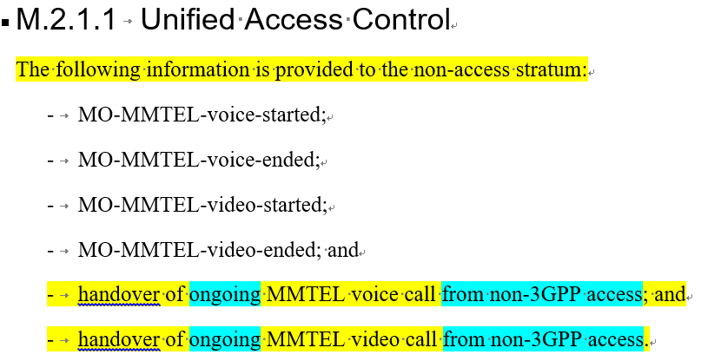
Summary of change: |  | Add the establishment causes for MMTEL voice call and MMTEL video call over non-3GPP access
Consequences if not approved: |  | Lack of establishment causes for MMTEL voice call and MMTEL video call over non-3GPP access
Clauses affected: |  | 9.2.2
 |  | Y | N
Other specs |  | X |  | Other core specifications |  |  |  | TS/TR ... CR ...
affected: |  |  | X | Test specifications |  |  |  | TS/TR ... CR ...
(show related CRs) |  |  | X | O&M Specifications |  |  |  | TS/TR ... CR ...
Other comments:
This CR's revision history:

***** start of change*****

9.2.2 Establishment cause for non-3GPP access
The purpose of the Establishment cause for non-3GPP access information element is to provide the establishment cause for non-3GPP access.
The Establishment cause for non-3GPP access information element is coded as shown in figures 9.2.2-1 and table 9.2.2-1.
The Establishment cause for non-3GPP access is a type 3 information element with length of 2 octets.
8 | 7 | 6 | 5 | 4 | 3 | 2 | 1
Establishment cause for non-3GPP access IEI |  |  |  |  |  |  |  | octet 1
0  Spare | 0  Spare | 0  Spare | 0  Spare | N3AEC |  |  |  | octet 2
Figure 9.2.2-1: Establishment cause for non-3GPP access information element
Table 9.2.2-1: Establishment cause for non-3GPP access information element
Establishment cause for non-3GPP access (N3AEC) (octet 2 bits 1 to 4)
Bits
4 3 2 1
0 0 0 0 emergency
0 0 0 1 highPriorityAccess
0 0 1 1 mo-Signalling
0 1 0 0 mo-Data
1 0 0 0 mps-PriorityAccess
1 0 0 1 mcs-PriorityAccess
1 0 1 0 mo-SMS
1 0 1 1 mo-VoiceCall
1 1 0 0 mo-VideoCall

All other values are spare values. The receiving entity shall treat a spare value as 0100, "mo-Data".

***** end of change*****

