3GPP TSG-CT WG1 Meeting #125-e C1-205047
Electronic meeting, 20-28 Aug 2020
CR-Form-v12.0
CHANGE REQUEST
 | 24.167 | CR | 0223 | rev | - | Current version: | 16.2.0
For HELP on using this form: comprehensive instructions can be found at
http://www.3gpp.org/Change-Requests.

Proposed change affects: | UICC apps |  | ME | x | Radio Access Network |  | Core Network | x

Title: | Adding new configuration parameter by which network can configure UE's APN parameter reading rule
Source to WG: | MediaTek Inc.
Source to TSG: | C1
Work item code: | TEI17 |  |  |  |  |  | Date: |  |  | 2020/08/13
Category: | F |  |  |  |  |  | Release: |  |  | Rel-17
 | Use one of the following categories:  F (correction)  A (mirror corresponding to a change in an earlier release)  B (addition of feature),  C (functional modification of feature)  D (editorial modification)  Detailed explanations of the above categories can  be found in 3GPP TR 21.900. |  |  |  |  |  |  |  | Use one of the following releases:  Rel-8 (Release 8)  Rel-9 (Release 9)  Rel-10 (Release 10)  Rel-11 (Release 11)  Rel-12 (Release 12)  Rel-13 (Release 13)  Rel-14 (Release 14)  Rel-15 (Release 15)  Rel-16 (Release 16)  Rel-17 (Release 17)
Reason for change: |  | For an open market device, the APN parameters can be obtained by UE by multiple ways. For example :  - Via UICC (Set as EFACL parameter in the UICC)  - Via Network (In the RRC response message or via config SMS)  - Via User provided values (User can add the APN using APN setting UI)  - Via code or configured inside device (Meaning the image already has default values)  Since there are multiple input sources possible for UE to read/receive APN parameter, some critical issues arises :  - Assuming that these input methods has different APN values, which one should the UE use in request to network? For example assume USIM has value A, User configure B and the default value stored in phone image is C. Which value should the UE use in the network request (A, B or C)?  - Since there are multiple input sources possible, which input source should the UE use? For example read from USIM first and if present use it (In this case the USIM is highest priority). Or always use the values provided by user (In this case, the values present in setting is highest priority). Or always use the values provided by network (In this case the network provided value is highest priority).  - How network can influence or control UE’s input source selection to read APN parameters?  To address these issues, we are proposing a new configuration parameter in the IMS MO so that the operator/network can configure UE to select the correct input source for reading APN parameters and use it for requesting to network.
Summary of change: |  | Added new configuration paramter in the IMS MO object “Access_Point_Name_Pameter_Reading_Rule “ so that UE can correctly choose the correct input source to read APN paramter.
Consequences if not approved: |  | The open market UE will fail to read the correct APN setting when multiple input sources have different values. This will critically impact end user experience.
Clauses affected: |  | Section 2, 5.XX (New) and Annex A
 |  | Y | N
Other specs |  |  | X | Other core specifications |  |  |  | TS/TR ... CR ...
affected: |  |  | X | Test specifications |  |  |  | TS/TR ... CR ...
(show related CRs) |  |  | X | O&M Specifications |  |  |  | TS/TR ... CR ...
Other comments:
This CR's revision history:

***** Next change *****

2 References
The following documents contain provisions which, through reference in this text, constitute provisions of the 3GPP IMS Management Object document.
- References are either specific (identified by date of publication, edition number, version number, etc.) or non-specific.
- For a specific reference, subsequent revisions do not apply.
- For a non-specific reference, the latest version applies. In the case of a reference to a 3GPP document (including a GSM document), a non-specific reference implicitly refers to the latest version of that document in the same Release as the present document.
[1] 3GPP TR 21.905: "Vocabulary for 3GPP Specifications".
[2] 3GPP TS 23.003: "Numbering, addressing and identification".
[3] 3GPP TS 23.221: "Architectural requirements".
[4] 3GPP TS 23.228: "IP Multimedia Subsystem (IMS); Stage 2".
[5] 3GPP TS 24.229: "Internet Protocol (IP) multimedia call control protocol based on Session Initiation Protocol (SIP) and Session Description Protocol (SDP); Stage 3".
[5a] 3GPP TS 24.341: "Support of SMS over IP networks; Stage 3".
[6] Void.
[7] Void.
[8] Void.
[9] Void.
[10] 3GPP TS 31.102: "Characteristics of the USIM application".
[11] 3GPP TS 31.103: "Characteristics of the IP Multimedia Services Identity Module; (ISIM) Application".
[12] OMA-ERELD-DM-V1_2-20070209-A: "Enabler Release Definition for OMA Device Management, Version 1.2".
[13] Void.
[14] 3GPP TS 23.221: "Architectural requirements".
[15] 3GPP TS 24.301: "Non-Access-Stratum (NAS) protocol for Evolved Packet System (EPS); Stage 3".
[16] 3GPP TS 24.292: "IP Multimedia (IM) Core Network (CN) subsystem Centralized Services (ICS); Stage 3".
[17] 3GPP TS 24.008: "Mobile Radio Interface Layer 3 specification; Core Network Protocols; Stage 3".
[18] RFC 5626: "Managing Client-Initiated Connections in the Session Initiation Protocol (SIP)".
[19] 3GPP TS 22.173: "IP Multimedia Core Network Subsystem (IMS) Multimedia Telephony Service and supplementary services; Stage 1".
[20] 3GPP TS 24.623: "Extensible Markup Language (XML) Configuration Access Protocol (XCAP) over the Ut interface for Manipulating Supplementary Services".
[21] 3GPP TS 24.238: "Session Initiation Protocol (SIP) based user configuration;Stage 3".
[22] 3GPP TS 29.292: "Interworking between the IP Multimedia (IM) Core Network (CN) subsystem and MSC Server for IMS Centralized Services (ICS)".
[23] RFC 3261: "SIP: Session Initiation Protocol".
[24] RFC 4566: "SDP: Session Description Protocol".
[25] 3GPP TS 23.122: "Non-Access-Stratum functions related to Mobile Station (MS) in idle mode".
[26] RFC 4028 (April 2005): "Session Timers in the Session Initiation Protocol (SIP)".
[27] 3GPP TS 23.501: "System architecture for the 5G System (5GS)".
[28] 3GPP TS 31.102: "Characteristics of the USIM Application".

***** Next change *****

4 3GPP IMS Management Object
The 3GPP IMS Management Object is used to manage settings of the UE for IM CN Subsystem protocols. The Management Object covers generic parameters for the IM CN subsystem. The Management Object enables the management of the settings on behalf of the end user.
The Management Object Identifier is: urn:oma:mo:ext-3gpp-ims:1.0.
Protocol compatibility: This MO is compatible with OMA DM 1.2.
The following nodes and leaf objects are possible under the 3GPP_IMS node:
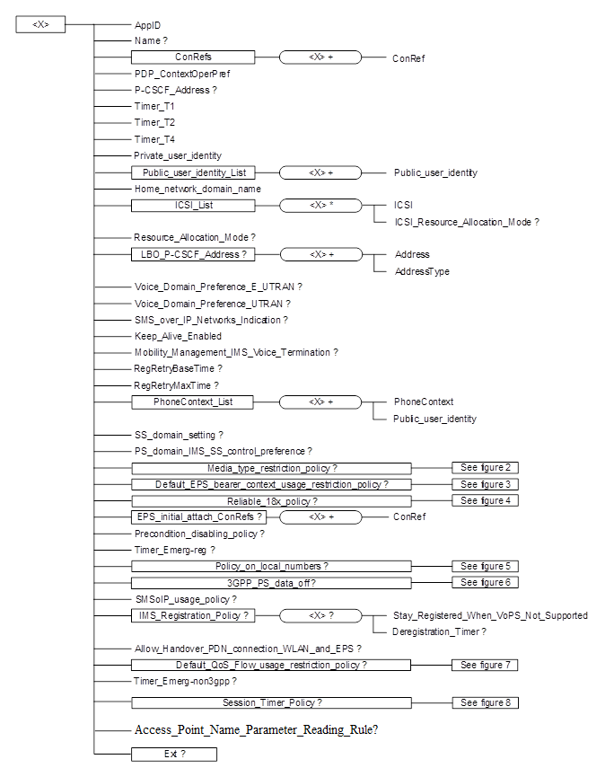
Figure 1: The 3GPP IMS Management Object
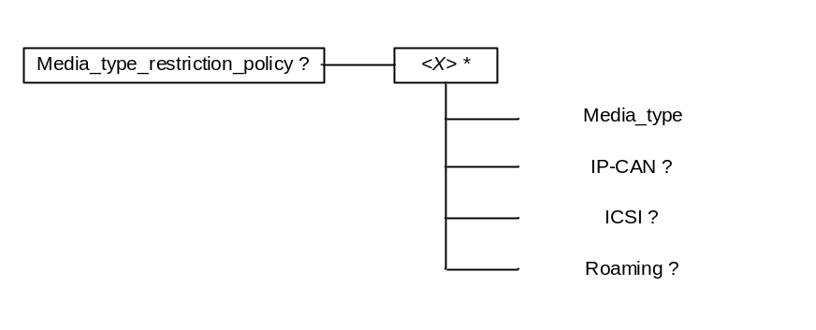
Figure 2: Media type restriction policy
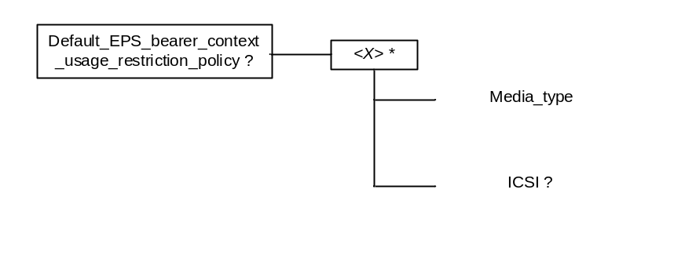
Figure 3: Default EPS bearer context usage restriction policy
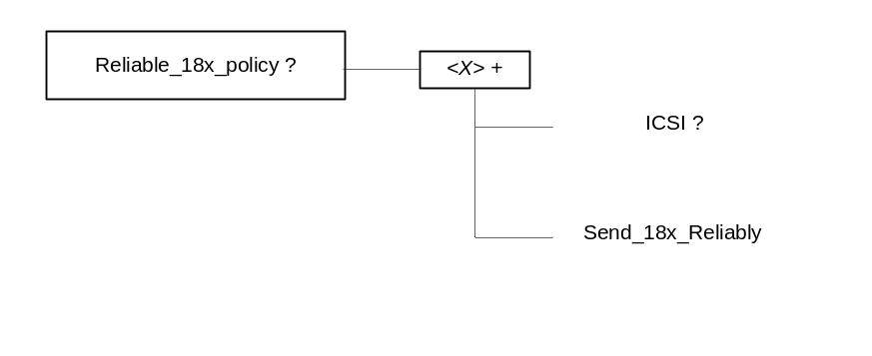
Figure 4: Reliable 18x policy

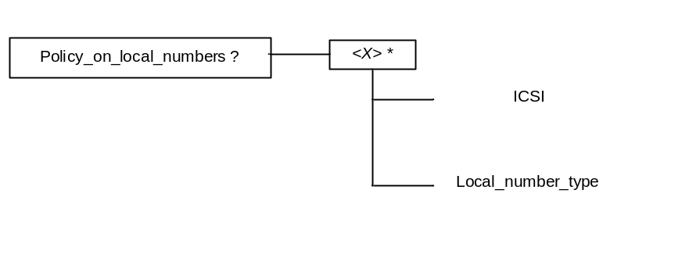
Figure 5: Policy on local numbers
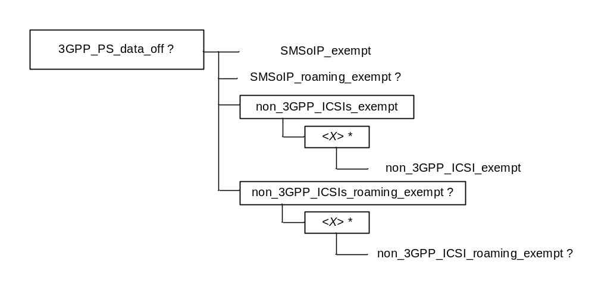
Figure 6: 3GPP PS data off
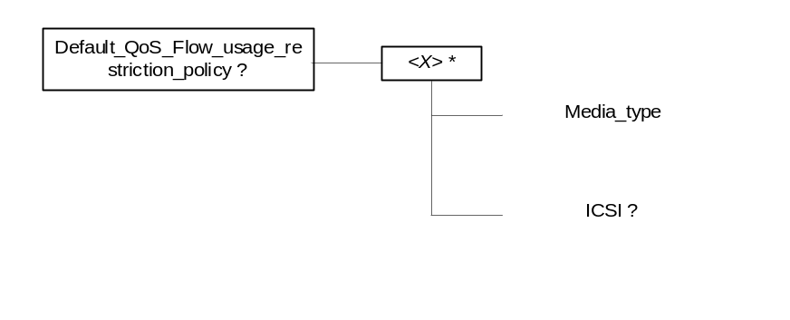
Figure 7: Default QoS Flow usage restriction policy
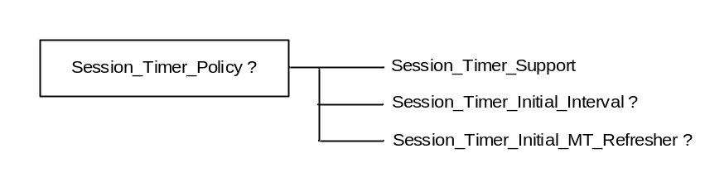
Figure 8: Session Timer policy

***** Next change *****

5.87 /<X>/Session_Timer_Policy/Session_Timer_Initial_MT_Refresher
The leaf indicates the value of the refresher parameter in the Session-Expires header to be used by the terminating UE when adding the refresher parameter for the first time.
- Occurrence: ZeroOrOne
- Format: chr
- Access Types: Get, Replace
- Values: <value for refresher parameter>
Possible values for refresher parameter in Session-Expires header are defined by RFC 4028 [26].
EXAMPLE: uac

5.88 /<X>/Access_Point_Name_Parameter_Reading_Rule
The UE can get the APN name from multiple sources. For example UICC via EF_{ACL} parameter, Network provided or User specified. The values provided by these different sources may differ. The optional Access_Point_Name_Parameter_Reading_Rule leaf defines which input source should the UE use to read the APN parameters.
- Occurrence: ZeroOrOne
- Format: int
- Access Types: Get, Replace
- Values: 0, 1, 2
0 – Indicates that UE should use APN values provided by UICC as per 3GPP TS 32.102 [28] rules.
1 – Indicates that UE should use values provided by network
2 – Indicates that UE should use the values provided by user via UE settings menu or any other method

In the absence of this node, which source to use for reading APN parameter is implementation specific.

***** Next change *****

Annex A (informative):
Management Object DDF
This DDF is the standardized minimal set. A vendor can define it's own DDF for the complete device. This DDF can include more features than this minimal standardized version.
<?xml version="1.0" encoding="UTF-8"?>
<!DOCTYPE MgmtTree PUBLIC "-//OMA//DTD-DM-DDF 1.2//EN"
"http://www.openmobilealliance.org/tech/DTD/DM_DDF-V1_2.dtd">
<MgmtTree>
<VerDTD>1.2</VerDTD>
<Man>--The device manufacturer--</Man>
<Mod>--The device model--</Mod>
<Node>
<NodeName>3GPP_IMS</NodeName>
<DFProperties>
<AccessType>
<Get/>
</AccessType>
<Description>3GPP IMS settings</Description>
<DFFormat>
<node/>
</DFFormat>
<Occurrence>
<OneOrMore/>
</Occurrence>
<Scope>
<Permanent/>
</Scope>
<DFTitle>The 3GPP IMS Management Object.</DFTitle>
<DFType>
<DDFName>urn:oma:mo:ext-3gpp-ims:1.0</DDFName>
</DFType>
</DFProperties>
<Node>
<NodeName>AppID</NodeName>
<DFProperties>
<AccessType>
<Get/>
</AccessType>
<DFFormat>
<chr/>
</DFFormat>
<Occurrence>
<One/>
</Occurrence>
<Scope>
<Permanent/>
</Scope>
<DFTitle>The Application ID.</DFTitle>
<DFType>
<MIME>text/plain</MIME>
</DFType>
</DFProperties>
</Node>
<Node>
<NodeName>Name</NodeName>
<DFProperties>
<AccessType>
<Get/>
</AccessType>
<DFFormat>
<chr/>
</DFFormat>
<Occurrence>
<ZeroOrOne/>
</Occurrence>
<Scope>
<Dynamic/>
</Scope>
<DFTitle>User displayable name for the node.</DFTitle>
<DFType>
<MIME>text/plain</MIME>
</DFType>
</DFProperties>
</Node>
<Node>
<NodeName>ConRefs</NodeName>
<!-- The ConRefs node starts here. -->
<DFProperties>
<AccessType>
<Get/>
</AccessType>
<DFFormat>
<node/>
</DFFormat>
<Occurrence>
<One/>
</Occurrence>
<Scope>
<Permanent/>
</Scope>
<DFTitle>A collection of network access point objects.</DFTitle>
<DFType>
<DDFName/>
</DFType>
</DFProperties>
<Node>
<NodeName/>
<DFProperties>
<AccessType>
<Get/>
</AccessType>
<DFFormat>
<node/>
</DFFormat>
<Occurrence>
<OneOrMore/>
</Occurrence>
<Scope>
<Dynamic/>
</Scope>
<DFTitle>The "name" node for a network access point object.</DFTitle>
<DFType>
<DDFName/>
</DFType>
</DFProperties>
<Node>
<NodeName>ConRef</NodeName>
<DFProperties>
<AccessType>
<Get/>
<Replace/>
</AccessType>
<DFFormat>
<chr/>
</DFFormat>
<Occurrence>
<One/>
</Occurrence>
<Scope>
<Permanent/>
</Scope>
<DFTitle>The ConRef (network access point object).</DFTitle>
<DFType>
<MIME>text/plain</MIME>
</DFType>
</DFProperties>
</Node>
</Node>
</Node>
<Node>
<NodeName>PDP_ContextOperPref</NodeName>
<DFProperties>
<AccessType>
<Get/>
<Replace/>
</AccessType>
<DFFormat>
<bool/>
</DFFormat>
<Occurrence>
<One/>
</Occurrence>
<Scope>
<Permanent/>
</Scope>
<DFTitle>Indication of the operator's preference for a dedicated PDP context for IMS signalling.</DFTitle>
<DFType>
<MIME>text/plain</MIME>
</DFType>
</DFProperties>
</Node>
<Node>
<NodeName>P-CSCF_Address</NodeName>
<DFProperties>
<AccessType>
<Get/>
<Replace/>
</AccessType>
<DFFormat>
<chr/>
</DFFormat>
<Occurrence>
<ZeroOrOne/>
</Occurrence>
<Scope>
<Dynamic/>
</Scope>
<DFTitle>The address of the P-CSCF.</DFTitle>
<DFType>
<MIME>text/plain</MIME>
</DFType>
</DFProperties>
</Node>
<Node>
<NodeName>Timer_T1</NodeName>
<DFProperties>
<AccessType>
<Get/>
<Replace/>
</AccessType>
<DFFormat>
<int/>
</DFFormat>
<Occurrence>
<One/>
</Occurrence>
<Scope>
<Permanent/>
</Scope>
<DFTitle>RFC 3261, timer T1.</DFTitle>
<DFType>
<MIME>text/plain</MIME>
</DFType>
</DFProperties>
</Node>
<Node>
<NodeName>Timer_T2</NodeName>
<DFProperties>
<AccessType>
<Get/>
<Replace/>
</AccessType>
<DFFormat>
<int/>
</DFFormat>
<Occurrence>
<One/>
</Occurrence>
<Scope>
<Permanent/>
</Scope>
<DFTitle>RFC 3261, timer T2.</DFTitle>
<DFType>
<MIME>text/plain</MIME>
</DFType>
</DFProperties>
</Node>
<Node>
<NodeName>Timer_T4</NodeName>
<DFProperties>
<AccessType>
<Get/>
<Replace/>
</AccessType>
<DFFormat>
<int/>
</DFFormat>
<Occurrence>
<One/>
</Occurrence>
<Scope>
<Permanent/>
</Scope>
<DFTitle>RFC 3261, timer T4.</DFTitle>
<DFType>
<MIME>text/plain</MIME>
</DFType>
</DFProperties>
</Node>
<Node>
<NodeName>Private_user_identity</NodeName>
<DFProperties>
<AccessType>
<Get/>
</AccessType>
<DFFormat>
<chr/>
</DFFormat>
<Occurrence>
<One/>
</Occurrence>
<Scope>
<Permanent/>
</Scope>
<DFTitle>The private user identity.</DFTitle>
<DFType>
<MIME>text/plain</MIME>
</DFType>
</DFProperties>
</Node>
<Node>
<NodeName>Public_user_identity_List</NodeName>
<!-- The Public_user_identity_List node starts here. -->
<DFProperties>
<AccessType>
<Get/>
</AccessType>
<DFFormat>
<node/>
</DFFormat>
<Occurrence>
<One/>
</Occurrence>
<Scope>
<Permanent/>
</Scope>
<DFTitle>A collection of public user identity objects.</DFTitle>
<DFType>
<DDFName/>
</DFType>
</DFProperties>
<Node>
<NodeName/>
<DFProperties>
<AccessType>
<Get/>
</AccessType>
<DFFormat>
<node/>
</DFFormat>
<Occurrence>
<OneOrMore/>
</Occurrence>
<Scope>
<Dynamic/>
</Scope>
<DFTitle>The "name" node for a public user identity object.</DFTitle>
<DFType>
<DDFName/>
</DFType>
</DFProperties>
<Node>
<NodeName>Public_user_identity</NodeName>
<DFProperties>
<AccessType>
<Get/>
</AccessType>
<DFFormat>
<chr/>
</DFFormat>
<Occurrence>
<One/>
</Occurrence>
<Scope>
<Permanent/>
</Scope>
<DFTitle>The public user identity.</DFTitle>
<DFType>
<MIME>text/plain</MIME>
</DFType>
</DFProperties>
</Node>
</Node>
</Node>
<Node>
<NodeName>Home_network_domain_name</NodeName>
<DFProperties>
<AccessType>
<Get/>
</AccessType>
<DFFormat>
<chr/>
</DFFormat>
<Occurrence>
<One/>
</Occurrence>
<Scope>
<Permanent/>
</Scope>
<DFTitle>The home network domain name.</DFTitle>
<DFType>
<MIME>text/plain</MIME>
</DFType>
</DFProperties>
</Node>
<Node>
<NodeName>ICSI_List</NodeName>
<!-- The ICSI_List node starts here. -->
<DFProperties>
<AccessType>
<Get/>
<Replace/>
</AccessType>
<DFFormat>
<node/>
</DFFormat>
<Occurrence>
<One/>
</Occurrence>
<Scope>
<Permanent/>
</Scope>
<DFTitle>A collection of IMS communication services identifier objects.</DFTitle>
<DFType>
<DDFName/>
</DFType>
</DFProperties>
<Node>
<NodeName/>
<DFProperties>
<AccessType>
<Get/>
</AccessType>
<DFFormat>
<node/>
</DFFormat>
<Occurrence>
<OneOrMore/>
</Occurrence>
<Scope>
<Dynamic/>
</Scope>
<DFTitle>The "name" node for an IMS communication services identifier object.</DFTitle>
<DFType>
<DDFName/>
</DFType>
</DFProperties>
<Node>
<NodeName>ICSI</NodeName>
<DFProperties>
<AccessType>
<Get/>
<Replace/>
</AccessType>
<DFFormat>
<chr/>
</DFFormat>
<Occurrence>
<One/>
</Occurrence>
<Scope>
<Permanent/>
</Scope>
<DFTitle>The IMS communication services identifier.</DFTitle>
<DFType>
<MIME>text/plain</MIME>
</DFType>
</DFProperties>
</Node>
<Node>
<NodeName>ICSI_Resource_Allocation_Mode</NodeName>
<DFProperties>
<AccessType>
<Get/>
<Replace/>
</AccessType>
<DFFormat>
<bool/>
</DFFormat>
<Occurrence>
<ZeroOrOne/>
</Occurrence>
<Scope>
<Permanent/>
</Scope>
<DFTitle>Indicates whether UE initiates resource allocation for the media controlled by IM CN subsystem when a certain ICSI is used for the IMS session and when both UE and network can initiate resource allocation for IMS media.</DFTitle>
<DFType>
<MIME>text/plain</MIME>
</DFType>
</DFProperties>
</Node>
</Node>
</Node>
<Node>
<NodeName>LBO_P-CSCF_Address</NodeName>
<DFProperties>
<AccessType>
<Get/>
<Replace/>
</AccessType>
<DFFormat>
<node/>
</DFFormat>
<Occurrence>
<ZeroOrOne/>
</Occurrence>
<Scope>
<Dynamic/>
</Scope>
<DFTitle>A collection of addresses of the P-CSCF for IMS Local Breakout.</DFTitle>
<DFType>
<DDFName/>
</DFType>
</DFProperties>
<Node>
<NodeName/>
<DFProperties>
<AccessType>
<Get/>
</AccessType>
<DFFormat>
<node/>
</DFFormat>
<Occurrence>
<OneOrMore/>
</Occurrence>
<Scope>
<Dynamic/>
</Scope>
<DFTitle>The "name" node for a P-CSCF address.</DFTitle>
<DFType>
<DDFName/>
</DFType>
</DFProperties>
<Node>
<NodeName>Address</NodeName>
<DFProperties>
<AccessType>
<Get/>
<Replace/>
</AccessType>
<DFFormat>
<chr/>
</DFFormat>
<Occurrence>
<One/>
</Occurrence>
<Scope>
<Permanent/>
</Scope>
<DFTitle>The P-CSCF Address.</DFTitle>
<DFType>
<MIME>text/plain</MIME>
</DFType>
</DFProperties>
</Node>
<Node>
<NodeName>AddressType</NodeName>
<DFProperties>
<AccessType>
<Get/>
<Replace/>
</AccessType>
<DFFormat>
<chr/>
</DFFormat>
<Occurrence>
<One/>
</Occurrence>
<Scope>
<Permanent/>
</Scope>
<DFTitle>The type of P-CSCF Address.</DFTitle>
<DFType>
<MIME>text/plain</MIME>
</DFType>
</DFProperties>
</Node>
</Node>
</Node>
<Node>
<NodeName>Resource_Allocation_Mode</NodeName>
<DFProperties>
<AccessType>
<Get/>
<Replace/>
</AccessType>
<DFFormat>
<bool/>
</DFFormat>
<Occurrence>
<ZeroOrOne/>
</Occurrence>
<Scope>
<Permanent/>
</Scope>
<DFTitle>Indicates whether UE initiates resource allocation for the media controlled by IM CN subsystem for all IMS sessions not covered by any "ICSI Resource Allocation Mode" when both UE and network can initiate resource allocation.</DFTitle>
<DFType>
<MIME>text/plain</MIME>
</DFType>
</DFProperties>
</Node>
<Node>
<NodeName>Voice_Domain_Preference_EUTRAN</NodeName>
<DFProperties>
<AccessType>
<Get/>
<Replace/>
</AccessType>
<DFFormat>
<int/>
</DFFormat>
<Occurrence>
<ZeroOrOne/>
</Occurrence>
<Scope>
<Permanent/>
</Scope>
<DFTitle>Network operator's preference for voice domain for E-UTRAN according to 3GPP TS 23.221.</DFTitle>
<DFType>
<MIME>text/plain</MIME>
</DFType>
</DFProperties>
</Node>
<Node>
<NodeName>Voice_Domain_Preference_UTRAN</NodeName>
<DFProperties>
<AccessType>
<Get/>
<Replace/>
</AccessType>
<DFFormat>
<int/>
</DFFormat>
<Occurrence>
<ZeroOrOne/>
</Occurrence>
<Scope>
<Permanent/>
</Scope>
<DFTitle>Network operator's preference for voice domain for UTRAN according to 3GPP TS 23.221.</DFTitle>
<DFType>
<MIME>text/plain</MIME>
</DFType>
</DFProperties>
</Node>
<Node>
<NodeName>SMS_over_IP_Networks_Indication</NodeName>
<DFProperties>
<AccessType>
<Get/>
<Replace/>
</AccessType>
<DFFormat>
<bool/>
</DFFormat>
<Occurrence>
<ZeroOrOne/>
</Occurrence>
<Scope>
<Permanent/>
</Scope>
<DFTitle>Indicates whether the SMS service is preferred to be invoked over the IMS domain, or it shall not be invoked over the IMS domain .</DFTitle>
<DFType>
<MIME>text/plain</MIME>
</DFType>
</DFProperties>
</Node>

<Node>
<NodeName>Keep_Alive_Enabled</NodeName>
<DFProperties>
<AccessType>
<Get/>
<Replace/>
</AccessType>
<DFFormat>
<bool/>
</DFFormat>
<Occurrence>
<One/>
</Occurrence>
<Scope>
<Permanent/>
</Scope>
<DFTitle>Indication whether the sending of keep alives by the UE is enabled.</DFTitle>
<DFType>
<MIME>text/plain</MIME>
</DFType>
</DFProperties>
</Node>

<Node>
<NodeName>Mobility_Management_IMS_Voice_Termination</NodeName>
<DFProperties>
<AccessType>
<Get/>
<Replace/>
</AccessType>
<DFFormat>
<bool/>
</DFFormat>
<Occurrence>
<ZeroOrOne/>
</Occurrence>
<Scope>
<Permanent/>
</Scope>
<DFTitle>Indicates whether the UE mobility management performs additional procedures as specified in 3GPP TS 24.008 and 3GPP TS 24.301 to support terminating access domain selection by the network.</DFTitle>
<DFType>
<MIME>text/plain</MIME>
</DFType>
</DFProperties>
</Node>

<Node>
<NodeName> RegRetryBaseTime</NodeName>
<DFProperties>
<AccessType>
<Get/>
<Replace/>
</AccessType>
<DFFormat>
<int/>
</DFFormat>
<Occurrence>
<ZeroOrOne/>
</Occurrence>
<Scope>
<Permanent/>
</Scope>
<DFTitle> Represents the value of the base-time parameter of the algorithm defined in subclause 4.5 of RFC 5626</DFTitle>
<DFType>
<MIME>text/plain</MIME>
</DFType>
</DFProperties>
</Node>
<Node>
<NodeName> RegRetryMaxTime</NodeName>
<DFProperties>
<AccessType>
<Get/>
<Replace/>
</AccessType>
<DFFormat>
<int/>
</DFFormat>
<Occurrence>
<ZeroOrOne/>
</Occurrence>
<Scope>
<Permanent/>
</Scope>
<DFTitle> Represents the value of the max-time parameter of the algorithm defined in subclause 4.5 of RFC 5626 </DFTitle>
<DFType>
<MIME>text/plain</MIME>
</DFType>
</DFProperties>
</Node>

<Node>
<NodeName>PhoneContext_List</NodeName>
<DFProperties>
<AccessType>
<Get/>
<Replace/>
</AccessType>
<DFFormat>
<node/>
</DFFormat>
<Occurrence>
<ZeroOrOne/>
</Occurrence>
<Scope>
<Dynamic/>
</Scope>
<DFTitle>A collection of phone-context parameters values with the associated public user identities</DFTitle>
<DFType>
<DDFName/>
</DFType>
</DFProperties>
<Node>
<NodeName/>
<DFProperties>
<AccessType>
<Get/>
</AccessType>
<DFFormat>
<node/>
</DFFormat>
<Occurrence>
<OneOrMore/>
</Occurrence>
<Scope>
<Dynamic/>
</Scope>
<DFTitle>The "name" node for a phone-context value</DFTitle>
<DFType>
<DDFName/>
</DFType>
</DFProperties>
<Node>
<NodeName>PhoneContext</NodeName>
<DFProperties>
<AccessType>
<Get/>
<Replace/>
</AccessType>
<DFFormat>
<chr/>
</DFFormat>
<Occurrence>
<One/>
</Occurrence>
<Scope>
<Permanent/>
</Scope>
<DFTitle>The phone-context parameter value </DFTitle>
<DFType>
<MIME>text/plain</MIME>
</DFType>
</DFProperties>
</Node>
<Node>
<NodeName>Public_user_identity</NodeName>
<DFProperties>
<AccessType>
<Get/>
<Replace/>
</AccessType>
<DFFormat>
<chr/>
</DFFormat>
<Occurrence>
<OneOrMore/>
</Occurrence>
<Scope>
<Permanent/>
</Scope>
<DFTitle>The associated Public User identity URIs </DFTitle>
<DFType>
<MIME>text/plain</MIME>
</DFType>
</DFProperties>
</Node>
</Node>
</Node>
<Node>
<NodeName>SS_domain_setting</NodeName>
<DFProperties>
<AccessType>
<Get/>
<Replace/>
</AccessType>
<DFFormat>
<int/>
</DFFormat>
<Occurrence>
<ZeroOrOne/>
</Occurrence>
<Scope>
<Permanent/>
</Scope>
<DFTitle>Domain or mechanism used to choose the domain for SS setting control</DFTitle>
<DFType>
<MIME>text/plain</MIME>
</DFType>
</DFProperties>
</Node>

<Node>
<NodeName>PS_domain_IMS_SS_control_preference</NodeName>
<DFProperties>
<AccessType>
<Get/>
<Replace/>
</AccessType>
<DFFormat>
<bool/>
</DFFormat>
<Occurrence>
<ZeroOrOne/>
</Occurrence>
<Scope>
<Permanent/>
</Scope>
<DFTitle>Mechanim used for performing IMS SS setting control over the PS domain for services defined in 3GPP TS 22.173</DFTitle>
<DFType>
<MIME>text/plain</MIME>
</DFType>
</DFProperties>
</Node>
<Node>
<NodeName>Media_type_restriction_policy</NodeName>
<DFProperties>
<AccessType>
<Get/>
<Replace/>
</AccessType>
<DFFormat>
<node/>
</DFFormat>
<Occurrence>
<ZeroOrOne/>
</Occurrence>
<Scope>
<Permanent/>
</Scope>
<DFTitle>Media type restriction policy</DFTitle>
<DFType>
<DDFName/>
</DFType>
</DFProperties>

<Node>
<NodeName/>
<DFProperties>
<AccessType>
<Get/>
<Replace/>
</AccessType>
<DFFormat>
<node/>
</DFFormat>
<Occurrence>
<ZeroOrMore/>
</Occurrence>
<Scope>
<Dynamic/>
</Scope>
<DFTitle>Media type restriction policy part</DFTitle>
<DFType>
<DDFName/>
</DFType>
</DFProperties>

<Node>
<NodeName>Media_type</NodeName>
<DFProperties>
<AccessType>
<Get/>
<Replace/>
</AccessType>
<DFFormat>
<chr/>
</DFFormat>
<Occurrence>
<One/>
</Occurrence>
<Scope>
<Dynamic/>
</Scope>
<DFTitle>A media type</DFTitle>
<DFType>
<MIME>text/plain</MIME>
</DFType>
</DFProperties>
</Node>
<Node>
<NodeName>IP-CAN</NodeName>
<DFProperties>
<AccessType>
<Get/>
<Replace/>
</AccessType>
<DFFormat>
<int/>
</DFFormat>
<Occurrence>
<ZeroOrOne/>
</Occurrence>
<Scope>
<Dynamic/>
</Scope>
<DFTitle>IP-CAN</DFTitle>
<DFType>
<MIME>text/plain</MIME>
</DFType>
</DFProperties>
</Node>
<Node>
<NodeName>ICSI</NodeName>
<DFProperties>
<AccessType>
<Get/>
<Replace/>
</AccessType>
<DFFormat>
<chr/>
</DFFormat>
<Occurrence>
<ZeroOrOne/>
</Occurrence>
<Scope>
<Dynamic/>
</Scope>
<DFTitle>ICSI</DFTitle>
<DFType>
<MIME>text/plain</MIME>
</DFType>
</DFProperties>
</Node>
<Node>
<NodeName>Roaming</NodeName>
<DFProperties>
<AccessType>
<Get/>
<Replace/>
</AccessType>
<DFFormat>
<null/>
</DFFormat>
<Occurrence>
<ZeroOrOne/>
</Occurrence>
<Scope>
<Dynamic/>
</Scope>
<DFTitle>Roaming</DFTitle>
<DFType>
<MIME>text/plain</MIME>
</DFType>
</DFProperties>
</Node>
</Node>
</Node>
<Node>
<NodeName>Default_EPS_bearer_context_usage_restriction_policy</NodeName>
<DFProperties>
<AccessType>
<Get/>
<Replace/>
</AccessType>
<DFFormat>
<node/>
</DFFormat>
<Occurrence>
<ZeroOrOne/>
</Occurrence>
<Scope>
<Permanent/>
</Scope>
<DFTitle>Default EPS bearer context usage restriction policy</DFTitle>
<DFType>
<DDFName/>
</DFType>
</DFProperties>

<Node>
<NodeName/>
<DFProperties>
<AccessType>
<Get/>
<Replace/>
</AccessType>
<DFFormat>
<node/>
</DFFormat>
<Occurrence>
<ZeroOrMore/>
</Occurrence>
<Scope>
<Dynamic/>
</Scope>
<DFTitle>Default EPS bearer context usage restriction policy part</DFTitle>
<DFType>
<DDFName/>
</DFType>
</DFProperties>

<Node>
<NodeName>Media_type</NodeName>
<DFProperties>
<AccessType>
<Get/>
<Replace/>
</AccessType>
<DFFormat>
<chr/>
</DFFormat>
<Occurrence>
<One/>
</Occurrence>
<Scope>
<Dynamic/>
</Scope>
<DFTitle>A media type</DFTitle>
<DFType>
<MIME>text/plain</MIME>
</DFType>
</DFProperties>
</Node>
<Node>
<NodeName>ICSI</NodeName>
<DFProperties>
<AccessType>
<Get/>
<Replace/>
</AccessType>
<DFFormat>
<chr/>
</DFFormat>
<Occurrence>
<ZeroOrOne/>
</Occurrence>
<Scope>
<Dynamic/>
</Scope>
<DFTitle>An ICSI</DFTitle>
<DFType>
<MIME>text/plain</MIME>
</DFType>
</DFProperties>
</Node>
</Node>
</Node>
<Node>
<NodeName>Reliable_18x_policy</NodeName>
<DFProperties>
<AccessType>
<Get/>
<Replace/>
</AccessType>
<DFFormat>
<node/>
</DFFormat>
<Occurrence>
<ZeroOrOne/>
</Occurrence>
<Scope>
<Permanent/>
</Scope>
<DFTitle>Reliable 18x policy</DFTitle>
<DFType>
<DDFName/>
</DFType>
</DFProperties>

<Node>
<NodeName/>
<DFProperties>
<AccessType>
<Get/>
<Replace/>
</AccessType>
<DFFormat>
<node/>
</DFFormat>
<Occurrence>
<OneOrMore/>
</Occurrence>
<Scope>
<Dynamic/>
</Scope>
<DFTitle> Reliable 18x policy part</DFTitle>
<DFType>
<DDFName/>
</DFType>
</DFProperties>

<Node>
<NodeName>ICSI</NodeName>
<DFProperties>
<AccessType>
<Get/>
<Replace/>
</AccessType>
<DFFormat>
<chr/>
</DFFormat>
<Occurrence>
<ZeroOrOne/>
</Occurrence>
<Scope>
<Dynamic/>
</Scope>
<DFTitle>An ICSI</DFTitle>
<DFType>
<MIME>text/plain</MIME>
</DFType>
</DFProperties>
</Node>
<Node>
<NodeName>Send_18x_Reliably</NodeName>
<DFProperties>
<AccessType>
<Get/>
<Replace/>
</AccessType>
<DFFormat>
<bool/>
</DFFormat>
<Occurrence>
<One/>
</Occurrence>
<Scope>
<Dynamic/>
</Scope>
<DFTitle> whether the UE sends reliable SIP 18x response against an INVITE request subject to the IMS service indicated in the ICSI leaf.</DFTitle>
<DFType>
<MIME>bool</MIME>
</DFType>
</DFProperties>
</Node>
</Node>
</Node>
<Node>
<NodeName>EPS_initial_attach_ConRefs</NodeName>
<DFProperties>
<AccessType>
<Get/>
<Replace/>
</AccessType>
<DFFormat>
<node/>
</DFFormat>
<Occurrence>
<ZeroOrOne/>
</Occurrence>
<Scope>
<Dynamic/>
</Scope>
<DFTitle>The policy on the PDN connection established during the EPS attach procedure.</DFTitle>
<DFType>
<DDFName/>
</DFType>
</DFProperties>
<Node>
<NodeName/>
<DFProperties>
<AccessType>
<Get/>
<Replace/>
</AccessType>
<DFFormat>
<node/>
</DFFormat>
<Occurrence>
<OneOrMore/>
</Occurrence>
<Scope>
<Dynamic/>
</Scope>
<DFTitle/>
<DFType>
<DDFName/>
</DFType>
</DFProperties>
<Node>
<NodeName>ConRef</NodeName>
<DFProperties>
<AccessType>
<Get/>
<Replace/>
</AccessType>
<DFFormat>
<chr/>
</DFFormat>
<Occurrence>
<One/>
</Occurrence>
<Scope>
<Dynamic/>
</Scope>
<DFTitle>The ConRef (network access point object).</DFTitle>
<DFType>
<MIME>text/plain</MIME>
</DFType>
</DFProperties>
</Node>
</Node>
</Node>
<Node>
<NodeName>Precondition_disabling_policy</NodeName>
<DFProperties>
<AccessType>
<Get/>
<Replace/>
</AccessType>
<DFFormat>
<bool/>
</DFFormat>
<Occurrence>
<ZeroOrOne/>
</Occurrence>
<Scope>
<Dynamic/>
</Scope>
<DFTitle>The precondition disabling policy.</DFTitle>
<DFType>
<MIME>text/plain</MIME>
</DFType>
</DFProperties>
</Node>
<Node>
<NodeName>Timer_Emerg-reg</NodeName>
<DFProperties>
<AccessType>
<Get/>
<Replace/>
</AccessType>
<DFFormat>
<int/>
</DFFormat>
<Occurrence>
<ZeroOrOne/>
</Occurrence>
<Scope>
<Permanent/>
</Scope>
<DFTitle>Optional timer for emergency registration request timeout.</DFTitle>
<DFType>
<MIME>text/plain</MIME>
</DFType>
</DFProperties>
</Node>
<Node>
<NodeName>Policy_on_local_numbers</NodeName>
<DFProperties>
<AccessType>
<Get/>
<Replace/>
</AccessType>
<DFFormat>
<node/>
</DFFormat>
<Occurrence>
<ZeroOrOne/>
</Occurrence>
<Scope>
<Permanent/>
</Scope>
<DFTitle>The policy on local numbers</DFTitle>
<DFType>
<DDFName/>
</DFType>
</DFProperties>

<Node>
<NodeName/>
<DFProperties>
<AccessType>
<Get/>
<Replace/>
</AccessType>
<DFFormat>
<node/>
</DFFormat>
<Occurrence>
<ZeroOrMore/>
</Occurrence>
<Scope>
<Dynamic/>
</Scope>
<DFTitle>A part of the policy on local numbers.</DFTitle>
<DFType>
<DDFName/>
</DFType>
</DFProperties>

<Node>
<NodeName>ICSI</NodeName>
<DFProperties>
<AccessType>
<Get/>
<Replace/>
</AccessType>
<DFFormat>
<chr/>
</DFFormat>
<Occurrence>
<One/>
</Occurrence>
<Scope>
<Dynamic/>
</Scope>
<DFTitle>An ICSI.</DFTitle>
<DFType>
<MIME>text/plain</MIME>
</DFType>
</DFProperties>
</Node>

<Node>
<NodeName>Local_number_type</NodeName>
<DFProperties>
<AccessType>
<Get/>
<Replace/>
</AccessType>
<DFFormat>
<int/>
</DFFormat>
<Occurrence>
<One/>
</Occurrence>
<Scope>
<Dynamic/>
</Scope>
<DFTitle>A local number type.</DFTitle>
<DFType>
<MIME>text/plain</MIME>
</DFType>
</DFProperties>
</Node>

</Node>
</Node>
<Node>
<NodeName>3GPP_PS_data_off</NodeName>
<DFProperties>
<AccessType>
<Replace/>
<Get/>
</AccessType>
<DFFormat>
<node/>
</DFFormat>
<Occurrence>
<ZeroOrOne/>
</Occurrence>
<Scope>
<Dynamic/>
</Scope>
<DFTitle>Configuration parameters for 3GPP PS data off.</DFTitle>
<DFType>
<DDFName/>
</DFType>
</DFProperties>
<Node>
<NodeName>SMSoIP_exempt</NodeName>
<DFProperties>
<AccessType>
<Get/>
<Replace/>
</AccessType>
<DFFormat>
<bool/>
</DFFormat>
<Occurrence>
<One/>
</Occurrence>
<Scope>
<Dynamic/>
</Scope>
<DFTitle>Whether the SMSoIP is a 3GPP PS data off exempt service.</DFTitle>
<DFType>
<MIME>text/plain</MIME>
</DFType>
</DFProperties>
</Node>
<Node>
<NodeName>SMSoIP_roaming_exempt</NodeName>
<DFProperties>
<AccessType>
<Get/>
<Replace/>
</AccessType>
<DFFormat>
<bool/>
</DFFormat>
<Occurrence>
<ZeroOrOne/>
</Occurrence>
<Scope>
<Dynamic/>
</Scope>
<DFTitle>Whether the SMSoIP is a 3GPP PS data off roaming exempt service.</DFTitle>
<DFType>
<MIME>text/plain</MIME>
</DFType>
</DFProperties>
</Node>

<Node>
<NodeName>non_3GPP_ICSIs_exempt</NodeName>
<DFProperties>
<AccessType>
<Replace/>
<Get/>
</AccessType>
<DFFormat>
<node/>
</DFFormat>
<Occurrence>
<One/>
</Occurrence>
<Scope>
<Dynamic/>
</Scope>
<DFTitle>IMS communication service identifiers of the IMS communication services not defined by 3GPP which are 3GPP PS data off exempt services.</DFTitle>
<DFType>
<DDFName/>
</DFType>
</DFProperties>
<Node>
<NodeName></NodeName>
<DFProperties>
<AccessType>
<Replace/>
<Get/>
</AccessType>
<DFFormat>
<node/>
</DFFormat>
<Occurrence>
<ZeroOrMore/>
</Occurrence>
<Scope>
<Dynamic/>
</Scope>
<DFTitle>IMS communication service identifier of the IMS communication service not defined by 3GPP which is 3GPP PS data off exempt service.</DFTitle>
<DFType>
<DDFName/>
</DFType>
</DFProperties>

<Node>
<NodeName>non_3GPP_ICSI_exempt</NodeName>
<DFProperties>
<AccessType>
<Get/>
<Replace/>
</AccessType>
<DFFormat>
<bool/>
</DFFormat>
<Occurrence>
<One/>
</Occurrence>
<Scope>
<Dynamic/>
</Scope>
<DFTitle>IMS communication service identifier of the IMS communication service not defined by 3GPP which is 3GPP PS data off exempt service.</DFTitle>
<DFType>
<MIME>text/plain</MIME>
</DFType>
</DFProperties>
</Node>

</Node>
</Node>
<Node>
<NodeName>non_3GPP_ICSIs_roaming_exempt</NodeName>
<DFProperties>
<AccessType>
<Replace/>
<Get/>
</AccessType>
<DFFormat>
<node/>
</DFFormat>
<Occurrence>
<ZeroOrOne/>
</Occurrence>
<Scope>
<Dynamic/>
</Scope>
<DFTitle>IMS communication service identifiers of the IMS communication services not defined by 3GPP which are 3GPP PS data off roaming exempt services.</DFTitle>
<DFType>
<DDFName/>
</DFType>
</DFProperties>
<Node>
<NodeName></NodeName>
<DFProperties>
<AccessType>
<Replace/>
<Get/>
</AccessType>
<DFFormat>
<node/>
</DFFormat>
<Occurrence>
<ZeroOrMore/>
</Occurrence>
<Scope>
<Dynamic/>
</Scope>
<DFTitle>IMS communication service identifier of the IMS communication service not defined by 3GPP which is 3GPP PS data off roaming exempt service.</DFTitle>
<DFType>
<DDFName/>
</DFType>
</DFProperties>

<Node>
<NodeName>non_3GPP_ICSI_roaming_exempt</NodeName>
<DFProperties>
<AccessType>
<Get/>
<Replace/>
</AccessType>
<DFFormat>
<bool/>
</DFFormat>
<Occurrence>
<ZeroOrOne/>
</Occurrence>
<Scope>
<Dynamic/>
</Scope>
<DFTitle>IMS communication service identifier of the IMS communication service not defined by 3GPP which is 3GPP PS data off roaming exempt service.</DFTitle>
<DFType>
<MIME>text/plain</MIME>
</DFType>
</DFProperties>
</Node>
</Node>
</Node>
</Node>
<Node>
<NodeName>SMSoIP_usage_policy</NodeName>
<DFProperties>
<AccessType>
<Get/>
<Replace/>
</AccessType>
<DFFormat>
<int/>
</DFFormat>
<Occurrence>
<ZeroOrOne/>
</Occurrence>
<Scope>
<Permanent/>
</Scope>
<DFTitle>Indicates the policy on usage of SMS over IP.</DFTitle>
<DFType>
<MIME>text/plain</MIME>
</DFType>
</DFProperties>
</Node>

<Node>
<NodeName> IMS_Registration_Policy </NodeName>
<DFProperties>
<AccessType>
<Get/>
<Replace/>
</AccessType>
<DFFormat>
<node/>
</DFFormat>
<Occurrence>
<ZeroOrOne/>
</Occurrence>
<Scope>
<Permanent/>
</Scope>
<DFTitle> indicates the handling of IMS registration on the UE when moving to area where IMS Voice Over PS Session is not supported </DFTitle>
<DFType>
<DDFName/>
</DFType>
</DFProperties>

<Node>
<NodeName> Stay_Registered_When_VoPS_Not_Supported </NodeName>
<DFProperties>
<AccessType>
<Get/>
<Replace/>
</AccessType>
<DFFormat>
<bool/>
</DFFormat>
<Occurrence>
<One/>
</Occurrence>
<Scope>
<Permanent/>
</Scope>
<DFTitle> The leaf indicates whether the UE stays registered or not from IMS when moving to area where IMS Voice Over PS Session is not supported </DFTitle>
<DFType>
<DDFName/>
</DFType>
</DFProperties>
</Node>

<Node>
<NodeName> Deregistration_Timer </NodeName>
<DFProperties>
<AccessType>
<Get/>
<Replace/>
</AccessType>
<DFFormat>
<int/>
</DFFormat>
<Occurrence>
<ZeroOrOne/>
</Occurrence>
<Scope>
<Permanent/>
</Scope>
<DFTitle> The Deregistration_Timer leaf indicates the time before deregistration on the UE when moving to area where IMS Voice Over PS Session is not supported </DFTitle>
<DFType>
<DDFName/>
</DFType>
</DFProperties>
</Node>

</Node>

<Node>
<NodeName>Timer_Emerg-request</NodeName>
<DFProperties>
<AccessType>
<Get/>
<Replace/>
</AccessType>
<DFFormat>
<int/>
</DFFormat>
<Occurrence>
<ZeroOrOne/>
</Occurrence>
<Scope>
<Permanent/>
</Scope>
<DFTitle>The maximum time between sending of an initial INVITE request for an emergency session and receiving an 18x response to the INVITE request.</DFTitle>
<DFType>
<MIME>text/plain</MIME>
</DFType>
</DFProperties>
</Node>
<Node>
<NodeName>Timer_Emerg-non3gpp</NodeName>
<DFProperties>
<AccessType>
<Get/>
<Replace/>
</AccessType>
<DFFormat>
<int/>
</DFFormat>
<Occurrence>
<ZeroOrOne/>
</Occurrence>
<Scope>
<Permanent/>
</Scope>
<DFTitle>The maximum time for searching a 3GPP access usable for establishing an emergency calls before performing the emergency call over the available non-3GPP access.</DFTitle>
<DFType>
<MIME>text/plain</MIME>
</DFType>
</DFProperties>
</Node>

<Node>
<NodeName>Allow_Handover_PDN_connection_WLAN_and_EPS</NodeName>
<DFProperties>
<AccessType>
<Get/>
<Replace/>
</AccessType>
<DFFormat>
<int/>
</DFFormat>
<Occurrence>
<ZeroOrOne/>
</Occurrence>
<Scope>
<Permanent/>
</Scope>
<DFTitle>Indicates whether a UE roaming in a VPLMN, is allowed to transfer the PDN connection providing access to IMS between EPC via WLAN and EPS.</DFTitle>
<DFType>
<MIME>text/plain</MIME>
</DFType>
</DFProperties>
</Node>

<Node>
<NodeName>Ext</NodeName>
<!-- The Extension node starts here. -->
<DFProperties>
<AccessType>
<Get/>
</AccessType>
<DFFormat>
<node/>
</DFFormat>
<Occurrence>
<ZeroOrOne/>
</Occurrence>
<Scope>
<Dynamic/>
</Scope>
<DFTitle>A collection of all Extension objects.</DFTitle>
<DFType>
<DDFName/>
</DFType>
</DFProperties>
</Node>
<Node>
<NodeName>Default_QoS_Flow_usage_restriction_policy</NodeName>
<DFProperties>
<AccessType>
<Get/>
<Replace/>
</AccessType>
<DFFormat>
<node/>
</DFFormat>
<Occurrence>
<ZeroOrOne/>
</Occurrence>
<Scope>
<Permanent/>
</Scope>
<DFTitle>Default QoS Flow usage restriction policy</DFTitle>
<DFType>
<DDFName/>
</DFType>
</DFProperties>
<Node>
<NodeName/>
<DFProperties>
<AccessType>
<Get/>
<Replace/>
</AccessType>
<DFFormat>
<node/>
</DFFormat>
<Occurrence>
<ZeroOrMore/>
</Occurrence>
<Scope>
<Dynamic/>
</Scope>
<DFTitle>Default QoS Flow usage restriction policy part</DFTitle>
<DFType>
<DDFName/>
</DFType>
</DFProperties>
<Node>
<NodeName>Media_type</NodeName>
<DFProperties>
<AccessType>
<Get/>
<Replace/>
</AccessType>
<DFFormat>
<chr/>
</DFFormat>
<Occurrence>
<One/>
</Occurrence>
<Scope>
<Dynamic/>
</Scope>
<DFTitle>A media type</DFTitle>
<DFType>
<MIME>text/plain</MIME>
</DFType>
</DFProperties>
</Node>
<Node>
<NodeName>ICSI</NodeName>
<DFProperties>
<AccessType>
<Get/>
<Replace/>
</AccessType>
<DFFormat>
<chr/>
</DFFormat>
<Occurrence>
<ZeroOrOne/>
</Occurrence>
<Scope>
<Dynamic/>
</Scope>
<DFTitle>An ICSI</DFTitle>
<DFType>
<MIME>text/plain</MIME>
</DFType>
</DFProperties>
</Node>
</Node>
</Node>
<Node>
<NodeName>Session_Timer_Policy</NodeName>
<DFProperties>
<AccessType>
<Get/>
<Replace/>
</AccessType>
<DFFormat>
<node/>
</DFFormat>
<Occurrence>
<ZeroOrOne/>
</Occurrence>
<Scope>
<Dynamic/>
</Scope>
<DFTitle>Session Timer policy</DFTitle>
<DFType>
<DDFName/>
</DFType>
</DFProperties>
<Node>
<NodeName>Session_Timer_Support</NodeName>
<DFProperties>
<AccessType>
<Get/>
<Replace/>
</AccessType>
<DFFormat>
<bool/>
</DFFormat>
<Occurrence>
<One/>
</Occurrence>
<Scope>
<Permanent/>
</Scope>
<DFTitle>Session Timer extension support</DFTitle>
<DFType>
<MIME>text/plain</MIME>
</DFType>
</DFProperties>
</Node>
<Node>
<NodeName>Session_Timer_Initial_Interval</NodeName>
<DFProperties>
<AccessType>
<Get/>
<Replace/>
</AccessType>
<DFFormat>
<int/>
</DFFormat>
<Occurrence>
<ZeroOrOne/>
</Occurrence>
<Scope>
<Dynamic/>
</Scope>
<DFTitle>Session Timer initial interval value</DFTitle>
<DFType>
<MIME>text/plain</MIME>
</DFType>
</DFProperties>
</Node>
<Node>
<NodeName>Session_Timer_Initial_MT_Refresher</NodeName>
<DFProperties>
<AccessType>
<Get/>
<Replace/>
</AccessType>
<DFFormat>
<chr/>
</DFFormat>
<Occurrence>
<ZeroOrOne/>
</Occurrence>
<Scope>
<Dynamic/>
</Scope>
<DFTitle>Initial MT Refresher parameter</DFTitle>
<DFType>
<MIME>text/plain</MIME>
</DFType>
</DFProperties>
</Node>
</Node>
<Node>
<NodeName>Access_Point_Name_Pameter_Reading_Rule</NodeName>
<DFProperties>
<AccessType>
<Get/>
<Replace/>
</AccessType>
<DFFormat>
<int/>
</DFFormat>
<Occurrence>
<ZeroOrOne/>
</Occurrence>
<Scope>
<Permanent/>
</Scope>
<DFTitle>Indicates which input soure should the UE use to read the APN prameters </DFTitle>
<DFType>
<MIME>text/plain</MIME>
</DFType>
</DFProperties>
</Node>

</Node>
</MgmtTree>

