Vienna, June 29th 2000

Invitation to the 3GPP CN5 #4 Meeting to be held in Retz, Austria, on 10 & 11 July 2000

Ladies and Gentlemen,

On behalf of SIEMENS AG it is a pleasure to invite you to the

3GPP_TSG_CN5#4

The meeting will be hosted by SIEMENS AG and held in

Retz, Niederösterreich, AUSTRIA

July 10th and 11th ,
at the
Hotel Althof,
Althofgasse 14, A-2070 Retz / AUSTRIA
Tel: +43 2942 3711–0

Fax: +43 2942 3711-55

The meeting will start at 9:30 h July 10th and finish not later than 17:00 h July 11th

We have made a block reservation at the Hotel Althof from 9th to 11th July for about 20 people at the special rate of 1.315.- ATS per day for a single room including breakfast. We recommend to arrive already sunday, 9th.

To book, please call directly the Hotel Althof and refer to the booking code
"3GPP-N5".

The block reservation is guaranteed until the 5th of July, please book your hotel room till this date !!!

Please complete the attached registration form and send it to us by
E-mail: andrea.handler@siemens.at
Phone: +43.1.1707.21241
Fax: +43.1.1707.51924
by July 7th at the latest.

Documents for the meeting should be sent by E-mail in advance to Monica Hellman (Monica.Hellman@ETSI.FR).

In support of a paperless meeting, floppy disks will also be provided and circulated throughout the meeting.

Hotel- and Travelinformation:

Retz is a traditional old town, located about 90 km NorthWest of Vienna in an area that is famous for its white wine.
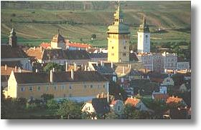
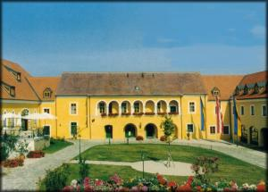
Hotel Althof is located in the town center, within walking distance (5-10 min) from the railway station
Like as most houses in Retz it has a very nice wine-cellar, which we plan to visit monday evening!

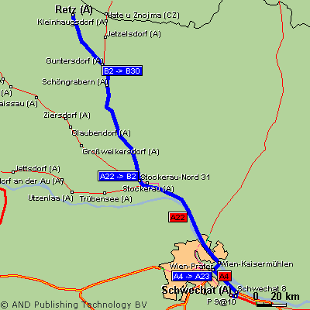
How to get there:
1.) By car:

Where to change roads | km | time
Schwechat (airport) | 0.0 | 0:00
Schwechat -> A4 (highway) | 2.3 | 0:02
A4 -> A23 Wien-Prater | 10.7 | 0:07
A23 -> A22 Wien-Kaisermühlen | 13.1 | 0:08
A22 -> B2 Stockerau-Nord 31 | 43.6 | 0:27
B2 -> B30 Guntersdorf | 75.7 | 0:59
Retz | 90.6 | 1:19

2.) By train:
Every hour (till 8 p.m.) there is a train (called "SCHNELLBAHN") going from the airport to Wien Nord, where you have to change to Retz. The train takes about 2 hours – timetable see below - and the fare is 151.- ATS

PLEASE SEE ALSO http://fahrplan.oebb.at/

 | Railway station | date | Arr. / platform |  |  | Dep. / platform |  |  | Train Nr.
2. | Wien Schwechat Flugh | 10.07.00 |  |  | 13:14 | 1 | S 7
 | Wien Nord |  | 13:50 | 3 | 14:00 | 6 | E 2208
 | Retz |  | 15:06 | 2
 | Lenght of trip: 1:52; runs daily
3. | Wien Schwechat Flugh | 10.07.00 |  |  | 14:14 | 1 | S 7
 | Wien Nord |  | 14:50 | 3 | 15:00 | 51 | E 2210
 | Retz |  | 16:06 | 2
 | Lenght of trip: 1:52; runs Mo – Fr
4. | Wien Schwechat Flugh | 10.07.00 |  |  | 14:44 | 1 | S 7
 | Wien Nord |  | 15:20 | 3 | 15:22 | 51 | R 2212
 | Retz |  | 16:39 | 2
 | Lenght of trip: 1:55; runs Mo – Fr
5. | Wien Schwechat Flugh | 10.07.00 |  |  | 15:14 | 1 | S 7
 | Wien Nord |  | 15:50 | 3 | 16:00 | 51 | E 2214
 | Retz |  | 17:08 | 2
 | Lenght of trip: 1:54; runs daily
6. | Wien Schwechat Flugh | 10.07.00 |  |  | 15:44 | 1 | S 7
 | Wien Nord |  | 16:20 | 6 | 16:22 | 51 | R 2216
 | Retz |  | 17:38 | 2
 | Lenght of trip: 1:54; runs Mo – Fr
7. | Wien Schwechat Flugh | 10.07.00 |  |  | 16:14 | 1 | S 7
 | Wien Nord |  | 16:50 | 3 | 17:00 | 51 | E 2218
 | Retz |  | 18:08 | 1
 | Lenght of trip: 1:54; runs Mo – Fr
8. | Wien Schwechat Flugh | 10.07.00 |  |  | 17:14 | 1 | S 7
 | Wien Nord |  | 17:50 | 3 | 18:00 | 51 | E 2220
 | Retz |  | 19:13 | 2
 | Lenght of trip: 1:59; runs daily
9. | Wien Schwechat Flugh | 10.07.00 |  |  | 18:14 | 1 | S 7
 | Wien Nord |  | 18:50 | 3 | 19:00 | 51 | E 2222
 | Retz |  | 20:06 | 2
 | Lenght of trip: 1:52; runs Mo – Fr
11. | Wien Schwechat Flugh | 10.07.00 |  |  | 20:14 | 1 | S 7
 | Wien Nord |  | 20:50 | 3 | 21:00 | 6 | R 2224
 | Retz |  | 22:15 | 2
 | Lenght of trip: 2:01; runs daily

3.) By taxi:
Since Retz is somewhat far away from the airport a Taxi will cost about 1.500.- as I have been informed. We recommend the taxis that are those provided by the airport service. They are called "Jetbus-Taxi" and you will find their desk when you exit the luggage collection hall on the right hand side of the sliding doors. Tel. Nr.: +43 1 7007 38778

If you have any questions or needs concerning the co-ordination of the meeting, please feel free to contact

Peter Markovics | or | Mrs. Andrea Handler
SIEMENS AG |  | SIEMENS AG
Autokaderstraße 29 |  | Autokaderstraße 29
1210 Wien |  | 1210 Wien
Austria |  | Austria
Tel.: +43 (0) 51707 21760 |  | Tel: +43 1 1707 21241
Fax: +43 (0) 51707 51924 |  | Fax: +43 1 1707 51924
E-mail:  peter.markovics@siemens.at |  | E-mail:  andrea.handler@siemens.at

We are looking forward to meeting you in Retz

Kind regards,

Peter Markovics

Mobile Network Solutions,
SIEMENS AG
REGISTRATION FORM

For the 3GPP TSG CN WG5
July 10th and 11th 2000
Retz, Austria
Please fill in this form and return it by July 7th 2000 to: | Mrs. Andrea Handler  E-mail:  andrea.handler@siemens.at or  Fax: +43.1.1707.51924

Title: | Ms Mrs. Mr. Dr.
Family name: | _____
First name: | _____
Postal address: | _____
Telephone: | _____
Fax: | _____
E-mail: | _____
Date and time of arrival: | _____ Taxi Service requested
Date and time of departure: | _____
I will attend:
I am unable to attend on this occasion:

Status of Member Represented (tick one box in one column 1, 2 or 3):
1) Organizational Partner Representative (SDO)  (tick one box below) | 2) Individual Member Representative  (tick one box below) | 3) Market Representation Partner Representative  (tick one box below)
Representing Partner:  ARIB | Representing Partner:  ARIB | Representing Partner:  UMTS Forum
ETSI | ETSI | GSA
T1 | T1
TTA | TTA
TTC | TTC
Other: _____ | Other: _____ | Other: _____
Individual Member organization* Name:
_____
I am the voting representative for this Individual Member.

* For a list of Individual Member organizations, see: HREF="http://www.3gpp.org/Individual_Member.htm

