3GPP TSGN1 & SMG3-A Meeting �������N199-zxy

To members of 3GPP TSG CN WG1

Invitation to the 3GPP TSG CN WG1/SMG3 WPA

#8th Meeting

to be held on 25th-29th October 1999

in Kobe, Japan

Dear Colleagues,

On behalf of Mr Hannu Hietalahti, chairman of N1, DoCoMo has the pleasure to inform you of the arrangements for the 8th meeting of the 3GPP TSG-CN WG1/SMG3 WPA taking place on 25th-29th October 1999 in Kobe, Hyogo in Japan.

The venue of the meeting will be:

Hotel Okura Kobe

2-1, Hatoba-Cho (in Meriken Park), Chuo-Ku, Kobe, 650-8560
1st Floor [Conference Room called “Kinsen”]

Participants are requested to directly go to the reception on 1st floor.

A block reservation has been made at the Hotel Okura Kobe, and Kobe Tower Side Hotel from Sunday 24th October to Thursday 28th October. Please be sure to make your hotel reservation personally by filling in the ACCOMMODATION RESERVATION FORM attached and faxing it directly to your choice.

Also attached is the REGISTRATION FORM FOR THE 3GPP TSG-CN WG1/SMG3 WPA Meeting #8, as well as information on transportation and accommodation.

You are kindly requested to return the meeting registration form no later than 15th October 1999 by e-mail to:

harris@nw.yrp.nttdocomo.co.jp

Please remember that local time in Japan is 9 hours ahead of GMT.

For more information, please contact

Takashi KOSHIMIZU. (koshimi@nw.yrp.nttdocomo.co.jp)
I look forward to seeing you in Japan.

Yours sincerely,

Takashi KOSHIMIZU
NTT Mobile Communications Network Inc.

REGISTRATION FORM FOR THE 3GPP TSG-CN WG1/SMG3 WPA Meeting #8

PLEASE COMPLETE THIS FORM AND SEND IT BY 15th October 1999, TO:
E-mail: harris@nw.yrp.nttdocomo.co.jp

Title: | Ms Mrs Mr
Last Name:
First Name:
Company:
Mailing address:
Telephone:
Fax:
E-mail:
Date and time of arrival:
Date and time of departure:

Status of Represented Membership (tick one box):
Organizational Partner Representative Individual Member(1) Representative**

Representing Partner: (tick one box) ARIB
ETSI
T1
TTA
TTC
UMTS Forum
Other:

** I am the Voting Representative for this Individual Member.

Status of Membership: (tick one box) 3GPP Individual Member
Organizational Partner Representative
Market Representation Partner Representative

Category of represented Individual Membership: (tick one box)
Administration
Manufacturer
Public Network Operator
Private Service Provider
Other:

(1) You can only represent an Individual Member organization of the 3GPP. Subsidiaries of Individual Member organizations need the authority of the represented Individual Member organization in order to register.

TRAVEL INFORMATION

Transportation from Kansai International Airport to Kobe Sannomiya Area:

1) Limousine Bus

Fare: 1,800 yen

Travel Time: 65 min

2) Train (JR)

Trains to take:
- From JR Kansai International Airport Stn., take the JR Kanku Express Line (called “Haruka”) to JR Shin-Osaka Stn. (approx. 48 min.)
- From JR Shin-Osaka Stn., take the JR Kobe Line to Sannomiya Stn.. (approx. 29 min.)
- From Sannomiya Stn., take a taxi to Hotel Okura Kobe. (approx. 5 min.)

Travel Time: approx. 1 h 30 min.

Fare: 4,300 yen (including taxi fare)
1 2 3
Kansai Int.Airport Shin-Osaka Sannomiya Hotel Okura Kobe

3) High Speed Ferry (K-Jet)
- From Kansai International Airport (arrival terminal) to Ferry Terminal, take a shuttle
bus. (Shuttle bus service is available every 7-10 min.)
- From Ferry Terminal to KCAT (Kobe City Air Terminal), take a K Jet. (It takes
about 25 min.)
3. From KCAT to Sannomiya, take a bus. (It takes about 20 min.)
Travel Time: approx 1 h
Fare: 2,400 yen
1 2 3
Kansai Int.Airport Ferry Terminal K-CAT Sannomiya

4) Or, directly from Airport to Hotel-Ohkura, Kobe by Taxi
Travel Time: 70 min
Fare: approx. 15,000 yen

*FOR the INFORMATION of Kansai International Airport, PLEASE SEE :
http://www.kansai-airport.or.jp/

ACCOMMODATION INFORMATION

A block reservation has been made available at the following hotels for the meeting participants.

HOTEL OKURA KOBE
2-1, Hatoba-Cho, Chuo-Ku, Kobe, 650-8560 Japan
TEL: +81-78-333-0111
FAX: +81-78-333-6673
Room rate (incl. breakfast, service charge and tax):
12,000 yen (single, 27 square meters per room, regular price:23,000yen)
14,000 yen (double room for single use, 37 square meters per room,
regular price 36,000 yen)
Note 1: This price is special for this conference.
Note 2: This conference will be held at this hotel.
Note 3: Check-in time (15:00), Check-out time (12:00)

KOBE TOWER SIDE HOTEL
6-1, Hatoba-Cho, Chuo-Ku, Kobe, 650-0042 Japan
TEL: +81-78-351-2151
FAX: +81-78-371-1651
Room rate (incl. breakfast, service charge and tax):
9,345 yen (twin or double room for single use, 15 square meters per room)
Note 1: 5 min. walk from HOTEL OKURA KOBE
Note:2 Check-in time (15:00), Check-out time (11:00)

How to make a reservation

Please fax the attached form DIRECTLY TO THE HOTEL of choice no later than 3rd October 1999 JST (+9:00 GST) to make your reservation. Please note that a “first come first served” principle will be applied.

Please bear in mind that cancellation penalties will be incurred as follows;
- Before previous day: 0%
- Check-in day: 80%
- No appearance: 100%

ACCOMMODATION RESERVATION FORM

For the 3GPP TSG-CN WG1/SMG 3 WPA meeting

Please complete ALL sections in BLOCK CAPITALS and send this form no later than 3rd October 1999.

To: HOTEL OKURA KOBE (FAX: +81 78 333 6673)
Attn to: Mr Kubo

I would like to reserve Single/ Double room for single use,
at the special meeting rate.

The room is for single person use / two persons use.

Dates: Arrival: Flight No Departure: Flight No

First Name:

Last Name:

Company:

Address:

Fax*:

Tel*:

(* = including country code)

Please guarantee my room for late arrival.

Credit card to guarantee this reservation:

VISA MASTER AMEX EC DINERS OTHER

Number: exp. Date:

Signature:

ACCOMMODATION RESERVATION FORM

For the 3GPP TSG-CN WG1/SMG 3 WPA meeting

Please complete ALL sections in BLOCK CAPITALS and send this form no later than 3rd October 1999.

To: KOBE TOWER SIDE HOTEL (FAX: +81 78 371 1651)
Attn to: Mr Ikeuchi

I would like to reserve Single room for the following nights,at the special meeting rate.

Dates: Arrival: Flight No: Departure: Flight no:

First Name:

Last Name:

Company:

Address:

Fax*:

Tel*:

(* = including country code)

Please guarantee my room for late arrival.

Credit card to guarantee this reservation:

VISA MASTER AMEX EC DINERS OTHER

Number: exp. Date:

Signature:

MAP

Asia | Japan
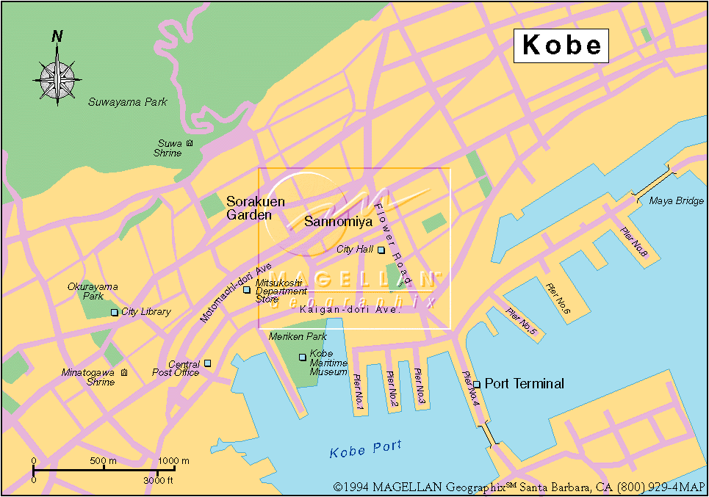Kobe, Japan
**HOTEL OKURA KOBE IS LOCATED IN MERIKEN PARK**
Here Hotel

KOBE City Profile and Tourist Information:
http://www.city.kobe.jp/index-e.html

http://www.jwindow.net/JMAP/htmls/Jmap-kinki-hyogo-kobe-city.html

