3GPP TSG-SA WG6 Meeting #51-e meeting S6-222658
10th – 19th October 2022, Online

Source: vivo
Title: New solution for Service continuity in PIN
Spec: 3GPP TR 23.700-78
Agenda item: 9.1
Document for: Approval
Contact: Huazhang Lv (Huazhang.lv@vivo.com)

1. Introduction
This pCR proposes to put forward a new solution for KI#5 and KI#2.
2. Reason for Change
As indicated in clause 6.38 of TS 22.261[2], the following requirements that describes the service continuity will be studied in this TR phase and reflect in this key issues 2:
- The 5G system shall be able to minimize service disruption when a PIN Element changes the communication path from one PIN Element (e.g. PIN Element with Gateway Capability) to another PIN Element or operator provided mobile access. The communication path between PIN Elements may include licensed and unlicensed spectrum as well as 3GPP and non-3GPP access.
For a certain PINE, it has the four communication type for the PINE:
- the PINE has direct communication with other PINE via Bluetooth or Wi-Fi
- the PINE has communication with other PINE via PEGC
- the PINE has communication with other PINE via PEGC and by means of the 5GS
- the PINE has communication with other PINE via PEGC and by means of the PIN server
Except the direct commmunication, other type of communication are the enhanced mechanism in PIN.
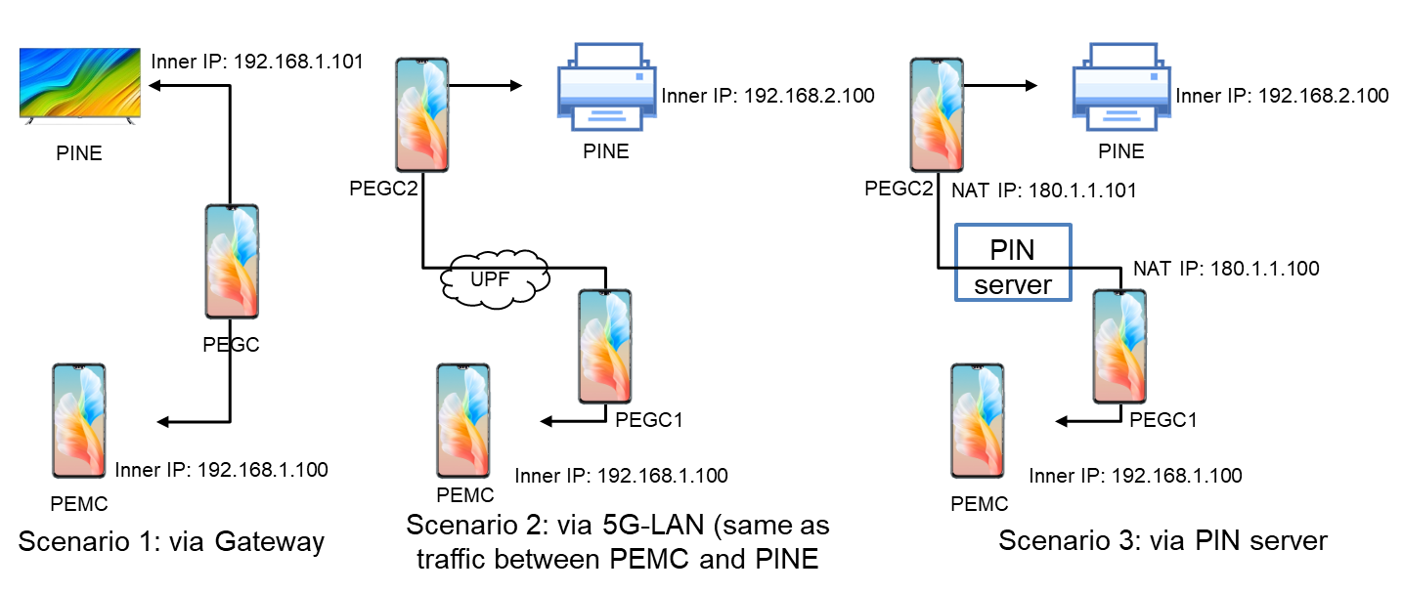
Figure 2-1: Communication type for PINE
For scenario 1, the PEMC communicates with the PINE via PEGC. And the PEMC and PEGC has the same private IP range and the PEGC can easily route the information to PINE under the same PEGC.
For scenario 2, the PEMC communicates with the PINE via two PEGCs. The PINE and PEMC are not under the same PEGC, and the PEMC should communicate with the PINE with the help of 5GS as indicated in the KI#2. The two PEGCs act as the 5G-LAN communication.
For scenario 3, as the default communication, the PEMC communicates with the PINE via PIN server. The PIN server supports both the user plane and control plane interactions.
But in the SA1 requirements, it describes the changing of access of PINE. So, only two situation of continuity should be studied in TR:
Firstly, the PEGC relocation. The PINE changes the gateway to communicate with other PINEs in PIN
Secondly, change the communication from via PEGC to via 5GS. The PINE when move out of PEGC coverage, the PINE can change the communicate via 5GS.
In this solution, it mainly solve the service continuity above to change the communication type, if needed.
3. Conclusions
N/A
4. Proposal
It is proposed to agree the following changes to 3GPP TR 23.700-78 v 0.5.0.

* * * First Change, all new text * * * *

7.X Solution #Y: Service continuity

7.X.1 Architecture enhancements
The architecture of PIN is referred to the solution 1 in clause 7.

7.X.2 Solution description

7.X.2.1 General
This solution addresses aspects of Key Issue #5 and some of Key Issue #2.
As indicated in clause 6.38 of TS 22.261[2], the following requirements that describes the service continuity will be studied in this TR phase and reflect in this key issues 2:
- The 5G system shall be able to minimize service disruption when a PIN Element changes the communication path from one PIN Element (e.g. PIN Element with Gateway Capability) to another PIN Element or operator provided mobile access. The communication path between PIN Elements may include licensed and unlicensed spectrum as well as 3GPP and non-3GPP access.
In PIN architecture, there are four potential communication type for PINE/PEMC or other elements:
- the PINE has direct communication with other PINE via Bluetooth or Wi-Fi
- the PINE has communication with other PINE via PEGC (scenario 1)
- the PINE has communication with other PINE via PEGC and by means of the 5GS (scenario 2)
- the PINE has communication with other PINE via PEGC and by means of the PIN server (scenario 3)
Figure 2-1: Communication type for PINE
For scenario 1, the PEMC communicates with the PINE via PEGC. And the PEMC and PEGC has the same private IP range and the PEGC can easily route the information to PINE under the same PEGC.
For scenario 2, the PEMC communicates with the PINE via two PEGCs. The PINE and PEMC are not under the same PEGC, and the PEMC should communicate with the PINE with the help of 5GS as indicated in the KI#2. The two PEGCs act as the 5G-LAN communication.
For scenario 3, as the default communication, the PEMC communicates with the PINE via PIN server. The PIN server supports both the user plane and control plane interactions.
But in order to coordinated with the SA1 requirements, it describes the changing of access of PINE. So, only two situation of continuity should be studied in TR:
Firstly, the PEGC relocation. The PINE changes the gateway to communicate with other PINEs in PIN.
Secondly, change the communication from via PEGC to via 5GS. The PINE when move out of PEGC coverage, the PINE can change the communicate via 5GS.

7.X.2.2 Procedures to support service continuity

7.X.2.2.1 PEGC relocation
This procedure solves the situation, that PINE A has application layer communication with PINE B via PEGC 1. And for some reasons, the PEGC 1 should relocate to PEGC 2. And the PINE1 should continue to communicate with PINE 2 via PEGC 2.
Figure 7.X.2.2.1-1 illustrates the service continuity to change the application layer communication to communication via different PEGC based on request/response model.
Pre-conditions:
1. The PEMC in a PIN has been pre-configured or has discovered the address (e.g. IP address, FQDN, URI) of the PIN server;
2. The PIN has already been created and a PIN ID is distributed by PIN server;
3. The PEMC has been authorized to communicate with the PIN server;
4. The PINE A and PINE B are both in the same PIN, and can communicate with PEGC 1;
5. The PEGC 2 is another PEGC that in this PIN;

Figure 7.X.2.2.1-1: PEGC relocation in PIN
1. The PINE A has application layer communication with PINE B via PEGC 1 in the PIN.
2. The PEGC 1 detects that PEGC 1 needs relocation, for example, the PEGC 1 will power down or will breakdown.
3a. The PEGC 1 discovers the PEGC 2 internal PIN. The PEGC 2 should be the PINE in the same PIN and should have the capability of gateway.
3b. If the PEGC 1 doesn’t discover another potential gateway in PIN, the PEGC 1 can send the request to PEMC to request to discover a new PEGC in PIN.
4a. If in step 3a, the PEGC 1 determines the PEGC 2 itself, the PEGC 1 indicates the address information about PEGC 2 to PEMC. This PEGC address information including gateway ID or IP address will be taken into consideration when PEMC determines the new gateway.
5. The PEMC determines the new gateway. For example, the PEGC 2 to replace the PEGC 1.
6. The PEMC configures the new access control information to PEGC 2, for example, the user name, account, SSID, BSSID. This information is used to control the PINE to access the network.
7. The PEMC also responses to PEGC 1 that the new PEGC 2 has been determined. And before the PEGC 1 offline, the PEGC 1 triggers the PIN profile relocation to new PEGC 2, because the profile and the route information that configured in PEGC 1 can still be used by the PEGC 2.
8. The PEMC also sends the updated access control information and authorization information to PINE A. The Auth Info may be included for authenticating/authorizing PINE connecting to PEGC 2.
9. The PINE A can connect into the PEGC 2 and communicate with PINE B.

7.X.2.2.2 Change application layer communication to communication via 5GS, with the support of PIN server

This procedure solves the situation, that PINE A has application layer communication with PINE B via PEGC. But when the communication via PEGC is not viable, for example, the PINB moves out of the coverage of PEGC 1, only newly establish the 5GS communication to connect PINE B is the potential way.
Figure 7.X.2.2.2-1 illustrates the service continuity to change application layer communication to communication via PEGC + 5GS based on request/response model.
Pre-conditions:
1. The PEMC in a PIN has been pre-configured or has discovered the address (e.g. IP address, FQDN, URI) of the PIN server;
2. The PIN has already been created and a PIN ID is distributed by PIN server;
3. The PEMC has been authorized to communicate with the PIN server;
4. The PINE A has the subscription that can communicate with PINE B via 5GS;

Figure 7.X.2.2.2-1: Change application layer communication to communication via PEGC + 5GS
1. The PINE A has application layer communication with PINE B via PEGC 1.
2. The PEGC 1 decides to use the 5GS communication to substitute the direct routing via PEGC 1. For example, if the PINE B move out of the coverage of PEGC 1 and can not communicate with PINE 1 via PEGC 1 directly anymore.
3. The PEGC 1 requests to establish the QoS towards PINE 2, reusing the procedure defined in solution 14. The PEGC 1 sends PINE 5GS connection request (PIN ID, PINE ID, Packet filters, [DN-specific ID]) to the PEMC. The PEMC sends PINE 5GS connection request (PIN ID, PEMC ID, PEGC ID, PINE ID, Packet filters) to the PIN server.
4. The PIN server will check with the 5GS that whether this PINE has the subscription to communicate with other PINE via 5GS. And if the PINE has the subscription, the PIN server will interact with 5GS to create/update the QoS flow of PEGC for the PINE.
5. According to the QoS flow establishment, the PIN server updates the route information and QoS information towards PINE 1 in PEGC 1 or the PIN server requests the PEMC to update.
6. The PINE A communicates with PINE 2 via 5GS.

* * * End of Change * * * *

