3GPP TSG-SA5 Meeting #148e S5-233386rev1
Electronic meeting, Online, 17 -25 April 2023

Source: Huawei

Title: clean-up

Document for: Approval
Agenda Item: 6.9.5.1

1 Decision/action requested
Approval

2 References
[1] 3GPP TR 28.824: "Study on network slice management capability exposure"

3 Rationale
This contribution is proposed to make clean-up for TR 28.824 [1].

4 Detailed proposal
This contribution proposes to make the following changes in [1].
1st change

4.2.6 Issue #6: Network slice management capability exposure interface via OSS
Scenarios regarding exposure interface via OSS have been introduced in clause 4.1.1.4. NSC can make contract with the NSP or CSP regarding exposure via BSS. Upon the completion of the contact, the NSC can directly get access to the OSS within the NSP or CSP for access the exposed MnS. Several key issues exist for the use cases. For example, how does the NSC identify the address of MnS producer for the exposed MnS within the OSS and how to consume the exposed MnS directly from OSS needs to be addressed.

Next change

5.2 Exposure of MnS for monitoring QoS of video application

5.2.1 Description
A use case of exposure of MnS for monitoring QoS of video application can be described as follows:
1. A live concert with high-resolution video application service is provided with service provider A (i.e. associate to exposed MnS consumer). A local hosting network (e.g. SNPN) is available and provides localized services for high-resolution video service of the concert. The local hosting network is managed by the service provider A. The high-resolution video streaming service of the live concert is available from both the local hosting network and PLMN. Service provider A and the provider of PLMN (i.e. associate to exposed MnS provider) are two different parties.
2. The service provider A of the local hosting network can have an offer from the Operator of PLMN before identifying the correct MnS for exposure through BSS (e.g. by using Product Catalog). The BSS may obtain the information of MnS that is allowed to be exposed using a MnS service for exposure provided by OSS. The contract may contain the agreement on the exposure of MnSs for consuming certain management MnS related to QoS. According to the contract, the service provider A can have the permission to use the MnS for consuming certain performance MnS related to QoS for the PLMN. The performance MnS can be related to NR and 5GC, e.g. Average DL UE throughput in gNB. For the hosting network, the service provider may have contract with the Network Operator which can offer network management service for the hosting network. The network management service may be offered by a management system that belongs to a service platform of the Network Operator. Due to the contract, the service provider can access the management system directly without going through BSS.
3. Once the offer has been accepted, the corresponding exposure governance management service within the 3GPP management system (of the Operator of PLMN) is configured with permission rule through the interface between BSS and OSS. The permission rule defines that the provider of the local hosting network can have the right to access certain management MnS regarding QoS.
4. Through obtaining the measurement MnS using exposure capability, the provider of the local hosting network can determine the situation when PLMN cannot support the high-resolution video service with satisfied QoS. In this case, the service provider A can notify its customers about the local hosting network that may improve the QoS of the high-resolution video application.

Next change

5.5.1.1 Sub-use case 1: NSP and NOP play by the same organization
In this scenario, the following organizations play aforementioned roles as follows:
- Company-V, which has a contract with Company-A for the exposure directly via OSS, plays the role of NSC
- Company-A plays the role of NSP and NOP
- As NSP, it has:
- a BSS, e.g. to manage its customers, products, contracts, and
- a SML, to manage the services that support its products,
- As NOP, it has:
- its own 5G network (RAN + core). In this sub-use case, Company-A owns the whole set of network resources used by the service that can potentially support the service required by Company-V
- a NML, to manage the network resources used by services
NOTE 1: NSC may have connection with Company-A BSS for the product-level interaction. If not, the OSS/SML may have an embedded BSS functionalities for the product-level interaction.
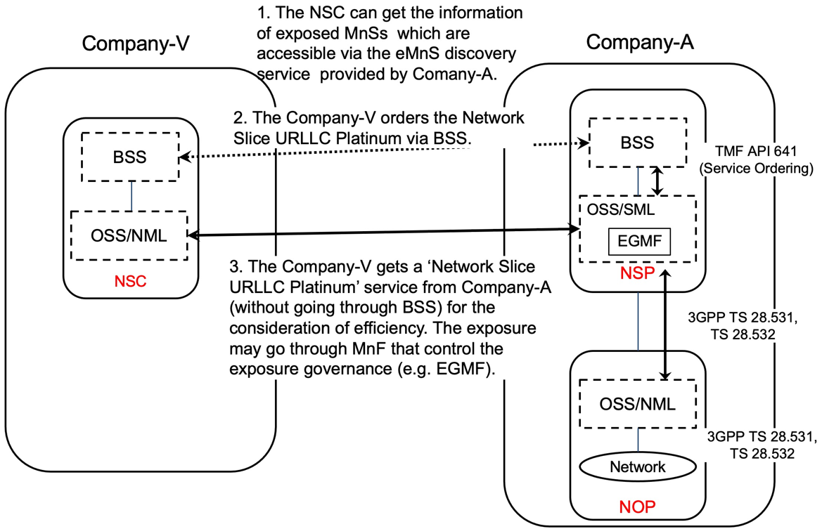
Figure 5.5.1.1-1 Sub-use case – NSP and NOP played by the same organization

Company-A proposes the following product offering together with the exposure capability:
- Network Slice eMBB with the exposure capability of related KPI monitoring and alarm notification, etc.
In this sub-use case 1:
1. Company-V (as the NSC) gets the information regarding exposed MnSs that are available via the exposed MnS discovery service from the Company-A.
2. Company-V sends a request to Company-A (as the NSP) for the access to exposed MnS set ‘Network Slice eMBB’, which contains the exposure capabilities such as related KPI monitoring and alarm notification, etc. To achieve this, a candidate API is the interface with the MnF that controls the exposure governance (e.g. EGMF).
2.1 Company-A SML determines which service supports the exposed MnS being requested by Company-V.
2.2 Company-A OSS / SML sends a response, including the authentication materials (e.g. key, token) for access to the chosen exposed MnS.
3. The company-V can direct consume the exposed MnS (e.g. KPI monitoring and alarm notification) from SML of the Company-A’s 3GPP management system.

Next change

7.9.2 Exposure via CAPIF alternative 2
This clause describes a potential solution where network slice management capability exposure is used in conjunction with a CAPIF core function (see TS 23.222 [14]) to expose management services to MnS consumers.
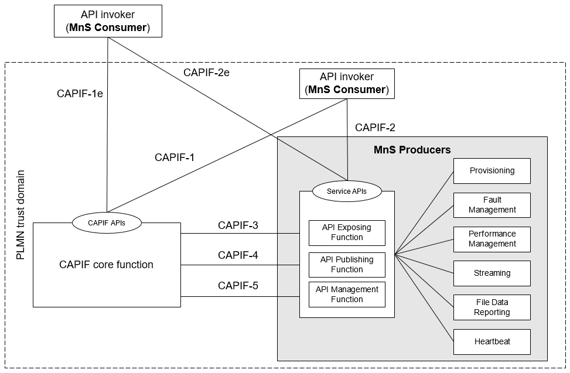
Figure 7.9.2-1: Exposure via CAPIF alternative 2
In this alternative, network slice management capability exposure consumes the interfaces at reference points CAPIF-3, CAPIF-4, and CAPIF-5 as defined in TS 23.222 [14]. It may be necessary to extend CAPIF-3/4/5 as defined in TS 23.222 [14] to support exposure of network slice management services.
In this alternative, network slice management capability exposure provides the interfaces at reference point CAPIF-2/2e. It may be necessary to extend CAPIF-2/2e as defined in TS 23.222 [14] to support network slice management capability exposure and authentication of MnS consumers.
In this alternative, MnS Consumers utilize the interfaces at reference point CAPIF-1/1e. It may be necessary to extend CAPIF-1/1e as defined in TS 23.222 [14] to support network slice management capability exposure and authorization/authentication of MnS consumers.
Editor’s note: Whether network slice management capability exposure is affected by transforming the management service API to another service API is FFS.
Table 7.9.2-1 shows the CAPIF interface and the potential MnS that can be implemented within the interface for alternative 2. In addition, extension of CAPIF interface may be needed to achieve certain functionalities in the context of network slice management capability exposure.
Table 7.9.2-1 Interface description
Interface | Related MnS | Gap analysis
CAPIF 1/1e | - Discovery of MnS(s) from MnS registry using ProvMnS  Specified in TS 28.622 [17], TS 28.623 [16], and TS 28.532 [15] | - How to discover the MnS producer for NSC using CAPIF 1/1e is not specified.  - The ServiceAPIDescription for CAPIF_Discover_Service_API needs to be extended in the context of network slice management capability exposure. The MnS address within the MnS data can indicate a MnS producer for exposing MnS after authentication and authorization.  - Management of MnS consumers includes the management of MnS consumer type and identity. The management of MnS consumer type and identity is for differentiating different access permission for different MnS consumer.
CAPIF 2/2e | - Authentication and authorization of MnS consumers is specified in TS 28.533 [11] clause 4.9.  - Service APIs (MnS): faultMnS, fileDataReportingMnS, heartbeatNtf, perfMnS, provMnS, and streamingDataMnS  Specified in in TS 28.532 [15] | - How to use MnS as extension for CAPIF 2/2e is not specified.  - The Service API for CAPIF 2/2e need to be extended to support MnS.
CAPIF 3 | - Nchf_ConvergedCharging  Specified in TS 28.201 [18] and TS 28.202 [6]  - Access control capability specified in TS 28.533 [11]
CAPIF 4 | - MnS Registry  Specified in TS 28.622 [17] and TS 28.623 [16]. | - How to publish the MnS data for MnS discovery for NSC using CAPIF 4 is not specified.  - The ServiceAPIDescription for CAPIF_Publish_Service_API needs to be extended in the context of network slice management capability exposure. The MnS address within the MnS data can indicate a MnS producer for exposing MnS after authentication and authorization.
CAPIF 5 | - Auditing of the MnS producer is not specified | - How to allow MnS producer to recognize and differentiate each MnS consumer during the auditing is not specified.  - MnS consumer ID is needed for auditing service API invocation.

After the completion of authentication and authorization with the NSC, the CAPIF core function needs to help the NSC to discover the address of the MnS producer so that the NSC can request for MnS consumption. In order to provide the discovery service to the NSC, the MnS data that contains the address of the MnS producer needs to be published to the CAPIF core function. This request for the extension of CAPIF-4 interface to make sure that the ServiceAPIDescription for CAPIF_Publish_Service_API can carry the MnS data in order to support the discovery service for NSC.
The mnsAddress of MnsInfo within CAPIF-1/1e and 4 can be extended as below:
Table 7.9.2-3 mnsaddress information within MnsInfo
Attributes | Support | Cardinality | Description
mnsAddress | M | 1 | The MnS address for external MnS consumer indicates a MnS producer for exposing MnS after authentication and authorization.

For CAPIF-5 interface, According to TS 23.222, API management function can access the service API invocation logs via CAPIF-5. The procedure for auditing needs the query service API log request from API management function to the CAPIF core function. Since API management function is within the 3GPP management system, in order to differentiate each MnS consumer, MnS consumer ID is needed in order to allow MnS producer to recognize each MnS consumer during the auditing. Therefore, API Invoker’s ID need to be extended as MnS customer ID.
The MnS consumer management information is needed for differentiating the MnS consumer in term of consumer type and different access permission. The MnS consumer type is for differentiate the MnS consumer inside and outside the PLMN trust domain.
CAPIF core function can authorize MnS consumer with certain permission (e.g. access token) using CAPIF-1/1e interface. The permission can allow the MnS consumer to get access to the authorized information of MnS from respective MnS producer. In order to allow the corresponding MnS producer to recognize the MnS consumer and the corresponding authorized MnS, MnS consumer ID is needed. Therefore, API Invoker’s ID need to be extended as MnS customer ID.
Editor’s note: The format of MnS consumer ID is FFS.
The MnS consumer management information within CAPIF-1/1e can be extended as below:
Table 7.9.2-4 MnS consumer management information
Attributes | Support | Cardinality | Description
MnSConsumerType | O | 1…N | It indicates the type of MnS consumer that requests for the exposure of the MnSs provided by MnS producer. The type of MnS consumer is external if the MnS consumer is outside the PLMN trust domain. The type of MnS consumer is internal if the MnS consumer is inside the PLMN trust domain.  allowedValue: EXTERNAL,  INTERNAL
MnSConsumerID | O | 1…N | It indicates the Identifier of the MnS consumer that requests MnSs from the MnS producer.  The identifier of the MnS consumer can be associated to its access token. The access token can represent a set of MnSs that are allowed to be exposed to MnS consumer.  The format of the MnS consumer ID can use FQDN (See TS 21.003 clause 19.4.2.1).

The NSC can directly get access to MnS producer after the authentication and validation with MnS producer if the expsoure governance is implemented in respective MnS producer. The MnS producer may be able to provide original MnS following exposure governance which includes filtering. As a result, MnS consumer may be able to access only a subset of original MnS via the response from the MnS producer.

7.9.3 Exposure via CAPIF alternative 3
This clause describes a potential solution where network slice management capability exposure implements a Common API Framework for 3GPP Northbound APIs (see TS 23.222 [14]) to expose management services to MnS consumers.
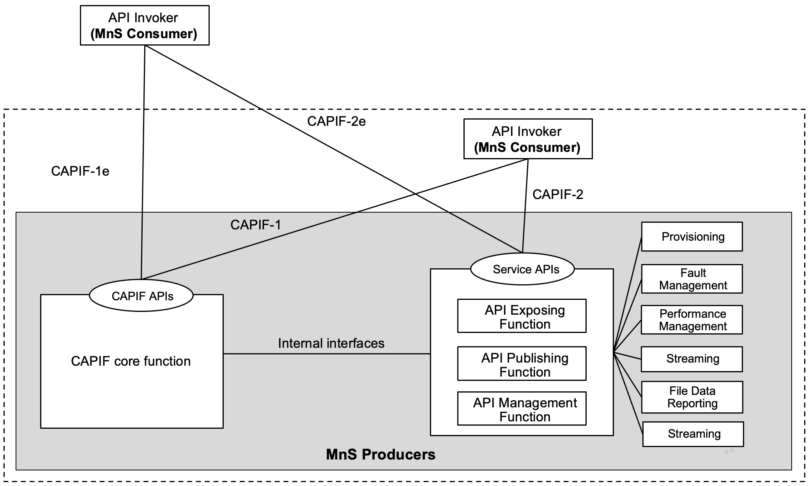
Figure 7.9.3-1: Exposure via CAPIF alternative 3
In this alternative, network slice management capability exposure may internally implement the internal interfaces using reference points CAPIF-3, CAPIF-4, and CAPIF-5 as defined in TS 23.222 [14] or may use non-standardized interfaces.
In this alternative, network slice management capability exposure provides the interfaces at reference point CAPIF-1/1e. It may be necessary to extend CAPIF-1/1e as defined in TS 23.222 [14] to support authorization/authentication of MnS consumers and discovery of MnS producers.
In this alternative, network slice management capability exposure provides the interfaces at reference point CAPIF-2/2e. It may be necessary to extend CAPIF-2/2e as defined in TS 23.222 [14] to support network slice management capability exposure and authentication of MnS consumers.
Editor’s note: Whether network slice management capability exposure is affected by transforming the management service API to another service API is FFS.
Table 7.9.3-1 shows the CAPIF interface and the potential MnS that can be implemented within the interface for alternative 3. In addition, extension of CAPIF interface may be needed to achieve certain functionalities in the context of network slice management capability exposure.
Table 7.9.3-1 Interface description
Interface | Related MnS | Gap analysis
CAPIF 1/1e | - Discovery of MnS(s) from MnS registry using ProvMnS  Specified in TS 28.622 [17], TS 28.623 [16], and TS 28.532 [15] | - How to discover the MnS producer for NSC using CAPIF 1/1e is not specified.  - The ServiceAPIDescription for CAPIF_Discover_Service_API needs to be extended in the context of network slice management capability exposure. The MnS address within the MnS data can indicate a MnS producer for exposing MnS after authentication and authorization.  - Management of MnS consumers includes the management of MnS consumer type and identity. The management of MnS consumer type and identity is for differentiating different access permission for different MnS consumer.
CAPIF 2/2e | - Authentication and authorization of MnS consumers is specified in TS 28.533 [11] clause 4.9  - Service APIs (MnS): faultMnS, fileDataReportingMnS, heartbeatNtf, perfMnS, provMnS, and streamingDataMnS  Specified in in TS 28.532 [15] | - How to use MnS as extension for CAPIF 2/2e is not specified.  - The Service API for CAPIF 2/2e need to be extended to support MnS.

After the completion of authentication and authorization with the NSC, the CAPIF core function needs to help the NSC to discover the address of the MnS producer so that the NSC can request for MnS consumption via the MnS producer. In order to provide the discovery service to the NSC, the MnS data that contains the address of the MnS producer needs to be published to the CAPIF core function.

The mnsAddress of MnsInfo within CAPIF-1/1e can be extended as below:
Table 7.9.2-3 mnsaddress information within MnsInfo
Attributes | Support | Cardinality | Description
mnsAddress | M | 1 | The MnS address for external MnS consumer indicates MnS producer for exposing MnS after authentication and authorization.

For CAPIF-5 interface, According to TS 23.222, API management function can access the service API invocation logs via CAPIF-5. The procedure for auditing needs the query service API log request from API management function to the CAPIF core function. Since API management function is within the 3GPP management system, in order to differentiate each MnS consumer, MnS consumer ID is needed in order to allow MnS producer to recognize each MnS consumer during the auditing. Therefore, API Invoker’s ID need to be extended as MnS customer ID.
The MnS consumer management information is needed for differentiating the MnS consumer in term of consumer type and different access permission. The MnS consumer type is for differentiate the MnS consumer inside and outside the PLMN trust domain.
CAPIF core function can authorize MnS consumer with certain permission (e.g. access token) using CAPIF-1/1e interface. The permission can allow the MnS consumer to get access to the authorized information of MnS from respective MnS producer. In order to allow the corresponding MnS producer to recognize the MnS consumer and the corresponding authorized MnS, MnS consumer ID is needed. Therefore, API Invoker’s ID need to be extended as MnS customer ID.
The MnS consumer management information within CAPIF-1/1e can be extended as below:
Table 7.9.2-4 MnS consumer management information
Attributes | Support | Cardinality | Description
MnSConsumerType | O | 1…N | It indicates the type of MnS consumer that requests for the exposure of the MnSs provided by MnS producer. The type of MnS consumer is external if the MnS consumer is outside the PLMN trust domain. The type of MnS consumer is internal if the MnS consumer is inside the PLMN trust domain.  allowedValue: EXTERNAL,  INTERNAL

The NSC can directly get access to MnS producer after the authentication and validation with MnS producer if the expsoure governance is implemented in respective MnS producer. The MnS producer may be able to provide original MnS following exposure governance which includes filtering. As a result, MnS consumer may be able to access only a subset of original MnS via the response from the MnS producer.

7.9.4 Evaluation
An evaluation of these 3 alternatives is given, which can help to draw the conclusion and recommendation for this solution.
 | Summary | pros | Cons
Alternative 1 | API provider domain acts as MnS consumer which interacts with the MnS producer within SA5. SA5 jurisdiction ends at MnS Consumer. What MnS consumers does to expose the MnS further to API Invoker (external entity) is out–of-scope of SA5.How the external MnS consumer conduct authentication, authentication, discover the MnS and consume the MnS is not specified in this alternative. | No standardization work needed for SA5. | The requirements in clause 6 are not addressed in a standardized manner.
Alternative 2 | MnS producer embeds API provider domain functions capabilities and has direct interaction with CAPIF core function. External MnS consumer can conduct authentication and authorization with CCF. After that, the external MnS consumer can consume the MnS via the service API provided by API provider domain. | With certain extension for CAPIF interface, solution on how external MnS consumer discover and consume MnS can be specified. | Extension of CAPIF interfaces (e.g. CAPIF-1e, CAPIF-2e, CAPIF-3, CAPIF-4, CAPIF-5) is needed.
Alternative 3 | MnS producer embeds both CAPIF Core Function and API provider domain functions capabilities. CCF and API provider domain interact with each other via internal interfaces. | With certain extension for CAPIF interface, solution on how external MnS consumer discover and consume MnS can be specified. | Extension of CAPIF interface (e.g. CAPIF CAPIF-1e, CAPIF-2e) is needed.

Editor’s note: The evaluation is FFS.

So far, there are several gaps regarding, MnS publishing, discovery, which are captured in TR 28.824:
- Whether and how to publish a MnS that can be discovered by external customer is not specified in existing 3GPP management system.
- If there is a need to publish MnS, then the exposure of MnS (e.g. performance MnS regarding NR and 5GC) is not specified in 3GPP management system.
- To limit issues the exposure from a discovery system of the operator may only provide “read” permissions (w.r.t the exposed MnS) without authentication and authorization. To execute the discovered exposed MnS the consumer still needs to be authenticated and authorized by the management system. Therefore, there is a gap in the difference in exposure for consumption, and exposure for discovery which needs to be solved.
All these gap can be resolved by alternative 2 and 3 since all the related interfaces are within the scope of alternative 2 and 3. Alternative 1 cannot solve the gaps mentioned above.
Based on the aforementioned evaluation, It is suggested to recommend alternative 2 and 3 as baseline for the normative work.

Next change

8 Conclusion and Recommendation

8.1 Reference Architecture for network slice ordering, provisioning and assurance

8.1.1 Conclusion
From the use case specific architectures depicted in:
# Clause 4.1.1.4.2 (Exposure scenarios)
# Clause 4.1.3.2 (Use case No.1: simple case)
# Clause 4.1.3.3 (Use case No.2: partners involved)
# Clause 5.5 (Exposure of network slice as a product)
- 5.5.1.1 (Sub-use case 1: NSP and NOP played by the same organization)
- 5.5.1.2 (Sub-use case 2: NOP role played simultaneously by different organizations)
# Clause 5.6 (Exposure of network slice as a service)
- 5.6.1.1 (Sub-use case 1: NSP and NOP play by the same organization)
- 5.6.1.2 (Sub-use case 2: NOP role played simultaneously by different organizations)
, it is possible to derive a reference architecture valid for all use cases, by merging the use case specific architectures.

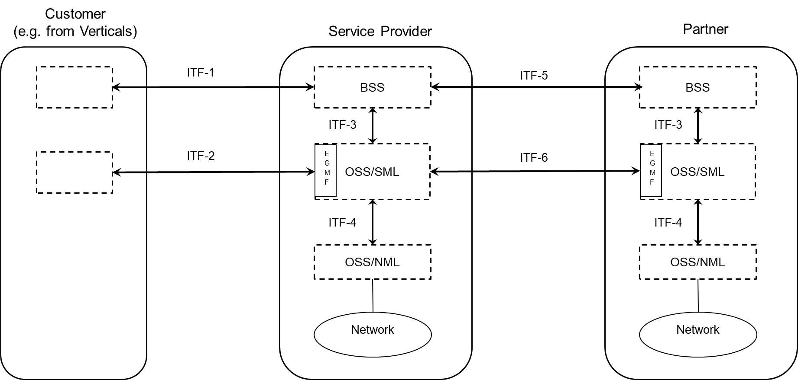
Figure 8.1.1-1: Reference architecture for network slice ordering, provisioning and assurance.

The interfaces present in this reference architecture are:
- Inter-organization interfaces (represented East-West):
- Between the Customer and the Service Provider:
- Interface ITF-1 to:
- create a product (e.g. network slice) order,
- retrieve information concerning a product (e.g. network slice) order,
- update a product (e.g. network slice) order,
- delete a product (e.g. network slice) order;
Candidate APIs for Interface ITF-1 include, but are not limited to, TMF API 622 (Product ordering), in which case entities managed via this interface include ProductOrder, ProductOrderItem, etc. defined in TMF 622 [2].- Interface ITF-2 to:
- enable the Service Provider to expose, from its Service Management Layer, network slice management capabilities to the Customer;
Candidate APIs for Interface ITF-2 include 3GPP TS 28.531, TS 28.532, TS 28.545, TS 28.550.
Entities managed via the Interface ITF-2 include NetworkSlice (cf. TS 28.541 [9]).
At the Service Provider’s side of Interface ITF-2, the Exposure Governance Management Function (EGMF) governs the network slice management capabilities exposure.
- Between the Service Provider and its Partner(s):
- Interface ITF-5 to:
- create a product order,
- retrieve information concerning a product order,
- update a product order,
- delete a product order;
Candidate APIs for Interface ITF-5 include, but are not limited to, TMF API 622 (Product ordering), in which case entities managed via this interface include ProductOrder, ProductOrderItem, etc. defined in TMF 622 [2].
- Interface ITF-6 to:
- enable the Partner to expose, from its Service Management Layer, network slice management capabilities to the Service Provider;
Candidate APIs for Interface ITF-6 include 3GPP TS 28.531, TS 28.532, TS 28.545, TS 28.550.
Entities managed via the Interface ITF-6 include NetworkSlice (cf. TS 28.541 [9]).
At the Service Provider’s side of Interface ITF-6, the Exposure Governance Management Function (EGMF) governs the network slice management capabilities exposure.
- Intra-organization interfaces (represented North-South), internal to the Service Provider:
- Between its BSS and its OSS/SML
- Interface ITF-3 to:
- create a service order,
- retrieve information concerning a service order,
- update a service order,
- delete a service order;
Candidate APIs for Interface ITF-3 include, but are not limited to, TMF API 641 (Service ordering), in which case entities managed via this interface include ServiceOrder, ServiceOrderItem, etc. defined in TMF 641 [3].
- Between its OSS/SML and its OSS/NML
- Interface ITF-4 to:
- create a network slice / network slice subnet,
- retrieve information concerning a network slice / network slice subnet,
- update a network slice / network slice subnet,
- delete a network slice / network slice subnet,
- collect PM and FM data concerning a network slice / network slice subnet;
Candidate APIs for Interface ITF-4 include, 3GPP TS 28.531, TS 28.532, TS 28.545, TS 28.550.
Entities managed via the Interface ITF-4 include NetworkSlice, NetworkSliceSubnet, etc. (cf. TS 28.541 [9]).

NOTE: in order not to create confusion, especially for external readers, it has been proposed in Figure 8.1.1-1 to rename interfaces, since interfaces Type-A and Type-B, used elsewhere in this TR, could be mixed up with MnS Component Type-A, Type B, Type C, defined in TS 28.533; similarly, interfaces Type-1 and Type-2, used elsewhere in this TR, could be mixed up with interfaces type 1, 2, etc. defined in TS 32.101.

End of changes

