3GPP TSG-SA WG4 Meeting #133-eS4-251495

Online, 18 – 25 July 2025

**Source: InterDigital, Samsung, Sony Group Corporation, Nokia, Philips, Deutsche Telekom, Fraunhofer HHI, KDDI, Huawei**

**Title: pCR on evaluation results for scenario 2**

**Spec: 3GPP TR 26.956 1.0.0**

**Agenda item: 9.6**

**Document for: Agreement**

**1. Introduction**

This pCR provides objective and subjective evaluation results for scenario 2 using dense dynamic point clouds as representation format and MPEG V-PCC as codec.

**2. Reason for Change**

Provided information is essential for the completion of the TR. In the current draft there are no evaluation results.

**3. Proposal**

It is proposed to agree the following changes to 3GPP TR 26.956.

\* \* \* First Change \* \* \* \* (ALL NEW)

<Proposed change in revision marks>

# 9 Evaluation of Selected Scenarios

Editor’s note: This clause defines test conditions and parameters, KPIs, Metrics, test sequences, agreed reference signals per scenario.

## 9.1 Introduction

Editor’s note: Identifies the preferred scenarios

## 9.X Scenario 2: <tbd>

### 9.X.1 Evaluation Overview

Editor’s note: Based on scenario in clause 6, summarizes the source formats parameters used for evaluation, the encoding and decoding constraints, interoperability considerations and the general idea of the performance metrics.

Clause 7 identifies the dense dynamic point cloud and dynamic mesh representation formats as the dominant formats used for provision of services based on scenario 2.

To ensure good quality for scenario 2, around 2 million points per frame for a dense dynamic point cloud and around 30k triangles and 4K texture per frame for dynamic mesh have been identified as appropriate. More details can be found in table 7.3.4-1 and table 7.3.4-2.

At time of writing of this technical report the MPEG V-DMC [DM20] test model was not publicly available, so for the evaluation of MPEG V-DMC is referred to clause 11.

The remaining part of clause 9.X concentrates on the evaluation of dense dynamic point clouds as representation format and MPEG V-PCC [Vol-11] as the codec.

Here follows a quick summary of the selected constraints of the representation format and encoding/decoding constraints which allow good quality including proven real time decoding/rendering on off-the-shelve consumer devices such as smartphones, tablets and VR headsets:

* Representation format dense dynamic point cloud: up to 2 million points / frame, 11-bit bounding box, more details in table 7.3.4-1
* Encoding/decoding: HEVC Main10 V-PCC Basic Rec0 profile with bitrates of up to 50Mbit/s, more details in table 7.3.5

The envisaged interoperability point is the one between the application server/playout system in the cloud and the consumer device, see figure 7.3.3-1, so focus is delivery volumetric video with single asset to end consumers.

As performance metrics, two objective metrics are provided and videos are provided for self-conducting subjective viewing.

### 9.X.2 Reference Sequences

Clause 7.3.8.1 lists all available candidate raw dense point cloud sequences and clause 7.3.8.2 selects from these 5 sequences for objective and subjective testing. Criteria for the selection were quality and diversity of content providers.

### 9.X.3 Performance Metrics

Clause 7.3.6.2 describes the “point-based” metric [Vol-16] and the “PCQM” metric [Vol-17]. Both objective metrics, the “point-based” metric and “PCQM” will be reported for all rate points and for all test sequences. MPEG V-PCC [Vol-11] is the first codec supporting the dense dynamic point cloud representation format with inter coding and therefore no anchor codec for the format has been selected.

### 9.X.4 Candidate Solutions

#### 9.X.4.1 Solution 1: MPEG V-PCC profile HEVC Main10 V-PCC Basic Rec0

##### 9.X.4.1.1 Introduction

The generation of objective metrics and generation of 2D videos for subjective viewing for scenario 2 is supported by a software package that widely automates the whole process. The principal stages are test sequence preparation, bitstream and objective metric generation and video generation.

##### 9.X.4.1.2 Reference Software

Clause 7.3.9.4 describes the stages for sequence preparation and bitstream and objective metric generation. For encoding and decoding the software package uses the MPEG V-PCC test model [Vol-26].

Clause 7.3.9.5 describes the stage video generation.

##### 9.X.4.1.3 Parameter Settings

Clause 7.3.9.1 describes the principal configuration files for the V-PCC test model [Vol-26], where e.g. the random-access mode is selected.

Clause 7.3.9.2 describes additional configuration information to obtain fixed target bitrates. Target bitrates are obtained by selecting values for the V-PCC codec parameters Occupancy Precision, QP Geometry and QP Texture per sequence. The fixed bitrate is not fully fixed, it is rather an average over the sequence length, which 5s or 10s depending on the sequence. Such fixed bitrates have been selected to enable an indicative subjective comparison of V-PCC with potential future other codecs for scenario 2, including codecs supporting another potential representation format (e.g. dynamic mesh with V-DMC).

##### 9.X.4.1.4 Distribution

The performed evaluation is on the V3C bitstream level does not include packaging and delivery of V-PCC based on ISO/IEC 23090-10. So potential overhead of packaging and delivery is not included in the evaluation.

##### 9.X.4.1.5 Evaluation Results

9.X.4.1.5.1 Objective evaluation

Below the graphs are plotted for the point-based metric (PSNRs for D1, D2, Cb, Cr and Luma) and for the PSNR metric. These results can be used as an anchor for comparing in future with other point-cloud based codecs for volumetric video.

Bitstreams are provided for those sequences that are provided as reference sequences on Aspera, i.e. Mitch, Nathalie and JuggleSoccer. Bitstreams can be accessed as follows:

* Log into Aspera: [https://aspera.pub/I4tSQ8k](https://aspera.pub/I4tSQ8k" \t "_blank" \o "https://aspera.pub/i4tsq8k)
* 3GPP members can request credentials by sending a request per email to: [3GPP\_B2D\_Datasets@interdigital.com](mailto:3GPP_B2D_Datasets@interdigital.com)
* Go to directory Bitstreams/Scenario-2/V-PCC. In the directories mitch, nathalie and jugglefootrouge there are zip files containing the bitstreams for the 5 rate points. The file md5sum\_bin.txt contains the md5 checksums that should be used to check if the download was correct.

For sequences coming from Renderpeople like Henry and Aliyah the bitstreams cannot be shared due to the license. Here again the file md5sum\_bin.txt contains the md5 checksums that should be used to check if it was possible to generate the bitstream from scratch.

The spreadsheet with full objective results can be downloaded from Aspera by using the same credentials and by going to the directory Bitstreams/Scenario-2/V-PCC/Metrics. To access the spreadsheet, open the file FiDx0\_Basic\_C2RA\_3gpp\_test\_configuration.xlsm. The spreadsheet has one tab named “C2 lossy RA” with detailed information how bits are spent between geometry, occupancy and color, PSNR information for both metrics and information on encoding/decoding time. The tab “Graphs” shows the plots for both metrics which are included below in this document. The sequence can be selected on the upper left corner when clicking on the sequence name.

Editor’s note: Spreadsheet can be moved to Akamai when directories have been created

9.X.4.1.5.1.1 Objective results of sequence Mitch

The following 5 figures present the point-based metric results.

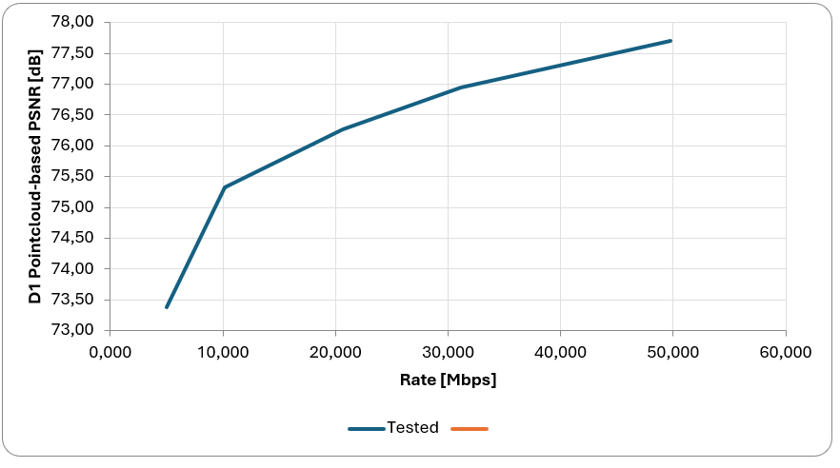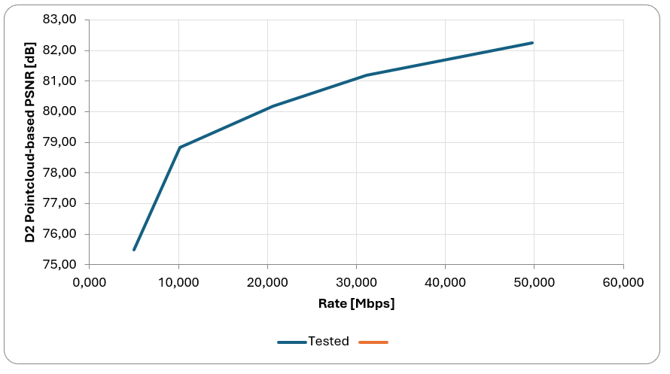

Figure 9.X.4.1.5.1.1-1: D1 and D2 metrics

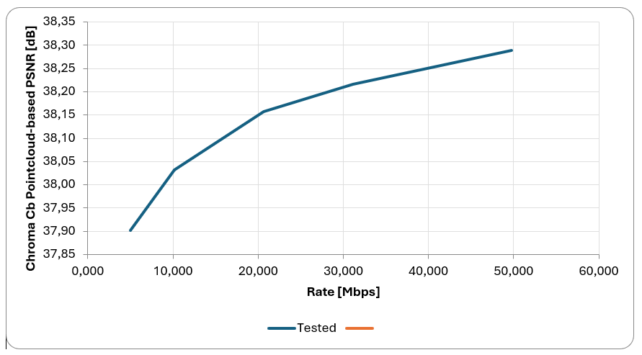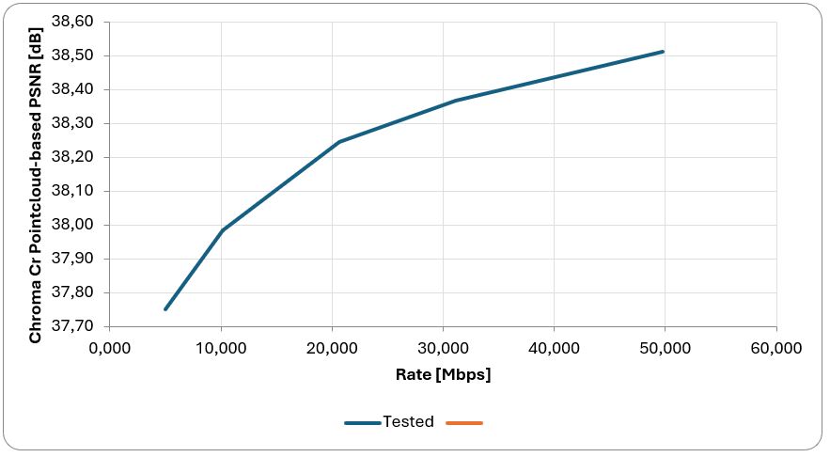

Figure 9.X.4.1.5.1.1-2: Cb and Cr metrics

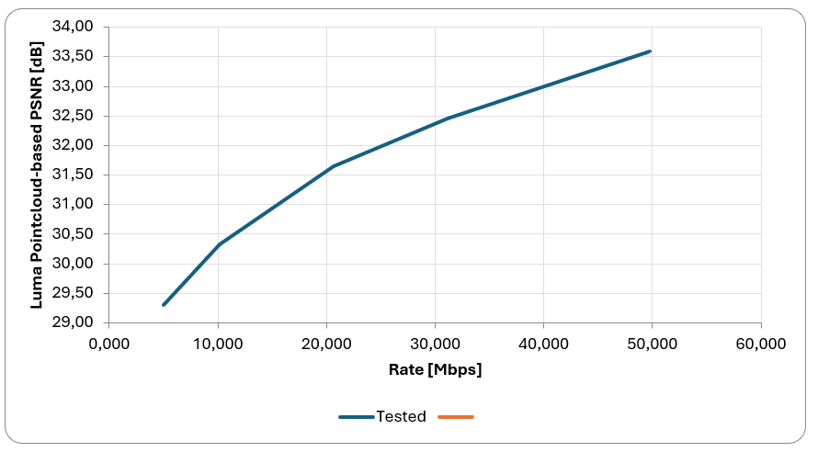

Figure 9.X.4.1.5.1.1-3: Luma metric

The following figure presents the PQCM metric results.

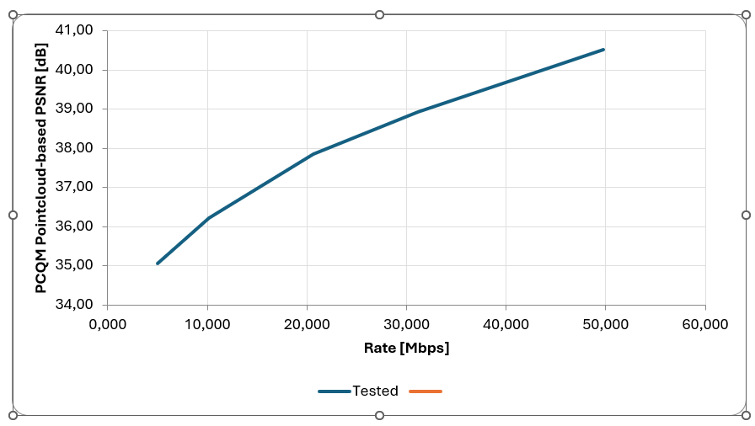

Figure 9.X.4.1.5.1.1-4: PCQM metric

9.X.4.1.5.1.2 Objective results of sequence JuggleSoccer

The following 5 figures present the point-based metric results.

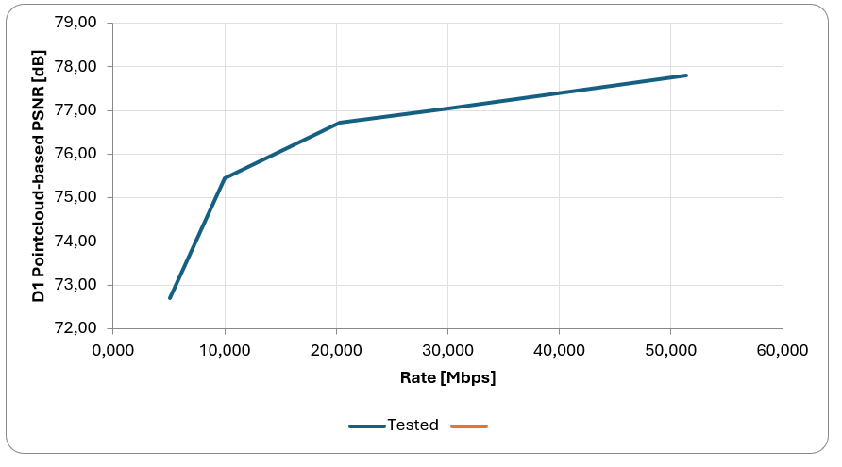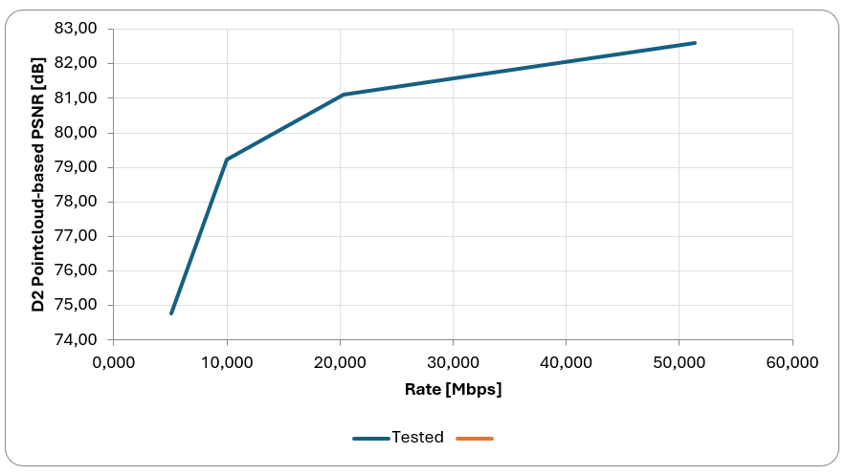

Figure 9.X.4.1.5.1.2-1: D1 and D2 metrics

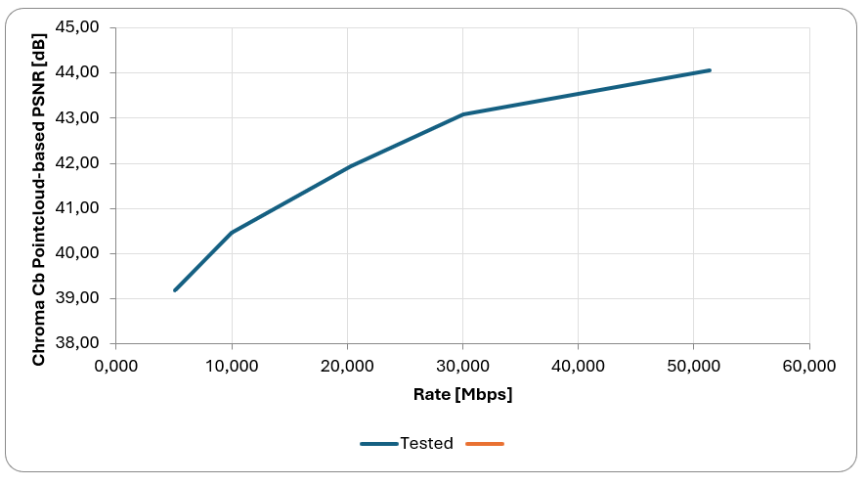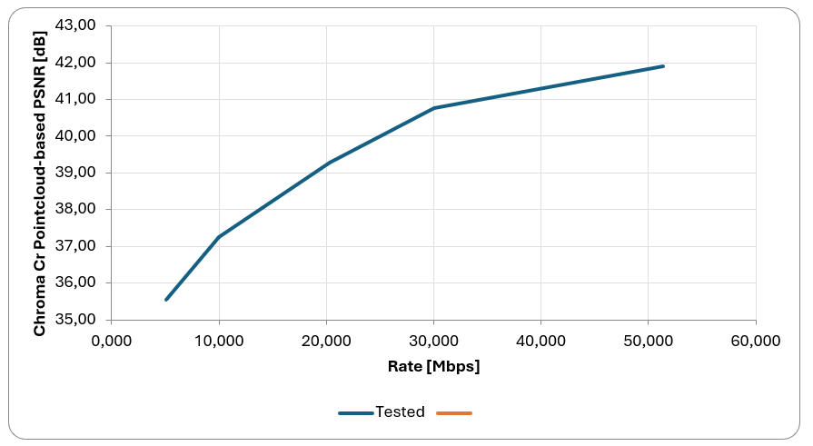

Figure 9.X.4.1.5.1.2-2: Cb and Cr metrics

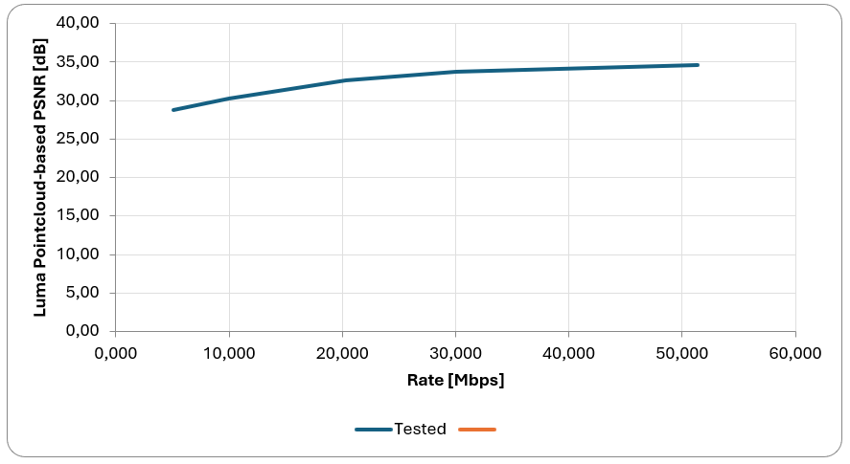

Figure 9.X.4.1.5.1.2-3: Luma metric

The following figure presents the PQCM metric results.

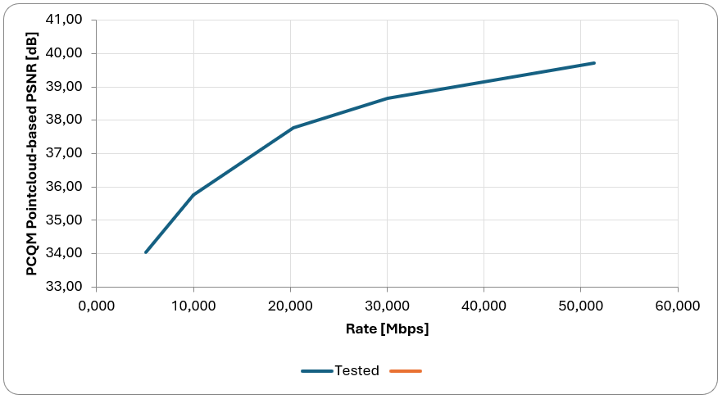

Figure 9.X.4.1.5.1.2-4: PCQM metric

9.X.4.1.5.1.3 Objective results of sequence Henry

The following 5 figures present the point-based metric results.

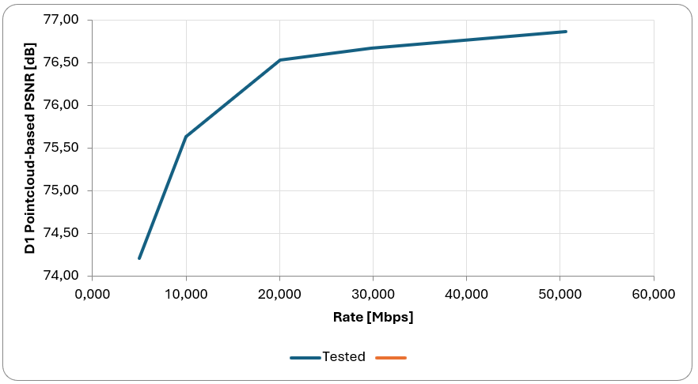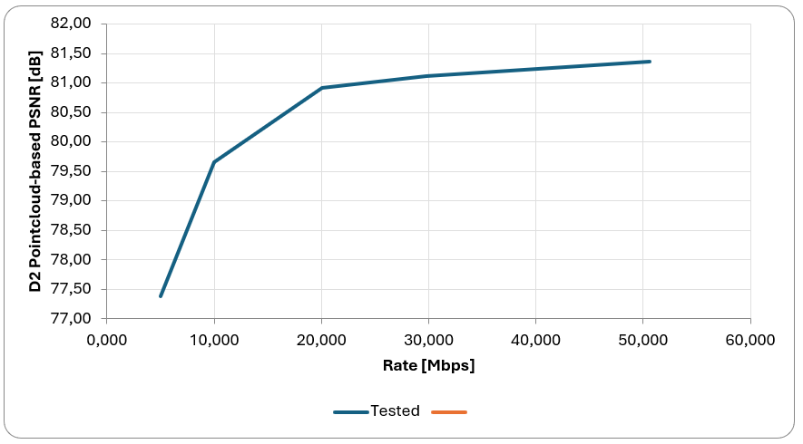

Figure 9.X.4.1.5.1.3-1: D1 and D2 metrics

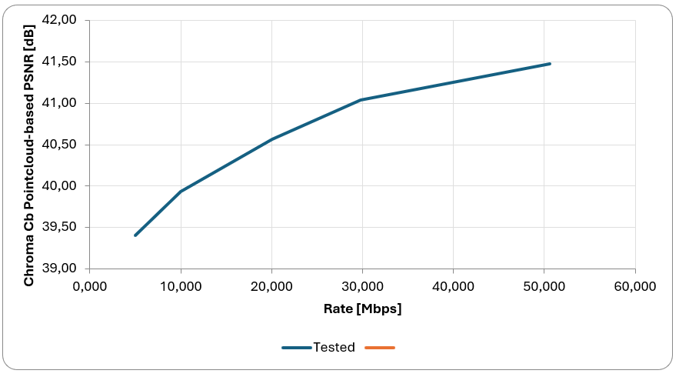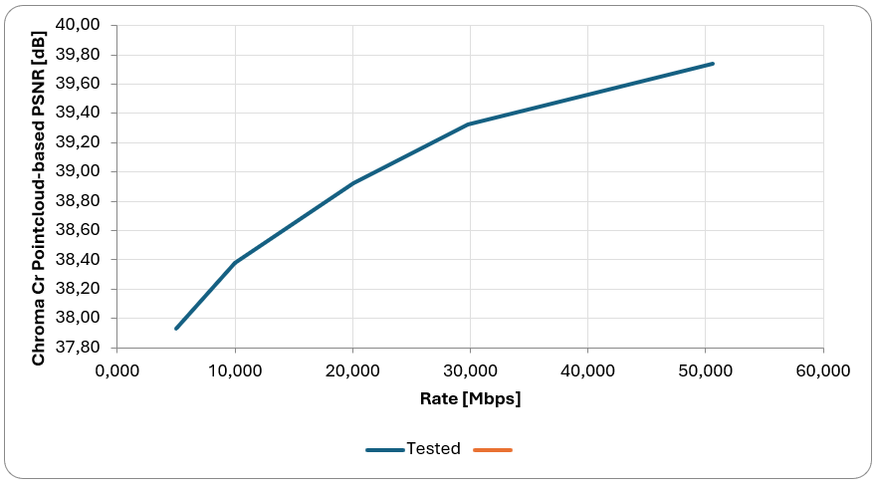

Figure 9.X.4.1.5.1.3-2: Cb and Cr metrics

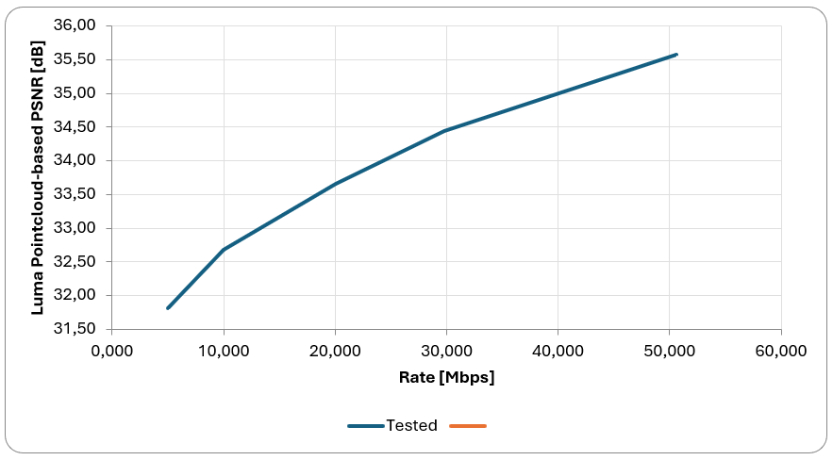

Figure 9.X.4.1.5.1.3-3: Luma metric

The following figure presents the PQCM metric results.

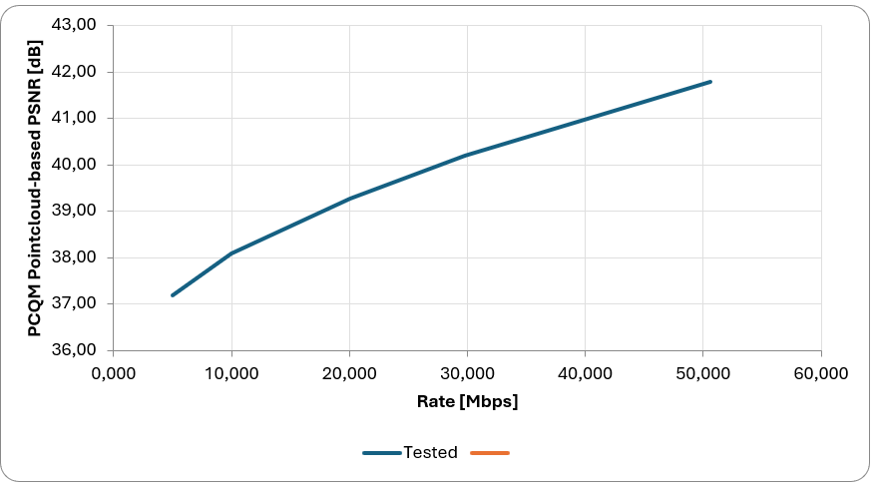

Figure 9.X.4.1.5.1.3-4: PCQM metric

9.X.4.1.5.1.4 Objective results of sequence Nathalie

The following 5 figures present the point-based metric results.

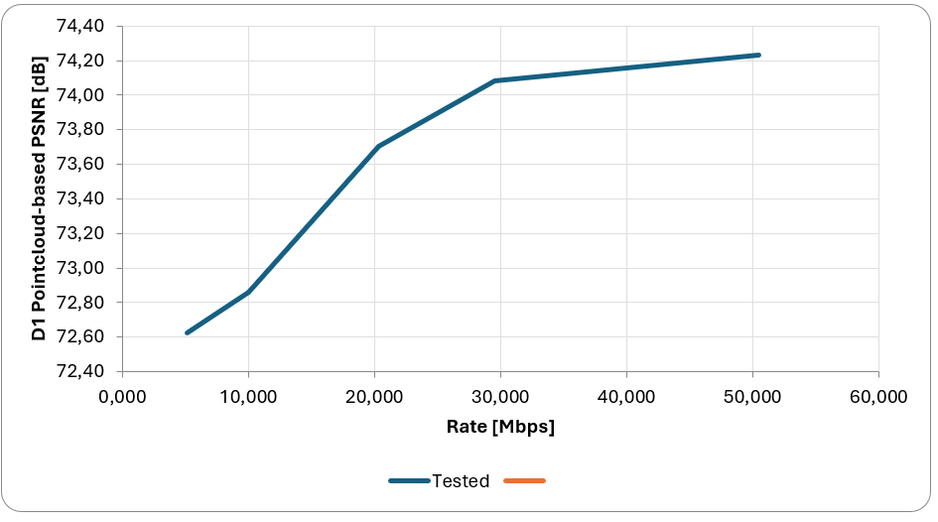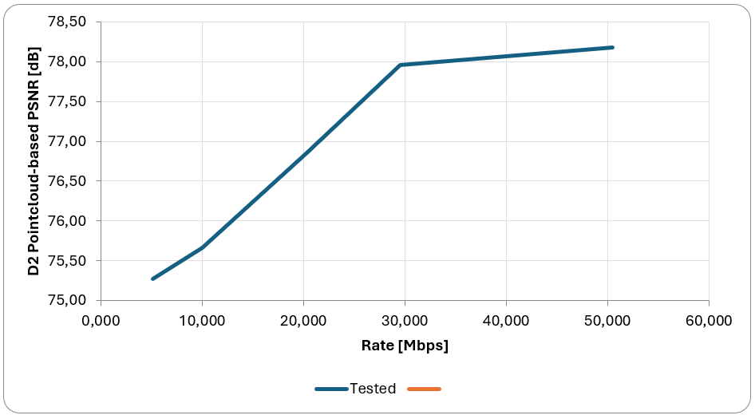

Figure 9.X.4.1.5.1.4-1: D1 and D2 metrics

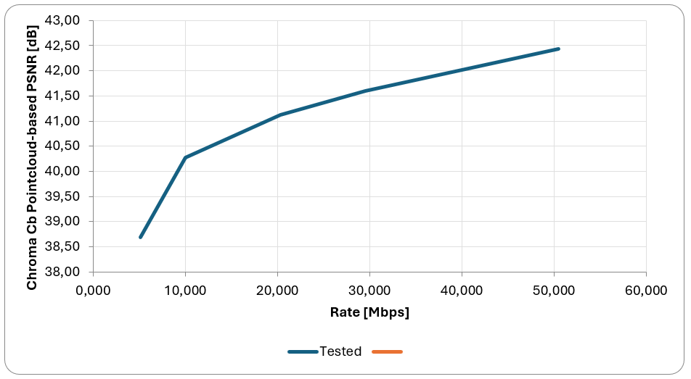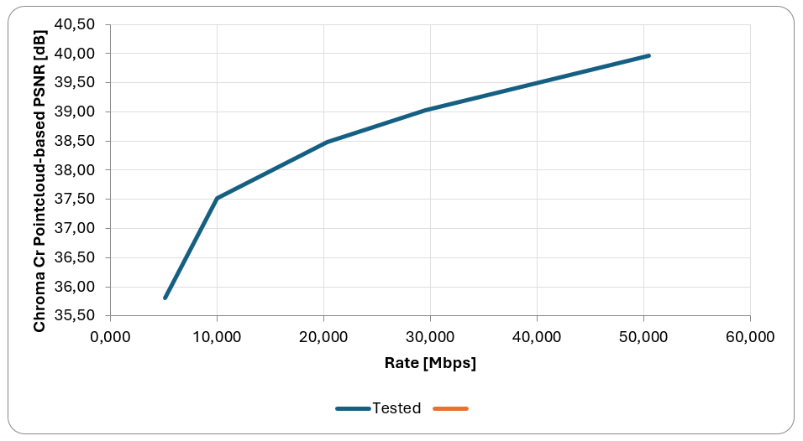

Figure 9.X.4.1.5.1.4-2: Cb and Cr metrics

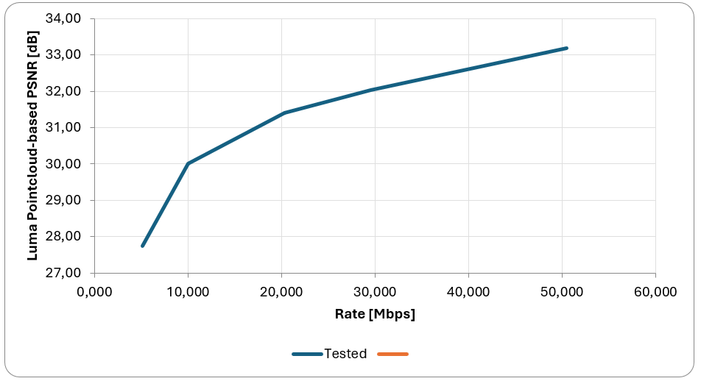

Figure 9.X.4.1.5.1.4-3: Luma metric

The following figure presents the PQCM metric results.

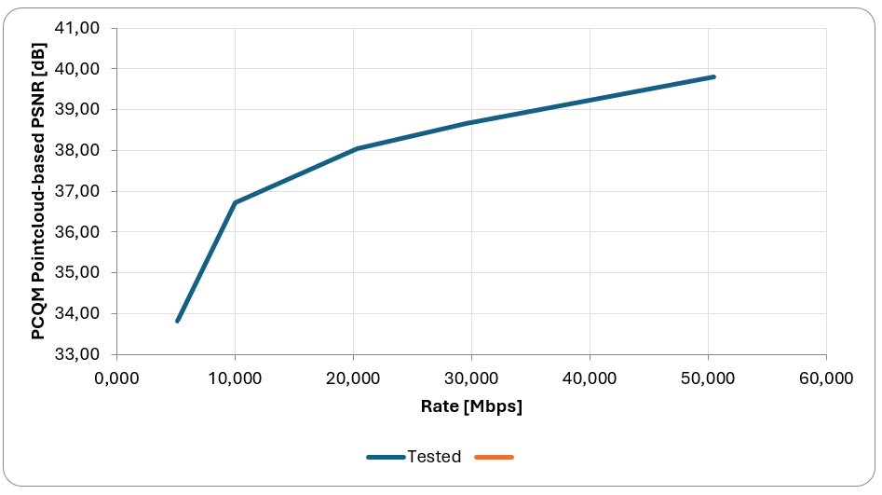

Figure 9.X.4.1.5.1.4-4: PCQM metric

9.X.4.1.5.1.5 Objective results of sequence Aliyah

The following 5 figures present the point-based metric results.

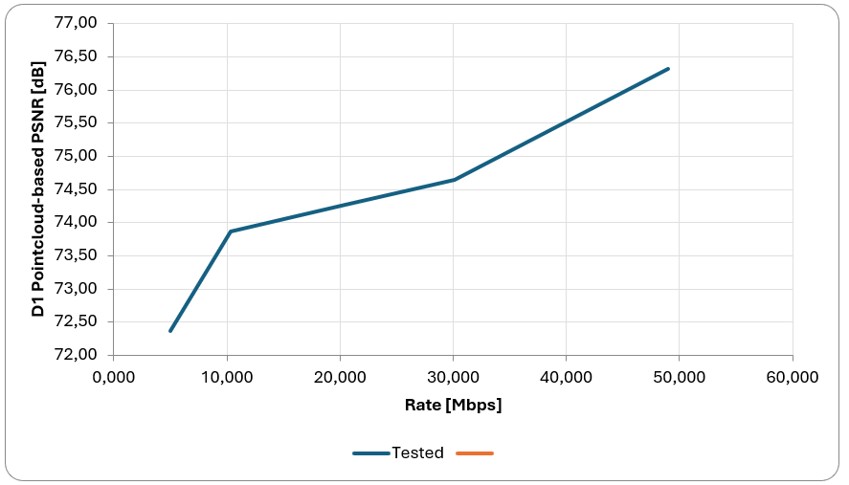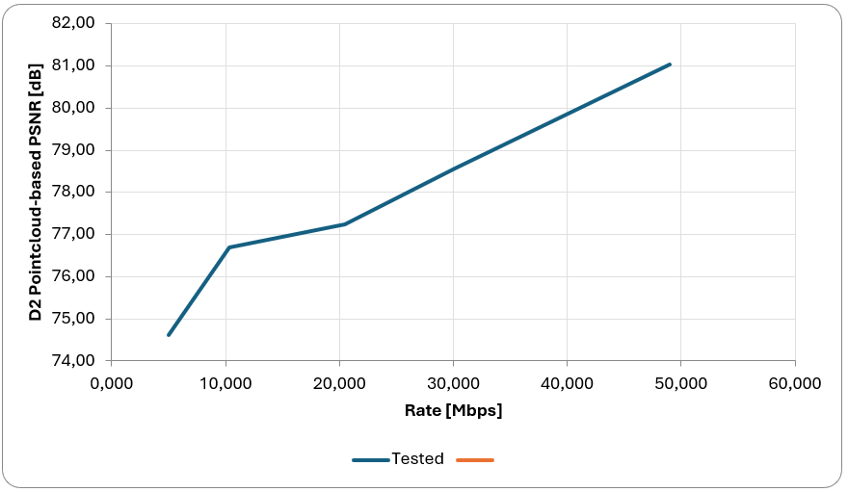

Figure 9.X.4.1.5.1.5-1: D1 and D2 metrics

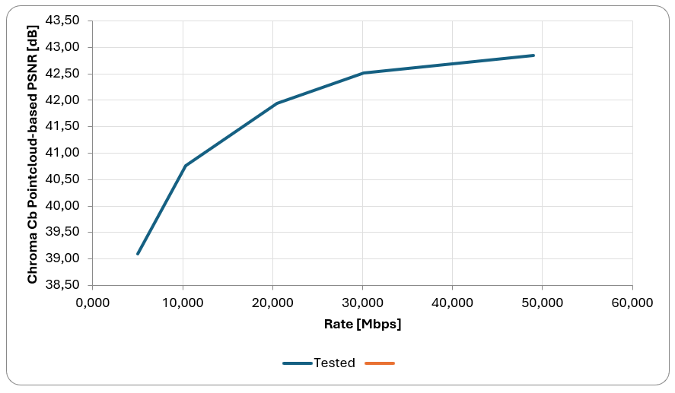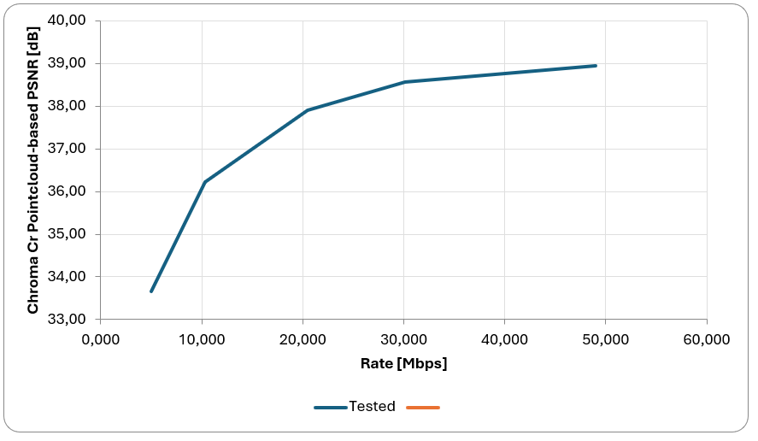

Figure 9.X.4.1.5.1.5-2: Cb and Cr metrics

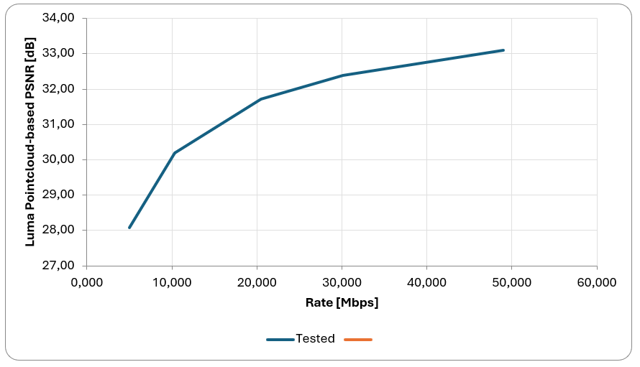

Figure 9.X.4.1.5.1.4-3: Luma metric

The following figure presents the PQCM metric results.

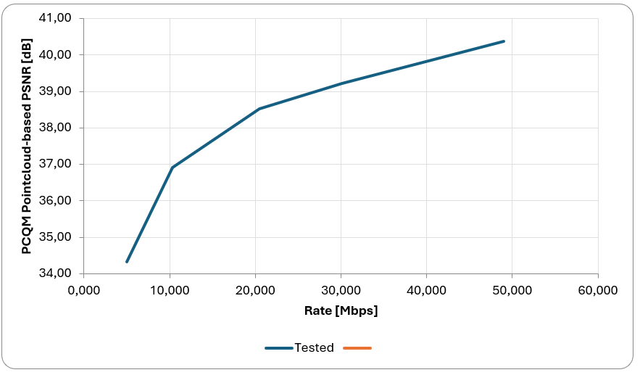

Figure 9.X.4.1.5.1.5-4: PCQM metric

9.X.4.1.5.1.6 Bitstream crosschecks

A spreadsheet summarizing the sequences, along with the corresponding originators and cross-checkers, is available in the directory Bitstreams/Scenario-2/V-PCC/Metrics.

9.X.4.1.5.2 Subjective evaluation

Videos are provided for all sequences and can be accessed as follows:

* Log into Aspera: [https://aspera.pub/I4tSQ8k](https://aspera.pub/I4tSQ8k" \t "_blank" \o "https://aspera.pub/i4tsq8k)
* 3GPP members can request credentials by sending a request per email to: [3GPP\_B2D\_Datasets@interdigital.com](mailto:3GPP_B2D_Datasets@interdigital.com)
* Go to directory Bitstreams/Scenario-2/V-PCC/Videos. In the directory there is a zip file with the name of each sequence. It includes 18 videos for each sequence, coming from the 5 rate points plus one for the reference sequence and each of these 6 is rendered in 3 modes as described in clause 7.3.9.5. In the same directory is a file md5sum.txt which contains the md5 checksums.
* A dedicated camera path has been selected for each sequence which can be found in the directory Bitstreams/Scenario-2/V-PCC/camerapath

Alternatively, the videos are provided on the public server:

* <https://dash-large-files.akamaized.net/WAVE/3GPP/Beyond2D/Bitstreams/Scenario-2/V-PCC/Videos>

The videos can be visualized on e.g. a TV set and can be used for a viewing test at 3GPP member’s premise.

9.X.4.1.5.3 External evaluation

9.X.4.1.5.3.1 External reports

For completeness the subjective verification test report for V-PCC organized by MPEG [VOL-20] is mentioned and the objective tests of V-PCC conducted by the Brazilian SBTVD Forum [VOL-31] is mentioned. For details see clause 7.3.10. These reports use dense dynamic point clouds with lower resolution and higher V-PCC profiles than tests conducted in this report and the information is complementary.

9.X.4.1.5.3.2 Evaluation platform

5G-MAG hosts a V3C Immersive Platform [Vol-8]. It provides a Unity package to decode, render and play V-PCC encoded content in real time supporting off-the-shelve Android and Windows based consumer devices.

##### 9.X.4.1.6 Network Requirements

Editor’s note: Documents required bitrates as well as possibly other aspects.

The performed evaluation did not analyze network requirements besides bitrates. It is referred to clause 11.

\* \* \* End of Changes \* \* \* \*